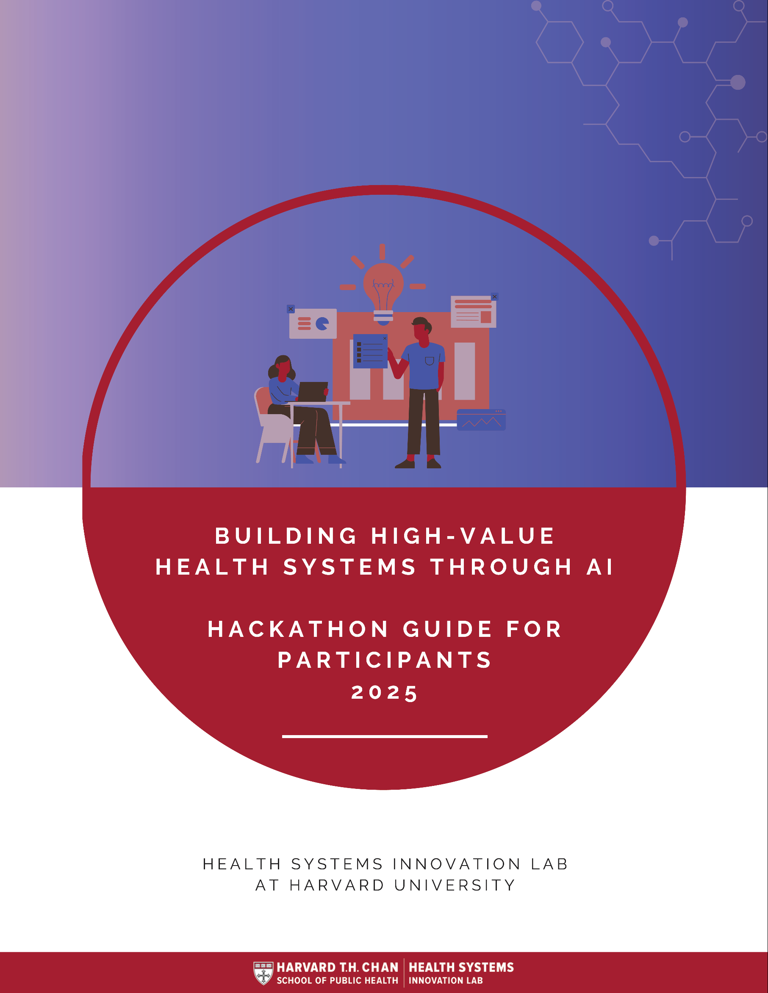

Harvard Health Systems Innovation Lab
2025 Hackathon Guide for Participants

Thank you for joining us at the 6th Health Systems Innovation Hackathon! The Harvard Health System Innovation Lab (HSIL) organizes a Hackathon every year in collaboration with our partners around the world. The Hackathon is a transformative event with a clear mission: to empower innovators to develop innovative solutions that improve health systems. This dynamic and collaborative event brings together students, young professionals, and experts from diverse fields to address critical health system challenges through innovation. By bringing together professionals from different backgrounds, it fosters cross-disciplinary collaboration and unconventional thinking to develop innovative solutions. Teams are supported to develop groundbreaking and practical solutions that can challenge the status quo and transform healthcare, bridging the gap between theory and practice. Teams will not only collaborate intensively during the event but hopefully also establish relationships and networks that extend beyond their duration. In summary, the HSIL Hackathon is a powerful platform for innovation and collaboration dedicated to improving healthcare systems around the world.

The 2025 Hackathon
This year’s Hackathon will take place on Friday 11th and Saturday 12th April 2025 and the theme is: ‘Building High-Value Health Systems: Leveraging Artificial Intelligence’.

Content

How is the Hackathon organized? 3
Event Program 4
Team Criteria 4
Team Formation and Digital Platform 5
Slack Instructions 6
Challenges 8
AI & Ethics 11
What to expect for the pitch? 12
Mentoring 12
Judging 13
Judging rubric for Health Systems Innovation Hackathon 14
What happens after the Hackathon? 15
Resources & Data Sources on Top Killer Diseases 16

How is the Hackathon organized?
The Hackathon is organized as a two-day in-person event in several Hubs across the different continents. Over the two-day Hackathon, teams will identify a pressing local or global health system challenge and develop an innovative solution to it. Teams will have access to mentors who have healthcare expertise and health innovation experience. They will advise the teams, challenge their assumptions, and provide feedback on their pitch. Teams will get ready to present their solution in front of a local judging panel by the end of the two days.
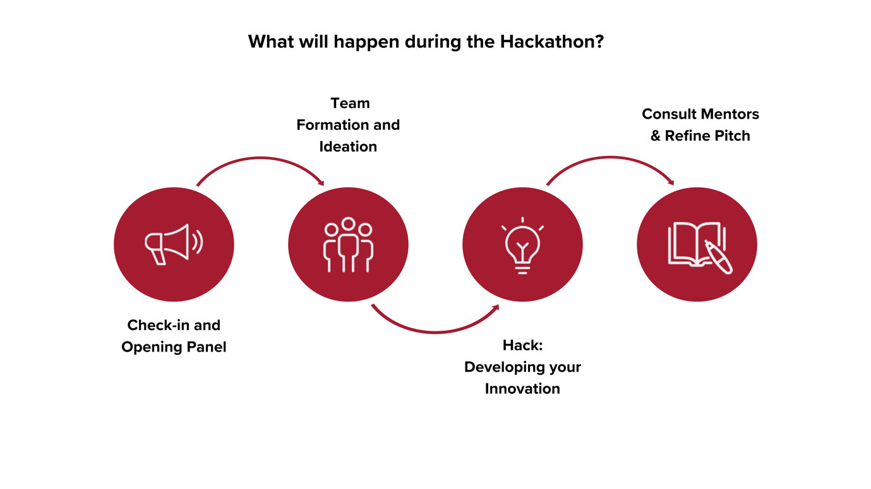Each Hackathon Hub is managed by a dedicated local organizer who ensures that all aspects of the event run smoothly. Local hub organizers will provide the necessary resources to host the event and will not charge any fees from participants. Should you have any questions regarding your local participation, please reach out directly to the local Hub organizers. They are your primary point of contact and are equipped to assist you with any inquiries or needs you may have during the event.

Event Program

Welcome

Your local hub will share specific timings with you. To kick-start the day, the Harvard Lab will host a global online welcome session tailored to connect with all participating hubs.

The event will begin with an Opening Panel on “AI-Driven Digital Solutions for Building High-Value Health Systems” moderated by Prof. Rifat Atun from Harvard University. Join our panel of esteemed experts as they explore how AI and digital innovations are revolutionizing health systems, providing cutting-edge insights into creating high-value healthcare solutions.

The Opening Panel will be followed by a “Hack 101” presentation with instructions, mentoring introductions and reminders on the hackathon.

Team Criteria

Our Hackathon is primarily focused on supporting early-stage innovations, offering an ideal environment for individuals and teams to develop and refine their ideas. While teams with mature innovations are welcome, the event is geared toward those in the initial stages of their journey.

During the two-day Hackathon, participants can choose to either identify a health system challenge or work on a pre-existing idea related to health and AI. We have outlined 11 priority challenges in the “Challenges” chapter below.

We suggest forming teams of 3-5 members and highly recommend building teams with a diversity of backgrounds and skills to enrich the innovation process. Whether joining as individuals, teams, or early-stage startups, participants can work on either non-profit or for-profit venture ideas. To fully engage in the Post-Hackathon Venture Incubation Program and Bootcamp conducted in English, it is essential that at least one to two team members are proficient in the language.

Our eligibility criteria are inclusive, encouraging participation from both students and professionals. In previous years, we've seen a vibrant mix of participants, from students to young professionals each contributing uniquely to the Hackathon's collaborative spirit.

Prototyping and Presentation
There is no requirement for teams to present fully working prototypes during the pitches. Concept-stage ideas are welcome, and we're open to creative presentation methods. The key is for teams to convey a clear understanding of how their prototype would function. Judges will be looking for compelling presentations that effectively communicate the concept and potential impact of your innovation.

Team Formation and Digital Platform
Once applicants are accepted and their participation in the Hackathon is confirmed, they will have the opportunity to join a joint Q&A session via Zoom, scheduled for two weeks before the event by their local Hub. This session will allow participants to introduce themselves, discuss their interest in specific tracks and challenges, and ask any questions they may have.

In addition, Slack groups for each Hub will be organized and accepted participants will be asked to create a profile and share information about their background, areas of interest in the Hackathon and skills they can bring to a team. From there, participants will be asked to form teams on Slack before the Hackathon begins.

Slack Instructions

Purpose of Using Slack for the Hackathon
Slack will serve as the primary communication platform for the HSIL Hackathon, facilitating
interactions among participants, organizers, mentors, and judges. Key features include:
- Central Communication Hub: For sharing logistics, announcements, and important details for participants.
- Direct Messaging: Enables participants to form teams, ask questions, and engage directly with anyone in the workspace.

Joining the HSIL Slack Workspace
- Access the Workspace: Go to the following link to initiate joining the HSIL Slack workspace: https://join.slack.com/t/hsil-hackathon/shared_invite/zt-30cwduvnl-dIrfYFrLsDs1d5Z9I8OC8g
- Create Your Account: Follow the prompt to create an account using your email address.
- Explore the Workspace: Once your account is set up, you'll have access to all public channels within the HSIL Slack.
- Optional Steps for Enhanced Accessibility:
- Slack App: Download the Slack desktop or mobile app for a more seamless experience. Log in to access the HSIL Slack space.
- Browser Access: Alternatively, the HSIL Slack can be accessed directly through any web browser.

Navigating to Relevant Channels
- Finding Channels: On the Slack Home page, look for the "Channels" section. Click the dropdown arrow next to it, select "Manage," and then choose "Browse Channels" to view available channels.
- Joining Channels: Select and join channels relevant to your hub within the Hackathon.
- Access to Locked Channels: If certain channels are restricted, Slack admins will add you to them as needed.
- Join the following Hub channels on Slack and get started:

- #jeddah-hub: All participants are requested to join this channel.
This channel will help you stay informed with important announcements and updates regarding the hackathon at the Boston Hub. Be sure to check here regularly for any news, changes, or reminders.

- #jeddah_teams_finalized: If you already have finalized a team, please join this channel. This channel will allow you to interact with others to network and learn from each other. Use this space to introduce your team, connect with other teams, and share resources that may be useful for the Hackathon.

- #jeddah_teams_in_the_making: Participants looking for additional team members - join this channel.
If you're a lone wolf with a vision for a team or a team looking for more members, please join this channel. Share your team concept, desired track, and the number of members you're seeking. Use this channel to scout for potential teammates or explore existing teams in need of additional members.

Challenges
These challenges are intended purely as a guide. You are encouraged to think creatively, innovate, and push the boundaries of your fields. We introduce some of the practical challenges faced across health systems but it is not an exhaustive list.

Artificial Intelligence and Healthcare
Recent developments in Artificial Intelligence (AI) present exciting possibilities for healthcare, a field characterized by vast amounts of data. Using AI to efficiently analyze this data can enhance both quality and operational efficiency in patient care. AI in healthcare offers transformative potential by analyzing vast medical datasets to improve diagnostic accuracy, predict disease risks, and enhance patient care outcomes beyond current human capabilities.

Selected cross-cutting Health Systems challenges

1. Electronic Health Record Analysis
Electronic health records (EHRs) have revolutionized the healthcare industry, allowing confidential patient information to be viewed by clinicians from anywhere in the world. They have also led to a boom in the volume of patient information which can be overwhelming but also presents an opportunity to innovate. The manual analysis of complex or lengthy patient records can be highly time-consuming. What systems can be created to analyze EHRs to form predictive models for patient’s diagnoses, disease trajectories and outcomes?

2. Diagnosis and monitoring improvements
Traditional diagnosis and condition monitoring is done through in-person consultations with human-to-human observation. AI and ML are revolutionizing diagnosis and condition monitoring by enhancing data analysis, identifying patterns that may be overlooked by humans, and offering improved predictive analytics. These technologies analyze large datasets to predict disease progression and tailor personalized treatment plans. In imaging and diagnostics, AI algorithms can interpret medical images like X-rays and MRIs with remarkable accuracy, surpassing traditional methods. Additionally, AI facilitates remote monitoring through apps and wearable devices, processing real-time health data to enable timely interventions. What AI-driven diagnostic or monitoring tools can be developed to detect patient changes earlier, allowing for timely treatment adjustments to prevent negative outcomes?

3. Intelligent Support Chatbots
With the rise of AI, chatbots have become increasingly powerful. They are now used by some for entertainment, education and work. But there also exist various opportunities in the healthcare sector for both patients and medical staff. Which AI and Large Language Models can be used to develop a chatbot that assists patients and medical staff (e.g. by directing them to resources or enhancing clinical decision-making)?

4. Fragmentation of Care
Patients frequently transition between various health systems, each often equipped with its own electronic health records (EHR) systems. Even within a single health network, mental health services and primary care often run on incompatible or poorly integrated platforms. Machine learning models that can dynamically adapt to sustain performance across different systems would save healthcare providers both time and money. What systems or models could be implemented to overcome these issues?

5. Too Much Information?
There is more data created every single second than one person could get through in a lifetime. Across almost every field, there is more information than a person can reasonably comprehend. In the field of mental health for example, there are more than 60,000 data points, and over 10,000 applications. However, the quality and effectiveness of these apps vary significantly, with many lacking substantial evidence to support their claims. This abundance of options can make it challenging for users to identify apps that are both reliable and beneficial for their health needs. How can we best match people with the health services or trustworthy apps that would suit them best?

6. Shortage of healthcare workers
A shortage of healthcare workers, including physicians, nurses, and health professionals, poses a significant challenge in many regions around the world. The demand for healthcare services often exceeds the available workforce, leading to long waiting times for appointments, limited access to specialized care, and suboptimal management of many conditions. Additionally, the shortage of healthcare workers can result in increased workload and burnout among existing staff, further compromising the quality of care provided to patients. How can we leverage AI to develop strategies that mitigate healthcare worker shortages in regions where demand surpasses workforce availability?

7. Fragmented Care Pathways
In healthcare systems worldwide, fragmented care pathways have emerged as a significant obstacle to providing comprehensive and effective care. Fragmentation occurs when there is a lack of coordination and continuity in healthcare delivery across different providers, settings, and stages of care. This often leads to disjointed communication, duplicated tests, conflicting treatment plans, and gaps in follow-up, ultimately compromising patient outcomes and experiences. How can healthcare systems use AI to address fragmented care pathways by enhancing coordination, communication, and continuity, ultimately improving patient outcomes and maximizing resource efficiency?

8. Health literacy
Poor health literacy hinders effective healthcare, as patients may misinterpret symptoms like distress or discomfort, delaying diagnosis and treatment. Misunderstandings about physical and mental health contribute to stigma and inadequate care-seeking. Improving health literacy empowers individuals to recognize symptoms, make informed decisions, and dispel myths. How can we leverage AI to improve overall health literacy, particularly focusing on those directly affected by health conditions or those in supportive roles?

9. Preventive Health Engagement
AI is revolutionizing preventive health engagement by enabling personalized, proactive health management. Through data analysis and predictive modeling. AI-powered tools can offer tailored health recommendations, monitor lifestyle habits, and remind patients of screenings or vaccinations, enhancing adherence to preventive measures. Additionally, AI chatbots and virtual health assistants provide accessible support and information, empowering individuals to take charge of their health. How can AI be used to create personalized preventive health programs that analyze individual health data, environmental factors, and social determinants to deliver targeted, actionable recommendations? Could machine learning models predict individual health risks and suggest specific interventions before conditions develop?

10. Breaking communication barriers
AI is transforming communication in medicine by bridging the gap between complex medical information and patient understanding. Advanced AI systems can translate medical jargon, such as lab results and diagnostic reports, into simple, clear language that laypeople can easily comprehend. This empowers patients to make informed decisions about their healthcare. AI tools can also provide multilingual support. By enhancing communication, AI contributes to more inclusive and effective patient care. What are additional ways AI could enhance communication between patients and their care teams?

11. AI in Pediatrics
Using AI in pediatric health care holds the promise to improve the accuracy and efficiency of diagnoses and treatments for young patients, especially for rare pediatric diseases. A major factor that distinguishes AI use in pediatrics from its application in adult care is data complexity. Varying developmental stages and growth add complexity to any analysis. Children change providers frequently and files often include input from various data sources (e.g. caregivers, clinicians and teachers). Higher thresholds for privacy and data security complicate access to pediatric datasets. How can AI be used to integrate data from diverse sources to provide a comprehensive view of a child’s health? How can AI solutions be designed to adapt to the different developmental phases of children?

AI & Ethics
Since the theme of this year’s Hackathon is Artificial Intelligence (AI), please keep in mind that it’s an evolving field. AI and machine learning (ML) models are only as good as the data given to them. When building AI solutions, carefully consider how algorithmic biases could unfairly impact different patient groups and work to prevent these disparities.

AI in healthcare requires careful consideration of data biases and ethical implications. Healthcare data often reflects existing inequalities, which AI systems can amplify if not properly addressed. Key challenges include protecting patient privacy, preventing algorithmic discrimination, maintaining human oversight of AI decisions, and addressing disparities in access to technology and digital literacy.

More info: WHO Ethics and governance of artificial intelligence for health: Guidance on large multi-modal models < https://www.who.int/publications/i/item/9789240084759>

What to expect for the pitch?
At the end of the hack, you and your team will deliver a 3-minute presentation, or “pitch” on your idea. With limited time, structure your pitch to ensure you cover all key points. Practice the pitch a few times before delivering it – this will not only help you remember the crucial points but also increase your comfort level when it's time to pitch. Be sure to allocate time to explain the technical aspects, your decision-making process, and showcase a demo of your solution.

Considering most hackathon pitches last 3 minutes, here’s a rule of thumb for maximizing your impact within that tight timeframe:
- Introduction (10 seconds): Briefly introduce yourself and your team in a memorable way. Since people recall more easily how things start and finish, ensure your introduction makes a lasting impression as the judges deliberate.
- Problem statement (20 seconds): Clearly describe the problem you are addressing. Whose lives can be improved by your solution, and what tangible impact will it have?
- Product (1 minute): Explain the technical aspects of your idea. Provide enough detail to demonstrate your technical expertise and decision-making process, without overwhelming your audience with excessive information.
- Demo (1 minute): Support your product presentation with a live demo (if possible) or use visualization tools to mockup the design, functionality, and key features
- Wrap-up (30 seconds): Summarize the main points of your pitch and end with a strong closing statement.

Mentoring
Each team will get support from local mentors in person in each Hub over the two-day event.
The mentors have diverse skills and expertise to guide teams composed of students and young professionals from fields such as medicine, engineering, public health, and beyond. We have subject matter experts in healthcare offering clinical insights and understanding patient needs; healthcare technology specialists with experience in digital health and medical devices; professionals with backgrounds in engineering and artificial intelligence for technical guidance; public health and policy experts to navigate broader healthcare landscapes; design thinking and user experience specialists to prioritize user needs; entrepreneurs and business professionals to assist with business models and market analyses; effective communicators and presenters to help teams convey their ideas; and adaptable problem-solvers capable of addressing challenges and unforeseen issues.

Local mentors will be available on-site to support teams with short questions or during 1:1 team mentoring sessions. Teams can sign up for mentoring via the schedules provided through Slack.

Judging
All teams will be given 3 minutes to pitch their innovation in front of local judges on the 2nd day of the Hackathon, April 12th. The judging panel will consist of three to five local judges collectively bringing in clinical, technical, and business expertise.

The judging panel will consist of three to five judges collectively bringing in clinical, technical, and business expertise. The judging panel will identify the best digital health solutions with a high potential for transforming healthcare systems and improving care around the world. Judging criteria can be found in the table below.

Judging rubric for Health Systems Innovation Hackathon
Criterion | Considerations | Score
- Challenge | - Is a clear need articulated?  - Does the team demonstrate understanding of the root causes of the problem?  - Is this a significant problem to address in terms of size, disease burden, consequences or perception?  - Does the team provide a convincing rationale as to why this needs to be addressed urgently? | /5
- Technology & Innovation | - Offers new technology solution (better / faster / cheaper)  - Provides convincing rationale for why this unique approach has the potential to work (if it doesn’t exist already in any other form)  - If the solution is focused on low resource settings, it addresses relevant technical issues (e.g., low-cost components, power supply, limited internet)  - Does the team clearly describe what the innovation is, its components and how it will address the challenge?  - Does the innovation possess transformative potential to improve outcomes at the health systems level?  - Does the team consider design and user experience in its innovation? | /5
- Implementation | - Beyond need, is there a demand for this solution?  - Does the team address obstacles to implementation and outlines a plan to overcome them? (e.g., Logistics, supply chain, overstretched implementing organizations, cultural appropriateness, etc.)  - Does the team outline a plan to develop the innovation and introduce it into the health system?  - Is there a sustainable business model and value proposition?  - Are critical stakeholders, the health system and the context adequately considered as part of the implementation strategy? | /5
- Team | - Is the team equipped with the right skill mix and attitude to implement the proposed innovation? | /5
- Pitch | - Does the team demonstrate the prototype or solution?  - Does the team clearly articulate the challenge it is addressing and how their innovation is addressing it?  - Does the team document next steps clearly – i.e. how they plan on working in the field to test their solution and how to continually incorporate end user feedback?  - Are visual aids (presentation design and use of diagrams and figures) used effectively? | /5
- Question & Answer | - Is the team able to defend their position and respond to specific questions from the judges? | /5
- Total |  | /30

What happens after the Hackathon?
Winners from local hubs (< 50 participants: 1 winning team, 50-100 participants: 2 winning teams, >100 participants: 3 winning teams) will enter a focused two-week Bootcamp, a critical phase aimed at refining their pitches and shaping their groundbreaking ideas. A selective HSIL judging panel will then invite 20 top teams to an extended bootcamp for deeper guidance and development. Following this, teams will present their innovations to an esteemed global judging panel. Eight exceptional teams will be chosen to participate in our rigorous 4-week online HSIL Venture Incubation Program, which includes specialized seminars, interactive workshops, and dedicated 1:1 mentoring. There will not be any prize money to winners.

Resources & Data Sources on Top Killer Diseases

Cardiovascular diseases and Diabetes
- State of Cardiovascular Disease in G20+Countries (Health Systems Innovation Lab Harvard): https://www.hsph.harvard.edu/health-systems-innovation-lab/2022/05/11/cvd-g20/
- Cardiovascular Disease & Diabetes Roadmaps (World Heart Federation): https://world-heart-federation.org/cvd-roadmaps/whf-global-roadmaps/cvd-diabetes/
- Diabetes Fact Sheet (WHO): https://www.who.int/news-room/fact-sheets/detail/diabetes
- Cardiovascular Disease Fact Sheet (WHO): https://www.who.int/news-room/fact-sheets/detail/cardiovascular-diseases-(cvds)
- “Diabetes a defining disease of the 21st Century” (Lancet Article): https://www.thelancet.com/journals/lancet/article/PIIS0140-6736(23)01296-5/fulltext

Cancer

Global cancer burden growing, amidst mounting need for services https://www.who.int/news/item/01-02-2024-global-cancer-burden-growing--amidst-mounting-need-for-services
- International Agency for Research on Cancer https://www.iarc.who.int/Union for International Cancer Control https://www.uicc.org/

Mental Health
- The Mental Health Atlas by the World Health Organization (WHO): https://www.who.int/publications/i/item/9789240036703
- A comprehensive study on the global burden of 12 mental disorders across 204 countries and territories from 1990 to 2019: https://www.thelancet.com/journals/lanpsy/article/PIIS2215-0366(21)00395-3/fulltext
- Global suicide data provided by the World Health Organization (WHO): https://www.who.int/teams/mental-health-and-substance-use/data-research/suicide-data
- Access to the WHO MiNDbank online database, which contains a wealth of mental health data, policies, and strategies: https://extranet.who.int/mindbank/
- Visualization of the global burden of mental health diseases through the Global Burden of Disease Study: https://vizhub.healthdata.org/gbd-results/
- Mental health data available from the Institute for Health Metrics and Evaluation (IHME): https://www.healthdata.org/research-analysis/health-risks-issues/mental-health#:~:text=12%25%20of%20the%20world's%20population,to%20mental%20disorders%20in%202019.

Infectious Diseases
The Global Health Data Exchange platform (IHME): https://ghdx.healthdata.org

