

Cyber Incident Response Plan (CIRP) for {organization}

Prepared by {owner}
Current at {today}

A computer security incident is a violation or imminent threat of violation of computer security policies, acceptable use policies, or standard security practices. (NIST - 2.1)

This template serves as a basis for you to develop a basic cyber incident response plan (CIRP) for your organization. It follows the structure and guidance contained in NIST 800-61 Rev 2 and references in brackets - e.g. (NIST - 3.0) - refer to the relevant section.

If you suspect an incident is taking place, go immediately to Step 2.
Step 2 - Detection and Analysis

Completion Guide - Delete After Use
1 - Terminology and Titles. Use edit / replace to match the template references and terms to your organization. Terms to be changed are bracketed with curly brackets - e.g., {organization} - so you can edit and replace as follows.
- Use Find / replace and search for ‘{‘
- Change the placeholder text to match the term for your organization. E.G. changing {owner} to ‘Jan Smith’.

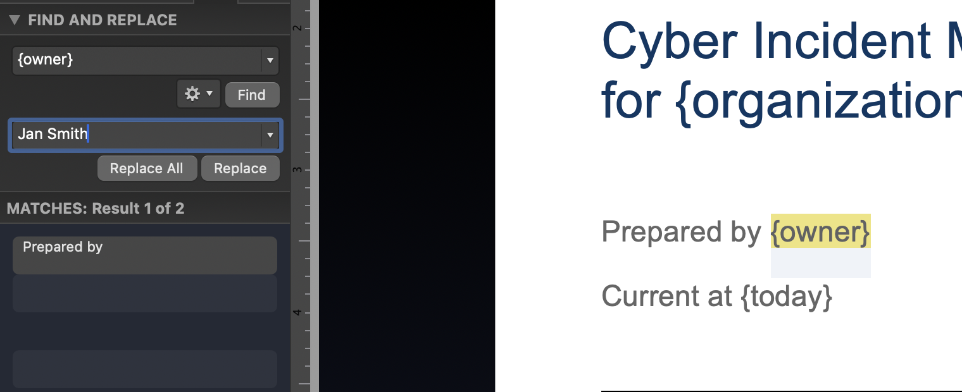
- Terms such as {organization} and {owner} can be updated using ‘Replace All’. However, in the CIRT Contact section, the term {email} is used as a placeholder multiple times so each instance should be updated individually.
2 - Organization-Specific Elements. IMPs cannot be 100% ‘cookie-cutter’ templates and some elements must be changed to meet the organization’s needs or aligned with existing processes. Where necessary, these considerations are highlighted in completion guides. These explain the considerations or discussions necessary to complete a section.
For example:
Consideration
Which team will coordinate with external parties? The CIRT or a higher-level organizational crisis management team (CMT)?
If your organization has an identified CMT, they will normally deal with all external communications, but in a smaller organization, the CIRT will.

Note: If you discover that there are too many cases where the answer is unclear, or this template cannot address your specific concerns, then this template will not fit your specific needs. In this case, we advise you to engage an adequately qualified expert to develop a plan specific to your organization’s needs.

3 - Final Steps. Read the final plan thoroughly to ensure that you have aligned all terminology and processes with your organization, and that all considerations in the completion guides have been addressed. Then
- Delete all completion guides.
- Delete this completion section.
- Remove any unnecessary blank pages.
Update the table of contents.
-- delete to here --

Document Management
Document Owner | {owner}
Created | {today}
Contact | {email}

Disclaimer
This incident management plan ("Plan") is provided by The Security Scientist for general informational purposes only. By using this Plan, you, the user, acknowledge and agree to the following terms and conditions.
1. Responsibility for Accurate Completion: You are solely responsible for the accurate completion and customization of the Plan to meet your specific requirements and circumstances. The Security Scientist does not guarantee the suitability or appropriateness of the Plan for your particular use and does not assume any responsibility for the content you input, or the final document produced.
2. Not Professional or Legal Advice: The Plan is not intended to provide, and should not be construed as, professional or legal advice or guidance. You should consult with your own technical experts, legal counsel or other professional advisors as necessary to ensure your response to any situation and the resulting documents and action are appropriate for your needs and compliant with applicable laws and regulations.
3. No Liability: The Security Scientist shall not be liable for any loss, damage, or harm, whether direct, indirect, incidental, consequential, or otherwise, that may arise from or be incurred in connection with your use of, reliance on, or inability to use this Plan. You expressly release and hold harmless The Security Scientist, its officers, directors, employees, agents, and affiliates from any and all claims, liabilities, and damages arising from or relating to your use of the Plan or the resulting document.
By using the Plan, you acknowledge that you have read, understand, and agree to be bound by these terms and conditions.

Contents

Overview - The NIST 4-Step Framework
The NIST Incident Handling Checklist
Foundational Elements
Organizational Mission
Organizational Values
Management Approval
1 - Preparation
Incident Mitigation
The {organization} Response Structure
CIRT Structure, Roles and Responsibilities
CIRT Contact Information
Training
CIRT Facilities and ‘Life Support’
Equipment
‘Life Support’
2 - Detection and Analysis
Incident Detection and Tracking
Analysis and Classification
Initial Incident Report
Mobilization
External Notification
3 – Containment, Eradication and Recovery
Response Planning
Plan Development, Adjustment and Execution
Closing the Incident
4 - Post Incident Activity
Capturing lessons learned and follow through

Overview - The NIST 4-Step Framework
This plan follows the 4-step framework outlined in NIST 800-61 as shown below (see NIST - 3.0).

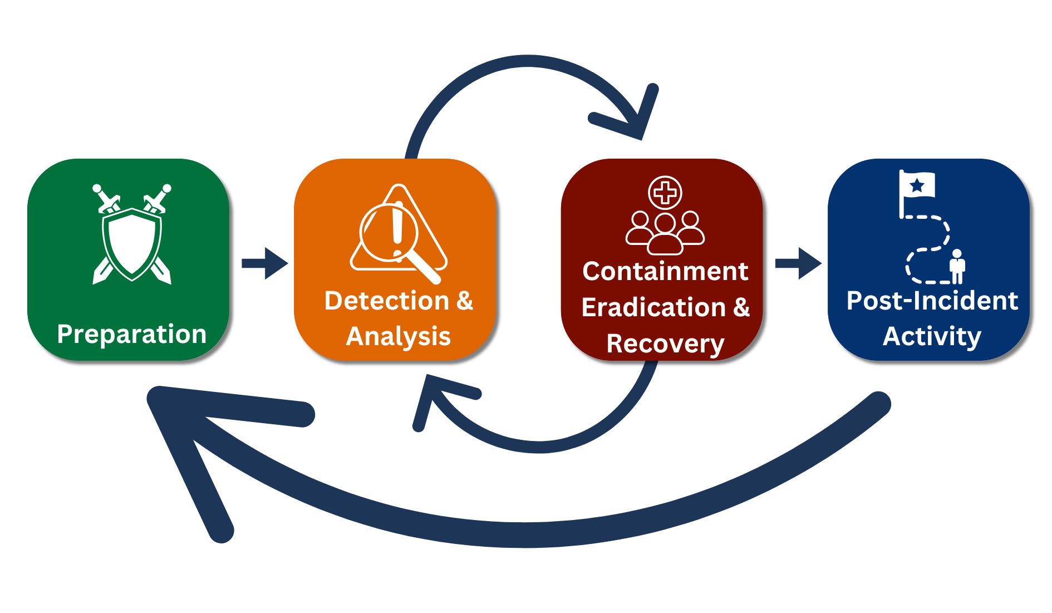
The preparation section is work that should be undertaken immediately to prepare the organization for a cyber incident. Completion of this plan is a step 1 activity.
Prior to that you should complete the ‘Foundational’ section of this plan.

➡️ Start Foundational Section

If you suspect an incident is taking place, go immediately to Step 2.
Step 2 - Detection and Analysis

The NIST Incident Handling Checklist
This is the formal NIST Cyber Incident Response Handling Checklist. Refer to this throughout an incident to ensure that all critical actions have been completed in accordance with the standard. (See NIST Section 3.5 Incident handling Checklist for more.)
Action | Completed
Detection and Analysis
1. Determine whether an incident has occurred
1.1 Analyze the precursors and indicators
1.2 Look for correlating information
1.3 Perform research (e.g., search engines, knowledge base)
1.4 As soon as the handler believes an incident has occurred, begin documenting the investigation and gathering evidence
2. Prioritize handling the incident based on the relevant factors (functional impact, information impact, recoverability effort, etc.)
3. Report the incident to the appropriate internal personnel and external organizations
Containment, Eradication, and Recovery
4. Acquire, preserve, secure, and document evidence
5. Contain the incident
6. Eradicate the incident
6.1 Identify and mitigate all vulnerabilities that were exploited
6.2 Remove malware, inappropriate materials, and other components
6.3 If more affected hosts are discovered (e.g., new malware infections), repeat the Detection and Analysis steps (1.1, 1.2) to identify all other affected hosts, then contain (5) and eradicate (6) the incident for them
7. Recover from the incident
7.1 Return affected systems to an operationally ready state
7.2 Confirm that the affected systems are functioning normally
7.3 If necessary, implement additional monitoring to look for future related activity
Post-Incident Activity
8. Create a follow-up report
9. Hold a lessons-learned meeting (mandatory for major incidents, optional otherwise)

Foundational Elements
This section provides a foundation for the plan and ensures that this CIRP adheres to the NIST guidance.
Guidance
During an incident or crisis it can be easy for an organization to lose sight of its mission and values and to cut corners to solve the immediate problem. However, this causes longer term issues for the organization and therefore the organization's mission and values must be top of mind during an incident.
Include these here for reference.
Have the CEO or their designate approve this plan once complete as this formalizes the measures in the CIRP and provides the necessary authority for training and resourcing the CIRT.

Organizational Mission
{mission}

Organizational Values
{values}

Management Approval
Recognizing the importance of an effective response to any cyber incident to ensure the success of {organization}, we approve this plan and require all staff with a CIRT responsibility to ensure that they are familiar with its contents and adhere to the direction herein.

Approved by -
Date -
Title -
Signature -

1 - Preparation
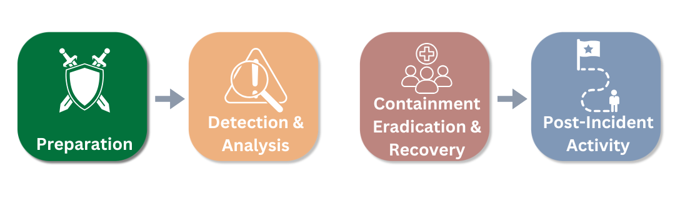
This section covers:
- The response structure
- CIRT Staffing and contact information
- Training
- CIRT Facilities and ‘Life Support’

Incident Mitigation

Guidance
A critical part of incident preparation is incident mitigation. Include a summary of mitigation measures and a link to your organization's cyber risk assessment and the incident mitigation measures here as a reference.
Risk assessments and mitigation plans are more dynamic that response plans so it is recommended that you do not include the ‘live’ risk assessment here unless you can update it dynamically.

{link to organization’s detailed incident mitigation plan}

The {organization} Response Structure
This is the framework {organization} will adapt in the event of a crisis and illustrates how the CIRT will coordinate with the other elements of an organizational response.
Completion Guide
Normally organizations will have a senior team in place to direct all elements of a major event, often referred to as the crisis management team or CMT. In the case of a major cyber event, the crisis management team would sit above the incident response team, but in smaller organizations, or where the event is not so serious, the incident response team may take the lead for all response elements.
Ensure the structure below is adapted to reflect the overall response structure for your organization.

Level | Team | Focus
C-Suite / Leadership | Crisis Management Team (CMT) | Strategic planning, coordination and outreach
 | ↕
Technical / Coordinating | Cyber Incident Response Team (CIRT) | Operational coordination and liaison. Technical response management.
 | ↕
Response | Responders | Problem resolution and local coordination.

CIRT Structure, Roles and Responsibilities
The role of the CIRT is to coordinate all the technical elements of the response to a cyber event, to direct the supporting teams and agencies, and to communicate with the senior leadership of the organization. At a minimum, the following functions and roles must be filled for the CIRT to be successful. Note:
- Anyone allocated to a role must be trained to ensure they are familiar with their responsibilities in the event of an incident.
- Each role must have an identified deputy or alternate who can stand in for the primary team member in the event of sickness, illness, or where team members need a break.

Role | Responsibility
CIRT Lead | The CIRT Lead runs the CIRT and coordinates the development and execution of the response plan and ensures that the organization’s senior leadership remains aware of the situation and any developments. They require a high degree of technical expertise but are focused on coordination of the overall response, not simply the technical aspects of incident management.
Technical lead | The Technical Lead is the technical subject matter expert and is responsible for ensuring that the response plan meets the challenges of the incident. They will direct the technical elements of the response and coordinate with vendors and third-party technical experts.
Finance / Insurance | The Financial Representative on the team is there to advise on the availability of funds for the response, the financial implications of the response, and ideally, insurance coverage and obligations of the organization.
Operations | The Operations Representative will advise on the impact of the event on the organization as a whole and advise on how the response plan may affect day-to-day operations.
HR | A representative from HR should be involved when any staff PII may be affected by the incident or where employee welfare is a concern.
Communications | The Communications Representative is responsible for ensuring that the organization can clearly explain the issue, what has happened and what is being done about it, while also communicating the public response. They are also responsible for managing any press inquiries and preparing any spokespersons and statements to be issued.
Legal | The Legal Representative is responsible for advising the CIRT on the organization's legal and regulatory responsibilities and raising any legal issues that may arise during response planning.

Not all team members will be required for the duration of the incident nor to attend every meeting, but the default presumption should be that all CIRT members should be mobilized in the early stages of an incident.

CIRT Contact Information
These members of the CIRT should be contacted as soon as an incident is suspected.
Completion Considerations
Do not use edit / replace all for terms such as {email} to avoid giving everyone the same details.
Ensure this remains up to date if staff change

This information is confidential / PII and should only be used in relation to the actions described in this plan.
Role | Contact Info | Alternate Contact Info
CIRT Lead | {lead name}  {lead email}  {lead phone} | {lead 2 name}  {lead 2 email}  {lead 2 phone}
Technical lead | {Technical lead name}  {Technical lead email}  {Technical lead phone} | {Technical lead 2 name}  {Technical lead 2 email}  {Technical lead 2 phone}
Finance / Insurance | {finance name}  {finance email}  {finance phone} | {finance 2 name}  {finance 2 email}  {finance 2 phone}
Operations | {Operations name}  {Operations email}  {Operations phone} | {Operations 2 name}  {Operations 2 email}  {Operations 2 phone}
HR | {HR name}  {HR email}  {HR phone} | {HR 2 name}  {HR 2 email}  {HR 2 phone}
Comms | {comms name}  {comms email}  {comms phone} | {comms 2 name}  {comms 2 email}  {comms 2 phone}
Legal | {legal name}  {legal email}  {legal phone} | {legal 2 name}  {legal 2 email}  {legal 2 phone}

Questions concerning this plan should be directed to the plan owner (See the document data page).

Training
{organization} will carry out the following annual training to embed and maintain this CMP and the associated skills.

Familiarization Briefings
Consideration

On-demand training could be used to accomplish these familiarization briefings.

Objective: All CIRT members, possible alternatives, and any supporting team members must be familiar with the contents of the CIRP and their role.
Method:
- The Plan Owner is to ensure that this CIRT is provided to all CIRT members and alternates.
- The Plan Owner is to run regular, short briefing sessions to familiarize CIRT members with the plan and answer any questions.
- New senior hires to {organization}’s senior leadership, the IT department or in a supporting function should attend plan familiarization training within 30 days of joining.

Consideration

Involve the organization’s CMP or equivalent and key third parties / vendors in future exercises.

Walkthrough Exercise
Objective: All CIRT members, possible alternatives and any supporting teams must be familiar with the processes contained in the CIRP and the roles and responsibilities of all CIRT members.
Method:
- The plan owner is to run a quarterly low-intensity tabletop ‘walkthrough’ exercise to familiarize CIRT members with the processes and responsibilities in the CIRP.
- The walkthrough should be based on one of the top-risk scenarios or an emerging situation as the basis for the exercise. The plan owner will walk the attendees through the scenario, beginning with initial notification. At each stage, attendees will discuss:
  - What they would do
  - The tools they would use available
  - Who they will be coordinating with
  - What concerns they might have
- The walkthrough exercise is a slow-paced, ‘open book’ event to ensure CMT members are familiar with their roles and the CMT processes.
- The plan owner and attendees should make note of any tools or processes that need adaptation or additional training and action these after the exercise.
- All CIRT members or alternates must attend two walkthrough exercises annually.
The first walkthrough must take place within 30 days of plan approval.

Tabletop Simulation Exercise
Objective: All CIRT members, possible alternatives for {leadership} members and any supporting teams must be able to comply with the processes contained in the CIRP and be able to execute their roles and responsibilities as part of the CIRT.
Method:
- The plan owner is to run an annual tabletop simulation exercise to allow CIRT members to practice their role and use the processes contained in the CIRP.
- The tabletop simulation should be based on one of the top-risk scenarios or an emerging situation as the basis for the exercise.
- The simulation should make use of realistic inputs to simulate the kind of updates the CIRT would receive to allow them to respond in a realistic manner.
- The simulation will be fast paced but remain an ‘open book’ event to ensure CIRT members are familiar with their roles and the CIRT processes.
- The plan owner and attendees should make note of any tools or processes that need adaptation or additional training and action these after the exercise.
- All CIRT members or alternates must attend one tabletop simulation annually.
The first simulation must take place within 180 days of the plan’s approval.

CIRT Facilities and ‘Life Support’

Completion Considerations
To function successfully, particularly at times of uncertainty, the CIRT requires a dedicated workspace to meet and plan effectively. The three locations that the CIRT may use are:
- Primary - at {organization}’s main office
- Alternate - at a pre-identified off-site location such as a hotel or satellite office
- Remote - a dedicated, secure video meeting space
These locations should be identified and tested before including these below and facilities should be checked regularly for serviceability. Thought must be given to access control for remote sites and for vendors and other support staff needing access to the main facility.
Conference call and video meeting room access codes should be considered as confidential, and you may not wish to list these in publicly accessible documents.

{organization} has identified the following facilities for use by the CIRT. The responsible party listed must ensure that these facilities remain serviceable and is responsible for preparing these prior to a CIRT meeting.
These facilities must be secure and offer a space for private confidential discussions and be sufficiently large for all CIRT members and potential support staff to access. Thought should also be given to where CIRT members can take breaks and access refreshments.

Facility | Address / Location | Access Control / Keyholder | Responsible Party
Primary
Alternate
Remote

Equipment
Each meeting facility requires the following basic equipment and CIRT members should ensure that they have access to the equivalent tools and supplies if working remotely.
- Sufficient deskspace or workstations for all CIRT members plus any vendors and support staff.
- Spare laptops / phones.
- Printer, paper and ink.
- Breakout rooms or alternate meeting facilities for breakout sessions and planning.
- IT and phone connectivity.
- Phones for 1-1 and conference calls
- Power strips and chargers.
- Whiteboards / flip charts.
- Technical tools for likely scenarios and / or license keys for specialist forensic or response software
- Secure records disposal.
- Stationary.
- Site and technical plans.
- Copies of response plans.
- Contact lists for staff, vendors, stakeholders and regulators.

‘Life Support’
Major incidents can extend for days if not weeks meaning that the CIRT may be mobilized for significant periods of time. The responsible party for the meeting room in use or the CIT lead for extended periods should ensure that the following facilities are available to support CIT members.
In the meeting room area
- Break areas
- Refreshments
- Restrooms
Easily accessible from the meeting room area
- Accommodation / sleeping areas
- Catering
- Showers
Arranging transport to / from home may also be necessary in an extended incident where staff may become sleep deprived.

2 - Detection and Analysis
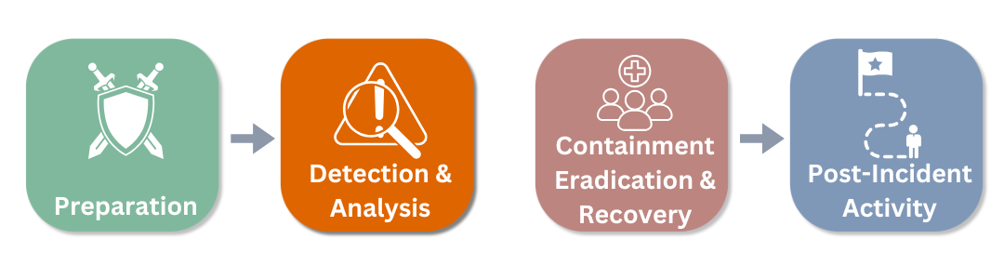

Incident Detection and Tracking
The following systems are in place to monitor the key attack vectors affecting {organization}’s IT systems.
Those listed under ‘Reports To’ must be familiar with the Analysis, Classification and Mobilization guidelines as they will be responsible for reporting an actual or suspected incident to the CIRT lead.
(See NIST 3.2.1 Attack Vectors for more)

Completion Guide
List the main systems and individuals in place responsible for critical system monitoring. This table acts as both a responsibility matrix for the reporting party and a contact list for the monitoring groups.
Include either attack vectors specific to {organization} if necessary, referring to NIST 3.2.1 for guidance.

Attack Vector | Party Monitoring | Monitor Reports To
External/Removable Media
Attrition (brute force)
Web
Email
Impersonation
Improper Usage
Loss or Theft of Equipment
{Other}

If an incident is suspected or detected, use the Analysis and Classification guide below to diagnose the event and prepare an initial incident report.
Refer to NIST 3.2.2 Signs of an Incident for more details on incident detection.

Analysis and Classification
When an incident is suspected or detected, analyze the initial reports and determine the parameters of the incident.
Use the assessment matrix below to diagnose the incident, deleting the non-applicable sections / text.
Consideration | Initial Analysis (Delete non-relevant text)
System or Process Affected
Likely Attack Vector | - External/Removable Media  - Attrition (brute force)  - Web  - Email  - Impersonation  - Improper Usage  - Loss or Theft of Equipment  - Other
Likely Perpetrator | - Staff member / direct contractor  - Indirect contractor / vendor  - Third party
Specific Indicators | - IDPSs  - SIEMs  - Antivirus and antispam software  - File integrity checking software  - Third-party monitoring services  - Operating system and network application logs  - Network device logs  - Network flows  - Publicly available Information on new vulnerabilities and exploits  - People from within the organization  - People from other organizations
Functional Impact of the Incident* | None / Low / Medium / High
Informational Impact of the Incident* | None / Privacy Breach / Proprietary Breach / Integrity Breach
Recoverability from the Incident* | Regular / Supplemented / Extended / Not Recoverable

* Refer to the NIST classification NIST 3.2.6 Incident Classification for full details.
Once complete, copy this diagnosis into the incident reporting template below and use this to notify and brief the CIRT Lead or designated point of contact as described in the Mobilization section below.

Remember that these situations can be dynamic and may change over time, so begin with your best assessment of the situation. Do not delay classification and notification while waiting for the ‘complete’ answer.

Initial Incident Report
Use this template for the initial report on the incident and update it as events develop. Ensure the report date / time is updated with each amendment so staff ensure they are working with the latest information.

Report Date / Time
Current Status
Summary of the Incident
Incident Indicators
Relevant incidents
Actions taken so far
Chain of custody
Impact Assessment
Contact information for those involved (include 3rd parties)
Evidence Gathered
Next steps

Once complete, inform the CIRT lead or delegate that an event is occurring or suspected and share the initial incident report.
➡️ CIRT contact Info

Mobilization

Mobilize, Monitor or Delegate
Completion Guide
This is a generic triage guide defining mobilize, monitor, delegate but you should check for any specific definitions or delegation guidelines in use at your organization. You may also want to set specific cut-offs based on the severity levels outlined in NIST 3.2.6 Incident Classification.

When informed of an incident or suspected incident, the CIRT Lead or delegate must decide on the correct course of action: mobilize, monitor or delegate.
- Mobilize. For serious events that require specialist expertise, high level of coordination and may affect the organization as a whole, the CIRT must be mobilized. Whenever the CIRT is mobilized, the {organization] leadership team or crisis management team (CMT) must also be notified.
- Monitor. Evens that are contained but may expand or require specialist support should be monitored. The CIRT Lead should inform the CIRT of the event and check in with the response team regularly to determine if the full CIRT is required.
- Delegate. A minor event that is being successfully contained and handled by the immediate response team can be delegated back to that team. The CIRT should be made aware of the incident but are unlikely to be required.
CIRT Lead is notified &
Course of Action Selected
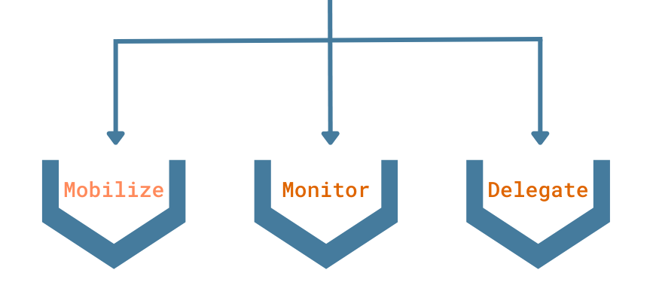
Mobilize the CIRT & Notify the Organization CMT | Notify the CIRT | Delegate to functional teams & Notify the CRT
If in doubt, err on the side of caution and work as higher level. (e.g. instead of delegate, monitor).

Mobilization Process
The purpose of the mobilization stage is to get the right people together as quickly as possible to start solving the problem. These meetings may be held in person or virtually, depending on the time of the event and {organization}’s normal work practices.
Before mobilizing the team, it's crucial to gather the necessary information to share with them.
❗️Use the initial incident report to summarize what you know at that time and share this with the CIRT members.
Also, provide meeting logistics so they know when and where to attend the first CMT meeting.
❗️See CIRT Facilities and ‘Life Support’ for meeting locations and pick the most suitable for the circumstances.
❗️Use the CIRT contact list to contact CIRT members that the team is being mobilized.
If sending a message or email, request confirmation from the recipient to ensure they have received the information and plan to attend.
At this stage, some CIRT members may feel compelled to take action to get ahead of the problem. Ideally, these actions should focus on aspects of the operational response rather than the strategic response, which necessitates the input of the entire CIRT. However, there might be some actions that individuals want to take before the first CMT meeting. Stress that any action taken at this time should only occur after consultation with the CIRT Lead.
❗️Once you assemble the CIRT, use latest Incident Report to update team members on the event and progress and then move to the Containment, Eradication and Recovery stage to begin planning the response.

External Notification
Many situations require external parties – law enforcement, regulators, customers – to be informed of a cyber incident. The CIRT may not be responsible for making the external notifications, but the CIRT Lead will be responsible for coordinating and tracking the external notifications.
Completion Guide
Review your local regulations and industry requirements with respect to external notifications. Communication with the press and customers will normally be handled by corporate communications but the CIRT’s technical input is essential to ensure that any technical explanation contained in a public communication is factually accurate.

Interested Party | Point of Contact / Method | Responsibility for Notification | Relevant Event Types | Notification Timeline
Law Enforcement
Regulators
Customers
Partners / Suppliers
Staff
Public
Other

3 – Containment, Eradication and Recovery

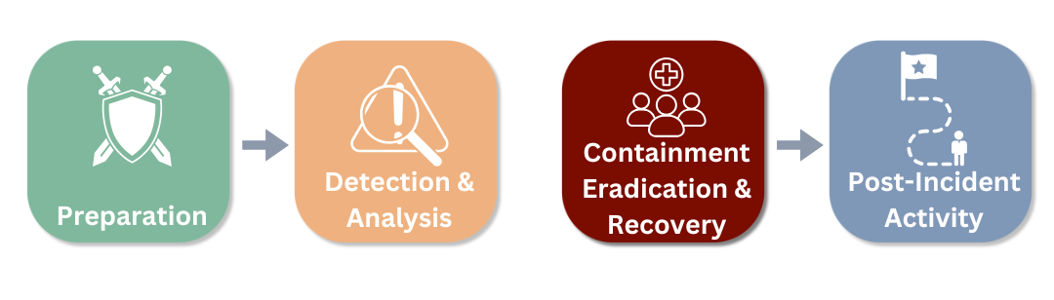
Completion Guide
In many cases it is possible to scenario plan or war game effective solutions to different types of incident or attack. The resulting plans will not fit every situation but will provide high-level playbooks that can be applied for similar types of event. Wherever possible, complete this work for your organization for what you deem to be the most likely incidents. (Refer to your risk assessment to identify the most likely scenarios)
Where such playbooks have been developed, reference them here in a simple matrix showing event or incident type with a link to the specific response plan.

(Remove this table if these plans have not been develoedp0

Event type | Response Plan reference or hyperlink

Response Planning

Strategy development
Each situation and incident type will require a different solution. Some criteria for determining the appropriate strategy include (from NIST 3.3.1 Choosing a Containment Strategy)
- Potential damage to and theft of resources
- Need for evidence preservation
- Service availability / effect on other systems
- Time and resources needed to implement the strategy
- Effectiveness of the strategy (e.g., partial containment, full containment)
- Duration of the solution / solution timeline / milestones

Response Plan Template

Response Plan - CONFIDENTIAL
Do not release outside of {organization} without approval from Legal
Plan version
Last Updated
Approved By
Containment Strategy
Containment actions and timeline
Eradication strategy
Eradication actions and timeline
Recovery Strategy
Recovery actions and timeline

Action Log
Maintain this action log to track progress on the critical actions contained in the response strategy. Review at the beginning of each meeting.
Key Actions (by owner)
Owner | Action(s) | Deadline | Dependency
CIRT Lead

Technical lead
Finance / Insurance
Operations
HR
Comms
Legal
Other

Plan Development, Adjustment and Execution
Any kind of incident is a confusing and dynamic event and therefore it is essential to have a clear action plan that everyone can refer to and execute on. Similar to many project plans, the initial plan is not necessarily set in stone and may be iterative. However, it is important to write down the plan and share it with the key decision makers and those responsible for critical actions to ensure that everyone is aligned and working towards the same goals and objectives.
Schedule regular check-in and progress meetings, timed to reflect the tempo of the event to track progress and adjust the plan as necessary.
Use the Response Plan Template below and Action Log to capture the key elements of the plan and to delegate and track actions. begin each planning meeting with the review of the action log to track progress and then move on to the next stage of the plan or adjust accordingly.
Ensure the {organization} leadership or any activated CMT are aware of the response plan and the progress being made.

Evidence handling
Collecting evidence is essential to help develop an appropriate response, but accurate and clear records and evidence are essential for any regulatory filings, legal actions, and to allow a comprehensive post-incident review.
At minimum a log should be maintained during the event capturing the following. (See NIST 3.3.2 Evidence Gathering and Handling for more). Identifying information (e.g., the location, serial number, model number, hostname, media access control (MAC) addresses, and IP addresses of a computer)
- Name, title, and phone number of everyone who collected or handled the evidence during the investigation
- Time and date (including time zone) of each occurrence of evidence handling
- Locations where the evidence was stored.
Ensure that legal are involved in the evidence handling process and consult them for further guidance on good practice for evidence gathering and log keeping.

Closing the Incident
When the response is complete, the immediate effects have been addressed, and broader strategic and reputational effects have been managed you can declare the incident over.
There may still be work to do: some recovery elements may take weeks and investigations can take months or even years. Nevertheless, once you have solved the immediate incident, you no longer need to maintain an active response and the CIRT can stand down.
This must be done with the approval of the {organization} leadership and the CIRT Lead should brief senior leadership on the status of the incident and why they believe it is time to declare the incident over and move into long-term actions.
Importantly, just as acknowledging the crisis's occurrence was vital at the beginning, formally declaring the incident’s end is crucial for your staff, customers, partners, clients, stakeholders, market, and regulators.
❗️Once you are sure the crisis is over, issue a formal statement or notification to all stakeholders, customers, staff, vendors and other interested parties.
❗️Ensure any necessary regulatory notifications are made that the CIRT has been stood down.
This declaration assures all interested parties that the situation is under control so avoid prematurely declaring the incident over; only do so when you are confident that all issues have been resolved and managed.

4 - Post Incident Activity
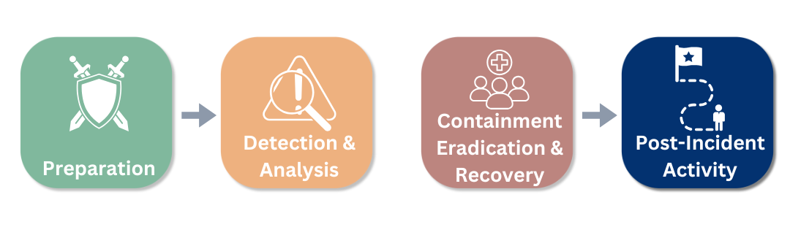

Lessons Learned
It is essential to conduct a post-incident review or wash-up to identify lessons learned. These sessions should take place within a few days of the incident so that people's memories are fresh. Broadly these sessions look at three areas.
- Event. To understand what happened and what measures could be taken to prevent future incidents of this type. This will also review the efficacy of existing preventative measures.
- Execution. How effective was the execution of the response plan and the performance of those involved?
- Plan and preparation. How effective or useful were pre-developed plans, templates and SOPs.
The outcome of the lessons learned session will be to identify the elements of the plans in preparation that worked well and any areas for improvement or adjustment. Specific questions to discuss are:
- Exactly what happened, and at what times?
- How well did staff and management perform in dealing with the incident?
- Were the documented procedures followed? Were they adequate?
- What information was needed sooner?
- Were any steps or actions taken that might have inhibited the recovery?
- What would the staff and management do differently the next time a similar incident occurs?
- How could information sharing with other organizations have been improved?
- What corrective actions can prevent similar incidents in the future?
- What precursors or indicators should be watched for in the future to detect similar incidents?

Capturing lessons learned and follow through
Some of the identified lessons learned or actions will need immediate implementation. For example, anything needed to rectify and identified vulnerability.
However, actions that require additional planning or resources should be captured in a formal lessons-learned document and each action should have an identified owner and deadline to ensure that these lessons are put into practice and adjustments made.
At this point the post-incident activity feeds into the first preparation step to ensure that the organization is better prepared for future incidents.

Investigations
In certain circumstances, investigations or regulatory inquiries may be necessary following an event. These are separate to and outside the scope of this plan, but the work done during the incident and the records kept, particularly the evidence records, will be essential to these post-incident events.

