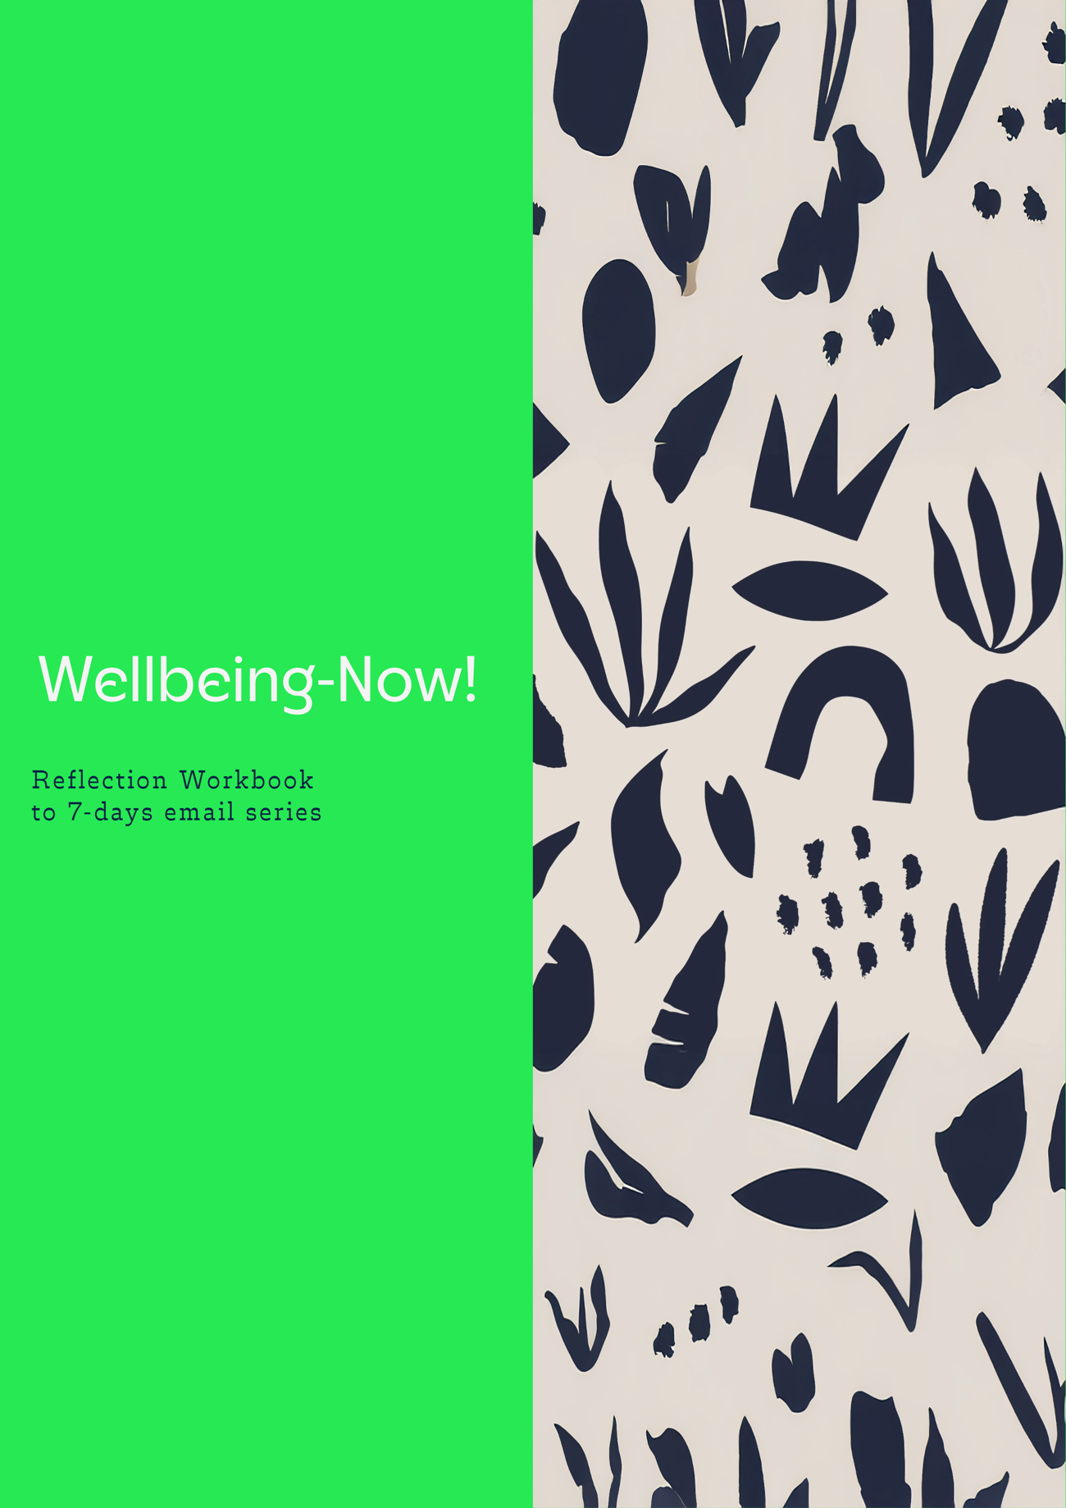

Copyright © Wellbeing-Now.com All rights reserved.
This book or any portion thereof may not be reproduced, relabelled, or used in any commercial manner whatsoever without the express written permission of the publisher.
.
Rüdiger Wenzel
Arnumer Kirchstrasse 4
30966 Hemmingen
Germany

https:/Wellbeing-Now.com

Table of Contents
Introduction
Session 1: Wellbeing 101 5
Session 2: Healthy Habits 22
Session 3: Positive Emotions 60
Session 4: Engagement 76
Session 5: Relationships 113
Session 6: Meaning 140
Session 7: Accomplishment 171

Introduction
Welcome to this Wellbeing email series Reflection workbook!
First, we briefly introduce wellbeing and the field of positive psychology. We’ll then provide an overview of the PERMAH Framework as a means of measuring and leveraging different ‘pillars’ of wellbeing. Next, we’ll explore some surprising science of wellbeing change to help set you up for small, sustainable wellbeing habits that have a big impact over time.
This should encourage you to become an active participant in shaping your wellbeing and the wellbeing of those you work, live, and play with, too. It is not a spectator sport but an interactive exploration of what’s working well, where you’re struggling, and what you’re learning every day about caring for wellbeing in yourself and others.
Let’s begin.

This Reflection Workbook
This Reflection Workbook was designed for several specific purposes:

to summarise the topics discussed in the email series
to design and commit to wellbeing interventions
to serve as a working space for completing reflections

Use this workbook however you like. Nevertheless it should help you to delve deeper into the topic of wellbeing, reflect on your thoughts and deepen the aspects mentioned.

Good luck!


Session 1

WELLBEING 101

Goals
The goals of this session are to prepare you for future sessions by:
Introducing Positive Psychology and The PERMAH Framework
Exploring the difference between ‘Feeling Good’ (Hedonic Wellbeing) and ‘Doing Good’ (Eudaemonic Wellbeing)
Understanding that wellbeing exists at the: Me, (Individual), We (Team), and Us (Organization/Community) Levels
Leveraging the power of small habits to create wellbeing behaviours we can stick to

Defining Wellbeing

“Wellbeing is our ability to feel good and function effectively.”

- Dr. Felicia Huppert

Humans have been attempting to define wellbeing for centuries, from ancient religious practices to the self-help section in bookstores. Every author, scholar, and philosopher has their own definition of what “wellbeing” encompasses.

Reflection Activity:
How do you currently define wellbeing? Does it include subjective and objective aspects, individual and societal perspectives, and accessible language?
Reframe your definition to include dynamic skills and resources rather than a static state.

Eudaemonic Wellbeing
Translating roughly to “the good life” or “flourishing,” eudaemonic wellbeing emphasises “living your best life” or “feeling truly fulfilled.” It’s about more than just having fun or feeling momentarily happy. Instead, it focuses on:
Growing as a person
Being true to yourself
Finding meaning in what you do
Doing things well and being proud of your efforts

Rapid Reflection: Can you remember a time in your own life when you felt really fulfilled? Maybe it was when you learned something new or did something that felt truly meaningful to you.

How did you feel during this period (e.g. energy, mood, social battery, sense of perspective…etc.)?

Hedonic Wellbeing
In contrast, “hedonic wellbeing” is about seeking pleasure and fulfilling desires, focusing on maximising pleasure and minimising discomfort.

Rapid Reflection: Can you remember a time when you felt pure enjoyment? Maybe it was savouring a delicious meal, relaxing in a hot bath, or simply enjoying a moment of leisure. How did that make you feel?

How did you feel during this period (e.g. energy, mood, social battery, sense of perspective…etc.)

Reflection Activity:
What matters more to you: feeling good or functioning effectively?
How can you balance both in your life?

The PERMAH Framework
While many suggestions for improving wellbeing exist, we will focus on the PERMAH framework because it is clear, measurable, and practical to apply in your day-to-day life. The PERMAH framework aims to improve wellbeing through six key elements that contribute to a fulfilling and happy life: Positive emotions, Engagement, Relationships, Meaning, Accomplishments, and Health. Let’s look at these pillars in a little more detail:

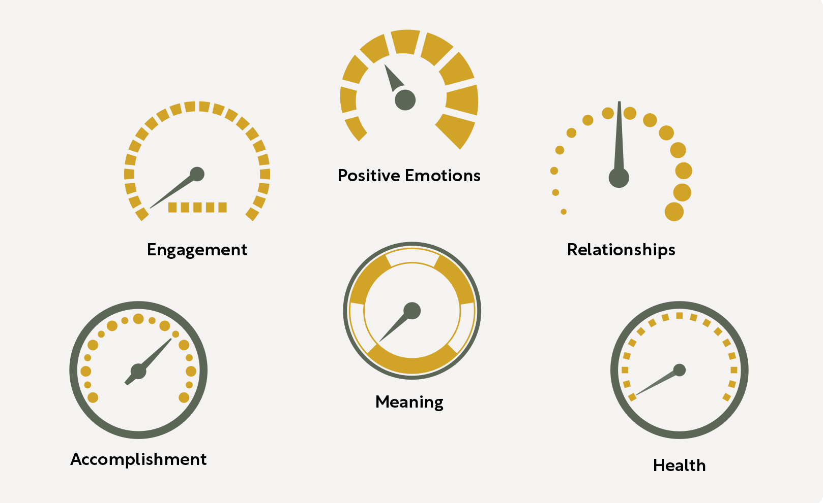

PERMAH in the Real World
To feel good and function effectively, we must cultivate each of the PERMAH Pillars. But the “PERMAH Pillars” we prioritise and our actions to cultivate them will depend on who we are, our energy levels, our circumstances, and the results we seek.
Your wellbeing naturally ebbs and flows based on what is happening in the world around you and the choices you’re making. This is not only normal but healthy. Rather than trying to achieve perfect PERMAH scores or even seeking constant improvement in our scores, researchers advise that we focus on enhancing our ability to tune into and take small actions to care for our wellbeing.
Throughout this intervention, we will explore each of the PERMAH Pillars and experiment with evidence-based, busy-proof ways to cultivate them in our lives. In the meantime, here is a quick overview of each of the PERMAH Pillars:

Let’s look at these pillars in a little more detail:

Pillar | Description | Real-World Example
Positive Emotions | Learning to identify, experience, and benefit from a range of emotions. | In the workplace, this might involve noticing moments of joy or satisfaction during your workday, like receiving positive feedback.  Acknowledging these emotions can boost your mood and motivation, making your work experience more enjoyable and productive.
Engagement | Leveraging our strengths and interests to feel capable and deeply. absorbed in activities. | Focusing on tasks that leverage your strengths and interests. For example, if you excel in creativity, brainstorming new ideas for a project, or designing innovative solutions to problems.  If prudence is your strength, planning, and organizing tasks, ensuring all details are accounted for and risks are minimized.  Setting aside time for activities that keep you engaged and enthusiastic, like learning new skills or seeking mentorship in areas you’re curious about.
Relationships | Feeling safe, loved, valued, and connected with other people. | Making an effort to connect with your colleagues by asking them appreciative questions like “What’s going well today?” or “What was the highlight of your weekend?”.  Spotting their strengths and providing strengths-based feedback, such as “Your creativity really elevated the pitch we wrote today.”
Meaning | Having a sense of direction, feeling that our lives are valuable and worthwhile,  and connecting to something bigger than ourselves. | Reflecting on how your role contributes to the larger goals of the organization. Seeking feedback about the impact your actions have had on others or clients.  Working with your supervisor to “job craft” your role to better integrate your values, strengths, and more productive personal connections.

Pillar | Description | Real-World Example
Accomplishment | Setting and striving for personal milestones with a sense of pride and self-compassion. | Setting clear, achievable, and personally meaningful goals for yourself and tracking your progress with regular reflections.  Celebrating both big victories (like a promotion) and small ones (like finishing a chapter in a book) along the way boosts your sense of capability and confidence.
Health | Developing habits of eating, sleeping, moving, and resting that give us the energy to thrive. | Incorporating small positive changes into your daily routine. This could include taking short breaks to stretch or walk, choosing more nutrient-dense snacks that keep you fuller for longer, or making tiny tweaks to improve your pre-sleep routine.

Stepping on the Short PERMAH Scale
The best way to begin this process is to assess your current levels of wellbeing by stepping on the Short PERMAH Scale, which measures different aspects of wellbeing. “Stepping on” this scale means evaluating yourself in these areas. This can be done weekly, monthly, or quarterly (or whenever you want to check in on your wellbeing).
Think about your experiences and feelings over the last week. How often has each of the following occurred? 0 = never, 5 = half the time, 10 = all the time?

FACTOR | DEFINITION | SCORE
POSITIVE EMOTIONS I felt positive
ENGAGEMENT | I felt interested and deeply engaged
RELATIONSHIPS | I felt respected and appreciated by others
MEANING | I felt what I did was valuable and worthwhile
ACCOMPLISHMENT | I made progress towards my goals
HEALTH | Physically, I felt strong and healthy

Reflecting on Your Score
Instead of focusing on aiming for the ‘perfect score’ or ruminating over your lower- scoring PERMAH Pillars, researchers suggest focusing on:
- How satisfied are you with your scores in each area of the PERMAH model?

- From your scores, which elements of your wellbeing do you think need the most attention?

- Why do you think these areas scored lower?

- What is going so well in the higher-scoring Pillars?

As we continue on our Wellbeing journey together, we’ll explore many different ways to conceptualise and care for our wellbeing. So stay calm, stay curious, and take it one small step at a time.

The Wellbeing Ecosystem
No human is an island, and this is especially true in our daily lives. Wellbeing isn’t solely about individual experience; it involves a complex interplay of personal, relational, and environmental factors. In fact, individuals with higher levels of wellbeing not only benefit themselves but also contribute to the wellbeing of those around them.

Three Levels of Wellbeing
It makes sense, then, that our approach to promoting wellbeing focuses on all three of these interconnected levels, including the following:
“Me” level (Intrapersonal), focusing on individual choices and practices for self-care.
“We” level (Interpersonal), emphasising relationships and collaboration with others; and
“Us” level (Systemic), addressing the broader environment, including shared values, culture, leadership, and societal structures that shape collective wellbeing.

The Ecosystem Metaphor
Describing the systemic nature of wellbeing through the metaphor of a Wellbeing Ecosystem is one of the most helpful ways to explore this concept. Through this lens, each of the wellbeing levels can be conveyed as:
- The Seed (Me): The individual seed must have an adequate level of health to begin to grow.
- The Surrounding Flora & Fauna (We): The surrounding plants and animals must be compatible (and non-threatening) with the health of this individual seed.
- The Environment (Us): The permaculture, weather, and environmental forces must support the survival of each of these individual seeds, as well as the way they coexist together.

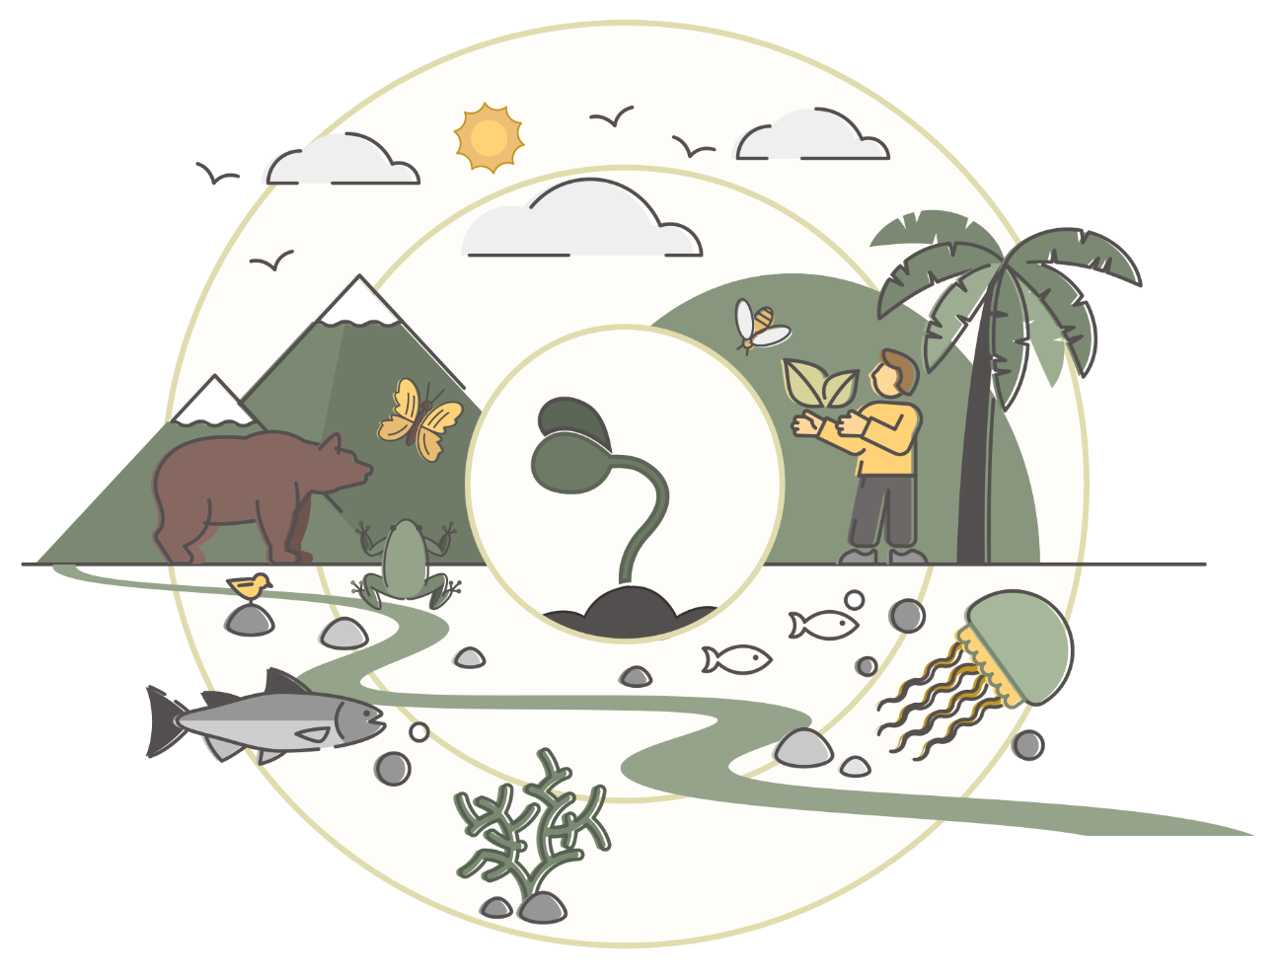

A key distinction between plants and humans is our higher level of consciousness, and therefore ability to consciously tune into and take steps to care for our wellbeing on an individual and group level.

Example: A systemic approach to wellbeing

The Seed (Me)

For example, you as an individual (seed) can use internal resources (e.g., your own reflections or experiences) or external resources (e.g., wellbeing surveys or objective health results) to help assess your current wellbeing levels and needs. Questions you might be asked to reflect on your wellbeing include:
Are you experiencing enough curiosity, joy, or gratitude in your daily life?
Do you feel connected to what gives your life meaning?
Are you setting and achieving goals that matter to you both personally and in the bigger picture?

From here, you may identify an area or two you’d like to focus on more (e.g., increasing how often you experience positive emotions in your daily life).

The Surrounding Flora & Fauna (We)

With many positive emotional interventions being relational in nature (e.g., expressing gratitude, exploring common interests, or sharing moments of humor), such a wellbeing focus will be impacted by the nature of the relationships (the surrounding flora and fauna) in daily life. Questions related to this include:
What sort of groups or communities are you part of?
What are the existing rituals and routines?
Do you spend most of your time alone or with others?
Do you experience enough psychological safety in your relationships?

The Environment (Us)

Asking these kinds of questions leads to broader inquiries into the larger environment (ecosystem) that has shaped collective norms, such as:
What is the overall temperature? Is it one of warmth and safety or frigidity and isolation?
What societal values, community norms, or leadership influences might be shaping this environment?
How do these factors affect interactions within and between groups?
Are there opportunities and space to connect with others meaningfully?
How is that affecting you?
Do you feel capable of connecting to your feelings and others in this climate?

Rapid Reflection: Does the Wellbeing Ecosystem resonate with you?

Common Detailers To Wellbeing Change
What is one of the most common excuses for not taking action towards caring for our wellbeing? More likely than not, you’ve used this excuse yourself many times. Sometimes, it may have even been true. We refer, of course, to the “I’m too busy” trap.
While very common and often meant in earnest, this excuse often masks deeper obstacles that derail our intentions for better wellbeing, especially regarding our health. There are three common detailers underlying this excuse: ‘I don’t really want to,’ ‘I’m not sure where to start,’ and ‘I don’t think I can.’

Detailer #1: I Don’t Really Want To
This detailer often reflects a misalignment between what we think we should do and what we actually want to do.
Example: Sarah’s friends all love yoga class, but she has never enjoyed it and finds excuses not to go. Recognising this reluctance helps us make authentic choices without feeling guilty about not prioritising activities that don’t genuinely interest us.

Detailer #2: I’m Not Sure Where to Start
This is when you feel unsure about where to begin, leaving you stuck and disempowered.

Example: When Tom wanted to start a healthier diet, he felt overwhelmed by all the information and didn’t know where to begin, leading to inaction. Finding support and asking questions, even if they seem simple, can help us take the first step and feel more confident.

Detailer #3: I Don’t Think I Can
This detailer is often driven by fear of failure.

Example: Emily wanted to join a weekly networking event but doubted her ability to connect with others, so she kept putting it off. Recognising that fear indicates the importance of the activity and approaching it with curiosity and a willingness to be a beginner can help overcome this obstacle.
By embracing a mindset of continual learning and leveraging support systems, we can navigate these detailers and make strides toward our wellbeing goals – no matter how little or lofty they may be.

Rapid Reflection: Which of these detailers have you experienced in the past?

Is there one that stands out more than the others, and why?

Advice
However you select your wellbeing focus, make sure to choose just ONE area to begin with. Rooted routines are simple yet powerful actions that nourish and sustain your wellbeing. By starting with one small, manageable action, you build a foundation for long-term growth

My chosen wellbeing focus/Pillar:

Why does this wellbeing focus matter to me right now?

How might investing in this area support my wellbeing?

Session 2

HEA LTHY HABITS

In this session, we’ll explore the PERMAH Pillar of “Health.” Although it is last in the PERMAH acronym, caring for our physical health is essential if we want to have the energy to invest in any other areas of wellbeing. That is why it’s our next stop.
We’ll begin by exploring the quality of our existing health behaviours and beliefs before exploring how we might optimise these habits with evidence-based approaches to help us eat, sleep, move, and rest better.
Let’s get started.

The Reflection Round

“Until you make the unconscious conscious, it will direct your life and you will call it fate.”

- Dr. Carl Jung

Can We Reflect on Our Health Habits?
Whether it’s a child using their caregivers’ feedback to gradually refine baby talk into effective language that allows them to express their needs and identity, or a child experimenting with the nuances of speed and balance as they learn to ride a bike, humans have been Trying, Testing, and Tweaking their way to mastery since our earliest days on earth.
Whether we are aware of it or not, each of us has naturally engaged in this process of continuous improvement by:
- Trying: Drawing upon our innate curiosity and creativity, we experiment with various approaches to achieve our goals. Whether it’s learning to walk, mastering a language, or cultivating relationships, we playfully explore different strategies.
- Testing: Reflecting on our experiences, we evaluate what’s working well, what’s not, and what lessons we can glean from our efforts. We can refine our approach by recognising our strengths and areas for improvement.
- Tweaking: Armed with insights from our test results, we adapt our behavior accordingly, striving for consistent progress toward our objectives. This iterative process allows us to refine our skills and capabilities continually.

The Reflection Round helps us build a “growth mindset” (the belief that, with effort and enthusiasm, we can enhance our knowledge and skills in anything) by doing something, reflecting on it, making improvements, and then doing it again.
It folds this learning process into four powerful questions that help us focus on our strengths, address our weaknesses, and finally take stock of and practically apply our learnings. The Reflection Round integrates the three elements of learning and growth by:
- Reflecting on the most/least successful things we’ve been trying: i.e., “What’s going well? Where do we notice challenges or resistance?”

Identifying what we’re learning from these peak/weak experiences: i.e., “What are we learning?”
Committing to actions informed by our experiences and interests: i.e., “What will we try next?”
This iterative process enhances personal and collective wellbeing by encouraging active participation in shaping one’s practices and outcomes.

Rapid Reflection
Think about what you currently do to care for your health, then consider the following questions and write your responses in the spaces provided. When it comes to caring for your health lately:
- What has been going well for you?

Where do you notice challenges or resistance?

What are you learning?

Are We Eating Well?
Rapid Reflection
Eating well is fundamental to maintaining health and wellbeing. However, our relationship with food is complex and influenced by various factors, including cultural norms, family traditions, and individual experiences.
On a scale of 1 (terrible) to 10 (ideal), how healthy is your current relationship with food?

 | 1 | 2 | 3 | 4 | 5 | 6 | 7 | 8 | 9 | 10
(Terrible) (Ideal)

- Why might this be?

Eating Well Essentials
Are eggs healthy or not right now? It seems to depend on the week and who you ask.

For many of us, navigating the realm of nutrition can feel like finding your way through a constantly shifting maze with a never-ending assault of conflicting advice. But among all the chatter, there are a few things most nutrition experts agree on:
Individualise your diet as much as you can.
Make any changes as small and sustainable as possible.
Choose self-compassion and learning over criticism along the way.

Your Positive Eating Pizza
With improved information and ingredients in your kitchen, it can still be difficult to know where to start, which is why we’ve compiled some top tips for better eating behaviours into a “Positive Eating Pizza.”
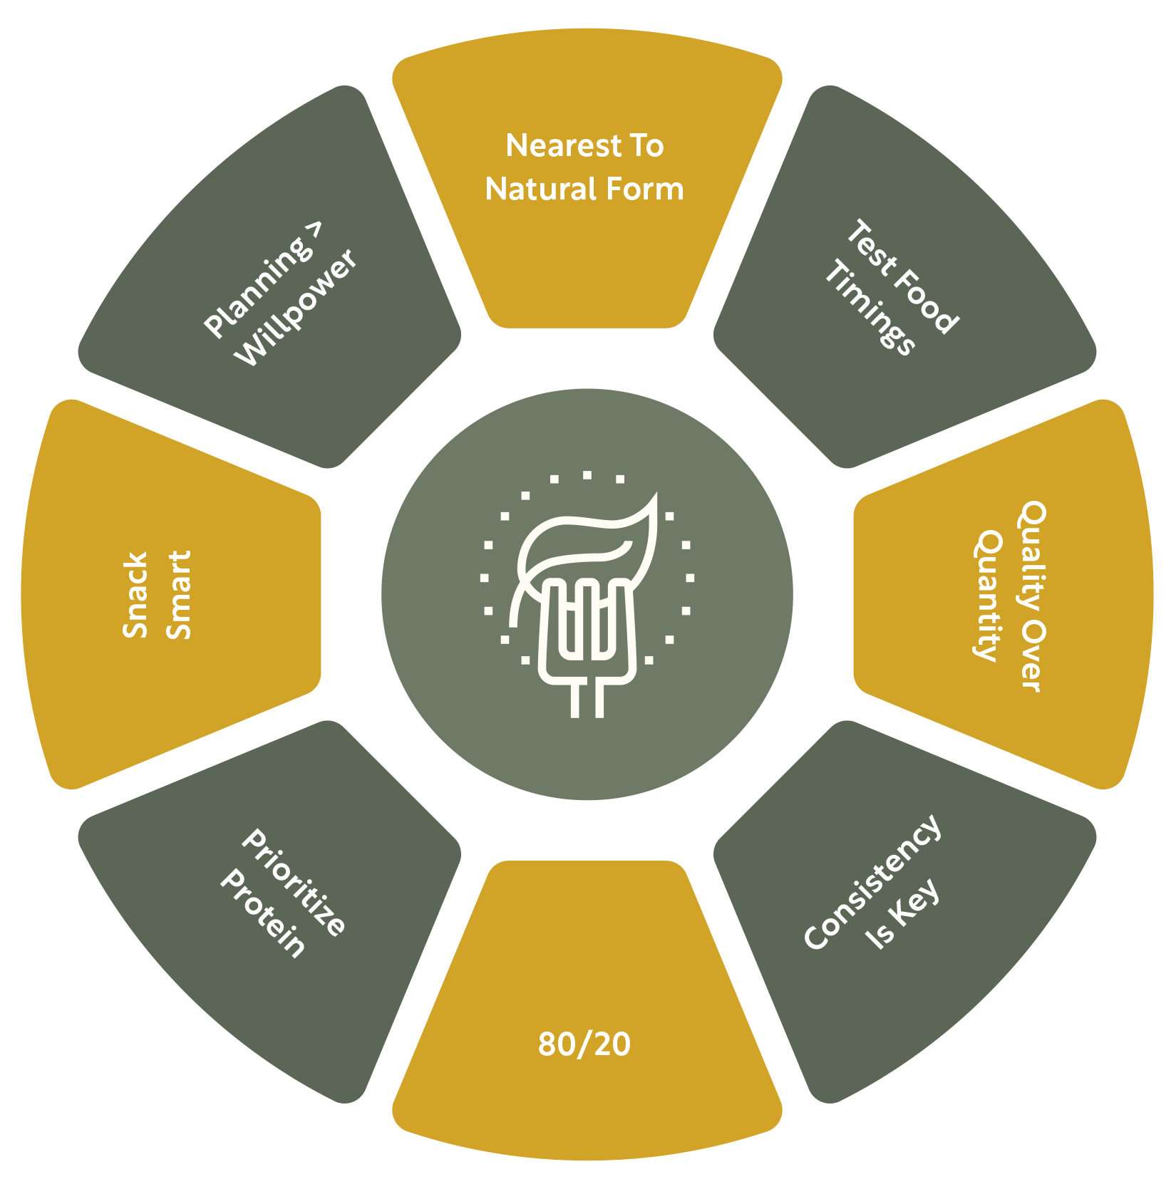

Nearest To Natural Form  Consuming foods that are minimally processed preserves more natural nutrients and avoids excessive added sugars, fats, and preservatives, thus supporting overall health and wellbeing. | Test Food Timings  Eating larger meals early in the day and smaller ones as the day progresses can optimize digestion and energy use, aligning with the body’s natural circadian rhythms for better overall metabolic health.

Quality Over Quantity  The book highlights the significance of food quality over quantity. Rath advises focusing on nutrient-dense foods that provide more health benefits rather than just calorie counting. | Consistency Is Key  Maintaining consistent meal times and eating habits can help stabilize our metabolism, reduce the risk of bingeing, and thereby improve overall health.
80/20  Life’s too short not to indulge. By taking a balanced approach to eating and encouraging healthy eating 80% of the time, while still incorporating more indulgent (less nutrient dense) indulgences 20% of the time, we make healthy eating more sustainable and enjoyable. | Prioritize Protein  Protein (in the form of meat, nuts, dairy, legumes, etc.) is essential for building and repairing tissues, supporting immune function, and can promote satiety, which helps in managing weight by reducing the impulse for frequent snacking.
Snack Smart  Choosing snacks that are low in refined sugars and high in fiber and protein helps maintain stable energy levels and mood, reducing the likelihood of overeating later due to hunger spikes. | Planning > Willpower  Fail to prepare, prepare to fail, as they say. With only a finite amount of willpower to expend on any given day, planning our meals ahead of time can help in making healthier food choices and avoid opting for fast food or processed meals due to convenience or inevitable dips in self-discipline.

Rapid Reflection

Which of the Positive Eating Pizza suggestions appeals to you most and why?

How might you incorporate this behaviour into your existing daily routine?

What support or structure might you need around this behaviour to set you up for success?

Are We Moving Mindfully?
Rapid Reflection

What is your relationship with movement?

Where do you think this has come from?

Movement Beliefs & Behaviours
In many Western societies, movement, and exercise are often approached as tasks to be completed – another box to tick. This practical view can strip the joy from movement, turning what could be a pleasurable activity into a source of stress. The societal push towards high-intensity, high-impact exercise regimens can intimidate or alienate those of us who might prefer (or only be capable of) gentler, more inclusive forms of movement.
Conversely, some cultures celebrate movement as an inherent part of daily life and community engagement. From the centenarians on the Greek island of Ikaria, who joyfully contribute to framework alongside far younger members of their community, to the traditional dances found in the daily life of many African and Caribbean cultures, incorporating movement (as opposed to “exercise”) into the fabric of the culture provides opportunities for building strength, cardiovascular health, as well as a heightened sense of identity, belonging, and community.

Are You Moving Enough?
If you’re thinking that hitting the gym after spending eight hours at a desk will make up for sitting all day, think again. Recent health studies suggest that regular exercise can’t completely counteract the risks associated with a sedentary lifestyle. Sitting for long periods – about nine hours a day for most people – can be as harmful as smoking. In fact, sitting for over six hours a day has been linked to a higher risk of early death.
As Tom Rath points out in his book Eat Move Sleep, the negative effects of sitting start almost immediately. Our muscles become less active, we burn fewer calories, and our bodies stop breaking down fats efficiently. Even our good cholesterol levels drop, and long periods of sitting can cause our backsides to grow larger due to pressure on fat cells.

Maximising Daily Movement
So, what can we do if our job keeps us at a desk? The key is to move as much as possible throughout the day. Small changes like taking the stairs, walking instead of driving, or doing stretches during breaks can significantly benefit our health. Regular movement helps keep our hearts healthy, lifts our spirits, manages stress, and boosts our energy. It’s also essential for maintaining a good metabolism and preventing chronic illnesses.

Keep It Joyful
Moving in ways that feel good enhances stress resilience and mood, due to them prompting the release of positive neuro-chemicals. It’s unsurprising that multiple studies show us that joyful movement promotes consistency, as we are far more likely to stick with activities we genuinely enjoy.

Rapid Reflection
- How do you manage periods of prolonged sitting in your day?

What strategies can you use to increase movement?

What types of physical activities bring you joy?

How can you incorporate them into your daily routine?

Your Mindful Movement Wheel
Even with the improved awareness and attitude towards movement, it can still be challenging to know where to begin, which is why we’ve adapted some top tips for better movement behaviours into a “Mindful Movement Wheel.”

Interrupt Sitting  By getting up and moving every 20 minutes, we can mitigate the negative health effects of prolonged sitting, such as reduced metabolism and increased risk of chronic disease. | Every Move Counts  By seeing each moment as a chance to move – even a little – we make cumulative contributions to our overall health, enhancing circulation, boosting metabolism, and reducing the risk of cardiovascular diseases.
Smiling > Shredding  Choosing enjoyable activities over more strenuous “exercises” that you enjoy less increases the likelihood of long- term consistency, as happier activities promote more sustainable habits. | Nurture Novelty  Incorporating a variety of movements – from solo activities to social sports or classes – keeps you engaged, prevents boredom, and ensures a more balanced development of physical abilities.

Consistency > Intensity  Consistent daily movement is better for our long-term health than sporadic, intense workouts, as regular activity helps maintain metabolic health and improves overall physical endurance. | Team Up With Tech  Utilizing technology like apps and wearables can provide motivational feedback and insightful data, helping to optimize our routine and keep us engaged as our movement journey develops.
Don’t Forget Flexibility  Incorporating flexibility exercises into our routine is crucial as it enhances joint health, reduces injury risk, and improves overall physical performance, especially as muscles and joints age. | Spotlight Strength  Incorporating some resistance activities into our week is vital as we age because it helps preserve mobility, prevents falls, maintains our metabolic rate, and reduces the burden on aging joints.

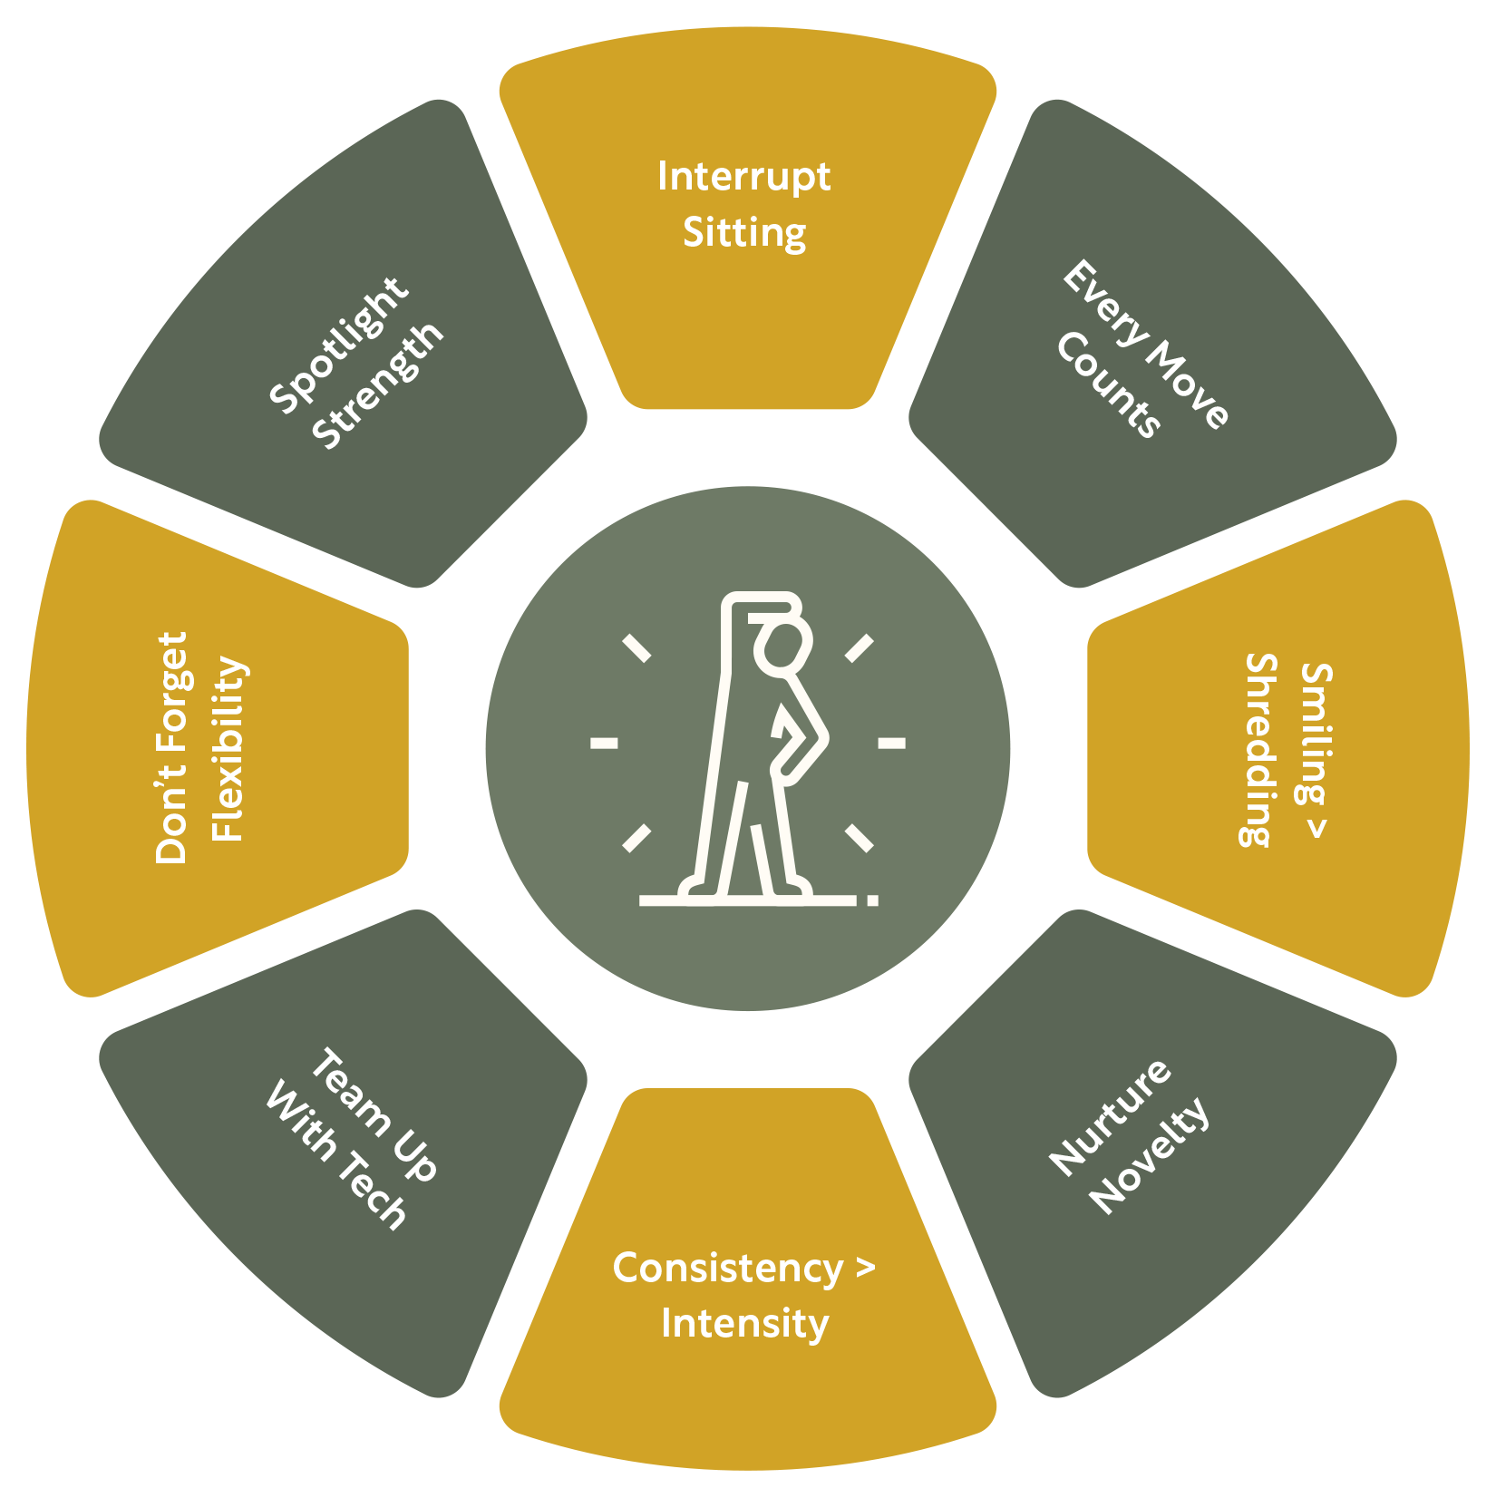

Rapid Reflection
Which of the Mindful Movement Wheel suggestions appeals to you most and why?

How might you incorporate this behaviour into your existing daily routine?

What support or structure might you need around this behaviour to set you up for success?

Are We Sleeping Enough?

“The cultural push towards productivity and the ‘always-on’ mentality has led to widespread sleep deprivation, impacting mental and physical health.”

- Tom Rath

Rapid Reflection
When, where, and how much do you sleep?

Where have these habits come from?

Understanding and Setting Your Sleep Schedule
Finding and setting a sleep schedule that supports you in working and playing at your best begins with understanding your body clock type. Researchers suggest the “Night Owl vs Lark” metaphor as a helpful way of deciphering your dominant sleep schedule type. Use the criteria below to assess whether you’re more of a Night Owl or a Lark.

Your Smart Sleep Circle
With so many cultural and lifestyle barriers between us and a better sleep routine, it can be all too easy to find ourselves with sleep as the source of our stress, instead of the remedy. Luckily, we’ve collected some of the best, busy-proof, evidence-based strategies for improved sleep into a “Smart Sleep Circle.”

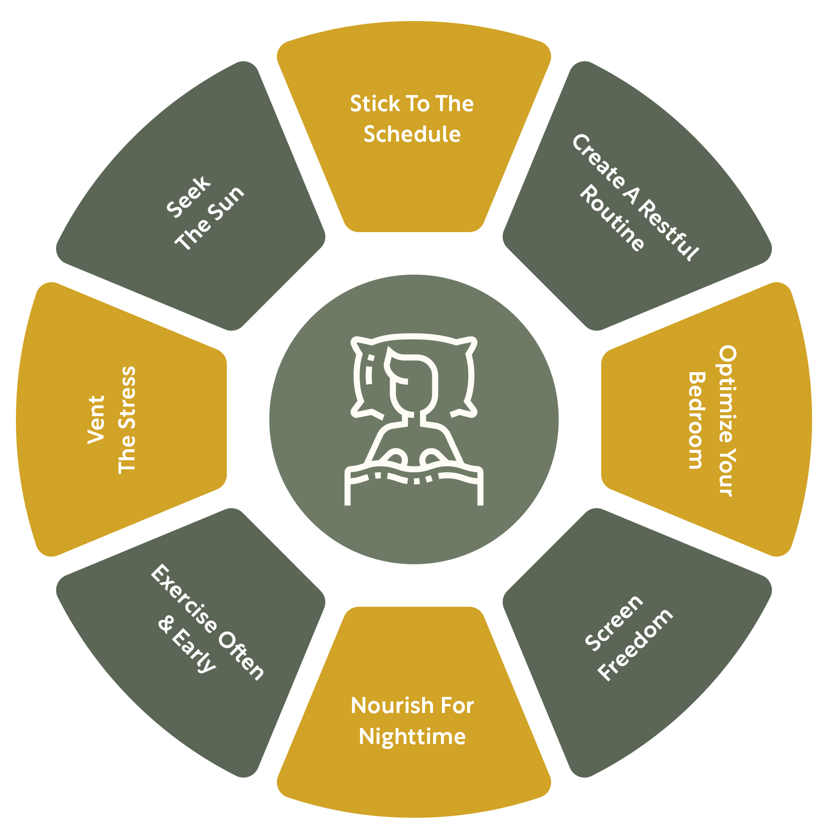

Stick To The Schedule  Maintaining a regular sleep-wake schedule (that suits your Night Owl or Lark tendencies) helps regulate your body’s internal clock, promoting better sleep quality and overall health. | Create A Restful Routine  Establish a calming pre-bedtime routine, such as dimming the lights, reading a book, or practicing restorative yoga, to signal to your body that it’s time to wind down.

Optimize Your Bedroom  Optimize your sleep environment by using comfortable sheets, blackout curtains, and maintaining a cool room temperature (around 60–67°F or 15–19°C) to enhance sleep quality. | Screen Freedom  Avoid screens an hour before bed and instead engage in relaxing activities like reading, meditating, or listening to calming music to prepare your mind for sleep.
Nourish For Nighttime  Eat foods that promote sleep, such as almonds, turkey, and chamomile tea, and avoid caffeine and heavy meals close to bedtime to prevent disruptions in sleep. | Exercise Often & Early  Regular physical activity, especially earlier in the day (as opposed to late at night when it may activate your nervous system), helps improve sleep quality and reduces the time it takes to fall asleep.
Vent The Stress  Manage stress by journaling, talking to a trusted friend, or practicing somatic stress release exercises such as deep breathing or progressive muscle relaxation to promote relaxation and better sleep. | Seek The Sun  Exposure to natural sunlight during the day helps regulate your circadian rhythm, improving sleep quality and duration by signaling to your body when it’s time to be awake and when it’s time to sleep.

Rapid Reflection
Which of the Smart Sleep Circle suggestions appeals to you most and why?

How might you incorporate this behaviour into your existing daily routine?

Stress, Rest & Recovery

“If you’ve dealt with the stressors but haven’t dealt with the stress itself, your brain won’t let you rest.”

- Emily & Amelia Nagoski

Rapid Reflection
On average, over the last week, what % of your time was spent on rest and recovery?

What are some of your favourite and most effective forms of rest and recovery?

Sources of Stress
Stress can come from external sources or internal sources:
External Stressors: Things like work pressure, money problems, family duties, not enough time, societal expectations, and facing discrimination.
Internal Stressors: Things like self-criticism, worries about how we look, identity issues, past memories, and concerns about the future.
Whether we’re always consciously aware of these stressors or not, our body picks up on them and sees them as threats.

The Stress Responses
The stress response is how our body and brain react to stress. Many know the “fight or flight” response, but there are actually four types: fight, flight, freeze, and fawn.

Fight Response

Body Reaction: Your body releases adrenaline to prepare for a confrontation.
Feelings: You might feel angry, aggressive, or irritable. Your fists may clench, muscles tighten, and your heart may race.

Flight Response

Body Reaction: Similar to fight, but preparing the body to escape/run away.
Feelings: You may feel anxious, restless, or have a strong urge to run away. This can look like pacing, fidgeting, or feeling trapped.

Freeze Response
Body Reaction: Your body may become immobile, heart rate drops, and you might feel disconnected.
- Feelings: You might feel numb, stuck, or unable to move or respond to the situation.

Fawn Response
Body Reaction: Your mind may dissociate (disconnect) from your body and its urges/feelings in order to priortize the needs of others.
Feelings: You might feel an urgency or anxiety to know and meet others needs. This can look like quickly agreeing to things or trying to make others happy to stay safe.

The type of stress response we use depends on several factors. Our past experiences play a big role; we might have learned to handle stress by fighting, running away, trying to befriend the threat, or disconnecting from it. The size of the threat also matters; for example, we might stand up to a rude person but run away from a group of tough strangers. We usually have one or two stress responses that we use more often than the others.

Rapid Reflection
- Which of these reflects how you typically behave when feeling stressed?

Your Rest & Recovery Wheel
Despite knowing its benefits to our resilience and performance, integrating moments of Rest & Recovery into our lives can be a daunting proposition. Fortunately, we’ve collated the best evidence-based, busy-proof tools to experiment with to make sure Rest & Recovery doesn’t fall off our to-do List.

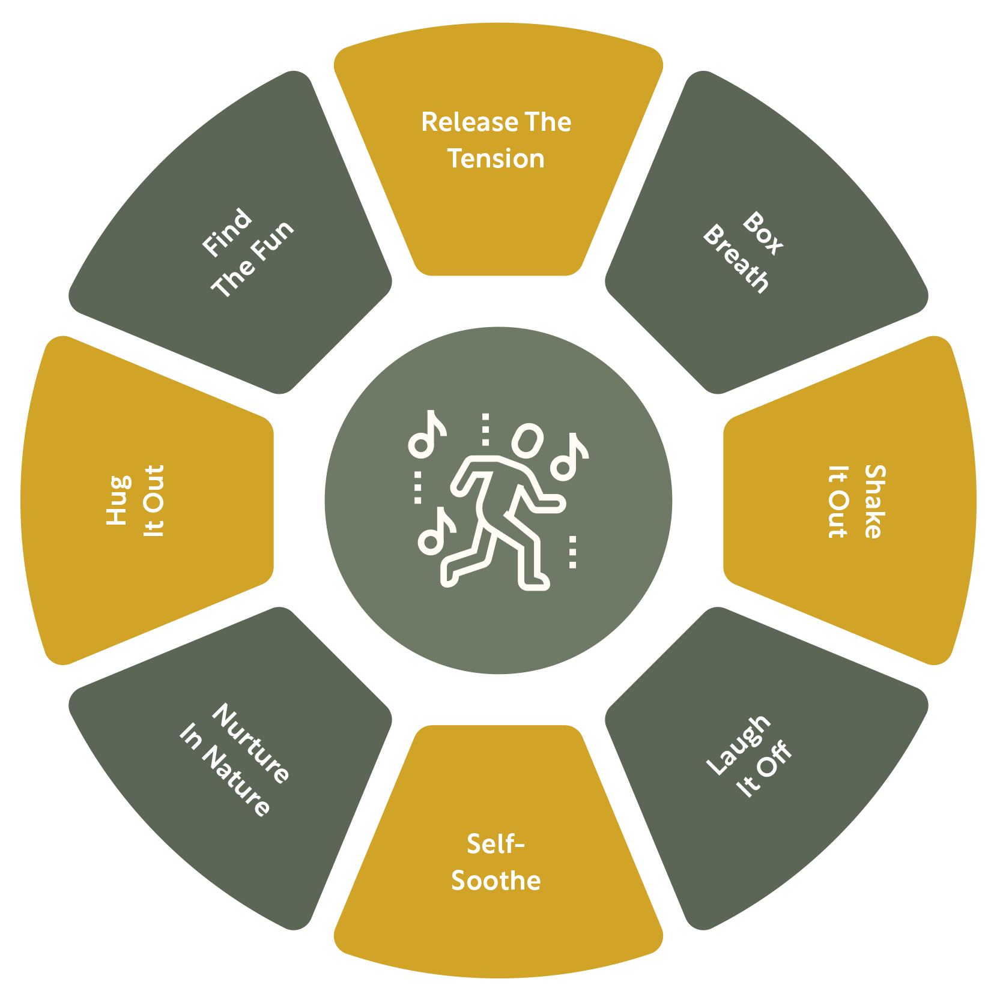

Release The Tension  Engaging in a good cry by watching a sad film or listening to sad music can be therapeutic as it helps to release pent-up emotional tension, allowing the body to move through the stress response cycle. | Box Breath  Box breathing, which involves inhaling, holding, and exhaling each for four seconds, helps regulate the autonomic nervous system, reducing stress and improving focus and calmness.
Laugh It Off  Laughter triggers the release of endorphins, the body’s natural stress- relievers, and reduces the level of stress hormones, promoting an overall sense of wellbeing. | Shake It Out  Somatic practices like shaking or dancing help to physically discharge the energy associated with the fight or flight response, effectively moving the body through the stress cycle.
Self-Soothe  Engaging in self-soothing behaviours, such as gentle self-touch or offering oneself kind words, can activate the body’s parasympathetic nervous system, which promotes relaxation and a sense of safety. | Nurture In Nature  Spending time in green spaces has been shown to lower stress hormone levels, enhance mood, and calm the nervous system, contributing to overall stress recovery.
Hug It Out  Physical touch, like hugging, can increase levels of oxytocin, a hormone that promotes a sense of bonding and reduces cortisol, thus helping to stabilize the nervous system. | Find The Fun  Engaging in activities that you genuinely enjoy can boost the production of neurotransmitters like serotonin and dopamine, which help signal safety and relaxation to the nervous system, aiding in stress recovery.

Rapid Reflection
Which of the Rest & Recovery Wheel suggestions appeals to you most and why?

How might you incorporate this behaviour into your existing daily routine?

What support or structure might you need around this behavior to set yourself up for success?

Creating A Rooted Routine for Health
Having explored the four main pillars of health (Eating Well, Moving Mindfully, Sleeping Enough, and Resting & Recovering), we are now going to leverage the best in behavior- change science to create a Rooted Routine for Health.
Remember, to overcome common behavior change derailers (I don’t really want to,” “I’m not sure where to start,” and “I don’t think I can”), we must choose a behavior we truly want to do and shrink it until we feel at least 8/10 confident that we can do it each day for the next week.
We will have plenty of time to try our new Rooted Routine for Health in coming weeks, however the research suggests that we build our ability and confidence best by starting small and scaling up as our skills and practice improve.
Create your Rooted Routine for Health.

To decide on your Rooted Routine refer to the theory and your reflections on each of the four Health areas (Eating, Moving, Sleeping, or Resting & Recovering).
- Refer to the previous chapter for inspiration on Rooted Routines.

GROUNDED BEGINNINGS

What is an existing action or routine in your day that would naturally allow you to add a new wellbeing habit? Think about behaviours you already do regularly. How can this moment “nurture” the start of your new habit?

I drink a cup of tea every morning.
NURTURING ACTION

What is the small, manageable action you can take right now to help foster your wellbeing? Make sure this is an action so easy you can do it even on busy days. How will you take your first step toward growth?

When I finish my tea, I will take three slow, deep breaths.

Once you’ve completed your action, how can you celebrate your success, no matter how small? What will you do to acknowledge your growth? This moment of recognition will help reinforce your habit.

I’ll say “Well done!” to myself quietly.

What do you expect to feel after completing your action? How do you anticipate this practice supporting your wellbeing? Think about any changes you hope to see in your thoughts, mood, or habits. How might this habit help you in the future?

I expect breathing will help me feel calmer and more focused throughout the day.
THRIVING MOMENT

Rapid Reflection
What was one surprising insight you had about the science of creating Healthy Habits?

What was the most useful piece of information you received today?

Who might you share this information with to create a small wellbeing ripple in your life?

Your Rooted Routine for Health Template
Identify the Health behaviour (Eating, Moving, Sleeping, or Resting and Recovering) you’d like to try this week.
Using the list of example Rooted Routines in session 1 as inspiration (feel free to create your own, too), complete your own Rooted Routine Template below.

Commit to this behaviour for at least the next week, making sure to note down your progress each day in the Rooted Routines Logbook, as well as any wins, wobbles, or burning questions down below:
NOURISHING REFLECTION
THRIVING MOMENT
NURTURING ACTION
GROUNDED BEGINNINGS

As you playfully experiment with a Rooted Routine, remember that the key to success lies less in achieving a perfect result and more in our ability to reflect on and reshape our efforts by asking:
What’s working well?
Where do I notice challenges or resistance?
What am I learning?
Based on this, what will I try next?

If you are curious about how to dive deeper and intensify your knowledge - what about growing to a wellbeing master

Check this out - https://wellbeing-now.learnworlds.com/course/mastering-happiness-with-positive-psychology

Rooted Routine for Health Reflection Round
When it comes to playfully experimenting with your Rooted Routine this week:

What’s working well?

Where do you notice challenges or resistance?

What are you learning?

Based on this, what could you try next time?

Session 3

POSITIVE EMOTIONS

Goals
The goals of this session are to:
Reflect on your current experience of a range of emotions through a Rapid Reflection
Explore: What Are Emotions?
Uncover: The pivotal role that both “Good” & “Bad” Emotions play in creating a thriving, meaningful life
Clarify: Emotions are data to help us make meaningful choices, not directives upon which we must react
Create: A Rooted Routine for Emotion

In this session, we will explore the role all human emotions play in shaping our wellbeing. We’ll discuss how identifying and mindfully responding to our emotions, rather than reacting mindlessly, can give us more choice and control over our emotional health.
Let’s get started.

What Are Emotions?

“We are not thinking machines that feel, rather, we are feeling machines that think.”

- Antonio Damasio

Reflection Round: Positive Emotions

“When awareness is brought to an emotion, power is brought to your life.”

- Tara Mayer Robson

How many emotions can you list? Take 60 seconds to write down as many as you can.

Most of us struggle to name more than three to four emotions: mad, sad, glad, and scared. When you can’t name or recognise different emotions, it’s like having a gap in your vocabulary. This makes it hard to understand the important signals your body is sending about what you need. If you can’t notice these emotions, you’ll struggle to make good decisions and act in ways that feel true to yourself.
To help you gauge your recent experiences around noticing, naming, and responding to your emotions, we’re going to perform a Rapid Reflection.
When it comes to feeling and identifying your emotions in the past:

- What has gone well?

Where do you notice challenges or resistance?

What have you been learning?

What might you try next?

The Three Key Elements of Emotion

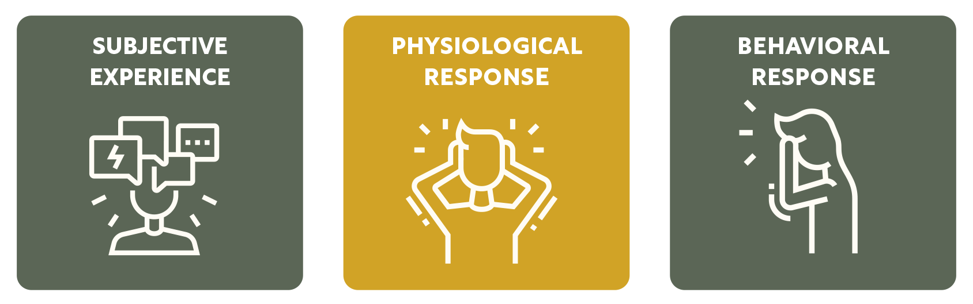

Experiencing an emotion involves three main parts:

- How you personally experience the emotion,
- How your body reacts to the emotion, and
- How you behave in response to the emotion.

Let’s look at each of these components in more detail.

How You Experience Emotions
This is the personal aspect of emotions. People experience emotions in different ways, often influenced by their life experiences. For example, two people might react differently to the same event based on their personal history.
Example 1: John is hosting a birthday party for his wife, Carol. He doesn’t know many people and feels uneasy and self-conscious in the crowd. Carol, however, is highly extroverted and knows most of the guests, so she feels excited and appreciative of the celebration.
Example 2: John and Carol are at the park when an off-leash dog runs up to them. John, who had dogs growing up, is thrilled by the unexpected encounter. Carol, who never had pets, feels unnerved and frightened by the unrestrained dog.

How Your Body Reacts
Emotions can trigger physical responses in the body, which can vary from person to person based on their emotional state and personal experiences.
Example 1: At the birthday party, John’s discomfort manifests physically as he feels hot, his hands get clammy, and his stomach feels unsettled. In contrast, Carol feels a rush of excitement, her heart beats faster in anticipation, and she has a warm feeling of happiness.

Example 2: When the dog approaches, John’s body relaxes, and he smiles, showing physical signs of enjoyment. Carol, on the other hand, feels her muscles tense, her heart races, and she instinctively steps back, showing physical signs of fear.

How You Behave
This refers to the actions and behaviours exhibited in response to emotions. These actions can signal to others how you’re feeling and are influenced by both the internal experience and physical responses.
Example 1: At the party, John tries to stay in the background, speaks minimally, and avoids eye contact, behaviours that reflect his discomfort. Carol, enjoying the party, moves around the room, engaging in lively conversations and laughing with friends, which reflects her joy and excitement.
Example 2: In the park, John reaches out to pet the dog, laughing and inviting the dog to play. Carol, feeling scared, crosses her arms, takes a step back, and asks John to keep the dog away from her. Her actions show her fear and discomfort with the situation.

These are just some examples illustrating how the same situation can evoke different emotions, physical reactions, and behaviours in different people. They highlight that, while most emotions are universal, each of us will experience emotions differently. The more we can attune to our own unique experiences of different emotions (and appreciate that others have their own ways of feeling and dealing with emotions), the better we’ll navigate the ups and downs of life.

Rapid Reflection
Which of the three elements of emotional experience are you usually most aware of in yourself?

What is the impact of each of us having unique, subjective experiences of emotions?

What action(s) did these feelings push you to take (or not take)?
(E.g., sending an angry message, or calling them repeatedly to make sure they were OK, etc.)

What was the result of these actions?
(E.g., an angry texting war, them feeling guilty for not calling and worrying you, etc.)

Name It, Normalise It, Navigate It
Every emotion has a purpose by preparing us for action. Here are some strategies to manage our emotions better:
Naming It: Describe your feelings. Saying “I’m noticing that I’m feeling sad” instead of “I am sad” can help create some distance from the emotion.
Normalising It: Accept that all emotions, both good and bad, are normal. Be open to experiencing all emotions without judgment.
Navigating It: Use your emotions as information to guide your actions, not as commands. Treat them as signs pointing to what you care about most.
The more mindfully we can name, normalise, and navigate our emotions, the more regulated we’ll be in our system and the better we’ll be able to show up in each (or most) moments as who we truly want to be.

Building up positive emotions can lead to an upward spiral in our growth and development, improving our resources:
Psychologically: Positive feelings help you think more clearly and solve problems better.
Intellectually: They make it easier for you to learn new things and be creative.
Socially: Positive emotions help you get along better with others and build stronger friendships.
Physically: Improve your overall health, like boosting your immune system and giving you more energy.

Can You Identify Your Emotions?
As we discovered earlier, most people can only identify three to four emotions – glad, sad, mad, and scared. This limited emotional vocabulary hampers our ability to understand and respond to our needs effectively. By expanding our emotional vocabulary and improving our emotional granularity, we can better attune to our inner experiences and respond to them mindfully.
Emotional granularity reflects a high level of clarity. It is about how well you can distinguish the most subtle differences between emotions and label them precisely, with lots of detail. Put simply, rather than using broad and general terms like “happy” or “sad,” with emotional granularity, you can be specific and distinguish between emotions like contentment, joy, satisfaction, melancholy, and disappointment.
People with high emotional granularity tend to have better emotional regulation, leading to improved mental health and wellbeing. When we can precisely identify our emotions, we gain clarity on what we need at any given moment and can take steps to meet those needs more effectively.
For example, being able to distinguish between feeling “embarrassed” vs. feeling “overwhelmed” may lead to very different actions. Embarrassment may lead us to seek reassurance from a trusted friend or reach for self-compassion through some kind self- talk. Overwhelm, on the other hand, may lead us to delegate or seek practical support in organising our tasks, so that we have time to calm our body and brain and get back to work when we’re ready.

The Wheel of Emotions
One helpful tool for enhancing emotional granularity is the Wheel of Emotions. The wheel visually represents a range of emotions and their relationships to each other, from basic emotions like feeling scared or joyful, to more granular emotions like feeling bewildered or optimistic. Using this tool can help you become more specific in identifying your emotions.
For example, if you experience a generally sad feeling, you can use the outer bands of the wheel to figure out what specific kind of sadness you might feel (e.g. maybe what you are experiencing is confusion or isolation). Note that the reverse can also happen. For instance, by using the wheel, you may realise that feeling inadequate may be rooted in hurt or sadness at a deeper level.

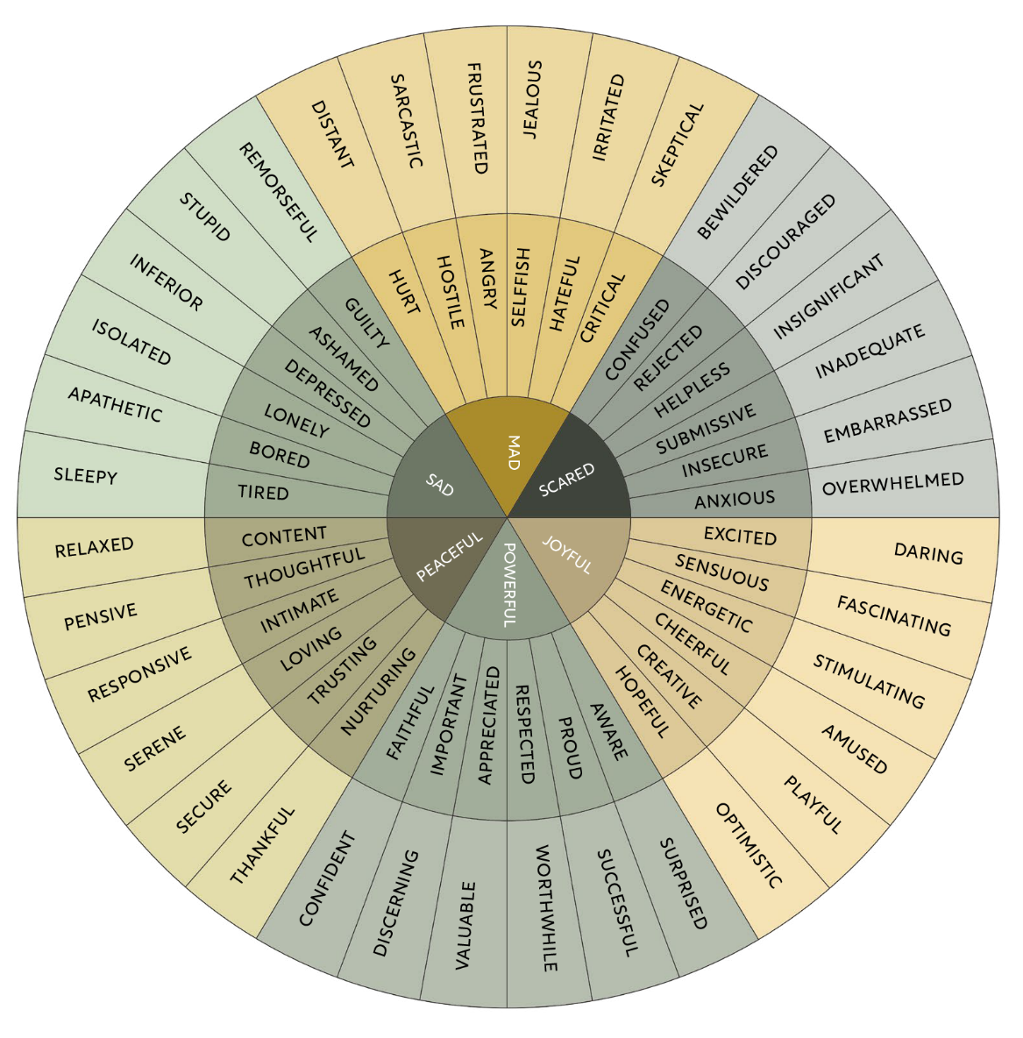

Using the Wheel of Emotions
- Ask “What isThe Function?”: Can you use the wheel to identify an uncomfortable emotion you’ve felt in the past week? Rather than seeking to avoid this sensation, ask yourself instead:
What function might this emotion serve?

What is this feeling trying to tell me about my needs? What human need (e.g., safety, connection, fun, reassurance, belonging, autonomy, freedom, etc.) might be going unmet right now, and how might I, or others, meet it?

Researchers also suggest the following:

- Journaling: When journaling, try to describe your feelings in more detail using the Wheel of Emotions. For example, instead of simply writing “I felt bad today,” you could be more specific and say, “I felt a mix of disappointment and frustration because my project was delayed.” This way of writing helps you understand your emotions better and can give you insights into what’s really bothering you, making it easier to address the issues.
- Conflict Resolution: In conflicts, using the Wheel of Emotions can help you express your feelings more clearly. For instance, instead of just saying you’re “angry,” you might say you feel “hurt.” This more precise expression helps others understand your true feelings and can lead to more empathetic and constructive communication. It allows people to see your perspective and can make resolving conflicts easier and more effective.

Emotions: Data, Not Directives
Rapid Reflection
Thinking back to the Model for a moment, consider:

What is a result you had recently that you didn’t want?

What different action might you have preferred to take instead to avoid this result?

- What emotional state would you have needed to be in to be able to choose that action (e.g., in order to think clearly enough to choose a response and not react in a way you’d regret later)?

Emotions should be seen as data, not directives. This means our emotions give us important information about ourselves and our surroundings, but they don’t have to control our actions. By seeing emotions this way, we can make thoughtful choices that match our values and goals in life.

Creating A Rooted Routine for Emotion
Having reframed emotions as positive, in that they provide vital, valuable information about our desires and needs in the moment, we are now going to create a Rooted Routine for Emotion…
If you are curious about how to dive deeper and intensify your knowledge - what about growing to a wellbeing master - Check this out -

https://wellbeing-now.learnworlds.com/course/mastering-happiness-with-positive-psychology

Session 4
ENGAGEMENT

Goals
The goals of this session are to:
Reflect on your current knowledge, skills, and behaviours regarding strengths
Understand what a strength is and its benefits
Explore the concept of flow and how to achieve it
Learn how to balance your strengths to avoid overuse and underuse
Practice strengths spotting in yourself and others
Create a Rooted Routine to consistently use your strengths

In this session, we will explore how identifying and leveraging our strengths can enhance our wellbeing, performance, and relationships. We will also look at how to find flow in our activities, balance our strengths, and apply strengths in team settings.
Let’s get started.

Reflection Round

“What would happen if we studied what is right with people instead of what is wrong with them?”

- Donald Clifton

Once upon a time, when we shared the plains, mountains, and jungles with predators and rival tribes, it was crucial for our survival to be hypervigilant to potential threats in our environment. Our ancestors who assumed the worst when they saw a shadow in the bushes were more likely to survive because they avoided dangers. This tendency to expect the worst helped them stay alive in a world where threats were constant and immediate.

This survival mechanism, known as negativity bias, was highly adaptive in times of hunting, gathering, and tribal warfare. However, in today’s world, where our daily stressors are more likely about missing a train rather than missing a meal or a limb, this predisposition towards pessimism can actually hinder our ability to thrive.
The good news is, we can rewire our brains to be more positive by shifting our focus to what is good and strong in ourselves and others. This change in perspective can significantly improve our overall wellbeing, performance, and relationships.
So, before we dive into the science, let’s take a moment to reflect on your recent experiences with recognising and using your strengths.
When it comes to knowing and using your strengths in the past (at work and beyond):

- What has gone well?

Where have you noticed challenges or resistance?

What have you been learning?

What might you try next?

What Is A Strength?
The best way to understand strengths is to reflect on when and how they show up in our everyday lives. With that in mind, take a moment to think of a recent time at work/in life when you felt energised, interested, and truly capable.
- What was happening?

What did you do?

What was your impact?

Defining A Strength
At some point, each of us has experienced what it feels like to use a strength – those things you’re good at and actually enjoy doing. These are the moments that you look forward to, get completely absorbed in, and that leave you feeling more confident, energised, and satisfied.
Your strengths may include:

Character strengths: These are positive personality traits like gratitude, perseverance, hope, and creativity. They represent how you like to work and are things you’ll do whether anyone pays you or recognises you for them.
Talents: These are natural abilities, such as musical talent, spatial reasoning, or social skills. Talents are the skills you enjoy using and would love to get paid for.
A strength is a strength because it shows how your brain is wired to perform at its best. Over time, practicing these particular thoughts, feelings, and behaviours builds up pathways in your brain, making it easy, effective, and enjoyable to use them at work.

Benefits Of Strengths
Using our strengths has many benefits:

Higher levels of happiness and lower levels of depression.
Increased collaboration, innovation, goal achievement, and job satisfaction.
Enhanced coping skills and resilience, providing better tools to manage stress and bounce back from challenges.
A stronger sense of purpose, improved physical health, and increased flow states.

By aligning tasks with what you are naturally good at, you experience more fulfilment and effectiveness in your work.

Below is a summary of the 24 character strengths and their Virtues. We encourage you to take the test and learn more by Googling VIA Character Strengths.

Strength Category | Strength | Description
Wisdom | Creativity | Thinking of new ways to do things is a crucial part of who you are.
Wisdom | Curiosity | You like exploration and discovery.
Wisdom | Judgment | You think things through and examine them from all sides.
Wisdom | Love of Learning | You have a passion for mastering new skills, topics, and bodies of knowledge.
Wisdom | Perspective | People who know you consider you wise.
Courage | Bravery | You do not shrink from threat, challenge, difficulty, or pain.
Courage | Honesty | You live your life in a genuine and authentic way.
Courage | Perseverance | You work hard to finish what you start.
Courage | Zest | You approach everything you do with excitement and energy.
Humanity | Kindness | You are kind and generous to others.
Humanity | Love | You value close relationships with others.
Humanity | Social Intelligence | You know how to fit into different social situations.
Justice | Fairness | One of your abiding principles is to treat all people fairly.
Justice | Leadership | You excel at encouraging a group to get things done.
Justice | Teamwork | You excel as a member of a group.
Temperance | Forgiveness | You forgive those who have done you wrong.

Strength Category | Strength | Description
Temperance | Humility | You do not seek the spotlight and others value your modesty.
Temperance | Prudence | You are a careful person.
Temperance | Self-Regulation | You are a disciplined person.
Transcendence | Appreciation of Beauty and Excellence | You notice and appreciate beauty and excellence in all domains of life.
Transcendence | Gratitude | You are aware of good things that happen and don’t take them for granted.
Transcendence | Hope | You expect the best in the future and you work to achieve it.
Transcendence | Humor | Bringing smiles to other people is important to you.
Transcendence | Spirituality | Your beliefs shape your actions and are a source of comfort to you.

Rapid Reflection
Which of these VIA Character Strengths would someone who knows and loves you consider to be in your top five strengths?

Why might they identify these strengths?

Identifying Your VIA Character Strengths
Thinking back to your example of when you were energised, interested, and capable; use the VIA Character Strengths to identify three strengths that you were drawing on.
Which VIA Character Strengths might you have been drawing on in this example:

How did you recognise these strengths?

How frequently in a week do you use these strengths?

What impact might this have on your wellbeing and performance?

Strengths & Finding Flow
Rapid Reflection
When was the last time you were so absorbed in a task that you lost track of time?
What was happening?

How did you feel before, during, and after?

Defining Flow
Flow is both a feeling and a state of being. Emotionally, flow is when you are so absorbed in an activity that you forget everything else and feel at your best, effortlessly using your strengths and skills. As a state, flow happens when what you’re doing is challenging enough to match your skills perfectly, giving you a sense of control and enjoyment.

The Flow Point
The flow point is when there’s a perfect balance between how challenging an activity is and your skill level. If the challenge is too high and your skill is low, you might feel anxious. If the challenge is too low and your skill is high, you might feel bored. Flow occurs when both the challenge and your skills are high, leading to full engagement and enjoyment.

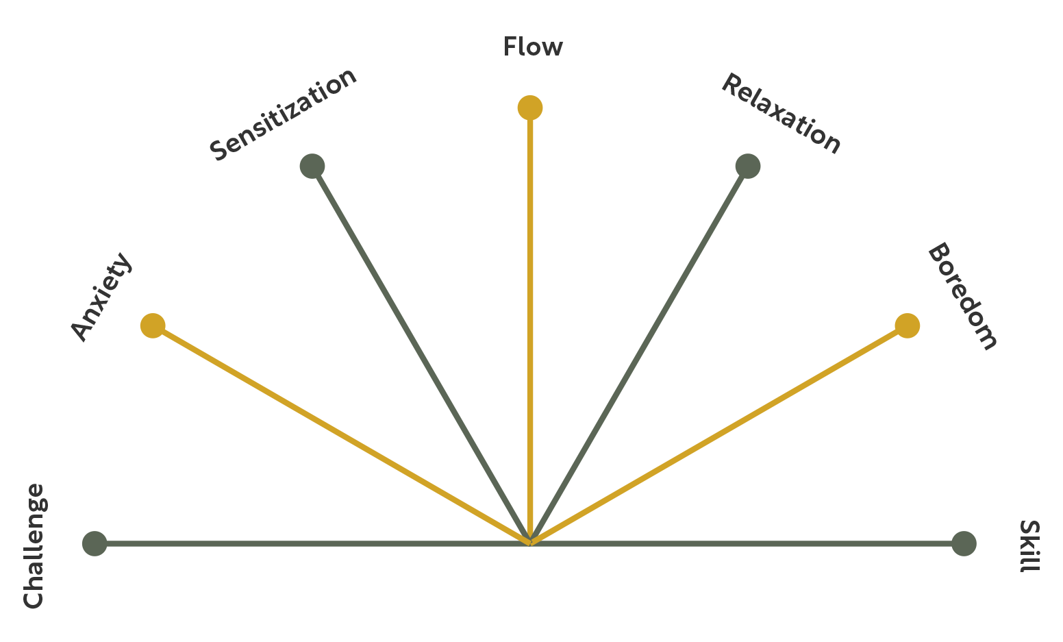

The diagram above depicts the different emotional states we may experience in response to the challenge-to-skill-level ratio. We see the flow point occur when the challenge and skill level are higher and equally matched.

Fostering Flow
We can increase our chances of experiencing flow by optimizing four key elements: temporal, environmental, physical, and social.

Temporal
Definition: When you choose to engage in tasks – time of day, week, or month.
Examples: Scheduling creative tasks during peak energy times; setting aside uninter- rupted blocks of time.

Rapid Reflection
When can you fit flow into your week? What time of the day? How long for?

Environmental
Definition: Your physical surroundings – sights, sounds, setup.
Examples: Creating a clutter-free space; using noise-canceling headphones to minimise distractions.

Rapid Reflection
Where might you set yourself up for flow best? What surroundings support your focus? What sounds support your focus?

Physical
Definition: How you support your body – eating, moving, sleeping, resting.
Examples: Eating brain-healthy snacks to get or stay energised; taking short walks to re-energise.

Rapid Reflection
How can you eat, move, sleep, and rest to support flow? How much? How often?

Social
Definition: Whether you work best alone or with others.
Examples: Collaborating with someone who inspires you; working alone in a quiet space.

Rapid Reflection
Who do you go into flow with? When do you flow best solo? What sort of tasks are best done in shared flow vs. solo flow?

Your Fostering Flow Toolkit
Here are some strategies to help cultivate flow in each of the four elements. If you want to know more about how to use the toolkit and practise your learnings - Check this out -
https://wellbeing-now.learnworlds.com/course/mastering-happiness-with-positive-psychology

Teaming With Strengths
While discovering and using our own strengths can improve our engagement, performance, and enjoyment, it becomes more effective, energizing and sustainable when we’re supported by the people and culture around us.

Strengths Spotting
One simple way to start using a strengths-based approach is through strengths spotting. This means recognising and appreciating strengths in ourselves and others.
At the team and community or organization levels, strengths spotting helps build better relationships, trust, and a culture of appreciation. It’s a practical way to create a positive work environment and improve team dynamics.
Recognising and using our strengths increases self-awareness, performance, and wellbeing. People who know and use their strengths feel more energetic, engaged, and resilient. Thinking about how our strengths affect others can also give us a greater sense of purpose and connection, making our social environment more positive.

Individual Strengths Spotting
Use the step-by-step process below to help you spot your own strengths in your day-to- day life.

Select The Moment
Think of a recent task or situation where you did well. Reflect on what made this experience positive and effective.
Example 1: “I recently led a successful team meeting where we resolved several ongoing issues.”
Example 2: “I organised a family gathering that went smoothly, and everyone enjoyed themselves.”

Pick The Strength
Identify which strengths you used during this time. Refer to the VIA Character Strengths list if needed.

Example 1: “During the meeting, I used my strengths in leadership and communication.”

Example 2: “While organising the family gathering, I used my strengths in planning and kindness.”

Observe The Outcomes
Consider the positive results your strengths brought to this situation.

Example 1: “My leadership and communication skills helped the team feel heard and valued, leading to a productive and collaborative meeting.”
Example 2: “My planning and kindness made everyone feel welcomed and comfortable, creating a warm and enjoyable family gathering.”

Test Your Perceptions
Ask a trusted person to check your findings. You can ask questions like, “What strengths do you see in me?” or “I’ve noted my strength of leadership in this activity. Does that ring true for you?”

Examples:
Work: “I asked my manager if they noticed my leadership and communication strengths during the meeting, and they confirmed that these were evident and impactful.”
Personal: “I asked my partner if they saw my planning and kindness during the family gathering, and they agreed that it made everyone feel welcomed and relaxed.”
By regularly practicing strengths spotting, you can better understand and use your strengths to improve your work and relationships.

Rapid Reflection
Select a recent moment where you performed well.

Pick the strengths used in that moment.

Observe (note down) the positive outcomes from using these strengths.

- Test the reality of your responses by asking for the input from a trusted friend/ family member/colleague or by referring to your VIA Character Strengths Survey. Are these a strength you know and use regularly? Or something new you’re leaning into? Write any reflections below.

Creating A Rooted Routine for Strengths
Having explored the science of strengths, including: ways to foster flow; balancing our strengths; spotting strengths in ourselves and strengths-based feedback, it’s time to apply our learning by creating our Rooted Routine for Strengths.

Choosing Your Habit
While you may create any Rooted Routine for Strengths you like (after all, the best habits are those we’re most eager to experiment with), if you’re unsure where to start, here are a few suggestions based on our shared learning during this session. You may wish to form a habit around:
- Identifying and using a strength each day this week at work/home.
- Selecting a small behaviour to experiment with from The Fostering Flow Toolkit.
Practice spotting strengths in yourself and/or others.
Practice giving strengths-based feedback.
Or any other ideas you have!

Remember, in order to overcome common behaviour change detailers (“I don’t really want to,” “I’m not sure where to start,” and “I don’t think I can”), we must choose a behaviour we truly want to do and shrink it until we feel at least 8/10 confident that we can do it each day for the next week.
Now, create your Rooted Routine for Strengths. For example:
NOURISHING REFLECTION
THRIVING MOMENT
NURTURING ACTION
GROUNDED BEGINNINGS

What is an existing action or routine in your day that would naturally allow you to add a new wellbeing habit? Think about behaviours you already do regularly. How can this moment “nurture” the start of your new habit?

I check my calendar every morning.

What is the small, manageable action you can take right now to help foster your wellbeing? Make sure this is an action so easy you can do it even on busy days. How will you take your first step toward growth?

While checking my schedule, I’ll identify one meeting or task where I can use my strength of curiosity, like asking a question to learn something new.

Once you’ve completed your action, how can you celebrate your success, no matter how small? What will you do to acknowledge your growth? This moment of recognition will help reinforce your habit.

I’ll take a moment to smile, feeling excited about exploring new ideas.

What do you expect to feel after completing your action? How do you anticipate this practice supporting your wellbeing? Think about any changes you hope to see in your thoughts, mood, or habits. How might this habit help you in the future?

I expect using my curiosity will help me feel more engaged and make the day more interesting.

Rapid Reflection
What was one surprising insight you had about the science of strengths today?

What was the most useful piece of information you received today?

Who might you share this information with to create a wellbeing ripple in your life?

Session 5
REL ATIONSHIPS

Goals
The goals of this session are to:
Reflect on the importance of relationships in your life
Understand the benefits of positive relationships and high-quality connections
Identify common barriers to forming strong relationships and learn how to overcome them
Explore the concept of psychological safety in relationships
Develop practical strategies to strengthen your relationships, both personally and professionally

In this session, we turn our focus to the R in the PERMAH model – Relationships. We will dive into the profound impact that positive relationships have on our overall wellbeing. We’ll explore the concept of high-quality connections (HQCs), learn about common barriers that hinder deep connections, and discuss the role of psychological safety in fostering trust and openness. By the end of this session, you’ll have practical strategies to apply in your personal and professional relationships to build and maintain strong, supportive connections.
Let’s get started.

Reflection Round
Take a few minutes to reflect on your recent experiences with relationships:

What has gone well in your relationships over the past few weeks?

Where have you encountered challenges in connecting with others?

What are you learning about yourself through these interactions?

What changes or improvements would you like to make in your relationships?

Why Connection Matters
Rapid Reflection
Consider where you are in your life right now. Consider your housing, health, hobbies, education, career, personal development, and treasured memories.
Who are the people that helped you get here?

How would life be different without those connections?

Wells of Wellbeing
Why do some relationships lift us up while others seem to drain our energy? Research shows that the quality of our relationships is one of the most important factors in determining our overall happiness and health. Over 75 years of studies have shown that people who have strong, supportive relationships are not only happier but also healthier and live longer lives. This shows just how powerful positive relationships can be in our lives.

The Benefits Of Positive Relationships
Here are 10 ways positive relationships can benefit us in different areas of our lives, whether in friendships, at work, in romantic partnerships, or with family:
- Enhanced Emotional Wellbeing: Positive relationships offer emotional support, help reduce stress, and increase overall life satisfaction by making us feel like we belong and are secure.
- Improved Physical Health: Being involved in positive relationships is linked to better physical health, including lower blood pressure, reduced risk of heart disease, and a stronger immune system.
- Increased Longevity: Strong social connections are associated with living longer. Good relationships can protect against unhealthy behaviours and encourage healthier lifestyles.
- Better Cognitive Functioning: Positive relationships help keep our minds sharp, improving memory and mental clarity, especially as we age.
- Greater Resilience: People with strong, positive relationships are better at handling tough times. These relationships provide support that helps us cope with and recover from stress.
- Higher Levels Of Happiness: Positive relationships are one of the biggest factors in how happy and satisfied we are with life. Feeling connected and supported boosts our wellbeing.
- Improved Workplace Performance: In the workplace, positive relationships lead to higher job satisfaction, better teamwork, and increased productivity. Employees are more engaged and motivated when they feel connected to their coworkers.
- Better Conflict Resolution: Positive relationships help with communication and understanding, which are key to resolving conflicts effectively. People in these relationships are more likely to work through disagreements in a constructive way.

- Support For Personal Growth: Positive relationships encourage us to grow by providing a safe space where we can express ourselves, try new things, and reach our potential.
- Stronger Family Bonds: In families, positive relationships create a sense of belonging and support, which are important for a stable and nurturing environment. These strong bonds are crucial for the healthy development of children and the wellbeing of all family members.

High-Quality Connections

What Is An HQC?
We all know that our relationships can greatly impact our wellbeing and performance, both from research and our own experiences. But in today’s busy world, especially with more people working remotely, how can we build these important connections? One approach suggested by researchers like Jane Dutton is to focus on creating more “high- quality connections” (HQCs).
HQCs are short, positive interactions that make us feel energised, valued, and that have a sense of mutual effort and enthusiasm. Unlike deep, long-term relationships, HQCs can happen in brief moments, like a positive chat with a colleague or a meaningful conversation with someone you just met.

The Benefits Of HQCs
These small connections might seem minor, but they can have a big impact on our wellbeing. HQCs can help us be more emotionally resilient, lower our stress, and even improve our work performance. In our fast-paced world, where building deep connections can be challenging, focusing on HQCs is a practical way to feel more connected and boost our happiness.

What Does A High-Quality Connection Look Like?
High-quality connections are often marked by mutual trust and positive feelings, even in brief interactions. Here are some examples you might recognise:
A colleague listens to your ideas during a meeting, giving thoughtful feedback that makes you feel heard and appreciated.
A friend remembers something small but important about your life and checks in on you during a tough time.
A mentor has a conversation with you that both challenges you to grow and supports your efforts.
You share a moment of laughter with a coworker, which lightens the mood and strengthens your bond.
A stranger gives you a smile or a compliment, creating a moment of genuine connection that leaves both of you feeling uplifted.

Your HQC Toolkit

Now that we know the benefits of high-quality connections and how to spot them, it’s time to get practical. Below is a toolkit with simple, everyday actions you can take to start cultivating HQCs, even in a busy world.

Dare To Share

Be open and vulnerable in your interactions by sharing something personal about yourself – whether it’s a recent challenge, a lesson you’ve learned, or a small success. When you dare to share, you invite others to connect with you on a deeper level, which can help build trust and mutual respect.

Listen To Learn

Practice active listening in your conversations, focusing not just on the words being spoken but also on the feelings and intentions behind them. Listening deeply and empathetically shows that you value the other person’s perspective, which is key to creating energizing and supportive connections. Make it a habit to listen with the goal of learning something new about the other person.

Ask Appreciatively

When asking questions, frame them in a way that highlights the other person’s strengths or positive experiences. For example, you could ask, “What’s a recent success you’re proud of?” or “What do you enjoy most about your work?” These types of questions encourage others to share their positive experiences, fostering a sense of appreciation and connection.

Spot Strengths

Make it a regular practice to identify and acknowledge the strengths you see in others, whether they’re colleagues, friends, or family members. For instance, you might say, “I noticed how patient you were in that meeting; it really helped keep things on track,” or “Your creativity really shines in this project.” Recognizing and affirming strengths in others not only boosts their confidence but also strengthens your connection with them.

Seek Out Strangers

Make an effort to initiate brief, positive interactions with people you don’t know well – whether it’s a colleague you don’t often speak to or someone you pass by regularly. Even small, positive exchanges with strangers can contribute to a sense of belonging and wellbeing. A simple “Good morning!” or a compliment can create a moment of connection that leaves both parties feeling uplifted.

Ask For Help

Don’t hesitate to ask for help when you need it, whether it’s advice, a favor, or just someone to listen. Asking for help not only provides you with the support you need but also strengthens your relationships by giving others the opportunity to contribute and feel valued. This can deepen trust and build a sense of reciprocity in your connections.

Five-Minute Favours

Offer to do small, unsolicited favours for others that take five minutes or less, such as making an introduction, sharing a helpful resource, or providing quick feedback. These small acts of kindness can significantly enhance relationships and build goodwill, contributing to a culture of mutual support and collaboration.

Keep It Curious

Approach conversations with genuine curiosity, especially when discussing differing opinions or perspectives. Curiosity helps bridge gaps in understanding and reduces conflict. Instead of assuming you know what the other person thinks, ask open-ended questions like, “What led you to that conclusion?” or “Can you tell me more about your perspective on this?”

Celebrate Successes

Take the time to celebrate others’ successes, whether big or small. How we respond to good news is critical for building strong relationships. When someone shares a success with you, respond enthusiastically, ask for details, and express your genuine happiness for them. This not only strengthens the connection but also reinforces a positive and supportive relationship.

Shifting From Judgment To Curiosity
To help make this shift from judgment to curiosity, you can use tools and practices that encourage empathy and a more generous view of others’ actions. One effective approach is to consciously replace judgmental thoughts with curious, kind ones. For example, instead of thinking “They’re being difficult,” try asking yourself, “I wonder what they’re going through?” Or instead of reacting with “They should know better,” consider, “How can I support them in this situation?”
To help you start swapping judgmental behaviours for more generous ones, we’ve created the Judgment Vs. Curiosity Toolkit.
To learn more - Check this out - https://wellbeing-now.learnworlds.com/course/mastering-happiness-with-positive-psychology

The OFTEN Process For Kind Conversations
To help structure a kind conversation, you can use the acronym OFTEN, which stands for observations, feelings, telling the story, essential needs, and next steps. This process provides a clear framework for expressing yourself in a way that is both honest and compassionate.

O: Observations – “I’m noticing …”

Start by objectively describing the situation without judgment. This sets the stage for a conversation based on facts rather than assumptions.
Example: “I’m noticing that during our recent meetings, you’ve been arriving about 10 minutes late.”

F: Feelings – “This is making me feel …”

Express how the observation makes you feel. This helps the other person understand the impact of their actions on you.
Example: “This is making me feel a bit frustrated and concerned.”

T: Telling The Story – “The story I’m telling myself about this is …”

Share the narrative you’ve created in your mind about the situation. This invites dialogue rather than defensiveness.
Example: “The story I’m telling myself about this is that maybe these meetings aren’t a priority for you, or that there might be something else going on.”

E: Essential Needs/Values – “This is going against my need to/ value of …”
Clearly state how this scenario is compromising your needs/values. This explains why the situation matters to you.
Example: “This is preventing me from meeting my need of starting our meetings on time, which is important for staying on schedule.”

N: Next Steps – “In the future, can you please … And I will …”

End by proposing a clear, actionable request for how to move forward.

Example: “In the future, can you please try to arrive on time for our meetings? And I will make sure to send reminders if that would help.”

Rapid Reflection
Think about a situation in your life that could be resolved with a kind conversation.

What are your observations (the objective facts of the situation)?

How has this been making you feel (consider referring to the emotions listed in the Wheel of Emotions)?

What stories have you been telling yourself about this situation/the people involved?

What essential needs/values might be in play?

What next steps could you/others take to improve the situation?

Creating A Rooted Routine for Relationships
Now that we’ve explored the importance of relationships, high-quality connections, common barriers to connection, and psychological safety, it’s time to apply what you’ve learned by creating and practicing a Rooted Routine for Relationships.
Follow the known steps and implement your Rooted Routine for Relationships.

Session 6
MEANING

Goals
The goals of this session are to:
Reflect on what gives your life meaning
Understand the role of meaning in enhancing overall wellbeing
Explore how balancing passions contributes to a fulfilling life
Learn strategies to craft more meaningful work experiences
Create a Rooted Routine to sustain a sense of meaning in everyday life

This session shifts our focus to “Meaning” in the PERMAH model. We will explore the critical role meaning plays in our overall wellbeing and how we can actively cultivate a sense of purpose and significance in our daily lives. The session will guide you through reflecting on your current sources of meaning, balancing your passions, crafting meaningful work, and creating Rooted Routines that reinforce your sense of purpose.
While this session will touch on work-life balance, it’s important to note that “work” can mean many things beyond professional employment. It could refer to the various roles we play in our personal lives – such as caregiving, volunteering, or pursuing passions and hobbies – that require effort and commitment. In exploring work-life balance, we’ll look at how these different areas of “work” impact our sense of meaning and purpose in a broader context.

Reflection Round
What motivates us to get out of bed every day and face life’s challenges? When we have a clear sense of purpose, we find it easier to tackle difficulties, whether big or small.
When it comes to meaning – perhaps more than any other area of wellbeing – reflecting on our experiences is crucial. Taking the time to pause and consider our deeper values and purpose in life is the only way we can act in more alignment with what matters most to us, and enjoy all the benefits that a sense of meaning brings to our lives.
What better way to do this than through a Reflection Round?

When it comes to connecting to a sense of meaning in your life in the past, what has gone well?

What challenges have you faced in connecting with a sense of meaning?

What lessons have you learned about what is meaningful in your life?

What would you like to try to reconnect with a sense of meaning?

Why Meaning Matters
The Pursuit Of Meaning
Is happiness really the ultimate goal in life, or is there something deeper we should aim for? While happiness is important, it’s the pursuit of meaning that truly makes life fulfilling. Unlike happiness, which can be fleeting, meaning gives us a sense of coherence and purpose that helps us through life’s challenges.
In our day-to-day lives, chasing happiness alone can often feel empty or unsatisfying. Those who focus on finding meaning tend to experience greater wellbeing and resilience. Meaning connects us to something bigger, like relationships, personal growth, or contributing to the community. It’s this connection that provides a stable foundation for long-term fulfilment.
Finding meaning isn’t always easy – it often requires us to think deeply about our values, purpose, and the impact of our actions. Sometimes, meaning can even come with discomfort, as it might involve sacrifices or facing difficult truths. But this complexity is what makes meaning so fulfilling. When we find meaning, we gain a sense of direction and significance that goes beyond temporary pleasures.

What Is Your “Passion Pie”?

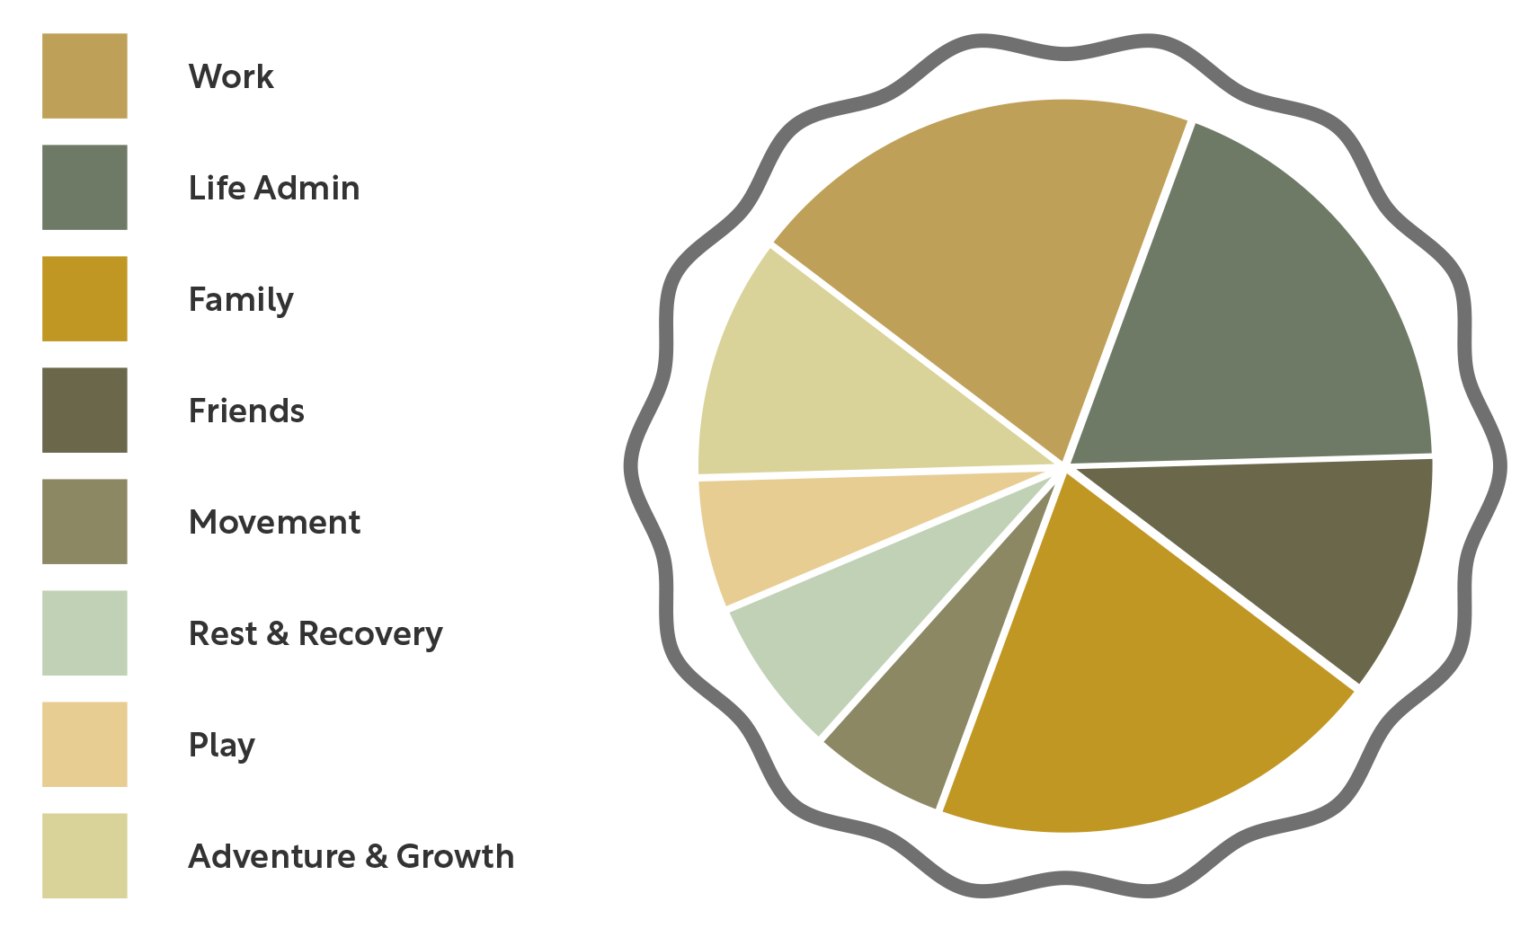

To help assess the balance in your life, imagine your life as a pie chart – your “Passion Pie.” Each slice represents a different area of your life, like work, family, friends, rest, and personal growth. By breaking down your daily activities into slices, you can better understand how much time and energy you’re dedicating to each area.
Here’s how to reflect on your Passion Pie:

- Reflect On Current Allocation: Consider (and allocate through shading a percentage of the pie) what percentage of your life is currently taken up by work.
- Ask Yourself: How much space is left for other important areas like family, friends, movement, rest, play, and personal growth?
Take time to allocate and shade in these remaining areas. This can help you see where your energy is overly concentrated or perhaps lacking.
- Assess The Impact: Consider the consequences of this allocation. If work dominates your Passion Pie, you might be experiencing stress, burnout, or strained relationships. On the other hand, too little investment in work or growth areas might lead to a lack of fulfilment or purpose.

What is the impact of this distribution on your wellbeing?

Where might there be too much or too little energy spent?

Making Our Passion Pie
If the commitments and context of our life are the ingredients of our pie, we can think of the following image as representing the factors that shape how we “bake” our Passion Pie. These three elements include:

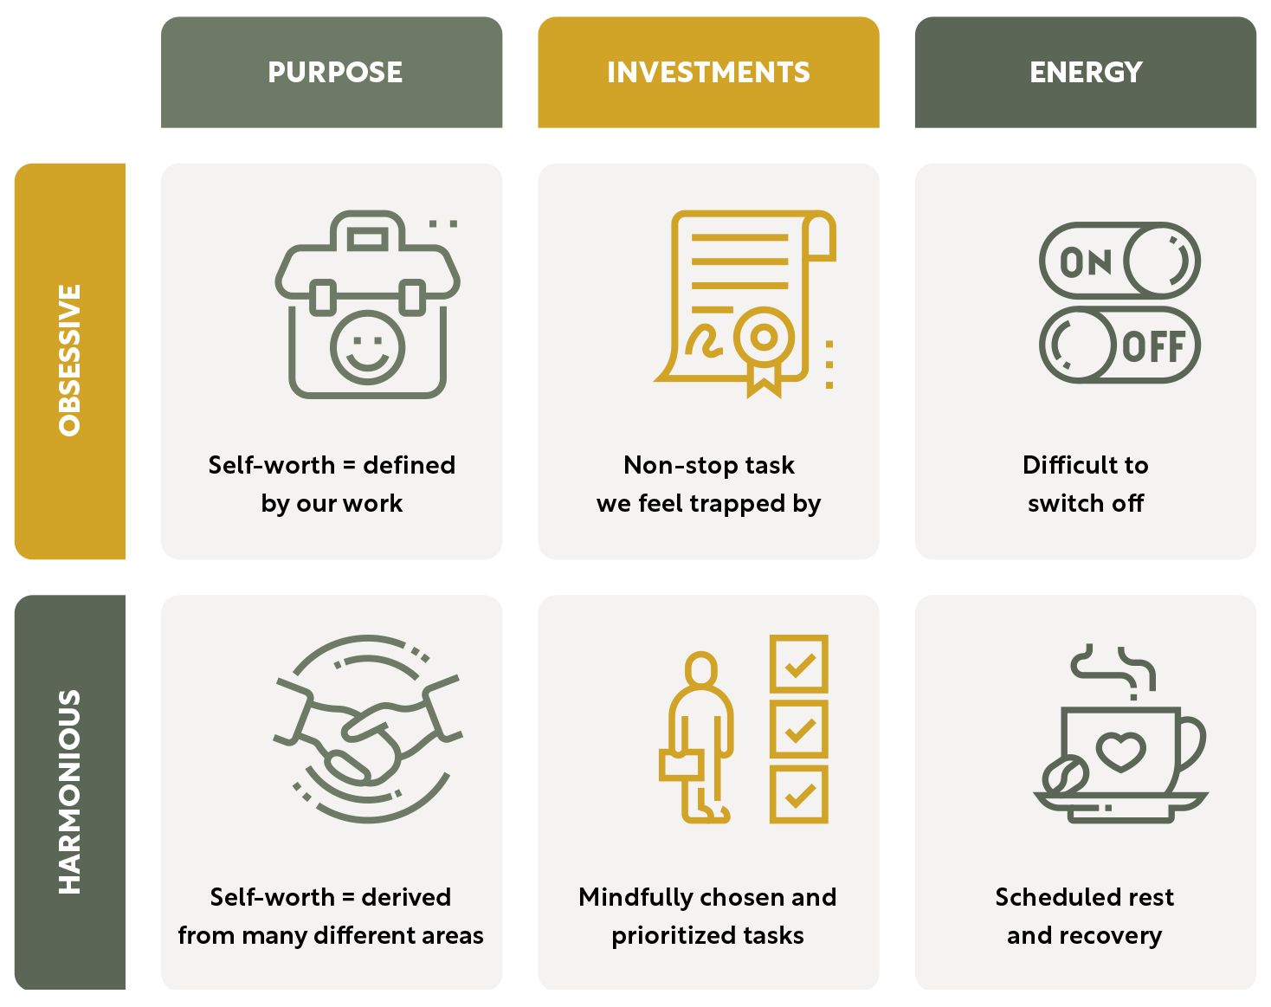

Purpose
Purpose is what drives us and gives our life meaning. When we clearly understand our purpose, we tend to feel more motivated and satisfied. However, if we focus too much on purpose – especially if it’s tied only to work – it can lead to an unhealthy obsession. This happens when our self-worth becomes too dependent on our professional success.

Investments
Investments are where we put our time, energy, and resources. When we carefully choose tasks that match our values, we create a healthy balance between work and life. This leads to a fulfilling life without the risk of burning out. But if we feel stuck in constant tasks driven by outside pressures, it can lead to stress and a feeling of being trapped.

Energy Levels
How we manage our energy – through care of ourselves – affects how well we can keep up our efforts and enthusiasm over time. It’s important to schedule time for rest and recovery to maintain our energy and avoid burnout. If we have trouble switching off or ignore self-care, it might be a sign of imbalance, leading to exhaustion.
By reflecting on these three elements – purpose, investments, and energy – we can understand whether our passions are healthy and balanced or if they’re becoming overwhelming. For example, do we only find self-worth in our work, leading to obsessive behaviour? Or do we value different aspects of life, allowing for a more balanced and fulfilling approach?
This reflection helps us see where our Passion Pie might need adjustments so that we can enjoy greater wellbeing and fulfilment.

Rapid Reflection
Take some time to reflect on the following and write your responses in the spaces provided.
Purpose: What matters most to me right now? Based on this, divide up your ideally balanced Passion Pie.

Investments: What small actions might I take to better balance my investments in a way that is sustainable and fills my “meaning bucket”?

Energy: How am I resting and recovering? Am I resting enough to have the energy to live out my more balanced Passion Pie?

- Share: To support me with my plan to better balance my passions, is there anyone I might share Passion Pie with (e.g., colleagues, boss, partner)? How and when might I share it?

Crafting Meaningful Work
Rapid Reflection
Thinking about your role at work (remember, “work” can mean many things, including personal, caregiving, or volunteer roles): What are your 10 most important tasks this week?

1.
2.
3.
4.
5.
6.
7.
8.
9.
10.

Which tasks energise you? Place an E for energise next to these. Which tasks de-energise you? Place a D for de-energise next to these. What are the neutral tasks? Place an N for neutral next to these.

Using the space below, write about what makes the energising tasks so engaging. Consider the following questions as inspiration:
Does the task call on your strengths?
Is it interesting or meaningful to you?
Do you enjoy collaborating with the people involved in this task?
Does the timing, pacing, or location of the task suit you?

Expanding Job Crafting: What, Who, Why, Where, When
How can you shape your job to make it more meaningful? Building on the idea of job crafting, Rob Baker expands the concept to include five key elements: what, who, why, where, and when. Each element offers a way to tailor your work experience to align with your values and goals.

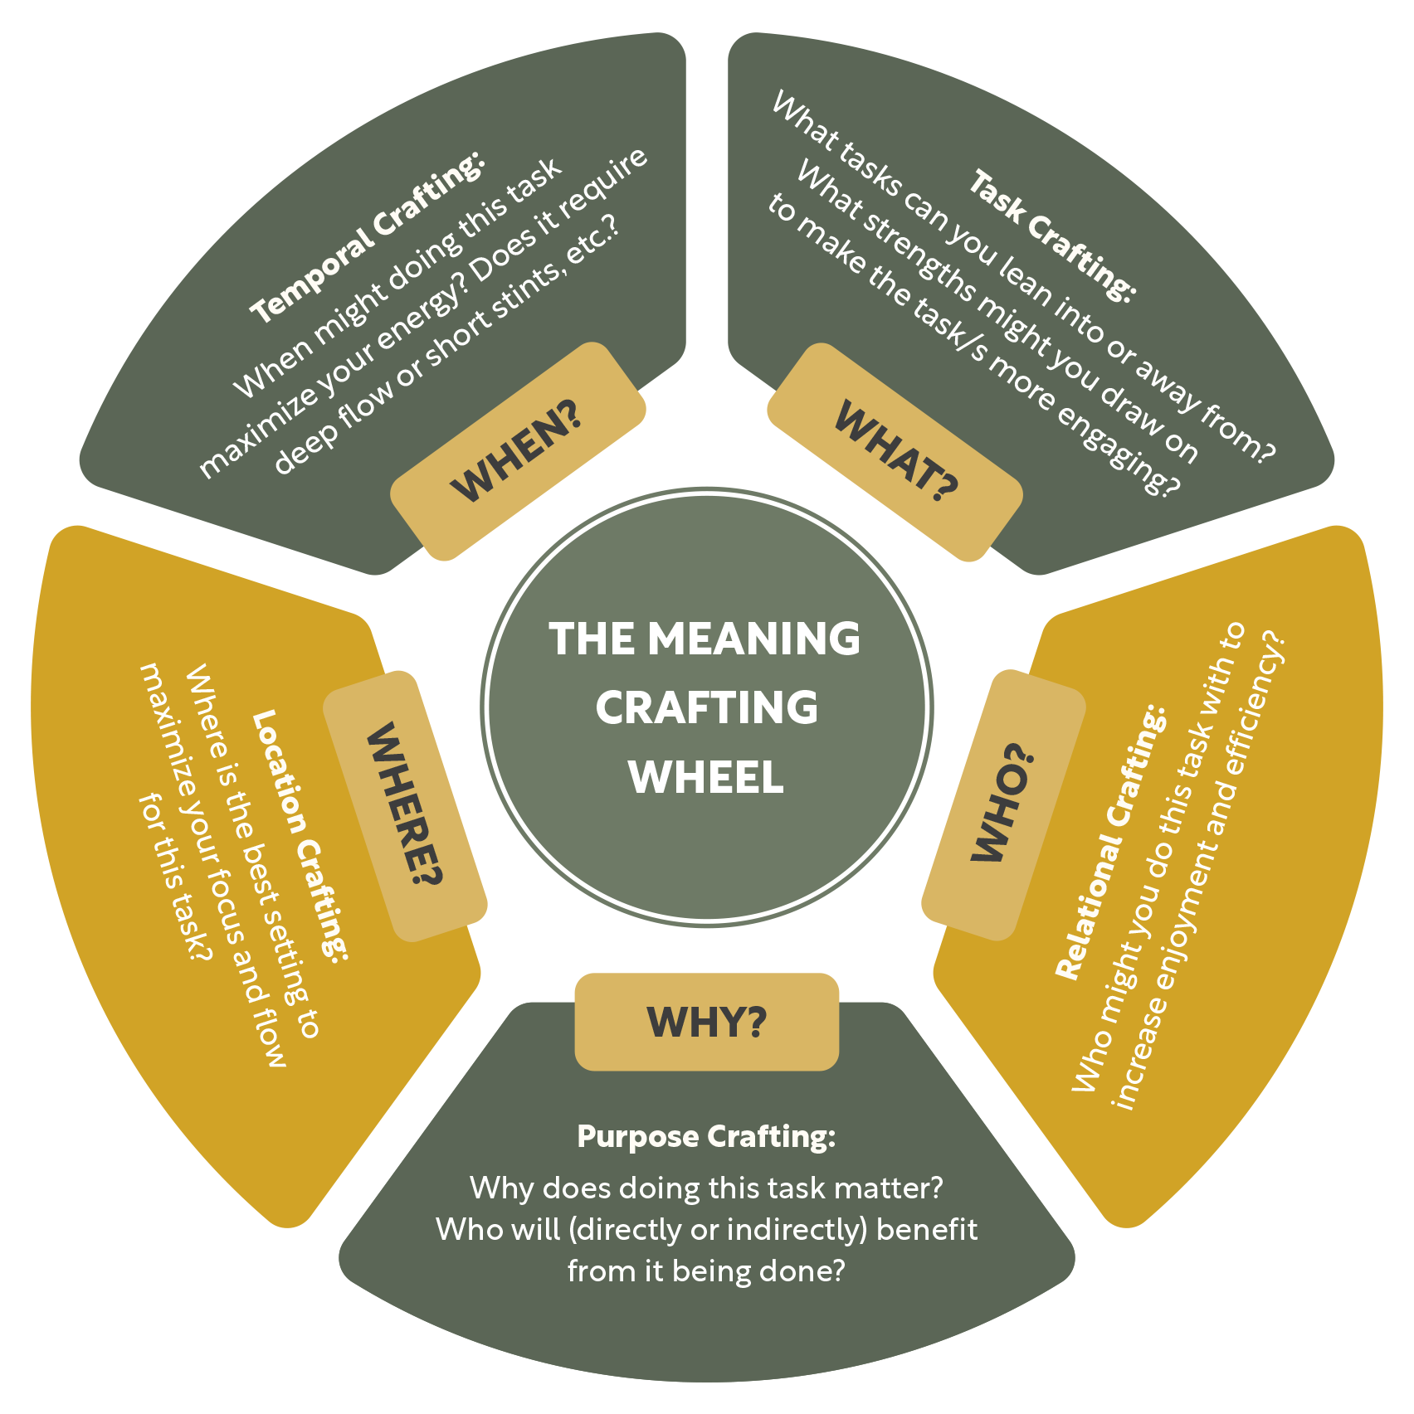

What (Tasks):
This involves changing the tasks you do, either by taking on new responsibilities that play to your strengths or by finding new ways to approach existing tasks. For example, you might try a different method for completing routine tasks, like using voice dictation instead of typing, to make them more engaging.

Who (Relationships):
Focus on building and nurturing relationships at work. This could mean connecting with colleagues who inspire and support you or strengthening the relationships you already have. Regular, informal check-ins with coworkers can help create a sense of community and collaboration.

Why (Purpose):
This is about redefining how you think about your work. By connecting your tasks to a larger purpose, you can find greater meaning even in routine activities. For example, you might start viewing mundane tasks, like managing finances, as ways of caring for your business and its stakeholders, giving those tasks a deeper sense of purpose.

Where (Environment):
Change your physical or virtual work environment to better suit your needs. This might involve rearranging your workspace, choosing different locations to work from, or adjusting your work-from-home setup to enhance comfort and productivity.

When (Timing):
Adjust when you perform certain tasks. This could mean restructuring your workday to match your natural energy levels or setting specific times for focused work. Finding flexible, personalised approaches to time management can help you maintain better work-life balance.
By considering each of these five elements, you can create a work experience that feels more fulfilling, balanced, and aligned with your personal goals and values.

Practical Applications Of Job Crafting
How can you apply these job-crafting strategies to your work? Job crafting is not just a concept; it’s a practical tool that can make your work more enjoyable and meaningful. Do dive deeper - check this out https://wellbeing-now.learnworlds.com/course/mastering-happiness-with-positive-psychology

Wellbeing-Now
Reflection Workbook

Session 7
ACCOMPLISHMENT

Goals
The goals of this session are to:
Reflect on what accomplishment means to you personally
Understand how values drive meaningful accomplishments
Explore strategies for setting goals that align with your core values
Develop self-compassion to navigate challenges effectively
Create a Wellbeing Ripple in our chosen workplace or community

Learn how to balance striving for success with savouring the journey

The session will guide you through reflecting on your past achievements, understanding the importance of value-driven goals, and learning how to balance the drive to succeed with the need to enjoy the process. By the end of this session, you will have practical tools to enjoy effectively pursuing what matters most to you.

Reflection Round
Reflecting on your accomplishments helps you assess whether the goals you’re pursuing are truly aligned with your values and whether they contribute to your life in a meaningful way. It’s an opportunity to celebrate your progress, learn from your experiences, and adjust your approach if needed. This reflection is the first step to helping you set more intentional, value-driven goals in the future.
When it comes to your accomplishments:

- What has gone well recently in your efforts to achieve your goals?

Where have you struggled to accomplish what matters most to you and why?

What have you learned about yourself through your recent successes and setbacks?

What would you like to try to accomplish more of what matters most to you?

Are You Accomplishing What Matters?
Have you ever reached a significant goal only to realise it didn’t bring the satisfaction you were expecting? This is a common experience, and it often happens when our goals aren’t aligned with our core values. Goals that resonate deeply with what truly matters to us provide a sense of purpose and fulfilment beyond just achieving the goal itself.
Steven C. Hayes, the creator of acceptance and commitment therapy, describes values as a compass that guides us in setting meaningful goals that reflect who we truly are. When our goals align with our values, we are more likely to stay motivated and committed, even when faced with challenges. This alignment helps ensure that the pursuit of our goals contributes to our overall wellbeing, rather than leaving us feeling empty or dissatisfied.

Goals Vs. Values
There’s a key difference between goals and values. While goals are specific outcomes we aim to achieve, values are the principles that guide our behaviour and decisions. Think of goals as stops along a journey, while values are the direction in which you’re traveling. Focusing on how you want to live your life, not just what you want to achieve, can lead to a more fulfilling journey.
Experts in motivation, like Richard Ryan and Edward Deci, suggest that goals tied to intrinsic values – such as personal growth, relationships, and health – lead to greater wellbeing and lasting motivation. These goals, which are inherently satisfying, differ from those driven by external rewards, like money or status. By aligning your goals with your values, you can ensure that your efforts contribute to a more meaningful and rewarding life.

THE VIA CLASSIFICATION OF STRENGTHS

Wellbeing-Now
Reflection Workbook
Remembering Our VIA Strengths
PERSPECTIVE  People who know you consider you wise. | LOVE OF LEARNING  You have a passion for mastering new skills, topics, and bodies of knowledge. | JUDGMENT  You think things through and examine them from all sides. | CURIOSITY  You like exploration and discovery. | CREATIVITY  Thinking of new ways to do things is a crucial part of who you are. | WISDOM
ZEST  You approach everything you do with excitement and energy. | PERSEVERANCE  You work hard to finish what you start. |  | HONESTY  You live your life in a genuine and authentic way. | BRAVERY  You do not shrink from threat, challenge difficulty, or pain. | COURAGE
SOCIAL INTELLIGENCE  You know how to fit in to different social situations. |  | LOVE  You value close relationships with others. |  | KINDNESS  You are kind and generous to others. | HUMANITY
TEAMWORK  You excel as a member of a group. | LEADERSHIP  You excel at encouraging a group to get things done. |  | FAIRNESS  One of your abiding principles is to treat all people fairly. |  | JUSTICE
SELF-REGULATION  You are a disciplined person. |  | PRUDENCE  You are a careful person. | HUMILITY  You do not seek the spotlight and others value your modesty. | FORGIVENESS  You forgive those who have done you wrong. | TEMPERANCE
SPIRITUALITY  Your beliefs shape your actions and are a source of comfort to you. | HUMOR  Bringing smiles to other people is important  to you. | HOPE  You expect the best in the future, and you work to achieve it. | GRATITUDE  You are aware of good things that happen and don’t take them for granted. | APPRECIATION OF BEAUTY + EXCELLENCE  You notice and appreciate beauty and excellence in all domains of life. | TRANSCENDENCE

A practical way to explore your values is by using the VIA Character Strengths survey, developed by positive psychology researchers Chris Peterson and Martin Seligman. As we explored in the Engagement session, the VIA framework identifies 24 character strengths that are valued across cultures, such as kindness, perseverance, and gratitude. These strengths can offer valuable insights into your core values and help you align your goals with what truly matters to you.

Rapid Reflection
Which of these values immediately stand out to you as priorities in your own life?

Are you enacting these values regularly? Why or why not?

What might be some of the values of the people around you? How might this influence you?

Creating Valuable Goals
To help us create valuable goals that we want to stick with, we’ve created a Valuable Goals Template for you to complete. Combining the principles of SMART goals, values- aligned goal setting, and job crafting, this template offers a comprehensive approach to reaching your goals by helping you to identify:
Your Objective: Making sure that your objective is specific, actionable, and clear ensures that you know exactly what you’re aiming for and how to get there.
The Relevant PERMAH Pillar: Identify which aspect of your wellbeing the goal supports helps you focus, motivate, and measure your outcomes.
Why: Understand why this goal is important to you and how it aligns with your values helps you stay the course.
- What “Done” Looks Like: Define what success looks like for this goal will give you both a clear target and a clear moment to know that you’ve achieved it.
- Support: You don’t have to go it alone! As we learned from our job crafting lessons, by identifying the resources, people, or tools that will help you achieve the goal, we likely improve both the final outcome and the journey getting there.
- Celebration: As we discovered through our Rooted Routine practice, viscerally celebrating our small wins helps keep us motivated and boosts our confidence.

Striving & Savouring
The Journey & The Destination
Achievement is usually viewed as the outcome of our hard work, but studies show that the process of working toward our goals is just as important as reaching them. Enjoying and fully experiencing positive moments along the way, known as savouring, helps keep us motivated and boosts our overall wellbeing as we strive toward our goals.
Savouring is about being present and mindful during the journey, allowing us to find joy and satisfaction in the process, not just the outcome. By staying connected to the positive aspects of our journey, we can make the pursuit of our goals a more fulfilling experience.

Step-By-Step Guide: “Taking In The Good”
Rick Hanson’s “taking in the good” exercise is a simple yet powerful way to savour positive experiences and build up a sense of happiness, resilience, and wellbeing. This practice helps you focus on and absorb the good moments in your life, whether they’re big accomplishments or small, everyday joys. Here’s how you can do it:

Step 1: Notice The Good
Start by paying attention to positive experiences as they happen. This could be something small, like the warmth of the sun on your face, a kind word from a colleague, or the satisfaction of completing a task. It could also be a more significant moment, like achieving a goal or sharing a meaningful connection with someone. The key is to be mindful and aware of these positive moments as they occur.
Step 2: Enrich The Experience
Once you’ve noticed a positive experience, take a moment to really savor it. Stay with the experience a bit longer than you normally would, and let it fill your awareness. Focus on the details. What do you see, hear, feel, or even smell? Let the experience grow in your mind, becoming richer and more vivid. Try to feel it in your body, letting it deepen and intensify.

Step 3: Absorb The Good
Next, consciously absorb the positive experience. Imagine that the good feelings and sensations are sinking into you, like warmth soaking into your skin. Visualise the experience being stored in your mind and body, becoming a part of you. This step is about letting the positive experience really take root, helping it to stay with you longer.

Step 4: Reflect And Repeat
Finally, reflect on the practice and how it felt. Notice any changes in your mood or mindset. The more you practice taking in the good, the more natural it will become. Over time, this exercise can help you build a reservoir of positive emotions and memories that support your resilience and overall wellbeing.
By regularly practicing taking in the good, you can train your brain to focus more on positive experiences, helping you to build lasting inner resources that enhance your life and increase your ability to handle challenges.

Rapid Reflection
- How was that experience of taking in the good?

What did you bring to mind?

How did you take in the good (with your thoughts, body sensations, hearing, smell, and so on)?

Defining Self-Compassion
Kristin Neff defines self-compassion as being made up of three main elements: mindfulness, common humanity, and self-kindness.
Mindfulness is about being aware of our thoughts and feelings without judging them.
Common humanity is the recognition that everyone experiences suffering and imperfection; it’s part of being human.
Self-kindness involves treating ourselves with warmth and understanding when we’re going through tough times.
Research shows that self-compassion can greatly improve our mental health and wellbeing. Studies have found that self-compassion is linked to lower levels of anxiety, depression, and stress, along with higher life satisfaction and emotional resilience. These results suggest that self-compassion is a powerful way to boost our overall wellbeing and handle life’s challenges more effectively.

Self-Compassion Steps

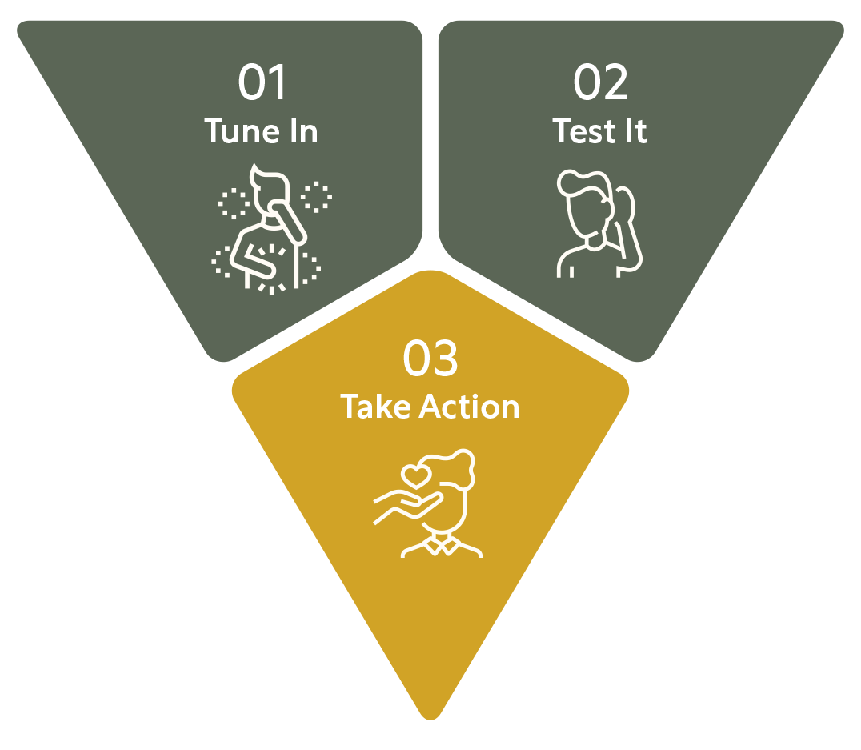

Tune In
Notice the signs of struggle in your mind or body. Engage all your senses to become fully aware of what you’re experiencing. What signs of struggle are you noticing?

Test
Pay attention to how you’re speaking to yourself. Would your words pass the “best friend test”? What would someone who loves and cares about you say in this situation?

Take Kind Action
- Consider what you need in this moment. Tune into your body to determine how you can best support yourself with kindness and understanding. What action can you take right now to be kind to your body and mind?

By following these steps whenever you find yourself struggling, you can begin to cultivate greater self-compassion and reduce the impact of self-criticism on your wellbeing.

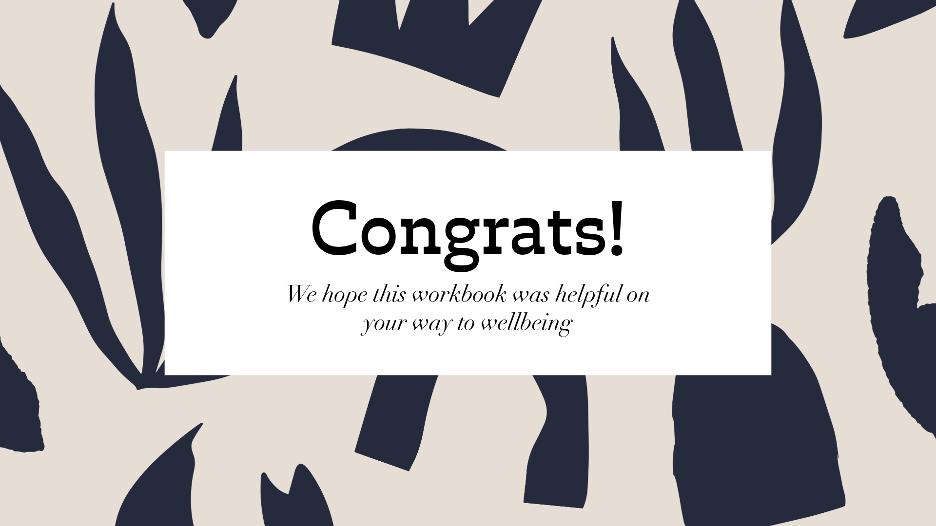

In these 7 days we have of course only been able to describe the basic principle and give initial suggestions for implementation. As with everything in life, achieving the set goals requires the right strategy and discipline in daily application.

For those who want to get to know and apply all the tools and strategies and learn everything necessary, we recommend our Master Course:

- https://wellbeing-now.learnworlds.com/course/mastering-happiness-with-positive-psychology

Copyright © Wellbeing-Now.com All rights reserved.
This book or any portion thereof may not be reproduced, relabelled, or used in any commercial manner whatsoever without the express written permission of the publisher.
.
Rüdiger Wenzel
Arnumer Kirchstrasse 4
30966 Hemmingen
Germany

https:/Wellbeing-Now.com

