WHY CONDUCT A POST-ELECTION REVIEW (PER)?

Mission: To protect the votes of your citizens by checking the accuracy of the machine counts in order to enhance security and transparency and to build voter confidence.

What your peers are saying:
Weston Rolf, Mayor City of Oak Grove, MN: “Nobody can confirm that the voting machine counted the ballots correctly on Election Day. It is important to me as your mayor that your vote counted.”
Deb Musgrove, Ramsey, MN City Council: "We value double checking everything in our society so why wouldn't we double check the counting of our votes."
Others are saying: "We spend millions on our budget so we can afford a few thousand dollars to hand count our votes."
What is PER?
The post-election review (PER) is a manual recount (or “audit”) of the paper ballots of randomly-selected precincts for specific offices following each state general election. It compares the hand count with the results from the machines in order to determine accuracy within defined standards. The precincts and offices to be counted is determined by the County Canvassing Board which meets 3-8 days after the general election. The hand count takes place between 9 and 14 days after the general election (206.89).

Municipalities can request to add precincts & offices
- Determine number of precincts and offices to hand count (see below)
- Calculate time and cost(see calculator below) based upon:
  - number of precincts and offices to be hand counted
  - estimated or known number of ballots in each precinct
  - hourly rate of pay to election judges if not waived
- Adopt resolution to request inclusion in PER (see templates below)
- Send resolution to county auditor or elections manager
- Provide election judges to hand count
- Cooperate with county during hand count
- Pay election judges
County can facilitate requests by expanding sample
- This request will be considered by County Canvassing Board. This board consists of five members: two county commissioners, the County Auditor, the County District Administrator, and Mayor of the largest city in the County). There is some flexibility in that each member can appoint a designee to appear for them and/or the County Auditor can appoint an eligible voter in the County to fill any vacancy. (MS 204C.31).
- The Canvassing Board must meet 3 to 8 days after the November 5, 2024 election, so between November 8-13. They make the decision about how many precincts are randomly drawn and how many offices are included (MS 204C.33 as amended in 2024).
- The Post-Election Review (PER) is held 9 to 14 days after the November 5, 2024 elections, so between November 14-19 (MS 206.89).
- Each municipality involved in the hand count provides election judges to conduct the count and pays them (MS 206.89, Subd. 9).
- The County elections department trains and supervises the hand count.
- The method of hand counting is the Piling System (MS 204C.21) and re-count protocols (204C.361).
- There are provisions in Statutes to deal with any deviants between the machine count on Election Day and the hand count under the PER (MS 206.89, Subd. 5).
Statutory Authority
- PER authorized & required: Sec. 206.89 MN Statutes
  - Option to expand precincts (MS 206.89, Subd. 2)
  - Option to expand offices (MS 206.89, Subd. 3)
- Hand Count Method is Piling System: Sec. 204C.21 MN Statutes
- County Canvassing Board: Sec. 204C.31 MN Statutes
- PER Guide: 2022 Post-Election Review Guide (state.mn.us)
- Sample hand count time & cost calculation (see below)
- Sample resolutions: Oak Grove (4/29/2024) & Ramsey (6/11/2024)

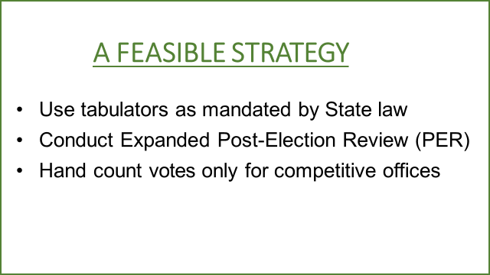

EXAMPLE: 2024 HAND COUNT CALCULATOR PER PRECINCT BELOW
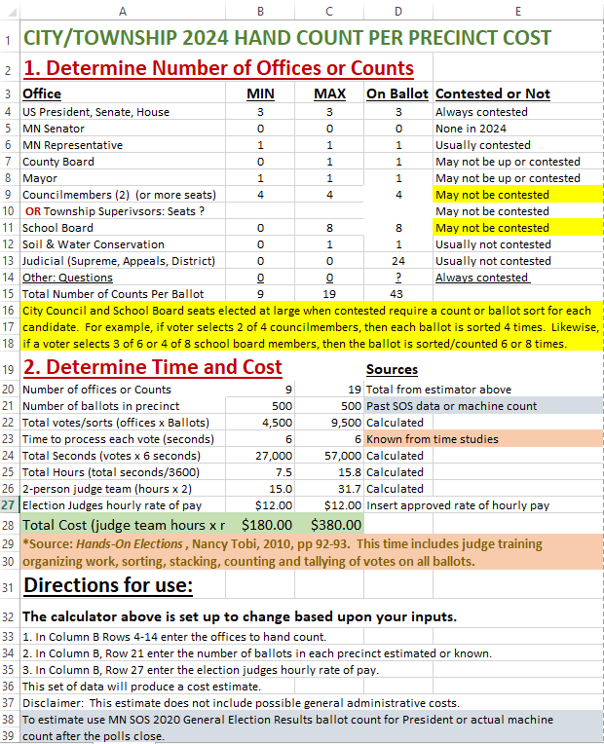
Disclaimer: this estimate reflects an approximate cost for hand counting by election judges and does not include other potential administrative costs.

(Upon request, ACEIT will provide this Excel spreadsheet on USB)
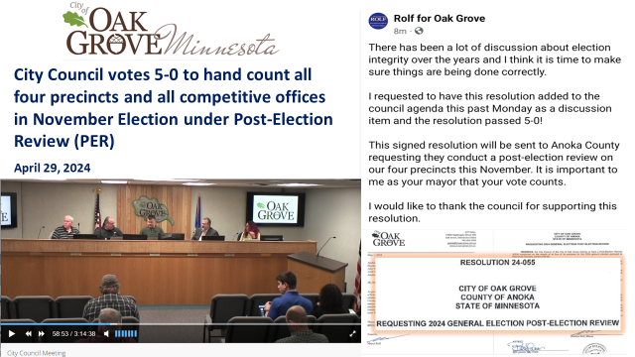

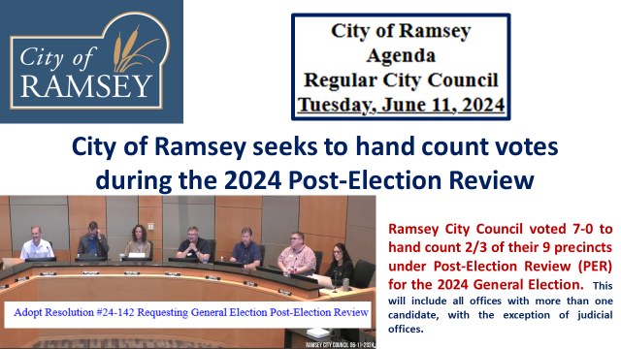

CITY OF OAK GROVE RESOLUTION
RESOLUTION 24-055
REQUESTING 2024 GENERAL ELECTION POST-ELECTION REVIEW
WHEREAS, the City council of the City of Oak Grove desires to have a Post-Election Review (PER) conducted on the results of all four of its precincts for the 2024 general election pursuant to Minnesota Statute 206.89; and
WHEREAS, PER are conducted at precincts that must be chosen by lot by the Anoka County Canvassing Board, but there is not a limit on the number of lot selections that may be performed and there is not a restriction on establishing the lot from which the selection is made; and
WHEREAS, a PER is required to include counting the votes for President or Governor, United States Senator, and United State Representative; and the county-appointed post-election review official may conduct a PER of votes cast for additional offices; and
WHEREAS, the City Council desires to have a PER performed for all four of its precincts and to include all offices for which there is more than one candidate;
NOW THEREFORE, BE IT RESOLVED BY THE CITY COUNCIL OF THE CITY OF RAMSEY, ANOKA COUNTY, STATE OF MINNESOTA, as follows:
- In the event an Oak Grove election precinct is selected for a Post-Election Review (PER) of the 2024 general election, the City Council requests that the Anoka County Canvassing Board perform a second lot selection that includes only the other three precincts in Oak Grove and select three additional precincts.

- In the event an Oak Grove election precinct is not selected for a PER of the general election, the City Council request that the Anoka County Canvassing Board perform a second lot selection that includes only the four precincts in Oak Grove and select four precincts.

- The City Council request that any PER of an Oak Grove precinct include all elections in which there are more than one candidate.

Adopted by the City Council this 29th day of April 2024.
_________________________
Mayor
ATTEST:
______________________________________
City Clerk (Seal)
CITY OF RAMSEY RESOLUTION
RESOLUTION #24-142
RESOLUTION REQUESTING GENERAL ELECTION POST-ELECTION REVIEW
WHEREAS, the City council of the City of Ramsey desires to have a Post-Election Review (PER) conducted on the results of two-thirds of its precincts for general elections pursuant to Minnesota Statute 206.89; and
WHEREAS, PER are conducted for precincts that must be chosen by lot by the Anoka County Canvassing Board, but there is not a limit on the number of lot selections that may be performed and there is not a restriction on establishing the lot from which the selection is made; and
WHEREAS, a PER is required to include counting the votes for President or Governor, United States Senator, and United State Representative; and the county-appointed post-election review official may conduct a PER of votes cast for additional offices; and
WHEREAS, the City Council desires to have a PER performed for two-thirds of its precincts and to include all offices for which there is more than one candidate but exclude all judicial offices.
NOW THEREFORE, BE IT RESOLVED BY THE CITY COUNCIL OF THE CITY OF RAMSEY, ANOKA COUNTY, STATE OF MINNESOTA, as follows:
1. In the event a Ramsey election precinct is selected for a Post-Election Review (PER) of the general election, the City Council requests that the Anoka County Canvassing Board perform a second lot selection that includes only the other precincts in Ramsey and select additional precincts to reach the threshold of two-thirds.
2. In the event a Ramsey election precinct is not selected for a PER of the general election, the City Council request that the Anoka County Canvassing Board perform a second lot selection that includes only Ramsey precincts and selects two-thirds of the precincts.
3. The City Council request that any PER of a Ramsey precinct include a review of the results of all state, county, and city offices, except judicial races, that include more than one candidate.
The motion for the adoption of the foregoing resolution was duly seconded by Councilmember, and upon vote being taken thereon, the following voted in favor thereof:
and the following voted against the same:
and the following abstained:
and the following were absent:
Whereupon said resolution was declared duly passed and adopted by the Ramsey City Council this the 11 day of June, 2024.
_____________________________________
Mayor
ATTEST:
______________________________________
City Clerk.

SAMPLE RESOLUTION

RESOLUTION #_______
RESOLUTION REQUESTING GENERAL ELECTION POST-ELECTION REVIEW
WHEREAS, the City Council/Town Board of the City/Township of _____ desires to have a Post-Election Review (PER) conducted on its precinct(s) for general elections pursuant to Minnesota Statute 206.89; and
WHEREAS, PER are conducted for precincts that must be chosen by lot by the _________ County Canvassing Board, but there is not a limit on the number of lot selections that may be performed and there is not a restriction on establishing the lot from which the selection is made; and
WHEREAS, a PER is required to include counting the votes for President or Governor, United States Senator, and United State Representative; and the county-appointed post-election review official may conduct a PER of votes cast for additional offices; and
WHEREAS, the City Council/Town Board desires to have a PER performed for its precinct(s) and to include all offices for which there is more than one candidate but exclude all judicial offices.
NOW THEREFORE, BE IT RESOLVED BY THE CITY COUNCIL/TOWN BOARD OF THE CITY/TOWNSHIP OF _____________, ___________________ COUNTY, STATE OF MINNESOTA, as follows:
1. In the event that a precinct(s) in City/Township of ___________ is not selected for a PER of the general election, the City Council/Town Board requests that the ________ County Canvassing Board perform a second lot selection that includes only the City/Township of _________ precinct(s) and select ____ precinct(s) in the 2024 PER.
2. The Council/Board requests that the PER of the City/Township precinct(s) include a review of the results of all state, county, and city offices, except judicial races, that include more than one candidate.

Adopted by the City Council this ____ day of ______ 2024.
_________________________
Mayor/Chair
ATTEST:
______________________________________
City/Township Clerk (Seal)

