

Dr. George Ackerman (Sharon’s son) is from Brooklyn, N.Y. Now residing in Florida, he works in the fields of law, police, and education. George lost his mother, Sharon Riff Ackerman on 1/1/2020 due to Parkinson’s Disease.
George wanted to honor his mother and continue to help in the Parkinson’s awareness cause and did not know how to bring change. We started TogetherForSharon® as a family for the purpose of keeping my mother, Sharon Riff Ackerman’s, memory alive and to share the message of Parkinson’s Awareness and hope for a cure.
Today https://www.togetherforsharon.com/ reaches thousands of individuals across the country for PD Awareness. George currently interviews individuals throughout the Parkinson’s community including various foundations, caregivers, and Parkinson’s warriors to help share their stories and causes.
I am on a mission, and nothing will ever stop me until there is a PD Cure.... nothing. Join me, share and we are a family in this mission toward a cure, always! https://www.togetherforsharon.com/about-us/#mission
Author, A Son’s Journey from Parkinson’s Disease Caregiver to Advocate. To order your copy click https://a.co/d/gqUwKJX
Also available in kindle/eBook and Hardcover at https://www.togetherforsharon.com/my-book/
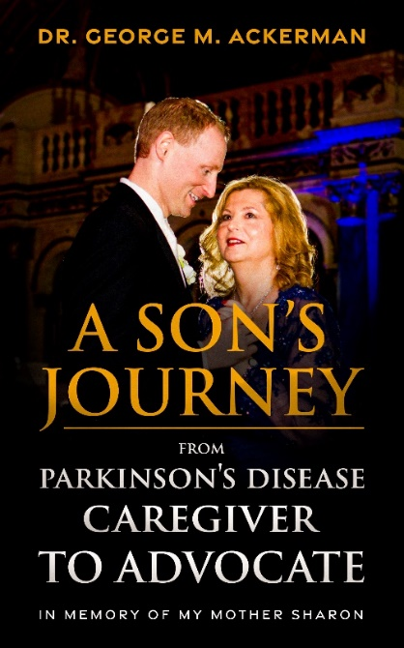
Author, Voices of Resilience: Conversations with Parkinson's Disease Warriors, Caregivers and Advocates. Book 1. https://www.amazon.com/dp/B0DG27S342
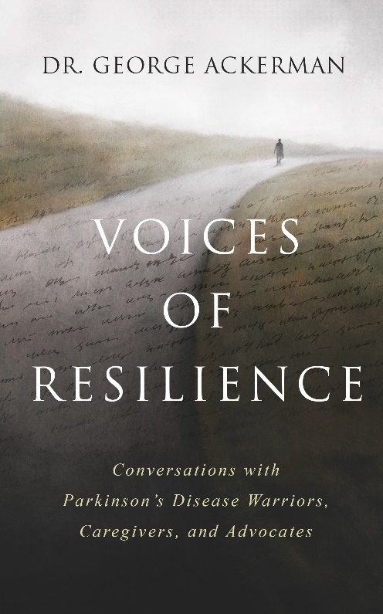

Author, Voices of Resilience: Conversations with Parkinson's Disease Warriors, Caregivers and Advocates. Book II.
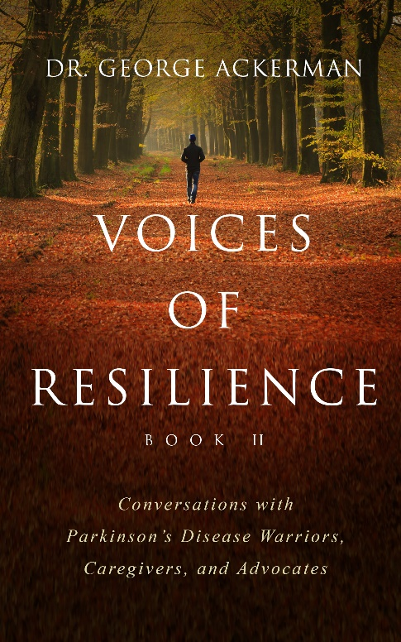

Social media links…
All Social can be found and linked here https://linktr.ee/togetherforsharon

Website https://www.togetherforsharon.com/
Email togetherforsharon@gmail.com
LinkedIn https://www.linkedin.com/in/george-ackerman-ph-d-esq-mba-00871a82/
TikTok https://www.tiktok.com/@togetherforsharon1
Facebook https://www.facebook.com/togetherforsharon112020
Twitter/X https://twitter.com/togetherforsha1
Instagram https://www.instagram.com/togetherforsharon/
& Threads
YouTube https://www.youtube.com/channel/UCIeBLOelhaLQNvgeNMzu-5g
The Parkinson’s Connection YouTube https://www.youtube.com/@TheParkinsonsConnectionYouTube/playlists
Podcast Link https://www.togetherforsharon.com/podcast-interviews/
Interview link https://www.togetherforsharon.com/interview-index/

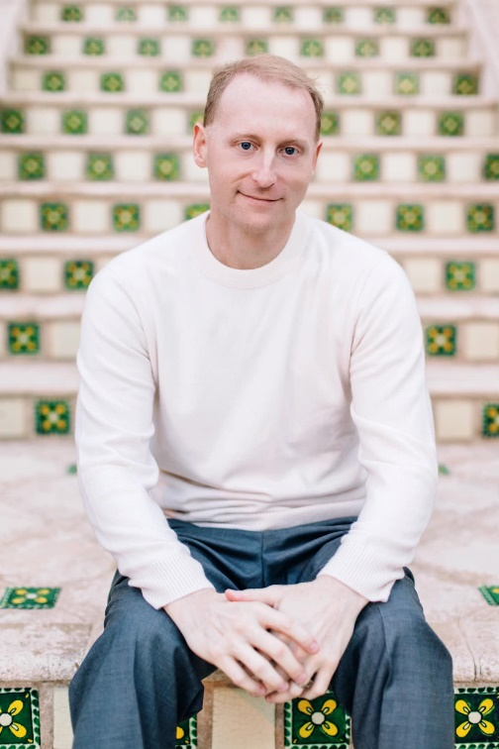

Brief
Dr. George Ackerman (Sharon’s son) lost his mother, Sharon on 1/1/2020 due to Parkinson’s Disease. With my family, we started TogetherForSharon® for the purpose of keeping my mother, Sharon’s, memory alive and to share the message of Parkinson’s Awareness and hope for a cure. Today https://www.togetherforsharon.com/ reaches thousands of individuals across the country for PD Awareness.

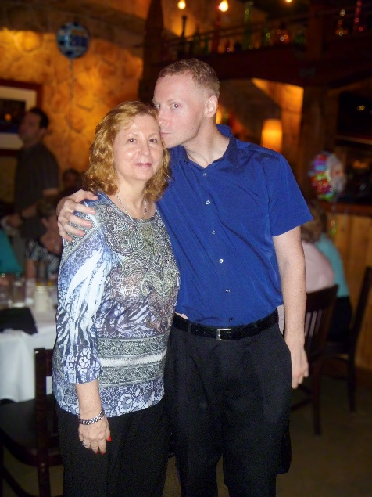
More on our book….
A Son’s Journey from Parkinson’s Disease Caregiver to Advocate. A Son’s Journey from Parkinson’s Disease Caregiver to Advocate. This book is, first, a memoir of and praise for my mother, Sharon, who was my best friend through both our lives and explores her journey with PD. The book is a heartfelt recollection of the beginnings of her Parkinson’s disease symptoms and my caregiving to support through her battle with PD.

However, I also want to reach those who are not aware of Parkinson’s throughout the world. Until we ensure that others outside the local or regional Parkinson’s community are made aware, a cure will be further from our grasp. Others, too, may find the book helpful, especially for those suffering from associated diseases.
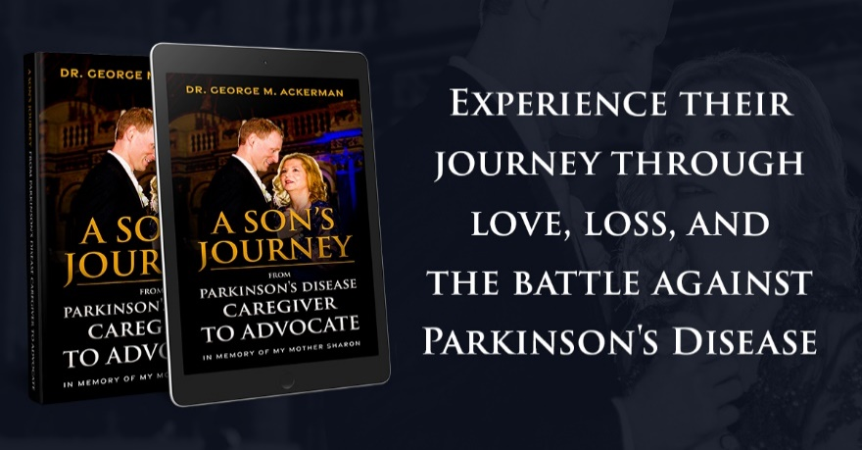
The book is available on Amazon at https://a.co/d/gqUwKJX In Kindle and Paperback versions.
Hardcover https://shop.ingramspark.com/b/084?3nkv2Q8ehyoct6Wp3clw187vNUim8eOtwoDyuxiaNvC

Sharon’s son, George & Michael J. Fox
I had a special time with Mr. Michael J. Fox on 2/2/2024 and I was able to share how he is my hero and an inspiration. He was so kind, and I handed him our band in memory of Mom. In our photo, he is wearing the band, and I was in such shock from the moment I didn’t realize it. I also told him we support Team Fox & the Michael J. Foundation and we agreed we are all a family in this fight for a cure! He was so gracious, and kind and that moment changed my life forever.
