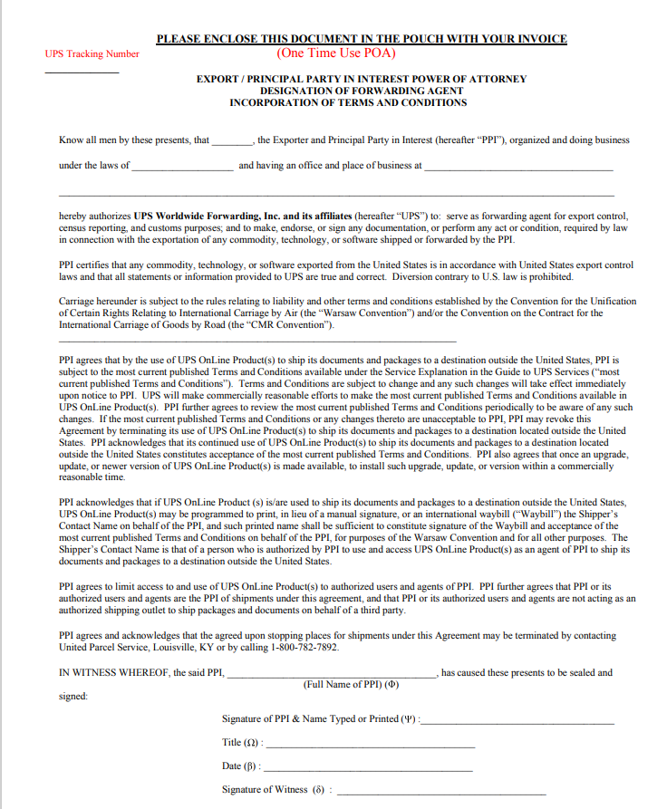
Enter company name on invoice
Complete signature, title, and date fields. No witness signature is needed.
Insert address that matches the ship from on the invoice
Insert shipment tracking number
Insert state of ship from on the invoice
Insert company name on invoice

