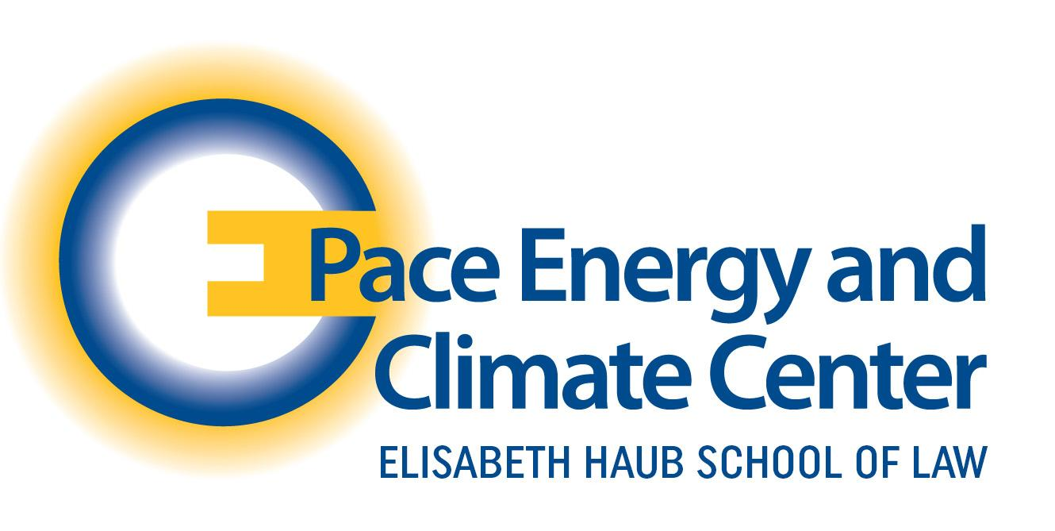

September 23, 2025
Via Dep.nj.gov
New Jersey Department of Environmental Protection
401 E State Street
Trenton, NJ 08608

Re: Transcontinental Gas Pipeline Co. - Northeast Supply Enhancement Project

The Pace Energy & Climate Center (“PECC”) submits this comment in response to the New Jersey Department of Environmental Protection (“NJDEP”) proposed NESE project that will be an expansion of Transco’s existing system from Pennsylvania through New Jersey to New York and urges NJDEP to deny the application of the NESE proposed gas pipeline expansion project. PECC empowers policy change at the intersection of energy, environmental policy, and climate justice. Established in 1987, PECC combines legal, economic, and social research with stakeholder engagement to advance clean energy, climate resilience, and environmental justice - finding solutions to our energy and climate challenges at the local, state, regional, national, and international levels, while also training future energy leaders at Pace Haub Law.

- Introduction

The soul of New Jersey’s promise for clean climate progress now stands directly opposed to the Federal Energy Regulatory Commission’s (“FERC”) natural gas agenda. FERC’s push to resurrect the controversial Northeast Supply Enhancement project pipeline expansion to 37.1 miles to reach Rockaway Transfer Point in Queens, NY has a major flaw - this is a construction project designed to benefit only New York residents, while heavily burdensome to New Jersey. TRANSCO NESE construction project compromises New Jersey’s long-term environmental health for a short-term energy supply that will never even reach the doors of New Jersey residents or businesses. The TRANSCO application resubmission calls for NJDEP regulated portions of the proposed NESE project, to construct three components in New Jersey: (i) construction of a new gas-fired compressor station CS 206 with connecting discharging piping; (ii) the Madison Loop; and (iii) the Raritan Loop (offshore) in order to only supply energy to New York residents. This construction illuminates TRANSCO’s systemic flaws and ambiguities that often lacks prioritizing long-term major environmental burdens. As this project shifts to NJDEP review and approval, once again, the burden is still immense for New Jersey’s residents. PECC strongly urges NJDEP to carefully weigh the undeniable environmental, social, and economic burdens to New Jersey residents and deny the NESE construction project application.

- The Construction of Proposed NESE Project Violates N.J.S.A. 13:9B The Freshwater Wetlands Protection Act

The New Jersey Department of Environmental Protection can issue a permit only if the activity meets specific conditions related to wetland impact, endangered species, water quality, and public interest. N.J.S.A. 13:9B The Freshwater Wetlands Protection Act is clear. A freshwater wetland is an area that is inundated or saturated by surface or groundwater sufficient to support vegetation typically adapted for life in saturated soil conditions and engage in regulated activities in freshwater wetlands for a permit to be required. This permit is the last stand for the state's most vulnerable and vital ecosystems. It is a legal framework that compels us to look beyond the stern lists but see the living, breathing heart of the wetlands that New Jersey seeks to protect. NJDEP relies on these six regulated activities to issue a permit: (i) removal, excavation, disturbance or dredging of soil, sand, gravel, or aggregate material of any kind; (ii) drainage or disturbance of the water level or water table; (iii) dumping, discharging or filling with any materials; (iv) driving of pilings; (v) placing of obstructions; and (vi) destruction of plant life which would alter the character of a freshwater wetland, including the cutting of trees. Moreover, The Freshwater Wetlands Protection Act provides for transition areas surrounding certain categories of freshwater wetlands, and prohibits activities in those areas. A transition area is an area of land adjacent to a freshwater wetland which minimizes adverse impacts on the wetland or serves as an integral component of the wetlands ecosystem. The statute shows that transition areas serve as: (i) an ecological transition zone from uplands to freshwater wetlands which is an integral portion of the freshwater wetlands ecosystem, providing temporary refuge for freshwater wetlands fauna during high water episodes, critical habitat for animals dependent upon but not resident in freshwater wetlands, and slight variations of freshwater wetland boundaries over time due to hydrologic or climatologic effects; and (ii) a sediment and storm water control zone to reduce the impacts of development upon freshwater wetlands and freshwater wetlands species. One exception, however, is for normal property maintenance or minor and temporary disturbances resulting from normal construction activities, or unless a waiver is obtained. The statute then states that the following activities are expressly prohibited in transition areas: (i) removal, excavation, or disturbance of the soil; (ii) dumping or filling with any materials; (iii) erection of structures, except for temporary structures of 150 square feet or less; (iv) placement of pavements; (v) destruction of plant life which would alter the existing pattern of vegetation.
A proposed activity must satisfy all nine of the following statutory requirements to obtain a freshwater wetlands permit from the NJDEP. These criteria are designed to protect New Jersey's freshwater wetlands and the surrounding aquatic ecosystems. However, this isn't just a regulatory check off the box; it is a fundamental test of necessity. It forces an applicant to ask, "is this truly a matter of 'must,' or is it simply a matter of 'convenience'? The first requirement focuses on the nature of the proposed activity itself. It must be either water-dependent or require access to the wetlands as a central element of its function. In addition, there can be no practicable alternative that would either completely avoid the wetlands or have a lesser negative impact on the ecosystem. This includes considering whether an alternative would have other significant adverse environmental consequences. The second requirement builds off of a portion of the first, emphasizing the need to avoid wetlands and minimize impact. In total, the direct environmental consequences of the proposed activity must meet the following requirements:
- The activity must cause only the minimum feasible alteration or impairment of the aquatic ecosystem. This includes minimizing impacts on the existing landscape, vegetation, fish, wildlife, and water circulation within the wetland. The demand for minimum feasible alteration is a recognition that any action will leave a mark. It is a call to humility and to minimize footprint on the existing contour, vegetation, and fish and wildlife resources. This is not an abstract concept; it is the difference between a thriving ecosystem and a lifeless one. The emotional weight of this provision is immense, as it directly impacts the lives of countless species.
- The activity must not jeopardize the continued existence of any species on the New Jersey or federal endangered species lists. It also can't result in the destruction or modification of a critical habitat as designated under the federal Endangered Species Act. This a powerful acknowledgement that progress cannot come at the cost of extinction.
- It must not violate any state water quality standards or any toxic effluent standards or prohibitions under the Water Pollution Control Act.
- The activity must not violate any requirements to protect a marine sanctuary under the Marine Protection, Research and Sanctuaries Act.
- The activity must not cause or contribute to a significant degradation of ground or surface waters.
Finally, the activity must serve the public interest. It must be deemed in the public interest, be necessary to achieve the benefits of the activity, and be otherwise lawful. This last criterion advances that even if the activity meets the environmental standards, it must still comply with all other relevant laws. It is not enough to be economically viable or environmentally compliant; the project must serve the common good.
The proposed TRANSCO NESE project, will involve construction of three components in the State of New Jersey in order to serve only New York residents: (i) construction of a new gas-fired compressor station CS 206 with connecting discharging piping; (ii) the Madison Loop; and (iii) the Raritan Loop (offshore). However, TRANSCO fails to assert an adequate account for the substantial environmental, economic, and social consequences to New Jersey residents that would result for NJDEP to deny this project application. In Matter of Proposed Const. of Compressor Station (CS327), 258 N.J. 312, the New Jersey Supreme Court reviewed the application of Exemption 11 under the Highlands Water Protection and Planning Act where the project aimed to increase gas flow to New York, raised objections from environmental groups who argued it provided no benefit to New Jersey residents. However, the court agreed with The Highlands Council and found the project consistent with the Highlands Act due to its location on a historically disturbed site. However, here TRANSCO proposes to construct Compressor Station 206 in Franklin Township, New Jersey. Therefore, a new gas-fired compressor station CS206 will not be located on a historically disturbed site. Accordingly, this construction of a new, gas-fired compressor station in Franklin Township, bordering East Brunswick will introduce a constant stream of new pollutants into the air and water, exposing vulnerable, historically marginalized communities to an unconscionable burden. The TRANSCO application explains that the purpose of the compressor station is to increase the pressure to heat the natural gas to propel through the underwater pipelines of the Madison and Raritan Loops to reach New York residents in Rockaway. However, TRANSCO ignores common sense when natural gas is under increased pressure and heat the pipelines are at an even greater susceptibility to leaks or ruptures. This failure in Transco Impact Assessment will release toxic contaminants into surrounding waters like in the Raritan Bay, a vital New Jersey wetland, causing acid producing soils and a catastrophic chain reaction. When these toxic contaminants are released in the Raritan Bay those toxic contaminates will blend with the already dredged toxic contaminates along the seabed from the Raritan Bay Slag Superfund Site that were disturbed to construct the Madison & Raritan Loops to form a harmful alliance. This will result in a perfect storm of new toxins blending with the old, exposing New Jersey’s wildlife, fishing industry, tourism, and most importantly, New Jersey residents to higher and more dangerous concentrations of toxic contaminates. It is a permanent scar on 78 acres of forests, wetlands, and ocean floor. This proposed construction would violate the underlying purpose of the New Jersey Freshwater Wetlands Protection Act. The proposed NESE project fails the test of minimum feasible alteration and the project contributes to a significant degradation of ground and surface waters and will almost certainly cause or contribute to a violation of state water quality standards. Therefore, the path forward is clear and unmistakable. The NJDEP must reject the TRANSCO NESE Construction Project.

- Conclusion

For the foregoing reasons, we urge NJDEP to deny the proposed NESE project pipeline expansion.

Respectfully,

Kenneth Sumter J.D. ‘26

Executive Board
Pace Energy & Climate Center

https://dep.nj.gov/nese/
ID
N.J.S.A. 13:9B-3
ID
N.J.S.A. 13:9B-3,16,17
N.J.S.A. 13:9B-16A
N.J.S.A. 13:9B-17A
N.J.S.A. 13:9B-9
https://dep.nj.gov/nese/
https://pmc.ncbi.nlm.nih.gov/articles/PMC10616731/
https://www.ferc.gov/final-environmental-impact-statement-northeast-supply-enhancement-project
https://dep.nj.gov/wlm/lrp/wetlands/
https://www.ferc.gov/final-environmental-impact-statement-northeast-supply-enhancement-project
https://www.ferc.gov/sites/default/files/2020-05/part-1.pdf

