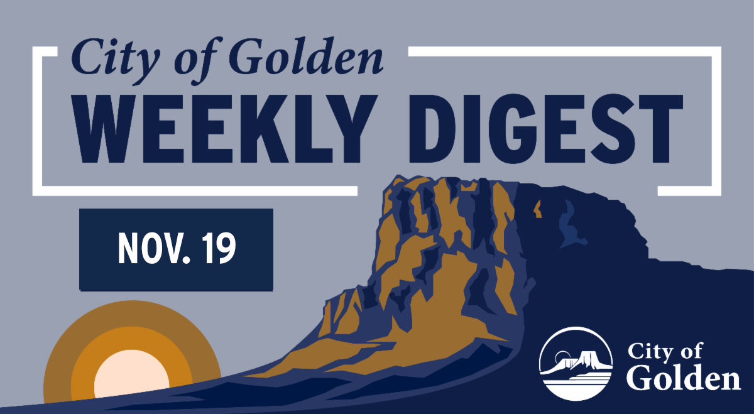

In this week's edition...

- Mondays with the Mayor
- Golden PD Community Engagement Group
- Vision Zero Safety Action Plan
- Police and Municipal Building Public Art Selection
- National Community Survey- there's still time to share your feedback!
- Light the Lights Contest
- Holiday Cookie Decorating Party
- Schools Out Camps for Winter Break

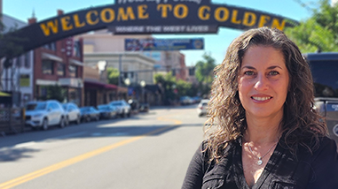

Mondays with the Mayor

During this week’s Mondays with the Mayor, Mayor Laura Weinberg highlighted several upcoming meetings and events, including:
- Monday's Downtown Development Authority (DDA) meeting and Tuesday's Historic Preservation Board meeting with a study session on 710 10th Street
- Special Events Review Committee meeting and discussion following last week’s City Council Study Session
- An opportunity to provide feedback on proposed artwork for the new Police and Municipal Building on Guiding Golden (see below)
- The Golden Police Department’s Community Engagement Group (see below)
- A Golden History Museum effort honoring the 50th anniversary of the end of the Vietnam War and gathering input for a future exhibit
- This month’s Golden Beer Talks featuring the topic “Women in Combat”
- The Foothills Holiday Art Market, beginning this Saturday

Tune in next Monday at noon for Mondays with the Mayor on Facebook. You can always watch recordings of the live streams on the City's Facebook page.

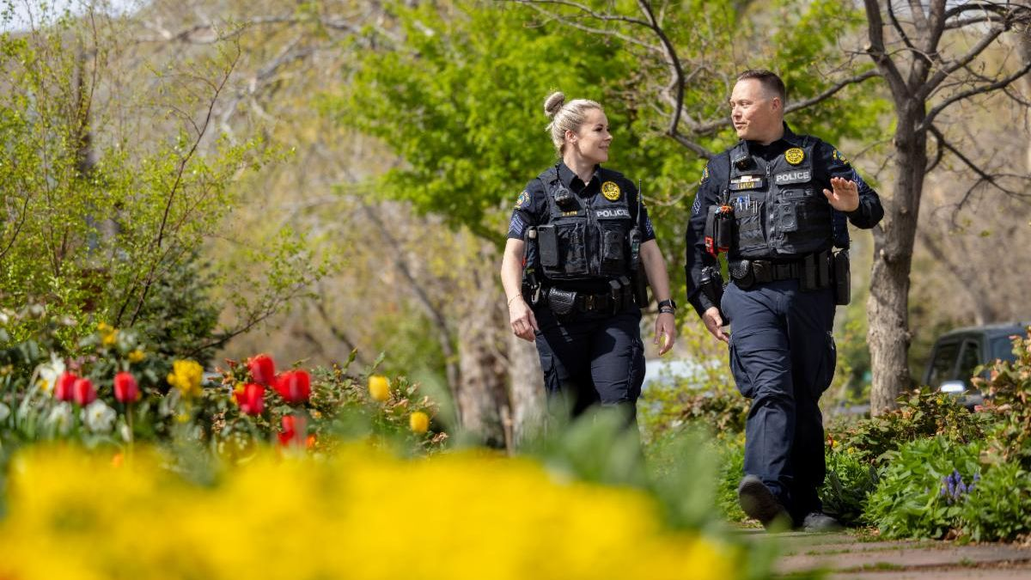

Join the Golden Police Department CEG

Golden Police are looking for new members for the Community Engagement Group!

The Community Engagement Group (CEG) is a diverse, informal advisory team that helps GPD stay connected to community perspectives on public safety. Members meet directly with the Chief and staff to share ideas and discuss community needs.

Interested in getting involved? Learn more and apply by January 9!

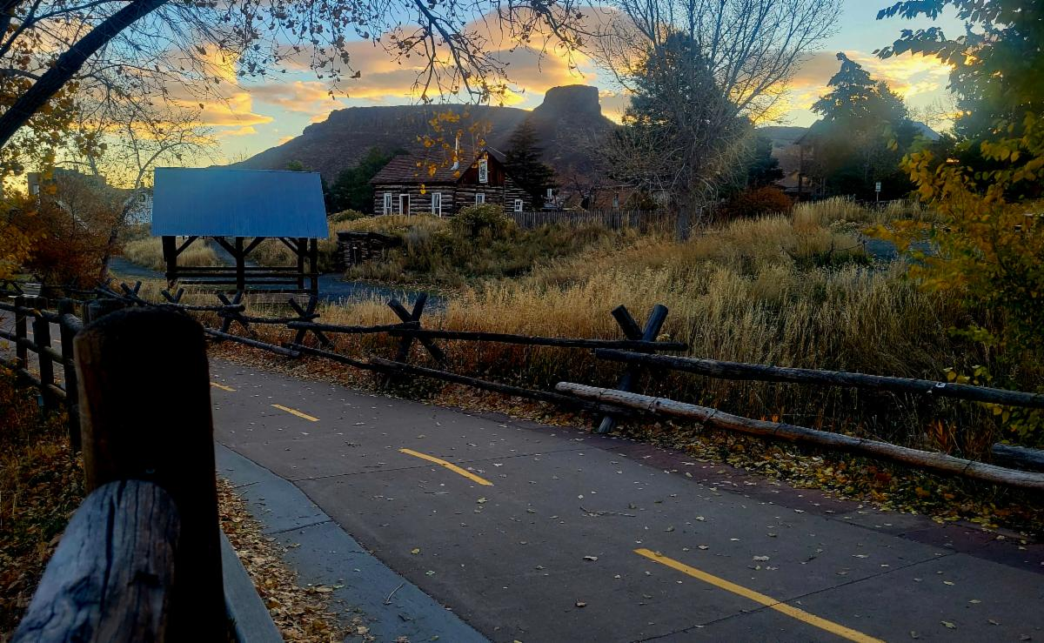

Vision Zero Safety Action Plan

We’re teaming up with Jefferson County to help make every trip, whether you’re walking, biking, riding transit, or driving, safer for everyone.

Jeffco is developing a countywide Vision Zero Safety Action Plan to eliminate serious injuries and deaths from traffic crashes, and they want to hear from you.

Tell us where you feel unsafe on the road, trail, or sidewalk by taking the survey (link in bio).

Sign up and participate in the online public meeting on December 11, 2025, from 5:30–7:00 p.m. or participate in the online survey.

(Photo by Rich Luckin)

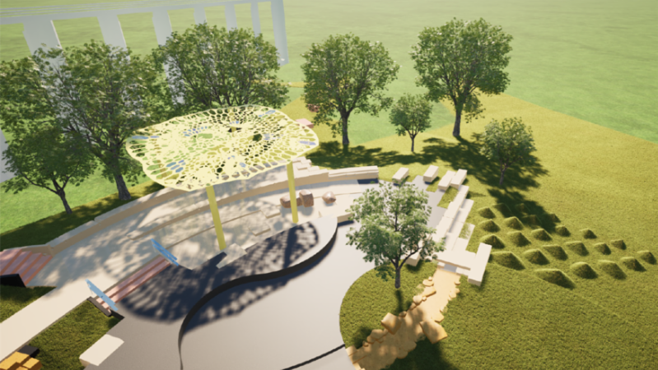

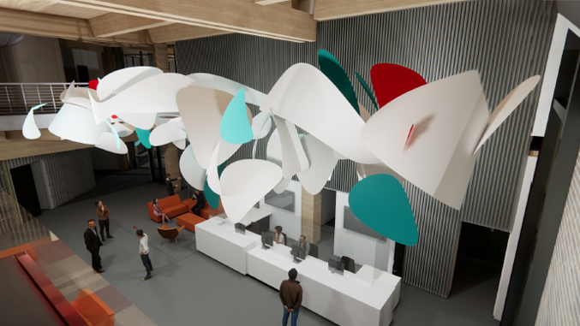

Share Your Feedback on Public Art for Golden's Police and Municipal Building

As part of Golden’s new Police and Municipal Building, 1% of the project budget is dedicated to public art. After a regional RFQ and jury review, two finalist artists have been selected to propose artwork for the lobby and outdoor spaces.

We’re inviting the community to help shape the final selection. All input will be shared with the Arts & Culture Commission before they make a final decision in December.

Public feedback is open November 13–27, 2025.

View the proposals and share your feedback.

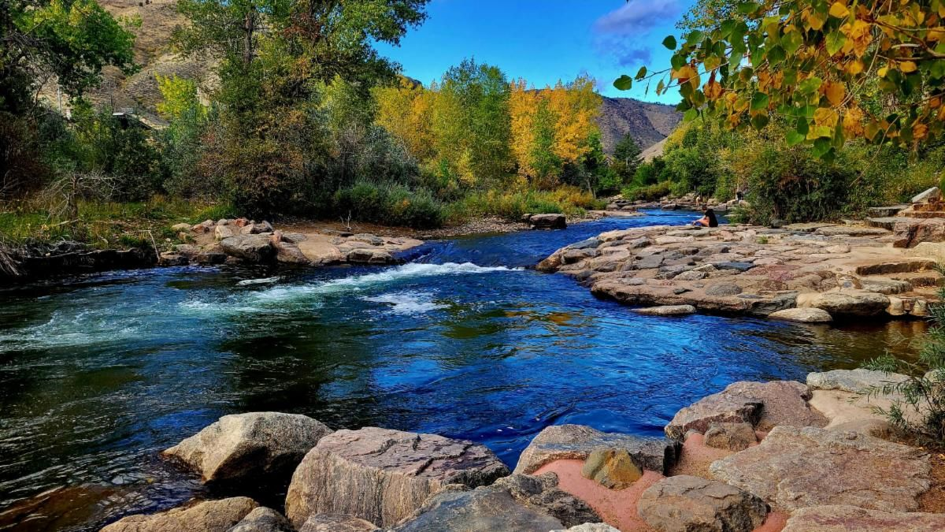

National Community Survey Gathering Feedback Through Thursday

Golden has partnered with Polco, a national leader in civic engagement, to conduct the 2025 National Community Survey. This survey helps the City understand residents’ perspectives on quality of life and local government services—and compares Golden’s results to similar communities across the country.

In the first phase, randomly selected households received mailed invitations. Now, we’re inviting all residents and community members to share their feedback through the open online survey.

All responses are confidential, and no identifying information is shared.

The survey is open through this Thursday, November 20—please take a few minutes to participate and help shape Golden’s future!

Take the National Community Survey

(Photo by Rich Luckin)

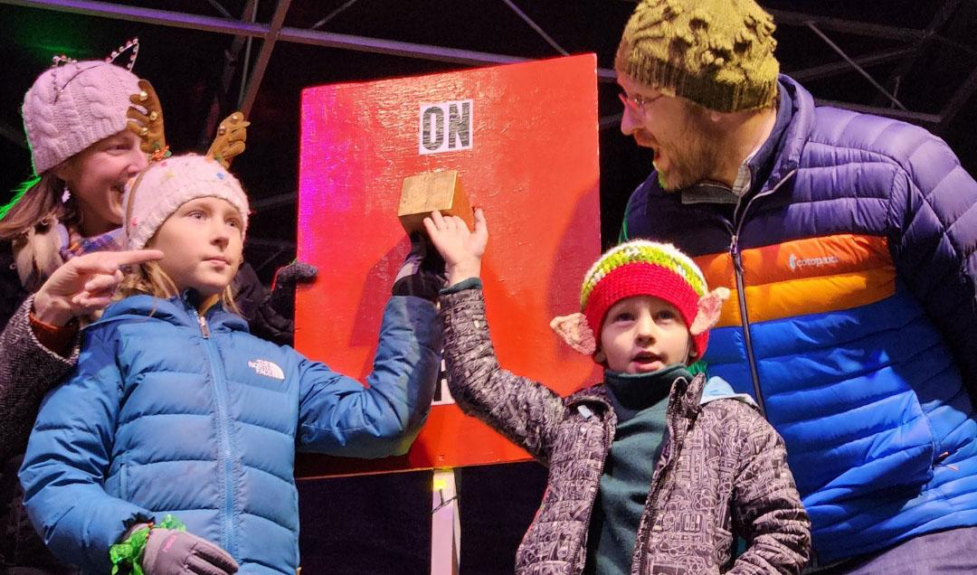

Light the Lights Contest

There's just under two weeks left to enter to win! One lucky Golden kid will be chosen to join Santa on Friday, December 5, to flip the switch and light the lights along Clear Creek for the holiday season.

To enter, your child must be from Golden and under 12 years old. Visit The Golden Mill at 1012 Ford Street anytime between November 1 - 30 to fill out an entry form. Only one entry per child will be accepted. The winner will be announced on Monday, December 1.

It’s a magical way to kick off the holidays—don’t miss your chance to make your child’s season sparkle!



Holiday Cookie Decorating Party
Thursday, December 4, 4:00 - 5:00 p.m. at the Golden Community Center (1470 10th St., Golden)

Parents, get ready for some sweet holiday fun! Join us for a Holiday Cookie Decorating Party on December 4 at the Golden Community Center, where you and your kids can unleash your creativity with frosting, sprinkles, and plenty of cheer.

All supplies are provided--just bring your sweet tooth and holiday spirit! Parents must stay with your children, and cookies may contain gluten.

Register once per family to secure your spot, and let us know how many kids you are bringing.Cost: $10 Residents / $12 Non-resident (per family, not per person)

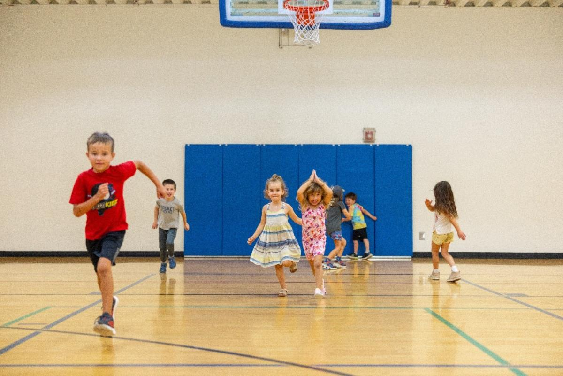

Schools Out Camp for Winter Break

Need an activity for your child over winter break? This state licensed day camp is guaranteed to keep your child busy! Activities include arts & crafts, gym/sports, swimming, and more. All campers are required to bring lunch and snacks. Required ePACT documents will be provided upon registration and are due before your child attends our camp program.
When: December 22, 23, 29, 30, January 5 and 6
Where: Golden Community Center (1470 10th St.)
Cost: $60/$65 Full Day and $30/$33 Half Day (Registration Required)

Public Meetings



All public meetings in Council Chambers are available to watch on the Agendas and Meetings page; most are both recorded and livestreamed. Meetings in Council Chambers that are not available via livestream will be denoted by an asterisk (*). Off-site meetings are audio recorded and uploaded as soon as possible.

Planning Commission Study Session
Wednesday, November 19, 5:30 p.m. | City Hall, 911 10th Street

Parks and Recreation Advisory Board Meeting
Thursday, November 20, 6:00 p.m. | City Hall, 911 10th Street

Municipal Court Criminal Arraignments
Monday, November 24, 8:00 a.m. | City Hall, 911 10th Street

City Council Regular Business Meeting
Tuesday, November 25, 6:30 p.m. | City Hall, 911 10th Street

Road and Construction Updates

Right of Way Impacts

JeffCo Government Area – Johnson Rd / W 10th Ave
- Xcel Energy underground electric installation
- 06/23 - 11/21/25
- Monday - Saturday
- 7:00 a.m. - 7:00 p.m.
- Expect construction related traffic delays and sidewalk impacts with pedestrian detours in place

Miners Alley / 13th St Area
- Xcel Energy overhead power pole replacements/maintenance
- 7:00 a.m. - 7:00 p.m.
- Monday 11/10 - Saturday 11/15/25
- 7am Sunday 11/16 - 8am Monday 11/17/25
- Xcel was granted an exception from the City Manager’s Office to work after normal working hours at this location.
- Expect construction related traffic delays, alley, and sidewalk impacts with pedestrian detours in place

10th and Maple
- Fiber locate by City crew
- 11/19/25
- 7:00 a.m. - 7:00 p.m.
- Expect parking impacts

13th and East Street/Castle Rock Road
- City of Golden Water main replacement
- 11/14 - 12/05/25
- Weekdays 7:00 a.m. - 7:00 p.m.
- Expect construction related traffic delays and parking/sidewalk impacts with pedestrian detours in place

10th St – East St to Vasquez St
- New electric distribution for new City Hall building
- 11/17 - 12/08/25
- Weekdays 7:00 a.m. - 7:00 p.m.
- Expect construction related traffic delays and parking/sidewalk impacts with pedestrian detours on place

Ford St – 16th St to 17th St
- New water service for private development project at 1615 Ford St
- 11/17 - 11/21/25
- Weekdays 7:00 a.m. - 7:00 p.m.
- Expect construction related traffic delays and parking/sidewalk impacts with pedestrian detours on place

Indiana St – US6 to W 4th Ave
- Occupancy only to access Lumen manholes
- 11/19 - 11/20/25
- Weekdays 7:00 a.m. - 7:00 p.m.
- Expect construction related traffic delays and parking/sidewalk impacts with pedestrian detours on place

South Golden Rd – Sunset Dr to 24th St
- Occupancy only to setup crane for City park sculpture installation
- 11/17/25
- 7:00 a.m. - 7:00 p.m.
- Expect construction related traffic delays and sidewalk impacts with pedestrian detours on place

Citywide
- Xcel Energy overhead power pole replacements/maintenance – wildfire mitigation
- 01/13 - 12/31/25
- Weekdays 7:00 a.m. - 7:00 p.m.
- Expect construction related traffic delays and parking/sidewalk impacts with pedestrian detours in place

Public Road Closures

Wondering about road closures that might impact your drive? Check out the Public Road Closures map for an update on all current permitted street closures in Golden.

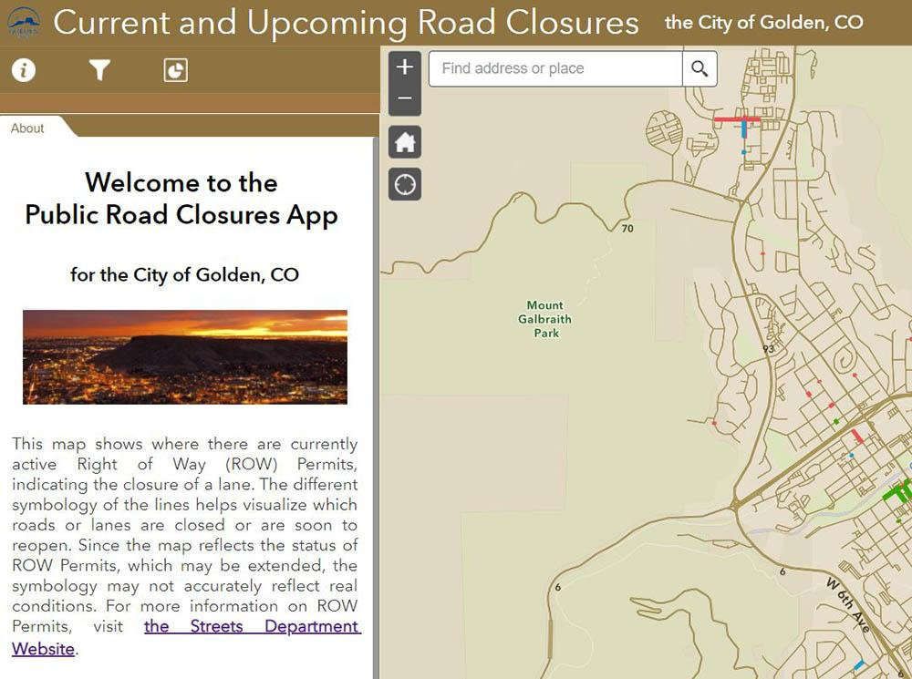

City of Golden | 911 10th Street | Golden, CO
(303) 384-8000



  Contact Us
  

City of Golden | 911 10th Street | Golden, CO 80401 US

