

In this week's Weekly Digest...

- Mondays with the Mayor
- Highway 93 Community Meeting
- Docked Bike Share Feasibility Study
- Radon Test Kits
- Transportatioon Demand Management Feedback
- ﻿Spring Sports in Golden

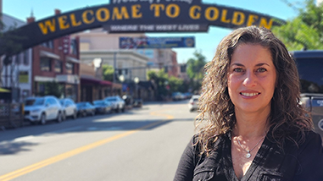

Mondays with the Mayor
There was no Mondays with the Mayor this week and will not be one next week. Please tune in on March 30th for our regularly scheduled program.

You can watch the full Facebook Live with Mayor Laura on Mondays at noon or watch recordings on the City's Facebook page.

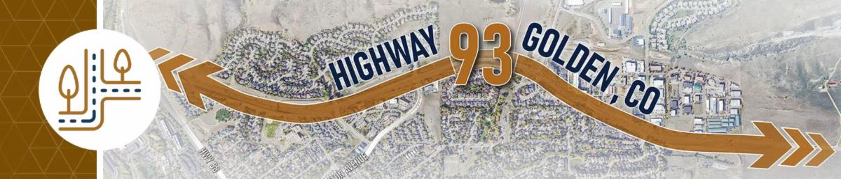

Highway 93 Analysis and Design Project Public Meeting

This Thursday, March 19, 2026 | 5:00 p.m. - 6:30 p.m. | Golden Community Center

Learn about past planning efforts for Golden's Highway 93 and renewed design efforts. This project has been ongoing for more than 20 years, and staff is excited to share the intent of the new analysis and design efforts as well as gather your insights. You can familiarize yourself with background on the project and its importance on the Guiding Golden webpage.

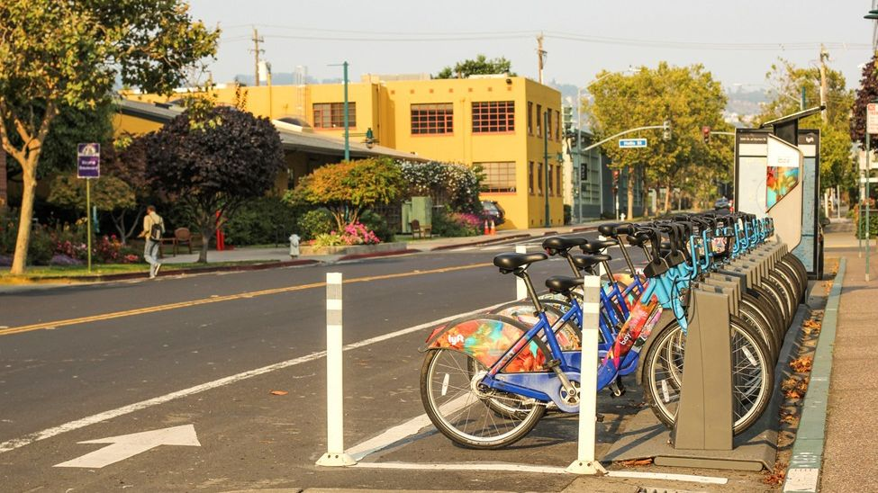

Docked Bike Share Feasibility Study

Tell us what you think about the potential for a docked e-bike share program in
Golden before April 3!

The City of Golden and the Denver Regional Council of Governments (DRCOG) are exploring the potential for a solar-powered, docked e-bike share program in Golden. The program would provide residents, workers, and students with a convenient option for short trips like commuting or running errands, while requiring bikes to be returned to docking stations to prevent sidewalk clutter.

Visit the project page on Guiding Golden to learn more, find answers to frequently asked questions, and complete the project survey.

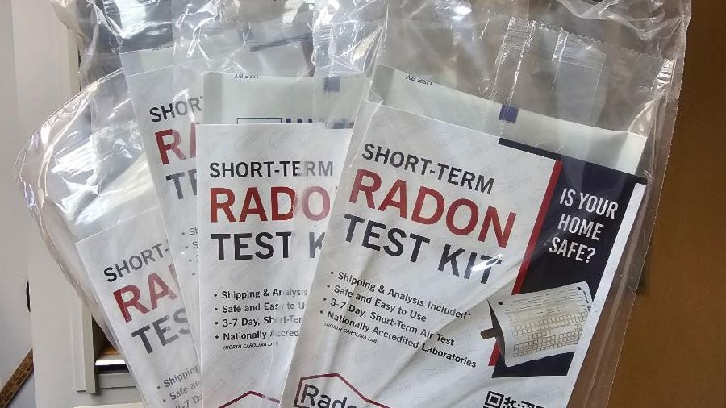

Free Radon Test Kits

﻿Jefferson County Public Health has partnered with the City of Golden to give an additional 15 radon test kits to Golden residents as part of the city's Healthy Housing Initiative. These kits are available at City Hall (911 10th Street) on a first-come, first-serve basis.

Radon is a naturally occurring invisible, odorless gas that comes from the breakdown of uranium in soil, rock, and water. About 50% of homes in Colorado have high radon levels. In Colorado, living in a home with average levels of radon is like having 200 chest x-rays every year. Testing for radon is easy and fixing the problem is relatively inexpensive. Learn more about radon.

CDPHE offers a Low-Income Radon Mitigation Assistance program for homeowners, and the City of Golden recently approved a rebate to support radon mitigation systems for rental properties. More info can be found on the City's sustainability rebate page.

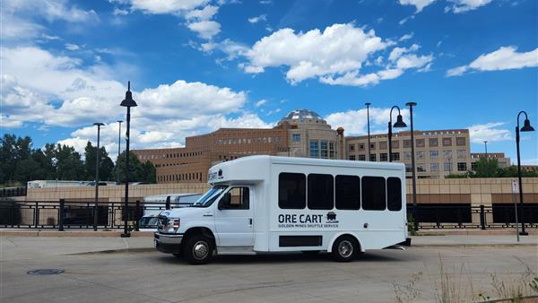

Transportation Demand Management Draft Document Available for Feedback

The City of Golden is creating a Transportation Demand Management (TDM) plan and program to help people get around more easily. The TDM program will offer ideas and solutions to help reduce the number of car trips and encourage people to use other ways of getting around, including walking, biking, carpooling, and public transit.

The draft Plan document is available for review and public comment on Guiding Golden. The Mobility and Transportation Advisory Board will consider a formal adoption recommendation to City Council at their April 23, 2026, meeting. City Council will consider formal adoption of the Plan at their May 12, 2026, meeting.

Recreation Programs to Explore

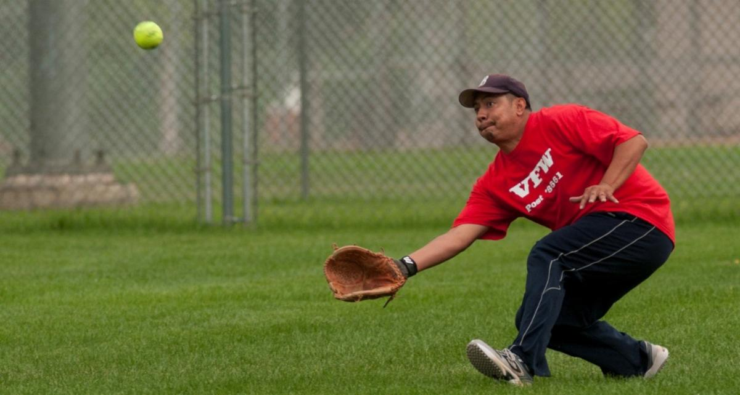

Game On, Golden: Volleyball & Softball are in Play this Spring

CARA Volleyball League – All Skill Levels Welcome
Get in the game this spring with CARA Volleyball, perfect for girls and boys of all experience levels, whether you're learning the basics or building your skills (divisions for 3rd–4th Grades, 5th–6th Grades, and 7th–8th Grades).

The season runs March 31 – May 23, with practices held at Tony Grampsas Gym on designated team days. Teams compete in Saturday tournaments at locations throughout the region.

Fees: Residents: $140 | Non-Residents: $145

Register for CARA Volleyball

Volunteer coaches are needed. If you are interested in coaching your child’s team, contact Interim Athletics Supervisor Joe Zaba at JZaba@cityofgolden.net.

Adult Softball Rec League – Play Ball This Spring
Looking for a fun, social way to stay active? Join Golden’s Adult Softball Rec League, open to ages 18 and up and all skill levels.

Sign up as an individual or register a team with friends, coworkers, or your local business. Games are played at the Ulysses Sports Complex, featuring new amenities ready for you to enjoy.

Register today and step up to the plate!

Public Meetings



All public meetings in Council Chambers are available to watch on the Agendas and Meetings page; most are both recorded and livestreamed. Meetings in Council Chambers that are not available via livestream will be denoted by an asterisk (*). Off-site meetings are audio recorded and uploaded as soon as possible.

Planning Commission Meeting
Wednesday, March 18, 5:30 p.m. in City Hall | 911 10th St., Golden

Golden Municipal Court Criminal Arraignments
Monday, March 23, 8:00 a.m. | City Hall | 911 10th St., Golden

Community Marketing Board Meeting
Tuesday, March 24, 10:00 a.m. in City Hall | 911 10th St., Golden

Special Events Review Committee Meeting
Wednesday, March 25, 8:30 a.m. in City Hall | 911 10th St., Golden

REDI Task Force Meeting
Wednesday, March 25, 4:30 p.m. at 1445 10th St., Golden

Road and Construction Updates

Ford St – Goldco Cir to 5th St
- Xcel Energy gas service installation for residential construction project at 414 Ford St
- 03/19 – 03/26/26
- Weekdays 7am to 7pm
- Expect construction related traffic delays and parking/sidewalk impacts with pedestrian detour in place

10th St at Maple St
- City of Golden Lions Park project
- 01/20 – spring of 2026
- Weekdays 7am to 7pm
- Expect construction related traffic delays and parking/sidewalk impacts with pedestrian detours in place

Clear Creek Trail behind The Golden Hotel – Washington Ave to Parking Lot at History Park
- Hotel exterior upgrades
- 12/1/25 - 3/31/26
- Pedestrian detours in place

City parking lot – 12th St to 13th St
- Dumpster (20 yard) located in parking stall located directly behind 1212 Washington Ave for private commercial renovation project at this address
- 02/16 – 03/30/26

18th St – Illinois St to Cheyenne St
- ROW flat work for Colorado School of Mines EMRF project
- 03/02 – 03/16/26
- Weekdays 7am to 7pm
- Expect construction related traffic delays and parking/sidewalk impacts with pedestrian detour in place

19th St – FULL CLOSURE – Elm St to Illinois St
- ROW improvements for Colorado School of Mines Residence Hall 7 project
- 19th St closed to traffic day, night and weekend 03/21 – 03/29/26
- Sidewalk on south side of 19th St to remain open for pedestrians

Table Dr – FULL CLOSURE – 19th St to 21st St
- Xcel Energy gas work
- 03/25/26
- 7am to 7pm
- Detour around closure will be in place

W 10th Ave- Johnson Rd to Ulysses St
- Xcel Energy underground electric upgrade
- 01/26 – March 2026
- Weekdays with occupancy hours restricted to 9am – 3pm
- Expect construction related traffic delays with bike lane and sidewalk impacts with pedestrian detours in place

Ulysses St – W 9th Ave to Mt Vernon Rd
- Consolidated Mutual Water District water main replacements
- 01/16 – March 2026
- Weekdays 7am to 7pm
- Expect construction related traffic delays with bike lane impacts

W Colfax Ave – Violet St to Corporate Dr
- Sidewalk improvements related to the Col private development project
- Weekdays 7am – 7pm through March
- Expect construction related traffic delays and a sidewalk impact with a pedestrian detour in place

Corporate Circle at W Colfax Ave business park
- Xcel Energy underground electric system upgrades
- 01/19 – spring 2026
- Weekdays 7am to 7pm
- Expect construction related traffic delays with parking/sidewalk impacts with pedestrian detours in place

W 2nd Pl – Orchard St to dead end
- City of Golden Utilities Division water main replacements
- 02/26 – 04/10/26
- Weekdays 7am to 7pm
- Expect construction related traffic delays with parking/sidewalk impacts with pedestrian detours in place

CITYWIDE
- Xcel Energy overhead power pole replacements/maintenance – wildfire mitigation
- 01/01 – summer 2026
- Weekdays 7am to 7pm
- Expect construction related traffic delays and parking/sidewalk impacts with pedestrian detours in place

Public Road Closures

Wondering about road closures that might impact your drive? Check out the Public Road Closures map for an update on all current permitted street closures in Golden.

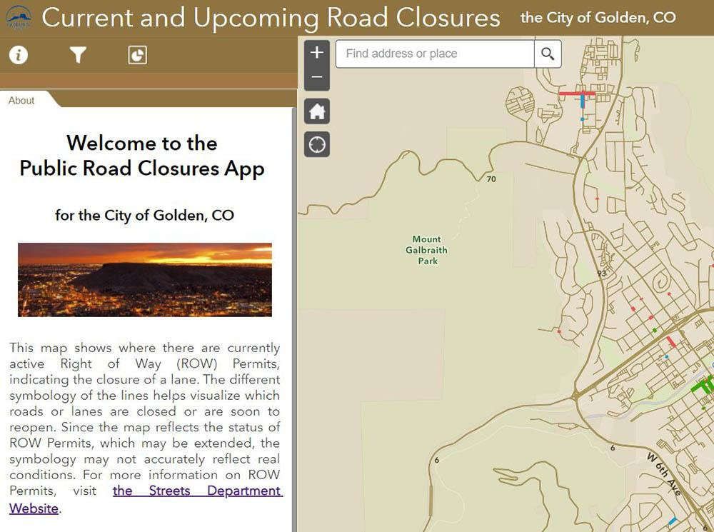

City of Golden | 911 10th Street | Golden, CO
(303) 384-8000



  Contact Us
  

City of Golden | 911 10th Street | Golden, CO 80401 US

