Writing Task 2: Cohesion

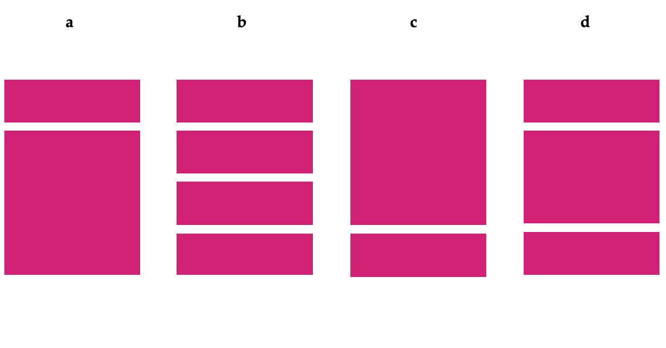
1. Which of these looks like a good writing task 2 essay? (Each block represents a paragraph).

2. Which of these structures is ideal for writing task 2? What’s wrong with the others?
Thesis statement
Background information

Argument against

Argument against

Conclusion: Against
Background information

Argument for and against

Argument for and against

Conclusion: For
Background information
Thesis statement

Argument for

Argument against + counter argument for

Conclusion: For
Thesis statement

Argument for

Argument against

Argument for

Conclusion: For

a b c d

3. True or false?

- When asked to give your opinion, your position should be clear in the first paragraph.
- You should use informal idioms in your writing.
- You can change your opinion during the essay.
- You will lose marks if you write over the word limit.
- Plan your structure before you start writing.
- You can use headings and bullet points to support your essay.

