TECHNICAL WHITEPAPER

Digital Twin of the
Steam Cracker

A Comprehensive Guide to Implementing Virtual Replicas
for Ethylene Production Optimization

Integrating First-Principles Models, Machine Learning,
and Real-Time Data for Operational Excellence

January 2026

Executive Summary
Steam crackers are the cornerstone of the petrochemical industry, converting hydrocarbon feedstocks into ethylene, propylene, and other essential building blocks for plastics, chemicals, and materials. These facilities represent some of the most energy-intensive and complex operations in the chemical sector, with typical ethylene plants consuming over 20 gigajoules of energy per ton of ethylene produced and operating under extreme conditions that challenge conventional optimization approaches.
A digital twin of a steam cracker creates a dynamic, data-driven virtual replica that mirrors the physical plant in real-time. Unlike traditional process simulation tools that provide static snapshots, a digital twin continuously synchronizes with plant operations, enabling predictive analytics, scenario analysis, and optimization recommendations that account for current operating conditions, equipment state, and market dynamics. This technology represents a paradigm shift from reactive to predictive operations management.
This whitepaper provides a comprehensive technical guide for petrochemical executives, operations managers, process engineers, and technology leaders seeking to understand and implement digital twin technology for steam cracker operations. The document covers the fundamental concepts of digital twins, detailed technical architecture, specific use cases and value drivers, implementation methodology, and practical considerations for successful deployment.
Organizations that have successfully implemented steam cracker digital twins report ethylene yield improvements of 1.5-2.5 percentage points, energy cost reductions of 5-8%, furnace run length extensions of 10-20%, and overall annual value creation of $15-30 million for a typical world-scale facility. With implementation timelines of 18-24 months and payback periods typically under two years, digital twin technology represents one of the highest-return digital investments available to petrochemical operators.

1. Introduction to Steam Cracker Operations

1.1 The Steam Cracking Process
Steam cracking, also known as pyrolysis, is the predominant technology for producing light olefins from hydrocarbon feedstocks. The process involves heating hydrocarbon feeds such as naphtha, ethane, propane, or gas oil to temperatures of 800-900 degrees Celsius in the presence of dilution steam, causing the molecular bonds to break and reform into smaller, more valuable molecules. The reaction occurs in tubular coils within large fired furnaces, with residence times measured in fractions of a second.
The cracked gas leaving the furnace must be rapidly cooled, or quenched, to prevent reverse reactions and preserve the desired product slate. This is accomplished through transfer line exchangers that simultaneously generate high-pressure steam and cool the process gas from approximately 850 degrees Celsius to 350 degrees Celsius in milliseconds. The cooled gas then passes through a series of separation and purification steps to isolate the individual products.
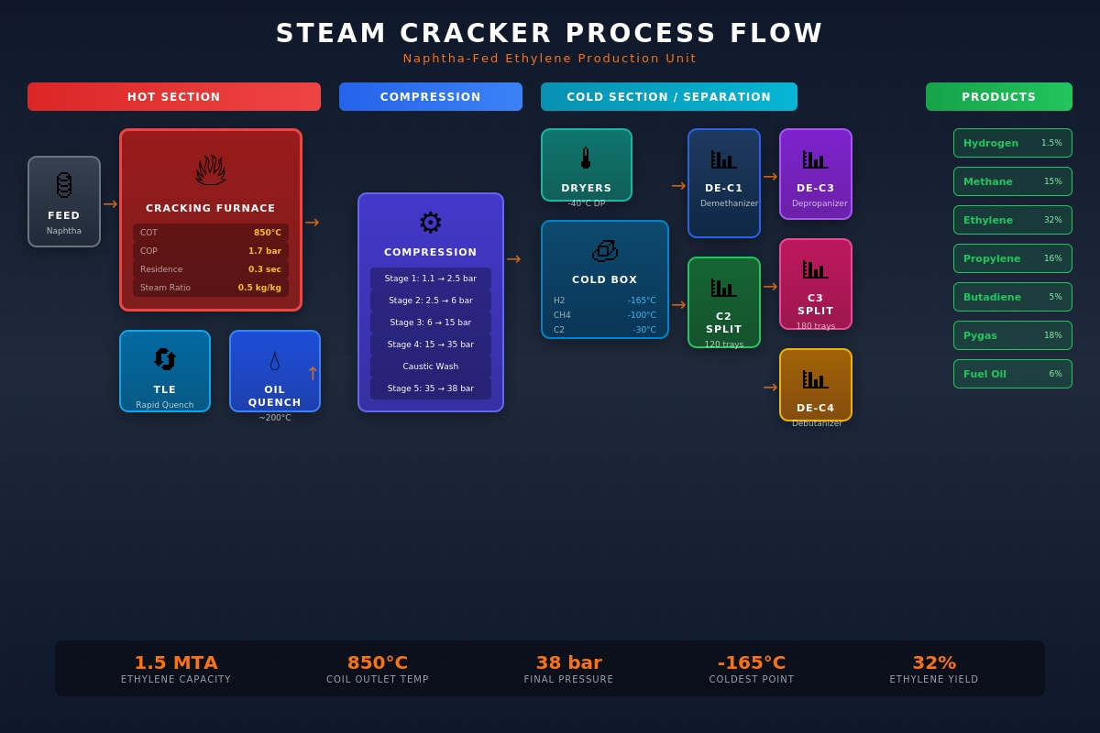
Figure 1: Steam Cracker Process Flow - Naphtha-Fed Ethylene Production Unit

1.2 Key Process Sections
Hot Section: The hot section comprises the cracking furnaces and transfer line exchangers. Modern furnaces contain multiple radiant coils where the cracking reactions occur, heated by floor and wall burners firing natural gas or fuel oil. The convection section preheats the feed and generates dilution steam. Typical furnace capacities range from 100,000 to 200,000 metric tons per year of ethylene equivalent, with large plants operating 6-10 furnaces in parallel.
Compression Section: The cracked gas is compressed in multiple stages, typically from near-atmospheric pressure to 35-38 bar. Between compression stages, the gas passes through interstage coolers and knockout drums to remove condensed liquids. A caustic wash system removes acid gases, primarily hydrogen sulfide and carbon dioxide. The compression section is one of the largest energy consumers in the plant.
Cold Section: Also known as the cold box or cryogenic section, this area separates the compressed gas into individual products using extremely low temperatures, reaching minus 165 degrees Celsius for hydrogen separation. The separation train includes demethanizer, deethanizer, depropanizer, and debutanizer columns, along with C2 and C3 splitters that separate ethylene from ethane and propylene from propane respectively.

1.3 Operational Challenges
Steam cracker operations face numerous challenges that make them ideal candidates for digital twin implementation. Furnace coking gradually deposits carbon on tube walls, reducing heat transfer efficiency and eventually requiring decoke operations that take furnaces offline for 24-48 hours. Balancing cracking severity, the intensity of the cracking reaction, against coking rate is a continuous optimization challenge with significant economic implications.
Feed variability presents another major challenge. Naphtha composition varies by crude source and refinery operations, directly impacting product yields. Operators must continuously adjust furnace parameters to accommodate feed changes while maintaining product specifications. Energy costs represent 50-60% of cash operating costs, creating strong incentives for optimization but limited tools for achieving it with traditional approaches.

2. Digital Twin Fundamentals

2.1 Defining the Digital Twin
A digital twin is a virtual representation of a physical asset, process, or system that is continuously updated with real-time data to mirror its physical counterpart. For a steam cracker, the digital twin encompasses mathematical models of the cracking chemistry, heat transfer physics, fluid dynamics, and equipment behavior, all synchronized with actual plant data through automated data pipelines. The twin enables operators and engineers to understand current plant state, predict future behavior, and optimize performance.
The digital twin differs fundamentally from traditional process simulation. While simulation models are configured, run, and analyzed as discrete exercises, a digital twin operates continuously, automatically ingesting plant data and updating its state. This enables real-time monitoring of unmeasured variables, early detection of deviations and anomalies, and immediate evaluation of optimization opportunities based on current conditions.
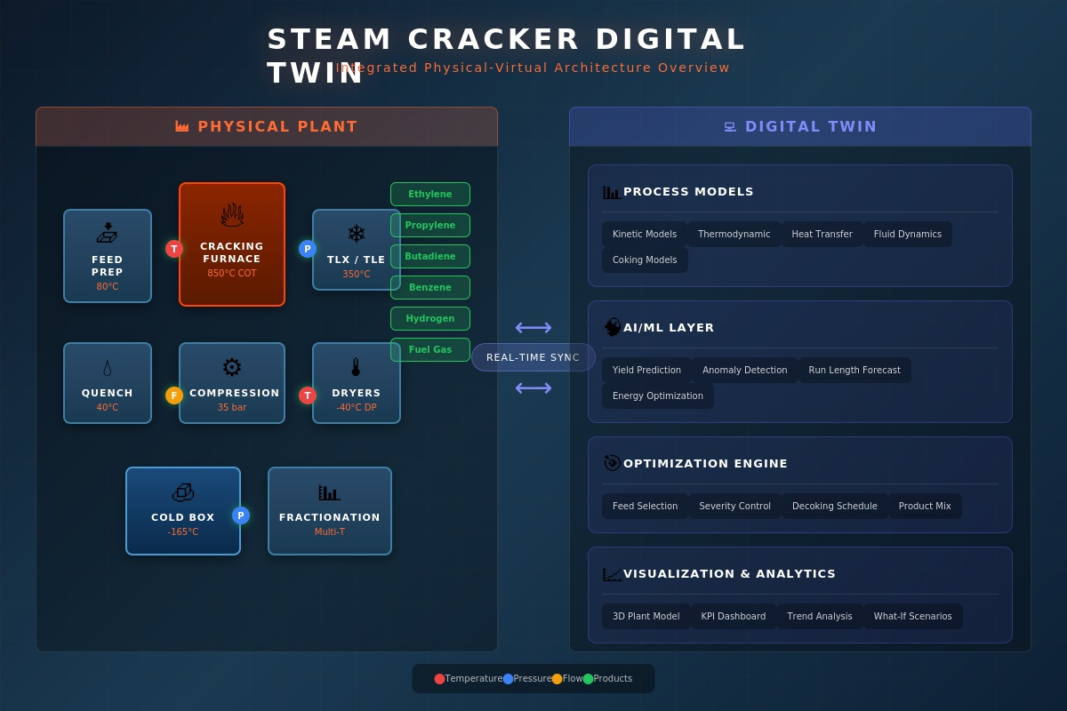
Figure 2: Steam Cracker Digital Twin - Integrated Physical-Virtual Architecture

2.2 Core Components
First-Principles Models: Physics-based models capture the fundamental chemistry, thermodynamics, and transport phenomena of steam cracking. Kinetic models, often based on the SPYRO methodology or similar frameworks, describe the thousands of reactions occurring during pyrolysis. Heat transfer models calculate temperature profiles along furnace tubes and predict tube metal temperatures. These models provide explainable, reliable predictions grounded in physical understanding.
Data-Driven Models: Machine learning models complement first-principles approaches by capturing complex relationships that are difficult to model mechanistically. Neural networks can predict coking rates, yield variations, and equipment degradation patterns from historical data. These models excel at pattern recognition and can identify subtle correlations that improve prediction accuracy.
Hybrid Models: The most effective digital twins combine physics-based and data-driven approaches. Physics-informed neural networks use first-principles constraints to guide machine learning, improving accuracy with less training data. Residual models use ML to capture the difference between physics predictions and actual measurements, providing the best of both worlds.
Optimization Engines: Mathematical optimization algorithms use digital twin predictions to recommend optimal operating conditions. These may include linear and nonlinear programming, genetic algorithms, or reinforcement learning approaches. The optimizer considers multiple objectives such as yield maximization, energy minimization, and run length extension subject to equipment and safety constraints.

2.3 Data Architecture
The digital twin requires comprehensive, high-quality data from multiple sources. Process sensors provide temperature, pressure, flow, and level measurements at frequencies ranging from once per second for critical variables to once per minute for slower processes. A typical steam cracker has 30,000-50,000 instrumented points, though only a subset are relevant for the digital twin.
Laboratory information management systems provide feed composition analyses, product quality measurements, and other analytical data typically available hourly or per shift. Maintenance management systems contribute equipment history, work orders, and inspection results. External data sources may include feedstock pricing, product pricing, and weather data for energy optimization.
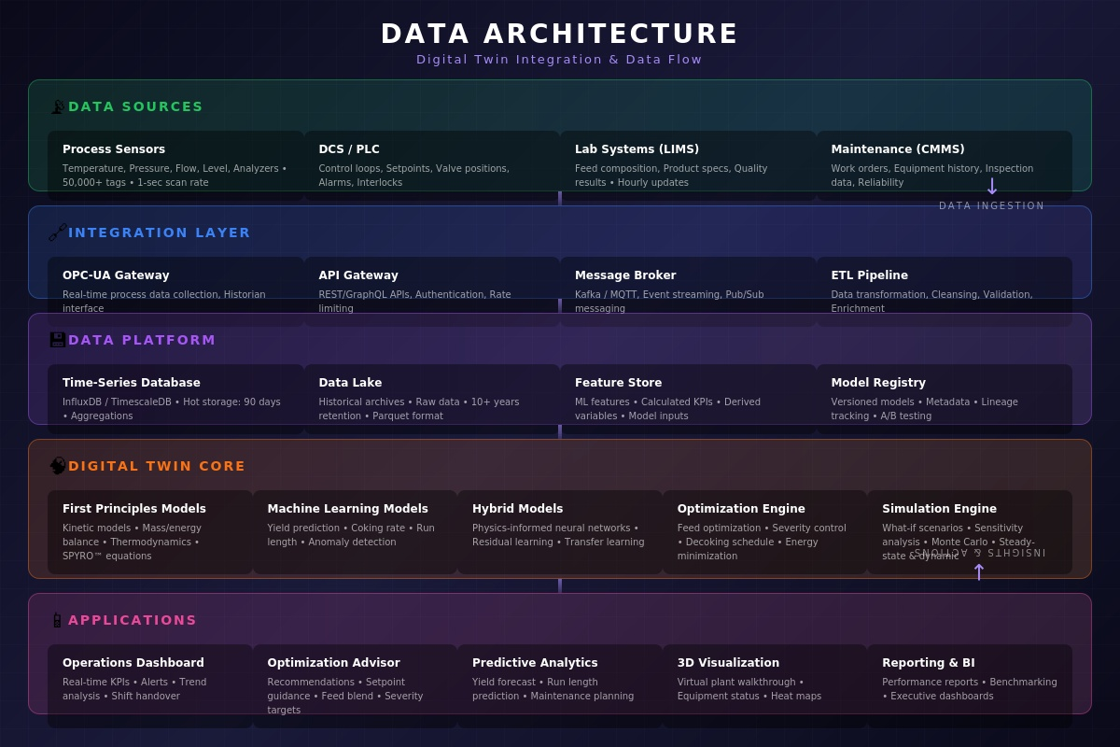
Figure 3: Data Architecture - Digital Twin Integration and Data Flow

3. Furnace Digital Twin: Deep Dive

3.1 Cracking Kinetics Modeling
The heart of the furnace digital twin is the kinetic model describing pyrolysis chemistry. Modern kinetic schemes contain 2,000 or more reactions involving 100 or more chemical species, from simple molecules like methane and ethylene to complex aromatics and heavy hydrocarbons. The SPYRO methodology, developed by Technip and widely licensed in the industry, provides a rigorous framework for modeling these reactions.
The kinetic model predicts product yields as a function of feed composition, coil outlet temperature, residence time, and steam-to-hydrocarbon ratio. Key reactions include the primary cracking of feed molecules into radicals, secondary reactions that form olefins and diolefins, and condensation reactions that lead to aromatics and coke precursors. Accurate kinetic modeling requires careful calibration against plant data, typically achieving yield predictions within 0.5 percentage points of actual measurements.

3.2 Heat Transfer Modeling
Heat transfer in the cracking furnace involves radiation from flames and hot refractory to tube surfaces, convection within the tubes, and conduction through tube walls and coke layers. The radiant section, where most cracking occurs, operates at firebox temperatures of 1,000-1,200 degrees Celsius with heat fluxes of 70-90 kilowatts per square meter.
Tube metal temperature monitoring is critical for safe operation and tube life management. The digital twin calculates TMT profiles along each tube pass, accounting for coke buildup that insulates the tube and raises metal temperatures. When predicted TMT approaches limits, typically around 1,050-1,100 degrees Celsius, the twin alerts operators and recommends decoking or severity reduction.
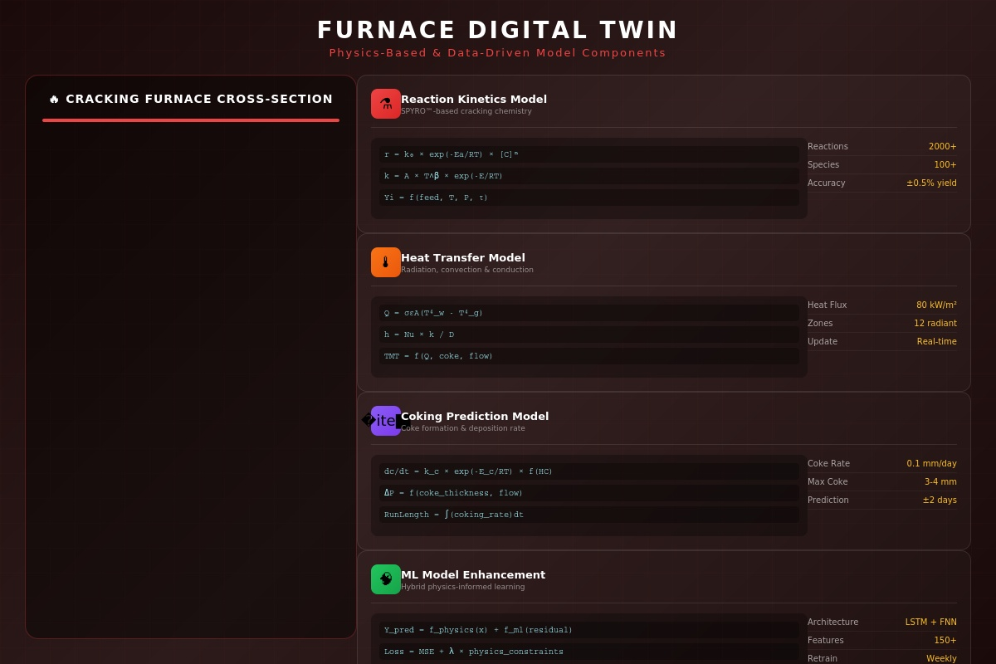
Figure 4: Furnace Digital Twin - Physics-Based and Data-Driven Model Components

3.3 Coking Prediction
Coke formation is the primary factor limiting furnace run length. Coke deposits on tube inner walls through two mechanisms: catalytic coking accelerated by nickel and iron in the tube alloy, and pyrolytic coking from gas-phase reactions. The coke layer grows at rates of 0.05-0.2 millimeters per day depending on operating severity and feed composition.
The digital twin tracks coke buildup continuously by reconciling heat transfer calculations with measured temperatures and pressures. Machine learning models trained on historical run data improve coking rate predictions by capturing relationships between operating conditions and coking that mechanistic models may miss. Accurate coking prediction enables optimization of run length versus severity tradeoffs.

3.4 Severity Optimization
Cracking severity, often characterized by coil outlet temperature or propylene-to-ethylene ratio, is the primary lever for yield optimization. Higher severity increases ethylene yield but also accelerates coking and increases energy consumption. The optimal severity depends on current product prices, energy costs, coke thickness, and remaining acceptable run length.
The digital twin optimizer evaluates thousands of scenarios to determine optimal severity for each furnace. It considers constraints including maximum TMT, minimum run length targets, product specifications, and downstream processing capacity. Real-time optimization can adjust severity recommendations hourly or more frequently as conditions change.

4. Use Cases and Value Drivers
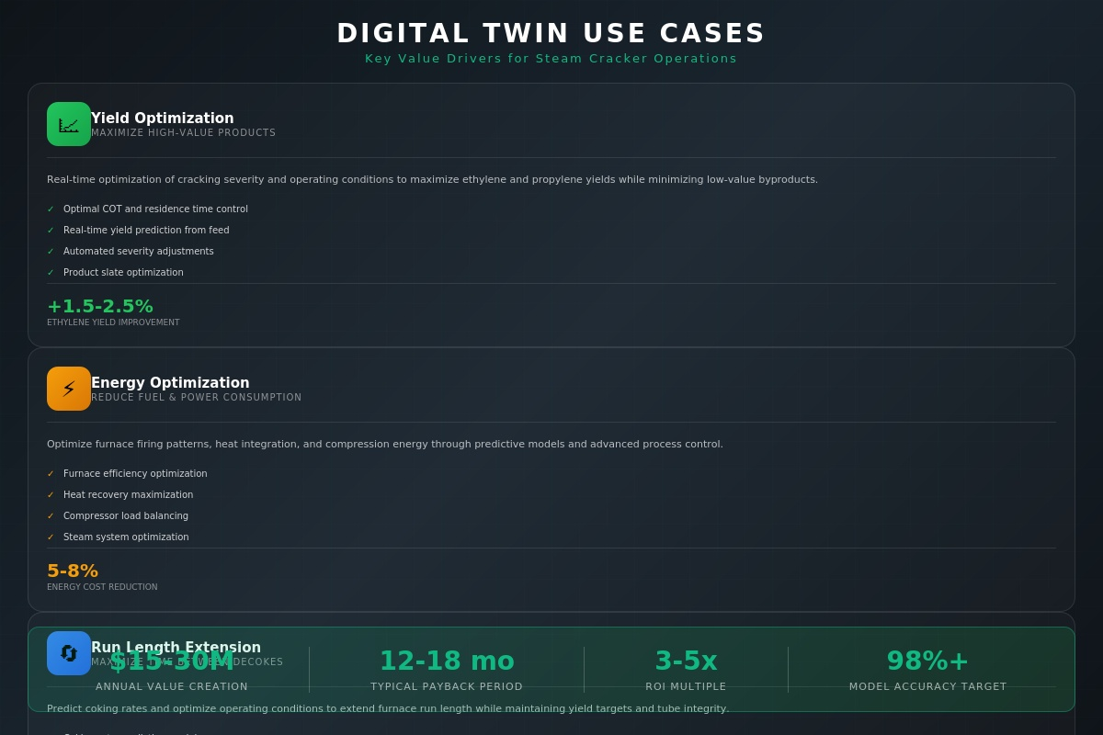
Figure 5: Digital Twin Use Cases - Key Value Drivers for Steam Cracker Operations

4.1 Yield Optimization
Yield optimization represents the largest value driver for most steam cracker digital twins. The objective is to maximize production of high-value products, primarily ethylene and propylene, while minimizing low-value byproducts like fuel gas and fuel oil. A one percentage point improvement in ethylene yield for a 1.5 million ton per year facility translates to 15,000 additional tons of ethylene annually.
The digital twin enables yield optimization through several mechanisms. Real-time yield prediction allows operators to verify that furnaces are achieving expected performance and identify deviations early. Severity optimization determines the optimal operating point considering current feed, prices, and equipment state. Feed-forward control adjusts parameters proactively when feed composition changes rather than waiting for yield measurements to indicate a problem.

4.2 Energy Optimization
Energy consumption in steam cracking accounts for 50-60% of variable operating costs, making energy optimization a significant value lever. The primary energy consumers are furnace firing, compression power, and refrigeration for the cold section. The digital twin optimizes each of these areas while respecting process constraints and product specifications.
Furnace efficiency optimization balances fuel consumption against cracking performance. The twin determines optimal excess air levels, burner patterns, and heat recovery from convection sections. Compression optimization balances load across multiple compressor trains and stages, minimizing total power while maintaining required pressures. Cold section optimization adjusts reflux ratios and temperature profiles to minimize refrigeration duty.

4.3 Run Length Extension
Extending furnace run length between decokes reduces downtime and associated production losses. Each decoke event typically takes 24-48 hours and reduces annual capacity by 1-2% per furnace. However, operating too long with excessive coke risks tube damage and safety incidents. The digital twin enables confident operation closer to true limits.
Coking rate prediction allows operators to plan decokes optimally rather than following fixed schedules or waiting for symptoms. The twin tracks actual versus predicted coking and updates remaining run length estimates continuously. When combined with maintenance planning and market forecasts, this enables strategic decoke scheduling that minimizes business impact.

4.4 Feed Optimization
Feedstock selection significantly impacts steam cracker economics. Different feeds, naphtha versus ethane for example, produce different product slates and have different energy requirements. Even within a feed type, composition variations affect yields. The digital twin evaluates feeds on a margin-optimized basis considering current prices and plant capabilities.
Feed-to-product yield mapping uses the kinetic model to predict yields for potential feed purchases. The optimizer compares net margins across available feeds, accounting for yield differences, energy impacts, and any operational constraints. For facilities with feed flexibility, this analysis can shift significant volume to higher-margin feeds.

4.5 Predictive Maintenance
Beyond the furnace, digital twin technology extends to equipment health monitoring across the plant. Compressors, pumps, heat exchangers, and rotating equipment all benefit from predictive analytics that identify degradation before failure occurs. Early warning enables planned maintenance that avoids costly unplanned shutdowns.
The digital twin monitors equipment performance indicators such as compressor efficiency, heat exchanger fouling factors, and pump curves. Machine learning models trained on historical failure data identify patterns preceding problems. Integration with the maintenance management system automates work order generation when intervention is recommended.

5. Implementation Approach
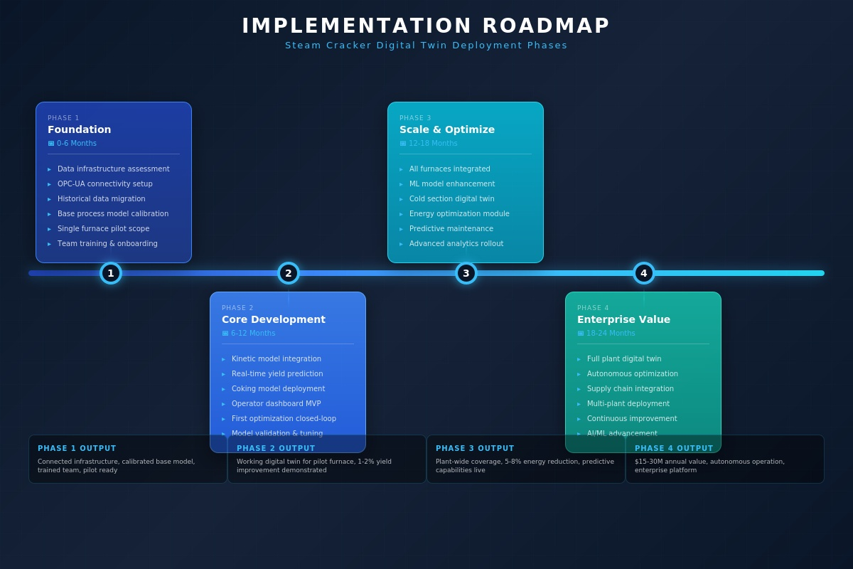
Figure 6: Implementation Roadmap - Steam Cracker Digital Twin Deployment Phases

5.1 Phase 1: Foundation (Months 0-6)
The foundation phase establishes the technical infrastructure and organizational capabilities needed for digital twin success. Data connectivity is the critical path item, requiring OPC-UA interfaces to DCS and historian systems, database connections to LIMS and CMMS, and a data platform to store and serve information to the digital twin.
Parallel activities include assessing data quality, identifying gaps, and implementing improvements where needed. The process model is configured with as-built equipment specifications and calibrated against historical plant data. A pilot scope, typically one or two furnaces, is defined to demonstrate value before full-plant deployment. Team training ensures operators and engineers understand digital twin concepts and applications.

5.2 Phase 2: Core Development (Months 6-12)
The core development phase delivers a working digital twin for the pilot scope. The kinetic model is integrated with real-time data feeds and validated against current plant operation. Coking models are calibrated using historical run data and TMT measurements. An operator dashboard provides real-time visibility into yield predictions, efficiency metrics, and optimization recommendations.
The first optimization closed loops are implemented during this phase, typically severity advisory recommendations that operators can accept or override. Model accuracy is continuously monitored and tuned based on comparison with actual measurements. Success criteria, typically yield improvement and prediction accuracy targets, are evaluated to confirm readiness for scale-up.

5.3 Phase 3: Scale and Optimize (Months 12-18)
The scale phase extends digital twin coverage to all furnaces and expands functionality. Cold section models are integrated to enable plant-wide optimization. Machine learning enhancements improve prediction accuracy beyond what first-principles models achieve alone. Energy optimization modules target the compression and refrigeration systems.
Predictive maintenance capabilities are deployed for critical rotating equipment. Advanced analytics provide deeper insights into operational patterns and improvement opportunities. The digital twin becomes embedded in daily operations, with shift engineers and operators using it routinely for decision support.

5.4 Phase 4: Enterprise Value (Months 18-24)
The enterprise value phase realizes the full potential of digital twin technology. The complete plant operates as an integrated digital twin with optimization spanning from feed receipt to product delivery. Autonomous optimization, where the twin adjusts setpoints directly without operator confirmation, may be enabled for lower-risk applications.
Supply chain integration connects the digital twin with feedstock procurement and product sales systems, enabling margin-optimized operation that considers market dynamics. Multi-plant deployment replicates success across the enterprise. Continuous improvement processes ensure the twin evolves with changing conditions and advancing technology.

6. Technical Architecture

6.1 Data Integration Layer
The data integration layer connects plant systems to the digital twin platform. OPC-UA provides the standard protocol for real-time process data, offering secure, reliable connectivity to DCS and SCADA systems. A data historian, such as OSIsoft PI or AspenTech InfoPlus.21, stores time-series data and serves historical queries. API gateways provide access to transactional systems like LIMS and CMMS.
Data quality management is essential for reliable digital twin operation. Automated validation checks identify sensor failures, out-of-range values, and suspicious patterns. Data reconciliation resolves inconsistencies between redundant measurements. Gap filling algorithms interpolate missing values using appropriate methods for each data type.

6.2 Data Platform
The data platform stores, processes, and serves data for digital twin applications. A time-series database optimized for high-frequency process data handles real-time queries and aggregations. A data lake stores raw historical data for machine learning training and long-term analysis. A feature store manages calculated variables and ML model inputs with appropriate versioning.
The platform should support both on-premises and cloud deployment options. Edge computing may be required for latency-sensitive applications or sites with limited connectivity. Hybrid architectures that combine local processing with cloud analytics provide flexibility and scalability.

6.3 Modeling Environment
The modeling environment hosts and executes digital twin models. Process simulation engines run first-principles calculations, potentially using commercial tools like Aspen HYSYS or proprietary solutions. Machine learning frameworks such as TensorFlow or PyTorch support data-driven models. An orchestration layer coordinates execution, manages model versions, and handles scaling.
Model management includes version control, testing, and deployment workflows. Continuous integration practices ensure model changes are validated before production deployment. A/B testing capabilities allow comparison of model versions on parallel data streams. Monitoring tracks model performance and triggers retraining when degradation is detected.

6.4 Application Layer
User-facing applications present digital twin insights to operators, engineers, and managers. Operations dashboards display real-time KPIs, yield predictions, and optimization recommendations with appropriate visualization for control room use. Engineering workbenches enable detailed analysis, model tuning, and scenario evaluation. Management reports summarize performance trends and value capture.
Mobile applications extend access beyond the control room, enabling field operators to view digital twin data during rounds and managers to monitor performance remotely. Alerting systems notify appropriate personnel when the twin detects anomalies or optimization opportunities. Integration with existing plant systems ensures the twin fits into established workflows.

7. Return on Investment

7.1 Value Quantification
Steam cracker digital twins generate value through multiple mechanisms that can be quantified and tracked. Yield improvements of 1.5-2.5 percentage points on ethylene, valued at $800-1,200 per metric ton, generate $15-30 million annually for a 1.5 million ton per year facility. Energy reductions of 5-8% on fuel and power consumption, representing 60% of variable costs, add $5-10 million in annual savings.
Run length extension of 10-20% reduces decoke frequency and associated downtime, worth $2-5 million annually in avoided production losses. Predictive maintenance prevents unplanned shutdowns that can cost $1-2 million per day in lost production. Feed optimization captures additional margin of $2-5 per metric ton on feed purchases. Combined value typically ranges from $25-50 million annually for world-scale facilities.
Value Driver | Improvement | Annual Value
Ethylene Yield Optimization | +1.5-2.5% | $15-30 million
Energy Cost Reduction | 5-8% | $5-10 million
Run Length Extension | +10-20% | $2-5 million
Predictive Maintenance | 30-50% fewer events | $3-8 million
Feed Optimization | $2-5/MT margin | $3-8 million

7.2 Investment Requirements
Digital twin implementation requires investment in technology, services, and organizational capabilities. Technology costs include software licenses for simulation tools, data platforms, and analytics applications, typically ranging from $2-5 million for a single-site deployment. Cloud infrastructure or on-premises hardware adds $0.5-1.5 million. Integration development, model configuration, and customization require $1-3 million in professional services.
Organizational investment includes training programs for operators, engineers, and IT staff. Dedicated resources, typically 2-4 full-time equivalents, are needed to operate and maintain the digital twin. Change management efforts ensure the twin is adopted and used effectively. Total investment for a comprehensive steam cracker digital twin typically ranges from $5-12 million over a 24-month implementation period.

7.3 Financial Returns
With annual value creation of $25-50 million and total investment of $5-12 million, digital twin implementations achieve payback periods of 12-18 months and ROI multiples of 3-5 times over a five-year horizon. These returns compare favorably with other capital investments available to petrochemical operators and represent some of the highest-return digital investments in the industry.
Value realization follows a characteristic pattern, with initial benefits appearing in months 9-12 as the pilot scope delivers yield and efficiency improvements. Value accelerates during scale-up phases as coverage expands and capabilities mature. Sustained value requires ongoing maintenance and continuous improvement, with investment of 10-15% of initial cost annually.

8. Conclusion
Digital twin technology represents a transformative opportunity for steam cracker operations. By creating virtual replicas that mirror physical plants in real-time, operators gain unprecedented visibility into process behavior and optimization opportunities. The combination of first-principles models grounded in chemistry and physics with data-driven machine learning delivers predictions accurate enough to guide operational decisions.
The value proposition is compelling and proven. Yield improvements, energy savings, extended run lengths, and reduced unplanned downtime combine to generate $15-30 million or more in annual value for world-scale facilities. Implementation investments of $5-12 million achieve payback in 12-18 months with minimal operational risk. Organizations across the petrochemical industry are adopting this technology, creating competitive pressure on those who delay.
Success requires more than technology. Leadership commitment, organizational readiness, and effective change management are equally important. The digital twin must be integrated into daily operations and decision-making processes to realize its full potential. Continuous improvement ensures the twin evolves with changing conditions and advancing capabilities.
The path forward is clear. Organizations should assess their current capabilities, identify pilot opportunities, and develop implementation roadmaps that balance ambition with practicality. Early movers are building competitive advantages that will be difficult to replicate. The question is not whether to implement a steam cracker digital twin, but how quickly to do so. The technology is mature, the value is proven, and the time to act is now.

9. References and Further Reading
Organizations seeking to deepen their understanding of steam cracker digital twins should consider the following resources:

Industry Standards: API Recommended Practice 584 (Integrity Operating Windows), API Standard 530 (Calculation of Heater-Tube Thickness), and ISA-95 (Enterprise-Control System Integration) provide foundational frameworks relevant to digital twin implementation.
Process Technology: Zimmermann and Walzl, Ethylene in Ullmanns Encyclopedia of Industrial Chemistry provides comprehensive coverage of steam cracking technology. The SPYRO User Conference proceedings offer insights into kinetic modeling advances.
Digital Twin Frameworks: The Digital Twin Consortium provides reference architectures and best practices. ISO 23247 (Digital Twin Framework for Manufacturing) offers standardized terminology and concepts applicable to process industries.
Technology Vendors: Major technology providers including AspenTech, AVEVA, Honeywell, and Siemens offer digital twin platforms with steam cracker applications. Licensor technology providers including Technip Energies, Lummus Technology, and Linde Engineering offer integrated digital solutions.

This whitepaper represents a point-in-time assessment of digital twin technology and applications. Given the rapid pace of technology evolution, organizations should continuously monitor developments and engage with technology providers for current capabilities and roadmaps.

