The WHY EDIFY Yearly Review

Thank you for downloading The Why Edify Yearly Review.

The Yearly Review is a simple exercise that will boost your personal growth. Taking two or three weeks at the end of the year to reflect on your wins (in and out of the classroom) and accomplishments will help you identify what went well and set you up to set goals for the upcoming year.

You have access to the PDF and Microsoft Word versions of The Yearly Review, so you can reflect using paper and pen or with your keyboard. Also, feel free to add your own sections to make this review work best for you.

The Yearly Review consists of the following parts:

  - Monthly - Big Events/Moments
  - School / Teaching Wins and Goal Setting
  - Health Wins and Goal Setting
  - Personal Development Wins and Goal Setting
  - Lessons Learned
  - Things That Made My Year

Credit and Thank-You

The following authors have inspired me to complete a yearly review. I'm appreciative for their ideas and inspiration.

  - James Clear: Annual Review
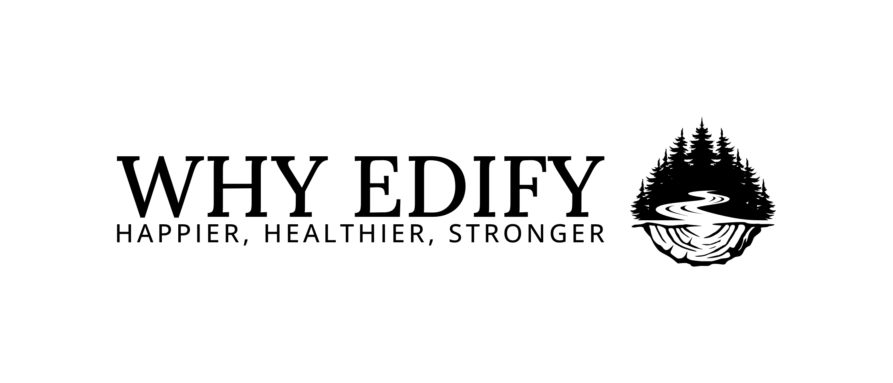
  - David Perell: Annual Review
  - Matthew Dicks: Resolutions and Monthly Goals

Why a Yearly Review Works
You already know that reflection matters. You ask your students to do it. You've sat through professional development sessions about it. But knowing something matters and actually doing it are different things—especially when you're tired and the year feels like a blur.
Here's why taking time for a yearly review is worth it, backed by research that confirms what you probably already sense.
Reflection Consolidates Learning
When we move quickly from one experience to the next, our brains don't have time to process what happened or what it means. Reflection creates space for that processing. Research on metacognition shows that pausing to think about what we've learned dramatically improves retention and future performance. The yearly review isn't just looking back—it's making sense of what you lived through so you can carry the lessons forward.
Writing Creates Clarity
There's something about putting thoughts into words that forces us to organize them. Psychologist James Pennebaker's research on expressive writing shows that writing about our experiences—especially the difficult ones—reduces stress and improves emotional processing. When you write down your wins, your lessons, and your goals, you're not just documenting them. You're making them real. You're giving them shape. And that clarity matters.
Documenting Progress Counters Negativity Bias
Our brains are wired to remember what went wrong more vividly than what went right. It's called negativity bias, and it's why the one rough lesson can overshadow twenty good ones. A yearly review counters that by creating a record of what actually happened—the wins, the growth, the moments that mattered. When you list your successes, you're building evidence against the story that nothing worked or nothing changed. That evidence builds confidence and resilience.

Structured Reflection Reduces Rumination
Reflection and rumination aren't the same thing. Rumination is getting stuck replaying problems without resolution. Reflection is purposeful—it moves you forward. The structure of a yearly review (wins, lessons, goals) keeps your thinking productive. You're not just spinning. You're learning, adjusting, and planning. Research shows that structured reflection like this reduces anxiety and increases clarity about next steps.
Annual Rituals Create Closure
Psychologists call them "temporal landmarks"—moments in time that help us close one chapter and open another. New Year's Day is one. So is the end of a school year. A yearly review leverages that natural sense of transition. It gives you permission to stop, assess, and reset. Without that closure, the year just keeps rolling, and you never really process what happened or what you want to be different.
You Already Believe in This
As a teacher, you know reflection works. You've seen students grow when they pause to think about their learning. You've experienced it yourself in the moments when you actually had time to process a lesson, a conflict, or a challenge.
This review simply gives you the structure to do what you already know matters.
Take the time. You've earned it. And the insights you gain will shape the year ahead.

Ready to begin? Turn the page and start reflecting.

Big Events / Moments - These are the big things that happened that tell the story of your year. Reference your calendar and photo roll to help you remember.

January

1.

2.

3.

4.

5.

February

1.

2.

3.

4.

5.

March

1.

2.

3.

4.

5.

April

1.

2.

3.

4.

5.

May

1.

2.

3.

4.

5.

June

1.

2.

3.

4.

5.

July

1.

2.

3.

4.

5.

August

1.

2.

3.

4.

5.

September

1.

2.

3.

4.

5.

October

1.

2.

3.

4.

5.

November

1.

2.

3.

4.

5.

December

1.

2.

3.

4.

5.

Personal Development Wins and Goal Setting
Here's your place to list what went right and to set some goals for next year. What habits did you develop? What were your successes in character development?

Wins

1.

2.

3.

4.

5.

6.

Goals

1.

2.

3.

4.

5.

6.

Teaching Wins and Goal Setting
Here's your place to list what went right during the school year. What did you try that worked out well? What kinds of professional development did you complete?

Wins

1.

2.

3.

4.

5.

6.

Goals

1.

2.

3.

4.

5.

6.

Health Wins and Goal Setting
Here's your place to list what went right and to set some goals for next year. Did you set and achieve any diet or fitness goals? Did you track your activity? Maybe you ramped up your self-care routine.

Wins

1.

2.

3.

4.

5.

6.

Goals

1.

2.

3.

4.

5.

6.

What Lessons Did You Learn?

1.

2.

3.

4.

5.

6.

7.

8.

9.

10.

Things That Made My Year
Have fun with this one. Think of your favorite songs, shows, movies, books, sporting events, etc. from the year.

1.

2.

3.

4.

5.

6.

7.

8.

9.

10.

MAY EACH YEAR BE BETTER THAN THE ONE BEFORE IT!

