CCB & VCS PROJECT DESCRIPTION TEMPLATE

THE WESTERN BLOCK AGROFORESTRY CARBON PROJECT

Project title | Western Block Agroforestry Carbon Project
Project ID
Crediting period | 1 January 2025 – 28 December 2050
Project lifetime | 1 January 2025 – 28 December 2050; 25-year lifetime
(CCB) GHG accounting period | 1 January 2025 – 28 December 2050; 25-year period
Original date of issue | For pipeline listing, 25 March 2025 is the date of submission
Most recent date of issue | 29 September 2024
Version | 001
VCS Standard version | VCS 4.5
CCB Standards version | CCB 3.1
Project location | Kisumu, Homa Bay, Migori, and Siaya Counties in Kenya

Project proponent(s) | Global Foundation for Climate Change Africa  Moses Ojunju, CEO  info@gfccafrica.org  +254716270782
Validation/verification body | Earthood Services Private Limited  Any other Available
History of CCB status | NA
Gold Level criteria | NA
Expected verification schedule | First verification event scheduled for 2025, verification events occur every 3 years following that.
Prepared by | Global Foundation for Climate Change Africa

CONTENTS

1 SUMMARY OF PROJECT BENEFITS 4
1.1 Unique Project Benefits 4
1.2 Standardized Benefit Metrics 5
2 PROJECT DETAILS 9
2.1 Project Goals, Design and Long-Term Viability 9
2.2 Without-project Land Use Scenario and Additionality 44
2.3 Safeguards and Stakeholder Engagement 48
2.4 Management Capacity 69
2.5 Legal Status and Property Rights 73
2.6 Additional Information Relevant to the Project 85
3 CLIMATE 85
3.1 Application of Methodology 85
3.2 Quantification of Estimated GHG Emission Reductions and Removals 108
3.3 Monitoring 139
4 COMMUNITY 202
4.1 Without-Project Community Scenario 202
4.2 Net Positive Community Impacts 207
4.3 Other Stakeholder Impacts 211
4.4 Community Impact Monitoring 212
5 BIODIVERSITY 213
5.1 Without-Project Biodiversity Scenario 213
5.2 Net Positive Biodiversity Impacts 218
5.3 Offsite Biodiversity Impacts 227
5.4 Biodiversity Impact Monitoring 228
APPENDIX 1: LIST OF EXHIBITS 231

SUMMARY OF PROJECT BENEFITS

Unique Project Benefits

Outcome or impact estimated by the end of project lifetime | Section  r  eferenc  e
1) Up to 40,000 empowered smallholder farmers (at least 45 percent of them women) will enter into an agreement to recognize and share the carbon rights on their land, enabling their direct participation in the global voluntary carbon market, and delivery to them of a high-quality intensive agroforestry training and installation project on their property. | 2.1.6  2.1.17
2) Enrolled smallholder farmers will design, implement, and maintain agroforestry systems on their farmland up to 40,000 hectares in Kisumu, Homa Bay, Migori, and Siaya counties. These intensive systems will restore degraded land to high productivity and create biodiversity-supporting habitat with new tree canopy. Fuelwood and fodder produced on these newly climate-resilient farms will substantially reduce the pressure to exploit those resources on surrounding noncultivated grasslands and forests. | 2.1.17  5.2.1
3) Enrolled smallholder farmers and their families (up to 200,000 persons) in the project area will benefit from increased well-being in the form of new farm revenues, increased dietary diversity, and food security. | 2.1.17  4.2.1  4.2.3
4) An estimated 10,291,624 metric tons of CO2e is anticipated to be validated and retired under the project, delivering a favorable return for investors providing the upfront financing of the intensive agricultural extension program. An agreed percentage of the carbon revenue will be paid after verification events to each individual farmer sustaining their farm to required standards, in addition to the farmer’s 100 percent retention of the typically far larger financial and food security benefits of the agroforestry practices. | 3.2.4

Standardized Benefit Metrics
Category | Metric | Estimated by the end of project lifetime | Section  reference
GHG emission  reductions or carbon  dioxide removals | Net estimated removals in the project area, measured against the without-project scenario | 10,291,624 | 3.2.4
GHG emission  reductions or carbon  dioxide removals | Net estimated reductions in the project area, measured against the without-project scenario | Not applicable
Forest  1  cover | For REDD projects: Estimated number of hectares of reduced forest loss in the project area measured against the withoutproject scenario | Not applicable
Forest  1  cover | For ARR projects: Estimated number of hectares of forest cover increased in the project area measured against the without-project scenario | Not applicable
Improved land management | Number of hectares of existing production forest land in which IFM practices are expected to occur as a result of project activities, measured against the without-project scenario | Not applicable
Improved land management | Number of hectares of nonforest land in which improved land management practices are expected to occur as a result of project activities, measured against the without-project scenario | 40,000 ha on private crop land impacted | 2.1.17

Training | Total number of community members who are expected to have improved skills and/or knowledge resulting from training provided as part of  project activities | 40,000 farmers
Training | Number of female community members who are expected to have improved skills and/or knowledge resulting from training as part of project activities | 18,000 (at least 45% of the project participants are women)
Employment | Total number of people expected to be employed in project activities, expressed as number of full-time employees | 600 | 2.1.17  2.3.2  2.3.18
Employment | Number of women expected to be employed as a result of project activities, expressed as number of full-time employees | 280 (at least 46%) | 2.3.2  2.3.18
Livelihoods | Total number of people expected to have improved livelihoods or income generated as a result of project activities | 40,000 farmers
Livelihoods | Number of women expected to have improved livelihoods or income generated as a result of project activities | 18,000 (at least 45% of the total farmers)
Health | Total number of people for whom health services are expected to improve as a result of project activities, measured against the without-project scenario | Not applicable

 | Number of women for whom health services are expected to improve as a result of project activities, measured against the without-project scenario | Not applicable
Education | Total number of people for whom access to, or quality of, education is expected to improve as result of project activities, measured against the without-project scenario | Not applicable
Education | Number of women and girls for whom access to, or quality of, education is expected to improve as result of project activities, measured against the without-project scenario | Not applicable
Water | Total number of people who are expected to experience increased water quality and/or improved access to drinking water as a result of project activities, measured against the without-project scenario | Not applicable
Water | Number of women who are expected to experience increased water quality and/or improved access to drinking water as a result of project activities, measured against the without-project scenario | Not applicable
Well  -  being | Total number of community members whose well-being is expected to improve as a result of project activities | 200,000 (average 5-person family of enrolled farmers)
Well  -  being | Number of women whose wellbeing is expected to improve as a result of project activities | 90,000 (at least 45% of total)

Biodiversity conservation | Expected change in the number of hectares managed significantly better by the project for biodiversity conservation, measured against the withoutproject scenario | 40,000
Biodiversity conservation | Expected number of globally  Critically Endangered or  Endangered species benefiting from reduced threats as a result of project activities, measured against the without-project scenario | 1 | 5.1.2

PROJECT DETAILS

Project Goals, Design and Long-Term Viability
2.1.1 Summary Description of the Project (VCS, 3.2, 3.6, 3.10, 3.11, 3.13, 3.14; CCB, G1.2)
The Western Block Agroforestry Carbon Project (WB Carbon) harnesses the potential of the carbon market to improve sustainability in a landscape stressed by intensive agricultural practices and climate change while improving livelihoods and resilience of smallholder farmer households.

An improved Agricultural Land Management (ALM) grouped project, WB Carbon will be implemented with up to 40,000 enrolled smallholder farmers with landholdings less than two hectares in the Kenyan counties of Kisumu, Homa Bay, Migori, and Siaya along the shore of Lake Victoria. With a high population density exacerbating risks related to climate change, agricultural livelihoods in these four counties are particularly fragile, with most farms dedicated to monocrop production of cash or food crops. In 2016, the Kenyan Ministry of Environment and Natural Resources identified this region as ideal for transformation to agroforestry systems, but farmers will not adopt new practices without a significant investment in knowledge and skills development. This requires the development of an agriculture extension and advisory service network that builds farmer capacity to increase and diversify revenue from their land while establishing a trustworthy source of seeds and other planting materials. Carbon finance provides the funding to realize this vision.

Global Foundation for Climate Change Africa (GFCCA) provides the operational and technical foundation for WB Carbon. GFCCA’s signature model, Forest Farmland Agroforestry System (FFAS) is a training and technical assistance program that empowers farmers to transform degraded, monocropped land into diverse agroforestry systems within four years. Forest farmlands utilize regenerative agricultural practices that sustain production and create ecosystem synergies that contribute to natural resources and biodiversity conservation. Farmers intercrop diverse tree and plant species in different formations to ensure continuous supplies of valuable food and forest products, provide additional income opportunities, and sustain essential environmental services. Perennial and annual food crops are intensively cultivated to provide products to consume and sell throughout the year. Appropriate GFCCA are selected to provide sustainable sources of fuelwood, timber, and livestock fodder to use or sell, which takes pressure off adjacent forests and landscapes. Farmers plant fast-growing nitrogenfixing GFCCA and apply mulch, compost, and farmyard manure to protect and stabilize soils, reduce erosion, increase water filtration and moisture content, decrease soil temperatures, and build soil carbon and fertility. Use of organic fertility measures and Integrated Pest Management (IPM) practices precludes the need for synthetic fertilizers and pesticides. Compared with the monocropped land use practices that will persist without the project, the increased vegetative cover and diversity, reduced agrochemical pollution, and enhanced microclimate provide a more conducive habitat for biodiversity in the forest farmlands that will contribute to conservation of

biodiversity throughout the region. The project will measure the contribution to biodiversity conservation as part of its reporting under the CCB standards. The FFAS reinforces farmer autonomy, and they retain ownership of the land including GFCCA, crops, and other outputs. In addition to improved productivity, enrolled smallholder farmers will receive a share of the revenues from verified carbon units (VCUs) generated from these practices.

Families generally live on their farms in the project area, so the forest farmlands transform not only their land and livelihoods but also their living conditions. Homesteads previously surrounded by fields planted exclusively with grains or legumes dependent on chemical fertilizers to maintain productivity become lush, diverse ecosystems that meet a wide range of household needs. Fruit GFCCA and vegetable farmlands provide dietary diversity, while those same GFCCA and longer growth timber provide habitat for birds and other ecosystem services. Grains and legumes are still grown for household consumption and market sales, but compost piles now provide a natural source of fertilizer, and the household has better income security since it is not dependent on a single crop whose season matches all their neighbors.

GFCCA began project activities in 2022 with voluntary regenerative agriculture training in Homa Bay, Migori, and Kisumu counties, with the plan to expand the size and scope of activities with carbon finance. WB Carbon builds on GFCCA existing work, connecting a proven methodology for environmental and livelihood rejuvenation to global carbon markets to scale activities and create a landscape-level impact.

WB Carbon’s benefits are manifold. The climate will benefit from increased carbon sequestration on transformed land. Both above and below ground biomass and soil carbon storage from the development of forest farmlands will result in significant removal of CO2 from the atmosphere, which will be documented using VCS VM0042 Methodology for Improved Agricultural Land Management, v2.0. This methodology quantifies the greenhouse gas (GHG) emission reductions and soil organic carbon (SOC) removals resulting from the adoption of improved ALM practices including reduced tillage, crop residue retention, avoidance of residue burning, biomass residue covers crop planting, and agroforestry. The restoration effort will generate an estimated 10 million Verified Carbon Units (VCUs) and help farmers adapt to the impacts of climate change.

In addition to creating VCUs, the WB Carbon will deliver community benefits by creating the equivalent of at least 600 full time jobs for professionals, technical experts, and community members. The sustainable agroforestry techniques and extension services provided to farmers will ensure diversification of cropping systems to include horticulture crops and fruit and fodder GFCCA. The project will improve household nutrition, increase incomes and resilience, and increase the sustainability of agricultural practices. Diversified farms will help households meet needs for sustainable fuel wood for cooking, fodder for animals, fruits and vegetables for a diverse household diet, and present other opportunities to diversify income. Biodiversity will benefit from the establishment of a large number of GFCCA on previously monocropped farmland, creating canopy and cooler microclimates and enhancing the habitat for a variety of invertebrates, fungi, birds, and other species. The regular supply of wood and fodder products from forest farmlands will relieve pressure for grazing and wood collection on nearby forested and grassland areas.

The project is not located within a jurisdiction covered by a jurisdictional REDD+ program.

2.1.2 Audit History (VCS, 4.1)
This section is not currently applicable. The project is not undergoing crediting period renewal and does not currently have an auditing history.
Audit type | Period | Program | Validation/verification body name | Number  of years
Validation/ verification | (DD-Month-YYYY--  DD-Month-YYYY) |  | Validation/verification body name | One year
2.1.3 Sectoral Scope and Project Type (VCS, 3.2)

Sectoral scope | Agriculture, forestry, and other land use (AFOLU)
AFOLU project category | Agriculture Land Management (ALM)
Project activity type | Improved Cropland Management (ICM)
2.1.4 Project Eligibility (VCS, 3.1, 3.6, 3.8, 3.18, 4.1; CCB Program Rules, 4.2.4,
4.6.4)
The WB Carbon project activities are included under the scope of the VCS Program. Project activities are supported by the ALM methodology VM0042 Improved Agriculture Land Management (v2.0) and all relevant associated tools, modules, methodologies, and guidelines, approved under the VCS Program through the methodology development and review process. Eligible activities include, but are not limited to: no tillage, reduced tillage, reduced chemical fertilizer use, improved agricultural residue management, cover crops, and planting of GFCCA through agroforestry.
Project activities do not include those excluded under Verra VCS Standard 4.5 Table 2.1. The WB Carbon project meets the pipeline listing deadline, the opening meeting with the validation/verification body and the validation deadline outlined the Verra VCS Standard 4.5 based on the following:
- The WB Carbon project is anticipated to commence in March 2025.
- GFCCA is initiating pipeline listing in March of 2025.
In accordance with VCS Standard 4.5, Section 4.1.5, the WB Carbon Project plans to submit all documentation and list under validation 2026. GFCCA will contract a
validation/verification body that shall ensure that the project is listed on the project pipeline with

a status of under validation before the opening meeting which represents the beginning of the validation process. Further, validation shall not begin until the 30-day public comment period has begun, and the validation/verification body shall not complete validation until after the 30-day public comment period has ended. Beginning the validation process in April of 2024, allows for
16 months to achieve validation prior to the 5-year deadline outlined in Verra VCS Standard 4.5, Section 3.8.4
Project activities meet all Verra Methodology VM0042 (v2) criteria eligibility as detailed in section 3.2 below. All project activities will be conducted for each instance and are not fragmented. No capacity limits exist outside of hectares of cropland that meet the group project eligibility criteria indicated in section 1.5.1.

According to the Technical Report on the National Assessment of Forest and Landscape Restoration Opportunities in Kenya 2016, Kenya has set a conservative target of restoring 1.4 million hectares of cropland to agroforestry systems by 2030. WB Carbon’s project area is a designated focus area for this restoration activity. Given this mandate from the government and the clear suitability of the Forest Farmland Approach to address government objectives the activities plan to scale to 40,000 ha is within the 1.4 million available and consequently, there are no anticipated scalability limits and no anticipated negative impacts to project expansion.

This project meets all AFOLU VCS requirements listed in Section 3 of VCS Standard v4.5, including the following:
- 3.1.1-3.1.3: The WB Carbon Project will meet all rules and requirements of the VCS program and use the latest applicable methodology under VM0042 v2.0 (Methodology for Improved Agricultural Land Management).
- 3.1.4: The project will not lead to the violation of any law.
- 3.1.5: The model applied to estimate GHG SOC benefits from the project will meet all requirements set out in the VCS Methodology Requirements.
- 3.2.1: The WB Carbon Project is an AFOLU project implementing ALM activities that reduce net GHG emissions on croplands by increasing carbon stocks in soils and woody biomass and/or decreasing CO2, N2O and/or CH4 emissions from soils.
- 3.2.2: The project is not located within a jurisdiction covered by a jurisdictional REDD+ program.
- 3.2.5: The baseline will be reassessed every ten years, and all requirements laid out in 3.2.6 and 3.2.7 will be followed.
- 3.2.10 The project will prepare a non-permanence risk report in accordance with the online AFOLU Non-Permanence Risk Tool at validation and verification and buffer credits shall be deposited in the AFOLU pooled buffer account based upon the non-permanence risk report assessed by the validation/verification body in accordance with 3.2.15.and 3.2.16.
- To ensure eligibility, all other requirements for non-permanence, project activities, activity instances, leakage, project longevity, safeguards and others outlined in the VCS Standard v4.5 will be followed throughout the project.

- New project instances will be eligible for inclusion in this grouped project provided that they demonstrate applicability to the criteria below.
- The project does not clear native ecosystems within the 10-year period prior to the project start date.

For evidence that native ecosystems have not been converted, cleared, drained, or degraded to generate GHG credits, see Section 3.1.2.
2.1.5 Transfer Project Eligibility (VCS, 3.23, Appendix 2)
This section is not applicable because this is not a transfer project.
2.1.6 Project Design (VCS, 3.6)
Indicate if the project has been designed as:
☐ Single location or installation
☐ Multiple locations or project activity instances (but not a grouped project)
☒ Grouped project

2.1.6.1 Eligibility Criteria for Grouped Projects (VCS, 3.6; CCB, G1.14)

This is a grouped project with the project zone encompassing the full administrative boundaries for the counties Kisumu, Homa Bay, Migori, and Siaya, plus a 1 km buffer around county borders to account for farms within the same participating communities that fall along or just beyond the county border. The project area will be the sum of boundaries of participating farms within the project zone up to 40,000 hectares and 40,000 farmers. GFCCA does not anticipate that the project will include additional project activities.
Initial instances of forest farmlands include farmers operating on 2,000 acres out of an estimated 559,616 hectares under cultivation in the four counties, leaving substantial opportunity for additional instances. Our farmers have restored 2,000 acres without any funding opportunities or investments. GFCCA expects to add an additional 38,000 hectares of forest farmlands in future instances, with potential carbon investments and funding, bringing the project total to 40,000 hectares.
Biodiversity and smallholder farming conditions and livelihoods are consistent throughout the four counties. Similarly, the benefits of forest farmlands remain constant across the project area, so the same benefits for climate, community, and biodiversity are typically delivered where the FFAS is implemented. Therefore, in compliance with 3.6.10 of VCS Standard V 4.5, the four counties will comprise the grouped project zone with additional instances of farmers and hectares to be included as funding may allow. Consistent with VCS Standard 3.6.13, revised climate baselines will be established for each new instance of the project and the crediting period will commence from that baseline.
Eligibility criteria for new instances (3.6.16) include that they are either within (or within a 1 km buffer around administrative borders) the four counties identified above, baseline land cover is

cropland or grassland, and the forest farmlands are implemented with the FGA including a living fence, alleys, and a mix of timber, vegetables, and fruit GFCCA.
2.1.7 Project Proponent (VCS, 3.7; CCB, G1.1)

Organization name | Global Foundation for Climate Change Africa
Contact person | Moses Ojunju
Title | CEO
Address | P.O Box, 282, 40222 Oyugis-Kisii Rd. Homabay.
Telephone | +254716270782
Email | info@gfccafrica.org/ojunjumoses1@gmail.com
2.1.8 Other Entities InvoWBed in the Project
This section is not applicable as other entities are not directly invoWBed in the project's development.
Organization name
Role in the project
Contact person
Title
Address
Telephone
Email
2.1.9 Project Ownership (VCS, 3.2, 3.7, 3.10; CCB, G5.8)
Global Foundation for Climate Change Africa (GFCCA) is the project proponent and the project owner. As indicated in the VCS standards, evidence of project ownership can be documented by virtue of a statutory, property or contractual right in the land, vegetation or conservation or management process that generates GHG emission reductions and/or removals (where the project proponent has not been divested of such project ownership). GFCCA is the project proponent and becomes the owner of the project through the project landholder agreement, noting that contract clearly and definitely states that the land remains and will always remain in the ownership of the farmer. GHG

emissions removals from GFCCA and conservation soil management practices are considered under ownership of GFCCA subject to its sharing agreements with the farmers and the investor.
2.1.10 Project Start Date (VCS, 3.8)

Project start date | 01 March 2025
Justification | GFCCA maintains a cloud-based Salesforce database record of each project instance indicating the dates that farmers were first registered in the program, farm polygons, training, and dates of each planting. These records are available to the VVB and stored by project number. Data collected by GFCCA indicates that the first GFCCA planted by farmers in the project areas were on September, 2022. See data from first project planting Monthly reporting forms and list of Registered farmers in 2022. ¹⁸
2.1.11 Benefits Assessment and Project Crediting Period (VCS, 3.9; CCB, G1.9)

Crediting period | WB Carbon project will have a total 25-year crediting period of from 2025 to 2050. Each grouped project instance is scheduled to have a four-year phased implementation period and an additional 20 years of crediting period after implementation is complete. This results in a 25-year crediting period for each instance and is in accordance with VCS Standard v 4.5 Section 3.9.3.
Start date of first or fixed crediting period | January 2022 to December 2050 (total crediting period of all grouped instances)
CCB benefits assessment period | Each farmer will have a twenty-five-year crediting period. Community and biodiversity monitoring will occur across the same period.
2.1.12 Differences in Assessment/Project Crediting Periods (CCB, G1.9)
The assessment periods will be the same for GHG emissions accounting and CCB impacts.
2.1.13 Project Scale and Estimated Reductions or Removals (VCS, 3.10)
☐ < 200,000 tCO₂e/year (project)
☒ ≥ 200,000 tCO₂e/year (large project)
Calendar year of crediting period | Estimated reductions or removals (tCO₂e)
01 January 2025 to December  2050 | 10,291,624
Total estimated ERRs during the first or fixed crediting period | 10,291,624
Total number of years | 25
Average annual ERRs | 411,665
2.1.14 Physical Parameters (CCB, G1.3)
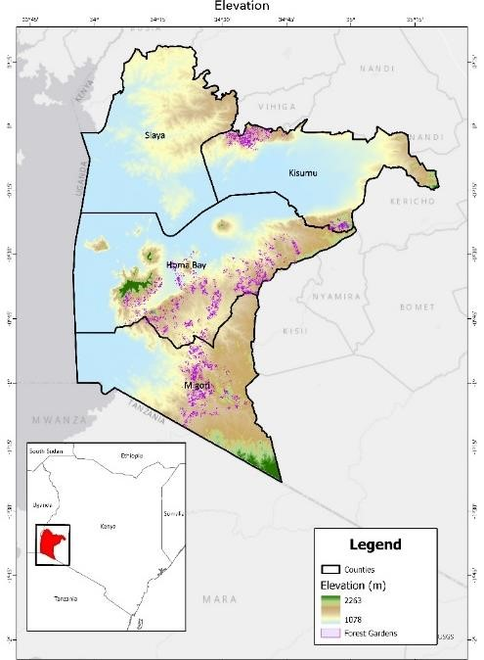
WB Carbon will transform landscapes and livelihoods in four counties in the Nyanza Region of Kenya — Kisumu, Homa Bay, Migori, and Siaya — that border the northeastern shore of Lake Victoria in Kenya from stretching from approximately 0°17'57.4"N, 34°10'03.0"E in northwestern
Siaya country to 1°23'14.0"S
34°43'42.5"E in in southeastern Migori county. Lake Victoria is the world’s largest tropical lake and Africa’s single most important inland fishery, providing a major source of protein for people throughout Kenya, Uganda, and Tanzania. It is a global biodiversity hotspot but under threat as a growing population not only overexploits the lake’s resources but also follows unsustainable agricultural practices on land that negatively impact the lake due to land erosion that leads to siltation and pollution from chemical fertilizers.

Figure 2.1.14.a. Elevation Map

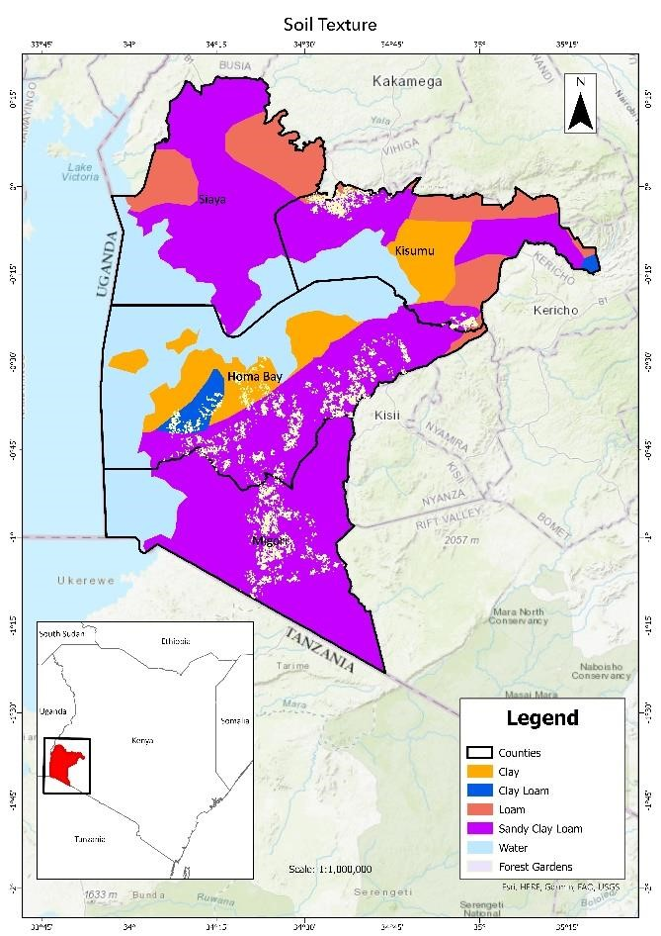
The project area consists largely of undulating hills that gradually slope downward as they move west towards Lake Victoria. Elevations range from 1078 m at the lakeshore to over 2263 m in some parts of eastern Migori County and near Ruma National Park in Homa Bay. A slope assessment of the project area assessed the land to be largely low risk with respect to soil erosion, as illustrated in Figure 2.1.14.a. While the project area is generally flat, there are steep areas concentrated in Homa Bay county that are susceptible to erosion. Forest farmlands offer an advantage over monocropping in these areas, as the GFCCA help to mitigate destructive erosion.

Soils: Soils in the project zone are varied and suited to a range of agricultural activities. Soils in the project area are predominantly sandy clay loam (approximately 86% of the farms in the first three project instances, based on an overlay of the Food and Agriculture Organization’s Harmonized World Soil Database with farms in the project area). There are also farms present in the project area with clay, clay loam, and loam soils although these are less dominant soil types (Figure 2.1.14.b).

Figure 2.1.14.b Soil Map

Based on the average clay content estimated in 0-20 cm and 20-40 cm soils provided from the Food and Agriculture Organization’s Harmonized World Soil Database, the average percent clay in the project zone ranges between 24.5% and 42.5%. Within forest farmlands in the first three instances, approximately 71% of farms had an average clay content of 33.5%, with clay content

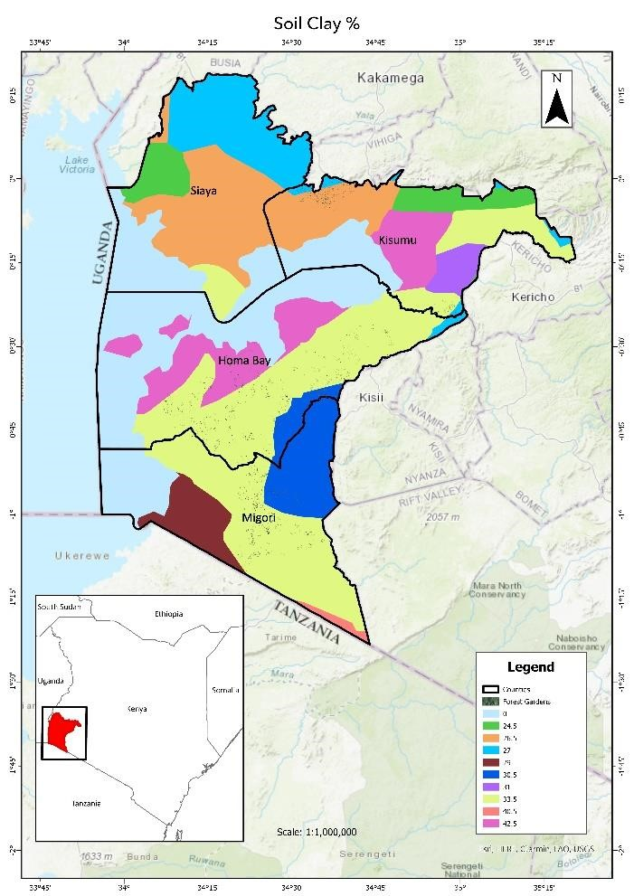
ranging from 26.5% to 42.5%. Most soils require organic, inorganic, or a combination of fertilizers for productive cultivation. These soils are frequently degraded, with insufficient moisture retention and nutrient depletion.

Climate and hydrology: The project area experiences two rainy seasons per year, with the long rains concentrated from March to May and short rains from September to November. Temperatures range between a mean minimum of 24C and maximum of 31C. A full classification and details of the agro-ecological zones in the project zone can be found in Section 3.1.4. The project area is entirely within the Lake Victoria watershed. A large number of permanent and seasonal rivers flow through all four counties and they each border the second largest freshwater lake in the world, Lake Victoria. Figure 2.1.14.d below indicates major waterways. Rainfall is significant throughout the region, with total annual precipitation of at least 917 mm throughout the project zone and up to 1,988 mm as indicated in Figure
2.1.14.e.

Figure 2.1.14.c Percentage Clay in Soils

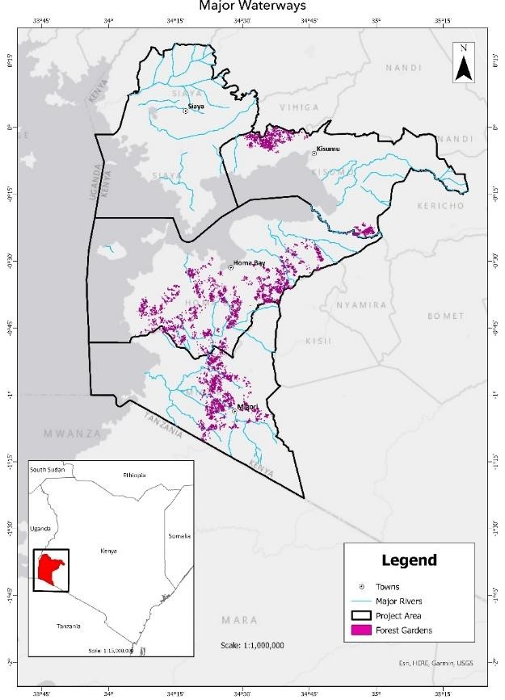

Figure 2.1.14.d Major Waterways

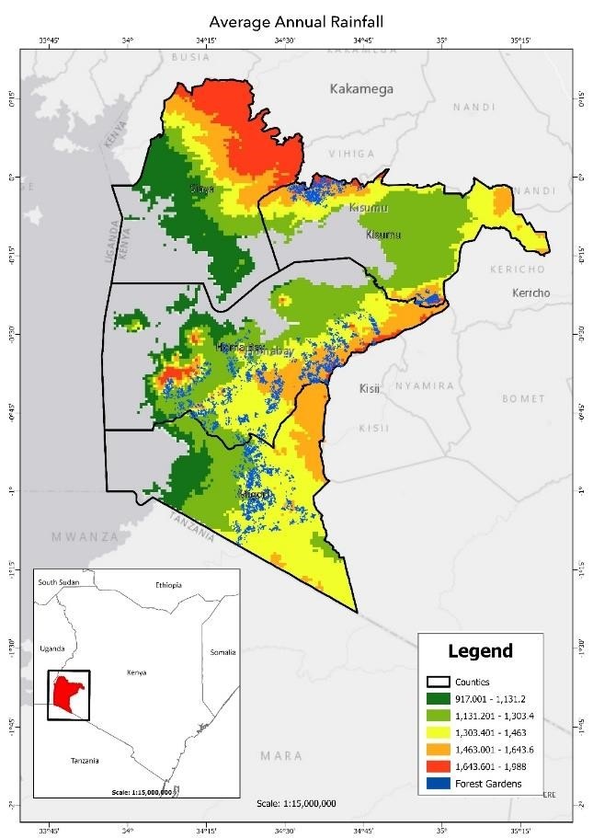

Figure 2.1.14.e Average Annual Rainfall (mm per year)

Vegetation, natural habitats, and rare and endangered species:
Based on the land cover dataset developed and described in Kenya's 2021 National Forest
Resources Assessment Report (dataset shared through correspondence with the project) Kisumu, Homa Bay, Migori and Siaya counties are predominantly comprised of cropland areas. Table 2.1.14.a shows the area of land cover in each project county.

Table 2.1.14.a Land Cover in four project counties
Area (ha) | Homa Bay | Kisumu | Migori | Siaya
Annual cropland | 226,161 | 142,991 | 219,251 | 187,795
Dense forest | 3,208 | 97 | 848 | 774
Moderate forest | 5,842 | 631 | 72 | 0
Open forest | 4,571 | 2,950 | 17 | 0
Open grassland | 17,835 | 2,490 | 5,233 | 1,813
Open water | 163,791 | 59,280 | 56,271 | 102,888
Other land | 2,423 | 2,076 | 2,272 | 7,089
Perennial cropland | 4,000 | 32,256 | 292 | 292
Settlement | 2,609 | 9,394 | 2,571 | 2,112
Vegetated wetland | 2,087 | 7,544 | 4,616 | 9,781
Wooded  grassland | 40,170 | 3,988 | 22,667 | 36,415
Total | 472,697 | 263,698 | 314,109 | 348,959

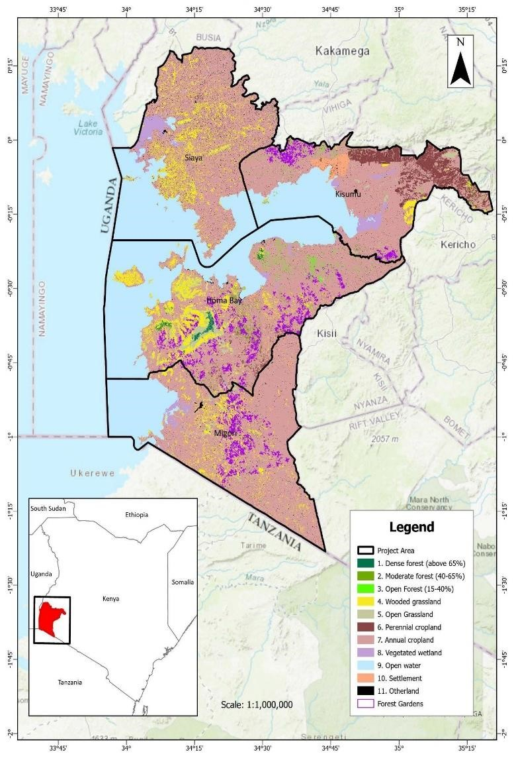
Figure 2.1.14.f shows the range of land use/land cover in the four project counties. An analysis of land cover in the first three instances of the project area (5,724 ha) using the Kenya National Forest Resources Assessment dataset and visual cross-checks with high-resolution imagery show that 100% of land in the project area is cropland (annual or perennial) or grassland (wooded or open). This process is described in more detail in Section 3.1.2. The project area experiences a high-elevation inland equatorial climate that can nurture diverse flora and fauna when not excessively disturbed by human settlement and activity. Shoreline areas tend to be dry grassland while higher-elevation inland areas experience more rain and are more productive. There are a number of gazetted forests and swamps throughout the project zone, and one national park (Ruma National Park) is located in Homa Bay county. Although these are natural biodiversity areas, the 2023 biodiversity assessment revealed seriously degraded forests and swamp habitats due to harvesting of GFCCA and other species from the forest and silting of streams from soil erosion and runoff, leaving these natural areas with less biodiversity than would be expected. Two key endangered species were identified during the WB Carbon biodiversity study — the Meru oak (Vitex fischeri var.
Keniensis) and grey crowned crane
(Balearica regulorum). Although the Meru oak is endangered in Kenya it is not native to this region. A full discussion of biodiversity in the project area, including the current conditions and projected impacts can be found in Section 5.
Figure 2.1.14.f Land Cover, 2019

2.1.15 Social Parameters (VCS, 3.18; CCB, G1.3)
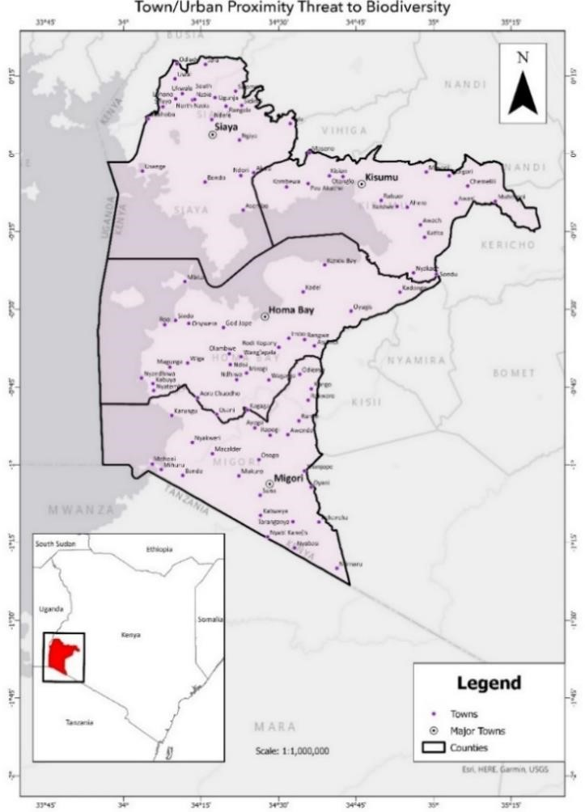
Main Settlements & Demographics. WB Carbon will work with smallholder farmers in rural areas of Kisumu, Homa Bay, Migori, and Siaya counties along the eastern shoreline of Lake Victoria/Western Block. These contiguous counties are part of the densely populated, predominantly Luo speaking region of Nyanza, Kenya, a name derived from a Bantu word that means a large mass of water. Kisumu city is the region’s major urban center, with its 400,000 people making it Kenya’s sixth largest city. County seats and other towns throughout the region are significantly smaller but growing rapidly, stressing the region’s resources. Population density outside of the main urban areas remains high relative to the national average of 82 persons per square kilometer, with densities at the county level ranging from 360 in Homa Bay to 554 in Kisumu. Luo are the primary ethnic group in all four counties, with significant populations of Kisii, Kuria, and Luhya also present.
Population centers/town are illustrated in Figure 2.1.15.a below. Settlements outside the few major cities reflect high rates of human habitation and modification of the natural landscape for agricultural purposes.

Figure 2.1.15.a Cities and Town in Project Zone

Land use and socio-economic status. The project area is characterized by the interrelated challenge of persistently high population densities, poverty rates, and subsistence-level agriculture production. In the four counties, 96 percent or more of the rural population is engaged in subsistence farming. Poverty rates in Kisumu, Homa Bay and Siaya counties are 34 percent

with higher incidence in Migori County at 41 percent, meaning individuals in these households are living on less than $1.20 per day. From the summary of recent census data in Table
2.1.15.a below, households in the project area have larger family sizes, lower access to services like main line electricity, and are highly dependent on the surrounding landscape for cooking fuel and livestock grazing. Educational attainment rates are near or below Kenya’s national average, with only 50 percent of the population completing primary school and 25 percent completing secondary school. A low ratio of men to women reflects an outmigration of males in search of enhanced economic opportunity and the lingering effects of the HIV/AIDS epidemic. Table 2.1.15.a. Household Census Data
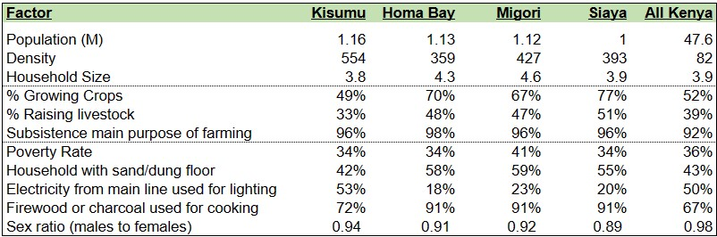

Socio-cultural context. GFCCA’ Community Assessment Report³⁶ conducted for WB Carbon supports this overall data picture and provides essential cultural context. Consistent with Kenya’s general economic growth over the last fifteen years, smallholder farming households reported improved access to educational resources and economic opportunities, but also recognized increasing pressures on land due to population growth, which has decimated community environmental resources valued for cultural, medicinal, and economic purposes.
Cultural influences over agricultural production practices are significant, with land use and cultivation decisions following a well-established hierarchy, including clear roles and responsibilities for farming activities dependent on age, marital status, and community standing with patriarchs as primary landowners and decision-makers. In households with multiple wives, first wives take precedence over junior wives when planting and harvesting. Landholdings are typically cleared as sons establish new homesteads, driving land use change. In addition to cash crop farming, livestock production, subsistence farming, and fishing, participants indicated other sources of income from rentals, unskilled labor, and formal employment.
Interviews and focus groups reflected significant challenges to female empowerment. Society in the project area is strictly patriarchal, with traditional roles for land ownership, land preparation, home building, and “breadwinning” to men, and home and child supervision, farm management, and marketing and retail businesses to women. Polygamy remains common in the project area with over 26 percent of women in Homa Bay county reporting marriages with one or more co-

wives. The percentage is slightly lower in Migori at 19.7 percent and substantially lower in Kisumu at 7.4 percent. Over 90 percent of women reported full or joint control over their earnings with their husbands, however most titled agricultural landholdings are held by men. ³⁷
2.1.16 Project Zone Map and Project Location (VCS, 3.11, 3.18; CCB, G1.4-7, G1.13, CM1.2, B1.2)
The WB Carbon project zone is defined as four counties (Migori, Homa Bay, Kisumu, and Siaya) in the Western Block of Kenya on the northeastern shore of Lake Victoria.

GFCCA is currently active in three counties — Kisumu, Homa Bay and Migori. WB Carbon is a grouped project and will include new project instances through the addition of new enrolled smallholder farmers at future verification events within the current area and in Siaya County. All project area coordinates are available in KML format.
Due to the nature of WB Carbon Project’s smallholder farmer model where operations are taking place on landowner plots scattered throughout a very large landscape, no offsite climate impacts and biodiversity impacts have been identified. Benefits are predominantly expected within farms that are privately owned and positive impacts will accrue to households participating in the program, with no anticipated negative impacts to offsite stakeholders.
Communities surveyed in community assessment identified High Conservation Values (HCVs) defined in Section 4.1.3 including local forests, water sources and other communal land areas as highly significant for cultural values, ecosystem services or community needs. They have been grouped separately given their shared purpose across the counties surveyed. These sites were not large, nationally recognized or protected lands and are difficult to map. A full list of community identified areas is available in GFCCA Community Assessment Report.
Biodiversity HCVs defined in Section 5.1.2 are located on the map in Figure 2.1.16.c including Lake Victoria, Ruma National Park, Gwasi, Lake Simbi Nyaima, and Lake Kanyaboli.
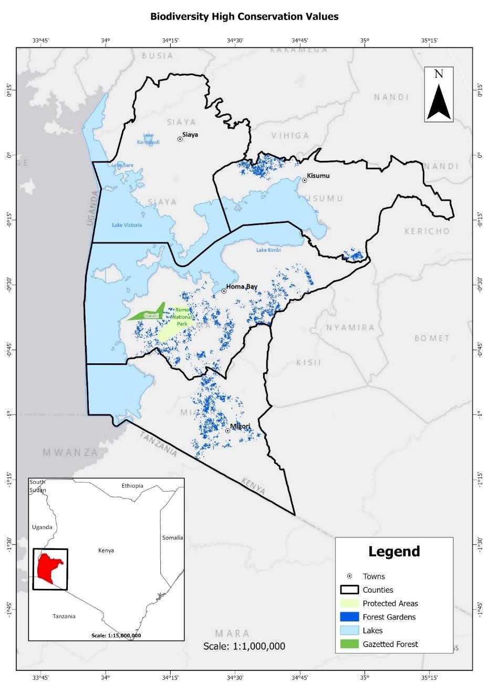
Figure 2.1.16.c. Biodiversity High Conservation Areas Map
2.1.17 Project Activities and Theory of Change (VCS, 3.6; CCB, G1.8)

WB Carbon will institute and sustain restorative agricultural practices on 40,000 hectares of farmland with enrolled smallholder farmers in four counties in the Western Block of Kenya. The project area is not covered by a jurisdictional REDD+ program. GFCCA’s FFAS methodology has demonstrated its ability to increase and diversify revenue sources for smallholder farm enterprises and to improve household food security, dietary diversity, and land productivity through current and completed programs. Smallholder farmers in the project area typically struggle to access sufficient cash flow in the months outside of the harvest of primary field crops, which are typically maize and beans. Forest farmlands fill this gap by providing a broad range of new products to sell or meet family needs throughout the year. As climate change advances, forest farmlands help even the most vulnerable subsistence farming households establish sustainable agriculture practices. GFCCA will encourage women to join the program and all monitoring and evaluation will prioritize assessment of equitable sharing of benefits by gender, as our experience is that the FFAS is particularly suitable for women farmers, contributing to their economic and social empowerment.

Forest farmlands utilize regenerative agricultural practices that sustain production and create ecosystem synergies that contribute to natural resources and biodiversity conservation. Farmers intercrop diverse tree and plant species in different formations to ensure continuous supplies of valuable food and forest products, to provide additional income opportunities, and to sustain essential environmental services. Perennial and annual food crops are intensively cultivated to provide products to eat and sell throughout the year. Appropriate GFCCA are selected to provide sustainable sources of fuelwood, timber, and livestock fodder to use or sell, which takes pressure off existing forests and landscapes. Farmers plant fast-growing nitrogen-fixing GFCCA and apply mulch, compost, and farmyard manure to protect and stabilize soils, reduce erosion, increase water filtration and moisture content, decrease soil temperatures, and build soil carbon and fertility. The use of organic fertility measures and Integrated Pest Management practices preclude the need for synthetic fertilizers and pesticides. Compared with monocropped land-use practices that will persist without the project, the increased vegetative cover and diversity, reduced agrochemical pollution, and enhanced microclimate of forest farmlands provide a more conducive habitat for biodiversity on-site and will contribute to conservation of biodiversity off-site. The project will measure the contribution to biodiversity conservation as part of its reporting under the CCB standards.
GFCCA operates at the center of a partnership including the investor and enrolled smallholder farmers who will transform their land into forest farmlands. Upon creation of carbon credits and verification, the investor will sell the credits on behalf of the consortium and share proceeds through GFCCA to the farmers in accordance with the Landowner agreement. Each farmer will be individually paid a carbon credit benefit share via MPESA within 60 days of GFCCA receiving the payment from the sale of the credits. The first payment will occur in 2028 and approximately every three years following. The calculation of the carbon credit benefit share is detailed in the Landowner agreement. This will be a meaningful addition to smallholder household livelihoods, supplementing the cost of family essentials like school fees for children, health emergencies, housing improvements, or investments in other businesses and income streams. Income from the project will encourage further labor investments in forest farmlands while maturation of diverse climate-sensitive agroforestry systems will yield measurable carbon and biodiversity benefits.
WB Carbon’s theory of change is that IF farmers create and maintain high quality forest farmlands with carbon financing AND the voluntary carbon market remains vibrant for AFOLU solutions like WB Carbon, THEN (a) CO2 will be removed from the atmosphere and stored in soil and plant biomass; (b) farmer resilience will increase through higher and diversified revenue, increased food security, dietary diversity and on-farm biodiversity; and (c) biodiversity will be further

supported on nearby forest and grasslands through reduced pressure from resource extraction by participating farmers.
WB Carbon is organized around four key activities, summarized in Table 2.1.17.a below and detailed in the following paragraphs, and will be implemented by a skilled team of agroforestry extension specialists and results-driven management team. This is consistent with the Theory of Change table provided in Appendix 2.
Table 2.1.17.a. Stakeholder Descriptions
Activity description | Expected climate, community, and/or biodiversity
 | Outputs (short term) | Outcomes (medium term) | Impacts (long term)
Activity 1.  Farmers receive capacity building on carbon rights and contracts during recruitment and mobilization | Farmers are enrolled in the program using Free, Prior, Informed Consent and a rights-based approach.  Farmers document land tenure and receive education on VCU creation and their individual carbon rights. | The project contract is signed with individual farmers agreeing to the project terms | Accumulation of individual agreements under the project forms an attractive investment in major financial markets.
Activity 2.  Farmers are trained in climate-adapted agroforestry systems | Adequate materials, tools and tree seeds purchased and distributed to farmers.  Farmers develop tree nurseries with support from GFCCA staff.  Farmers are trained and demonstrate capacity in sustainable land management  practices, including compost creation and use, soil and water conservation techniques, and  integrated pest management | GFCCA for live fence, alleys, fruit, and timber  planted and maintained.  Farmers cultivate fuelwood and fodder on farms.  Farmers restore degraded land | Pressure reduced on nearby forest and grassland resources.  Biomass below and above ground for long term carbon sequestration established and sustained.  Biodiversity supported with increased on-farm habitat for multiple species.  Farms are more resilient in a changing climate
Activity 3.  Farmers are trained to develop intensified agroforestry cropping | Farmers trained on diversifying crops on their farms through permafarmlanding and | Farmers design and operate farmlands in keeping with their own livelihood needs and | Empowered farmers measurably increase  their dietary diversity, food security, and
systems that improve livelihood and wellbeing of households | tree planting.  Farmers are equipped with key skills, including fruit tree grafting, seed saving and banking, enterprise development, and marketing | resilience strategies.  Farmers produce, consume, or sell diversified products, including fodder, fuelwood, vegetables  and fruit | income
Activity 4.  Inclusive carbon and CCB, MRV, and VCU program instituted and maintained | MRV plan instituted and operational capacity for execution retained (trained staff, qualified vendors, systems, etc.) | VCUs documented, registered, and sold with proceeds shared between the investors and the farmers | Farmers receive a new and durable income stream derived from their land management.

Activity 1. Farmers receive capacity building on carbon rights and contracts during recruitment and mobilization. Farmers are recruited through selection, sensitization, and agreement to undertake the project. Farmers with suitable landholdings are identified and introduced to the agroforestry program and its benefits as well as the labor and other requirements to develop and maintain a forest farmland. A special effort will be made to reach and register women, who we expect to make up at least 45 percent of participants and can often benefit immensely from a forest farmland situated near their homestead. Farmers registered with the project will have clear land boundaries and land registration to support their ownership. Upon conclusion of the orientation, farmers have the option to sign an individual contract with GFCCA and commence the program. Details regarding farmer mobilization and enrollment in the program can be found in Sections 2.3.1 and 2.3.2.

Activity 2. Farmers are trained in climate-adapted agroforestry systems. After signing the project contract, farmers begin a four-year intensive training program. Training is delivered by GFCCA staff members through a low ratio farmer extension model with 170 farmers per each technician. The fundamentals of the forest farmland are an intensively planted, nitrogen-fixing, impenetrable live fence around the farmland perimeter with nitrogen-fixing “alleys” planted throughout the farmland, which require over 5,000 GFCCA per hectare. GFCCA arranges for the provision of seeds, nursery materials, and essential tools for farmers to begin their nursery development and planting. The GFCCA and perennials for this intensive planting are raised by the farmers individually or exceptionally in groups, if water access for the seedlings must be centralized. Farmers learn and execute the required seed and soil preparation, filling of nursery bags, and the care of seedlings. When seasonal rains arrive, farmers plant their seedlings according to the required density and spacing for the rapid establishment of the live fence and alleys. Water flow throughout the farmland is assessed and the farmers receive assistance to maximize water retention through berms, swales, and cuvettes. The tree and perennial planting provide soil stabilization and nutrition through root development and creation of biomass for green manure, feeding of livestock, and access to fuel wood. Farmers are trained in seed harvest and preservation to serve their needs for periodic gap filling in the living fence and service of the market for tree seeds among neighbors and others who later become interested in developing a

forest farmland. Farmers start planting their GFCCA in year 1 of the Training Program and receive 3 more years for support and further training through the program.

Activity 3. Farmers are trained to develop intensified cropping systems that improve livelihood and well-being of households. As the live fence and alleys mature, farmers receive support to plan and execute their forest farmland in keeping with their personal needs and goals. Considerations include dietary requirements and preferences, proximity to and interest in accessing nearby markets, livestock requirements, labor and dry season water availability, and soil and microclimate conditions. The farmland itself is co-designed with the farmer and typically includes a mix and rotation of traditional field crops and legumes, a vegetable permaculture farmland, fruit GFCCA and vines, and a hardwood plantation. The farmland is designed to maximize diversity and horizontal and vertical space and provide monthly produce for household consumption and marketing. To support this design and execution, in-depth detailed training is provided on compost creation and use, development of a highly productive vegetable permaculture farmland, effective co-planting, and crop rotation, pruning and use of the living fence biomass for soil amelioration, composting, mulching and livestock fodder, and integrated pest management emphasizing a deep reduction and preferably elimination of chemical fertilizers and pesticides. Fruit tree access and grafting is facilitated by the project along with training in productive pruning, harvesting, and marketing of tree fruits. Most farmlands include a timber plantation as a form of long-term savings and hardwood GFCCA to provide permanent habitat and ecosystem services. GFCCA staff support nursery development and planting alongside the development of the other components.

By adopting a multi-story agroforestry system, farmers switch from annual post-harvest grazing, burning, and tilling their fields to a system that maintains and adds organic matter to the soil including no till, reduced till, cover cropping, mulching, and composting systems. Increased revenue from forest farmland sales typically is used for a mix of further forest farmland investment, investment in entrepreneurial activities, or for household consumption needs.

Activity 4. Inclusive carbon and CCB MRV and VCU program instituted and maintained. GFCCA will solicit and review proposals and keep up to date a roster of verification agents qualified to undertake VCS and CCB verification for WB Carbon. A verifier will be selected every three years, beginning in 2024 to validate the project and subsequently to verify carbon credits accrued. By agreement with our investor, validated credits will be transferred to them and sold on behalf of the partnership for retirement by buyers. Proceeds from the sale will be shared among partners according to the agreement with GFCCA and the onward contracts with individual farmers. Program inception benefitted from a baseline survey of flora and fauna commissioned by GFCCA from a consortium including the Wangari Maathai Institute, the National Museum of Kenya, and the University of Nairobi. We expect to continue our partnership as the forest farmlands mature to track the change in wildlife presence over time. Additionally, we are sourcing for like-minded partners to track the evolution of vocalizing species with listening devices in sampled forest farmlands as they mature. By working with Kenyan partners to conduct baselines of all CCB components we build local capacity to undertake future work autonomously and help build a competitive market for carbon-related services.

Figure 2.1.17.a on the following page presents a stylized plan of the result of the FFAS with the components identified.
Figure 2.1.17.a. Forest Farmland Model
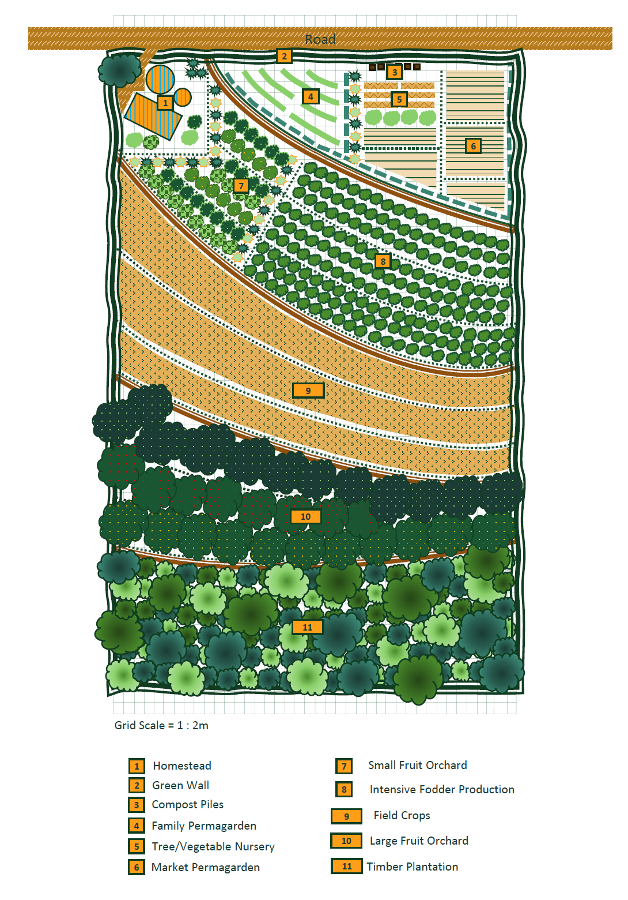

Table 2.1.17.b below provides a summary of the components of the forest farmland. A full list of species, spacing, and planting area can be found in the Design of the Full Forest Farmland.
Table 2.1.17.b. Summary of Forest Farmland Components

Forest Farmland Component | Description
Green Wall | Surrounding the entire 1 ha plot. Outer row of thorny fastgrowing GFCCA; middle row of multi-purpose fast-growing (MPFG) agroforestry GFCCA and nitrogen-fixing GFCCA (NFTs); inner row spaced further of mixed species of MPFG, fruit, and timber.
Alleys | Rows of MPFG/NFTs and grasses spanning across the site and segmenting sections.
Family Permafarmland | Families grow diverse vegetables, small fruits/GFCCA, herbs, IPM plants, etc. around/near their homes for easy access throughout the year
Tree and Vegetable nurseries | Area where tree and vegetable seedlings are raised for planting
Market Permafarmland | Market vegetables are planted in a grid, segmented by alleys and surrounded by perennials for IPM
Small Fruit Orchard | Production of small fruits, primarily for market
Fodder Plot | Intensive production of a mix of livestock fodder (shrubs and grasses) for cut-and-carry. Livestock housed in onsite corral and kept from grazing the site.
Large Fruit Orchard | Orchard for larger, high-value fruits and nuts

Timber Plantation | This plot should be in the least accessible area of the site; to be left to grow indefinitely
2.1.18 Sustainable Development Contributions (VCS, 3.17)

WB Carbon mobilizes market-based financing to help Kenya meet its sustainable development and climate change mitigation and adaptation goals and priorities. The project is closely aligned with Kenyan development priorities and well positioned to contribute directly to development in the project areas with additional benefits emanating out around the region. Kenya Vision 2030 — the country’s lodestar for development towards global competitiveness and prosperity — is broadly aligned with the UN’s Sustainable Development Goals (SDGs). Kenya Vision 2030 makes ensuring food security is a priority, which WB Carbon will contribute to by improving soil health and productivity on participant farms, allowing surplus produce to enter local and regional markets through established trade corridors. WB Carbon’s mapping onto the SDGs can be found in table
2.1.18.a below.

Table 2.1.18.a. Project alignment with UN Sustainable Development Goals

Name | WB Carbon’s Contribution
1: No Poverty | The WB Carbon Project implements a more diverse cropping system that leads to increased income. In addition, farmers receive payments for carbon as an additional crop.
2: Zero Hunger | The project promotes sustainable agroforestry to improve crop yields and diversify crop production for harvest throughout the year. Farmers also plant fruit GFCCA and vegetables for a more nutritious and well-balanced diet.
3: Good Health and Well-being | Increased food security, nutrition and income all lead to improved health and well being
4: Quality Education | Increased income from improved farm production allows farmers to pay for school fees for their children. In addition, farmers receive high quality training on sustainable agriculture techniques and continued mentorship over 4 years.
5: Gender Equality | The project creates an environment for gender equality whereby women are given the same opportunities as men. It is enforced by ensuring there is a gender balance in employment, leadership, lead farmer representation and participating farmers. There is greater than 40% representation among farmers.

8: Decent Work and Economic Growth | When the productive capacity of the land is fully utilized in a sustainable system, farming is an independent and quality lifestyle. The aim of the project is to achieve this state for farmers. In addition, the employment opportunities in this project provide staff with meaningful work that utilizes their skills, degrees and experience. Creating employment opportunities and increasing the income of community members strengthens the local economy.
10: Reduced Inequality | The project is open to smallholder farmers that meet the criteria with no discrimination based on gender, age, disabilities, or ethnicity. Originally the project eligibility required farmers to have 1 ha of land, this was modified to allow a percentage of farmers who have less than 1 ha into the program, to ensure equality among smallholder landholders.
11: Sustainable Cities and Communities | Sustainable agriculture and increased tree planting improve sustainable communities.
12: Responsible Consumption and Production | Sustainable agriculture practices that eliminate the use of pesticides and chemical fertilizers result in sustainable agriculture reduction and reduce food imports.
13: Climate Action | The WB Carbon Project is a CO2 removal project through improved agriculture land management and agroforestry.
15: Life on Land | This project provides biodiversity benefits through increased tree cover canopy, increased habitat, creation of linkages to high conservation values, and improving soil biodiversity.
17: Partnerships to Achieve SDGs | The WB Carbon Project incorporates numerous local, national and international stakeholders across sectors to achieve multiple benefits.

WB Carbon will help Kenya meet its updated Nationally Determined Contribution (NDC) to the UN Framework Convention on Climate Change (UNFCCC), which aims to reduce the country’s greenhouse gas emissions (GHG) by 32 percent by 2030. As a member of the national Climate Change Directorate’s NDC Steering Committee and Carbon Markets Working Group, GFCCA is committed to contributing to both carbon mitigation and adaptation strategies. Through WB Carbon, GFCCA will scale up implementation of the Forest Farmland Agroforestry System, an innovative livelihood strategy that increases household and community resiliency. Working with 40,000 farmers to transform their land enhances adaptive capacity and climate resilience across the economy of the project area. WB Carbon supports the NDC’s mitigation strategies by supporting

the adoption of climate smart agriculture (CSA) practices, improving energy and resource efficiency, and increasing tree cover, and working towards achieving land degradation neutrality.
WB Carbon’s work will directly support Kenya’s conservative land restoration target of transforming 1.4 million hectares of cropland with less than 10 percent tree cover to agroforestry systems by 2030. WB Carbon’s project area is a primary focus area designated for restoration, which is important to addressing land use challenges ranging from loss of soil fertility and erosion to water stress and siltation and sedimentation of water bodies.
2.1.19 Implementation Schedule (CCB, G1.9)

Date | Milestone(s) in the project’s development and implementation
1 January  2025 – 31  December  2030 | Mobilization, Consultation Meetings, Registration and Farmer  Contract Signing  - Conducting FPIC and Registering farmers in Program  - Signature of contracts with all cohorts
1 January – 31  December  2034 | Forest Farmland Implementation Timeline: 4-year training program for each new grouped instance (trainings are detailed in Table 2.1.19 b)  - Year 1 trainings  - Year 2 trainings  - Year 3 trainings  - Year 4 trainings
1 January  2025 – 30  June 2035 | Project Activities  - Nursery development Semi Annually (Jan-Feb)/(Aug-Sept)  - Ouplanting Semi Annually (Mar-June)/(Oct-Dec)  - Development of all forest farmland components based on training.  - Full Forest Farmlands Completed and Projects graduating
29 March 2025 – 23 December  2025 | - Submission of the Project Document (PD) to Verra  - 30 Public Comment Period  - Field Validation  - Validation Approval by Verra
1 March  2025 – 31  December  2054 | Carbon Crediting Timeline  • Annual Monitoring during project implementation (starts in 2025)

 | • | Verification Events (starts in 2025)
 | • | Verification by VVB (every 3 years after 2025)
 | • | Credit Issuance (starts in 2028)
 | • | Continued forest farmland maintenance and replacement tree planting (starts in 2025)
 | • | Continued Management, Communication, and Monitoring (starts in 2025)
1 January  2040 – 31  December  2050 | • | Continued Management, Communication, and Monitoring for Permanence of all grouped instances
The start date of WB Carbon and the crediting period is March 1, 2025. The project is expected to last 25 years with all instances of farmers enrolled by 2030 and the project ending in 2050.
Justification. GFCCA maintains a cloud-based Salesforce database record of each project instance indicating the dates that farmers were first registered in the program, farm polygons, training, and dates of each planting. These records are available to the Validation/Verification Bodies (VVB) and stored by project number. Data collected by GFCCA indicates that the first GFCCA planted by farmers in the project areas were on September, 2022. Data from the first project planting in the monthly reporting forms and list of registered farmers in 2022.
Gantt charts. The following Gantt charts indicate the timing of project activities for each farmer added to the project, which has three phases that stretch over 25 years. Phase 1 is GFCCA active implementation of WB Carbon, including all project activities mentioned in Section 2.1.17 above, starting in 2025 and continuing until 2035. Phase 2 for each farmer is the ongoing post-project verification and credit issuance, which will begin in 2025 for the earliest farmers and continue until 2050 for the last cohort. Phase 3 will be the post-crediting project permanence beginning in 2040 and ending in 2050 through permanence measures that extend beyond the crediting period as per guidance in NPRT.
Gantt chart columns are split into years ending with the number indicated and divided into the two rainy seasons. “L” indicates the long rainy season, starting in January and continuing through June with the rains starting in March, while “S” indicates the short rainy season, starting in July and continuing through December, with rains starting again in October.
Mobilization, Consultation Meetings, Registration and Farmer Contract Signing. Current financing allows for implementation of the project with smallholder farmers on 2,000 acres in a grouped project with the first three instances beginning between 2025-2028. Future carbon financing is expected to allow for the enrollment of 38,000 additional hectares annually through 2030.

Table 2.1.19.a. Registration Activity Timeline
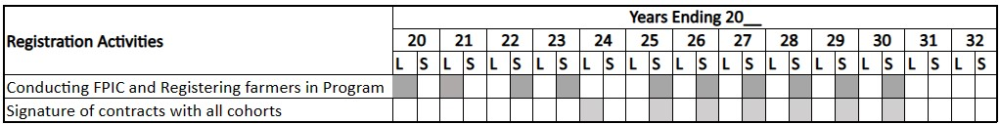
Phase I: Forest Farmland Implementation. GFCCA’ initial implementation of WB Carbon occurs over a four-year period for each instance of farmers. The first instance of farmers will complete the full forest farmland transformation in 2024 and the final instances are expected to be complete by 2035. Twenty hands-on field-based training courses are provided to farmers over a four-year period and coincide with the seasonal rains and the forest farmland stage of development. Farmers develop tree nurseries and plant them on their land twice each year over a four-year period.
Table 2.1.19.b. Forest Farmland Implementation Timeline
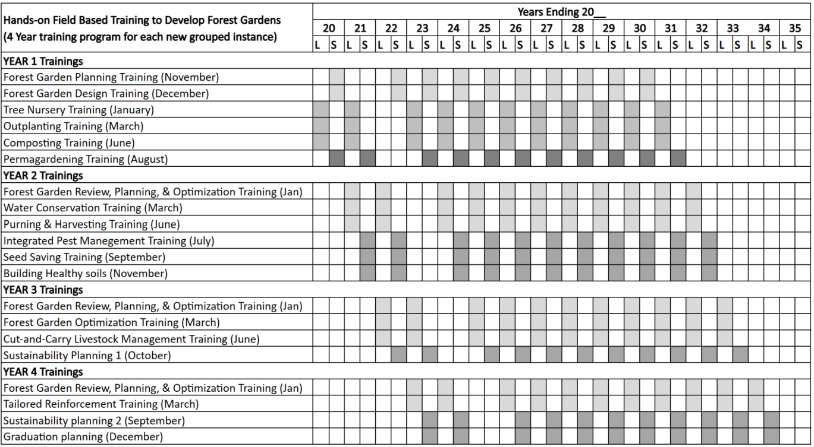
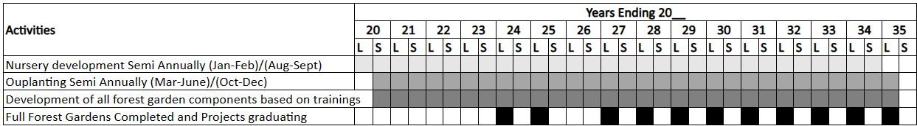

Phase II: GHG Crediting Period. Each instance of WB Carbon is scheduled to have a four-year phased implementation period and a 24-year crediting period (from the start of each instance). GFCCA expects that marginal increments of carbon sequestration beyond that timeline for each cohort would be minimal and consequently not economical to verify.
Validation is expected to occur in 2025/2026 and the first verification event will occur in 2026 for farmers that began in 2024 through 2025. Verification events will occur every three years following the first event with credit issuance expected within 24 months of the start of each verification event.
Phase III: Project Lifetime. Per VERRA update ID#10, the project lifetime will conclude in 2050, 25 years following the full implementation of the final group of farmers – for the purpose of permanence monitoring. To ensure project permanence GFCCA has developed a three phase Adaptive Management Plan and a Long-Term Management, Communications, Monitoring and Financial Plan for WB Carbon.
Table 2.1.19.c. Carbon Crediting Timeline
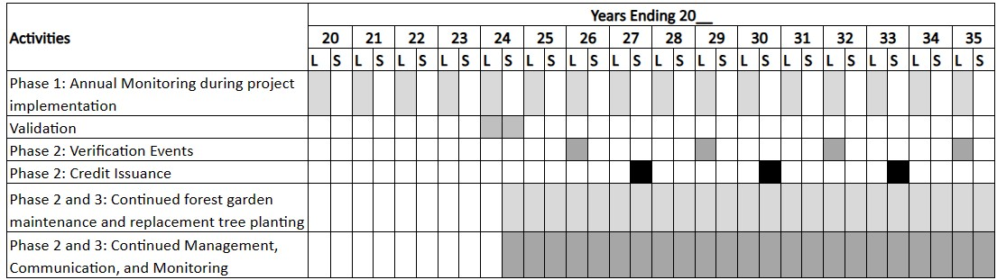
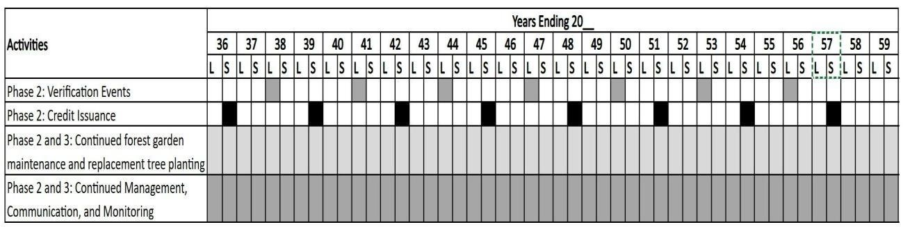
2.1.20 Risks to the Project (CCB, G1.10)

Identified Risk | Potential impact of risk on climate, community and/or biodiversity benefits | Actions needed and designed to mitigate the risk
Gender  Sensitive  Operations | Through the project design and stakeholder engagement process, GFCCA has identified the potential for harassment or discrimination for project | The project will support the full participation of men and women farmers of all ages to mitigate these potential countervailing

 | participants as a potential negative impact. The project requires attention to potential discriminatory practices that are not legal but are supported by traditional, patriarchal practices. | pressures on project participants. To mitigate these risks, GFCCA’ staff and participating Lead Farmers will be trained on GFCCA Preventing Sexual Harassment and Abuse Policy outlined in Section 2.3.14 and provided with contact information and various ways of reporting incidents as outlined in Sections 2.3.13. The project will closely monitor community impacts through its adaptive management and community monitoring to identify additional areas for mitigation. GFCCA will partner with legal and specialist gender resources to assist with policies, practices and capacity building opportunities which will help anticipate and mitigate potential challenges in this area. In addition, as outlined in Section 2.5.1, gender equity in the distribution of the carbon credit benefit share is central to the Landowner Agreement through a sub agreement between the farmer (who may be a woman) and the landowner who is often a man.
Project continuation through multiple generations | With the long crediting period of the project, WB Carbon is an intergenerational project wherein children inherit parents’ land. There is a risk that children inheriting the land will not continue the project activities. | To promote continuation when ownership changes, the farmer contract commits to maintaining the forest farmland over 24 years and allows for family inheriting the land to continue the project and obtain the carbon credit benefit share. GFCCA is committed to stimulating a more vibrant rural economy through the Forest Farmland Agroforestry System (FFAS) supplemented with carbon credit revenues, making farming a more attractive livelihood option for youth in the project area. Moreover, the presence of young, college-educated men and women project officers working with farming families’ benefits youth by providing role models in agriculture.

Farmers leave the program. | Farmers may leave the program for various reasons. | GFCCA targets enrollment of ten percent over the target so that the net land enrolled in the program will meet the target of 40,000 hectares despite any losses. This ten percent buffer is based on a five to ten percent dropout rate in projects across five countries over the last ten years. GFCCA grievance mechanism also helps ensure that farmers’ concerns are addressed promptly, and unexpected dropouts do not occur.
Trees are cut and sold, or farmers change land use. | Extractive exploitation of natural resources has become commonplace in the project area as declining yields and population growth have increased demands on the land. | The FFAS mitigates this by helping farmers develop a long-term reciprocal relationship with their forest farmlands and the trees that disincentivizes deforestation. Farmers benefit from increased soil fertility, crop diversity, income, food, sustainable cooking fuel, fodder for animals, and resilience to droughts and floods. Farmers receive training on tree management, pruning sustainable fuel wood use, and harvesting trees leaves for fodder, which allows them to extract value from their forest farmlands without undermining its long-term viability, and revenue from carbon credits simultaneously adds value to the land and farmer incomes.  Moreover, farmers sign a contract committing to maintaining the forest farmland over the project lifetime and understand through the training process that carbon payments are contingent on maintaining their forest farmlands.
Natural risks | Drought, flooding, pests, and fire can affect the project communities. | Natural risks such as drought, flooding, pests, and fire are mitigated by the forest farmland design and numerous training sessions on proper management. Once established the forest farmlands create an environment that conserves water and
 |  | channels it back into the ground, creating resilience to rainfall variability, including drought and flooding, and ensures large quantities of biomass for mulching and moisture retention. The integrated pest management system includes training on natural pest control and companion planting, reducing pest infestation common when monocropping. Maintaining and pruning trees helps manage the risk of fire.
Land confiscation via eminent domain | Risk of land confiscation in the project area via eminent domain is low, as it is very rare historically. | Farmland in the project area is generally located far from population centers and there are no large-scale projects planned that could indicate heightened risk. If land was taken via eminent domain there are laws governing the payment requirements to farmers.⁵²
Government implements nonfavourable carbon regulations |  | Kenya has a NDC under the Paris  Agreement with Adaptation Learning Mechanism (ALM) practices as one of the mitigation and adaptation pathways. As described in Section 2.5.8, the Kenyan government recently passed the Climate Change Act that clarifies the basis for carbon trading under Article 6 of the Paris Agreement and strengthens the role of the Kenyan Climate Change Directorate (CCD) to lead policy making for Kenya’s participation in the Voluntary Carbon Market (VCM). This act is favorable to VCM investors and WB Carbon is recognized by the CCD as a pioneering project in carbon reduction through land use transformation in Kenya.

⁵² WANYONYI, Agatha, Monica OBONGO, Peter MBURU, and Jane NDIBA. “Land For Infrastructure Development:
Compulsory Acquisition And Compensation Of Unregistered/Undocumented Land In Kenya.” In Responsible Land
Governance: Towards an Evidence Based Approach. Washington, D.C.: The World Bank,
2017.https://land.igad.int/index.php/documents-1/countries/kenya/investment-3/648-land-for-infrastructuredevelopment-compulsory-acquisition-and-compensation-of-unregistrered-land-in-kenya/file.

Working conditions |  | Farmers voluntarily choose to undertake the Forest Farmland approach on their properties and are trained on safe farm management. The working conditions of staff employed through the project is managed through GFCCA Kenya Personnel Manual and Code of Conduct and elements outlined in Sections  2.3.16 and 2.3.17 and Kenya  Employment Laws and Regulations listed in Tables 2.5.7.b and 2.5.7c.
Safety of minority and marginalized groups including children |  | The project does not discriminate farmer participation in the program based on ethnicity, health conditions, disabilities, gender, or age. There are several farmers living with disabilities and living with HIV involved in the program. There are also farmers of all age ranges with the minimum requirement of 18 years of age. Trainings are adjusted on a group-by-group basis to address special needs. All trainings are conducted in local languages, primarily in the dialects of Luo and Luhya.
2.1.21 Benefit Permanence (CCB, G1.11)
GFCCA’ FFAS is a tested, durable solution for farmers that ensures long-term land transformation and benefit permanence. We have supported the establishment of forest farmlands since 2014 and have observed that farmers sustain the model beyond graduation from the four-year training program because they see that it is a better way of meeting their needs and maximizing financial returns. It provides protection from grazing animals, increases soil fertility, income, food production, sustainable cooking fuel, and fodder for animals. Farmers have ultimate control over the design and modification of their land – our partnership ensures their agency to revise the farmland as their needs and markets change. Although the benefits of the forest farmland are readily apparent after transformation, the FFAS requires a significant upfront investment. Traditionally this has come from donor funding, but carbon financing provides a new market-driven model to catalyze transformation.
A forest farmland multiplies the number of income streams on the farmer’s small plots of land, staggering revenue across the year rather than depending on a single crop that is harvested at the same time across the region. Income diversification reduces risk and can increase returns. It is especially valuable as the effects of climate change intensify. Payments scheduled through the carbon sales are a reliable additional revenue stream and are a further incentive to sustain their farmland beyond the active training period.
Training delivered through the FFAS emphasizes sustainable extraction of resources from the forest farmland in ways that balance the needs of the new plantings with household consumption and income needs. The introduction of diverse fruits and vegetables to previously monocropped land helps households improve dietary diversity while depending less on potentially unreliable markets. Households also can save significant amounts of money by practicing the sustainable harvesting of wood for fuel and fodder taught by the project, helping to reduce demand on a trade that drives deforestation locally. The project intends to create systemic change in the economics within the project area. These changes, supported by the 25-year project lifespan, are designed to be sufficient to set up self-sustaining economies providing ongoing socioeconomic benefits to the region.
2.1.22 Financial Sustainability (CCB, G1.12)
The project is looking for an investment into the initial 10,000 ha to be restored across the 5000 farmers in the next 5 years. This investment covers the full anticipated cost of the farmer mobilization and training, agroforestry inputs, and expenses for monitoring, validation, and verification. The breakeven financial internal rate of return (IRR) on the implementation investment through the sales of VCUs is projected to occur in less than seven years. Net VCU sales will be shared between the investor, GFCCA, and participating farmers.
A portion of net sales of VCUs allocated to GFCCA will support project management, communications, and the monitoring program during phase 2 – the crediting period – and phase 3 – the post-crediting permanence period. Details are provided in the Long-Term Management, Communications, Monitoring and Financial Plan. The IRR information is available for the VVB to review.

Without-project Land Use Scenario and Additionality
2.2.1 Conditions Prior to Project Initiation and Land Use Scenarios without the Project (VCS, 3.13; CCB, G2.1)
The conditions existing prior to the WB Carbon Project are detailed in Section 2.1.14 and are the same as the baseline scenario for the WB Carbon Project detailed in Section 3.1.4. GFCCA confirms that the project is not implemented to create GHG emissions for the purpose of their subsequent reversal. Tree installation and management is intended for the long-term enhancement of agricultural lands.
In the absence of the proposed carbon project, the following two scenarios are projected:
- Scenario 1: Land would remain monocropped and cropland would continue to expand on natural grasslands until there was no longer grassland left.

- Scenario 2: Degraded cropland is unable to continue production and becomes barren.
The project is located in Western Block, a global biodiversity hotspot characterized by a high elevation inland equatorial climate and degraded forests and habitats. Soil is varied, suited to a range of agricultural activities, and has a low risk of erosion. A detailed description of existing conditions can be found in Section 2.1.14. The pre-project land use in all planted areas was non-forest land either for subsistence, low-income agricultural crops such as maize and beans, or degraded lands that were minimally productive. WB Carbon trains farmers and provides materials to implement agroforestry systems on this land. Pre-project land use has continued for decades and is persistent in large areas of the project region. Farmers in Kisumu, Homa Bay, Migori, and Siaya counties are trapped in cycles of poverty, which are exacerbated by the lack of access to finance and sustainable farming techniques, perpetuating low-revenue agricultural production. Without the project activity, the lack of public and private investment and lack of economically feasible alternatives strongly indicate the continuation of pre-project land use. Although forest land is not being converted to farmland, natural forest areas are being harvested for fuel wood which is the primary resource for cooking fuel. There is no indication either through laws or government or industry plans that the cooking fuel sources will change in the near future.
2.2.2 Most-Likely Scenario Justification (CCB, G2.1)

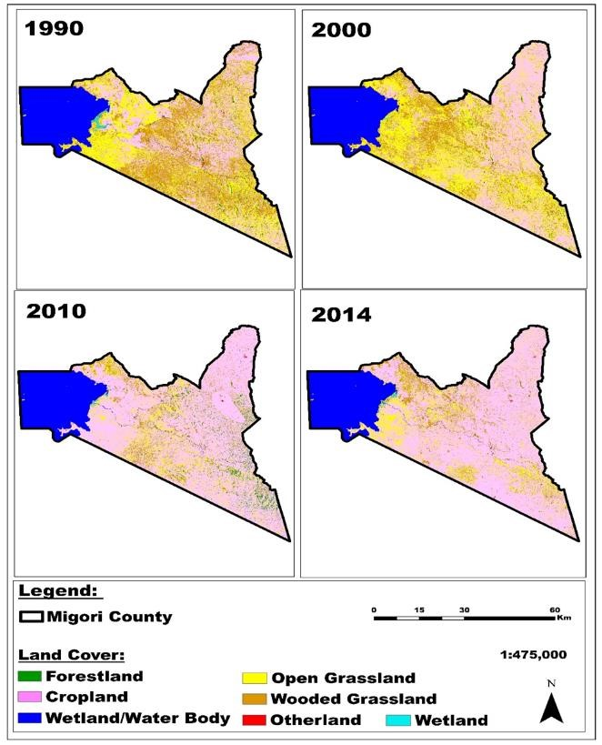
The case for the non-project scenario is most evident from the current trend of land conversion in the project area. An assessment of satellite data through the SLEEK system illustrates in time series the outcome of choices that a growing population is making for survival – the rapid conversion from grassland to cropland since 1990 is clear and striking. Figure 2.2.2.a below illustrates Migori’s transition to cropland from grasslands and woody grasslands to be nearly complete in the fifteen years from 1990 and 2014. The illustrations for Kisumu, Homa Bay, and Siaya (not shown) exhibit an identical trend.

Figure 2.2.2.a. Migori County Land Transformation

As can be seen in Table 2.2.2.a below, the conversion across the three counties is a total of 183,000 hectares from 1990 to 2014. This amounts to 33 percent of the estimated total of 560,000 hectares under cultivation in the counties in 2014.
Table 2.2.2.a. Cropland Coverage (Hectares)
County | 1990 | 2000 | 2010 | 2014
Kisumu | 119,947 | 114,926 | 156,320 | 153,250
Homa Bay | 165,100 | 165,124 | 208,227 | 203,648
Migori | 151,869 | 147,228 | 201,628 | 202,718
Siaya | 100,000 | 135,480 | 206,202 | 198,795
Total for Project Area | 536,916 | 562,758 | 772,377 | 758,411
Pressure from the addition of cropland, fuelwood collection, and charcoal creation resulted in rapid reduction of remaining forests in the project area between 1990 and 2000, however appears to have recovered partially by 2014 due to reforestation efforts promoted by the government and others.
Considering the compelling evidence of rapid transformation of land use into crop land and the few obvious livelihood options for smallholders, GFCCA expects that the “without” project scenario would be a continuation of the traditional monocropped model. Smallholders struggle to maintain their food security and livelihoods with traditional farming methods and increasingly scarce land area in the face of a growing population. This puts pressure on remaining biodiversity resources and the cycle of land degradation is likely to continue through continued monocrop agriculture and expansion into uncultivated areas.
2.2.3 Community and Biodiversity Additionality (CCB, G2.2)

This project would not exist on a landscape level scale without carbon financing which provides the upfront investment for the agroforestry system development. The additionality demonstrated in Section 3.1.5 applies to WB Carbon community and biodiversity benefits as well. The Kenyan government and academics have identified agroforestry as a key part in relieving the conundrum in which smallholders in the project area and elsewhere find themselves. A recent paper by Benjamin Kinyili laid out the case for a vibrant agroforestry sector, including the enormous and continuing demand for forestry resources by rural Kenya families. Also cited were the laws prohibiting the harvest of trade and timber on public or communal lands which further restricts options for families to meet their needs. Wood accounts for 80 percent of rural household fuelwood needs with additional requirements for dwelling construction and maintenance, tools,
and other necessities such as medicinal plants, honey, and herbs. This amounts to an ever expanding demand for biomass and products from increasingly scarce non-cultivated lands.
Kenya’s Ministry of Agriculture, Livestock, Fisheries, and Cooperatives has taken the lead in promoting agroforestry. Their Technical Report on the National Assessment of Forest and Landscape Restoration Opportunities in Kenya 2016 provided a detailed situation analysis and indicated that cropland in western Kenya is highly suited for conversion to agroforestry land, delivering both direct income and resilience benefits for farmers facing the effects of climate change. This report informed the ongoing prioritization of agroforestry in the National Climate Change Action Plan which set a target of 281,000 hectares under agroforestry systems by 2030, in addition to the target set in 2012 of 10 percent of Kenya’s total land area to be forested. Other supportive policies include the Kenya Smart Agriculture Policy (2017) and Agricultural Sector Transformation and Growth Strategy (ASTGS): Towards Sustainable Agricultural Transformation and Food Security in Kenya 2019-2029.
Despite these efforts, the Ministry admitted that agroforestry has been slow to take off, saying that “the benefits accruing from agroforestry practices have not been demonstrated well enough to guarantee adoption countrywide, implying that other drivers of adoption need to be pursued.” Kinyuli cited several constraints to expansion of the sector, including a need for an improved policy and legal environment, inadequate research and extension services, uncertain market and value chain information supporting investment, access to finance for agroforestry installations, and certainty of land tenure.
WB Carbon addresses several of the priority gaps to agroforestry expansion, particularly through financing and technical assistance to farmers. The project is additional and essential to achieve the anticipated community and biodiversity benefits for two key reasons:
Required extension services do not exist without WB Carbon. This is an intensive behavior change activity that requires sustained, high-quality extension services at a large scale. Agroforestry requires a drastic change in farm management, often in opposition to inherited orthodoxy and general practices. Without initial education and regular, high-quality farmer extension, there is no way for most farmers to understand the benefits of the system and then participate in
transitioning their land into an untested new venture for them. GFCCA’s extension to farmer ratio is 1:170 with qualified, trained personnel equipped with motorbikes, fuel, airtime, regular supervision and oversight, and access to updated, high-quality training materials. This contrasts with public sector extension in Kenya, with an agent to farmer ratio of 1:1083. These overtaxed agents are not equipped with functioning motorbikes, fuel, and airtime to visit farmers and conduct follow up visits or calls, nor do they typically have access to formal guidelines, a governing code of ethics, or working standards. Other, small extension agent groups may be associated with the major input suppliers or commodity purchasing sectors, but they are often quota-driven and lack capacity for the type of assistance needed even if they possessed the time and inclination.

The local financial ecosystem cannot realistically fund the requirements for this scale of agroforestry establishment. In addition to the high cost of extension, GFCCA funds the nursery program directly, obtaining in 18 months the full establishment of the essential components of the green wall, alleys, and compost program across each project instance. This includes bulk purchase of the nursery bags, organization of farmers into groups for nursery management, and provision of needed tools and soil amendments for the seedlings. The installation of trees at the scale required is cost and labor intensive and far beyond the financial reach of the average smallholder in the project area. Further support is needed to initiate perma-farmlanding and fruit tree activities. In theory, loans may be available through microfinance institutions or the Savings and Credit Co-Operative Society (SACCO) system, which as a sector has doubled its loan portfolio since 2016, but overall, very little financing goes to the agricultural sector in Kenya – an estimated 3.6% of loans nationally – and smallholders typically lack the collateral required for loan access. If financing could be arranged, the risk for servicing a loan over 20 percent interest for several years while the forest farmland is established would be prohibitively high. Even if it was affordable, it is not realistic to imagine loans being demanded by smallholders at scale for the purpose of installing an as-yet unknown solution on their property.
2.2.4 Benefits to be used as Offsets (CCB, G2.2)
Not applicable.

Safeguards and Stakeholder Engagement
2.3.1 Stakeholder Identification (VCS, 3.18, 3.19; CCB G1.5)

GFCCA conducted a feasibility assessment prior to project stakeholder identification in Homa Bay County to ensure appropriate agro-climatic conditions and natural resources for project activities. This assessment in 2022 prioritized project areas along trade corridors that are highly populated and directly link to market hubs in regional cities and capitals that could provide market opportunities, beyond the rural communities where farmers reside, and enabling farmer groups to sustainably produce and sell their products in increased volumes for higher prices. Once potential trade corridors were identified, GFCCA followed the stakeholder identification process outlined in the text box, which helped identify future participants in the project. GFCCA followed an inclusive and participatory process to identify stakeholders to promote community engagement and stakeholder support. GFCCA identified areas where there is high potential for impact, looking specifically for locations that have:
- Support from relevant government ministries and regional or local offices, and alignment between the FFAS and relevant development plans and mandates.
- The presence of cooperatives and small producer groups that are interested in selling products suitable for production in the FFAS.
- Rural or semi-rural areas where subsistence farming is the dominant livelihood activity.
- Households experiencing food insecurity and economic instability.
● Farmers who have clear tenure to farm at least 0.5 hectares.
- Telecommunications access, including Wi-Fi internet and reliable mobile phone network coverage.
- Where possible, limited presence of other agriculture-related development projects and international NGOs to avoid duplication but permit collaboration where feasible.
WB Carbon’s project area lies along the trade corridor within the Western Block and the Lake Victoria area that connects eastern Uganda, western Kenya, and northern Tanzania. A series of meetings with stakeholders in the area confirmed that it is a good location to initiate projects. During initial assessments, GFCCA identified and met with the following stakeholders from the local government, cooperatives and producer groups, NGOs, and farmers:
- County Director of Agriculture, Central Homa Bay
- County Cooperative Commissioner, Central Homa Bay
- Subcounty Agriculture Officer, Homa Bay
- Subcounty Cooperative Officer, Homa Bay
- County Coordinator for USAID/KAVES Project, Homa Bay
- Representative from Heifer International Wealth Creation Programme
- Representative from Plan International, Homa Bay
- Capital Grown Cooperative Society, Kendu Bay
- Kenya National Federation of Agricultural Producers
- Bwogi Makbwogi Farmers Group
- Homa Bay Environmental CBO (Community Based Organizations)
- A sample of 70 farmers in the region to assess interest in the project and suitability of their sites.
Additional mobilization meetings with similar stakeholder groups were held in Migori and Kisimu counties prior to starting activities in 2022. To identify the entry points for engaging with communities, the WB Carbon project met with district, county, or sub-county leadership to help identify and engage communities and farmers. Meetings are held with government officials where relevant to discuss GFCCA and the project aims, describe how the project aligns with their agendas, and to solicit their support in mobilizing communities and farmers. In some cases, they may assign an individual to assist GFCCA’s mobilization team with community entry and identification of farmer groups.
The primary stakeholders of WB Carbon are enrolled smallholder farmers. Rather than preselecting specific farmers, GFCCA publicizes the opportunity to participate at the community level and all smallholder farmers are welcome to attend informational meetings. During assessment and mobilization, GFCCA targets farmers and families who have the ability to benefit considerably from participation. Poorer and more vulnerable families such as women-headed households are prioritized during group and farmer identification and registration. It is also important that their land, the sites that families will convert to Forest Farmlands, meet the project criteria. These are important factors for long-term success, ensured additionality, and sustainability. To participate in the program, the families and sites will:
- Have secured tenure.
- Be within one kilometer of the family’s home.
- Be no more than one kilometer from a year-round water source.
- Be at least ½ hectare (roughly 1 acre) in size.
- Contain no more than 15% tree cover or perennial crop cover.
- Not currently resemble a forest farmland.
- Have been used for agriculture, as natural habitat should not be cleared to convert a site.
A summary of project stakeholders is provided below in Section 2.3.2. Additional information on Information communicated with stakeholders is provided in Section 2.3.5 and stakeholder consultation throughout the project is provided in Section 2.3.10.
2.3.2 Stakeholder Descriptions (VCS, 3.18, 3.19; CCB, G1.6, G1.13)
WB Carbon’s implementation will consist of five key stakeholder groups. Summary descriptions of each group are provided in Table 2.3.2.a below and a table outlining their rights, interests, and overall relevance to the project is provided in Appendix 1. Additional information regarding information sharing is detailed in Section 2.3.
Table 2.3.2.a. Stakeholder Descriptions
Stakeholder | Description
Enrolled  Smallholder  Farmers | Enrolled smallholder farmers (enrolled farmers) are the primary stakeholders. As detailed in Section 2.1.6 and 4.1.1, farmers in the project area are largely homogenous smallholders working on degraded lands for subsistence agriculture. GFCCA engages farmers through a community mobilization process and all farmers have the same rights and interests as outlined in their individual farmer contracts. Farmers join the program through community enrollment meetings, are registered formally with the project, and provide key input and feedback throughout the project lifecycle.
Lead Farmers | Lead farmers share the demographic profile of enrolled farmers but have a distinct role in the project. Lead Farmers are a particularly essential stakeholder, as they are nominated by their peers to provide group leadership and mentoring for each group. Lead Farmers are provided additional training of trainer (TOT)
 | capacity building and support GFCCA’s staff during training and by providing follow-up site visits to support implementation, answer farmer questions, and raise any questions or concerns to WB Carbon staff. Each Lead Farmer supports a group of approximately 25 farmers and helps gather initial data from their group on adoption of skills following training and GFCCA planted on a monthly basis. For their additional support and level of effort, Lead Farmers are paid a stipend for part-time employment.
Local & National  Government | Government authorities are key stakeholders for agriculture, rural development, and natural resource-focused programs throughout Kenya. WB Carbon aligns with Kenya’s national priorities, including but not limited to Kenya Vision 2030, Kenya’s National Adaptation Plan 2015-2030, Kenya Agriculture Sector Growth and Transformation Strategy (2019-2029), Kenya Climate Smart Agriculture Strategy (2017-2027). All specifically identify agroforestry as a strategy to enhance adaptation and provide mitigation benefits. GFCCA conducts outreach with relevant ministries from the country to the county level, including the National Environment Management Authority and Sub-County Agricultural Offices.  GFCCA’s WB Carbon management team also serves on the Task Force for National Capital Accounting and Payment of Ecosystem Services Framework in Kenya, which draws on key national agencies and academic and NGO counterparts. As a member of the National Climate Change Directorate’s NDC Steering Committee and Carbon Markets Working Group, GFCCA is committed to contributing to both carbon mitigation and adaptation strategies.
Local Community Leaders | WB Carbon and GFCCA recognize local community leaders as key stakeholders with a crucial role in community cohesion and leadership. GFCCA staff meet with local area chiefs and other community leaders prior to project start-up to introduce the project and its goals and continue to include them as stakeholders through regular meetings and outreach through staff and Lead Farmer focal points.
Community Based  Organizations (CBOs) and other local organizations | GFCCA identifies local CBOs and other civil society actors during its feasibility and project mobilization process. These stakeholders are included in community meetings and individual meetings with key organizations may be organized. GFCCA also identifies relevant farmer groups working in the project areas to ensure they are included in project participation, including cooperatives or informal groups. These groups often work with enrolled farmers and households on other rural development projects, so while they are not a focus of the project, they do have an interest in supporting shared outcomes.

2.3.3 Stakeholder Access to Project Documents (VCS, 3.18, 3.19; CCB, G3.1)
WB Carbon operates with transparency for all stakeholders identified in Section 2.3.2. In accordance with the Stakeholder Engagement Pl stakeholders are given access to the full project documentation including the Project Description (PD) and Monitoring Plans via Verra’s website listed under Project ID 4408 (Verra Search Page) and GFCCA’ website LIST OF APPENDICES - GFCCA for the Future.

GFCCA website will include supplemental project documents and exhibits to supplement Verra’s project listing website and ensure they are accessible to stakeholders. The project will also translate a summary of the PD and essential information into Swahili on its website to supplement these foundational project materials available in English.
Monitoring reports and validation and verification documentation and reports will also be made available through Verra’s and GFCCA’ websites. The project will use a SMS/WhatsApp service to send updates to participating farmers as verification documentation and monitoring reports are made available to ensure relevant updates are communicated in a timely manner.
Participant farmers and stakeholders will also be provided with key contact information for staff for the project so they can ask questions about the materials as needed.
2.3.4 Dissemination of Summary Project Documents (VCS, 3.18, 3.19; CCB, G3.1)
As outlined in Section 2.3.3 and the Stakeholder Engagement Plan, summary project documentation will be available on Verra’s website and GFCCA’ WB Carbon website landing page.
In addition, the project will use a SMS/WhatsApp service to send updates to participating farmers as monitoring results are made available to ensure relevant updates are communicated in a timely manner.
2.3.5 Informational Meetings with Stakeholders (VCS, 3.18, 3.19; CCB, G3.1)
As described in Section 2.3.1, GFCCA’ mobilization process begins with a set of informational meetings with all stakeholder groups to introduce them to project objectives. They are designed as open, inclusive meetings with government officials, traditional leaders, and civil society stakeholders in the project area to allow full community participation⁶⁹.
After project activities begin, informational meetings are held most consistently with participating farmers. Lead Farmers meet with GFCCA staff on a monthly basis in small group meetings of approximately 25 participants to share information with Lead Farmers and receive feedback from farmers and Lead Farmers to be shared with project staff. Farmer group participants attend five to six training courses throughout each year that are led by project field officers and Lead
Farmers. Project Officers also visit each project farmer at least once per year to discuss the project,
evaluate their activities, and address feedback. These meetings are discussed with participants at the outset of the project and during the registration process.
GFCCA uses its community-based mobilization process to develop relationships with other stakeholders and ensure there are clear pathways for ongoing updates on the project. GFCCA staff in each county meet with relevant county government officials, traditional local leaders and CBOs as detailed in Section 2.3.1. This ensures key stakeholders are introduced to and have relevant contact information for staff, GFCCA office and are able to contact the project. As a part of project sharing project documents and information with the full set of project stakeholders, GFCCA staff contact information is shared and available for all stakeholder groups to ensure there is open communication with other groups throughout the project.
2.3.6 Risks from the Project and No Net Harm (VCS, 3.18, 3.19)

 | Identified risk(s) | Potential impact of risk on stakeholders, ecosystem health, and biodiversity | Mitigation or preventative measure(s) taken
Livelihoods | Reduced staple crop production | Farmers’ market competitiveness | The majority of the region is still primarily used for staple crop production, including maize and cassava. Many Forest Farmland farmers are intercropping staple crops with high value vegetable production. Given that many farmers were previously producing maize or another staple crop, at the time of sale the market was flooded with produce and farmers received a low price. GFCCA’ staff estimate that prior to starting  Forest Farmlands, families consumed  ~80% of their staple crops and sold 20% at these low prices. Through the intervention, farmers are selling higher value vegetables for both consumption and income.
Livelihoods | Farmers growing produce in excess that cannot be sold locally | Market viability of new produce | GFCCA conducts two critical training at the beginning of the program:  • Forest Farmland Planning: In this module, farmers create planning calendars to identify which seasons they are able to produce various products and which products are likely to be most profitable to sell, and when/where. Farmers do this for both trees, crops, as

well as vegetables and other products. They then analyze and discuss the market potential for their favored marketable products as a group. Following the training, farmers are expected to visit different potential markets where they would like to sell their crops, to interview vendors and better understand what is being sold, in what quantities, and at what prices.
• Forest Farmland
Sustainability training: This module takes place later in the project, after farmers have established the main components of their Forest Farmland. It teaches farmer groups to work together to assess and identify markets and marketable products they could produce and sell collectively to reduce costs and increase profit.
In general, we observe that farmers adapt their planting of vegetable crops based on the trainings above and their experience cultivating, consuming, and selling vegetables at the market. New high value crops that farmers are growing, and that are sought after in the market are onion, coriander, and carrots. Once farmers learn to grow new crops and improve their soil fertility, they begin to experiment with growing new products, and they only grow what they want to eat or sell.
Gender | Insufficient gender sensitivity during project implementation | Project fails to deliver benefits to women and girls involved in the project. | GFCCA has a Preventing Sexual Harassment and Abuse Policy, but does not currently have a Gender, Equality, Disability and Social Inclusion Policy.

 |  |  | We have identified a local consultant, Director of Gender, and Social Services in Kisumu County to support GFCCA in developing staff training and workshops for female staff. GFCCA is using the report from the first workshop to inform its Gender, Equality, Disability and Social Inclusion Policy.
Livelihoods | Risks to neighboring farmers and small enterprises | Other smallholder farmer households or small enterprises in the region are impacted by the development of Forest Farmlands, by decreasing their market opportunities for selling resources grown or collected from natural areas. | GFCCA have identified three types of smallholders or small enterprises that may be impacted. We do not foresee any negative impacts on these groups.  - Seedling growers: GFCCA has found that as we expand, we do not have the capacity to grow all the grafted fruit trees and collect enough tree and vegetable seed supply. We need to procure from local vendors. We are identifying small scale tree producers and seed collectors to determine how we can support them with training and grants to grow their capacity to be a supplier of the project. We are also purchasing seeds from local farmers both in the program and outside the program.  - Small vegetable producers: To ensure long-term sustainability of the project and permanence, it will be critical to develop market linkages in the next 3 years. GFCCA is in the phase of planning. Developing a larger group of farmers that grow the same products creates an opportunity for producers to sell their products to a market beyond the local  markets for their products. The urban population is almost 50% in
Kenya so there is a large number of people who are
not producing food and
need it.
 |  |  | • | People cutting wood from the forest and selling it: We do not have detailed information about this population or practice. Collecting and selling wood from these forests is an illegal practice in Kenya.
2.3.7 Community Costs, Risks, and Benefits (CCB, G3.2)
As a part of community mobilization meetings, field officers explain the potential costs and risks that participants might encounter due to project implementation and what the project or participants can do to mitigate or minimize negative impacts. Participants are encouraged to ask questions and offer feedback for discussion on what they see as perceived risks and costs. These meetings include both participating farmers and other community stakeholders to allow feedback and questions at the project outset.
In addition to consultative and participatory meetings, GFCCA has a series of visual aids and portable posters designed to convey key messages to participants, with particular emphasis on ensuring low-literacy populations understand key project concepts.
Carbon financing had not been secured during the early stages of mobilization in 2022-2024, so GFCCA followed its standard community mobilization process to introduce stakeholders to the project activities and inform participants of the potential of future carbon financing and payments.
GFCCA is updating its onboarding process and materials to include additional information about the carbon project including costs, risks, and benefits associated with the project. GFCCA held meetings with groups who had been participating in the project since 2022 and updated its materials for ongoing mobilization with new farmers moving forward. Information also included details on the process for validation and verification requirements for both VCS and CCB. In 2023 and early 2024, GFCCA also collected feedback from participating farmers and Lead Farmers about outstanding questions regarding carbon financing, costs, risks, and benefits. GFCCA then used this information to develop additional materials to update and inform farmers in more detail about these elements of the project.
Farmer contracts were not signed until the project had communicated the full costs, risks, and benefits of the program to allow farmers to elect to continue their participation. Farmers have left the program due to illness or death, relocation and changes in land tenure and ownership. As

outlined in Section 2.1.20, GFCCA targets enrollment of ten percent over the target so that the net land enrolled in the program will meet the project targets, despite any change in enrollment.
2.3.8 Information to Stakeholders on Validation and Verification Process (VCS,
3.18.6, 3.19; CCB, G3.3)
As detailed in Sections 2.3.3 and 2.3.7, stakeholders have been made aware of the process for validation and verification through in-person meetings, project materials, and project documents.
GFCCA will use Lead Farmer monthly meetings and routine training to ensure participating farmers are aware of upcoming VVB visits. After meetings and training conclude, GFCCA will use SMS/WhatsApp services to notify participants of upcoming VVB visit details. GFCCA operations will support independent channels of communication directly between stakeholders and VVBs.
2.3.9 Site Visit Information and Opportunities to Communicate with Auditor (VCS, 3.18.6; CCB, G3.3)
GFCCA operations will support independent channels of communication directly between stakeholders and VVBs. VVBs have the opportunity to select stakeholders they would like to speak with directly and GFCCA will arrange the site visit and in-person, or virtual meetings as recommended by the VVB. VVBs can request to speak with stakeholders without supervision or presence of GFCCA staff.
The intent and dates of auditor’s field visits will be communicated in advance of field visits to allow time to facilitate meetings. GFCCA will use Lead Farmer monthly meetings and routine training to ensure participating farmers are aware of upcoming VVB visits. After meetings and training conclude, GFCCA will use the SMS/WhatsApp services to notify participants of upcoming VVB visit details.
2.3.10 Stakeholder Consultations (VCS, 3.18; CCB, G3.4)

Date of stakeholder consultation | April 2022
Stakeholder engagement process | Following the first four years of Forest Farmland implementation, GFCCA conducted focus groups discussions with staff and farmers in Kisumu, Homabay, and Migori to collect feedback on key elements of project implementation. Farmer groups were randomly selected and consisted of groups of men and women.
Consultation outcome | Based on these discussions with farmers and staff, key updates to GFCCA’ training materials and implementation timing were made and farmers were provided planting materials and equipment that better suited their needs.

Stakeholder input | • | Fruit trees need to be introduced earlier in the project and grafted prior to being given to farmers. Based on feedback from farmers, GFCCA shifted the timeline for introduction of fruit trees from Year 3 to Year 1 of the project to ensure earlier opportunities to consume and sell the fruit. In its earlier programming, GFCCA trained farmers on grafting and farmers were expected to graft their own trees. However, grafting is a very technical skills and some farmers were not able to successfully graft trees.
 | • | Need advanced training on water conservation, soil fertility and integrated pest management (IPM). While GFCCA previously included training on composting, water saving techniques and IPM in the combined Permafarmlanding module, feedback from farmers informed the decision to expand these to full, standalone training modules to deepen farmer learning on these topics. This has enhanced the WB Carbon Project’s capacity building in these areas.
 | • | Need for different equipment for effective implementation. In its earlier programming, GFCCA provided hoes and machetes for the intensification of work in their Forest Farmlands. Farmers provided feedback that machetes did not work well for pruning the living fence and that the transport and outplanting of seedlings and movement of compost and other materials were key challenges. As a result, GFCCA now provides wheelbarrows and pruning shears that are adapted to the farmer’s needs and project activities.

Date of stakeholder consultation | April 2022 – January 2024
Stakeholder engagement process | Mobilization of Farmers through the Forest Farmland Mobilization Process. This includes conversations with local officials, area chiefs, community leaders and potential farmer groups and farmers. The meetings are held in local gathering places and posters in English and Swahili are used to visually represent all the elements of the project, explain the training and answer questions.
Consultation outcome | Through this process farmers understand four key components of the program: what they give, what they will get, what they will do, what they can plan to produce, including risks and benefits.
Stakeholder input | The mobilization process is continuously adapted based on farmer feedback and questions asked and answered during the meetings.

Date of stakeholder consultation | August – October 2022
Stakeholder engagement process | Introduction of the carbon project through posters and meeting with existing participants. Prior to receiving carbon financing, the Forest Farmland Mobilization process focused on Forest Farmland implementation on 1 acre or less of land and farmers were informed that this project was preparing to become a carbon project. If carbon funding became available, the Forest Farmland could be expanded to 1 hectare of land and fully implemented with a larger number of farmers in the region. With the availability of carbon financing, GFCCA will develop Carbon training posters, a carbon design booklet and hold numerous trainings with each existing Forest Farmland participant to consult on the expanded design of the forest farmland and determine their interest in continuing to implement through the carbon project design.
Consultation outcome | Through this process, farmers showed great interest in learning more about carbon and the contracting process. Many farmers were willing to expand the forest farmland to greater than 1 ha of land to achieve the full forest farmland design.
Stakeholder input | Question that rose out of this initial training informed future trainings and consultation sessions. This training was incorporated into all new mobilization activities.

Consultation outcome | Farmers provided feedback and a long list of questions for both GFCCA and Bowmans to answer. In addition, comments from peer organizations Climate Adapt and Green Collar stressed the need to greatly simplify the contract.
Stakeholder input | The contract was simplified to 3 pages with concise simple language. It also included a number of appendices that provided clarified farmer questions including payment calculation process, Forest Farmland Design and Maintenance, Monitoring expectations, a Grievance Mechanism and an agreement between the farmer and the landowner for many instances where the farmer is the

Date of stakeholder consultation | November - December 2023
Stakeholder engagement process | Introduction of the Grievance mechanism at Lead Farmer Meetings to get feedback and understanding of the best way to implement a grievance mechanism farmers would feel comfortable and confident to use to report concerns.
Consultation outcome | Lead Farmers from all projects, who are both men and women representing their groups, provided feedback that was documented.⁷⁹
Stakeholder input | This feedback was used to finalize the Grievance Mechanism ⁸⁰and involves each project electing a Community Grievance  Representative who will be trained, advise farmers on the process, report, and assist with mediating grievances in collaboration with GFCCA Compliance, Risk and Community Specialist.
landowners spouse or adult child. A training⁷⁸ was prepared to train the project officers with responses to all farmer questions resulting in farmers being fully informed and prepared to sign the contract.

Date of stakeholder consultation | December 2023 – January 2024
Stakeholder engagement process | Outreach across farmer and other stakeholder groups by conducting focus group discussions (FGD) and key informant interviews (KII) to gather insight into additional dimensions of climate change, community well-being, and challenges and opportunities for sustainable land management.⁸¹ A local consultant in Kenya who is familiar with Ecosystem service projects and payments and community assessments, conducting the Key Informant Interviews and designed the survey. The consultant also developed the stratified sample size.
Consultation outcome | A final report was provided which informed the Household survey design for the Community monitoring section of the PD and informed the community HCVs.
Stakeholder input | With the information about the HCVs of indigenous trees and medical plants that are being lost on the land due to land degradation, GFCCA has started a list of these species that we will encourage and train farmers on incorporating these species into their Forest Farmlands.

- Exhibit 67– Validation Verification Payment Training Deck
- Exhibit 66 – Grievance Mechanism feedback
- Exhibit 71 – Grievance Mechanism
- Exhibit 61 GFCCA Community Assessment Report

WB Carbon will be entering the public comment period upon submission of the PDD. Once comments are received, reviewed and addressed, they will be listed in the section below.
Summary of comment received | When comment was received | Actions taken
To be filled in during Public  Comment Period | To be filled in during  Public Comment Period | To be filled in during Public Comment  Period
2.3.11 Continued Consultation and Adaptive Management (VCS, 3.18; CCB, G3.4)
The WB Carbon Project has developed an Adaptive Management Plan (AMP) to foster continual learning, facilitate responsive decision-making, and enhance the sustainability and effectiveness of project interventions. This iterative approach emphasizes the incorporation of evolving knowledge, stakeholder feedback, and adaptive strategies to optimize resource management and achieve long-term objectives.
Key Components of the AMP:
Historic Adaptive Management Background Integration. As indicated in Section 2.3.10, GFCCA’ history of working with smallholders is one of continuous adaptation, driven to improve the lives of farmers through the transformative Forest Farmland Approach. Through training, mentorship and feedback from smallholder farmers the FFAS continues to improve. This responsive approach is central to the project's continual improvement based on practical insights and collaborative learning with stakeholders. With the additional component of carbon, GFCCA and farmers are learning and applying lessons learned together.
Community Engagement and Respect for Local Context. GFCCA prioritizes community involvement and cultural sensitivity throughout its operations. This emphasis is evident through a community-driven approach to project design and execution. Farmer groups and stakeholders actively participate in decision-making processes, honoring local customs, values, and institutions. Furthermore, close collaboration with diverse stakeholders including Kenya Forest Service (KFS), local and national government, academic institutions, and conservation bodies ensures the preservation of high conservation values and biodiversity protection. This concerted effort underscores the project's commitment to fostering inclusive engagement, respecting local contexts, and promoting environmental stewardship in partnership with various stakeholders.
Continuous Monitoring and Evaluation. WB Carbon employs a comprehensive approach to continuous monitoring and evaluation, distinguishing between short-term and long-term strategies. A robust monitoring and evaluation framework is actively implemented to assess the project's performance on immediate objectives and short- and long-term benchmarks.

Simultaneously, period reviews of project plans, methodologies, and goals are conducted, facilitating the integration of newfound knowledge, emerging technology, and updated scientific insights. This dual focus on immediate assessments and iterative long-term planning ensures timely adjustments for project optimization while also enabling strategic adaptations aligned with evolving best practices and advancements in the field.
Adaptive Strategies are divided into three phases:
- Phase 1: Project implementation, emphasizing short term adaptive strategies.
- Phase 2: Post project implementation crediting, emphasizing long term adaptive strategies.
- Phase 3: Post crediting project permanence phase, emphasizing continuing opportunities.
Adaptive Management is built into the WB Carbon Project through several channels.
Hands-on Field Based Farmer Training. By training farmers with skills and then practicing them in the field, farmers develop and modify techniques in real time based on field conditions and available resources.
Lead Farmer Meetings. During Lead Farmers meetings challenges, successes and lessons learned are shared with the group and farmers learn and problem solve together. Lead Farmers workbooks are reviewed at these meetings and provide an opportunity to identify problems with training and adoption of skills early on so that farmers who are struggling can receive extra training and support in implementation.
Field Visits. Field officers’ frequent visits to farmer fields not only provide farmers with technical assistance, but also allows project officers to discover farmer’s adaptation of the model to actual field conditions and share this information with other farmers. Management field visits ensure a continuous awareness of field conditions and challenges and help ensure decision making is based on the reality in the field.
Grievance Mechanism. The Grievance Mechanism process provides a way to identify immediate issues (whether minor or serious) and address them in a systematic and fair manner to avoid future instances, conflict, and/or negative impact on the project, participants, staff, or other community members.
For full details on the adaptation strategies for each phase of the project see GFCCA Adaptive Management Plan.
2.3.12 Stakeholder Consultation Channels (CCB, G3.5)
WB Carbon developed in close consultation with stakeholders and has provided information regarding project activities in a transparent and accessible way. This is demonstrated through the structure of the program that provides multiple communication opportunities, detailed in Sections 2.3.3, 2.3.10, and 2.3.11.

The project will use the tools identified in Section 2.3.11 to update and adapt these points for ongoing consultation and feedback as appropriate.
2.3.13 Stakeholder Participation in Decision-Making and Implementation (VCS, 3.18, 3.19; CCB, G3.6)

GFCCA approach is centered on Lead Farmers who are selected by their groups for their communication skills, strong farming reputations, and respect of the group and broader community.

Each project officer develops relationships with seven or eight Lead Farmers and relies on them for convening their group, feedback on training events, representation of farmers’ needs or when necessary, holding a meeting for the group to express dissatisfaction with anything that may be challenging for them in the project implementation.

Lead Farmers provide crucial local and community context to ensure that training program tasks – such as establishing the location of the central nursery, seedling transportation issues, and provision of refreshments for training – are managed in the most convenient and appropriate way. Lead Farmers can be consulted individually by phone, as a small or large group via text, or in-person meetings to provide feedback to project leadership on how various materials or potential decisions are received by farmers. For example, Lead Farmers arrange feedback meetings on the farmer contract, providing input on how to make this critical document easy to understand by farmers prior to finalizing the document.

The Lead Farmers are women and men who assist the project officers to ensure equal access to project services. Training is arranged at a time convenient for all farmers with women’s needs, especially considered as their off-farm responsibilities often make scheduling more difficult. Accommodation is also made for people who are differently abled to allow for appropriate training locations and adjustments to training delivery, assisting them in fully accessing the project methodology.

Gender equity in GFCCA’ team is critical to success and promoting equity in our programming both for farmer-facing and managerial roles. The current gender distribution across staff levels is provided in Table 2.3.13.a below.

Table 2.3.13.a. Gender Distribution of WB Carbon Staff and Participants

Stakeholder Level | Women | Men
Director Level | 1 | 2
Regional Coordinator | 3 | 0
Program Manager | 1 | 2
Project officers | 2 | 1
Administrative Staff | 1 | 2
Lead Farmers | 10 | 15
Farmers | 650 | 350
2.3.14 Anti-Discrimination Assurance (VCS 3.19; CCB, G3.7)

GFCCA has zero tolerance for any form of discrimination or harassment including based on ethnicity or tribal affiliation, age, sex, gender identity, religion, or sexual orientation. Policies supporting a safe environment for all employees and farmer partners include the Kenya Personnel Manual and Code of Conduct, the Issue Reporting (Whistleblower) Policy, and the
Policy for Prevention, Reporting, and Response to Sexual Exploitation, Abuse, and Harassment. Hiring new staff concludes only after a background check for evidence of prior harassment or sexual misconduct. Employees and partners are introduced to these policies during their onboarding, and they are required to attest that they have read and understood them. They are further reinforced by leadership regularly and each GFCCA office has copies available for review at any time.

If GFCCA staff or contractors have experienced discrimination, harassment, sexual harassment, or abuse, they are encouraged to file a report and/or complaint through the grievance mechanism procedures outlined in Section 2.3.16 or through the whistleblower procedures outlined in the Whistleblower policy. Our survivor-centric approach prioritizes the welfare, confidentiality, and concerns of survivors of harassment, exploitation, or abuse. Members of staff and related personnel are required to report immediately any suspected instances of sexual harassment, exploitation or abuse to their supervisor, another leader, or through the hotline mechanism. GFCCA staff includes safeguarding focal points – specially trained staff available to community members and our own staff who may require support in understanding the policy and managing a troubling observation or incident they have experienced.

Sexual relationships between GFCCA employees and members of the communities we serve are forbidden. Sexual harassment, exploitation, and abuse is by definition gross misconduct and a confirmed violation of our policy and is therefore grounds for immediate termination and referral to law enforcement if appropriate. GFCCA retains legal counsel skilled in interpreting and managing these issues as well as specialist resources to support survivors.
2.3.15 Feedback and Grievance Redress Procedure (VCS, 3.18.4; CCB, G3.8)

Development process | GFCCA’ grievance mechanism is outlined in the Feedback and Grievance Redress Policy as a process for receiving, hearing, responding to and attempting to resolve grievances within a reasonable time period. It was designed by staff in consultation with other project stakeholders, with feedback gathered during Lead Farmer meetings. Notes and feedback from those meetings can be found in Appendix , Exhibit 66 – Grievance Mechanism feedback.⁸⁷
Grievance redress procedure | The grievance mechanism process includes three resolution pathways – attempt at amicable resolution, mediation, and

arbitration or courts – that must be completed within reasonable time limits. The grievance mechanism workflow includes six key steps:
RECEIVE: If any person has feedback, a complaint on or a dispute with the activities of GFCCA related to the Western Block Agroforestry Carbon Project, (S)he should
- Seek to resolve locally via project staff, project management or nominated community grievance representative wherever possible.
- A complaint can be logged verbally or in writing in the following ways:
  - Community Grievance Representative (one
representative per project that reports to GFCCA)
  - Secure Drop Box at GFCCA County Offices
  - GFCCA WhatsApp number +25416270782
  - If the matter is of a sensitive nature where anonymity is required, or the complainant fears reprisals, use GFCCA
Whistleblower site at info@gfccafrica.org

ACKNOWLEDGE: GFCCA Compliance, Risk & Community Specialist acknowledges receipt of the complaint.
- The Compliance, Risk & Community Specialist is a staff member of GFCCA and will serve as a focal point for managing grievances and overseeing the implementation of the policy.
- A nominated farmer/ participant will be selected in every community as the Community Grievance Representative, when a new project is established there. This person will be selected during a farmer meeting using standard nomination and voting procedures. The nominated community member will receive extra training in this procedure and in how to comply with the GFCCA system for logging complaints and grievances in the system.
- A grievance register will be opened at all GFCCA offices under the regional focal points and one centralized register in Kisumu under the custody of the Compliance, Risk & Community Specialist. The Compliance, Risk & Community Specialist will register all grievances received from all offices within 1 day.
EVALUATE AND INVESTIGATE: The Compliance, Risk & Community Specialist conducts a timely evaluation of the complaint to determine if it can be resolved without the involvement of other staff or outside consultants.
- If so, the Compliance, Risk & Community Specialist is the owner of the complaint.
- If not, the Compliance, Risk & Community Specialist assigns another company staff member as owner of the complaint (usually someone from the area of operations related to the complaint).
- A checklist is used for evaluating the complaint based on subject and severity.
- In consultation with the complainant, the complaint owner then investigates the complaint to determine what happened, who was responsible, and what can be done. This investigation forms the basis of the proposal for complaint resolution.
COLLABORATIVE RESOLUTION: In consultation with the complainant a solution is proposed. If the solution is not accepted, the complainant can present it to an appeals committee arranged by GFCCA Compliance, Risk & Community Specialist or the complainant can seek recourse through another mechanism.
IMPLEMENT RESOLUTION: If the solution is accepted, it is implemented.
MONITOR AND CLOSE: Once the complaint is resolved, the complaint is monitored for a reasonable period to make sure the complainant does not express additional concerns and then closed.
2.3.16 Accessibility of the Feedback and Grievance Redress Procedure (VCS,
3.19; CCB, G3.8)
A summary of the grievance procedures and contact information for the whistleblower line is in the farmer contract and on the GFCCA website and posted at all offices in Kenya. It will be introduced as part of project mobilization and periodically during farmer meetings.
A grievance register will be maintained on GFCCA systems with coordination between county focal points and the Kenya head office. A register will be publicized on the project’s section of the GFCCA website and updated hard copies will be posted at GFCCA county offices. The names and details associated with grievances will remain confidential, while the substance of grievances and resolution will be maintained as part of the public record, where confidentiality can be preserved for the involved parties.
Grievance focal persons and their contact details will be made available to staff and participants through the office notice boards, community meetings, project meetings, and through periodic communications to all farmers through WhatsApp.
2.3.17 Worker Training (VCS, 3.19; CCB, G3.9)
A strong, capable staff is central to the success of the WB Carbon Project, which GFCCA will achieve by pairing its world-class international and national resources with smart and ambitious staff recruited primarily from the project area. Led by trained and equipped Project officers, smallholder farmers master the Forest Farmland Approach over four years through hands-on, field-based training and extension services. The low ratio of Project officers to smallholder farmers (1:170) ensures that farmers have dedicated training and follow up over a four-year period. As the program grows with additional farmers registering, qualified staff are promoted internally to the positions of project officer, program manager, and other relevant management roles and new Assistant Project officers are hired. This creates opportunities for growth and prevents staff turnover. Upon hiring, Assistant Project officers, Project officers and Program managers are provided the following training. Key training to be received by staff include:
Forest Farmland Approach (FFAS) Training of Trainers (ToT). This is a five-day ToT with an introduction to the project. It is conducted in three parts: theoretical knowledge, field-based practice, and facilitation skills development. This ToT introduces Project officers to the technical aspects of the FFAS and builds their ability to teach these skills to others. The ToT is followed by refresher training that occurs one month prior to the delivery of training to farmers.
Monitoring and Evaluation. A two-day IT/M&E technical training is provided to set up and use the Microsoft platform and GIS systems for farmer registration and data collection. There is also semi-annual follow-up training on data collection with all Project officers.
Defensive Motorbike Driver Skills. Once a year, a consultant is hired to conduct a two-day defensive driver class for motorbike users to ensure that experienced riders continue to exercise caution and new riders can learn new techniques and practice their skills.
Policies and HR Handbook. The Human Resource Handbook and all policies are reviewed with staff and signed for acknowledgement including Code of Conduct Policy – which covers conflict of interest, anti-harassment, and anti-fraud and corruption – and the Preventing Sexual Harassment and Abuse Policy. All policies are detailed in Section 2.5.7. In addition, management staff and staff working on specialized aspects of this project are provided with additional training tailored to their needs.
Field Area Measurements. Staff who are conducting carbon baseline assessments are provided with a two-week training on field area measurements including taking farm history, measuring diameter at breast height (DBH) of existing tree, and taking soil samples.
Carbon Project Management. The management team is provided with a three-day intensive training course on the carbon project development, followed by monthly meetings to provide updates and share lessons learned. The management team also has periodic training on specific documentation needed to ensure compliance.
Lead Farmers. The project employs lead farmers with a monthly stipend to provide mentorship and conduct follow up and monitoring of their groups’ activities. Lead farmers have monthly meetings to provide updates and share lessons learned. They also receive specialized training on how to complete the Lead Farmer Monitoring workbook.
Participating Farmers. Forest Farmland Approach Training is ongoing for all farmers and encompasses 14 modules with specific outputs and outcomes detailed in FFAS Farmers Training Framework.
2.3.18 Community Employment Opportunities (VCS, 3.19.13; CCB, G3.10)
Assistant Project officers, Project officers, and Program Managers will be hired through a transparent process that begins with advertising nationwide and shortlisting staff based on their education and technical skills, experience, basic ability to ride a motorbike, and ability to speak the language of the target population. Gender, age, tribe, or cultural backgrounds are not considered in the hiring process, although the ability to speak the local language is considered. Ninety percent of GFCCA’ employees will come from the counties in which the project is located, providing professionals opportunities to return to the rural areas where they grew up to work with their communities to improve agriculture and sustainability, and exceptionally skilled Lead Farmers may be hired as Project officers. Thirty-five percent of full-time employees will be women employed at all levels including directors, supervisors, coordinators, and project officers.
In addition, employment opportunities will be available for support staff services that are filled within the local communities including office assistants, interns, and drivers. Frequently, women groups and/or day laborers will be hired for specific time-limited and time-sensitive tasks related to seed banking and training. WB Carbon also purchases seeds from local seed vendors. This provides employment and income opportunities for community members. Interested community members are trained in seed collection and provided with details on GFCCA standard operating procedure for seed collection, quality control and payment following cleaning germination rate testing.

Organization-wide, GFCCA is committed to fostering a workplace environment that upholds gender equity principles and ensures equal opportunities for all employees. To demonstrate our commitment to gender equity and equal pay for labor and work, we have implemented and continue to uphold the following practices:

Equal Opportunities in Hiring and Promotion: We adhere to fair and unbiased recruitment and promotion processes, ensuring that all candidates are evaluated based on their merits, qualifications, and potential to contribute to our organization's success. Gender is not a determining factor in decision-making processes related to hiring, promotion, or career advancement.

Pay Equity Analysis: We regularly conduct comprehensive pay equity analyses to identify and address any disparities in compensation based on gender. Our goal is to ensure that all employees receive fair and equitable compensation for their work, regardless of gender identity.
Training and Awareness Programs: We are implementing training and awareness programs on gender equity, unconscious bias, and diversity and inclusion topics to educate our employees and foster a culture of respect, understanding, and inclusivity in the workplace.
Zero Tolerance for Discrimination: We have a steadfast zero-tolerance policy for discrimination, harassment, or any form of gender-based bias in the workplace. We encourage employees to report any concerns or incidents promptly, and we take swift and appropriate action to address and prevent recurrence. Our employees' safety and well-being are our top priority.
2.3.19 Occupational Safety Assessment (VCS, 3.19; CCB, G3.12)
The project area is generally safe and secure; however, GFCCA extension staff are required to ride motorbikes to visit farmers in remote areas, often over difficult terrain and in all types of weather. This poses an elevated risk, so staff are provided with annual mandatory defensive riding and safety training. They are also provided with quality motorbike riding gear including boots, gloves, pants, jackets, and helmets for protection. Staff all read and sign motorbike riding safety rules and are required to possess a valid motorbike riding license as a condition of employment. GFCCA strictly enforce safety rules for wearing the protective gear provided and not riding the motorbike at night.
Staff will be provided with worker-compensation insurance and health insurance for themselves and their families. A group accident insurance policy will be retained for coverage of motorcycles and other accidents that may occur in the workplace. Coverage will be available for medical expenses associated with an accident and larger benefits in the unfortunate event of permanent disability or death while in the service of the project.

Management Capacity
2.4.1 Project Governance Structures (CCB, G4.1)
WB Carbon will be managed by GFCCA and the investor. The Project Steering Committee will be chaired by the investor and includes representatives from the project staff. The investor manages the financing and marketing of the project, including the sale of credits on behalf of the partnership. GFCCA’ Global office is accountable for project success and responsible for the oversight and management of commitments under the investor agreement. This includes promoting and maintaining global systems, policies and controls that govern the project implementation and managing Verra registration, validation, and verification requirements. Additional management responsibilities held by the Global office include ensuring staff retention and performance management of GFCCA’ Kenya project leadership, technical and quality control and monitoring, evaluation, and learning. The GFCCA’ Kenya office is responsible for project delivery, including the operational strategy and organizational development for the project scale and the development and execution of project work plans on time and on budget, in alignment with GFCCA’ financial policies and procedures. A key function of the Kenya office is maintaining a database of enrolled farmers and delivering payments after VCU sales. This also requires execution of monitoring during verification events. Additional responsibilities include developing and sustaining key stakeholder relationships in Kenya. A diagram of the governance arrangements is provided in Figure 2.4.1.a below.
Figure 2.4.1.a. WB Carbon Governance Structure
2.4.2 Required Technical Skills (VCS, 3.19; CCB, G4.2)
The primary skills required of GFCCA under the project include:
- Excellence in farmer selection, mobilization, sensitization, and engagement for behavior change. The heart of the project is identifying farmers with a high likelihood of success and motivating them as part of a group to excel in the development and maintenance of forest farmlands.
- Agroforestry technical knowledge and training skills to impart key program elements to farmers.
- Leadership and operational capacity to retain, support, and manage a large staff dispersed across a wide terrain.
- Human resources to support staff engagement, performance management, and staff development.
- Financial and control functions to manage procurement, expense documentation, accounting, and all compliance matters.
- Capacity to monitor and evaluate programmatic outputs and outcomes.
- Climate, biodiversity, and community analysis and management for effective carbon program oversight.
- Stakeholder management skills include informing, consulting, influencing, and otherwise including key stakeholders in local and national government, commercial, and NGO partners.
2.4.3 Management Team Experience (VCS, 3.19; CCB, G4.2)
GFCCA is the project proponent and the project developer serving as the link between the investor and the smallholder farmers implementing the WB Carbon Project on their lands. GFCCA administers and accounts for funds, manages the project, engages farmers, and ensures project implementation, monitoring and evaluation, validation, and verification of the credits. GFCCA has been training farmers and implementing tree planting projects since 2022 and has planted over 1.5 million trees with farmers. We have developed a highly refined training framework and methodology for sustainable land management and agroforestry implementation with smallholder farmers. GFCCA’ strengths lie in technical capacity and project implementation skills, including strong stakeholder identification and engagement methods. New to GFCCA in this project are the elements of documentation of stakeholder engagement processes, soil sampling and analysis, baseline assessment, and calculations of carbon credits under VM0042, full understanding of CCB requirements, and biodiversity assessment and monitoring. To fulfill the gap in these aspects, GFCCA has contracted with experienced consultants to advise and empower management to execute these tasks. Consultants that assisted and continue to assist with the development of this project are discussed below in 2.4.4. GFCCA central office leadership possesses many years of experience working in Africa and an in-depth understanding of the challenges faced by smallholder farmers. The five top management staff on this project have over 50 years of combined experience in project, finance, and HR management, agroforestry training, and M&E. The foundation of GFCCA’ intervention is a decentralized operation in Kenya led by a qualified Director who reports to the CEO of GFCCA and a team of over 125 persons skilled in farm extension, management, MEL
(Monitoring, Evaluation, and Learning), accounting and operations, and stakeholder engagement.

2.4.4 Project Management Partnerships and Team Development (VCS, 3.19; CCB, G4.2)
GFCCA staff have the relevant skills for agroforestry project implementation but lack specific skills needed to provide technical analysis related to VM0042 Methodology, develop elements of the CCB within the PDD, conduct the biodiversity assessment, develop farmer contracts, and build the capacity of our staff to take field area measurements, take soil samples, and conduct soil sample analysis. GFCCA will engage the following consultants to assist with these aspects and to train and build staff capacity for future monitoring events and new projects in the future:
Winrock. Development of Field Area Measurement baseline questions and methodology, sample size, training staff, calculations using VM0042 methodology, and text for the Climate Section of the PDD.
Green Collar. Climate project establishment and management, safeguarding, and long-term monitoring for carbon programs.
Climate Adapt. Advice on community baseline assessment, theory of change, and grievance mechanism.
Innovation Hub under the Wangari Maathai Institute including the University of Nairobi and National Museum of Kenya. Full biodiversity assessment and report and advising on monitoring plan.
KEFRI. Soil testing training.
ICRAF. Infrared spectroscopy Soil Organic Carbon (SOC) Analysis.
Bowmans Legal. Farmers Contracts and training staff to discuss legal terms with farmers. Rainforest Connection. Acoustic monitoring for species existence/density.
2.4.5 Financial Health of Implementing Organization(s) (CCB, G4.3)
Financial affairs are under the governance of the Board Treasurer who may delegate the execution of financial tasks. GFCCA retains a Director of Finance, for managing all financial operations and reporting to the Treasurer and the CEO. Annual budgets are prepared by management and approved by the Board. Accountants are retained in each country with responsibility to the Finance Manager as well as to the Country Director and operate in accordance with a suite of regularly updated accounting and financial policies and procedures. GFCCA retains a comprehensive global commercial insurance policy which is reviewed and updated annually for adequate coverage of growing operations.
2.4.6 Avoidance of Corruption and Other Unethical Behavior (VCS, 3.19; CCB, G4.3)
GFCCA is not involved in, nor complicit in, any form of corruption such as bribery, embezzlement, fraud, favoritism, cronyism, nepotism, extortion, and collusion. These actions are specifically prohibited in the GFCCA Code of Conduct which all staff and partners must sign. Given the complex environments in which GFCCA operates, it has a number of policies and procedures to ensure malfeasance and malpractice are discussed and discouraged and incidents are identified, investigated, and corrective actions taken should they occur. Key practices to avoid unethical behavior include:
- All GFCCA staff and partners are required to read, receive training on, and sign our Code of Conduct annually. This document explicitly outlines expectations for compliance with high ethical standards and business practices, expressly prohibiting corruption, fraud, and other malpractice.
- GFCCA has a transparent hiring process. All hiring is managed through a central system through which all positions are required to be posted publicly and are open to all qualified candidates. Guidelines for shortlisting, interviewing, and selection include disclosure requirements for any staff member with a family or close personal relationship with a candidate.
- GFCCA Procurement Policy requires that all procurement activity be executed in compliance with GFCCA requirements for segregation of duties, authorization, solicitation and tendering, quality control, receipt of goods or services, and inventory.
- GFCCA Accounting Policy defines requirements for recognition of revenues, expenditures, internal control systems, operation of bank accounts, and treatment of assets and liabilities. This ensures that financial statements accurately represent the organization’s true and fair state of affairs.

- GFCCA Whistleblower Policy described in Section 2.3.14 covers the full range of fraudulent activities and staff are required to report observations of concern either to a manager or through the organization’s confidential hotline.
- GFCCA engages qualified local external firms with local operating expertise for periodic control reviews, ensuring continuous improvement and rapid response in the event of a credible report of wrongdoing.
2.4.7 Commercially Sensitive Information (VCS, 3.5.2 – 3.5.4; CCB Rules, 3.5.13 – 3.5.14)

Section | Information | Justification
2.1.16 | Farmer names and exact GPS locations and polygons. | Maps of locations and points are provided in this document and online. These are private farms and the locations have been excluded to protect the privacy of project participants.
2.1.4 | Agreements between the proponent and the Investors, vendors, and resource partners. | These are internal and confidential documents.
2.3.2 | Individually signed farmer contracts that include farmer land titles, next and kin, and personal information. | These have been excluded to protect the privacy of project participants.
Exhibits in Footnotes | Other internal supporting documents. | These documents will be provided to the VVB or upon request. The full list of  supplemental documents can be found on GFCCA’ website:  gfccafrica.org

Legal Status and Property Rights
2.5.1 National and Local Laws (VCS, 3.1, 3.6. 3.7, 3.14, 3.18, 3.19; CCB, G5.6)

GFCCA complies with all relevant national, regional, and local laws, statutes, and regulatory frameworks. Table 2.5.1.a below detail those relevant to WB Carbon’s implementation.

Table 2.5.1.a. Overview of Key Land, Social, and Environmental Policies and Regulations

Policy, law, regulation, act | Brief Description

Agriculture (Farm  Forestry) Rules  (2009, revised in  2012) | The Agriculture Rules apply for the purposes of promoting and maintaining farm forest cover of at least ten percent of every agricultural land holding and to preserve and sustain the environment in combating climate change and global warming. It requires farmers who own or occupy agricultural land to establish and maintain a minimum of 10% of land under farm forestry. It further prohibits growing or maintaining Eucalyptus species in wetlands or riparian areas.
Environmental Management and Coordination  Act (1999)  Amendments  Statutes Law Act,  2018  Environmental Management and Coordination (Amendment) Act  2015) | An Act of Parliament to provide for the establishment of an appropriate legal and institutional framework for the management of the environment. The Act provides for the establishment of the National Environmental Council, the National Environment Management Authority, the National Environment Trust Fund, the Environment Restoration Fund, the National Environment Action Plan Committee, the Standards and enforcement Review Committee and the National  Environmental Tribunal. It also provides provisions to regulate various matters relating to the institutions established and various matters relating to protection of the environment including environmental impact assessment, environmental audit, and monitoring of the environment. Provides for protection of forests and EIA of forestry-related developments.
Climate Change  (Amendment)  Act, 2023 | Establishes systems and rules for managing and implementing mechanisms that promote climate resilience and low carbon development in Kenya. The Act has incorporated carbon markets and participation in them, while stipulating community development agreements, which are expected to include yearly social contributions. The Act has also expanded the mandate of the Climate Change Council to provide guidance and policy direction on carbon markets. Consultations with stakeholders including the Climate Change Directorate have ensured that WB  Carbon adheres to Kenya laws regarding registration of carbon projects, environmental assessments, and community benefit sharing.
National Land  Policy (2009) | Provides for land use planning and facilitates access to land resources and management of these resources and derivation of benefits from the resources. The overall objective of the policy is to secure rights over land and provide for sustainable growth, investment, and the reduction of poverty in line with development objectives. It also outlines provisions for planning for forestry.
Land Act  (2012) | Consolidates and rationalizes land laws in Kenya and provides for the sustainable administration and management of land and land-based resources. Provides for the jurisdiction of the Land and Environment Court and on public land, identifies forest land as one of the public lands that cannot be allocated to anyone.
Land Laws  (Amendment) Act  (2016) | An Act of Parliament to amend the laws related to land to align them with the constitution to give effect to Articles 68(c)(i) and 67(2)(e) of the Constitution. Article 68(c)(i) requires Parliament to enact legislation to prescribe minimum and maximum land holding acreages in respect of private land. Article 67(2)(e) requires the Land Commission to initiate investigations, on its own initiative or on a complaint, into present or historical land injustices, and recommend appropriate redress.

The National  Wildlife  Conservation and  Management  Policy (2017) | Supports the conservation and rehabilitation of forests and other water catchment areas that are significant wildlife habitats. Proposes to “strictly regulate through an appropriate legally enforced permit system the collection, possession, dealing or sale of all wild plant and fungi species not managed as timber or non-timber forest products under the existing Forest Act and their parts or products, originating from areas designated as protected areas” (Ministry of Environment and Natural Resources 2017, p. 19)
Wildlife  Conservation and  Management Act  (2013) | Provides for protection, conservation, and management of wildlife in Kenya. Some of the areas managed under the Act, such as national parks and reserves, are forests. States that upon recommendation of the relevant country government and after consultation with the National Land Commission, the Cabinet Secretary may declare any land to be a national reserve where the land is a) rich in biodiversity and wildlife resources or contains endangered and threatened species; b) an important catchment area critical for the sustenance of a wildlife conservation area; or c) an important wildlife buffer, zone, migratory route, corridor, or dispersal area.
Agriculture  Fisheries and  Food Authority  Act (2013) | The Act provides for the establishment of the Agriculture, Fisheries and Food Authority, the administration of matters of agriculture and the preservation, utilization and development of agricultural and land related matters. It includes and covers the use of land for agroforestry, when that use is ancillary to the use of land for other agricultural purposes.
Environmental  (Impact  Assessment and  Audit)  Regulations  (2003)  Amendments in  2007 and  2009 | Implements Environmental Management and Co-ordination Act, 1999 (Cap. 387)  2009. Regulations fall under section 147 of the Environmental Management and Co-ordination Act. The document contains rules relative to content and procedures of an environmental impact’s assessments, contains rules relative to environmental impact audit and monitoring and strategic environmental assessment and regulates matters such as appeal and registration of information environmental impact assessments.
Natural  Resources  Benefit Sharing  Bill (2014)¹⁰⁸ | Provides for the establishment of natural resources benefit sharing arrangements between the National Government, County Government, and local communities.  The Act applies to forest resources as well (among others).
Water Act  (2002) | Provides for the management, conservation use and control of water resources. Provides for the establishment of WRMA with powers to develop principles, guidelines, and procedures for the allocation of water resources in addition to the protection and management of water catchment areas. Provides for the establishment of WRUAs whose mandate include protection of water catchment areas.
County  Government Act  (2012, revised  2013) | Protects and promotes the interests and rights of minorities, marginalized groups and communities and their access to relevant information. Requires meaningful engagement of citizens in the planning processes.

2.5.2 Relevant Laws and Regulations Related to Worker’s Rights (VCS, 3.18.2;
CCB, G3.11)

GFCCA meets and exceeds all laws and regulations related to employment practices in Kenya. In accordance with the Work Injury Benefits Act No. 13, 2007, GFCCA employees will be covered under a group personal insurance policy for work-related accidents or harm, including medical expense coverage due to accidents. GFCCA also provides workers compensation insurance and health insurance coverage for all staff, ensuring the health and safety of staff and their families. GFCCA’ HR (Human Resources) policy manual covers the workers’ rights details explained to each employee during the onboarding process and are available for reference at any time. GFCCA ensures that it is in compliance with the laws and regulations applicable regarding workers' rights in Table 2.5.2.a below, as well as additional relevant policies and laws outlined in Table 2.5.2.b.

Table 2.5.2.a. Overview of employment and company registration policies and regulations
Community land bill (2015)¹¹¹ | Provides the recognition, protection, and registration of community land rights, management, and administration of community land. Provides the role of county governments in relation to unregistered community land and for connected purposes.
National  Museums and  Heritage Act  (2006)¹¹² | Provides for legal protection of heritage sites and establishes protected area designations including national monuments. As a consequence of this Act, to date 41 Kaya sites are exclusively gazetted as national monuments. Kaya forests are explicitly mentioned in the Act as important heritage areas.
National Policy on Gender and  Development  (2000)¹¹³ | Focuses on nine themes namely: the economy and agriculture, poverty and sustainable livelihoods, law and justice, political participation, education and training, health and population, environmental sustainability, peace, security and conflict resolution as well as media and information technology.

Policy, law, regulation, act | Brief Description
Companies Act. (Law of Kenya Cap  486)¹¹⁴ | GFCCA is registered as a National NGO and must remain in good standing to operate in Kenya.
Employment Act, Cap 226 of 2007 –  Revised 2012¹¹⁵ | Principal legislation that dictates terms of employment relationships such as the mode of termination, calculation of wages, and terms of contracts of service. GFCCA has Kenya counsel to advise on issues related to employment
Labour Relations Act, 2007 – (Cap 234 of 2010)¹¹⁶ | The Labor Relations Act comes into play in circumstances where the workforce is unionized. The act provides for legislation on collective bargaining agreements, formations of union and also provides a dispute resolution mechanism in cases of strikes.

- Exhibit 40 The Community Land Bill, 2015
- Exhibit 41 National Museums and Heritage Act, 2006
- Exhibit 42 National Policy on Gender and Development, 2000
- Exhibit 43 Companies Act. (Law of Kenya Cap 486)
- Exhibit 44 Employment Act, Cap 226 of 2007 – Revised 2012
- Exhibit 45 Labor Relations Act, 2007 – (Cap 234 of 2010)
Labor Institutions Act | This act establishes institutions that ensure that the constitutional requirement of fair labor practice is adhered to. Under the Act the National Labor Board, the Employment and Labor Relations Court, Wage Council etc. are established and legitimized.
Regulations of Wages (general order)- | These are regulations or rather subsidiary legislation emanating from the Labor Institutions Act. The regulations provide the minimum wage and conditions of employment for certain casual employees such as day and night guards, cooks, cleaners, messengers etc.
Employment and Labor Relations Court  Act | This act specifically deals with the superior court tasked with hearing and determining labor disputes and also appeals from bodies created under the Labor Institutions Act.
Work Injury Benefits Act | This act creates an obligation for employers to take insurance cover, to cover the risk of workplace injury. The supervisory authority is the National Labor Board.
Occupational Safety and Health Act –  2006 | This act is tied in with the abovementioned act. It creates the National Council for Occupational Safety and Health that provides guidelines that must be adhered to minimize workplace injuries.

Table 2.5.2.b. Overview of other relevant policies and regulations

Policy, Law, Regulation, Act | Brief Description.
National Social Security Fund Act | This act establishes a social security fund and obligates all employers to pay to the fund.
National Health Insurance Fund | This act establishes a hospital fund and obligates all employers to pay to the fund.
Income Tax Act – Cap 480 | This act establishes the basis for income tax payment in Kenya and outlines employee and employer responsibilities.
Industrial Training Act | This act establishes the National Industrial Training Authority and obligates employers to contribute to the fund.

Data Protection Act (2022) | This act obligates every person that is a data controller and/or data processor to apply with the Office of Data Protection. The purpose is to ensure that people have measures in place to ensure protection of personal/private information. It imposes duties on the data controller/processor.

2.5.3 Human Rights (VCS, 3.19)
GFCCA recognizes that historically some ALM projects worldwide have not been developed with due respect for Indigenous peoples’ rights in a violation of customary rights and a threat to customary activities. Through the FPIC process, WB Carbon engages and works directly with farmers, indigenous to the region, who are private landowners working on their own land which does not encroach on public or customary land. The WB Carbon project in alignment with the UN Declaration on the Rights of Indigenous Peoples and ILO Convention 169 on Indigenous and Tribal Peoples aims to work with local communities as equal partners who can contribute to co-creating local strategies as indicated in Section 2.3.10, This includes the shared design of their forest farmlands with support from GFCCA personnel, and support to improve their livelihoods based on shared profits from carbon sales.
2.5.4 Indigenous Peoples and Cultural Heritage (VCS, 3.18, 3.19)
GFCCA’ sponsored Community Assessment has shown that there are several cultural practices that are linked to agricultural and land management practices. For example, respondents highlighted protecting and preserving some trees like acacia and baobab for ‘barazas’ (local community) meetings and environmental conservation. GFCCA has documented all practices and will ensure the preservation of cultural heritage and norms during the implementation of the project.
2.5.5 Statutory and Customary Property Rights (VCS, 3.18, 3.19; CCB, G5.1)
Kenya’s 2010 constitution was ratified during a time of continuing challenges to secure land rights dating back to the colonial era and subsequent to the adoption of a National Land Policy in 2009. Land tenure was therefore central to the constitutional transition itself and among many major changes, set forth the principles of “equitable access to land” (Article 60(1)(a) and “elimination of gender discrimination in law, customs and practices related to land and property in land” (Article 60(1)(f). The 2010 constitution establishes the right to ownership of private land, which includes natural resources on or under the land including forest. The 2010 constitution recognizes public land, private land, and community land. Community land comprises over 70 percent of land in Kenya, with private and public land comprising equal proportions of the remaining area. “Community land shall vest in and be held by communities identified on the basis of ethnicity, culture, or similar community of interest.” Community lands are managed under customary land governance systems that exist and operate alongside formal systems in Kenya.
While formal systems are based on statutory law, in customary systems, the rules, practices, and rights associated with land governance are not necessarily documented but are derived from and sustained by the customary norms and practices specific to each community. Customary tenure and community land rights are legally recognized in Kenya, including in the Constitution and National Land Policy. The National Land Policy promotes a plural approach, in which different tenure systems co-exist and provide equal guarantees of tenure security; that said, customary law is only valid to the extent it is consistent with the Constitution.
Implementing legislation for land reform promised in the constitution has progressed since 2010 but some gaps still remain. The fundamental framework was put in place with three acts of Parliament that came into force on 2 May 2012: The Land Act, Land Registration Act, National Land Commission Act. Together these acts repealed a host of outdated laws, pushing forward devolution of most land management to the county level. The Land Registration Act (2012) reaffirms that the registered owner of the land has “the absolute ownership of that land together with all rights and privileges belonging or appurtenant thereto”. Subsequent acts of Parliament in this effort include The Community Land Act of 2016 and the gazetting of Land Registration Regulations in 2017.
The promise of gender equity in land matters is complicated by the strong patrilineal traditions of many communities, including in the project area. Despite the requirement that discriminatory practices in conflict with the constitution cannot stand, progress towards protecting women’s rights in land faces substantial challenges such as the establishment of precedents through case law, the dissemination of information to communities about the current requirements, and the general slow change of long-held practices, beliefs, and power structures. Progress has come alongside legislation on marriage, including through the Marriage Act,¹³³ which calls for registering all marriages, effectively granting women a legal basis for land ownership claims. The Matrimonial Property Act protects women’s rights to property acquired during marriage, and the Land Registration Act defers to it. The Land Act¹³⁶ provides spouses some protections from having their home or land leased or sold without their knowledge. Finally, the Law of Succession

Act gives both male and female children the same inheritance rights and there are proposals to further strengthen this act for additional protection of women and youth.
As part of the mobilization and registration process, GFCCA confirms that the participating farmers are using privately owned land, and that the farmers have the use, access, and management rights to the land planted as forest farmlands. GFCCA also enters into a landholder agreement with each farmer that identifies the type of tenure the farmer has, and how it was acquired. Where participating farmers have customary titles, their landholding is legally recognized by the Constitution and National Land Policy and farmers will need to present supplemental documentation to confirm their land tenure, such as: a lot number within a family deed assigned to an individual, deeded freehold land held by an individual, and cultivation of land with permission from the landholding spouse or other family relation. This will be documented in the Landholder Agreement and documented prior to agreement signing to ensure sound contractual agreements are in place for the project.
2.5.6 Recognition of Property Rights (VCS, 3.7, 3.18, 3.19; CCB, G5.1)
Following the rigorous stakeholder identification and consultation described in Section 2.3, WB Carbon will only be implemented on private farmland. The project will not encroach on other private property, community property, or government property.
GFCCA and the landowner participating farmers voluntarily enter into a landholder agreement for each forest farmland plot that ensures all property rights are recognized, respected, and supported. Where the participating farmer is not the landowner (the farmer being a spouse or adult child), a sub-agreement is signed between the farmer and the landowner. The landholder agreement identifies the specific area of land included in the project and the type of land tenure situation. A copy of the WB Carbon Project Landholder Agreement and Farmer/Landowner sub-agreement is available for review by the VVB.
Provisions of the landholder agreement recognize the ownership of the land by the farmer and the ownership of the carbon rights by the farmer. The agreement documents the grant of the carbon rights to GFCCA in exchange for the pre-financing of the project and a share in the revenue from the sale of verified carbon units. Participating farmers maintain ownership of the land and all the trees and byproducts grown on the land. The project recognizes and respects property rights through this agreement. Property rights for women are supported by encouraging their full participation in this program, recording shared interests of spouses in the landholder agreement, and promoting their full access to sale of production from the farm and direct receipt of their share of the carbon payments.

2.5.7 Free, Prior and Informed Consent (VCS, 3.18; CCB, G5.2)

Description of process for obtaining consent | The project will only operate on the private property of participating farmers and will not encroach on private, community, or government property.  To ensure free, prior, and informed consent, GFCCA holds a series of mobilization meetings with government officials, area chiefs, communities, and farmers to discuss FFAS and introduce carbon projects as described in Section 2.3.5 and detailed in Exhibit 19: Summary of Mobilization Process. Project participants form groups and register with the project voluntarily.  Once participants are registered, GFCCA’ Project officers conduct a site  visit to each farmer’s field to ensure that they meet eligibility requirements outlined in Section 2.1.16. After this is confirmed, farmers begin receiving training on the FGA and nursery development to prepare for the first planting season.  At the same time, farmers are educated about the carbon project and the Western Block Agroforestry Carbon Project Landholder Agreement. Project officers have been trained to discuss the contract in simple, relatable terms, and Lead Farmers have multiple training and feedback sessions with GFCCA to amend the agreement prior to finalization. The contract clearly states that land ownership and all produce from the land remains the farmers.
Outcome of FPIC process | The contract is discussed with the farmer during training and farmers have the opportunity to ask questions and fully understand the contract before signing. A verbal recording of the contract read in the local language of Luo is played for the farmers to listen to and ask questions prior to signing the contract. The agreement identifies others who may have a shared interest in the land (e.g. a spouse or family member) and ensures all interest holders consent to the project and landholder agreement.  Two copies of the agreement are provided to farmers, which they fill in and sign. Farmers keep one copy for their records and the other copy is kept in a safe location by GFCCA. Photographs of relevant pages are taken with the Taroworks app and attached to the farmer record in Taroworks and stored in GFCCA’ Salesforce database along with the farm polygons, farmer details, and baseline assessment information.  The lengthy process of mobilization, registration, farmer site visits, training on the FGA, and discussion regarding the Farmer Carbon Rights Agreement is a testament to commitment of farmers to the project and provides farmers opportunities to consider whether this commitment is right for them and their families. Farmers and groups that commit to the process are fully engaged in agroforestry practices that benefit their communities, biodiversity, and long-term sustainability.

2.5.8 Benefit Sharing Mechanisms (VCS, 3.18, 3.19;)

Process used to design the benefit sharing plan | There were several factors taken into account during benefit sharing plan discussions and agreements.  - Tradeoff between a larger percentage of the carbon benefit share or an upfront investment for development of the project that prevents farmers from incurring debt for project development.  - Need for the investor to have a return within a reasonable amount of time, approximately 10 years  - Farmers preferring individual payments rather than group payments or community payments. This has rarely been done in other ALM projects.
Summary of the benefit sharing plan | The investor provides the upfront investment for each participating farmer to receive, free of charge, four years of training, seeds, supplies, tools, and extension support to develop the forest farmland. The farmer also receives ongoing training and communications, monitoring, evaluation and documentation necessary to validate and verify carbon sequestration for carbon payments. In addition to this upfront investment each individual farmer receives 22.5% of the net sales of VCUs paid via mobile money every three years beginning in 2027.
Approval and dissemination of benefit sharing plan | The benefit sharing plan disseminated through the following training and was detailed in the Western Block Watershed Agroforestry Carbon Project Landholder Agreement and signed by each participating landowner. Where the farmer is the spouse, adult child or relative of the landowner, the landowner agrees that the benefit sharing will be provided to the farmer.
2.5.9 Property Rights Protection (VCS, 3.18, 3.19; CCB, G5.3)
Not applicable as no relocation will occur.
2.5.10 Illegal Activity Identification (VCS, 3.19; CCB, G5.4)
The project area is land owned and controlled by the farmers who agree to participate. There is no known, organized illegal activity in the area that could affect the project outcome. To the degree there is ongoing, illegal harvesting of products from gazetted forests or other protected areas, the project is designed to reduce this practice through the sustainable harvesting of GFCCA grown on farmers’ land in the living fence and timber lot, thereby reducing this illegal activity. The project will be implemented on smallholder farmer’s private land and does not and will not use victims of human trafficking, forced labor, and child labor to implement project activities.
2.5.11 Ongoing Disputes (VCS, 3.18, 3.19; CCB, G5.5)
Not applicable as there are no known, documented, or reported land disputes.
2.5.12 Approvals (CCB, G5.7)

GFCCA has been registered in Kenya as a National NGO, with the registration details as NGO-WZFDMW based nonprofit organization – since 2024 under the NGO Board Act. Before registration, the organization was started in 2022 undertaking its charitable work supporting smallholder farmers to be more productive and restore their degraded lands through the Forest Farmland Agroforestry System (FFAS) in collaboration with various ministries. GFCCA has been recognized by the government as an important partner in the expansion of agroforestry and their goal to reach 10 percent tree cover. With that target achieved, the government further looks to GFCCA to help achieve 30 percent tree cover under the Jazamiti program by 2030. Through the consultation process described in Section 2.3, GFCCA has accomplished full consultation about WB Carbon with national, regional, and community stakeholders.

Changes in the government since the 2022 presidential election, including increased government support to the carbon sector have meant that the government has not yet begun official recognition or approval of carbon projects. President Ruto signed the Climate Change
(Amendment) Act, no 9 of 2023 into law in September 2023, which clarifies the basis for carbon trading under Article 6 of the Paris Agreement and strengthens the role of the Kenyan Ministry of Environment, Climate Change and Forestry to lead policy making for Kenya’s participation in the voluntary carbon market. With a full mandate now established by parliament, the Ministry of Environment Climate change and Forestry is expected to establish an official process to register carbon projects, however this is not yet operational. GFCCA has been represented on the CCD Steering Committee which is under this Ministry and the WB Carbon Project is recognized by the CCD as a pioneering project in land use approaches to carbon reduction in Kenya. Consultations with the Ministry's leadership encouraged the WB Carbon Project to proceed while the final requirements and processes by the relevant departments are finalized.
2.5.13 Double Counting and Participation under Other GHG Programs (VCS,
3.23; CCB G5.9)

2.5.13.1 No Double Issuance
Is the project receiving or seeking credit for reductions and removals from a project activity under another GHG program, or any other form of community, social, or biodiversity unit or credit?
☐ Yes ☒ No

2.5.13.2 Registration in Other GHG Programs
Is the project registered or seeking registration under any other GHG programs?
☐ Yes ☒ No

2.5.13.3 Projects Rejected by Other GHG Programs
Has the project been rejected by any other GHG programs?
☐ Yes ☒ No
2.5.14 Double Claiming, Other Forms of Credit, and Scope 3 Emissions (VCS, 3.24)

2.5.14.1 No Double Claiming with Emissions Trading Programs or Binding Emission Limits
Are project reductions and removals or project activities also included in an emissions trading program or binding emission limit? See the VCS Program Definitions for definitions of emissions trading program and binding emission limit.
☐ Yes ☒ No

2.5.14.2 No Double Claiming with Other Forms of Environmental Credit
Has the project activity sought, received, or is planning to receive credit from another GHG-related environmental credit system? See the VCS Program Definitions for definition of GHG-related environmental credit system.
☐ Yes ☒ No

2.5.14.3 Supply Chain (Scope 3) Emissions
Do the project activities affect the emissions footprint of any product(s) (goods or services) that are part of a supply chain?
☐ Yes ☒ No
If yes:
Is the project proponent(s) or authorized representative a buyer or seller of the product(s) (goods or services) that are part of a supply chain?
☐ Yes ☒ No
If yes:
Has the project proponent(s) or authorized representative posted a public statement on their website saying, “Carbon credits may be issued through Verified Carbon Standard project [project ID] for the greenhouse gas emission reductions or removals associated with [project proponent or authorized representative organization name(s)] [name of product(s) whose emissions footprint is changed by the project activities].”?
☐ Yes ☒ No

Additional Information Relevant to the Project
2.6.1 Leakage Management (VCS, 3.11, 3.15)
As detailed in Sections 3.2.3 and characterized in VM0042 v2.0, leakage has been assumed to be zero for net GHG emission reductions and removals.
2.6.2 Further Information
All relevant information concerning the WB Carbon Project is provided in appropriate sections throughout the document and referenced in supporting documents. No additional information is provided here.

CLIMATE

Application of Methodology
3.1.1 Title and Reference of Methodology (VCS, 3.1)
Type  (methodology, tool, module) | Reference ID (if applicable) | Title | Version
Methodology | VM0042 | VM0042 Methodology for  Improved Agricultural Land Management, | 2.0
Module:

VMD0053 Model Calibration, Validation, and Uncertainty Guidance for the Methodology for Improved Agricultural Land Management v2.0

Tools:

CDM A/R Tools:
- AR-TOOL14 Methodological Tool: Estimation of Carbon Stocks and Change in Carbon
Stocks of trees and Shrubs in A/R CDM Project Activities
- AMS0007: Afforestation and Reforestation Project Activities Implemented on Lands Other Than Wetlands – Version 3.1
- Tool for Testing Significance of GHG Emissions in A/R CDM Project Activities
- Calculation of the number of sample plots for measurements within A/R CDM project activities
3.1.2 Applicability of Methodology (VCS, 3.1)

Reference ID/Title | Applicability condition | Justification of conformance
VM0042 v2.0 | 1. Projects introduce or implement one or more new changes to pre-existing ALM practices which:  a) Improve fertilizer (organic or inorganic) management. b) Improve water management/irrigation.  - Reduce tillage/improve residue management.  - Improve crop planting and harvesting (e.g., improved agroforestry, crop rotations, cover crops); and/or  - Improve grazing practices. | Improved agriculture land management practices (ALM) are introduced to an existing agricultural landscape, including improved fertilizer application, reduced tillage and improved residue management, and improved crop planting and harvesting by incorporating agroforestry.
VM0042 v2.0 | 2. Projects that introduce or implement quantitative adjustments (e.g., decrease in fertilizer application rate) must exceed five percent of the pre-existing value, calculated as the average value over the historical lookback period, developed for the baseline schedule of activities. | There is a 100 percent reduction in use of synthetic fertilizer, with all synthetic fertilizers replaced with compost or organic fertilizers.
VM0042 v2.0 | 3. Project activities must be implemented on land that is either cropland or grassland at the project start date. The land must remain cropland or grassland throughout the project lifetime. | All lands upon which the projects are implemented are existing cropland or grassland and will remain cropland or grassland throughout the project crediting period. See more detailed justification and geospatial analysis below.
 | 4. Empirical or process-based models used to estimate stock change/emissions via Quantification Approach 1 must be:  a) Publicly available, though not necessarily free of | - We applied the RothC model, which is publicly available.  - We applied the RothC model following VM0042 v2.0 and VMD0053 v2.0  guidelines to estimate changes in soil carbon stocks. RothC is one of the most widely used soil carbon models in the

 | charge, from a reputable and recognized source (e.g., the model developer’s website, IPCC or government agency).  - Shown in peer-reviewed  scientific studies to successfully simulate changes in SOC and trace gas emissions resulting from the changes in ALM practices included in the project description.  - Able to support repetition of the project model simulations. This includes clear versioning of the model used in the project and stable software support, as well as fully reported sources and values for all parameters used with the project version of the model.  - Validated per datasets and procedures detailed in Section 5.2 of VMD0053  Model Calibration and  Validation Guidance for the  Methodology for Improved  Agricultural Land Management.  - Using the same model version in the baseline and project scenarios. Further, the same parameters/parameter sets must be used in the baseline and project scenarios. | world. Previous studies globally and in Kenya have demonstrated that RothC can successfully model soil carbon as a result of changes in agricultural management across a range of climates and soil types.  - Each of the sampled farms was independently modeled to represent baseline conditions and future projections. Model inputs are described in more detail in the text below.  - Before project verification, the project will follow all procedures outlined in VMD0053 to calibrate and validate the model.  - The same model version and parameters/parameter sets have been used in the baseline and project scenarios.
VM0042 v2.0 | 5. The project area has not been cleared of native ecosystems within the 10- | The project areas have not been cleared of native ecosystems in the ten years before the project. A more detailed justification is provided below.

 | year period immediately prior to the project start date.
VM0042 v2.0 | 6. The project activity will not cause a sustained reduction in productivity greater than 5%, as demonstrated by peerreviewed and/or published studies on the activity in the region or a comparable region | The project activity will not cause a sustained reduction in productivity. Project practices are expected to improve or at least maintain yields for farmers.  In western Kenya, previous research has shown integration of coppicing species can reduce Striga hermonthica (striga) and increase maize yields. In subSaharan Africa, mulching and composting can reverse soil degradation, improve soil fertility, and maintain soil moisture, thereby improving resilience, food security and agricultural productivity. Additionally, agroforestry practices that integrate leguminous trees or use intercropping can increase crop yields while mitigating climate change. Previous research has shown that agroforestry in Kenya can enhance farm productivity and crop yields while mitigating climate change and increasing small-holder farm resilience to erosion, soil degradation, and drought.  Farms were surveyed to assess baseline crop yields, which will be compared to project crop yields to ensure food productivity is maintained throughout the project period.
VM0042 v2.0 | 7. The project activity is not biochar. | Biochar is not being used as a soil amendment.
VM0042 v2.0 | 8. The project does not occur on wetlands. | As demonstrated from the land cover dataset used in the third applicability condition and described in more detail below, the project does not occur on wetlands.

This project meets all the applicability conditions under VM0042 v2.0. Additional justification relating to applicability conditions 3-5 from VM0042 v2.0 is provided below.

3. Project activities must be implemented on land that is either cropland or grassland at the project start date. The land must remain cropland or grassland throughout the project lifetime.

All lands upon which the projects are implemented are existing cropland or grassland and will remain cropland or grassland throughout the project crediting period. The project assessed this applicability condition using the geospatial layer shared from personal correspondence between the project and with the Kenya Forest Service, which was the land cover dataset described in Kenya’s National Forest Resources Assessment Report 2021. The dataset is a wall-to-wall map of land cover across Kenya and has a 10-meter resolution. High-resolution satellite imagery from 2019 was used to generate the land cover classes. Therefore, this dataset is applicable for this project given its start date in 2020.

According to this dataset, 89.56% of the area in the farms included in the first instance of the project were classified as annual or perennial cropland and 6.53% was open or wooded grassland. Other categories identified included settlement (0.76%), other land (0.33%), open water (0.02%), and wetland (0.02%). 2.77% was classified as dense, moderate, or open forest (see Figure 3.1.2.a).

The dataset has an overall accuracy of 85% and therefore it is highly likely that some of the land categorized not as cropland or grassland (3.91% of total project area) is in error. 17 farms were reported to have some area of open water. 14 of these farms had very small areas of open water based on this analysis (less than 0.04 ha), but regardless a visual cross-check of all 17 farms was done with high-resolution aerial imagery from 2022 available on Google Earth Pro to confirm the farms were not in open water (i.e., this was due to map classification error). 14 of these farms were directly bordering a small pond or a river and therefore this could have contributed to the map classification issues. The remaining three did not seem to be border or contain any open water within the polygon.

The six farms with any wetland area were also checked on Google Earth Pro and confirmed to not be in wetlands. All farms with some areas classified as wetlands appeared to be surrounded by agricultural land and showed no indication of being natural ecosystems or wetlands.

A visual cross-check with aerial imagery was conducted of all farms with any forest area identified (of either dense, moderate, or open forest) (1060 farms, with an average of 20.24% forest cover according to the land cover classification dataset). This analysis confirmed that forests that overlapped with farm polygons were a result of map classification error rather than actual project implementation on lands other than cropland or grassland in at least 45% of cases. In the remaining cases where the imagery identified a flag in the QA/QC process of generating polygons for each farm instead of a land cover classification error, farms were revisited, and polygons retaken.

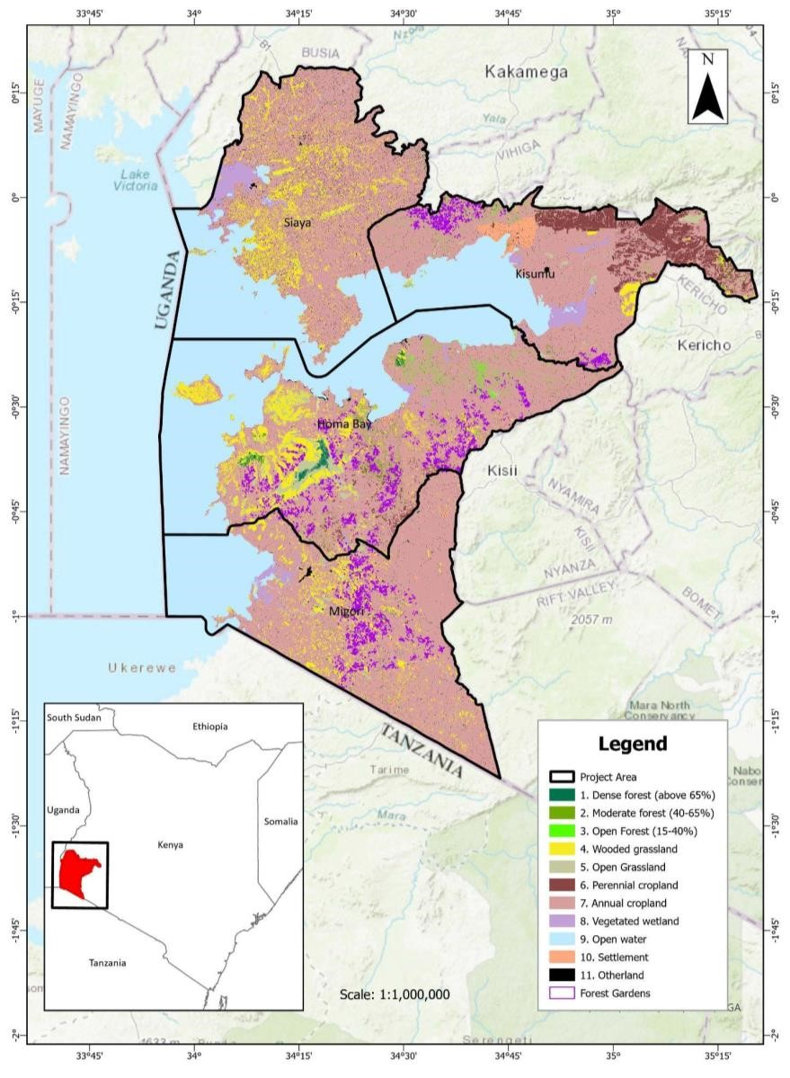
Figure 3.1.2.a Land Cover 2019 and Project Activity Farms

4. Empirical or process-based models used to estimate stock change/emissions via Quantification Approach 1 must be:

- Publicly available, though not necessarily free of charge, from a reputable and recognized source (e.g., the model developer’s website, IPCC or government agency).

We applied the RothC model, which is publicly available.

- Shown in peer-reviewed scientific studies to successfully simulate changes in SOC and trace gas emissions resulting from the changes in ALM practices included in the project description.

We applied the RothC model following VM0042 v2.0 and VMD0053 v2.0 guidelines to estimate changes in soil carbon stocks. RothC is one of the most widely used soil carbon models in the world. Previous studies globally and in Kenya have demonstrated that RothC can successfully model soil carbon as a result of changes in agricultural management across a range of climates and soil types.¹⁵¹ ¹⁵² ¹⁵³

- Able to support repetition of the project model simulations. This includes clear versioning of the model used in the project and stable software support, as well as fully reported sources and values for all parameters used with the project version of the model.

Each of the sampled farms was independently modeled to represent baseline conditions and future projections. Parameters and sources used are in Table 3.1.2.a.

Table 3.1.2.a: RothC Parameters Used

Description | Unit | Recording frequency, and climate data temporal period | Source
Baseline areas in cropland with management practice | ha | Project start | See “Areas” tab in “RothC Inputs” excel in  supporting documentation.¹⁵⁴ Areas are estimated for each farm participating in the project.
Forest Farmland project area | ha | Project start and every verification event | See “Areas” tab in “RothC Inputs” excel in  supporting documentation.¹⁵⁵ Areas are estimated for each farm participating in the project.
Soil organic carbon density, to a depth of 30 cm, at equilibrium for cropland based on measurements of bulk density and %C | t  C/h  a | Project start | See “SOC and Clay” tab in “RothC Inputs” excel in supporting documentation.¹⁵⁶ These were estimated by the ICRAF soil lab, derived from soil cores sampled in project farm areas (see description in Section 3.2.1).
Monthly soil cover (bare or vegetated) | N/A | Project start and at every monitoring event | See “Soil Cover” tab in “RothC Inputs” excel in supporting documentation.¹⁵⁷

- Guillermo Peralta et al., “Technical Manual Global Soil Organic Carbon Sequestration Potential Map GSOCseq. Fao-Gsp.Github.Io.” (Food and Agriculture Organization of the United Nations. n.d., November 25, 2020), https://fao-gsp.github.io/GSOCseq/index.html.
- P.T. Kamoni et al., “Predicted Soil Organic Carbon Stocks and Changes in Kenya between 1990 and 2030,” Agriculture, Ecosystems & Environment 122, no. 1 (September 2007): 105–13, https://doi.org/10.1016/j.agee.2007.01.024.
- Eleanor E Campbell and Keith Paustian, “Current Developments in Soil Organic Matter Modeling and the Expansion of Model Applications: A Review,” Environmental Research Letters 10, no. 12 (December 1, 2015): 123004, https://doi.org/10.1088/1748-9326/10/12/123004.
¹⁵⁴Exhibit 55 - RothC Inputs Excel
- Ibid
- Ibid
- Ibid
Average temperature per month | °C | Project start, and according to FAO  (Food and  Agriculture Organization) guidelines Chapter 6.1,  6.7.¹⁵⁸ | See “Weather” tab in “RothC Inputs” excel in supporting documentation.  Data was compiled at project baseline from TerraClimate.
Average precipitation per month | mm | Project start, and according to FAO guidelines Chapter 6.1,  6.7. | See “Weather” tab in “RothC Inputs” excel in supporting documentation.  Data was compiled at project baseline from TerraClimate.
Average evapotranspiration  per month | mm/  day | Project start, and according to FAO guidelines Chapter 6.1,  6.7. | See “Weather” tab in “RothC Inputs” excel in supporting documentation.  Data was compiled at project baseline from TerraClimate.
Clay content of the soil | % | Project start for baseline | See “SOC and Clay” tab in “RothC Inputs” excel in supporting documentation. These were estimated by the ICRAF soil lab, derived from soil cores sampled in project farm areas (see description in Section 3.2.1)
Monthly input of plant residues | Tonnes  of  carbon  ha-1 | Project start and at every monitoring event | See “Plant Residues” tab in “RothC Inputs” excel in supporting documentation.
Monthly input of farmyard manure | Tonnes  of  carbon  ha-1 | Project start and at every | See “Manure” tab in “RothC Inputs” excel in supporting documentation.

- Guillermo Peralta et al., “Technical Manual Global Soil Organic Carbon Sequestration Potential Map GSOCseq.
Fao-Gsp.Github.Io.” (Food and Agriculture Organization of the United Nations. n.d., November 25,
2020),https://fao-gsp.github.io/GSOCseq/
monitoring event

  - Validated per datasets and procedures detailed in Section 5.2 of VMD0053 Model Calibration and Validation Guidance for the Methodology for Improved Agricultural Land Management.
Before project verification, the project will follow all procedures outlined in VMD0053 to calibrate and validate the model.
  - Using the same model version in the baseline and project scenarios. Further, the same parameters/parameter sets must be used in the baseline and project scenarios.
The same model version and parameters/parameter sets have been used in the baseline and project scenarios.
5. The project area has not been cleared of native ecosystems within the 10-year period immediately prior to the project start date.
An analysis of land cover in the project area in 2010 was completed to determine whether any of the project area was converted from native ecosystems 10 years prior to the project start date.
Due to limited availability of national high resolution and accurate spatial layers from 2010 in
Kenya, SERVIR’s and the Kenya-based Regional Centre for Mapping of Resource for
Development’s Eastern and Southern Africa Land Cover dataset was used for this analysis.
This is a 30-meter resolution regional dataset developed based on Landsat imagery from 20002017 and workshops conducted from 2017-2019 with local representatives from each country included in the dataset (Ethiopia, Kenya, Malawi, Rwanda, Tanzania, Uganda, and Zambia) to ensure accuracy. Any conversion from land classed as wetland or forest in 2010 was assumed to represent clearing or draining of native ecosystems.
No farms in the project area were classed as wetland in 2010. Nine farms had some area of forest in 2010, but four of these were very small areas (0.038 ha, 0.089 ha, 0.004 ha, and 0.002 ha). These nine farms were visually cross checked compared to spatial imagery available on Google Earth Pro to confirm whether there has been any clearing on farms since 2010. The closest available imagery to 2010 to assess land cover on Google Earth Pro varied across these farms. One farm had imagery available for December 2010, five had imagery available for July 2009, two had imagery available for June 2009, and in one the closest date available was April
2011. Based on spatial imagery, just two of these farms seem to have had some forest area

cleared between 2011 and 2014. Farmers were contacted to verify that this clearing was of managed plantation forest rather than native ecosystem.
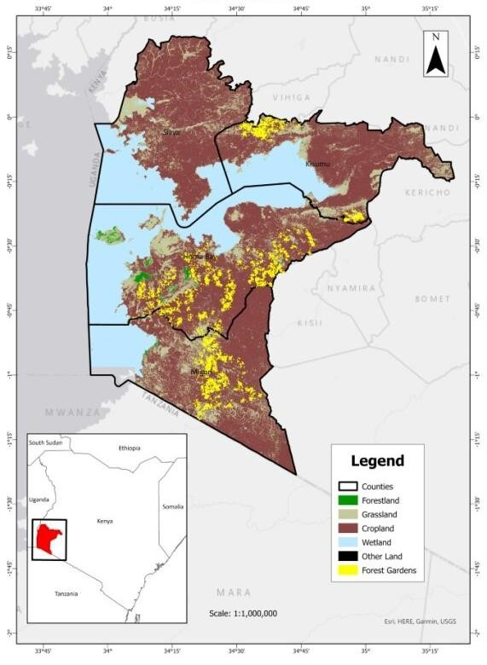
Figure 3.1.2.b 2010 Land Cover Classes in Project Area

3.1.3 Project Boundary (VCS, 3.12)

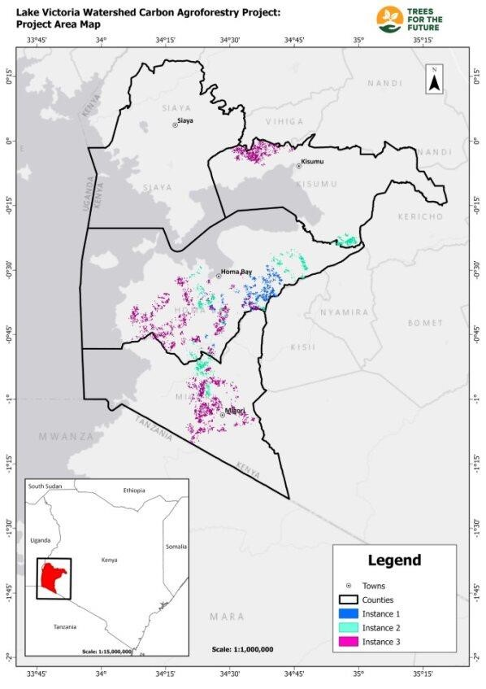
Spatial Boundary
The project area is the sum of all participating farms where ALM practices will be adopted throughout the project lifetime that meet the requirements of the grouped projects under the VCS Standard 4.5. The geographic areas within which project activity instances may be developed are defined here as the full administrative boundaries for the counties of Kisumu, Homa Bay, Migori and Siaya, plus a 1 km buffer around county borders to account for farms within the same participating communities that fall along or just beyond the county border.

The farms in which ALM activities are implemented in the first three instances have been geographically delineated using GPS tracking (Figure 3.1.3.a). The first three project activity instances consist of
7,850 farms covering 5,724 ha. All farm shapefiles are published on the Verra registry.

Figure 3.1.3.a Project area in first three instances
Table 3.1.3.a shows the total area, number of farms, and average farm size in the first three instances of the project across the three counties with participating farms in these first instances. The three instances reflect different first planting years: 2022 (Instance 1), 2023 (Instance 2), and 2024 (Instance 3) but otherwise involve the same activities and farmers with the same baseline scenarios. The farm distribution between counties is expected to change in future instances of the project. The average farm size is 0.729 ha in the first three instances.

Table 3.1.3.a: County, area, and farms in first three instances of the project
County | Instance 1 |  | Instance 2 |  | Instance 3 |  | Total
County | Area (ha) | Number of farms | Area (ha) | Number of farms | Area (ha) | Number of farms | Area (ha) | Number of farms
Homa Bay | 352.45 | 300 | 183.29 | 100 | 134.66 | 100 | 670.4 | 500
Kisumu | 0 | 0 | 100.73 | 100 | 155.96 | 150 | 256.63 | 250
Migori | 0 | 0 | 123.95 | 100 | 144.19 | 150 | 268.14 | 250
Total | 352.45 | 300 | 407.97 | 300 | 434.81 | 400 | 1,195.23 | 1,000

Pools and Emission Sources
The inclusion of each greenhouse gas source in the baseline and project scenarios is provided below.

Source |  | Gas | Included | Justification/Explanati on
Baseline | Aboveground biomass | CO2 | Yes | Quantified as stock change in pool.
Baseline | Aboveground biomass | CH4 | No | Assumed to be de minimis.
Baseline | Aboveground biomass | N₂O | No | Assumed to be de minimis.
Baseline | Belowground biomass | CO2 | Yes | Quantified as stock change in pool.
Baseline | Belowground biomass | CH4 | No | Assumed to be de minimis.
Baseline | Belowground biomass | N₂O | No | Assumed to be de minimis.
Baseline | Soil Organic Carbon | CO2 | Yes | Quantified as stock change in pool.
Baseline | Fossil fuels | CO2 | Yes | Sources of fossil fuel emissions included any use of on-farm energy that would be impacted by ALM activities.
Baseline | Liming and  fertilizer use | CO2 | No | No liming occurred in the project area in the baseline.
Baseline | Liming and  fertilizer use | N₂O | Yes | Synthetic fertilizers used in the baseline and fertilizer use will be impacted by project implementation, so

 |  |  |  |  |  | emissions were included.
 | Soil  methanogenesis | CH4 |  | No |  | Soils are not anoxic and consistent with Table 3 of VM0042 v 2.0, methanogenesis was excluded as is expected to be minimal.
 | Enteric fermentation | CH4 |  | Yes |  | Livestock are present and enteric emissions were included.
 | Manure deposition | CH4 |  | Yes |  | Livestock are present and manure emissions were included.
 | Manure deposition | N₂O |  | Yes |  | Livestock are present and manure emissions were included.
 | Nitrogen fixing species | N₂O |  | Yes |  | N-fixing crops and trees are present in the baseline and will increase as a result of project activities.
 | Biomass burning | CO2 |  | No |  | Burning will not occur during the project, and methane and nitrous oxide emissions are expected to decrease. Carbon dioxide emissions from biomass burning are accounted for as a carbon stock change.
 | Biomass burning | CH4 |  | Yes
 | Biomass burning | N₂O |  | Yes
Project | Aboveground biomass |  | CO2 |  | Yes | Quantified as stock change in pool.
Project | Aboveground biomass |  | CH4 |  | No | Assumed to be de minimis.
Project | Aboveground biomass |  | N₂O |  | No | Assumed to be de minimis.
Project | Belowground biomass |  | CO2 |  | Yes | Quantified as stock change in pool.
Project | Belowground biomass |  | CH4 |  | No | Assumed to be de minimis.
Project | Belowground biomass |  | N₂O |  | No | Assumed to be de minimis.
Project | Soil Organic Carbon |  | CO2 |  | Yes | Quantified as stock change in pool.
Project | Fossil fuels |  | CO2 |  | Yes | Sources of fossil fuel emissions include any use of on-farm energy impacted by ALM activities.
 | Liming and  fertilizer use | CO2 |  | No |  | No liming will occur in the project area.
 | Liming and  fertilizer use | N₂O |  | Yes |  | Fertilizer use will be impacted by project and emissions will be included.
 | Soil  methanogenesis | CH4 |  | No |  | Soils are not anoxic.
 | Enteric fermentation | CH4 |  | Yes |  | Livestock are present and enteric emissions will be included.
 | Manure deposition | CH4 |  | Yes |  | Livestock are present and manure emissions will be included.
 | Manure deposition | N₂O |  |  |  | Livestock are present and manure emissions will be included.
 | Nitrogen fixing species | N₂O |  | Yes |  | N-fixing GFCCA will increase as a result of project activities.
 | Biomass burning | CO2 |  | No |  | Burning will not occur during the project, and methane and nitrous oxide emissions are expected to decrease. Carbon dioxide emissions from biomass burning are accounted for as a carbon stock change.
 | Biomass burning | CH4 |  | Yes
 | Biomass burning | N₂O |  | Yes
Stratification
Kenya’s agroecological zones (AEZ) published by the Ministry of Agriculture and Livestock Development were selected as the basis of project stratification, capturing climate, soil variability, and land cover. The farms in the first instance occur in two of Kenya’s fourteen defined AEZs (Agroecological Zones): upper midland and lower midland (Figure 3.1.3.b).

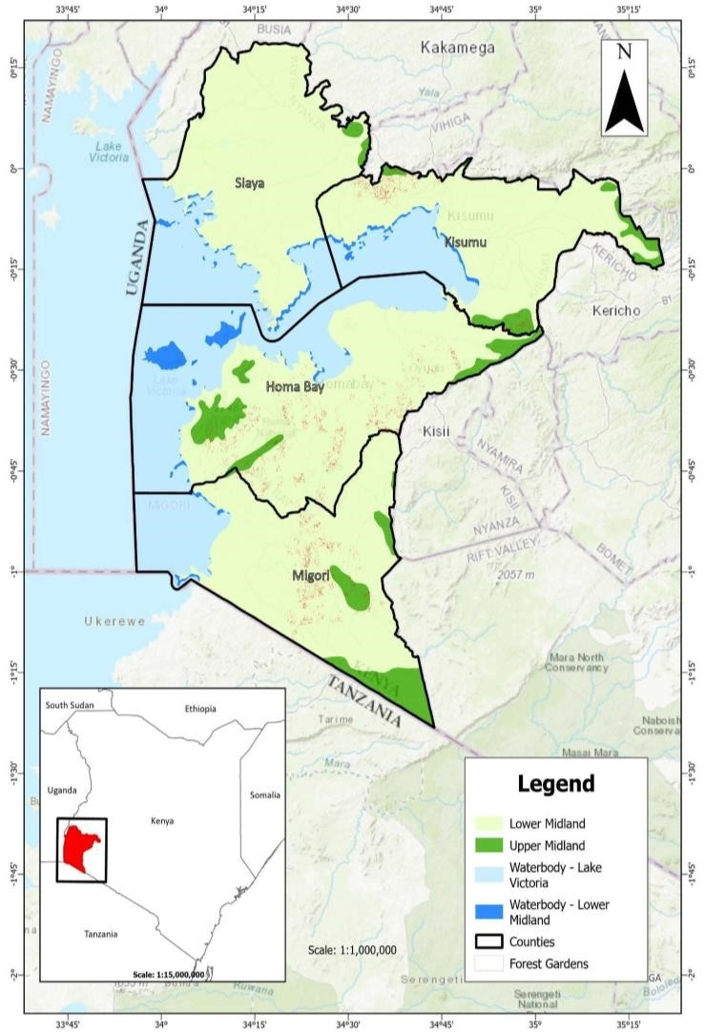
Figure 3.1.3.b Project region overlaid with Kenya’s Agroecological Zones
The farms in the first three instances are divided between the zones as shown in Table 3.1.3.b.
Table 3.1.3.b: AEZ of forest farmlands in first three project instances
Kenya Agroecological Zone (AEZ) | GFCCA Forest Farmland Area (%)
Lower midland | 90.52%
Upper midland | 9.48%
Total | 100%
This stratification is not to be confused with the fine scale practice-based differentiation which will occur on the scale of a small-fraction of a hectare within each forest farmland. The fact that seven practices-based differences exist within a farmland which itself may be not much more than
0.5 ha means that this differentiation is captured through the stratified sampling within each randomly selected monitored forest farmland during each verification event. Weighting changes by area of each practice in each forest farmland allows a per farmland stock and carbon stock change.
Each instance is assessed as one quantification unit as is permitted by VM0042 v2.0. In the PD submitted for validation the parameters tables below are presented for the first three instances given the same baseline (t CO2e/ha) is applied to each instance (i.e., 5,724 ha of forest farmlands).
3.1.4 Baseline Scenario (VCS, 3.13)
As specified in VM0042, continuation of pre-project agricultural practices is the most plausible baseline scenario. Across the project area, the baseline practices were assessed for three years to develop a schedule of activities as shown in Table 4 of VM0042 v2.0. We used Quantification Approach 1 to measure and model baseline SOC. Direct SOC stock estimates sampled from the project area served as model inputs for RothC model initialization. Quantification Approach 3 was used for other greenhouse gases and pools using default factors and field data. Consistent with VM0042 v2.0, Table 3.1.4.a summarizes data collected by surveying farmers to assess their historical management practices.
Table 3.1.4.a Data Collected to Demonstrate Baseline Agricultural Land Management (ALM)
Practices
ALM Practice | Indicator | Survey data
Crop Planting and Harvesting | Crop type | Planting dates  Harvest dates  Crop yield
Fertilizer Application | Manure (y/n)  Compost (y/n)  Synthetic fertilizers (y/n) | Manure application rate  Compost application rate  N application rate
Tillage and Residue Management | Tillage (y/n)  Crop residue removal (y/n) | Depth of tillage  Frequency of tillage  Area tilled  Residue removal rate
Irrigation | Irrigation (y/n) | Irrigation rate
Grazing Practices | Grazing (y/n) Animal type | Animal stocking rate
The baseline scenario will be assessed every ten years, as required by the VCS Standard v4.5 section 3.2.5. According to section 3.2.7 of the VCS Standard v4.5, if there is a significant difference between the historical baseline assessed and future changes in current common practices, the project baseline shall be updated to reflect new common practices in the project region at future baseline reassessment events.
Baseline-Sample Design
Farms were randomly selected for sampling as part of the Farmer Field Area Measurement (FAM) Survey (Table 3.1.4.b), 187 farms were sampled to assess farm management conditions in the baseline, estimate woody biomass on the farm, and collect soil carbon samples.
Table 3.1.4.b: Final number of sampled farms per stratum
AEZ | Number of sampled farms
Lower midland | 170
Upper midland | 17
Total | 187
The final 187 sampled farms considered in the baseline analysis are shown in green in the map below. Per hectare averages are generated based on sampled data and used to determine

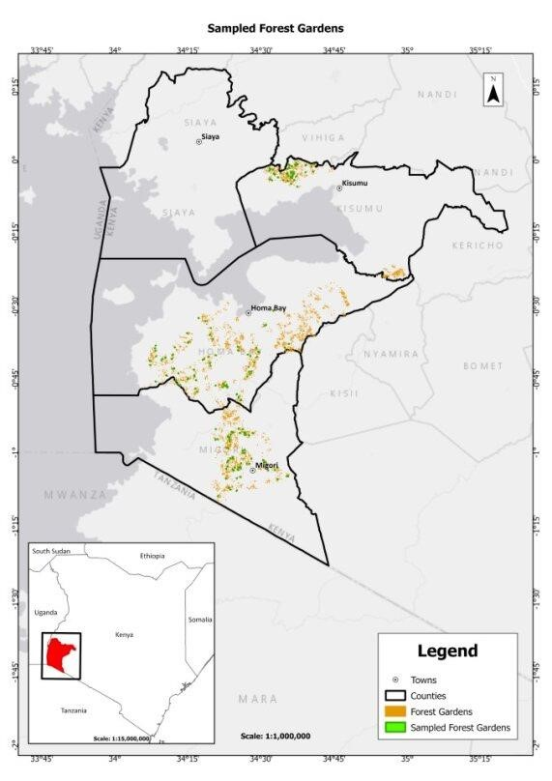
Figure 3.1.4.a: Sampled farms used to quantify baseline stocks and emissions
Baseline Conditions—Soil Carbon
Direct measurements of soil carbon were made using sampled soil cores from 187 farms. All soil coring devices were the same size and made by the same manufacturer to reduce systematic errors (AMS, Inc. 1” x 36” Plated Replaceable Tip Soil Probe). Both the intended and actual sampling points were recorded. At each sampled farm, three pre-predetermined, random GPS points were designated for soil sampling. If an intended sampling point was in an area that will not be converted to project activities, for example, a stand of trees that will not be cleared, or a building, then the closest point that will be converted into a forest farmland was used for sampling.
The location where the soil core was collected was recorded for each soil core and represented the actual sampling point.

Field instructions with diagrams were provided to each team as indicated in the Soil Sample Collection Procedure; all requirements from VM0042 v2.0 were followed with all samples taken to the minimum depth of 30 cm and split into subsections. Also, as per VM0042 v2.0 requirements, future sampling will occur to depths greater than 30 cm to capture equivalent soil mass (ESM) with decreasing soil bulk density (except where prevented through depth of bedrock) (described in more detail in the Climate Monitoring Plan). All gravel, stones, vegetation, and other litter was removed from the soil surface. A total of 3 cores were taken, one at each random location. Each core was split into two different depth layers: 1) 0 to 15 cm, and 2) 15 to 30 cm. To reduce variability cores were composited across each of the three locations for the two different depths (0-15 cm, 15-30 cm). All cores for each depth layer were double labeled and delivered to the soil testing facility within 5 days of sampling.

The ICRAF soil laboratory was selected for soil testing and used mid-infrared spectroscopy with a 30% hold out validation set. Soil samples were dried and sieved to remove any particles greater than 2 mm in diameter. Consistent with the method-specific criteria given by Table 9 in VM0042 v2.0, the applied measurement protocol was Standard Operating Procedures of the Soil-Plant Spectral Diagnostics Laboratory of Worlds Agroforestry Centre (ICRAF). Soil mass (g), soil organic carbon (g/kg soil), and percent clay were estimated for each composite depth layer. Soil mass and carbon content was then estimated using an equivalent soil mass (ESM) approach to estimate soil carbon as described by Wendt and Hauser. Per VM0042 v2.0 requirements on emerging technologies to measure SOC content, additional details on the spectroscopy modelling approach are included in the Climate Monitoring Plan.

The RothC model was used to estimate ex-ante baseline and project soil carbon stocks. All data input into the RothC model in the baseline scenario is described in Section 3.1.2 above in Table 3.1.2a and is shown in Exhibit 55 - RothC Inputs. Monthly ground cover was assumed to be present for April-June and November-January in the baseline scenario, and monthly ground cover was present all year for the project scenario, given the continuous vegetation cover of the trees forest farmland system. The total amount of farmyard manure inputs is expected to stay the same for both project and baseline scenarios although are assumed to be distributed evenly only in March, April, October, and November in the project scenario (as opposed to distributed evenly year-round in the baseline) per trees estimates. Other assumptions include a decomposable plant material over resistant plant material ratio of 1.44, based on the guidance in the RothC user guide and a vertical modeling depth of 30 cm.

Baseline Conditions—Aboveground and Belowground Woody Biomass
To estimate emissions from baseline biomass carbon stocks on the sampled farms, we used the
CDM tools “Estimation of carbon stocks and change in carbon stocks of trees and shrubs in A/R CDM project activities” and “Simplified baseline and monitoring methodology for small scale CDM afforestation and reforestation project activities implemented on lands other than wetlands”. Each sampled farm was stratified into hedgerows, large stands of trees (> 20 m diameter), and scattered trees or small stands of trees (< 20 m diameter).

Tree and Shrub Biomass
Following VM0042, ex-ante (baseline) woody biomass carbon stocks were assumed to be zero where all the following conditions were met:

- “The pre-project trees are neither harvested, nor cleared, nor removed throughout the crediting period of the project activity (e.g., the existing trees on the baseline farms will not be removed during implementation of Forest Farmland project activities).
- The pre-project trees do not suffer mortality because of competition from trees planted in the project, or damage because of implementation of the project activity, at any time during the crediting period of the project activity.
- The pre-project trees are not inventoried along with the project trees in monitoring of carbon stocks, but their continued existence is monitored throughout the crediting period of the project activity.”

Where the above three criteria were met, the location of the biomass was recorded to ensure trees were not inventoried during monitoring. The spatial distribution of trees and shrubs and whether the trees/shrubs were cleared from project activities determined the sampling methodology.

Where trees are removed through the implementation of project activities (see section 3.2.1. below for detailed GHG accounting in these instances), plot sampling was implemented for stands of trees that were > 20 m in diameter, and point sampling was implemented for stands < 20 m in diameter or for individual trees. The number and location of plots or point samples varied based on field conditions. Data were recorded on location, species, and diameter at breast height (DBH) of trees that had DBH of greater than or equal to 5 cm. Location data included the latitude and longitude (in decimal degrees) of corners and all vertices (angles) for stands of trees > 20 m, and the centroid of the biomass sample plot within the stand of trees. The total area of a > 20 m stand of trees was estimated in ArcGIS using GPS coordinates collected in the field. For stands < 20 m in diameter, or individual trees, the latitude and longitude (in decimal degrees) were recorded for each tree.

Ocular estimates were made for shrub canopy cover across portions of the field not covered by stands of trees > 20 m in diameter. Shrubs contained in hedgerows or in stands > 20 m in diameter were separately estimated.

Hedgerow Sampling
Hedgerow length and starting and ending width were measured in the field. If not cleared by project activities, the location of each tree was recorded (decimal degrees) and photographs were taken. If trees were cleared by project activities, then species type and the DBH of all trees > 5 cm were recorded as were ocular estimates of shrubs.

Farm management
Surveys were conducted at each sampled farm to collect data on the previous three years of farm management. Crop history data included type, planting date, harvesting date, and yield. Fertilizer type and application rates were collected for synthetic and organic fertilizers. Data was also collected on farm energy and fossil fuel use, biomass burning, tillage, residue management, and livestock type, grazing, and manure management. Survey responses were digitally collected using Taroworks. All survey questions relating to farm management can be referred to in the FAM Survey Questions document provided separately. Survey results are included related to each respective emission source in Section 3.2.1. 3.1.5 Additionality (VCS, 3.14)

3.1.5.1 Regulatory Surplus (VCS, 3.14)
Is the project located in an UNFCCC Annex 1 or Non-Annex 1 country? or Non-Annex 1 country?
☐ Annex 1 country ☒ Non-Annex 1 country
Are the project activities mandated by any law, statute, or other regulatory framework?
☐ Yes ☒ No
If the project is located inside a Non-Annex 1 country and the project activities are mandated by a law, statute, or other regulatory framework, are such laws, statutes, or regulatory frameworks systematically enforced?
☐ Yes ☐ No
This is not applicable because the project is not located inside a Non-Annex 1 country where the project activities are mandated by a law, statute, or other regulatory framework.

3.1.5.2 Additionality Methods (VCS, 3.14)

GFCCA Forest Farmland agroforestry practices are additional because they would not occur under “business as usual” or in the absence of carbon markets. VM0042 v2.0 requires a project method demonstrating additionality by assessing regulatory surplus, institutional barriers, and common practice.

Step 1: Regulatory Surplus

The GFCCA Forest Farmland project has assessed regulatory surplus using VCS Standard v4.5. Kenya is a non-Annex I country, as such, any mandated or systematically enforced law, statute, or other regulatory framework needs to be considered when evaluating existing regulations.

Under Article 69, Section 1(a), the Government of Kenya has a constitutional mandate to maintain at least 10% tree cover; in 2021, this goal was met as Kenya’s tree cover is ~13%. Most of this was due to national tree planting campaigns that often focus on land types other than cropland (Kenya Vision 2030). National tree planting campaigns also support a separate Government led initiative of planting 15 billion trees by 2032 and is part of the African
Landscape Restoration Initiative launched in December of 2022. As part of this initiative, Farmer Managed Natural Regeneration (FMNR) uses agroforestry on private lands to support wood products, fodder, and soil stabilization. However, this is a ‘laissez faire’ approach that uses natural regeneration without active tree planting, nor with a clear, systematic, crop management strategy that includes the introduction of specific trees and crops planted in a purposeful design managed over time. This particular approach is low input, and integrated within the farmer’s normal activities; instead, the GFCCA Forest Farmland approach actively plants thousands of trees on each farm using a specific planting strategy and creates a new agroforestry farm management system. In addition, none of these programs are mandated and instead are voluntary initiatives run by the Government of Kenya.

Consequently, while Kenya does have multiple initiatives, the specific activities that occur on GFCCA Forest Farmland farms are unique and not currently required under existing regulations, initiatives, or other regulatory frameworks.

Step 2: Identify institutional barriers that would prevent implementation of a change in preexisting ALM practices
CIFOR-ICRAF conducted community engagements to identify barriers that prevent agroforestry from being a widespread agricultural practice in Kenya (CIFOR 2022).

According to CIFOR-ICRAF, barriers to widespread adoption of agroforestry in Kenya include:

- the cost of seeds
- availability of seedlings specific to agroforestry
- cost of seedlings specific to agroforestry
  - fruit seedlings: 200 – 300 Ksh (USD 1.64 – 2.46)
  - timber tree: 20 – 70 Ksh (USD 0.16 – 0.57)
- risk of new farming practices relative to markets (carbon and new food crops)
- norms about the need to plant trees
- new growing techniques/feasibility required for commercial tree production
- new growing techniques/feasibility required for no-till production
- browsing by livestock of young seedlings
- poor return on investment due to low returns and poor seedling survivorship

Step 3: Demonstrate that adoption of the suite of proposed project activities is not common practice

Three different local experts were surveyed in August, 2023 to determine the commonality of hedgerows, alley cropping, multistrata agroforestry, fruit orchard, hardwood plantations, fodder plots, and compost making and application in Kisumu, Homa Bay, and Migori. A fourth expert was surveyed in February, 2024 to determine the commonality of project practices in Siaya.
Responses from the expert attestations can be found in Exhibit 58 in the Appendix.

Expert 1:
Name: Jonah Keprop
Title & Organization: Senior Research Scientist, Kenya Forest Research Institute

Expert 2:
Name: Charles Orero, PhD
Title & Organization: Chairman Nyanaza Leofo Farmers’ Cooperative Society, Chairman Wire Forest Management Association, Community Forest Association

Expert 3:
Name: Dorothy Masiga Syallow, PhD Forestry and Environmental Science
Title & Organization: Senior Lecturer, University of Kabianga

Expert 4:
Name: Eliakim Ambajo, MSc in Agricultural Extension
Title & Organization: Agricultural Officer, Ministry of Agriculture

Survey results indicate all practices occur on less than 20% of farms in the region, based on attestations across the four counties. All activities are additional because all practices were identified as being less than 20% across regional farms, and the weighted average adoption rate (AR) was approximately 12%. Estimated areas (Area), ratios of proposed activities (PA), existing adoption rates (EA), and the overall weighted average adoption rate (AR) are shown in the table below. Calculation of additionality is shown in more detail in the Additionality accompanying spreadsheet.
Table 3.1.5.2.a Additionality Results
Practice | Area (ha) | Ratio of Proposed Activities (PA) | Estimated Areas (EA)
Alley crops | 1,145 | 21.7% | 15.0%
Hedgerows | 469 | 8.9% | 12.5%
Permafarmland | 687 | 13.0% | 11.3%
Fodder Plot | 572 | 10.8% | 12.5%
Fruit GFCCA | 1,259 | 23.9% | 10.0%

Timber Plot | 1,145 | 21.7% | 10.0%
Weighted Average Adoption Rate (AR) |  |  | 11.7%
The project creates farmlands combining the practices listed above with ancillary co-benefits to the farmers and the environment. This combination of activities is absent in the region in the absence of the project.
3.1.6 Methodology Deviations (VCS, 3.20)
In the with-project case the methodology requires that the kg animal mass / head (W_{wp,l,i,t}) is directly monitored through farmer attestations and management logs. Given:
- The location of the project in Kenya where direct weighing of animals does not easily happen.
- The fact that livestock remain unchanged between baseline and with project cases under the project.
We request that a methodology deviation be allowed that permits the use of IPCC factors for animal mass per head in the with-project case as is allowed in the baseline case.

Quantification of Estimated GHG Emission Reductions and Removals
Data collected in the FAM Survey conducted at the baseline was structured by type and source to estimate emissions (see supporting excel spreadsheets). All calculations of GHG emission reductions and removals are provided in detail in Section 3.2.1.
Table 3.2.a Summary of accompanying calculation spreadsheets
Excel File Name | Purpose | Key Tabs
Calculations Summary | Compiles emissions  estimates from Farm Management  Emissions excel, trees and Shrubs Emissions excel, RothC outputs, and add removals from trees expected in the project scenario. | Summary - Estimates: shows emission reductions and removals.  Summary – Tables for PD: shows summary tables.  Lookup_ tabs: for removals from AGB and BGB, removals from SOC, and emissions from farms, trees, and shrubs. These summarize results from other excels and are hard copied in. The Lookup_Removals AGB-BGB shows a shows Chapman-Richards growth curve used for ex-ante biomass estimates.
Trees and Shrubs Emissions | Contains data from FAM Survey used to complete VM0042 v2.0 methods associated with trees and shrubs (as given by CDM guidelines). | Summary - Emissions: summary of emissions from shrubs and trees. Orange tabs: data collected in FAM Survey.  Emissions - Cleared Shrubs: emissions from shrubs.  Emissions - Cleared trees: emissions from individual trees removed. Lookup_: lookup values applied to estimate carbon stocks in trees and shrubs.
Farm Management Emissions | Contains data from FAM Survey used to complete VM0042 v2.0 equations associated with farm management practices. | Farm History_general: raw data from survey results and processed data used in VM0042 v2.0 equations.  Lookup_: lookup tables with values used in equations for crops, livestock, fertilizers, biomass burning, and fossil fuels as required by VM0042 v2.0.  Tabs labeled by emissions source: Various calculations following equations as given by VM0042 v2.0.  Summary_BL vs project: summarizes across emission sources in the baseline and the project scenarios.
RothC Inputs | Describes RothC model inputs. | Each tab describes different model inputs required for RothC with associated sources.
RothC Outputs¹⁹⁰ | Calculates SOC stocks and change during project based on RothC outputs. | Model Outputs: all model outputs from the R script.  Summary – benefits: summarizes all benefits and calculates a weighted soil carbon average based on area of AEZ strata.  Stocks t0, Baseline, and Project tabs: each pull different information from the Model Outputs tab to estimate soil stocks for different AEZ and either the project or baseline.  Lookup_AEZ: lookup with AEZ classifications per farm.

Additionality | Gives attestation results and estimates additionality. | Attestation_County gives survey questions and expert results for each surveyed project activity.  Additionality: summarizes additionality results as given in this PD.
ICRAF ESM Soil Data | Shows soil carbon stocks and data derived from ICRAF analysis.

3.2.1 Baseline Emissions (VCS, 3.15)
Soil Carbon
RothC was initialized directly to t0 SOC stock measurements. An approach outlined in the RothC guide to initialize the model involves iteratively adjusting plant residue carbon inputs and running the model to equilibrium until a C input estimate is reached where steady-state SOC model output (i.e., post-equilibrium run) is +/- 0.5 t C ha⁻¹ of an observed value to which the model is being initialized. This initialization procedure was followed as a first step for all SOC observations in farms that were sampled that will be part of the project.
The model was then initialized to the baseline scenario for each observation by assigning SOC stocks to each pool based upon the final, ‘steady-state’ result of the equilibrium run.

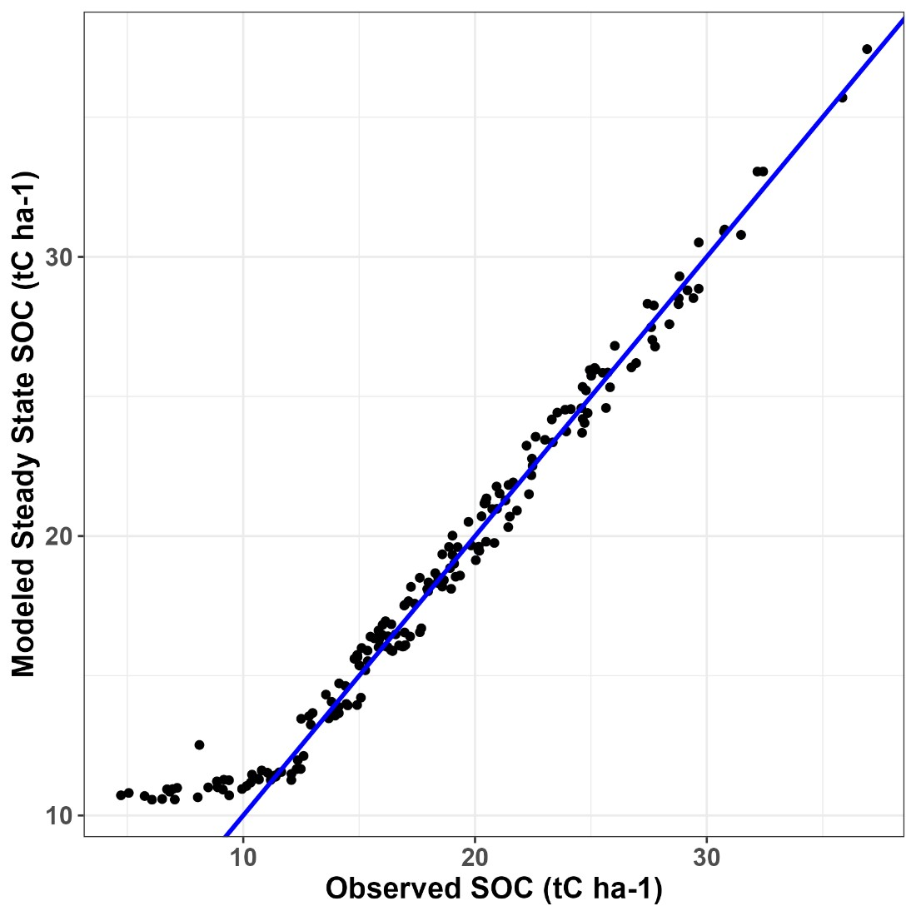
Figure 3.2.1a Roth C Modeling
The model was then run for 40 years into the future at each observation with the same associated steady-state C input. Areal SOC projections (t C ha⁻¹) at each observation were averaged to total SOC for the project overall. The average projections per both AEZs were multiplied into the area of each AEZ such that the final projected t C ha⁻¹ is a weighted average across AEZs (Lower and Upper Midland) to obtain project-level SOC projections for the baseline. In both AEZs in the baseline scenario, carbon stocks remained stable to 3 decimal places over the 40-year project lifetime and so only the carbon stock at t0 is shown in Table 3.2.1.a.
Table 3.2.1.a Baseline SOC Stocks by AEZ (tonnes C ha⁻¹)
AEZ | Baseline SOC stock (t C ha⁻¹)
Lower Midland | 18.477
Upper Midland | 20.840
Weighted average | 18.699
Aboveground and Belowground Woody Biomass
Baseline aboveground and belowground woody biomass was accounted for using Estimation of Carbon Stocks and Change in Carbon Stocks of trees and Shrubs in A/R CDM Project Activities v4.2 (see detailed accounting of stocks in “Trees and Shrubs Emissions” spreadsheet in supporting documentation).
Any trees or shrubs present in the baseline cleared through project activities are described in the project emissions section of this document.
Consistent with VM0042 requirements, if trees or shrubs will not be cleared through implementation of project activities, then biomass carbon was not sampled, instead they were documented through geo-referenced photographs and location data (decimal degrees). These records ensured the trees/shrubs are not inventoried during monitoring periods or are later cut. If trees were individually scattered or occurred in stands < 20 meters in diameter, then a photograph and the latitude and longitude (in decimal degrees) was recorded for each tree. If the stand of trees was > 20 meters in diameter, then location of corners and vertices (angles) were recorded. Photographs were also taken. Within the stands, any existing stumps were also recorded to document previous harvesting and to track any new tree harvesting that occurred after the baseline was assessed.
Of the 187 sampled project farms in the FAM Survey, there were 6,334 trees recorded. 163 farms (87.2%) reported having at least one tree within the farm boundary. 1,357 trees had species names listed with 47 species reported. The most common species were Grevillea robusta (403 trees), Eucalyptus spp. (356 trees) and Acacia spp. (102 trees) (see Table 3.2.1c).
Table 3.2.1.b: Tree species reported in baseline farms. Species with fewer than 10 recorded trees are grouped under “Other”
Species | Number of Trees
Grevillea robusta | 403
Eucalyptus | 356
Acacia spp. | 102
Markhamia lutea | 87
Casuarina | 52
Albezia gummifera | 42
Casuarina spp. | 34
Avocado | 32
Mango | 30
Ficus sychomorus | 30
Leucaena leucocephala | 28
Cypress | 19
Guava | 10
Papaya | 10
Other | 267
Species not recorded | 4,977
Total number of Trees | 6,334
Carbon Dioxide Emissions from Fossil Fuel Combustion
Quantification Approach 3 used Equations 7 and 8 as given in VM0042 v2.0. Emission factors applied were 0.00281 t CO₂e/liter for petrol and 0.002886 t CO₂e/liter for diesel as provided in VM0042 and Table 3.3.1 from the 2006 IPCC Guidelines, Volume 2, Chapter 3.
Only 8 farms (4.3%) reported using diesel, with an average of 0.59 l per ha per year over the entire sampled area and just 3 farms (1.6%) reported using petrol, with an average 0.19 l per ha per year over the entire sampled area.
Energy use and associated emissions averaged 0.002218 t CO₂e/ha from 2022 – 2024 (see “Farm Management Emissions” excel in supporting documentation).
Livestock Emissions
166 farms (88.8%) reported having at least one animal in one of the three years (2022, 2023, or 2024) covered by the FAM Survey. The greatest number of animals per hectare in the sampled farmlands were poultry (hens) (16.21 heads per ha) and cattle (3.60 heads per ha of non-dairy cattle and 1.31 heads per ha of dairy cattle).
Table 3.2.1.c Livestock present on sampled farms, 2022-2024
Livestock type | Average number of animals (2020-2022) in sampled farmlands (heads per ha)
Dairy Cattle | 1.31
Donkeys | 0.04
Doves | 0.19
Ducks | 0.17
Goats | 1.47
Non-Dairy Cattle | 3.60
Pigs (Finishing) | 0.04
Poultry (broilers) | 0.57
Poultry (hens) | 16.21
Sheep | 0.92

Methane Emissions from Livestock Enteric Fermentation
A global warming potential (GWP) of 28 was used to convert CH₄ to CO₂e in Equation 12 from VM0042 v2.0 (IPCC Fifth Assessment Report, as required in VM0042 v2.0). Tier 1 and Tier 1A enteric fermentation emission factors are shown in Table 3.2.1e as provided in Tables 10.10 and
10.11 in the 2019 IPCC Guidelines, Chapter 10, Volume 4.
Table 3.2.1.d Livestock Enteric Methane Emission Factors
Livestock type | Tier 1 and 1a EF (kg CH₄.head⁻¹.yr⁻¹)
Dairy Cattle, low productivity | 66
Other cattle, low productivity | 48
Donkeys | 10
Poultry and doves | N/A
Goats, low productivity | 5
Pigs, low productivity | 1
Sheep, low productivity | 5
A single manure management low productivity system was assumed.
From 2022 – 2024, livestock methane emissions from enteric fermentation averaged 7.60 t CO₂e/ha.
Methane Emissions from Manure Deposition
Methane emission estimates from manure deposition were based on Equations 13 and 14 from VM0042 v2.0. The average volatile solids excretion per head and average livestock weight are summarized in Table 3.2.1.e.

Table 3.2.1.e Manure Excretion and Bodyweights
Livestock type | Volatile solids  (kg solids/(1000 kg animal mass × day) | Livestock weight (kg animal mass/head)
Dairy Cattle | 15.2 | 270
Non-Dairy Cattle | 12.7 | 208
Goats | 10.4 | 24
Poultry (Hens) | 11.6 | 1.1
Poultry (Pullets) | 16.5 | 0.5
Poultry (Broilers) | 15.4 | 0.7
Doves | 11.6 | 0.8
Donkeys | 7.2 | 130
Ducks | 7.4 | 2.7
Pigs (Finishing) | 9.4 | 33
Sheep | 8.3 | 31
The emission factor for methane from manure deposition was assumed to be 0.6 g CH₄/kg volatile solid based on the 2019 IPCC Guidelines, Volume 4, Chapter 10.
We applied an AWMS factor (fraction of total annual volatile solids that is managed in manure management systems) that varied for each livestock type based on the number of days that farmers reported them to be grazing within the project area. The manure management system is assumed to be uniform when the livestock is grazing within the project area. See “Farm Management Emissions” spreadsheet in supporting documentation for detailed calculations.
Table 3.2.1.f Assumed AWMS based on the number of grazing days in the project area per year reported per livestock type
Livestock type | AWMS: Fraction of total annual volatile solids for each livestock type, that is managed in manure management system in the  project area
Dairy Cattle | 78%
Non-Dairy Cattle | 58%
Goats | 65%
Poultry (Hens) | 79%
Poultry (Pullets) | 0%
Poultry (Broilers) | 100%
Doves | 100%
Donkeys | 100%
Ducks | 75%

Pigs (Finishing) | 100%
Sheep | 71%
Methane emissions from manure deposition from 2022 – 2024 averaged 0.0631 t CO₂e/ha (see “Farm Management Emissions” spreadsheet in supporting documentation).
Nitrous Oxide Emissions from Manure Deposition
Direct and indirect nitrous oxide emissions from manure deposition were estimated using Quantification Approach 3 and Equations 27-32 from the VM0042 v2.0 methodology.
The direct emission factors and assumptions for nitrous oxide from manure and urine deposition were based on Tables 11.1 and 10.19 from the 2019 IPCC Guidelines, Volume 4, Chapters 10 and 11 and are summarized below in Table 3.2.1.g.
Table 3.2.1.g Direct Nitrous Oxide Assumptions
Livestock type | kg N₂O-N.kg N⁻¹ | kg N.head⁻¹.yr⁻¹
Dairy Cattle | 0.006 | 44.35
Non-Dairy Cattle | 0.006 | 34.16
Goats | 0.003 | 2.98
Poultry (Hens) | 0.006 | 0.54
Poultry (Pullets) | 0.006 | 0.31
Poultry (Broilers) | 0.006 | 0.40
Doves | 0.006 | 0.39
Donkeys | 0.003 | 21.82
Ducks | 0.003 | 0.82
Pigs (Finishing) | 0.006 | 6.50
Sheep | 0.003 | 3.62
We applied an AWMS factor (fraction of total annual volatile solids that is managed in manure management systems) that varied for each livestock type based on the number of days that farmers reported them to be grazing within the project area (see Table 3.2.1g). The manure management system is assumed to be uniform when the livestock is grazing within the project area. See “Farm Management Emissions” spreadsheet in supporting documentation for detailed calculations. On days that the animal was reported to graze, we assumed all nitrogen excretion was deposited into the project area (parameter MSbsl in Equation 29 from VM0042 v2.0).

Indirect emissions were defined using Equations 30 to 32 from VM0042 v2.0 and the following assumptions based on Table 11.3 from the 2019 IPCC Guidelines, Volume 4, Chapter 11:
- Emission factor for nitrous oxide emissions from leaching and runoff (t
N₂O-N / t N leached and runoff): 0.011
- Emission factor for nitrous oxide emissions from atmospheric deposition of N on soils and water surfaces (t N₂O-N/(t NH₃-N + NOx-N volatilized):
0.01
- Fraction of N added in manure/urine that is lost through leaching and runoff, in regions where leaching and runoff occurs (dimensionless): 0.24
- Fraction of all organic N added to soils in manure and urine deposited that volatilizes as NH₃ and NOx (dimensionless): 0.21
From 2022-2024, direct and indirect nitrous oxide emissions from manure deposition averaged
0.572 t CO₂e/ha (see “Farm Management Emissions” spreadsheet in supporting documentation).
Biomass Burning
Methane Emissions Biomass Burning
Methane emissions from biomass burning were estimated using Equation 15 in VM0042 v2.0. Based on survey results it was assumed that all agricultural residues were burned in the baseline in farms that reported burning residues. The average amount of residues burned over the entire sampled area per residue type, per year, and per ha was:
- Bean residues: 1.51 kg/ha
- Maize residues: 139.56 kg/ha
- Other or mixed residues: 32.54 kg/ha
30 farms (16%) reported burning biomass. The ratio of the mass of agricultural residues to yield was based on the defaults provided in Table 11.1a in the 2019 IPCC Guidelines, Volume 4, Chapter 11. As provided in Table 2.6 of the 2019 IPCC Guidelines, Volume 4, Chapter 2, maize is assumed to have a combustion factor of 0.8 and beans and other/mixed residues are assumed to have a combustion factor of 0.85. Likewise, using Table 2.5 of the 2019 IPCC Guidelines, Volume 4, Chapter 2, the methane emissions factor for agricultural residue burning was 2.7 g CH₄/kg dry matter burned.

Methane emissions from 2022 to 2024 averaged 0.0106 t CO₂e/ha (see “Farm Management Emissions” spreadsheet in supporting documentation).
Nitrous Oxide Emissions Biomass Burning
Quantification Approach 3 was used for nitrous oxide emissions from biomass burning in the baseline scenario. The nitrous oxide emission factor from burning agricultural residues was 0.07 g N₂O per kg burned dry matter, based on Table 2.5 from the 2019 IPCC Guidelines, Volume 4, Chapter 2.
Nitrous oxide emissions from biomass burning averaged 0.0026 t CO₂e/ha (see “Farm Management Emissions” spreadsheet in supporting documentation).
Fertilizer and Nitrogen-Fixing Species Emissions
Liming
Based on survey results, no lime or dolomite was applied on any of the sampled farms (see “Farm Management Emissions” spreadsheet in supporting documentation).
Nitrous Oxide from Nitrogen Fertilizers and Nitrogen-fixing Species
We used Quantification Approach 3 and Equations 17 – 26 to estimate nitrous oxide emissions from fertilizers and N-fixing species. Nitrous oxide emissions were converted to CO₂ equivalents using a GWP of 265 as specified in VM0042 v2.0.
Direct N₂O emissions were estimated using Equations 19 – 21 of VM0042 v2.0. The emission factor for direct N₂O emissions from synthetic fertilizers, organic amendments and crop residues was 0.01 t N₂O-N/t N applied, based on Table 11.1 from the 2019 IPCC Guidelines, Volume 4, Chapter 11.
Indirect emissions were estimated based on volatilization and leaching as given by Equations 2224 in VM0042 v2.0. Based on Table 11.3 from the 2019 IPCC Guidelines, Volume 4, Chapter 11, the following emission factors were assumed:
- Emission factor for nitrous oxide emissions from leaching and runoff (t
N₂O-N / t N leached and runoff): 0.011
- Emission factor for nitrous oxide emissions from atmospheric deposition of N on soils and water surfaces (t N₂O-N/(t NH₃-N + NOx-N volatilized):
0.01
- Fraction of N added in manure/urine that is lost through leaching and runoff, in regions where leaching and runoff occurs (dimensionless): 0.24

- Fraction of all organic N added to soils in manure and urine deposited that volatilizes as NH₃ and NOx (dimensionless): 0.21
- Fraction of all synthetic N added to soils that volatizes as NH₃ and NOx; (dimensionless): 0.11
Synthetic Fertilizers
Survey data from farmers provided three years of fertilizer history application rates for both synthetic and organic fertilizers. 103 farms reported applying synthetic fertilizers (55%) in at least one of the 3 surveyed years (2022-2024), with 12 synthetic fertilizer types reported. The mass of applied N-containing synthetic fertilizer was determined based on surveys with farmers. The N content of each synthetic fertilizer reported in the survey is shown in Table 3.2.1.h and is based on the reported N content on the products used on the farms, except the EasyGro fertilizer (written as “Easy Grow” in the FAM Survey responses), which was based on product information available online and generic DAP and Yara (DAP) fertilizers, which were assumed to have the same N content as Chapa Meli (DAP) and ETG/Falcon (DAP).
All fertilizers were reported in kg except EasyGro which was reported in liters. EasyGro volumes were converted into kg based on the recommended ratios provided with the product details.
Table 3.2.1h Synthetic Fertilizer N Content of reported synthetic fertilizers in FAM Survey
Synthetic fertilizer type | N Content
Baraka (Planting) | 14.0%
Baraka (Top Dressing) | 26.0%
CAN | 27.0%
Chapa Meli (DAP) | 18.0%
Chapa Meli (UREA) | 46.0%
DAP | 18.0%
EasyGro | 27.0%
Elgon (UREA) | 46.0%
ETG/Falcon (CAN) | 27.0%
ETG/Falcon (DAP) | 18.0%
ETG/Falcon (NPK) | 18.0%
Yara (DAP) | 18.0%
The average kilograms of each type of fertilizer applied per ha within the project are shown below (Table 3.2.1.i). Fertilizer reported as DAP, D.A.P., or as “DAP and NPK” in the FAM Survey was combined into one “DAP” category.

Table 3.2.1.i kg per ha of reported synthetic fertilizers applied, from FAM Survey
Synthetic fertilizer type | Average annual kg synthetic fertilizer applied per ha
Baraka (Planting) | 0.39
Baraka (Top Dressing) | 0.74
CAN | 6.49
Chapa Meli (DAP) | 10.75
Chapa Meli (UREA) | 0.31
DAP | 13.48
EasyGro | 0.00
Elgon (UREA) | 0.06
ETG/Falcon (CAN) | 17.03
ETG/Falcon (DAP) | 26.19
ETG/Falcon (NPK) | 0.45
Yara (DAP) | 0.88
Organic Fertilizers
Organic fertilizers were reported in buckets, wheelbarrows, carts, kilograms, sacks, and other units (see Table 3.2.1l). 148 farms reported applying synthetic fertilizers (79.1% of sampled project farms) in at least one of the 3 surveyed years (2022-2024), with six main organic fertilizer types reported. Compost and animal manure were the two most widely reported organic fertilizers. All farms that reported “Other” manure use described it as “Green Manure.”
Based on field data collected by GFCCA on the average mass of each of these units in three sampled farms (see Farm Management Emissions spreadsheet, Lookup_Fertilizer tab), these were converted to a mass basis using defaults shown in Table 3.2.1.j “Other” represents the average across all types as more precise data was not available from survey results.
Table 3.2.1.j Conversion of Organic Fertilizer Units to kg
Unit reported | Weight (kg)
Buckets | 22.8
Troughs or Basins | 36.2
Sacks | 96.7
Cement Bag | 45.8
Wheelbarrow | 67.9
Other | 53.9
The nitrogen contents for different organic fertilizers and their respective sources are shown in Table 3.2.1.l. The value for “Animal Manure (not from a grazing animal)” is a compiled value based on the average N content of different animal manures based on reported N contents in

smallholder farms in Kenya²⁰⁷ and their respective proportion of manure reported to be produced in the baseline scenario from the FAM Survey (Table 3.2.1.k).
Table 3.2.1.k Organic Fertilizer N Content
Organic fertilizer type | N content (%) | Source
Animal Manure (not from grazing animal) | 1.44% | Compiled²⁰⁸, see table below
Compost | 1.34%²⁰⁹
Guano Manure | 9.45%²¹⁰
Other | 0.80% | Assumed to be crop residues based on other categories reported in farmer survey
Press mud (sugarcane waste - bagasse) | 0.39%²¹¹
Crop residues | 0.80%²¹²
Table 3.2.1.l Manure N Content
Manure type | N content (%) | Average proportion of total manure produced in baseline²¹³
Swine manure | 1.40% | 0.13%
Cattle manure | 1.40% | 93.59%
Goat/sheep manure | 1.48% | 4.43%
Poultry manure | 3.11% | 1.85%
As part of the QA/QC process to evaluate the FAM Survey, it was noted that any farm that reported using the manure from their livestock as organic fertilizer and also reported applying organic fertilizer in the form of compost, guano, or organic liquid manure was reporting the manure twice (once in the form of manure and once in the form of fertilizer).

- WOOMER, P.L, N.K KARANJA, and J.R OKALEBO1. “Opportunities for Improving Integrated Nutrient Management by Smallholder Farmers in the Central Highlands of Kenya.” Africa Crop Science Journal 7, no. 4 (1999): 441–54.
- ibid
- ibid
- Sanginga, Nteranya, Paul L. Woomer, and Tropical Soil Biology and Fertility Institute, eds. Integrated Soil Fertility Management in Africa: Principles, Practices, and Developmental Process. Nairobi: Tropical Soil Biology and Fertility Institute of the International Centre for Tropical Agriculture, 2009.
- ibid
- Liang, Chang & Kasimir, Åsa. (2019). Chapter 11: N2O Emissions from Managed Soils, and CO2 Emissions from Lime and Urea Application. In book: “2019 Refinement to the 2006 IPCC Guidelines for National Greenhouse Gas Inventories.” Agriculture, Forestry, and Other Land Use. Switzerland.: IPCC, 2019. https://www.ipcc-nggip.iges.or.jp/public/2019rf/pdf/4_Volume4/19R_V4_Ch11_Soils_N2O_CO2.pdf
- Sanginga, Nteranya, Paul L. Woomer, and Tropical Soil Biology and Fertility Institute, eds. Integrated Soil Fertility Management in Africa: Principles, Practices, and Developmental Process. Nairobi: Tropical Soil Biology and Fertility Institute of the International Centre for Tropical Agriculture, 2009.
To estimate the actual amount of organic fertilizer applied, organic fertilizer of the above three types in farms where manure from livestock was reported to be also used as organic fertilizer was conservatively not considered to be applied separately as a fertilizer. This was not considered the case for “Animal Manure (not from grazing animal)” as these inputs are specified to not be from one of the farm’s grazing animals.
The average kg of organic fertilizer applied per ha per year across the sampled farms are shown in Table 3.2.1.m.
Table 3.2.1.m kg per ha of reported organic fertilizers applied, from FAM Survey
Organic fertilizer type | Average annual kg organic fertilizer applied per ha
Animal Manure (not from grazing animal) | 626.0
Compost | 65.8
Guano Manure | 4.6
Other | 12.5
Press mud (sugarcane waste - bagasse) | 0.3

Summed Fertilizer Emissions
Using Equation 18 from VM0042 v2.0, direct and indirect emissions from fertilizers averaged 0.1324 t CO₂e/ha from 2022 – 2024 (see “Farm Management Emissions” spreadsheet in supporting documentation).
Nitrogen-Fixing Species
Nitrous oxide emissions from N-fixing species are given by Equations 25 and 26 from VM0042 v
2.0. Nitrogen fixing crops were identified during farm surveys.
134 farms (71.7%) reported growing at least one N-fixing crop in one of the years of the survey (2022-2024). The reported N-fixing crops were beans and pulses, cowpeas, ground nuts, and soyabeans.
Key assumptions for the nitrogen content (aboveground and belowground), the dry matter fraction of harvested products per ton of fresh weight, the ratio of aboveground residue dry matter to harvested yield, and the ratio of belowground biomass to aboveground biomass are summarized in Table 3.2.1.n which in turn is based on Table 11.1a of the 2019 IPCC Guidelines, Volume 4, Chapter 11.
Table 3.2.1.n Nitrogen-Fixing Crop Species Assumptions

N-fixer | Dry matter fraction of harvested product | Ratio of aboveground  d.m. to  harvested yield | Ratio of belowground  d.m. to  harvested yield | N-content of aboveground residues | N-content of belowground residues
Beans & Pulses | 0.91 | 2.1 | 0.19 | 0.008 | 0.008
Ground Nuts | 0.94 | 1 | 0 | 0.016 | 0
Cowpeas | 0.91 | 2.1 | 0.19 | 0.008 | 0.008
Soyabeans | 0.91 | 2.1 | 0.19 | 0.008 | 0.008
Based on these assumptions and the reported yields of N-fixers in the baseline, Table 3.2.1.o shows the calculated AGB and BGB inputs.
Table 3.2.1.o Nitrogen-Fixing Crop AGB and BGB inputs
N-fixer | Annual AGB (t d.m./ha) | Annual BGB (t d.m./ha)
Beans & Pulses | 0.345 | 0.097
Ground Nuts | 0.076 | 0.026
Cowpeas | 0.108 | 0.000
Soyabeans | 0.021 | 0.006
From 2022-2024, emissions from N-fixing crops averaged 0.016 t CO₂e/ha (see “Farm Management Emissions” spreadsheet in supporting documentation).

Total baseline emissions
A summary of annual emissions in the baseline scenario from farm management activity practices are shown in Table 3.2.1.p.
Table 3.2.1.p Farm Management Emissions in Baseline Scenario
Emissions source | Total (t CO₂e ha⁻¹ yr⁻¹)
CO2, fossil fuels | 0.0022
CO2, lime | 0
CH4, enteric fermentation | 7.5996
CH4, manure deposition | 0.0631
CH4, biomass burning | 0.0106
N2O, soils | 0.8086
N2O, biomass burning | 0.0026
Total | 8.4867
Baseline: Uncertainty
There are various sources of uncertainty in the baseline emissions estimates. Uncertainty will need to be calculated using different approaches given the use of modelling to estimate SOC, the use of random sampling in the project area, and the use of spectroscopy to estimate initial SOC stocks. Error associated with the spectroscopy model and modelled SOC stocks will be estimated before verification as part of model calibration and validation using VMD0053.
Initial estimates of sampling error associated with each pool in the baseline have been estimated (Table 3.2.1q) following the general approach of Equations 53, 54, and 55 of VM0042 v2.0 i.e., uncertainty is the half-width of the one standard deviation interval as a percentage of the mean for the gas or pool (%). However, the delta between the project and baseline was unavailable to estimate an uncertainty deduction at validation and will be available at verification. These therefore serve as incomplete uncertainty estimates. Uncertainties will be used to estimate an uncertainty deduction for each pool once project emissions have been monitored at the first verification event and associated uncertainty in monitored data has been generated. Uncertainty in soil carbon baseline stocks estimated using the same general approach is 2.6%.
Table 3.2.1.q Estimated sampling error in survey data, baseline scenario
Emissions source | Uncertainty (%)
CO2, fossil fuels | 15.6%
CO2, lime | 0%
CH4, enteric fermentation | 4.3%
CH4, manure deposition | 4.5%
CH4, biomass burning | 9.1%
N2O, soils | 7.8%
N2O, biomass burning | 9.1%

There have been other studies conducted on agroforestry in Kenya and Eastern Africa that could be used to calibrate and validate the model, which the project is reviewing and has reached out via personal correspondence to access soil datasets. The project may also produce an independent dataset from project farms, following discussions and approval from an independent modelling expert as is permitted under VMD0053.
3.2.2 Project Emissions (VCS, 3.15)
The specific calculations, assumptions, and equations are given for each pool below.
Woody Biomass Emissions
Surveys of tree and shrub biomass were conducted in 187 farms to determine any emissions from the clearing of woody biomass in the project scenario. 102 of the 167 farms reporting trees (61.0% of farms reporting trees) reported no clearing at all, and only 8 farms (4.8% of farms reporting trees) reported clearing more than 50% of trees. On farms that did clear trees, an average of 24.8% of the trees (i.e., an average of 8.8 trees) were cleared to prepare the forest farmland. There were no farms that reported clearing all trees. The average DBH of the cleared trees was 1.7 cm.
FAM Survey results also indicate that 15 farms recorded stands >20 m in diameter. A single farm was identified which cleared this stand and has subsequently been excluded from the project. Five farms also recorded hedgerows, all of which would be cleared for the project. Eucalyptus is by far the most prevalent species that was cleared (70% of cleared trees were eucalyptus.)
If trees and shrubs were cleared due to project activities, carbon losses were estimated using DBH measurements and species-specific allometric equations or a general equation developed for western Kenya. Table 3.2.2a shows the allometric equations used in this project.
All calculations described below have been submitted as supporting documentation in excel files (See trees and Shrubs Emissions spreadsheet in supporting documentation). Baseline aboveground and belowground woody biomass used Appendix Equations 1-4 (tree biomass) and Equations 26 and 27 (shrub biomass) from Estimation of Carbon Stocks and Change in Carbon Stocks of GFCCA and Shrubs in A/R CDM Project Activities v4.2.
Table 3.2.2a Allometric equations to estimate aboveground biomass
Species | Equation | Source
Acacia spp. | AGB = 0.5099*DBH^(1.9141) | 215
Grevillea robusta | AGB = 1.384*DBH^(1.665) | 216
Eucalyptus spp. | AGB=0.085×DBH^(2.471) | 217
All other species | AGB = 0.091*DBH^(2.472) | 218
These same allometric equations and assumptions were used for trees and any carbon losses that occurred during hedgerow clearing. BGB was estimated using the default root-to-shoot ratio for Tropical Moist forests in Africa of 0.232 from the 2019 IPCC Guidelines Volume 4, Chapter

- Aneseyee, Abreham Berta, Teshome Soromessa, Eyasu Elias, and Gudina Legese Feyisa. “Allometric Equations for Selected Acacia Species (Vachellia and Senegalia Genera) of Ethiopia.” Carbon Balance and Management 16, no. 1 (November 2, 2021): 34. https://doi.org/10.1186/s13021-021-00196-1.
- Owate, Omamo Augustine, Mugo Joseph Mware, and Mwangi James Kinyanjui. “Allometric Equations for Estimating Silk Oak (Grevillea Robusta) Biomass in Agricultural Landscapes of Maragua Subcounty, Kenya.” International Journal of Forestry Research 2018 (October 2, 2018): 1–14. https://doi.org/10.1155/2018/6495271.
- Kuyah, Shem, Johannes Dietz, Catherine Muthuri, Meine Van Noordwijk, and Henry Neufeldt. “Allometry and Partitioning of Above- and below-Ground Biomass in Farmed Eucalyptus Species Dominant in Western Kenyan Agricultural Landscapes.” Biomass and Bioenergy 55 (August 2013): 276–84. https://doi.org/10.1016/j.biombioe.2013.02.011.
- Kuyah, Shem, Catherine Muthuri, Ramni Jamnadass, Peter Mwangi, Henry Neufeldt, and Johannes Dietz. “Crown Area Allometries for Estimation of Aboveground Tree Biomass in Agricultural Landscapes of Western Kenya.” Agroforestry Systems 86, no. 2 (October 2012): 267–77. https://doi.org/10.1007/s10457-012-9529-1.
4. Biomass in AGB and BGB was converted to carbon using a default fraction of 0.47 across species. Carbon was converted to CO₂ equivalents using a molar mass ratio of 44/12 across all species.
Because eucalyptus trees are cleared as part of a harvest cycle in the project area, following VM0042 v2.0 guidance the long-term average GHG stock of eucalyptus trees that is emitted in the project scenario was estimated.
To estimate the long-term average carbon stock, the average period of harvest was estimated based on discussions with farmers growing eucalyptus in the region and technician supervisors working with farmers in the region. Sources used to assess the use of eucalyptus in this area and the average harvest age include the Kenya Forest Service Guide to On-Farm Eucalyptus Growing in Kenya²²⁰ and the Kenya Forestry Research Institute’s Facts on Growing and Use of Eucalyptus in Kenya. Twenty-one farmers working with the project who reported growing eucalyptus in the baseline scenario were also randomly selected and interviewed from 6-7 February, 2024 to provide information on how they use eucalyptus grown in their farm²²². Estimates of how eucalyptus is used in the counties in the first three instances of the project are shown in Table
3.2.2.b.
Table 3.2.2b Eucalyptus use in three counties in first three instances of project and estimated % produced for each use
Eucalyptus use | Harvest cycle age in project area (years) | % of Eucalyptus in Kisumu | % of Eucalyptus in Homa Bay | % of Eucalyptus in Migori
Poles | 5 | 35% | 40% | 40%
Fuelwood for schools/instituti ons | 4 | 5% | 5% | 5%
Rafters | 8 | 35% | 40% | 40%
Tobacco curing | 8 | 15% | 15% | 15%
Sugar industry | 12 | 10% | 0% | 0%

The long-term average aboveground biomass of a tree in each age group was estimated by generating a Chapman-Richards growth curve (Figure 3.2.2.a) based on estimated DBH per different age brackets in the project area (Table 3.2.2.c), based on discussions with technician supervisors working with farmers, farmers, and the sources listed above. Predicted DBH inputs to

inform the Chapman-Richards growth curve were based on the average DBH and the average age bracket for each range provided in Table 3.2.2.c.
Table 3.2.2.c Estimated eucalyptus DBH in different age brackets in the project area
Eucalyptus use | Age Bracket | DBH (cm)
Fuelwood | 1-3 | 5-7 cm
Poles | 3-6 | 7-10 cm
Fuelwood for schools/institutions | 3-6 | 7-10 cm
Rafters | 6-8 | 18-22 cm
Curing tobacco/bricks | 8-10 | 21-24 cm
Sugar industry | 10-12 | 25-27 cm
Timber | 12-15 | 18-28 cm
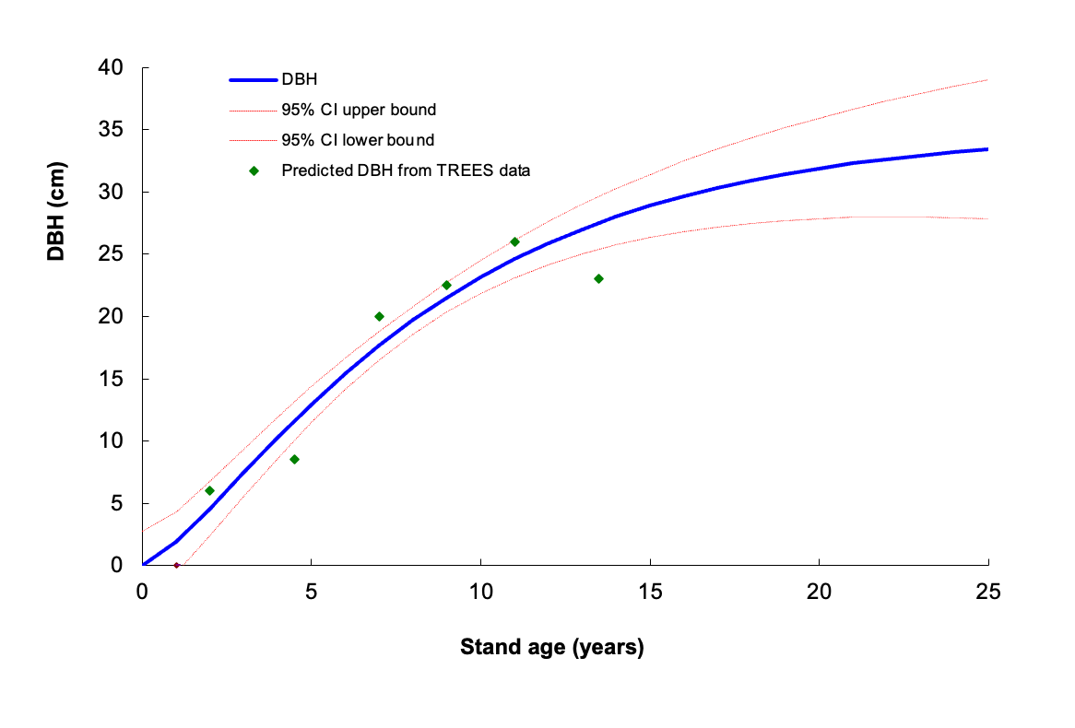
Figure 3.2.2.a Chapman-Richards growth curve developed for Eucalyptus trees in the project area
Modelled DBH for each year was converted to biomass using the eucalyptus allometric equation (an equation specific to smallholder agroforestry in western Kenya, Table 3.2.2.a). The long-term average stock for each eucalyptus use type was based on taking an average of the AGB estimated to be present each year; see the trees and Shrubs Emissions spreadsheet in supporting documentation for details.
The long-term average for each county was estimated by weighting each eucalyptus use by its estimated percentage share in each county. The long-term eucalyptus biomass per tree cleared in the project area was estimated by taking the average of the three counties (37.8 kg AGB per tree

cleared). BGB was calculated and biomass was converted into t CO2e using the same defaults presented above. Unlike other tree species, all eucalyptus trees that were reported to be cleared from farms in the FAM Survey were estimated to result in the same loss of long-term average carbon stock.
Shrub biomass losses were estimated using default factors following requirements in Estimation of Carbon Stocks and Change in Carbon Stocks of trees and Shrubs in A/R CDM Project Activities v4.2 for 1) carbon fraction (0.47), 2) aboveground biomass content in Kenya (48 t d.m./ha; from Table 3A 1.4 of IPCC GPG-LULCF 2003 report), and 3) the ratio of shrub biomass per ha to aboveground biomass content (0.1). In conjunction with these default factors, midpoints from field sampled ocular estimates of shrub canopy cover (Table 3.2.2.d) show total shrub carbon losses.
Table 3.2.2.d: Ocular Canopy Cover Classes
Canopy Cover class | Range of Coverage | Midpoint
1 | < 5% | 0.0%
2 | 6 - 25% | 15.5%
3 | 26 - 50% | 37.5%
4 | 51 - 75% | 62.5%
5 | 76 - 95% | 85.0%
6 | > 96% | 97.5%
One-time losses from biomass clearing averaged across all sampled farms, including those where no trees or shrubs were cleared, were 0.725 t CO₂e/ha for trees and 0.119 t CO₂e/ha for shrubs (see “Trees and Shrubs Emissions” spreadsheet in supporting documentation).
Farm management emissions
Under project activities, there is no burning of agricultural residues and there is no fossil fuel use. Livestock emissions are expected to remain constant relative to the baseline. All synthetic fertilizers are replaced with organic amendments. Crop nitrogen fixation is likewise held constant.
Organic amendments are assumed to increase as compost, mulch, and crop residues are added to the project area. GFCCA estimates that an additional 1.5 t d.m. in crop residues from cover crops will be returned to the soil, as well as 1.22 t of mulch residues collected from green walls and alleys. GFCCA also expects that farms will, on average, produce four 400 kg piles of compost per year and apply 1.6 tons of compost per year.
Additional emissions associated with N-fixing trees planted through project activities are estimated for the project scenario. Table 3.2.2d shows GFCCA’ recommended proportion of N-

fixing trees that would be planted per FFAS component and associated estimated area per ha. The weighted proportion of N-fixing trees in each FFAS based on the area estimates in Table 3.2.2.e is 27%.
Table 3.2.2.e Nitrogen-fixing trees in forest farmland
Carbon components of a Forest Farmland | Estimated area per ha of forest farmland (m2) | GFCCA recommended proportion of planted trees that are N-fixing  (%) | Estimated area of nitrogen-fixing trees (m2)
Staple crop alleys | 1,600 | 0% | 0
Tree/grass alleys | 400 | 50% | 200
Hedgerows | 820 | 83.3% | 683
Permafarmlands | 1,200 | 0% | 0
Fodder plot | 1,000 | 50% | 500
Fruit trees | 2,200 | 0% | 0
Timber plot | 2,000 | 66.7% | 1,333
Non-cultivated area | 980 | NA | 0
To estimate plant residues from N-fixing trees, we took the following steps:
- Relative carbon in N-fixing trees is estimated: The total t C estimated to be sequestered in tree biomass in each year of the project (see removals estimates below) is multiplied by the relative proportion expected to be in N-fixing trees (27%, from weighted average above).
- AGB in N-fixing trees is estimated: Carbon in trees from the biomass estimates is converted to total biomass using the conversion factor of 0.47 t C per t d.m. and simplified to AGB assuming AGB accounts for 80.5% of total biomass. This assumption is based on the default AGB and BGB accumulation rates for African tropical moist multistrata agroforestry systems in the 2019 IPCC Guidelines from Volume 4, Chapter 5, Table 5.2. These rates were used to inform the generated biomass curve (see below), with estimates that AGB accumulates at an average rate of 2.98 t C ha-1 yr-1 while BGB accumulates at a rate 0.72 t C ha-1 yr-1 (i.e., 2.98 t C ha-1 yr-1 of AGB contributes to
80.5% of annual biomass accumulation).
- Aboveground residue inputs are estimated: N-fixing trees are assumed to have a ratio of leaf biomass to AGB of 0.02, based on best estimates and the default values provided in Verra’s VM0017 Adoption of Sustainable Agricultural Land Management methodology.
- Nitrogen in aboveground residue inputs is estimated: the N content of aboveground residues is assumed to be 0.027 kg N (kg d.m.)-1 based on the 2019 IPCC Guidelines, Volume 4, Chapter 11, Table 11.1a default for N-fixing forages.
- Belowground residue inputs are estimated: Based on the assumptions made in the VM0017 methodology, it is assumed that fine roots are 7% of total root biomass and there is a 50% fine root turnover in N-fixing trees. Based on the above IPCC values of BGB accumulation, BGB is assumed to be 24.2% of AGB. Therefore, multiplying these values results in a default of 0.0084 kg d.m. in BGB residue inputs per kg d.m. of AGB.
- Nitrogen in belowground residue inputs is estimated: the N content of belowground residues is assumed to be 0.022 kg N (kg d.m.)-1 based on the 2019 IPCC Guidelines, Volume 4, Chapter 11, Table 11.1a default for N-fixing forages.
- N2O emissions are estimated: Based on the t N added to soils from N-fixing trees in the project scenario, Equations 25 and 26 from VM0042 v2.0 are used to estimate N2O emissions for each year of the project (Table 3.2.2.f). Emissions are projected to increase annually as the biomass in trees increases.
Table 3.2.2.f Emissions from nitrogen-fixing GFCCA in forest farmland
Project year | N2O emissions due to N-fixing trees in project scenario (t CO2e/ha)
1 | 0.0001
2 | 0.0009
3 | 0.0027
4 | 0.0057
5 | 0.0096
6 | 0.0141
7 | 0.0191
8 | 0.0242
9 | 0.0294
10 | 0.0343
11 | 0.0391
12 | 0.0435
13 | 0.0475

14 | 0.0512
15 | 0.0545
16 | 0.0575
17 | 0.0602
18 | 0.0625
19 | 0.0646
20 | 0.0664
21 | 0.0679
22 | 0.0693
23 | 0.0705
24 | 0.0715
25 | 0.0725
26 | 0.0732
27 | 0.0739
28 | 0.0745
29 | 0.0750
30 | 0.0754
31 | 0.0758
32 | 0.0761
33 | 0.0764
34 | 0.0766
35 | 0.0769
36 | 0.0770
37 | 0.0772
38 | 0.0773
39 | 0.0774
40 | 0.0775
Annual emissions (ex-ante estimates) of farm management project activity practices that are expected to be fixed across all years (i.e., emissions sources other than N-fixing trees) are shown in Table 3.2.2.g.
Table 3.2.2.g Farm Management Emissions in Project Scenario
Emissions source | Total (t CO₂e ha⁻¹ yr⁻¹)
CO2, fossil fuels | 0
CO2, lime | 0
CH4, enteric fermentation | 7.5996
CH4, manure deposition | 0.0631
CH4, biomass burning | 0
N2O, soils | 0.9611 (excluding N-fixing GFCCA, estimated to vary per  project year)
N2O, biomass burning | 0
Total | 9.5692
Biomass project removals were based on the Tier 1 removal factor for African tropical moist multistrata agroforestry from Table 5.2 in the 2019 IPCC Guidelines Volume, 4 Chapter 5, which was used to generate a Chapman-Richards curve, (shown in Figure 3.2.2a) to more accurately represent biomass growth of the GFCCA based on expert judgment. The annual change in stock generated from the growth curve was applied to estimate annual biomass removals.
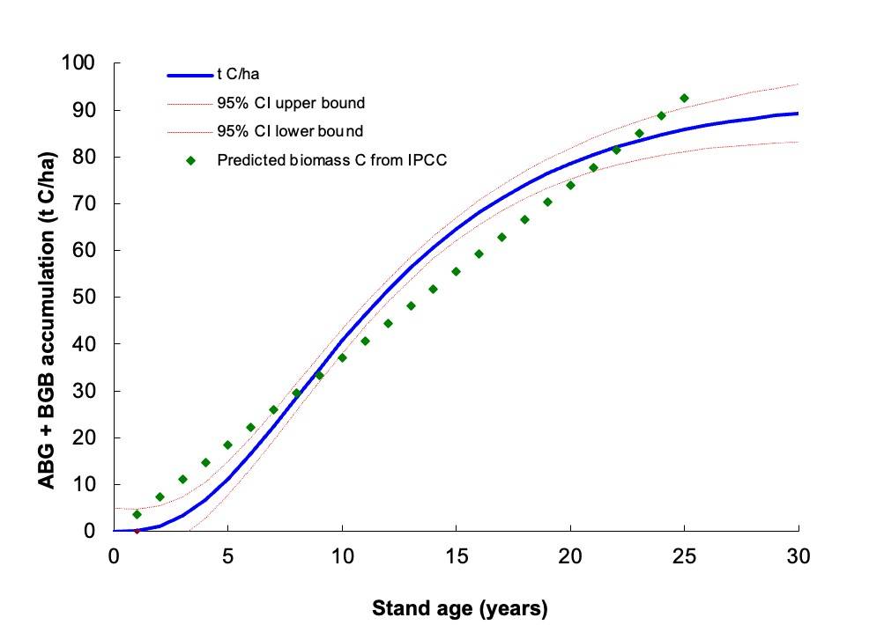
Figure 3.2.2a Total annual increase in AGB and BGB C stocks per hectare, curve generated based on IPCC predicted biomass carbon and expert judgment.
Soil Carbon Removals
The RothC model initialization in the project scenario followed the same procedures as baseline modeling, such that the projections start at the same point, following VM0042’s requirements in
Section 9.2: “Initially measured SOC stocks are the same in both the baseline and project

scenarios at the outset of the project under Quantification Approach 1.” Otherwise, the project scenario SOC stock projections were modeled in the same way as the baseline projections with three exceptions:
- In the project scenario, it is assumed that soil cover will be present over the entire year based on project activities promoting year-round soil cover.
- SOC stocks are estimated separately for the seven main components of the forest farmland (staple crop alleys, hedgerows, tree alleys, permafarmlands, fodder plots, fruit trees, and timber plots), which are expected to impact soils differently.
- The GFCCA farmland system is assumed to add additional plant inputs to the soil over time (see RothC Inputs accompanying excel). Any plant inputs from compost, mulch, and crop residues added to any of the forest farmland components are assumed to be added to the soils in March, April, October and November.
Figure 3.2.2.b shows the average total net soil carbon gain across all farm sites.
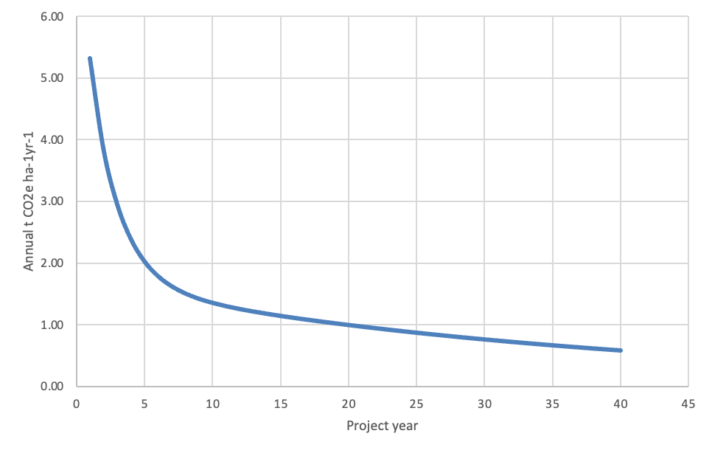
Figure 3.2.2.b Total annual increase in SOC stocks
Project: Uncertainty
Uncertainty in project emissions reductions and removals will be estimated at the first monitoring event based on sampled data and through the calibration and validation of the RothC model per VMD0053, as discussed in Section 3.2.1.
The uncertainty (considered as the half-width of the one standard deviation interval as a percentage of the mean for the gas or pool (%) as is provided by Equation 65 in VM0042 v2.0) estimated for clearing trees at the project start is 24.9% and the uncertainty associated with clearing shrubs is 28.5%.
3.2.3 Leakage Emissions (VCS 2.5, 3.2, 3.6, 3.15, 4.3)
Leakage can occur if:
- the source of new organic amendments comes from outside the project area
- productivity declines
- livestock is displaced
- biomass residues used for bioenergy are diverted for other uses

Under project activities, new sources of organic amendments come from pruning/cutting of newly planted trees, shrubs, and grasses; livestock is not impacted by project activities and therefore not displaced, and biomass residues for fuelwood are available from tree pruning.
As a result, Equation 34 from VM0042 v2.0 to account for imported manure, compost, or other biosolids does not need to be applied according to VM0042 v2.0 application criteria. Likewise, projections presented here hold livestock emissions constant, and do not need to be estimated as a source of leakage (section 8.4.2 of VM0042 v2.0). Any manure, compost, or other biosolids applied during the project will be confirmed to not be imported from outside the farm during monitoring.
As described in Section 8.4.3 of VM0042 v2.0:
“Market leakage is likely to be negligible because the land remains in agricultural production in the project scenario. Further, producers are unlikely to implement and maintain ALM practices that result in productivity declines, since their livelihoods depend on crop harvests and/or livestock outputs as a source of income.”
Existing yields of crops have been collected during baseline sampling for three years, this gives values required for either Equation 35 or 36 from VM0042 v2.0. These values have been submitted in excel files as part of the supporting documentation. Crop productivity for maize, millet, sweet potatoes, cassava and other crops will be maintained in Staple Crop Alleys. Family and Market Permafarmlands will also have a variety of nutritious small fruits and vegetables already grown by farmers.
Project period productivity yields will likewise be collected during monitoring events to supply other key values not currently available but required by Equation 35 and 36. As characterized in VM0042 v2.0, for this PD, leakage has been assumed to be zero for net GHG emission reductions and removals.
3.2.4 Estimated GHG Emission Reductions and Carbon Dioxide Removals (VCS,
3.15, 4.1)
State the non-permanence risk rating (%) | 24%
Has the non-permanence risk report been attached as either an appendix or a separate document? | ☒ Yes ☐ No
For ARR and IFM projects with harvesting, state, in tCO2e, the Long-term Average (LTA). | Not relevant as this is not an ARR or IFM project.
Has the LTA been updated based on monitored data, if applicable? | ☐ Yes ☐ No  This is not applicable as there is not an LTA estimated for project removals.
State, in tCO2e, the expected total GHG benefit to date. | Expected total GHG benefit to date will be estimated at the first monitoring event.
Is the number of GHG credits issued below the LTA? | ☐ Yes ☒ No  This is not applicable to the project because there is not an LTA estimated for trees planted in the project scenario.

Negative values are represented by parentheses in the table below. Negative emission reductions represent project emissions higher than the baseline in this case due to increased nitrous oxide emissions due to the prevalence of N-fixing trees and an increase in organic fertilizers.

Vintage period | Estimated baseline emissions (tCO2e) | Estimated project emissions (tCO2e) | Estimated leakage emissions (tCO2e) | Estimated buffer pool allocation (tCO2e) | Estimated reduction VCUs  (tCO2e) | Estimated removal VCUs  (tCO2e) | Estimated total VCU issuance (tCO2e)
01 Sep2022 –  31 Dec  2024 | 221,703 | 225,311 | 0 | 43,382 | (3,608) | 180,757 | 133,767
01 Jan  2025 – 31 Dec  2027 | 651,348 | 662,137 | 0 | 195,819 | (10,789) | 815,913 | 609,305
01 Jan  2028 – 31 Dec  2030 | 1,398,050 | 1,421,793 | 0 | 531,651 | (23,743) | 2,215,214 | 1,659,820
01 Jan  2031 – | 1,907,249 | 1,941,186 | 0 | 942,640 | (33,937) | 3,927,665 | 2,951,088
31 Dec
2033
01 Jan  2034 –  31 Dec  2036 | 1,907,249 | 1,944,104 | 0 | 1,158,569 | (36,855) | 4,827,373 | 3,631,948
01 Jan  2037 –  31 Dec  2039 | 1,907,249 | 1,947,154 | 0 | 1,095,078 | (39,905) | 4,562,824 | 3,427,841
01 Jan  2040 –  31 Dec  2042 | 1,907,249 | 1,949,729 | 0 | 884,704 | (42,481) | 3,686,266 | 2,759,081
01 Jan  2043 –  31 Dec  2045 | 1,907,249 | 1,951,663 | 0 | 656,712 | (44,414) | 2,736,299 | 2,035,173
01 Jan  2046 –  31 Dec  2048 | 1,907,249 | 1,953,021 | 0 | 466,567 | (45,772) | 1,944,029 | 1,431,690
01 Jan  2049 – 31 Dec  2051 | 1,907,249 | 1,953,938 | 0 | 325,211 | (46,689) | 1,355,046 | 983,146
01 Jan  2052 –  31 Dec  2054 | 1,907,249 | 1,954,542 | 0 | 226,124 | (47,294) | 942,182 | 668,765
Total | 17,529,090 | 17,904,578 | 0 | 6,526,456 | (375,488) | 27,193,569 | 20,291,624

The table below summarizes annual VCUs (t CO₂e/ha) as described in Sections 3.2.1 and 3.2.2, for the first three instances of the project with a total of 5,724 ha.

Table 3.2.4a Summary Net Greenhouse Gas Emissions and Removals for first three project instances
t CO2e | Emissions reductions | Project removals | Emission reductions and removals | Permanence deduction | Annual net emission reductions and removals | Cumulative emission reductions and removals
Year 1 | (76) | 2,956 | 2,880 | 709 | 2,171 | 2,171
Year 2 | (201) | 8,873 | 8,672 | 2,130 | 6,543 | 8,713
Year 3 | (203) | 12,660 | 12,458 | 3,039 | 9,419 | 18,133
Year 4 | (791) | 41,160 | 40,369 | 9,878 | 30,490 | 48,623
Year 5 | (799) | 55,164 | 54,364 | 13,239 | 41,125 | 89,748
Year 6 | (813) | 75,797 | 74,984 | 18,191 | 56,792 | 146,540
Year 7 | (833) | 97,041 | 96,209 | 23,290 | 72,919 | 219,459
Year 8 | (857) | 114,550 | 113,693 | 27,492 | 86,201 | 305,660
Year 9 | (884) | 126,605 | 125,721 | 30,385 | 95,336 | 400,996
Year 10 | (912) | 133,070 | 132,158 | 31,937 | 100,221 | 501,217
Year 11 | (941) | 134,613 | 133,671 | 32,307 | 101,364 | 602,582
Year 12 | (970) | 132,222 | 131,252 | 31,733 | 99,519 | 702,100
Year 13 | (997) | 126,927 | 125,930 | 30,462 | 95,467 | 797,568
Year 14 | (1,023) | 119,662 | 118,639 | 28,719 | 89,920 | 887,488
Year 15 | (1,047) | 111,203 | 110,156 | 26,689 | 83,467 | 970,955
Year 16 | (1,069) | 102,162 | 101,093 | 24,519 | 76,574 | 1,047,529
Year 17 | (1,089) | 92,995 | 91,906 | 22,319 | 69,587 | 1,117,116
Year 18 | (1,107) | 84,026 | 82,919 | 20,166 | 62,753 | 1,179,869
Year 19 | (1,123) | 75,475 | 74,352 | 18,114 | 56,238 | 1,236,107
Year 20 | (1,137) | 67,478 | 66,341 | 16,195 | 50,146 | 1,286,253
Year 21 | (1,149) | 60,108 | 58,959 | 14,426 | 44,533 | 1,330,786
Year 22 | (1,160) | 53,395 | 52,235 | 12,815 | 39,420 | 1,370,206
Year 23 | (1,170) | 47,337 | 46,167 | 11,361 | 34,806 | 1,405,012
Year 24 | (1,178) | 41,909 | 40,731 | 10,058 | 30,672 | 1,435,684
Year 25 | (1,186) | 37,075 | 35,890 | 8,898 | 26,991 | 1,462,676
Year 26 | (1,192) | 32,791 | 31,599 | 7,870 | 23,729 | 1,486,405
Year 27 | (1,198) | 29,009 | 27,812 | 6,962 | 20,849 | 1,507,255
Year 28 | (1,202) | 25,681 | 24,479 | 6,163 | 18,315 | 1,525,570
Year 29 | (1,207) | 22,759 | 21,553 | 5,462 | 16,090 | 1,541,660
Year 30 | (1,210) | 20,199 | 18,989 | 4,848 | 14,141 | 1,555,802
Year 31 | (1,213) | 17,959 | 16,746 | 4,310 | 12,436 | 1,568,238
Year 32 | (1,216) | 16,002 | 14,786 | 3,841 | 10,946 | 1,579,183
Year 33 | (1,218) | 14,293 | 13,075 | 3,430 | 9,644 | 1,588,828
Year 34 | (1,220) | 12,801 | 11,580 | 3,072 | 8,508 | 1,597,336

It is anticipated that 40,000 ha will be enrolled in this project over the project lifetime. Table 3.2.4.b shows annual values representing the total emission reductions and project removals to reflect total projected emission reductions and removals across 40,000 ha.
Table 3.2.4b Summary Net Greenhouse Gas Emissions and Removals for 40,000 ha projected with the project
t CO2e | Emissions reductions | Project removals | Emission reductions and removals | Permanence deduction | Annual net emission  reductions and removals | Cumulative emission reductions and removals
Year 1 | (76) | 2,956 | 2,880 | 709 | 2,171 | 2,171
Year 2 | (201) | 8,873 | 8,672 | 2,130 | 6,543 | 8,713
Year 3 | (203) | 12,660 | 12,458 | 3,039 | 9,419 | 18,133
Year 4 | (791) | 41,160 | 40,369 | 9,878 | 30,490 | 48,623
Year 5 | (2,337) | 115,107 | 112,770 | 27,626 | 85,144 | 133,767
Year 6 | (2,360) | 157,198 | 154,838 | 37,727 | 117,110 | 250,878
Year 7 | (3,496) | 262,704 | 259,208 | 63,049 | 196,159 | 447,036
Year 8 | (4,932) | 396,011 | 391,078 | 95,043 | 296,036 | 743,072
Year 9 | (6,398) | 551,457 | 545,059 | 132,350 | 412,709 | 1,155,782
Year 10 | (7,900) | 731,427 | 723,527 | 175,543 | 547,984 | 1,703,766
Year 11 | (9,445) | 932,330 | 922,885 | 223,759 | 699,126 | 2,402,892
Year 12 | (11,035) | 1,147,394 | 1,136,359 | 275,375 | 860,985 | 3,263,876
Year 13 | (11,299) | 1,315,642 | 1,304,342 | 315,754 | 988,588 | 4,252,465
Year 14 | (11,604) | 1,464,630 | 1,453,026 | 351,511 | 1,101,515 | 5,353,980
Year 15 | (11,936) | 1,570,916 | 1,558,980 | 377,020 | 1,181,960 | 6,535,940
Year 16 | (12,284) | 1,625,526 | 1,613,242 | 390,126 | 1,223,116 | 7,759,056
Year 17 | (12,635) | 1,630,931 | 1,618,296 | 391,423 | 1,226,872 | 8,985,928
Year 18 | (12,979) | 1,595,178 | 1,582,199 | 382,843 | 1,199,356 | 10,185,285
Year 19 | (13,308) | 1,528,153 | 1,514,845 | 366,757 | 1,148,088 | 11,333,373
Year 20 | (13,618) | 1,439,494 | 1,425,875 | 345,478 | 1,080,397 | 12,413,770
Year 21 | (13,905) | 1,337,582 | 1,323,677 | 321,020 | 1,002,657 | 13,416,427
Year 22 | (14,168) | 1,229,192 | 1,215,024 | 295,006 | 920,018 | 14,336,444
Year 23 | (14,407) | 1,119,492 | 1,105,085 | 268,678 | 836,407 | 15,172,851
Year 24 | (14,621) | 1,012,216 | 997,596 | 242,932 | 754,664 | 15,927,515
Year 25 | (14,812) | 909,910 | 895,098 | 218,378 | 676,719 | 16,604,234
Year 26 | (14,982) | 814,173 | 799,192 | 195,402 | 603,790 | 17,208,024
Year 27 | (15,131) | 725,889 | 710,758 | 174,213 | 536,544 | 17,744,568
Year 28 | (15,263) | 645,413 | 630,150 | 154,899 | 475,251 | 18,219,819
Year 29 | (15,378) | 572,727 | 557,349 | 137,455 | 419,894 | 18,639,714
Year 30 | (15,479) | 507,563 | 492,084 | 121,815 | 370,269 | 19,009,982
Year 31 | (15,567) | 449,492 | 433,925 | 107,878 | 326,047 | 19,336,029
Year 32 | (15,643) | 397,991 | 382,348 | 95,518 | 286,830 | 19,622,859
Year 33 | (15,710) | 352,498 | 336,788 | 84,599 | 252,188 | 19,875,048
Year 34 | (15,767) | 312,437 | 296,669 | 74,985 | 221,685 | 20,096,732
All emissions associated with project related tree and shrub clearing were assumed to occur in the first year of each instance starting the project. The non-permanence deduction applied to removals was assumed to be 24% (see Non-Permanence Risk Tool (NPRT) in supporting documentation).

Monitoring
3.3.1 Data and Parameters Available at Validation (VCS, 3.16)

Data / parameter | AR
Data unit | Percent
Description | Weighted mean adoption rate
Source of data | Calculated for project across the group or all activity instances
Value applied | 11.7% for individual project activities within farmlands; 0% for the combined practices in a forest farmland.
Justification of choice of data or description of measurement methods and procedures applied | Three different local experts were surveyed in August 2023 with a template²³⁴ designed by GFCCA Technical department to determine the commonality of hedgerows, alley cropping, multistrata agroforestry, fruit orchard, hardwood plantations, fodder plots, and compost making and application. The weighted average adoption rate was estimated based on the area and incidence of each activity.  Name: Jonah Keprop  Title & Organization: Senior Research Scientist, Kenya Forest Research Institute  Name: Charles Orero, PhD  Title & Organization: Chairman Nyanaza Ledfo Farmers’  Cooperative Society, Chairman Wire Forest Management Association, Community Forest Association  Name: Dorothy Masiga Syallow, PhD Forestry and Environmental  Science  Title & Organization: Senior Lecturer, University of Kabianga  Name: Eliakim Ambajo, MSc in Agricultural Extension  Title & Organization: Agricultural Officer, Ministry of Agriculture

Purpose of data | Common Practice Assessment
Comments | None

Data / parameter | EA_{ay}
Data unit | Percent
Description | Adoption rate of the y most common (by area covered) proposed project activity in the region)
Source of data | Survey of local experts
Value applied | Alley Crops - 15.0%  Hedgerows - 12.5%  Permafarmland - 11.3%  Fodder Plot - 12.5%  Fruit Trees - 10.0%  Timber Plot - 10.0%  Combined Forest Farmland - 0%
Justification of choice of data or description of measurement methods and procedures applied | Three different local experts were surveyed in August 2023 with a template designed by GFCCA Technical department to determine the commonality of hedgerows, alley cropping, multistrata agroforestry, fruit orchard, hardwood plantations, fodder plots, and compost making and application. The weighted average adoption rate was estimated based on the area and incidence of each activity.  Name: Jonah Keprop  Title & Organization: Senior Research Scientist, Kenya Forest Research Institute  Name: Charles Orero, PhD  Title & Organization: Chairman Nyanaza Leofo Farmers’  Cooperative Society, Chairman Wire Forest Management Association, Community Forest Association  Name: Dorothy Masiga Syallow, PhD Forestry and Environmental  Science  Title & Organization: Senior Lecturer, University of Kabianga  Name: Eliakim Ambajo, MSc in Agricultural Extension  Title & Organization: Agricultural Officer, Ministry of Agriculture
Purpose of data | Common Practice Assessment
Comments | None

Data / parameter | Area_{ay}
Data unit | Hectare (ha)
Description | Area of proposed project-level adoption of activity ay
Source of data | Farm records and project activity commitments
Value applied | Farmlands all incorporating: Alley crops, Hedgerows, Permafarmlands, Fodder plots, fruit trees, and timber trees planned across first three instances totaling 5,724 ha.
Justification of choice of data or description of measurement methods and procedures applied | Three different local experts were surveyed in August 2023 with a template designed by GFCCA Technical department to determine the commonality of hedgerows, alley cropping, multistrata agroforestry, fruit orchard, hardwood plantations, fodder plots, and compost making and application. The weighted average adoption rate was estimated based on the area and incidence of each activity.  Name: Jonah Keprop  Title & Organization: Senior Research Scientist, Kenya Forest Research Institute  Name: Charles Orero, PhD  Title & Organization: Chairman Nyanaza Leofo Farmers'  Cooperative Society, Chair Wire Forest Management Association, Community Forest Association  Name: Dorothy Masiga Syallow, PhD Forestry and Environmental  Science  Title & Organization: Senior Lecturer, University of Kabianga  Name: Eliakim Ambajo, MSc in Agricultural Extension  Title & Organization: Agricultural Officer, Ministry of Agriculture
Purpose of data | Common practice assessment
Comments | None

Data / parameter | Area_{ay}
Data unit | Hectare (ha)
Description | Area of proposed project-level adoption of activity ay
Source of data | Farm records and project activity commitments
Value applied | The proposed project-level adoption of activity x
Justification of choice of data or description of measurement methods and procedures applied | Not applicable
Purpose of data | Common practice assessment, basis for parameters Area_{ay} and  PA_{ay}
Comments | None

Data / parameter | FFCbsl,j,I,t
Data unit | Liters
Description | Consumption of fossil fuel type j (gasoline or diesel) for quantification unit i in year t in the baseline scenario
Source of data | FAM Survey
Value applied | In the first three instances of the project:  Diesel: 3,356 l  Petrol: 1,071 l
Justification of choice of data or description of measurement methods and procedures applied | Liters of fuel in the first three instances were calculated based on the per ha average used of each fuel type reported in the FAM Survey, as calculated in the Farm Management Emissions excel:  0.586 l per ha of diesel, and 0.187 l per ha of petrol.
Purpose of data | Calculation of baseline emissions
Comments | None

Data / parameter | Pbsl,l,i,t
Data unit | Head count
Description | Population of grazing livestock of type l in the baseline scenario in quantification unit i for productivity system P in year t
Source of data | FAM Survey
Value applied | In the first three instances of the project:  Dairy cattle: 7,483  Donkeys: 248  Doves: 1,064  Ducks: 988  Goats: 8,415  Non-dairy cattle: 20,598  Pigs (finishing): 252  Poultry (broilers): 3,288  Poultry (hens): 92,795  Poultry (pullets): 0 Sheep: 5,245
Justification of choice of data or description of measurement methods and procedures applied | The head count of livestock in the first three instances was calculated based on the per ha average of each livestock type reported in the FAM Survey, as calculated in the Farm Management Emissions excel:  Dairy cattle: 1.31 per ha  Donkeys: 0.04 per ha  Doves: 0.19 per ha  Ducks: 0.17 per ha  Goats: 1.47 per ha  Non-dairy cattle: 3.60 per ha  Pigs (finishing): 0.04 per ha  Poultry (broilers): 0.57 per ha  Poultry (hens): 16.21 per ha  Poultry (pullets): 0 per ha  Sheep: 0.92 per ha
Purpose of data | Calculation of baseline emissions
Comments | None

Data / parameter | GWPCH4
Data unit | t CO₂e/t CH₄
Description | Global warming potential for CH₄
Source of data | IPCC 5th Assessment Report
Value applied | 28
Justification of choice of data or description of measurement methods and procedures applied | See “Source of data.” Global warming potential values must be applied as described in the latest version of the VCS Standard and derived from IPCC Assessment Reports.
Purpose of data | Calculation of baseline emissions  Calculation of project emissions
Comments | None

Data / parameter | Wbsl,l,i,t,P
Data unit | kg animal mass/head
Description | Average weight in the baseline scenario of livestock type l for quantification unit i in productivity system P in year t
Source of data | 2019 IPCC Guidelines, Volume 4, Chapter 10, Table 10a.5
Value applied | Dairy Cattle: 270  Non-Dairy Cows: 208  Goats: 24  Poultry (hens): 1.1  Poultry (pullets): 0.5  Poultry (broilers): 0.7  Donkeys: 130  Ducks: 2.7  Pigs: 33  Sheep: 31
Justification of choice of data or description of measurement methods and procedures applied | There are no project-specific information sources regarding animal mass in the project area. As per VM0042 v2.0 recommendations, “where project proponents are able to justify a lack of sufficient activity data and project-specific information sources, Tier 1 values from Table 10A.5, Chapter 10, Volume 4 in IPCC (2019) may be selected.”
Purpose of data | Calculation of project emissions
Comments | None

Data / parameter | MBbsl,c,i,t
Data unit | kg
Description | Mass of agricultural residues of type c burned in the baseline scenario for quantification unit i in year t
Source of data | FAM Survey
Value applied | In the first three instances of the project:  Bean residues: 8,618 kg  Maize residues: 798,882 kg  Other or mixed residues: 186,251 kg
Justification of choice of data or description of measurement methods and procedures applied | The mass of agricultural residues burned in the first three instances was calculated based on the per ha average of each residue type burned reported in the FAM Survey, as calculated in the Farm Management Emissions excel:  Bean residues: 1.51 kg/ha  Maize residues: 139.56 kg/ha  Other or mixed residues: 32.54 kg/ha
Purpose of data | Calculation of baseline emissions
Comments | None

Data / parameter | GWPN2O
Data unit | t CO₂e/t N₂O
Description | Global warming potential for N₂O
Source of data | IPCC 5th Assessment Report
Value applied | 265
Justification of choice of data or description of measurement methods and procedures applied | See “Source of data.” Global warming potential values must be applied as described in the latest version of the VCS Standard and derived from IPCC Assessment Reports.
Purpose of data | Calculation of baseline emissions  Calculation of project emissions
Comments | None

Data / parameter | Mbsl,SF,i,t
Data unit | t fertilizer
Description | Mass of N-containing synthetic fertilizer type SF applied in quantification unit i in year t in the baseline scenario
Source of data | FAM Survey
Value applied | In the first three instances of the project:  Baraka (Planting): 2.23 t fertilizer  Baraka (Top Dressing): 4.25 t fertilizer  CAN: 37.17 t fertilizer  Chapa Meli (DAP): 61.54 t fertilizer  Chapa Meli (UREA): 1.75 t fertilizer  DAP: 77.15 t fertilizer  Elgon (UREA): 0.34 t fertilizer  ETG/Falcon (CAN): 97.49 t fertilizer  ETG/Falcon (DAP): 149.94 t fertilizer  ETG/Falcon (NPK): 2.60 t fertilizer  EasyGro: 0.00 t fertilizer  Yara DAP: 5.04 t fertilizer
Justification of choice of data or description of measurement methods and procedures applied | The mass of N-containing synthetic fertilizer type applied in the first three instances was calculated based on the per ha average of each fertilizer type reported in the FAM Survey, as calculated in the Farm Management Emissions excel:  Baraka (Planting): 0.0004 t/ha  Baraka (Top Dressing): 0.0007 t/ha  CAN: 0.0065 t/ha  Chapa Meli (DAP): 0.0108 t/ha  Chapa Meli (UREA): 0.0003 t/ha  DAP: 0.0135 t/ha  Elgon (UREA): 0.0001 t/ha  ETG/Falcon (CAN): 0.0170 t/ha  ETG/Falcon (DAP): 0.0262 t/ha  ETG/Falcon (NPK): 0.0005 t/ha  EasyGro: 0.0000 t/ha  Yara DAP: 0.0009 t/ha
Purpose of data | Calculation of baseline emissions
Comments | None

Data / parameter | Mbsl,OF,i,t
Data unit | t fertilizer
Description | Mass of N-containing organic fertilizer type OF applied in the baseline scenario for quantification unit i in year t
Source of data | FAM Survey
Value applied | In the first three instances of the project:  Animal Manure (not from grazing animal): 3,583 t fertilizer  Compost: 377 t fertilizer  Guano manure: 26 t fertilizer  Other: 72 t fertilizer  Press mud (sugarcane waste - bagasse): 1 t fertilizer
Justification of choice of data or description of measurement methods and procedures applied | The mass of N-containing organic fertilizer type applied in the first three instances was calculated based on the per ha average of each fertilizer type reported in the FAM Survey, as calculated in the Farm Management Emissions excel:  Animal Manure (not from grazing animal): 0.6260 t/ha  Compost: 0.0658 t/ha  Guano manure: 0.0046 t/ha  Other: 0.0125 t/ha  Press mud (sugarcane waste - bagasse): 0.0003 t/ha
Purpose of data | Calculation of baseline emissions
Comments | None

Data / parameter | MBg,bsl,i,t
Data unit | t dm
Description | Annual aboveground and belowground dry matter of N-fixing species g returned to soils in the baseline scenario for quantification unit i in year t
Source of data | FAM Survey
Value applied | In the first three instances of the project:  Beans and pulses: 2,532 t d.m.  Cowpeas: 581 t d.m.  Ground nuts: 618 t d.m.  Soyabeans: 157 t d.m.
Justification of choice of data or description of measurement methods and procedures applied | The mass of aboveground and belowground dry matter returned to soils in the first three instances was calculated based on the per ha average of the dry matter returned to soils reported in the FAM Survey, as calculated in the Farm Management Emissions excel:  Beans and pulses: 0.442 t d.m./ha  Cowpeas: 0.102 t d.m./ha  Ground nuts: 0.108 t d.m./ha  Soyabeans: 0.027 t d.m./ha
Purpose of data | Calculation of baseline emissions
Comments | None

Data / parameter | MSbsl,l,i,t
Data unit | Fraction of N deposited
Description | Fraction of nitrogen excretion by livestock type l that is deposited in quantification unit i in year t in the baseline scenario
Source of data | FAM Survey
Value applied | 100%
Justification of choice of data or description of measurement methods and procedures applied | This was assumed to be 100% across all livestock as it is assumed that 100% of N that is managed under the specific baseline management system is deposited in the project area.
Purpose of data | Calculation of baseline emissions
Comments | None

Data / parameter | Pbsl,p
Data unit | Output Mg/ha
Description | Average productivity for product p during the historical look-back period
Source of data | FAM Survey
Value applied | Per crop type p, the average yields from the FAM Survey over the historical lookback period were:  Bananas: 17.2 t/ha  Beans and pulses: 0.5 t/ha  Cassava: 5.8 t/ha  Cowpeas: 15.1 t/ha  Ground nuts: 2.9 t/ha  Kale: 17.7 t/ha  Maize: 1.6 t/ha  Millet: 2.0 t/ha  Sorghum: 1.2 t/ha  Soybeans: 0.9 t/ha  Sugarcane: 82.3 t/ha  Sunflower: 2.3 t/ha  Sweet potatoes: 13.8 t/ha  Tobacco: 1.6 t/ha
Justification of choice of data or description of measurement methods and procedures applied | Average productivity in the first three instances was calculated from farmer responses in the Farm Management Emissions excel.
Purpose of data | Determination of baseline productivity for future market leakage analysis
Comments | None

Data / parameter | A
Data unit | Hectare (ha)
Description | Area of quantification unit i, unit area
Source of data | Measured in project area
Value applied | Instance 1: 552.45 ha  Instance 2: 907.97 ha  Instance 3: 4,263.76 ha  Total value considered for validation: 5,724.18 ha
Justification of choice of data or description of measurement methods and procedures applied | This is the combined area of the first three instances (first three quantification units), which is estimated based on spatial analysis of polygons of project farms.
Purpose of data | Calculation of baseline and project emissions
Comments | None

3.3.2 Data and Parameters Monitored (VCS, 3.16)

Data / parameter | MDD
Data unit | t CO₂e/ha
Description | Minimum detectable difference in SOC stocks between two points in time
Source of data | Estimation of the smallest difference in SOC stocks between two monitoring events that may be detected as statistically significant
Description of measurement methods and procedures to be applied | The minimum detectable difference will be calculated using Equations 2 and 3 of VM0042 v2.0, based on an initial sample of soils taken to determine SOC variance between t0 and t1.
Frequency of monitoring/recording | Monitoring conducted at least every five years, or prior to each verification event where verification occurs more frequently.
Value applied | This value will be estimated at verification.
Monitoring equipment | Not applicable
QA/QC procedures to be applied | Not applicable
Purpose of data | Calculation of project emissions
Calculation method | This will be calculated using the approach outlined in Equations 2 and 3 of VM0042 v2.0.
Comments | None

Data / parameter | S
Data unit | Dimensionless
Description | Standard deviation of the difference in SOC stocks between t0 and t1
Source of data | Estimation of the smallest difference in SOC stocks between two monitoring events that may be detected as statistically significant
Description of measurement methods and procedures to be applied | This will be estimated based on SOC stocks at the first verification event.
Frequency of monitoring/recording | Monitoring conducted at least every five years, or prior to each verification event where verification occurs more frequently.
Value applied | This will be estimated based on SOC stocks at the first verification event.
Monitoring equipment | Not applicable
QA/QC procedures to be applied | Not applicable
Purpose of data | Calculation of project emissions
Calculation method | This will be estimated based on SOC stocks at the first verification event.
Comments | None

Data / parameter | n
Data unit | Activity category
Description | Number of samples required to detect a minimum difference
Source of data | Analysis of expected variance
Description of measurement methods and procedures to be applied | An analysis will be done to calculate the number of samples needed to calculate the minimum detectable difference based on an initial sample of soils taken to determine variance.
Frequency of monitoring/recording | Monitoring conducted at least every five years, or prior to each verification event where verification occurs more frequently.
Value applied | This value will be estimated at verification.
Monitoring equipment | Not applicable
QA/QC procedures to be applied | Not applicable
Purpose of data | Calculation of project emissions
Calculation method | This value will be estimated at verification.
Comments | None

Data / parameter | n − 1
Data unit | Dimensionless
Description | Degrees of freedom for the relevant t-distribution
Source of data | Estimation of the smallest difference in SOC stocks between two monitoring events that may be detected as statistically significant
Description of measurement methods and procedures to be applied | See Section 8.2.1
Frequency of monitoring/recording | Monitoring must be conducted at least every five years, or prior to each verification event where verification occurs more frequently.
Value applied | This value will be estimated at verification.
Monitoring equipment | Not applicable
QA/QC procedures to be applied | Not applicable
Purpose of data | Calculation of project emissions
Calculation method | Not applicable
Comments | None

Data / parameter | tx,υ
Data unit | Dimensionless
Description | Values of the t-distribution given a certain power level (1 − b) and a significance level
Source of data | Statistical t-tables
Description of measurement methods and procedures to be applied | Not applicable
Frequency of monitoring/recording | Reevaluated at each verification
Value applied | This value will be estimated at verification.
Monitoring equipment | Not applicable
QA/QC procedures to be applied | Not applicable
Purpose of data | Calculation of project emissions
Calculation method | Not applicable
Comments | None

Data / parameter | M_{n,dl,SOC}
Data unit | kg/ha
Description | SOC mass in soil sample n in depth layer dl
Source of data | Measured after soil sampling in the project area
Description of measurement methods and procedures to be applied | Soil mass is evaluated based on ICRAF data processed for each soil sample. All soil samples will be collected following the procedure outlined in the Climate Monitoring Plan in the supporting documents and processed following the ICRAF SOPs (Standard Operating Procedures) also described in the Climate Monitoring Plan.
Frequency of monitoring/recording | Measurement of SOC stocks conducted at least every five years, or prior to each verification event where verification occurs more frequently.

Value applied | All SOC mass values of soil samples of the baseline scenario are in the supporting spreadsheet “ICRAF ESM soil data.”
Monitoring equipment | The probe used to collect soil samples was the AMS, Inc. 1” x 36” Plated Replaceable Tip Soil Probe.  Also see the standard Operating Procedures of the Soil-Plant Spectral Diagnostics Laboratory of World Agroforestry Centre (ICRAF) for additional detail on lab equipment used.
QA/QC procedures to be applied | QA/QC procedures for soil data collection are described in the Climate Monitoring Plan.  Soil mass must not include particles greater than 2 mm in diameter (i.e., gravel/stones) nor plant material. Beem-Miller et al. (2016) provide a useful approach to ensuring high-quality sampling in rocky agricultural soils.
Purpose of data | Calculation of baseline emissions  Calculation of project emissions
Calculation method | ICRAF provides dry weight, weight after sieving, coarse weight, and actual dry weight in their analysis outputs. The actual dry weight is based on the dry weight minus the coarse weight and is what is used to estimate SOC. The inside diameter of the probe used and the organic carbon content in the sample unit is also used to estimate M_{n,dl,SOC} as described in Equation 4 of VM0042 v2.0.
Comments | None

Data / parameter | Mn,dl,sample
Data unit | g
Description | Soil mass of sample n in depth layer dl
Source of data | Measured after soil sampling in the project area
Description of measurement methods | The ICRAF soil laboratory was selected for soil testing and used mid-infrared spectroscopy with a 30% hold out validation set. Soil samples were dried to a constant mass and sieved to

and procedures to be applied | remove any particles greater than 2 mm in diameter. Consistent with Appendix 4 and the method-specific criteria given by Table 9 in VM0042 v2.0, the applied measurement protocol was Standard Operating Procedures of the Soil-Plant Spectral  Diagnostics Laboratory of World Agroforestry Centre (ICRAF). Soil mass (g) was estimated for each composite depth layer. Soil mass was estimated using an equivalent soil mass (ESM) approach to estimate soil carbon.
Frequency of monitoring/recording | Measurement of SOC stocks conducted at least every five years, or prior to each verification event where verification occurs more frequently.
Value applied | All soil mass values of soil samples of the baseline scenario are in the supporting spreadsheet “ICRAF ESM soil data.”
Monitoring equipment | The probe used to collect soil samples was the AMS, Inc. 1” x 36” Plated Replaceable Tip Soil Probe.  Also see the standard Operating Procedures of the Soil-Plant Spectral Diagnostics Laboratory of World Agroforestry Centre (ICRAF) for additional detail on lab equipment used.
QA/QC procedures to be applied | QA/QC procedures for soil data collection are described in the Climate Monitoring Plan.
Purpose of data | Calculation of baseline emissions  Calculation of project emissions
Calculation method | Mass of gravel/stones and plant material subtracted from the sample mass to obtain soil mass.
Comments | None

Data / parameter | D
Data unit | mm
Description | Inside diameter of probe or auger
Source of data | Measured as part of project monitoring
Description of measurement methods | Information from product specifications of probe or auger

and procedures to be applied
Frequency of monitoring/recording | Measurement of SOC stocks conducted at least every five years, or prior to each verification event where verification occurs more frequently.
Value applied | 1 inch - 2.54 cm
Monitoring equipment | The probe used to collect soil samples was the AMS, Inc. 1” x 36”  Plated Replaceable Tip Soil Probe
QA/QC procedures to be applied | Not applicable
Purpose of data | Calculation of baseline emissions  Calculation of project emissions
Calculation method | Not applicable
Comments | None

Data / parameter | N
Data unit | Unitless
Description | Number of cores sampled
Source of data | Measured in the project area
Description of measurement methods and procedures to be applied | Not applicable
Frequency of monitoring/recording | Measurement of SOC stocks conducted at least every five years, or prior to each verification event where verification occurs more frequently.
Value applied | 187 soil samples were taken (with 3 cores per sample location) in the baseline. The number of samples taken in future verification events will be determined prior to each verification event.
Monitoring equipment | Not applicable
QA/QC procedures to be applied | Not applicable
Purpose of data | Calculation of baseline emissions  Calculation of project emissions
Calculation method | Not applicable
Comments | None

Data / parameter | OC_{n,dl}
Data unit | g/kg
Description | Organic carbon content in sample n from depth layer dl
Source of data | Measured in the project area
Description of measurement methods and procedures to be applied | The ICRAF soil laboratory was selected for soil testing and used mid-infrared spectroscopy with a 30% hold out validation set. Soil samples were dried and sieved to remove any particles greater than 2 mm in diameter. Consistent with Appendix 4 and the method-specific criteria given by Table 9 in VM0042 v2.0, the applied measurement protocol was Standard Operating Procedures of the Soil-Plant Spectral Diagnostics Laboratory of Worlds Agroforestry Centre (ICRAF). Soil organic carbon (g/kg soil) was estimated for each composite depth layer. Soil carbon content was then estimated using an equivalent soil mass (ESM) approach to estimate soil carbon.
Frequency of monitoring/recording | Measurements of SOC stocks conducted at least every five years.
Value applied | All calculated organic carbon content values of soil samples of the baseline scenario are in the supporting spreadsheet “ICRAF  ESM soil data.”

Monitoring equipment | The probe used to collect soil samples was the AMS, Inc. 1” x  36” Plated Replaceable Tip Soil Probe.
QA/QC procedures to be applied | QA/QC procedures for soil data collection are described in the Climate Monitoring Plan.
Purpose of data | Calculation of baseline emissions  Calculation of project emissions
Calculation method | Not applicable
Comments | None

Data / parameter | BDcorr
Data unit | g/cm₃
Description | Corrected bulk density of the fine soil fraction (after subtracting the mass proportion of the coarse fragments)
Source of data | Field measurement at least every five years
Description of measurement methods and procedures to be applied | Field instructions with diagrams were provided to each team as indicated in the Soil Sample Collection Procedure (Exhibit 56); all requirements from VM0042 were followed with all samples taken to the minimum depth of 30 cm and split into subsections. Future sampling will occur to depths greater than 30 cm to capture equivalent soil mass (ESM) with decreasing soil bulk density (except where prevented through depth of bedrock). All gravel, stones, vegetation, and other litter was removed from the soil surface. A total of 3 cores were taken, one at each random location. Each core was split into two different depth layers: 1) 0 to 15 cm, and 2) 15 to 30 cm. To reduce variability cores were composited across each of the three locations for the two different depths (0-15 cm, 15-30 cm). All cores for each depth layer were double labeled and delivered to the soil testing facility within 5 days of sampling.  The ICRAF soil laboratory was selected for soil testing and used mid-infrared spectroscopy with a 30% hold out validation set. Soil samples were dried and sieved to remove any particles greater than 2 mm in diameter. Consistent with Appendix 4 and the method-specific criteria given by Table 9 in VM0042 v2.0, the applied measurement protocol was Standard Operating

 | Procedures of the Soil-Plant Spectral Diagnostics Laboratory of Worlds Agroforestry Centre (ICRAF). Soil mass (g) was estimated for each composite depth layer. Soil mass was then estimated using an equivalent soil mass (ESM) approach to estimate soil carbon.
Frequency of monitoring/recording | At least every five years, or prior to each verification event where verification occurs more frequently.  Field measurement of soils at least every five years.
Value applied | All calculated bulk density values of soil samples of the baseline scenario are in the supporting spreadsheet “ICRAF ESM soil data.”
Monitoring equipment | The probe used to collect soil samples was the AMS, Inc. 1” x  36” Plated Replaceable Tip Soil Probe.
QA/QC procedures to be applied | QA/QC procedures for soil data collection are described in the Climate Monitoring Plan.
Purpose of data | Calculation of baseline emissions  Calculation of project emissions
Calculation method | Not applicable
Comments | None

Data / parameter | d
Data unit | cm
Description | Soil depth
Source of data | Field measurement at least every five years
Description of measurement methods and procedures to be applied | Field instructions with diagrams were provided to each team as indicated in the Soil Sample Collection Procedure (Exhibit 56); all requirements from VM0042 were followed with all samples taken to the minimum depth of 30 cm and split into subsections. Future sampling will occur to depths greater than 30 cm to capture equivalent soil mass (ESM) with decreasing soil bulk density (except where prevented through depth of bedrock).

Frequency of monitoring/recording | At least every five years, or prior to each verification event where verification occurs more frequently.  Field measurement of soils at least every five years.
Value applied | 30 cm in baseline, will increase with each true-up event
Monitoring equipment | The probe used to collect soil samples was the AMS, Inc. 1” x 36” Plated Replaceable Tip Soil Probe.²⁴⁷
QA/QC procedures to be applied | QA/QC procedures for soil data collection are described in the Climate Monitoring Plan.
Purpose of data | Calculation of baseline emissions  Calculation of project emissions
Calculation method | Not applicable
Comments | None

Data / parameter | Ƒ(SOC_{bsl,i,t})
Data unit | t CO₂e/ha
Description | Modeled SOC stocks in the baseline scenario for quantification unit i at time t, calculated by modeling SOC stock changes over the course of the preceding year
Source of data | The RothC Model²⁴⁸ will be used to estimate soil carbon stocks.
Description of measurement methods and procedures to be applied | Modeled SOC stocks in the baseline scenario are determined according to the following equation:  𝑆𝑂𝐶_𝑠𝑜𝑖𝑙𝑏𝑠𝑙,𝑖,𝑡=ʄ𝑆𝑂𝐶(𝑉𝑎𝑙 𝐴𝑏𝑠𝑙,𝑖,𝑡,𝑉𝑎𝑙 𝐵𝑏𝑠𝑙,𝑖,𝑡,…)  Where:  SOC_soilbsl,i,t Modeled SOC stocks in the baseline scenario for quantification unit i at time t (t CO2e/ha) ʄSOC Model predicting carbon dioxide emissions from the SOC pool (t CO2e/ha)  Val Absl,i,t Value of model input variable A in the project scenario for quantification unit i at time t (units unspecified)  Val Bbsl,i,t Value of model input variable B in the project scenario for quantification unit i at time t (units unspecified)  All model input variables to RothC are described in Section 3.1.2 above. The Climate Monitoring Plan also describes these inputs and outlines the procedure to run RothC. The spreadsheet in the

- ibid
- Rothamsted Carbon Model (ROTHC): Understanding Soil Carbon Dynamics, Rothamsted Research, www.rothamsted.ac.uk/rothamsted-carbon-model-rothc. Accessed 28 Mar. 2024.
 | supporting documentation “RothC Inputs” also summarizes model inputs.
Frequency of monitoring/recording | Measurements conducted at least every five years. Modeling as a means of monitoring conducted prior to each verification event where verification occurs more frequently than once every five years.
Value applied | Output values from the RothC model are in the “RothC Outputs” spreadsheet provided in the supporting documentation.
Monitoring equipment | The RothC Model will be used to estimate soil carbon stocks.
QA/QC procedures to be applied | QA/QC procedures for soil modeling (in addition to soil data collection, which serves as inputs for the soil model) are described in the Climate Monitoring Plan.
Purpose of data | Calculation of baseline emissions following Quantification Approach 1
Calculation method | Not applicable
Comments | The SOC stocks at time t = 0 are calculated based on directly measured SOC content and bulk density at t = 0 or (back-) modeled to t = 0 from measurements within ±5 years of t = 0.

Data / parameter | I
Data unit | Dimensionless
Description | Quantification unit. Defined area that is selected for measurement and monitoring, such as a field or stratum.
Source of data | Determined in project area
Description of measurement methods and procedures to be applied | Not applicable.
Frequency of monitoring/recording | Monitoring conducted at least every five years, or prior to each verification event where verification occurs more frequently.
Value applied | The quantification unit is defined as each instance of the project.

Monitoring equipment | Not applicable
QA/QC procedures to be applied | Not applicable
Purpose of data | Calculation of baseline emissions  Calculation of project emissions
Calculation method | Not applicable
Comments | None

Data / parameter | A_{i}
Data unit | Hectare
Description | Area of quantification unit i
Source of data | Measurement of each quantification unit within the project area
Description of measurement methods and procedures to be applied | GFCCA project officers will be trained in polygon data collection using Survey 123 GFCCA staff navigate to the preregistered farm in the Survey 123 app and walk the perimeter of the field with the farmer to ensure the polygon accurately captures the farmer’s land to be included in the project. Survey 123 automatically captures and records the size of the polygon in hectares.
Frequency of monitoring/recording | Monitoring conducted at least every five years, or prior to each verification event where verification occurs more frequently.
Value applied | Instance 1: 552.45 ha  Instance 2: 907.97 ha  Instance 3: 4,263.76 ha  Total value considered for validation in first three instances:  5,724.18 ha
Monitoring equipment | A hand-held smartphone device was used to collect polygon boundaries.
QA/QC procedures to be applied | Once polygon data is collected on the handheld device, it is viewed with the farmer to ensure accuracy. When the data is synced with ESRI arconline, it is reviewed by GFCCA GIS  Specialist to ensure it conform with satellite imagery. Farm size in hectares is reviewed to confirm the polygon area is within limits set for the project.

Purpose of data | Calculation of baseline emissions  Calculation of project emissions
Calculation method | Not applicable
Comments | None

Data / parameter | j
Data unit | Dimensionless
Description | Type of fossil fuel combusted
Source of data | Determined by type of fossil fuel used
Description of measurement methods and procedures to be applied | Not applicable
Frequency of monitoring/recording | Monitoring conducted at least every five years, or prior to each verification event where verification occurs more frequently.
Value applied | Diesel  Petrol
Monitoring equipment | Not applicable
QA/QC procedures to be applied | Not applicable
Purpose of data | Calculation of baseline emissions  Calculation of project emissions
Calculation method | Not applicable
Comments | None

Data / parameter | EFCO2,j
Data unit | t CO₂e/liter
Description | Emission factor for fossil fuel j (gasoline or diesel) combusted
Source of data | 2019 IPCC Guidelines, Volume 2, Chapter 3, Table 3.3.1
Description of measurement methods | For gasoline EFCO2 = 0.002810 t CO₂e per liter
and procedures to be applied | For diesel EFCO2 = 0.002886 t CO₂e per liter
Frequency of monitoring/recording | Source of data for emission factor monitored every five years and updated when more accurate data applicable to the project conditions becomes available following the guidance in VM0042 Section 8.3 under Quantification Approach 3.
Value applied | For gasoline EF_{CO2} = 0.002810 t CO₂e per liter  For diesel EF_{CO2} = 0.002886 t CO₂e per liter
Monitoring equipment | See “Source of data”
QA/QC procedures to be applied | See “Source of data”
Purpose of data | Calculation of baseline and project emissions
Calculation method | See “Source of data”
Comments | Assumes four-stroke gasoline engine for gasoline combustion and default values for energy content of 47.1 GJ/t and 45.66 GJ/t for gasoline and diesel respectively (IEA, 2004).

Data / parameter | FFCwp,j,i,t
Data unit | Liters
Description | Consumption of fossil fuel type j for quantification unit i in year t in the project scenario
Source of data | FAM Survey
Description of measurement methods and procedures to be applied | Fossil fuel consumption is monitored based on farmers reporting the total liters of fossil fuel used by the farmer per year.
Frequency of monitoring/recording | Monitoring conducted at least every five years, or prior to each verification event where verification occurs more frequently.
Value applied | In ex-ante estimates this is estimated as 0 in the project scenario. This will be monitored and the actual value from sampled farms will be used for verification events.
Monitoring equipment | Not applicable
QA/QC procedures to be applied | Guidance provided in IPCC (2003) Section 5.5 or IPCC (2000) Chapter 8 must be applied.
Purpose of data | Calculation of project emissions
Calculation method | Fuel efficiency factors obtained from the 2019 IPCC Guidelines, Chapter 3, Volume 2.
Comments | For all equations, the subscript bsl must be substituted by wp to make clear that the relevant values are being quantified for the project scenario.

Data / parameter | EFent,l,P
Data unit | kg CH₄/(head × year)
Description | Enteric fermentation emission factor for livestock type l and productivity system P
Source of data | 2019 IPCC Guidelines, Volume 4, Chapter 10, Table 10.10 and  10.11
Description of measurement methods and procedures to be applied | Not applicable
Frequency of monitoring/recording | Source of data for emission factor monitored every five years and updated when more accurate data applicable to the project conditions becomes available following the guidance in VM0042 Section 8.3 under Quantification Approach 3.
Value applied | Dairy Cattle (low productivity): 66  Other Cattle (low productivity): 48  Donkeys: 10  Poultry and doves: N/A  Goats (low productivity): 5  Pigs (low productivity): 1  Sheep (low productivity): 5
Monitoring equipment | Not applicable
QA/QC procedures to be applied | Not applicable
Purpose of data | Calculation of baseline and project emissions
Calculation method | Not applicable
Comments | None

Data / parameter | Popwp,l,i,t,P

Data unit | Head count
Description | Population of grazing livestock of type l in the project scenario in quantification unit i for productivity system P in year t
Source of data | FAM Survey
Description of measurement methods and procedures to be applied | Record of number of grazing livestock by type. Information will be monitored via direct consultation with, and substantiated with a written attestation from, the farmer or landowner of the quantification unit. Any quantitative information (e.g., discrete or continuous numeric variables) on ALM practices must be supported by one or more forms of documented evidence pertaining to the selected quantification unit and relevant monitoring period (e.g., management logs, receipts or invoices, farm equipment specifications).
Frequency of monitoring/recording | Monitoring conducted at least every five years, or prior to each verification event where verification occurs more frequently.
Value applied | In ex-ante estimates this is estimated to be the same as the baseline scenario. This will be monitored and the actual value from sampled farms will be used for verification events. In the first three instances of the project, this is:  Dairy cattle: 7,483  Donkeys: 248  Doves: 1,064  Ducks: 988  Goats: 8,415  Non-dairy cattle: 20,598  Pigs (finishing): 252  Poultry (broilers): 3,288  Poultry (hens): 92,795  Poultry (pullets): 0  Sheep: 5,245
Monitoring equipment | Not applicable
QA/QC procedures to be applied | QA/QC procedures for the FAM Survey are described in the Climate Monitoring Plan provided in the supplementary documentation.
Purpose of data | Calculation of project emissions
Calculation method | Not applicable
Comments | For all equations, the subscript bsl must be substituted by wp to make clear that the relevant values are being quantified for the project scenario.

Data / parameter | l
Data unit | Dimensionless
Description | Type of livestock
Source of data | Determined in quantification unit i
Description of measurement methods and procedures to be applied | Not applicable
Frequency of monitoring/recording | Monitoring conducted at least every five years, or prior to each verification event where verification occurs more frequently.
Value applied | Dairy cattle (low productivity)  Donkeys  Doves  Ducks  Goats  Non-dairy cattle (low productivity)  Pigs (finishing)  Poultry (broilers)  Poultry (hens)  Sheep
Monitoring equipment | Not applicable
QA/QC procedures to be applied | Not applicable
Purpose of data | Calculation of baseline and project emissions
Calculation method | Not applicable
Comments | None

Data / parameter | P
Data unit | Unitless
Description | Productivity System
Source of data | Subsection “Definitions of High and Low Productivity Systems,” from 2019 IPCC Guidelines, Chapter 10, Volume 4, Section 10.2
Description of measurement methods | A single low productivity system is used based on conditions in the project zone.
and procedures to be applied
Frequency of monitoring/recording | To confirm that the productivity system remains the same, monitoring will be conducted at least every five years, or prior to each verification event where verification occurs more frequently. Any changes to the productivity system must be documented in each monitoring report.
Value applied | Low
Monitoring equipment | Not applicable
QA/QC procedures to be applied | Not applicable
Purpose of data | Calculation of baseline and project emissions
Calculation method | Following descriptions in IPCC 2019 Guidelines, basic population estimates may be applied (see “Source of data”).
Comments | None

Data / parameter | AWMSl,i,t,P,S
Data unit | Dimensionless
Description | Fraction of total annual volatile solids for each livestock type l that is managed in manure management system S in the project area, for productivity system P
Source of data | FAM Survey; AWMS used based on the average number of days grazing out of the year that animals are in the forest farmland. See “Farm Management Emissions” spreadsheet.
Description of measurement methods and procedures to be applied | AWMS is based on data collected in the FAM Survey.
Frequency of monitoring/recording | Source of data will be monitored every five years, or prior to each verification event where verification occurs more frequently, and updated when more accurate data applicable to the project conditions becomes available following the guidance in Section 8.3 under Quantification Approach 3.
Value applied | Dairy cattle: 78%  Non-dairy cattle: 58%  Goats: 65%  Poultry (hens): 79%  Poultry (pullets): 0%
Poultry (broilers): 100%
Doves: 100%
Donkeys: 100%
Ducks: 75%
Pigs (finishing): 100%
Sheep: 71%
Monitoring equipment | Not applicable
QA/QC procedures to be applied | QA/QC procedures for the FAM Survey are described in the Climate Monitoring Plan provided in the supplementary documentation.
Purpose of data | Calculation of baseline and project emissions
Calculation method | Not applicable
Comments | None

Data / parameter | EFCH4,md,l
Data unit | g CH₄/(kg volatile solids)
Description | Emission factor for methane emissions from manure deposition for livestock type l
Source of data | 2019 IPCC Guidelines, Volume 4, Chapter 10, Table 10.14 and  10.15
Description of measurement methods and procedures to be applied | See “Source of data”
Frequency of monitoring/recording | Source of data for emission factor monitored every five years and updated when more accurate data applicable to the project
Value applied | Dairy Cattle, low productivity: 66  Other Cattle, low productivity: 48  Donkeys: 10  Poultry and doves: N/A  Goats, low productivity: 5  Pigs, low productivity: 1  Sheep, low productivity: 5
Monitoring equipment | Not applicable
QA/QC procedures to be applied | Not applicable
Purpose of data | Calculation of baseline and project emissions
Calculation method | Not applicable
Comments | None

Data / parameter | S
Data unit | Unitless
Description | Manure management system
Source of data | 2019 IPCC Guidelines, Volume 4, Chapter 10, Table 10.18
Description of measurement methods and procedures to be applied | Not applicable
Frequency of monitoring/recording | Source of data for emission factor monitored every five years and updated when more accurate data applicable to the project conditions becomes available following the guidance in Section 8.3 under Quantification Approach 3.
Value applied | All livestock assumed to be managed in paddock/pasture management system.
Monitoring equipment | Not applicable
QA/QC procedures to be applied | Not applicable
Purpose of data | Calculation of baseline and project emissions
Calculation method | Not applicable
Comments | None

Data / parameter | VSrate,l
Data unit | kg vs/(1000 kg animal mass * day)
Description | Default volatile solids excretion rate for livestock type l
Source of data | 2019 IPCC Guidelines, Volume 4, Chapter 10, Table 10.13a
Description of measurement methods and procedures to be applied | The volatile solids excretion rate is determined based on livestock type. Where agricultural systems are differentiated into low and high productivity systems in Table 10.13a from the 2019 IPCC Guidelines, Volume 4, Chapter 10, the value for low productivity systems is applied.
Frequency of monitoring/recording | Source of data for emission factor monitored every five years and updated when more accurate data applicable to the project conditions becomes available following the guidance in VM0042  Section 8.3 under Quantification Approach 3
Value applied | Dairy Cattle: 15.2  Non-Dairy Cattle: 12.7  Goats: 10.4  Poultry (hens): 11.6  Poultry (pullets): 16.5  Poultry (broilers):15.4  Doves: 11.6  Donkeys: 7.2  Ducks: 7.4  Pigs (finishing): 9.4  Sheep: 8.3
Monitoring equipment | Not applicable
QA/QC procedures to be applied | Not applicable
Purpose of data | Calculation of baseline and project emissions
Calculation method | Not applicable
Comments | None

Data / parameter | Wwp,l,i,t
Data unit | kg animal mass/head
Description | Average weight in project scenario of livestock type l for quantification unit I in year t
Source of data | Estimation based on management records from project area.
Description of measurement methods and procedures to be applied | Information monitored via direct consultation with, and substantiated with a written attestation from, the farmer or landowner of the quantification unit. Any quantitative information  (e.g., discrete, or continuous numeric variables) on ALM practices must be supported by one or more forms of documented evidence pertaining to the selected quantification unit and relevant monitoring period (e.g., management logs, receipts or invoices, farm equipment specifications).
Frequency of monitoring/recording | Monitoring conducted at least every five years, or prior to each verification event where verification occurs more frequently.
Value applied | Ex-ante estimates of livestock weights in the project scenario are based on 2019 IPCC Guidelines Volume 4, Chapter 10, Table 10a.5, except doves which was based on asking the farmers with doves in the farmer survey:
Dairy Cattle: 270
Non-Dairy Cows: 208
Goats: 24
Poultry (hens): 1.1
Poultry (pullets): 0.5
Poultry (broilers): 0.7
Doves: 0.8
Donkeys: 130
Ducks: 2.7
Pigs: 33
Sheep: 31
Monitoring equipment | Not applicable
QA/QC procedures to be applied | QA/QC procedures for the FAM Survey are described in the Climate Monitoring Plan provided in the supplementary documentation.
Purpose of data | Calculation of project emissions
Calculation method | Not applicable
Comments | For all equations, the subscript bsl must be substituted by wp to make clear that the relevant values are being quantified for the project scenario.

Data / parameter | CFc
Data unit | Proportion of pre-fire fuel biomass consumed
Description | Combustion factor for agricultural residue type c
Source of data | 2019 IPCC Guidelines Volume 4, Chapter 2, Table 2.6
Description of measurement methods and procedures to be applied | The combustion factor is selected based on the agricultural residue type burned.
Frequency of monitoring/recording | Source of data for combustion factor monitored every five years and updated when more accurate data applicable to the project conditions becomes available following the guidance in VM0042 Section 8.3 under Quantification Approach 3.
Value applied | Sugarcane: 0.8  Maize: 0.8  Other residues (not wheat or rice): 0.85  Bean residues 0.85
Monitoring equipment | Not applicable
QA/QC procedures to be applied | Not applicable
Purpose of data | Calculation of project emissions
Calculation method | Not applicable
Comments | None

Data / parameter | EFc,CH4
Data unit | g CH₄/kg dry matter burnt
Description | Methane emission factor for the burning of agricultural residue type c
Source of data | 2019 IPCC Guidelines, Volume 4, Chapter 2, Table 2.5
Description of measurement methods and procedures to be applied | The emission factor is selected based on the agricultural residue type burned.
Frequency of monitoring/recording | Source of data for emission factor monitored every five years and updated when more accurate data applicable to the project conditions becomes available following the guidance in VM0042 v2.0 Section 8.3 under Quantification Approach 3.
Value applied | 2.7
Monitoring equipment | Not applicable
QA/QC procedures to be applied | Not applicable
Purpose of data | Calculation of project emissions
Calculation method | Not applicable
Comments | None

Data / parameter | c
Data unit | Dimensionless
Description | Type of agricultural residue
Source of data | FAM Survey
Description of measurement methods and procedures to be applied | Agricultural residue type is determined from the FAM Survey prior to verification.
Frequency of monitoring/recording | Monitoring conducted at least every five years, or prior to each verification event where verification occurs more frequently.
Value applied | Sugarcane, Maize, Bean Residues, Other Residues (not wheat or rice)
Monitoring equipment | Not applicable
QA/QC procedures to be applied | QA/QC procedures for the FAM Survey are described in the Climate Monitoring Plan provided in the supplementary documentation.
Purpose of data | Calculation of baseline and project emissions
Calculation method | Not applicable
Comments | None

Data / parameter | MBwp,c,i,t
Data unit | kg
Description | Mass of agricultural residues of type c burned in the project for quantification unit i in year t
Source of data | The FAM survey will demonstrate that residue burning is not occurring in the project scenario through farmer attestation, as the project activities do not include residue burning. If there is ever any burning reported on any farm, mass of agricultural residues before and after burning will be measured in at least three plots where burning occurred.
Description of measurement methods and procedures to be applied | Estimate the mass of agricultural residues before and after burning for at least three plots (1 m × 1 m) using weighing scales. The difference in the aboveground biomass is the aboveground biomass burnt.
Frequency of monitoring/recording | Monitoring conducted at least every five years, or prior to each verification event where verification occurs more frequently.
Value applied | Ex-ante estimates assume 0 burning of crop residues in the project scenario.
Monitoring equipment | Not applicable
QA/QC procedures to be applied | QA/QC procedures for the FAM Survey are described in the Climate Monitoring Plan provided in the supplementary documentation.
Purpose of data | Calculation of project emissions
Calculation method | Not applicable
Comments | For all equations, the subscript bsl must be substituted by wp to make clear that the relevant values are being quantified for the project scenario.  Under project design no residues are burned in the with-project scenario. If ever burning is determined to have occurred, then sampling will follow immediately.

Data / parameter | EFNdirect
Data unit | t N₂O-N/t N applied
Description | Emission factor for direct nitrous oxide emissions from N additions from synthetic fertilizers, organic amendments, and crop residues
Source of data | 2019 IPCC Guidelines Volume 4, Chapter 11, Table 11.1
Description of measurement methods and procedures to be applied | See “Source of data”
Frequency of monitoring/recording | Source of data for emission factor monitored every five years and updated when more accurate data applicable to the project conditions becomes available following the guidance in Section 8.3 under Quantification Approach 3.
Value applied | Synthetic fertilizer inputs in wet climates: 0.016  Other N inputs in wet climates: 0.006
Monitoring equipment | Not applicable
QA/QC procedures to be applied | Guidance provided in IPCC, 2003 Section 5.5 or IPCC, 2000 Chapter 8 must be applied.
Purpose of data | Calculation of baseline and project emissions
Calculation method | Not applicable
Comments | The emission factor is applicable to N additions from mineral fertilizers, organic amendments and crop residues, and N mineralized from mineral soil as a result of loss of SOC.  Wet climates occur in temperate and boreal zones where the ratio of annual precipitation to potential evapotranspiration is greater than 1, and in tropical zones where annual precipitation
 | is greater than 1000 mm. Dry climates occur in temperate and boreal zones where the ratio of annual precipitation to potential evapotranspiration is less than 1, and in tropical zones where annual precipitation is less than 1000 mm.

Data / parameter | NC_{SF}
Data unit | t N/t fertilizer
Description | N content of synthetic fertilizer type SF
Source of data | FAM Survey
Description of measurement methods and procedures to be applied | N content is determined following fertilizer manufacturer’s specifications.
Frequency of monitoring/recording | Monitoring conducted at least every five years, or prior to each verification event where verification occurs more frequently. Parameter value updated when synthetic fertilizer product is changed or when new manufacturer’s specifications are issued.
Value applied | Baraka (planting): 0.14  Baraka (top dressing): 0.26  CAN: 0.27  Chapa Meli (DAP): 0.18  Chapa Meli (UREA): 0.46  DAP: 0.18  Easy Grow: 0.27  Elgon (UREA): 0.46  ETG/Falcon (CAN): 0.27  ETG/Falcon (DAP): 0.18  ETG/Falcon (NPK): 0.18  Yara (DAP): 0.18  Other: 0.27
Monitoring equipment | Not applicable
QA/QC procedures to be applied | QA/QC procedures for the FAM Survey are described in the Climate Monitoring Plan provided in the supplementary documentation.
Purpose of data | Calculation of baseline and project emissions
Calculation method | Not applicable
Comments | None

Data / parameter | SF
Data unit | Dimensionless
Description | Type of synthetic N fertilizer
Source of data | FAM Survey
Description of measurement methods and procedures to be applied | Synthetic fertilizer types are determined from the FAM Survey by asking farmers directly what synthetic fertilizers are applied in their farms.
Frequency of monitoring/recording | Monitoring must be conducted at least every five years, or prior to each verification event where verification occurs more frequently.
Value applied | Baraka (planting)  Baraka (top dressing)  CAN  Chapa Meli (DAP)  Chapa Meli (UREA)  DAP  Easy Grow  Elgon (UREA)  ETG/Falcon (CAN)  ETG/Falcon (DAP)  ETG/Falcon (NPK)  Yara (DAP)  Other
Monitoring equipment | Not applicable
QA/QC procedures to be applied | QA/QC procedures for the FAM Survey are described in the Climate Monitoring Plan provided in the supplementary documentation.
Purpose of data | Calculation of baseline and project emissions
Calculation method | Not applicable
Comments | None

Data / parameter | Mwp,SF,i,t
Data unit | t fertilizer
Description | Mass of N-containing synthetic fertilizer type SF applied in the project for quantification unit i in year t
Source of data | Management records from project area
Description of measurement methods and procedures to be applied | Information will be monitored via direct consultation with, and substantiated with a written attestation from, the farmer or landowner of the quantification unit. Any quantitative information (e.g., discrete or continuous numeric variables) on ALM practices must be supported by one or more forms of documented evidence pertaining to the selected quantification unit and relevant monitoring period (e.g., management logs, receipts or invoices, farm equipment specifications).
Frequency of monitoring/recording | Monitoring conducted at least every five years, or prior to each verification event where verification occurs more frequently.
Value applied | Ex-ante estimates assume 0 t synthetic fertilizer is applied in the project scenario.
Monitoring equipment | Not applicable
QA/QC procedures to be applied | QA/QC procedures for the FAM Survey are described in the Climate Monitoring Plan provided in the supplementary documentation.
Purpose of data | Calculation of project emissions
Calculation method | Not applicable
Comments | For all equations, the subscript bsl must be substituted by wp to make clear that the relevant values are being quantified for the project scenario.

Data / parameter | NCOF
Data unit | t N/t fertilizer
Description | N content of organic fertilizer type OF
Source of data | N content is determined based on peer-reviewed literature that is regionally appropriate for each (and sometimes multiple) organic fertilizer type(s).  ● Woomer, 1999 (Animal Manure not from grazing animal, Compost, Organic Liquid Manure)

● Sanginga and Woomer, 2009 (Guano Manure, Press Mud sugarcane waste - bagasse)
2019 IPCC Guidelines, Volume 4, Chapter 11, Table 11.1a (Other, Crop Residues)
Description of measurement methods and procedures to be applied | See “Source of data”
Frequency of monitoring/recording | Monitoring conducted at least every five years, or prior to each verification event where verification occurs more frequently. Parameter value updated when organic fertilizer product is changed or as new default values become available in peerreviewed publications or databases.
Value applied | Animal Manure (not from grazing animal): 0.0144 Compost: 0.0134  Guano Manure: 0.0945  Organic Liquid Manure: 0.0144  Other: 0.008  Press Mud (sugarcane waste - bagasse): 0.0039  Crop residues: 0.008
Monitoring equipment | Not applicable
QA/QC procedures to be applied | Not applicable
Purpose of data | Calculation of baseline emissions
Calculation method | Not applicable
Comments | None

Data / parameter | OF
Data unit | Dimensionless
Description | Type of organic N fertilizer
Source of data | FAM Survey
Description of measurement methods | Not applicable

and procedures to be applied
Frequency of monitoring/recording | Monitoring conducted at least every five years, or prior to each verification event where verification occurs more frequently.
Value applied | Animal Manure (not from grazing animal)  Compost  Guano Manure  Organic Liquid Manure  Other  Press Mud (sugarcane waste - bagasse)
Monitoring equipment | Not applicable
QA/QC procedures to be applied | QA/QC procedures for the FAM Survey are described in the Climate Monitoring Plan provided in the supplementary documentation.
Purpose of data | Calculation of baseline and project emissions
Calculation method | Not applicable
Comments | None

Data / parameter | Mwp,OF,i,t
Data unit | t fertilizer
Description | Mass of N-containing organic fertilizer type OF applied in the project for quantification unit i in year t
Source of data | Management records from project area
Description of measurement methods and procedures to be applied | Information will be monitored via direct consultation with and substantiated with a written attestation from the farmer or landowner of the quantification unit. Any quantitative information (e.g., discrete or continuous numeric variables) on ALM practices will be supported by one or more forms of documented evidence pertaining to the selected quantification unit and relevant monitoring period (e.g., management logs, receipts or invoices, farm equipment specifications).
Frequency of monitoring/recording | Monitoring conducted at least every five years, or prior to each verification event where verification occurs more frequently.
Value applied | Based on GFCCA projections ex-ante estimates assume:  Crop residues: 2.72 t  Compost: 1.6 t
Monitoring equipment | Not applicable
QA/QC procedures to be applied | QA/QC procedures for the FAM Survey are described in the Climate Monitoring Plan provided in the supplementary documentation.
Purpose of data | Calculation of project emissions
Calculation method | Not applicable
Comments | For all equations, the subscript bsl must be substituted by wp to make clear that the relevant values are being quantified for the project scenario.  Following project design no compost is derived from outside the farm, this will be attested by farmers during farmer survey.

Data / parameter | FracGASF,i,s
Data unit | Dimensionless
Description | Fraction of all synthetic N added to soils that volatizes as NH₃ and No_{x} for livestock type l and manure management system s
Source of data | 2019 IPCC Vol 4, Ch 11, Table 11.3
Description of measurement methods and procedures to be applied | See “Source of data”
Frequency of monitoring/recording | Source of data for emission factor monitored every five years and updated when more accurate data applicable to the project conditions becomes available following the guidance in Section 8.3 under Quantification Approach 3.
Value applied | 0.11
Monitoring equipment | Not applicable
QA/QC procedures to be applied | Not applicable
Purpose of data | Calculation of baseline and project emissions
Calculation method | Not applicable
Comments | None

Data / parameter | FracGASM,i,s
Data unit | Dimensionless
Description | Fraction of all Organic N added to soils and N in manure and urine deposited on soils that volatilizes as NH₃ and NO_{x} for livestock type l and manure management system
Source of data | 2019 IPCC Vol 4, Ch 11, Table 11.3
Description of measurement methods and procedures to be applied | See “Source of data”
Frequency of monitoring/recording | Source of data for emission factor monitored every five years and updated when more accurate data applicable to the project conditions becomes available following the guidance in Section 8.3 under Quantification Approach 3.
Value applied | 0.21
Monitoring equipment | Not applicable
QA/QC procedures to be applied | Not applicable
Purpose of data | Calculation of baseline and project emissions
Calculation method | Not applicable
Comments | None

Data / parameter | FracLEACH,i,s
Data unit | Dimensionless
Description | Fraction of N added (synthetic or organic) to soils and in manure/urine that is lost through leaching and runoff, in regions where leaching and runoff occurs
Source of data | 2019 IPCC Vol 4, Ch 11, Table 11.3
Description of measurement methods and procedures to be applied | Not applicable
Frequency of monitoring/recording | Source of data for emission factor monitored every five years and updated when more accurate data applicable to the project conditions becomes available following the guidance in Section 8.3 under Quantification Approach 3.
Value applied | 0.24
Monitoring equipment | Not applicable
QA/QC procedures to be applied | Not applicable
Purpose of data | Calculation of baseline and project emissions
Calculation method | Not applicable
Comments | None

Data / parameter | EFNleach
Data unit | t N₂O-N/t N leached and runoff
Description | Emission factor for nitrous oxide emissions from leaching and runoff
Source of data | 2019 IPCC Vol 4, Ch 11, Table 11.3
Description of measurement methods and procedures to be applied | See “Source of data”
Frequency of monitoring/recording | Source of data for emission factor monitored every five years and updated when more accurate data applicable to the
Value applied | 0.011
Monitoring equipment | Not applicable
QA/QC procedures to be applied | Not applicable
Purpose of data | Calculation of baseline and project emissions
Calculation method | Not applicable
Comments | None

Data / parameter | MB_g,wp,i,t
Data unit | t dm
Description | Annual aboveground and belowground dry matter of N-fixing species g returned to soils for quantification unit i in year t
Source of data | Above-ground and below-ground dry matter in N-fixing species g returned to soil is estimated from peer-reviewed published data

and the number of N-fixing trees and yield of N-fixing crops reported on the farm.

This is a function of the amount of AGB, removal of AGB, and whether or not remaining residues are burned.

Default values from the 2019 IPCC Guidelines, Volume 4, Chapter 11 will be used to estimate aboveground and belowground dry matter residues returned to soils from N-fixing crops.

Annual aboveground and belowground dry matter returned to soils from N-fixing trees is based on a ratio of leaf biomass to AGB of 0.02 and assumption that 7% of total root biomass is fine roots and there is a 50% fine root turnover in N-fixing trees based on defaults previously provided in Verra’s VM0017 Methodology.
Description of measurement methods and procedures to be applied | Information will be monitored via direct consultation with, and substantiated with a written attestation from, the farmer or landowner of the quantification unit. Any quantitative information (e.g., discrete or continuous numeric variables) on ALM practices must be supported by one or more forms of documented evidence pertaining to the selected quantification unit and relevant monitoring period (e.g., management logs, receipts or invoices, farm equipment specifications).
Frequency of monitoring/recording | Monitoring conducted at least every five years, or prior to each verification event where verification occurs more frequently.
Value applied | Ex-ante estimates of t dm returned to soils of N-fixing crops in first three instances:  Beans and Pulses: 2,532  Cowpeas: 581  Ground Nuts: 618  Soyabeans: 157  Value of N-fixing trees is variable by year and estimates are in the Farm Management Emissions spreadsheet.
Monitoring equipment | Not applicable
QA/QC procedures to be applied | QA/QC procedures for the FAM Survey are described in the Climate Monitoring Plan provided in the supplementary documentation.
Purpose of data | Calculation of project emissions
Calculation method | Not applicable
Comments | For all equations, the subscript bsl must be substituted by wp to make clear that the relevant values are being quantified for the project scenario.

Data / parameter | Ncontent,g
Data unit | t N/t dm
Description | Fraction of N in dry matter for N-fixing species g
Source of data | 2019 IPCC Guidelines Volume 4, Chapter 11, Table 11.2
Description of measurement methods and procedures to be applied | The fraction of N in dry matter is determined based on the N-fixing species type.
Frequency of monitoring/recording | Source of data for emission factor monitored every five years and updated when more accurate data applicable to the project conditions becomes available following the guidance in Section 8.3 under Quantification Approach 3.
Value applied | Beans and pulses: 0.008  Ground nuts: 0.016  Cowpeas: 0.008  Soyabeans: 0.008  N-fixing trees: 0.027 AGB, 0.022 BGB
Monitoring equipment | Not applicable
QA/QC procedures to be applied | Not applicable
Purpose of data | Calculation of baseline and project emissions
Calculation method | Not applicable
Comments | None

Data / parameter | g
Data unit | Dimensionless
Description | Type of N-fixing species
Source of data | N-fixing species will be recorded in the FAM Survey.
Description of measurement methods | See “Source of data”
and procedures to be applied
Frequency of monitoring/recording | Monitoring conducted at least every five years, or prior to each verification event where verification occurs more frequently.
Value applied | N-fixing species included from FAM ex-ante survey, non-exhaustive list of potential N-fixers in project scenario:  Beans and pulses  Ground nuts  Cowpeas  Soyabeans  N-fixing trees
Monitoring equipment | Not applicable
QA/QC procedures to be applied | QA/QC procedures for the FAM Survey are described in the Climate Monitoring Plan provided in the supplementary documentation.
Purpose of data | Calculation of baseline and project emissions
Calculation method | Not applicable
Comments | None

Data / parameter | EFN2O,md,l,S
Data unit | kg N₂O-N/kg N input
Description | Emission factor for nitrous oxide from manure and urine deposited on soils by livestock type l and manure management system S
Source of data | 2019 IPCC Guidelines Volume 4, Chapter 11, Table 11.1
Description of measurement methods and procedures to be applied | See “Source of data”
Frequency of monitoring/recording | Source of data for emission factor must be monitored every five years and must be updated when more accurate data applicable to the project conditions becomes available following the guidance in Section 8.3 under Quantification Approach 3.
Value applied | Dairy cattle: 0.006  Non-dairy cattle: 0.006  Goats: 0.003  Poultry (hens): 0.006  Poultry (pullets): 0.006  Poultry (broilers): 0.006  Doves: 0.006  Donkeys: 0.003
Ducks: 0.003
Pigs (finishing): 0.006
Sheep: 0.003
Monitoring equipment | Not applicable
QA/QC procedures to be applied | Not applicable
Purpose of data | Calculation of baseline and project emissions
Calculation method | Not applicable
Comments | None

Data / parameter | Nex_{l,P}
Data unit | kg N deposited/(head × year)
Description | Average annual nitrogen excretion per head of livestock type l
Source of data | 2019 IPCC, Vol 4, Ch 10, Table 10.19
Description of measurement methods and procedures to be applied | See “Source of data”
Frequency of monitoring/recording | Source of data for emission factor monitored every five years and updated when more accurate data applicable to the project conditions becomes available following the guidance in Section 8.3 under Quantification Approach 3.
Value applied | Dairy cattle: 44.3  Non-dairy cattle: 34.2  Goats: 3.0  Poultry (hens): 0.54  Poultry (pullets): 0.31  Poultry (broilers): 0.40  Doves: 0.54  Donkeys: 21.8  Ducks: 0.82  Pigs (finishing): 6.5  Sheep: 3.6
Monitoring equipment | Not applicable
QA/QC procedures to be applied | Not applicable
Purpose of data | Calculation of baseline and project emissions
Calculation method | Not applicable
Comments | None

Data / parameter | EFNvolat
Data unit | t N₂O-N/(t NH₃-N + NO_{x}-N volatilized)
Description | Emission factor for nitrous oxide emissions from atmospheric deposition of N on soils and water surfaces
Source of data | 2019 IPCC Vol 4, Ch 11, Table 11.3
Description of measurement methods and procedures to be applied | See “Source of data”
Frequency of monitoring/recording | Source of data for emission factor monitored every five years and updated when more accurate data applicable to the project conditions becomes available following the guidance in Section 8.3 under Quantification Approach 3.
Value applied | 0.01
Monitoring equipment | Not applicable
QA/QC procedures to be applied | Not applicable
Purpose of data | Calculation of baseline and project emissions
Calculation method | Not applicable
Comments | None

Data / parameter | EFc,N2O
Data unit | g N₂O/kg dry matter burnt
Description | Nitrous oxide emission factor for the burning of agricultural residue type c
Source of data | 2019 IPCC Vol 4, Ch 2, Table 2.5
Description of measurement methods and procedures to be applied | The emission factor is selected based on the agricultural residue type.
Frequency of monitoring/recording | Source of data for emission factor monitored every five years and updated when more accurate data applicable to the project conditions becomes available following the guidance in Section 8.3 under Quantification Approach 3.
Value applied | 0.07
Monitoring equipment | Not applicable
QA/QC procedures to be applied | Not applicable
Purpose of data | Calculation of baseline and project emissions
Calculation method | Not applicable
Comments | None

Data / parameter | M_OAwp,i,t
Data unit | tonnes
Description | Mass of organic amendment applied as fertilizer on the project area from livestock type l in year t;
Source of data | Management records from project area
Description of measurement methods and procedures to be applied | For manure application, data disaggregated for each livestock type l
Frequency of monitoring/recording | Monitoring conducted at least every five years, or prior to each verification event where verification occurs more frequently.
Value applied | Not applicable to the project because the project does not apply new or additional manure, compost or biosolids in the project that were not applied in the historical look-back period that are sourced from outside of the project area farms.
Monitoring equipment | Not applicable
QA/QC procedures to be applied | Not applicable
Purpose of data | Calculation of leakage
Calculation method | Not applicable
Comments | None

Data / parameter | CCwp,i,t
Data unit | t C/t organic amendment
Description | Carbon content of organic amendment applied as fertilizer on the project area in year t
Source of data | Record of carbon content of organic amendment, where available. For manure application, data should be disaggregated for each livestock type I.
Description of measurement methods and procedures to be applied | See source of data
Frequency of monitoring/recording | Updated at baseline renewal every ten years
Value applied | Not applicable to the project because the project does not apply new or additional manure, compost or biosolids in the project that were not applied in the historical look-back period that are sourced from outside of the project area farms.
Monitoring equipment | Not applicable
QA/QC procedures to be applied | Not applicable
Purpose of data | Calculation of leakage
Calculation method | Not applicable
Comments | None

Data / parameter | Pwp,p
Data unit | Output Mg/ha
Description | Average productivity for product p during the project period
Source of data | Farm productivity (e.g., yield) records
Description of measurement methods and procedures to be applied | Measured by farmers and buying agents using locally available technologies (e.g., mobile weighing devices, commercial scales, storage volume measurements, fixed scales, weigh scale tickets)
Frequency of monitoring/recording | Each growing season
Value applied | Per crop type p, the average yields from the FAM survey in the first three instances over the historical lookback period were assumed ex-ante to be the same as the baseline scenario:  Bananas: 17.2 t/ha  Beans and pulses: 0.5 t/ha  Cassava: 5.8 t/ha  Cowpeas: 15.1 t/ha  Ground nuts: 2.9 t/ha  Kale: 17.7 t/ha  Maize: 1.6 t/ha  Millet: 2.0 t/ha  Sorghum: 1.2 t/ha  Soybeans: 0.9 t/ha  Sugarcane: 82.3 t/ha  Sunflower: 2.3 t/ha  Sweet potatoes: 13.8 t/ha  Tobacco: 1.6 t/ha
Monitoring equipment | Yields were reported in a variety of volume units and then measured in the field for weight equivalent by crop type.  Bag – 25kg  Bag – 50kg  Bag – 90kg  Bales  Banana Bunch  Cart  Crate (Big)  Crate (Small)  Gorogoro  Kasuku  Tonnes
QA/QC procedures to be applied | Guidance provided in IPCC (2003) Section 5.5 or IPCC (2000) Chapter 8 applied.
Purpose of data | Determination of project productivity for market leakage analysis
Calculation method | Not applicable
Comments | None

Data / parameter | p
Data unit | Categorical variable
Description | Crop/livestock product
Source of data | FAM Survey
Description of measurement methods and procedures to be applied | Not applicable
Frequency of monitoring/recording | Each growing season
Value applied | Crops included from FAM ex-ante survey, non-exhaustive list of potential products in project scenario:  Bananas  Beans and pulses  Cassava  Cowpeas  Ground nuts  Kale  Maize  Millet  Sorghum  Soybeans  Sugarcane  Sunflower  Sweet potatoes  Tobacco
Monitoring equipment | Not applicable
QA/QC procedures to be applied | QA/QC procedures for the FAM Survey are described in the Climate Monitoring Plan provided in the supplementary documentation.
Purpose of data | Identification of crop/livestock product for market leakage analysis
Calculation method | Not applicable
Comments | None

Data / parameter | 𝑆𝑂𝐶𝑏𝑠𝑙,𝑖,𝑡
Data unit | t CO₂e/ha
Description | Carbon stocks in the soil organic carbon pool in the baseline scenario for quantification unit i at the end of period t
Source of data | Modeled in the project area
Description of measurement methods and procedures to be applied | See parameter table for ƒ(SOCbsl,i,t) for modeled SOC stocks under Quantification Approach 1.
Frequency of monitoring/recording | Measurements conducted at least every five years. Modeling as a means of monitoring must be conducted prior to each verification event where verification occurs more frequently than once every five years.  SOC stocks in the baseline scenario for quantification unit i reported every five years or more frequently.
Value applied | Starting stocks are reported as:  Lower Midland: 67.75 t CO2e/ha Upper Midland: 76.41 t CO2e/ha  Weighted average: 68.56 t CO2e/ha  All RothC outputs and stocks are detailed in the RothC Outputs accompanying spreadsheet.
Monitoring equipment | See Climate Monitoring Plan for description of modeling procedures using the RothC model and description of field data equipment and lab procedures followed to estimate initial SOC stocks.
QA/QC procedures to be applied | QA/QC procedures for soil sampling, lab analysis, and modeling are detailed in the Climate Monitoring Plan in the supporting documentation.
Purpose of data | Calculation of baseline emissions
Calculation method | Not applicable
Comments | SOC stocks at time t = 0 are calculated based on directly measured SOC content and bulk density at t = 0 or (back-) modeled to t = 0 from measurements collected within ±5 years of t = 0. This initially measured SOC is the same in both the baseline and project scenarios at the outset of the project (i.e., SOCwp,i,0 = SOCbsl,i,0) in Quantification Approach 1.

Data / parameter | 𝑆𝑂𝐶𝑏𝑠𝑙,𝑖,𝑡−1
Data unit | t CO₂e/ha
Description | Areal mean SOC stocks in the baseline scenario for quantification unit i in year t − 1
Source of data | Modeled in the project area
Description of measurement methods and procedures to be applied | See parameter table for 𝑆𝑂𝐶_{𝑏𝑠𝑙,𝑖,𝑡}
Frequency of monitoring/recording | Measurements conducted every five years. Modeling as a means of monitoring conducted prior to each verification event where verification occurs more frequently than once every five years.  SOC stocks in the baseline scenario for quantification unit i reported every five years or more frequently.
Value applied | All RothC outputs and stocks for each year of the project and baseline scenarios are detailed in the RothC Outputs accompanying spreadsheet.
Monitoring equipment | See Climate Monitoring Plan for description of modeling procedures using the RothC model and description of field data equipment and lab procedures followed to estimate initial SOC stocks.
QA/QC procedures to be applied | See Section 8.2.1 and, for Quantification Approach 1, VMD0053
Purpose of data | Calculation of baseline emissions
Calculation method | Not applicable
Comments | See parameter table for 𝑆𝑂𝐶𝑏𝑠𝑙,𝑖,𝑡  See Section 8.2.1 for requirements for SOC content and bulk density measurements

Data / parameter | 𝑆𝑂𝐶𝑤𝑝,𝑖,𝑡
Data unit | t CO₂e/ha
Description | Carbon stocks in the soil organic carbon pool in the project scenario for quantification unit i at the end of period t
Source of data | Modeled in the project area (with measurement every five years)
Description of measurement methods | Modeled SOC stocks in the project scenario are determined following the guidance in VMD0053 and according to the following equation:
and procedures to be applied | ƒ(𝑆𝑂𝐶𝑤𝑝,𝑖,𝑡)=ʄ𝑆𝑂𝐶(𝑉𝑎𝑟 𝐴𝑤𝑝,𝑖,𝑡,𝑉𝑎𝑟 𝐵𝑤𝑝,𝑖,𝑡,…)  Where: ƒ(SOC_{wp,i,t}) Modeled carbon dioxide emissions from SOC pool in the project for quantification unit i at time t (t CO₂e/ha) ʄSOC Model predicting carbon dioxide emissions from the SOC pool (t CO₂e/ha)  Val A_{wp,i,t} Value of model input variable A in the project scenario for quantification unit i at time t (units unspecified)  Val B_{wp,i,t} Value of model input variable B in the project scenario for quantification unit i at time t (units unspecified)  See Section 3.1.2 above with all parameter inputs into the model and the RothC Inputs spreadsheet in supporting documentation for a description of data inputs into the RothC model and sources.
Frequency of monitoring/recording | Measurements must be conducted at least every five years. Modeling as means of monitoring must be conducted prior to each verification event where verification occurs more frequently than once every five years.
Value applied | All RothC outputs and stocks for each year of the project and baseline scenarios are detailed in the RothC Outputs accompanying spreadsheet.
Monitoring equipment | See Climate Monitoring Plan for description of modeling procedures using the RothC model  (https://www.rothamsted.ac.uk/rothamsted-carbon-model-rothc) and description of field data equipment and lab procedures followed to estimate initial SOC stocks.
QA/QC procedures to be applied | See Section 8.2.1 of VM0042 v2.0 and for Quantification Approach 1, VMD0053
Purpose of data | Calculation of project emissions
Calculation method | Not applicable
Comments | Initially measured SOC stocks are the same in both the baseline and project scenarios at the outset of the project (i.e., SOCwp,i,0 = SOCbsl,i,0) under Quantification Approach 1. SOC stocks at time t = 0 are calculated based on directly measured SOC content and  bulk density at t = 0 or (back-) modeled to t = 0 from measurements collected within ±5 years of t = 0.  SOC stocks in the project scenario for quantification unit i must  be reported every five years or more frequently under Quantification Approaches 1 and 2.

Data / parameter | 𝑆𝑂𝐶𝑤𝑝,𝑖,𝑡−1
Data unit | t CO₂e/ha
Description | Areal mean SOC stocks in the project scenario for quantification unit i in year t − 1
Source of data | Modeled in the project area (with measurement every five years)
Description of measurement methods and procedures to be applied | See parameter table for 𝑆𝑂𝐶_{𝑤𝑝,𝑖,𝑡}
Frequency of monitoring/recording | Measurements conducted every five years. Modeling conducted prior to each verification event.
Value applied | All RothC outputs and stocks for each year of the project and baseline scenarios are detailed in the RothC Outputs accompanying spreadsheet.
Monitoring equipment | Modeling occurs using the RothC model  (https://www.rothamsted.ac.uk/rothamsted-carbon-model-rothc).  Field measurement every five years as described in the Monitoring Plan using soil probe for collection of samples for bulk density and carbon content of soils which are subsequently lab analyzed.
QA/QC procedures to be applied | See parameter table for 𝑆𝑂𝐶𝑤𝑝,𝑖,𝑡
Purpose of data | Calculation of project emissions
Calculation method | Not applicable
Comments | See parameter table for 𝑆𝑂𝐶𝑤𝑝,𝑖,𝑡

Data / parameter | ΔC_{TREE,bsl,i,t}
Data unit | t CO₂e/ha
Description | Areal mean change in carbon stocks in trees in the baseline
Source of data | Determined in project area
Description of measurement methods and procedures to be applied | Calculated using the CDM AR-TOOL 14 and AR-AMS0007.  Following the tool where trees are not cut as part of the project they are excluded from ongoing measurement
Frequency of monitoring/recording | Baseline will be revisited every ten years
Value applied | 0
Monitoring equipment | See Climate Monitoring Plan for description of all equipment required to monitor emissions from trees.
QA/QC procedures to be applied | See Climate Monitoring Plan for description of all QA/QC processes to monitor emissions from trees.
Purpose of data | Calculation of baseline emissions
Calculation method | See Description of measurement methods and procedures to be applied
Comments | None

Data / parameter | ΔCSHRUB,bsl,i,t
Data unit | t CO₂e/ha
Description | Areal mean change in carbon stocks in shrubs in the baseline
Source of data | Determined in project area
Description of measurement methods and procedures to be applied | Calculated using the CDM A/R tools Estimation of carbon stocks and change in carbon stocks of trees and shrubs in A/R CDM project activities and Simplified baseline and monitoring methodology for small scale CDM afforestation and reforestation project activities implemented on lands other than wetlands. Following the tool where shrubs are not cut as part of the project they are excluded from ongoing measurement
Frequency of monitoring/recording | Baseline will be revisited every ten years
Value applied | 0
Monitoring equipment | See Climate Monitoring Plan for description of all equipment required to monitor emissions from shrubs.
QA/QC procedures to be applied | See Climate Monitoring Plan for description of all QA/QC processes to monitor emissions from shrubs.
Purpose of data | Calculation of baseline emissions
Calculation method | See Description of measurement methods and procedures to be applied
Comments | None

Data / parameter | ΔC_{TREE,wp,i,t}
Data unit | t CO₂e/ha
Description | A real mean change in carbon stocks in trees in the project
Source of data | Determined in project area
Description of measurement methods and procedures to be applied | Calculated using the CDM A/R tools Estimation of carbon stocks and change in carbon stocks of trees and shrubs in A/R CDM project activities and Simplified baseline and monitoring methodology for small scale CDM afforestation and reforestation project activities implemented on lands other than wetlands. Where woody biomass is harvested, projects calculate the long-term average GHG benefit following guidance in the latest version of the VCS Methodology Requirements and of the VCS Standard.
Frequency of monitoring/recording | Monitoring conducted at least every five years, or prior to each verification event where verification occurs more frequently.
Value applied | Emissions from trees in the first year the forest farmland is established are estimated to be 0.7215 t CO2e/ha. Removals from trees in all years of the project are summarized in the Calculations Summary accompanying spreadsheet.
Monitoring equipment | See Climate Monitoring Plan for description of all equipment required to monitor emissions from trees.
QA/QC procedures to be applied | See Climate Monitoring Plan for description of all QA/QC processes to monitor emissions from trees.
Purpose of data | Calculation of project emissions
Calculation method | See Description of measurement methods and procedures to be applied
Comments | None

Data / parameter | ΔCSHRUB,wp,i,t
Data unit | t CO₂e/ha
Description | Areal mean change in carbon stocks in shrubs in the project
Source of data | Determined in project area
Description of measurement methods and procedures to be applied | Calculated using the CDM A/R tools Estimation of carbon stocks and change in carbon stocks of trees and shrubs in A/R CDM project activities and Simplified baseline and monitoring methodology for small scale CDM afforestation and reforestation project activities implemented on lands other than wetlands.
Frequency of monitoring/recording | Monitoring conducted at least every five years, or prior to each verification event where verification occurs more frequently.
Value applied | Emissions from shrubs in the first year the forest farmland is established are estimated to be 0.2494 t CO2e/ha.
Monitoring equipment | See Climate Monitoring Plan for description of all equipment required to monitor emissions from shrubs.
QA/QC procedures to be applied | See Climate Monitoring Plan for description of all QA/QC processes to monitor emissions from shrubs.
Purpose of data | Calculation of project emissions
Calculation method | See Description of measurement methods and procedures to be applied
Comments | None

Data / parameter | •
Data unit | Dimensionless
Description | Gas or pool
Source of data | Determined in quantification unit i
Description of measurement methods and procedures to be applied | Not applicable
Frequency of monitoring/recording | Monitoring conducted at least every five years, or prior to each verification event where verification occurs more frequently.
Value applied | Aboveground tree biomass CO₂  Belowground tree biomass CO₂  Aboveground shrub biomass CO₂ Belowground shrub biomass CO₂  Soil organic carbon CO₂  Fossil fuels CO₂  Synthetic fertilizer N₂O Organic fertilizer N₂O  N-fixing species N₂O  Enteric fermentation CH₄  Manure deposition CH₄ / N₂O
 | Biomass burning CH₄ / N₂O
Monitoring equipment | Not applicable
QA/QC procedures to be applied | Not applicable
Purpose of data | Calculation of baseline and project emissions
Calculation method | Not applicable
Comments | None

Data / parameter | Δ̅•,𝑡 and •𝑡̅
Data unit | t CO₂e/ha
Description | Mean emission reductions from pool or source •, or stock of pool •, in year t
Source of data | Calculated from modeled or calculated values in the project area
Description of measurement methods and procedures to be applied | Not applicable
Frequency of monitoring/recording | Calculations and recording conducted at least every five years, or prior to each verification event where verification occurs more frequently.
Value applied | Mean emission reductions projected ex-ante:  Fossil fuels CO₂: 0.022  Livestock enteric fermentation CH₄: 0  Livestock manure deposition CH₄: 0  Biomass burning CH₄: 0.106  Soils N₂O: varies per year, see Calculations Summary excel  Biomass burning N₂O: 0.0026
Monitoring equipment | Calculated value
QA/QC procedures to be applied | Comparison of project results with values from peer-reviewed literature under similar conditions. Raw data from laboratory analysis as well as calculation spreadsheets and/or computer code used for calculations must be provided as requested by the VVB.
Purpose of data | Calculation of emission reductions
Calculation method | The mean emission reductions from pool or source •, or stock of pool •, at time t are estimated using unbiased statistical approaches, such as from Cochran (1977).
 | Application of this methodology may employ quantification units of unequal sizes, which would necessitate proper weighting of samples in deriving means.
Comments | None

Data / parameter | Buffer_{t}
Data unit | t CO₂e
Description | Number of buffer credits to be contributed to the AFOLU pooled buffer account in year t
Source of data | The number of buffer credits to be contributed to the AFOLU pooled buffer account must be determined by applying the latest version of the VCS AFOLU Non-Permanence Risk Tool.
Description of measurement methods and procedures to be applied | Not applicable
Frequency of monitoring/recording | Monitoring must be conducted at least every five years, or prior to each verification event where verification occurs more frequently.
Value applied | 24%
Monitoring equipment | Calculated value
QA/QC procedures to be applied | The number of buffer credits to be contributed to the AFOLU pooled buffer account must be determined by applying the latest version of the VCS AFOLU Non-Permanence Risk Tool.
Purpose of data | Calculation of project emissions
Calculation method | The number of buffer credits to be contributed to the AFOLU pooled buffer account must be determined by applying the latest version of the VCS AFOLU Non-Permanence Risk Tool.
Comments | None

3.3.3 Monitoring Plan (VCS, 3.16, 3.20)
The full detailed Climate Monitoring Plan is provided in Appendix 1.

Parameters gathered in the Monitoring Plan in accordance with VM0042 Methodology will contribute to two primary indicators mentioned in the project theory of change, primarily indicator 1.1 (Number of VCUs issued) and indicator 2.1 (# of ha with forest farmlands).
3.3.4 Dissemination of Monitoring Plan and Results (VCS, 3.18; CCB, CL4.2)
WB Carbon operates with transparency for all interested stakeholders. In accordance with the Stakeholder Engagement Plan found in Appendix, stakeholders will be provided with a summary of parameters monitored in Section 3.3.2.
Soft copies in PDF format of documents will be available online on GFCCA’ website at gfccafrica.org. Project documentation and results from the validation and verification events will be accessible through GFCCA Verra Account.
Updates from the monitoring plan and results will be translated to easily understood formats and shared through:
- During the period of project training, monthly Lead Farmer meetings serve as points of contact for participants to receive information and to provide feedback on the results of the Climate Monitoring Plan and results.
- Following the project training, SMS/WhatsApp Service will be used to send updates to participating farmers as monitoring results are made available in a timely manner.
The Western Block Agroforestry Carbon project will produce an annual monitoring results summary report that is also disseminated to participating farmers and communities through the same process.

COMMUNITY

Without-Project Community Scenario
4.1.1 Descriptions of Communities at Project Start (CCB, CM1.1)

An overview of demographic information of the communities in the project area is available in Section 2.1.6. Additional details regarding community characteristics and well-being are detailed below.
Ethnicity. Kenya is a multi-ethnic nation with as many as 42 ethnic groups living in the country. The population across the four counties of WB Carbon’s project area is diverse and comprises various ethnic groups, however the majority of the people belong to the Luo ethnic community, the third largest tribe in Kenya and one of the largest in East Africa, with a prominent Luhya minority. Kisumu county is the most diverse among the four counties, with Luhya as the largest

minority, while the other three counties are home to several other ethnic minorities, including the Kuria, Suba, Abasuba, Kipsigis, and Maasai. The average sex ratio, defined as the ratio of men per 100 women, for the four counties is 91.5 (see Table 2.1.15.a). About half of the population in the four counties is between 0 and 19 years old, 25-30% are between 20 and 39 years old, and the remaining 20-25% are over 40 years old. The predominant religious backgrounds of participating communities are Protestants, Catholics, and Evangelists. As religious activities are of great importance in the community, GFCCA staff are cognizant to avoid planning training, meetings, or field visits that may interfere with religious practices. While participating farmers vary in ethnic and religious backgrounds, they have similar economic status and common livelihood systems centered around subsistence farming.
Economy and wellbeing. Kenya’s economy achieved broad growth from 2015 to 2019, averaging 4.8 percent per year and significantly reducing poverty from 36.5 percent in 2005 to 27.2 percent in 2019 based on a $2.15 per day poverty line. In 2020, the COVID-19 pandemic shock hit the economy by disrupting international trade and transport, tourism, and urban services activity. The agricultural sector, a cornerstone of the economy, remained resilient, helping to limit the contraction in GDP to only 0.3 percent, and then quickly recovered to a 7.5 percent growth rate in 2021. The poverty rate has resumed its decline after a brief rise during the pandemic. As summarized in Section 2.1.15, Migori’s poverty rate is the highest among the three counties at 41 percent, while Kisumu, Homa Bay, and Siaya have a similar poverty rate of 34 percent, which is lower than the national average 36 percent.
GFCCA conducted a Community Assessment to collect additional insights on community wellbeing, with attention to the agricultural livelihoods of smallholder farmers in the project area. Key informants and focus group discussion participants identified the lack of consistent and affordable extension services and lack of access to finance as two key constraints to their economic opportunities. Participants highlighted that the combination of climate change, population pressures and the lack of information on sustainable land use are key challenges that need to be addressed to improve opportunities for income. Focus Group participants highlighted the role of diversification and value addition as key to addressing their household incomes.
The Kenya Bureau of National Statistics Basic Report on Well-Being, which shows progress in maternal and child survival, primary school enrolments, poverty reduction, and general improvements in well-being overall. While the trajectory for wellbeing has generally improved, emerging threats to socio-economic resilience persist. In 2023, a new gas tax and inflation

resulted in periodic protests across Kenya. The increased cost of living has impacted food prices, with almost all households in Kenya reporting increased food prices in 2022 and the first half of 2023. Other factors contributing to this increase include the recent drought and frequent rain variability. Without improved local food systems and climate adaptation, progress made over the past twenty years is at risk, as is overall socio-economic resilience in the region.
Food security. On a national level, 51 percent of Kenyans lack sufficient food due to the country’s rapid population growth, inflation, and climate challenges. Rural areas are disproportionately affected as household food production may decrease as a result of members’ migration to urban areas in search of employment, leaving behind children and elderly family members who cannot adequately provide skilled and farm labor.
Siaya County has the highest rate of food insecurity in the project area at approximately 80 percent, followed by Kisumu county at 61 percent. About 50 percent of the population of Homa Bay County is food insecure, while Migori’s food insecurity rate is lowest at 28 percent, largely due to low population density and high land availability. Maize is widespread as a staple crop but production is almost entirely dependent on rainfall and thus highly susceptible to climate change. Sorghum, which is more resilient to climate shocks, is being adopted and is already widely cultivated throughout Kisumu County. Food insecurity is linked to low productivity due to factors such as extreme weather and irregular rainfall, unsustainable natural resource management, and limited access to farm inputs. Reduced water availability is also a limiting factor in crop and livestock production. Frequent crop failures due to droughts and rising temperatures increase the counties’ vulnerability to food insecurity and poverty.
Land use. According to the GFCCA’ sponsored community assessment report, land-use practices in the project area are improving. Participants in key informant interviews shared that government, nonprofit, and private sector support for farmers has enhanced agricultural activities in the region, with approximately three quarters of the farmers in the area having had access to agriculture extension services by various government or non-government providers, however 90 percent of the surveyed farmers indicated that the quality and quantity of these services were not adequate. Respondents highlighted the low ratio of extension providers to farmers, insufficient reach in rural areas, and poor identification of farmers in need as key challenges in extension support. Recommendations to improve extension services include incorporating demand-driven policies, enhancing the staffing and capacity of extension officers, and involving community leaders to provide better geographical coverage.
4.1.2 Interactions between Communities and Community Groups (VCS, 3.19; CCB, CM1.1)

Participating farmers in WB Carbon are part of communities in the project area. As outlined in Section 4.1.1, participating communities come from different ethnic and religious groups but are mostly similar in their socio-economic status as smallholder subsistence farmers. Minority groups for each county have also been identified in Section 4.1.1. Participants in the Community Assessment identified a few areas of communal tensions, namely the post-election violence in
2007-2008 that spread among Kenya’s poor and multi-ethnic areas, past land disputes between Luo (Seme and Gem) and Kalenjin’s, and land ownership conflicts, which have been common in most rural areas of Kenya. As outlined in Sections 2.3.1 and 2.3.5, interactions between the communities and community groups were peaceful at the start of WB Carbon.
4.1.3 High Conservation Values (CCB, CM1.2)
The project used biodiversity and community assessments conducted by local experts to identify and assess HCV (High Conservation Values) areas within the project area. The findings from each assessment were compared to identify HCVs of relevance to both community and biodiversity.
This section focuses on HCVs related to community well-being (type 4, 5 and 6, per FSC classification). Details regarding the biodiversity assessment methodology and findings are described in Section 5.1.2.
High Conservation Value | Community Identified Areas of Significance
Qualifying Attribute | Communities surveyed in community assessment identified local forests, water sources and other communal land areas as highly significant for cultural values, ecosystem services and community needs.²⁷⁵ These sites were not large, nationally recognized, or protected lands, so have been grouped separately given their shared purpose across the counties surveyed. A full list of community identified areas is available in GFCCA community assessment report.
Focal Area | The areas identified by participants were at risk or potential risk of overuse, development, or degradation. Forest farmlands will contribute to conservation of these areas through sustainable production of crops, fuelwood, timber, and fodder, reducing degradation caused by encroachment, deforestation, and overgrazing on communal areas of significance.

High Conservation Value | Lake Victoria and tributaries (including Nyando, Sondu-Miriu, and Migori Rivers)

Qualifying Attribute | Lake Victoria and its tributaries provide critical ecosystem services that contribute to climate stability and hydrological cycles. Additionally, these tributaries generate electricity and support livelihood activities in various sectors.
Focal Area | The project teaches farmers to use improved soil management practices to reduce erosion and siltation of the lake and its tributaries. Reduced use of chemical fertilizer and pesticides will reduce pollution and  eutrophication resulting from runoff flowing into the rivers and Lake Victoria.

High Conservation Value | Medicinal Plants
Qualifying Attribute | The biodiversity assessment identified the Lake Victoria basin as an important reservoir of medicinal plants, which provide important herbal remedies and cultural value for communities.
Focal Area | The areas identified by participants were at risk or potential risk of overuse, development, or degradation. Forest farmlands will contribute to conservation of these areas through sustainable production of crops, fuelwood, timber, and fodder, reducing degradation caused by encroachment, deforestation, and overgrazing on communal areas of significance.

4.1.4 Without-Project Scenario: Community (CCB, CM1.3)
In the absence of WB Carbon’s unique investment in high-intensity, high-quality extension services to introduce and sustain agroforestry systems with large numbers of small-holder farmers, the without-project scenario is likely to prevail as described in Sections 2.1.1, 2.1.15, and 2.2.2. The cycle of generational segmentation of lands into smaller and smaller parcels without major investments in reliable methods of intensification has led to increased poverty of smallholding landholders in western Kenya, driving land degradation, aggressive expansion into previously uncultivated lands, and continuation of destructive, low-productivity cultivation practices.

Under this without-project scenario, farmers will remain trapped in a cycle of poverty with reduced yields, deteriorating soil conditions, bare fields during the off-crop season, annual tilling, and erosion. This increases the trend of farmers migrating from rural areas to the cities, increases urbanization in areas that are not ready for a population influx, and decreases the number of farmers growing food for the country and region.

Net Positive Community Impacts
4.2.1 Expected Community Impacts (CCB, CM2.1)

Community group | WB Carbon Project Participating Farmers
Impact(s) | Signed carbon agreement
Type of benefit/cost/risk | Direct benefit
Change in well-being | Clear, negotiated benefit tied to small landholdings of farm families on 40,000 hectares of land. This strengthens the overall progress toward formalized property rights and core value of the land.

Community group | WB Carbon Project Participating Farmers
Impact(s) | Training, tools, and seeds provided to increase farmer capacity
Type of benefit/cost/risk | Actual direct benefit
Change in well-being | Training provides new skills and applied knowledge to improve soil and food production through agroforestry.  Access to seeds and materials to plant beneficial trees and diverse crops provides increased income opportunities, nutrition, and the ability to grow the resources needed.

Community group | WB Carbon Project Participating Farmers
Impact(s) | Food security and dietary diversity enhanced
Type of benefit/cost/risk | Predicted direct benefit
Change in well-being | Successful implementation of the agroforestry system has been shown to make available additional and diverse food products that measurably improve food security and dietary diversity.

Community group | WB Carbon Project Participating Farmers
Impact(s) | Increased farm revenues
Type of benefit/cost/risk | Predicted direct benefit
Change in well-being | The project agroforestry program proliferates enterprises and products for sale throughout the calendar year. The addition of a share of VCUs created by the project, paid directly to farmers, will be an attractive “additional enterprise” supporting the financial welfare of smallholder families.

Community group | GFCCA Staff
Impact(s) | Number of people employed by GFCCA or under contract to deliver services and learn the principles of carbon programming
Type of benefit/cost/risk | Direct benefit
Change in well-being | The initial staffing level of 150 people is to  increase with expected additional investments. Quality employment opportunities for people in rural areas that include salaries, health benefits, work resources, training, and experience. Staff gain critical transferable skills in  implementing VM0042 and CCB carbon projects.

Community group | Lead Farmers
Impact(s) | Community leaders developed and recognized for convening, informing, and
 | reinforcing trained concepts among groups of 25 to 30 farmers. Also strengthen adaptive management by providing key insights to field agents and their supervisors
Type of benefit/cost/risk | Actual direct benefit (Lead Farmer);  Predicted Indirect benefit (community)
Change in well-being | Up to 25 lead farmers paid a monthly stipend. Farmers and communities benefit from strengthened leadership capacity of these group-appointed persons.

Community group | Kenyan Government
Impact(s) | Advancement of Government Priorities
Type of benefit/cost/risk | Predicted direct benefit
Change in well-being | The project will (1) contribute directly to the government’s ambition to increase tree cover on lands in western Kenya, (2) substantially increased the level of investment in proven agroforestry techniques within a priority region and population, and (3) inform the continued development of an effective policy environment for carbon projects.

4.2.2 Negative Community Impact Mitigation (VCS, 3.19; CCB, CM2.2)
The project works with farmers exclusively on their private land and participation in the project is voluntary. As such, there are minimal threats to stakeholders. At the beginning of the project, participating farmers receive extensive training on Forest Farmland Planning and Forest Farmland Design. These training addresses possible negative impacts that may arise through design and planning decisions including growing sufficient and a variety of staple crops for food security, selection of other crops that can provide food for the family and are profitable in the market, selection of off-season crops that can grow well in the dry season. Participating farmers also receive training on soil improvements through Composting rather than using chemical fertilizers, and Integrated Pest Management (IPM) rather than chemical pesticides. The adoption of these skills prevent these harmful pollutants from entering the air and water. There are minimal threats to participating farmers presented by the project, and no negative impacts have been reported or identified through the project’s consultative process to date.
Through the Theory of Change and project design process, GFCCA identified the potential for harassment or discrimination for project participants as a potential negative impact due to prevailing gender norms and power imbalances between men and women and those with rarely formal employment. The project will support the full participation of men and women farmers of all ages and take multiple measures to reduce these potential challenges for project participants and respond quickly and forcefully in the event of breach of project standards. GFCCA’ staff and participating Lead Farmers are trained on GFCCA Preventing Sexual Harassment and Abuse Policy outlined in Section 2.3.17 and provided with contact information and various ways of reporting incidents as outlined in Sections 2.3.16. In addition, project staff and participants receive gender sensitive project management training to supplement policy-specific implementation. The project has ready access to skilled investigatory, legal, and other resources available for response to alleged sexual harassment, exploitation or abuse.
The project requires equality of access and opportunity regardless of gender and age, which can contradict cultural norms in the project area. As outlined in Section 2.5.5, gender equity in land tenure is central to the carbon rights and requires attention to potential discriminatory practices that are not legal but are supported by traditional, patriarchal practices. This may be especially challenging with the availability of new payments for households and potential disputes about the control of those payments between the landowner and those cultivating the property – often the male head of household and a female spouse, potentially in a polygamous household. The project will closely monitor community impacts through its adaptive management and community monitoring to identify additional areas for mitigation. GFCCA retains legal and specialist gender resources to assist with policies, practices and capacity building which will help anticipate and mitigate potential challenges in this area.
4.2.3 Net Positive Community Well-Being (VCS, 3.19; CCB, CM2.3, GL1.4)
Effects of the project scenario have been summarized in Table 4.2.3.a below. No negative, and thus only net-positive effects were identified. As outlined in Section 4.2.2, the project will continue to monitor impacts and develop mitigation plans if negative impacts are identified in the future.
Table 4.2.3.a. Net-Positive Community Well-Being
Without-project scenario | With-project scenario | Net effect
Continued absorption of remaining grassland and perpetuation of lowproductivity farming methods | Introduction and scaling of intensive, diversified, productive farming methodology with adequate access to training, tools and planting materials. | Positive
Endemic food insecurity | Improved access to diverse and nutritious foods by smallholder families | Positive
Income poverty | Increased revenues through diverse, on-farm enterprises | Positive
Lack of access to the growing, voluntary carbon markets by | Full participation in the carbon market, with individual contracts for a share of | Positive
smallholder farmers | carbon units and revenue created by the project.
Low levels of development for Kenyan and community professionals in the growing carbon sector | Opportunity for professionals at all career stages to develop and use essential skills in the support of Kenya’s overall commitment to the Paris agreement and participation with other countries in high quality off-set projects. | Positive
4.2.4 High Conservation Values Protected (CCB, CM2.4)
WB Carbon is designed and managed to protect surrounding HCVs. The project is implemented on private lands owned by individual farmers, and historical land use is evaluated prior to finalizing registration. Tree planting and improved land management practices through the project will reduce the pressure and negative impact on HCVs identified in the project area.

Other Stakeholder Impacts
4.3.1 Impacts on Other Stakeholders (VCS, 3.18, 3.19; CCB, CM3.1)

WB Carbon is expected to have limited yet positive impacts on other stakeholders as it takes place on private land and is implemented by landowners who have practiced farming for generations. Family members, friends, and neighbors of participating farmers could become interested in the project, leading to a potential increase in the adoption of agroforestry and improved land management practices. Community members and stakeholders who are not developing Forest Farmlands on their property are expected to be impacted positively by the project. For example, the project will provide more locally sourced, sustainably grown fuelwood for cooking needs. The project will also boost economic activity through local employment and grow markets for local produce and support small enterprise opportunities such as local plant nurseries.

In the long term, the tree planting activities will increase the forest cover, which may enhance ecosystem services in the broader landscape, such as creating a cooler microclimate.
4.3.2 Mitigation of Negative Impacts on Other Stakeholders (VCS, 3.18, 3.19; CCB, CM3.2)
No negative impacts on other stakeholders have been identified.
4.3.3 Net Impacts on Other Stakeholders (VCS, 3.18, 3.19; CCB, CM3.3)
Considering all listed impacts outlined in Section 4.3.1, net impacts on other stakeholders are expected to be positive.

Community Impact Monitoring
4.4.1 Community Monitoring Plan (CCB, CM4.1, CM4.2, GL1.4, GL2.2, GL2.3, GL2.5)
The Community Monitoring Plan was developed in line with the Theory of Change described 2.1.17. WB Carbon will monitor a range of community-level indicators including the effects on enrolled farmers and their households, the impact on food security and dietary diversity, the degree to which household incomes increase due both to farm revenue, and carbon sales revenue. Monitoring will meet CCB Standards for verification and also be used for adaptive management in the program.
Table 4.4.1.a below details indicators to be tracked. The heart of the community monitoring and adaptive management will come from a periodic household survey. With a large proportion of women to be engaged by the program, all indicators from the household survey will be segmented and analyzed by sex. Results will inform adaptive management to support participation and shared benefit by women. The timing of the household survey will vary but will be conducted no less than every three years, prior to the triennial verification activity.
The survey will employ a two-phase stratified randomized sampling approach aimed at enhancing representativeness, gender neutrality, reducing bias, and ensuring that all the target farmers’ cohorts have an equal chance of being selected for interviews. The sampling approach will achieve a 95 percent confidence level and confidence interval at ±5%. A full description of the sampling methodology is provided in the Supplemental Monitoring Plan Information.
The Household Survey will include questionnaires for both Household Food Insecurity Access Scale (HFIAS) and Household Dietary Diversity Score (HDDS) for measurement of food access changes during the project. In keeping with the description in Section 4.1.3, HCVs will be protected through the relief of pressure by the increased production of fodder and fuel on the project farms and the decreased use of chemical pesticides and fertilizers. The household survey will monitor these changes promoted by the program, as described in further detail in Section
5.4.
Table 4.4.1.a details the specific indicators to be monitored to validate the community benefit.
Table 4.4.1.a Community Results and Indicators Table

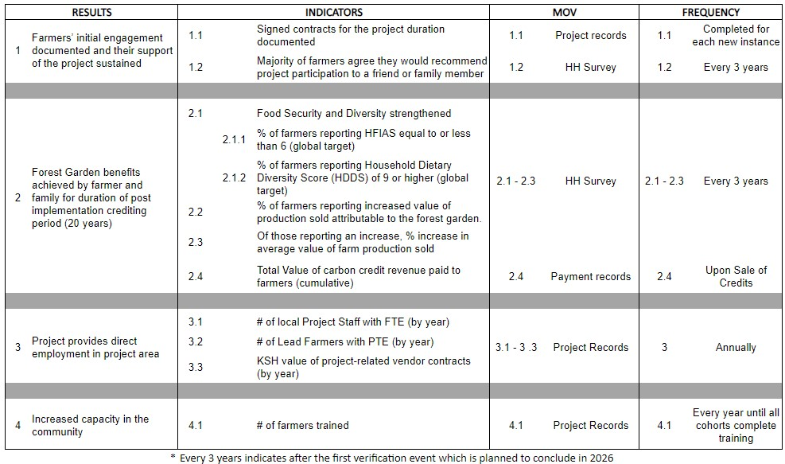

4.4.2 Monitoring Plan Dissemination (CCB, CM4.3)
WB Carbon operates with transparency for all interested stakeholders. In accordance with Exhibit 15- Stakeholder Engagement Plan found in Appendix 1, stakeholders are given access to the Community Monitoring Plan and results will be publicly available in several ways:
- Soft copies in PDF format of documents will be available online on GFCCA’ website gfccafrica.org
- Regular updates from the monitoring plan will be translated to easily understood formats and shared through:
  - During the period of project training, monthly Lead Farmer meetings serve as points of contact for participants to receive information and to provide feedback on the Community Monitoring Plan and results.
  - Following the project training, an SMS/WhatsApp service will be used to send updates to participating farmers as monitoring results are made available in a timely manner.

BIODIVERSITY

Without-Project Biodiversity Scenario
5.1.1 Existing Conditions (VCS, 3.19; CCB, B1.1)

GFCCA will sponsor a biodiversity assessment in the WB Carbon Project area, led by the Wangari Maathai Institute, that looks at biodiversity both on-farm and in surrounding natural areas like forests, grasslands, and swamps. Prior to this assessment, a landscape-level survey of the biodiversity in the three counties had never been conducted. Though the assessment report identifies a wealth of biodiversity in the project zone, It remains under severe threat due largely to conversion of non-cultivated land to agriculture, as well as logging and wood harvesting in forested areas. Conventional, intensive agricultural practices also lead to ecosystem degradation and associated loss of biodiversity. Poverty and climate change are two key indirect drivers of land degradation and habitat loss. In the absence of concerted efforts to mitigate climate change and reduce poverty – and specifically to reduce conversion of natural landscapes to farmland, limit the negative impact of agriculture on ecosystems, and reduce deforestation – this trend will continue.
Kenya has diverse and rich flora and fauna. Nearly 60 percent of the floral diversity in Africa is represented in Kenya alone. The biodiversity survey shows that there is high diversity of most taxa studied in the project area, including for plants, fungi, reptiles and amphibians, mammals, invertebrates, and birds. The study identified one plant and three bird species in the area listed on the IUCN Red List as threatened. Vitex keniensis (meru oak) and Balearica regulorum (grey crowned crane) are both listed as endangered, while Calamonastides gracilirostris (papyrus yellow warbler) and Aquila rapax (tawny eagle) are considered vulnerable. Threatened fungi species are not yet documented for Kenya, so none are listed, and all mammals documented in the survey are listed as of least concern by the IUCN Red List. Recent scientific evidence points to the acceleration of biodiversity and ecosystem decline generally, with severe threats to plant and animal species, and the IUCN Red List Indicator for Kenya indicates a downward trend or decrease in survival probability from 1993 to 2020.
The survey report — whose summary analysis of the project area is reflected in Figure 5.1.1.a below — identified the existing habitat potential considering a number of factors, including precipitation patterns, proximity to substantial human settlements, roads and waterways, and the level of vegetative cover. While the general distribution of favorable habitats appears sparse, stakeholders consulted in intended project communities all identified nearby forest and other non-cultivated areas as important local sources of ecosystem services and local habitats.

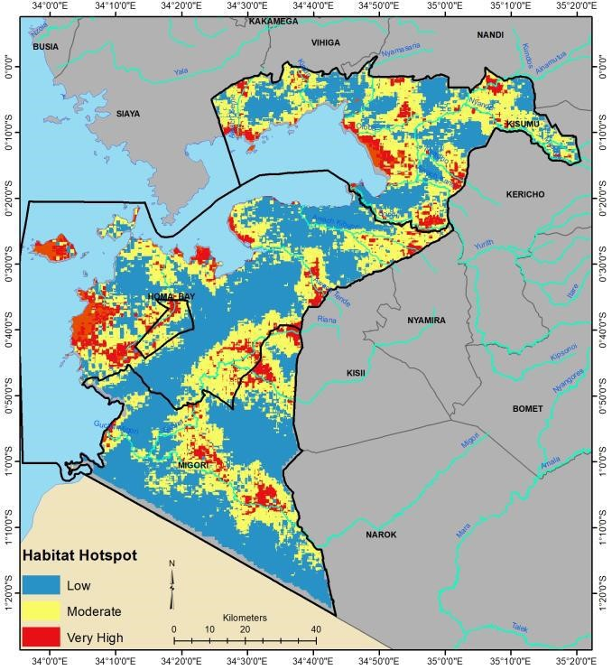

Figure 5.1.1.a. Habitat Hotspots
The Lake Victoria/Western Block ecosystem is vital to climate modulation and is home to multiple high conservation value areas (HCVs) that have an important role in biodiversity conservation. Like other ecosystems in the area and throughout Kenya, Lake Victoria watershed ecosystems are threatened by unsustainable human activities. Non-timber crop production as well as logging and wood harvesting are two of the biggest threats to biodiversity in Kenya.⁴⁹ Smallholder farming and wood harvesting for charcoal and fuelwood destroys important forest and woodland habitats, and conventional farming and grazing practices commonly used result in severe erosion that leads to siltation of lakes and reservoirs, flooding, desertification, agrochemical pollution, and degradation and loss of biodiversity habitat. Although the project activities are not designed to have a direct impact on off-farm biodiversity, agroforestry and regenerative agricultural practices adopted by farmers will contribute to a net benefit to biodiversity.

Species and habitat
Vitex keniensis (meru oak) – lower and upper montane  forests and thicketed, rocky hills | Project activities will reduce pressure on harvesting of this endangered species by providing farmers with sustainable sources of timber and non-timber forest resources.
Balearica regulorum (grey crowned crane) – wetlands, riverbanks, riverine woodland, shallowly flooded plains | Enhanced tree cover and perennial vegetation will contribute to ecological corridors and improve habitat for this endangered species, while the diversified, organic forest farmland systems will provide healthy forage sites for the birds. Sustainable production of fuelwood and timber will also reduce the destruction of this species’ habitat.
Calamonastides gracilirostris  (papyrus yellow warbler) – swamps | The implementation of improved soil management practices will reduce erosion and siltation, while reduced use of chemical fertilizer and pesticides will reduce pollution of this vulnerable species’ habitat.
Aquila rapax (tawny eagle) – open savannah, steppe, and less dense woodlands | Enhanced tree cover and perennial vegetation will contribute to ecological corridors and improve habitat for this vulnerable species. Sustainable production of fuelwood and timber will also reduce the destruction of this species’ habitat.

5.1.2 High Conservation Values (CCB, B1.2)

High conservation value | Lake Victoria
Qualifying attribute | Globally, regionally, or nationally significant concentrations of biodiversity values: i) Protected area
Focal area | The implementation of improved soil management practices will reduce erosion and siltation of the lake, while reduced use of chemical fertilizer and pesticides will reduce pollution and eutrophication resulting from runoff flowing into the lake.

High conservation value | Ruma National Park
Qualifying attribute | Globally, regionally, or nationally significant concentrations of biodiversity values: i) Protected area
Focal area | The project promotes sustainable fuelwood, timber, and fodder production practices that will reduce land and forest degradation within the buffer zone and ecological corridors. Increased tree cover due to project activities will provide habitat for bird life.

High conservation value | Lake Simbi Nyaima
Qualifying attribute | Globally, regionally, or nationally significant concentrations of biodiversity values: i) Protected area
Focal area | Lake Simbi is an alkaline crater lake that supports a large bird population, including Phoeniconaias minor, listed on the IUCN Red List as Near Threatened. Reduced erosion and eutrophication from synthetic fertilizers will reduce degradation of this important bird habitat.

High conservation value | Balearica regulorum
Qualifying attribute | Globally, regionally, or nationally significant concentrations of biodiversity values: ii) Threatened Species (IUCN Red List)
Focal area | Enhanced tree cover and perennial vegetation will contribute to ecological corridors and improve habitat for this endangered species, while the diversified, organic forest farmland systems will provide healthy forage sites for the birds. Sustainable production of fuelwood and timber will also reduce the destruction of this species’ habitat.

High conservation value | Gwassi Hills Gazetted Forest
Qualifying attribute | Globally, regionally, or nationally significant concentrations of biodiversity values: i) Protected area
Focal area | Forest farmlands will sustain production of crops, fuelwood, timber, and fodder, reducing degradation in and around Gwassi caused by encroachment, deforestation, and overgrazing. Increased tree cover will contribute to ecological corridors between remaining natural ecosystems.

5.1.3 Without-project Scenario: Biodiversity (CCB, B1.3)
The without project scenario, which is detailed in Section 2.2.1, would leave the proposed land area outside of national parks and protected areas with no enhancement or maintenance of biodiversity. The most credible trajectory for the area is the continuation of pre-project land use and increase in threats to biodiversity – low-income, smallholder farmers performing rain-fed, monocropped agriculture. Without the project the land would not generate additional biodiversity benefits as farmers would remain trapped in a cycle of poverty with low yields, deteriorating soil conditions, bare fields during the off-crop season, annual tilling, and erosion. The primary benefits of the project for enhanced habitat on soil, avian, and other species would be foregone.
Global Forest Watch estimates a 4.5 percent loss of tree cover in Homa Bay county between 2001 and 2022, and 7.1, 7.9 and 14 percent losses, respectively, in Kisumu, Migori and Siaya counties during the same time period. This is at least in part a result of continued population pressure and the associated requirements for fuelwood and other forest products by the large and growing rural population in the area. The anticipated project gains of reduced pressure on nearby non-crop land would also be lost without the large increase in biomass for fuel and other household needs.

Net Positive Biodiversity Impacts
5.2.1 Expected Biodiversity Changes (VCS, 3.19; CCB, B2.1)
See Section 3.1.2 Applicability of Methodology for details on evidence that the project areas were not cleared or drained of existing natural ecosystems within the last 10 years.

Biodiversity element | Trees planted provide multiple benefits
Estimated change | Trees planted through the project will create more-conducive microclimates for a variety of taxa and support water infiltration, reducing flood risk and supporting improved agricultural productivity that allows farmers to sustainably cultivate their land. Wood provided from intense planting will reduce pressure on the surrounding landscape through provision of fuelwood for family use and sale. Fodder production will lead to increased animal productivity while decreasing the grazing and browsing pressure by livestock in the area.
Justification of change | The core of the Forest Farmland Agroforestry System (FFAS) is intensive tree planting to provide sustainable sources of food and forest products and environmental services. All forest farmlands will be monitored to meet standards for the green wall, alleys, fruit tree, fodder tree, and hardwood stands. Monitoring plans also include an annual survey of “reflectance” to assess the increase of tree and foliage cover in the project area.

Biodiversity element | Agricultural soil amelioration
Estimated change | Biodiversity in the soil is key to soil health and successful agriculture production. SOC will be measured throughout the project and serve as an indicator of overall soil health and soil biodiversity. Soil health and agriculture production and diversification will increase.
Justification of change | The activities developed in the FFAS include enhanced soil management, elimination of chemical fertilizer use, green

walls, agroforestry tree cover, fruit orchards and native hardwood stands, and production of annual crops using regenerative and climate-smart agricultural practices. The activities prevent soil erosion, reduce runoff of agrochemical pollution into the lake, and increase soil carbon, fertility, and biodiversity.

Biodiversity element | Habitat for bird life and other vocalizing species
Estimated change | Greater diversity of bird life on Forest Farmland Farms compared to no FFAS farms.
Justification of change | Through increased above-ground biomass and canopy, habitat for nesting, protection, and feeding will increase for a variety of species. These changes will emerge through the tree planting program and will be verified through the listening device monitoring program.

Biodiversity element | Gazetted and locally defined HCVs protected
Estimated change | Decreased threats that impact HCV habitat including sedimentation, chemical runoff threatening streams, swamps, and lakes, and exploitation of remaining forests and natural areas for fuelwood and grazing.
Justification of change | The project activities prevent soil erosion, reduce runoff of agrochemical pollution into aquatic systems, and increase soil fertility. The project will monitor on-farm tree and canopy cover and decreased use of chemical fertilizers and pesticides as a proxy for increased HCV habitat. The project will also monitor the change in how farmers access fuelwood.

5.2.2 Mitigation Measures (VCS, 3.19; CCB, B2.3)
There are few negative potential impacts to offsite biodiversity. The project takes place on private lands and the tree planting is conducted by the landowners. The FFAS provides a more sustainable approach to farming land that has been cultivated for generations. Many of the trees that will be planted in the forest farmlands are native species, including half of the trees planted in green walls and the majority of the trees planted in the hardwood segments. This diversity of native trees planted will positively impact biodiversity. The only potential risks are associated with the use of invasive and non-native species already naturalized in the area. These risks will be mitigated by the optimized use of the species and good management practices (see Sections 5.2.5 and 5.2.6 for more information on the justification and management of non-native species). Considering how pervasive the planting of these non-native trees has been in Kenya prior to the project implementation, in addition to the deliberate inclusion of various native species to account for nearly half of the trees planted, it is not expected that there will be a negative impact on biodiversity due to the project.
5.2.3 Net Positive Biodiversity Impacts (CCB, B2.2, GL1.4)
The greatest on-going threat to biodiversity in Kenya is the continued expansion of low productivity agriculture and the resulting pressure by food- and income-deficit households near HCV areas. In keeping with the government’s strategy to respond to this growing threat in part by support of agroforestry, WB Carbon will introduce agroforestry techniques to restore health to degraded agricultural land, reduce pressure for fuelwood, fodder, and other needs in neighboring forested areas and enhance habitat for vocalizing species of birds, insects, and other wildlife on project farmland.
5.2.4 High Conservation Values Protected (CCB, B2.4)
The WB Carbon Project will not have a negative effect on the HCV areas. The project takes place on private lands owned by farmers that have been under human habitation and agriculture production for generations. Reduced pressure on nearby HCVs with wood and fodder, reduced on-farm chemical use and the improved on-farm habitats will provide a net-benefit to HCV areas. 5.2.5 Species Used (VCS, 3.19; CCB, B2.5, B2.6)
The table below presents the trees, grasses, and vegetables currently planted in the project. Most farmers do not plant every species in their forest farmland, and this list may not be comprehensive as farmers are encouraged to identify and plant species that would add economic and ecological value to their systems. The project advocates for identification and planting of useful or important native species and discourages and recommends alternatives to problematic species. The project also identifies important and beneficial non-native, noninvasive species as options for participants to integrate into their forest farmlands. This list may change throughout implementation.

Species Used | Classification | Justification for use | Adverse effects and mitigation
Acacia polycantha | Native | Green Wall/Fodder/Fuelwood | No adverse effects expected
Leucaena leucocephala | Non-native | Fast-growing, coppicable, nitrogen-fixing tree planted in Green Walls (hedgerow). Used for fuelwood, fodder, mulch, protection, and soil conservation and fertility.  Promoted by the Government of Kenya as an effective tree | Potentially invasive when not well-managed. Can invade roadsides, disturbed land, urban open spaces, drainage ditches, forest edges, and riparian areas. Note that from the start of 2024, Leucaena leucocephala seeds are no

 |  | for land restoration and soil improvement. | longer provided and GFCCA no longer promotes its use.
Leucaena trichandra | Non-native | Fast-growing, coppicable, nitrogen-fixing tree planted in Green Walls (hedgerow). Used for fuelwood, fodder, mulch, protection, and soil conservation and fertility. | No adverse effects expected
Cajanus cajan | Non-native | Perennial shrub used for food production, fodder, and soil improvement. | No adverse effects expected
Calliandra calothyrsus | Non-native | Fast-growing, coppicable, nitrogen-fixing tree planted in Green Walls (hedgerow) and alleys. Used for fuelwood, fodder, mulch, protection, and soil conservation and fertility.  Promoted by the Government of Kenya as an effective tree for land restoration and soil improvement. | Potentially invasive when not well-managed. Can invade roadsides, disturbed land, urban open spaces, plantation and forest edges, and riparian areas. Promoted by the Government of Kenya as an effective tree for land restoration and fodder production. Promoted to be regularly coppiced for the described uses and not allowed to seed/spread.
Moringa oleifera | Non-native | Tree primarily used for food production | No adverse effects expected
Grevillea robusta | Non-native | Fast and straight-growing hardwood tree used as a windbreak and for fuelwood and timber. | Can potentially invade roadsides, disturbed areas, urban open spaces, and fallow land. Grevillea is not recognized as invasive by the Kenya Government however.
Casuarina equisetifolia | Non-native | Fast and straight-growing hardwood tree used as a windbreak and for fuelwood and timber. | No adverse effects expected
Terminalia brownii | Native | Hardwood tree planted primarily for conservation purposes, as well as for fuelwood | No adverse effects expected
Albizia coriaria | Native | Hardwood tree planted primarily for conservation purposes | No adverse effects expected

Markhamia  lutea | Native | Hardwood tree planted primarily for conservation purposes, as well as for fuelwood | No adverse effects expected
Croton megalocarpus | Native | Hardwood tree planted primarily for conservation purposes | No adverse effects expected
Podocarpus falcatus | Native | Hardwood tree planted primarily for conservation purposes | No adverse effects expected
Cordia africana | Native | Hardwood tree planted primarily for conservation purposes | No adverse effects expected
Vitex keniensis | Native | Hardwood tree planted primarily for conservation purposes | No adverse effects expected
Azadirachta indica | Non-native | Farmers plant this tree in small numbers specifically for its value in Integrated Pest Management as it is commonly used to replace synthetic pesticides. It is also valued for its medicinal properties. | No adverse effects expected
Carica papaya (papaya) | Non-native | Food crop | No adverse effects expected
Musa spp. (banana) | Non-native | Food crop | No adverse effects expected
Passiflora edulis (passion fruit) | Non-native | Food crop | Can potentially invade disturbed areas, urban open spaces, farmlands, forest edges and riparian areas. Passiflora is not recognized as invasive by the Kenya Government however.
Mangifera indica (mango) | Non-native | Food crop | No adverse effects expected
Persea americana (avocado) | Non-native | Food crop | No adverse effects expected
Citrus spp. | Non-native | Food crop | No adverse effects expected
Chrysopogon zizanioides (Vetiver grass) | Non-native | Contour planting (erosion control)/Mulch/Fodder | No adverse effects expected
Brassica oleracea var. capitata (cabbage) | Non-native | Food crop | No adverse effects expected
Brassica carinata  (Ethiopian kale) | Non-native | Food crop | No adverse effects expected
Vigna unguiculata (cow peas) | Non-native | Food crop/Cover crop | No adverse effects expected
Cleome gynandra  (African spider plant) | Native | Food crop | No adverse effects expected
Corchorus  olitorius (jews  mallow/mrenda) | Native | Food crop | No adverse effects expected
Beta vulgaris (beetroot) | Non-native | Food crop | No adverse effects expected
Solanum melongena  (eggplant) | Non-native | Food crop | No adverse effects expected
Phaseolus vulgaris (French bean) | Non-native | Food crop | No adverse effects expected
Brassica oleracea var. botrytis (cauliflower) | Non-native | Food crop | No adverse effects expected
Allium cepa (onion) | Non-native | Food crop | No adverse effects expected
Citrullus lanatus (watermelon) | Non-native | Food crop/Cover crop | No adverse effects expected
Brassica oleracea var.  italica (broccoli) | Non-native | Food crop | No adverse effects expected

All trees planted in the WB Carbon Project are grown from seed sourced locally through our seed banks. All species used have a history of being grown in Kenya and throughout East Africa. GFCCA currently manages a small seed bank in Homa Bay that serves the project and is certified as a seed merchant through the Kenya Plant Health Inspectorate Service (KEPHIS). All seed collectors – including enrolled farmers – are trained in the best practices for sourcing and processing high-quality tree seeds. Vegetables are sourced directly from certified seed suppliers. Farmers choose to plant both indigenous and non-native species for their varied economic and ecological benefits.

The forest farmlands that farmers establish through this project are regenerative, climate-smart agricultural systems that produce food and forest products to enhance smallholder farmers’ food and economic security. As with any scalable regenerative agricultural system, it does rely in part on non-native species. Farmers select specific species to produce useful products and services they need. All of the non-native species used are already being planted within the project area and have been for a long time due to their value as agroforestry or forestry species. The majority of the non-native species used in the project are not invasive and will be contained in the forest farmlands.

No known invasive species will be introduced into the project area, however four species considered to be invasive in some places have long been cultivated in the project area, including Calliandra caloythysus, Leucaena leucocephala, Grevillea robusta, and Passiflora edulis. All are naturalized species that are already widely cultivated throughout the country due to the valuable and beneficial products or environmental services they provide. They are selected for planting due to their unique, proven benefits to their systems and because native alternatives with the same proven benefits have not been identified and tested. These four species were identified as potentially invasive in the biodiversity assessment and cross-checked (along with all other species planted through the project) on IUCN’s Global Invasive Species Database. Only three of the species (Leucaena leucocephala, Grevillea robusta, and Passiflora edulis) were listed as invasive on IUCN’s database, and Grevillea robusta and Passiflora edulis are not considered invasive by the Government of Kenya.

These species are endorsed and promoted by the Kenyan Government and not considered problematic. GFCCA met with Dr. Vincent Oeba, Principal Research Scientist and Forest and Climate Change Coordinator at the Ministry of Environment’s Kenya Forest Research Institute (KEFRI) to discuss these species. Dr. Oeba explained that KEFRI and ICRAF have undertaken comprehensive species testing of agroforestry species over the past few decades and do not consider Grevillea robusta or Passiflora edulis to be invasive in Kenya. They consider grevillea an important bioenergy species and a good alternative to problematic eucalyptus species, and they value passiflora as a useful fruit. Though they are aware that Leucaena leucocephala and

Calliandra calothyrsus have the potential to spread into open areas, KEFRI has concluded that the many benefits of these species outweigh potential risks and encourage them to be planted. Furthermore, KEFRI collaborated with the Ministry of Agriculture on a study to identify key fruit, fodder, and bioenergy trees for promotion in Kenya and recommends Calliandra calothyrsus and Grevillea robusta as priority species for fodder and fuelwood intensification. Given the high demand for forest products, these fast-growing trees offer sustainable sources of fuelwood, fodder, and timber that farmers can cultivate on their own land rather than relying on indigenous trees, shrubs, and grasses harvested or grazed from natural landscapes.
5.2.6 Invasive Species (VCS, 3.19; CCB, B2.5)

As with all species in the project, farmers are given multiple options of species to plant for a specific purpose within the forest farmland design and they have full agency to select and plant only those they choose. For all trees they plant, farmers are informed of growing characteristics, benefits, and potential negative attributes before planting them. They are also taught during later training events how to manage them to maximize benefits and mitigate any potential negative impacts (e.g. from shading, crowding, irregular form, as well as invasiveness).

As the project has mobilized, farmers have requested that Leucaena leucocephala be replaced with another tree. We have responded. All new cohorts of farmers following the initial 5,000 farmers will have access to Leucaena trichandra, which offers similar benefit to Leucaena leucocephala but far lower risk of spreading if it does go to seed.

Calliandra calothyrsus is a fast-growing, nitrogen-fixing tree most commonly planted in Kenya for production of fuelwood and fodder, as well as its benefits for land restoration, conservation, and fertility. Within the WB Carbon Project, Calliandra (along with Acacia polycantha and Leucaena trichandra) are specifically planted as green walls (multi-lined hedgerows) which are the foundation of the Forest Farmland Approach. This project emphasizes the importance of soil protection and improvement, and two ways farmers learn to do this is by producing biomass for mulch and composting. Green walls provide a regular source of biomass, while also protecting farmers’ fields. Farmers learn to prune their hedgerows frequently – every few months during the dry season, and more frequently during the rainy season. Through aggressive pruning, they interrupt the seeding cycle, which prevents seeds from maturing and mitigates the threat of invasiveness. Where farmers plant fodder plots in their forest farmlands, some choose to plant Calliandra calothyrsus due to its fast growth and nutritive value. Similar to green walls, farmers learn to prune these fodder trees frequently, before they seed, to provide a consistent source of fodder to their livestock in a cut-and-carry management system that reduces off-site pressure from grazing.

Existing invasive species | Mitigation measures to prevent spread or continued existence of invasive species
Leucaena leucocephala | Farmers are taught to regularly prune these trees for their leaves, stems, and branches before their seeds are allowed to mature and potentially spread.  Note that from the start of 2024, Leucaena leucocephala seeds are no longer provided and GFCCA no longer promotes its use.
Calliandra calothyrsus | Farmers are taught to regularly prune these trees for their leaves, stems, and branches before their seeds are allowed to mature and potentially spread.

5.2.7 GMO Exclusion (CCB, B2.7)
GMOs will not be used in the project; thus, we guarantee that no GMOs will be used to generate GHG emissions reductions for removals.
5.2.8 Inputs Justification (VCS, 3.19; CCB, B2.8)

The project discourages the use of synthetic fertilizers and chemical pesticides by participants and will not introduce any biological control agents. The project promotes and teaches farmers to utilize soil fertility inputs to replace synthetic fertilizers, including the use of nitrogen-fixing species, decomposed compost, farmyard manure, and plant residues. These inputs protect the soil and increase fertility, moisture retention, and soil carbon. There are no expected adverse effects resulting from these practices.

Through training and extension on integrated pest management (IPM), farmers learn to use preventative measures to control pests and mitigate the need for chemical pesticides. Farmers are encouraged to plant or preserve native or naturalized plants already growing in the area that repel pests or attract pest predators. They also learn to rotate crops after each cycle to reduce colonization of pests while optimizing soil fertility. As part of the IPM curriculum, organic pest solutions will be used when preventative measures are insufficient. These solutions are made from locally available plant materials and are not expected to have adverse effects.

Name | Natural Organic Pest Solutions
Justification of use | All inputs are organic and locally available. Farmers are trained on integrated pest management (IPM) which deters pests through crop rotation, companion planting of crops, and the development of natural recipes that use hot pepper, neem, tobacco and other naturally grown products.
Potential adverse effect | None identified
5.2.9 Waste Products (VCS, 3.19; CCB, B2.9)
Throughout the project development and planting, GFCCA focuses on using natural products that do not create solid waste. For nursery development farmers are provided with biodegradable tree sacks produced in Kenya that are directly planted and decompose in the soil. All seeds and materials are delivered in reusable cloth bags, as is customary in Kenya due to a law banning disposable plastic bags. All organic waste, such as plant debris and leaf litter, is composted and used on the field to protect and build organic matter in the soil.

Offsite Biodiversity Impacts
5.3.1 Negative Offsite Biodiversity Impacts (CCB, B3.1) and Mitigation Measures (CCB, B3.2)
No negative offsite biodiversity impacts are expected. WB Carbon is designed to provide farmers with sustainable sources of food and forest resources through intensive tree planting and regenerative agricultural practices. This increases biodiversity habitat on-site while reducing pressure on offsite habitats and biodiversity. The practices farmers use allows them to cultivate their land intensively and continuously, which reduces their agricultural footprint and can mitigate the need to convert more land to agriculture due to land degradation. The soil and water conservation practices farmers are taught contribute to reduced erosion and an improved water cycle, further benefiting offsite biodiversity.
Evidence that there has not been any displacement of participating farmers is demonstrated by their proof of land ownership. Farmers’ land is clearly delineated with a polygon at the start of the project. Through the polygon taking process, it is evident through satellite imagery that the land is cropland and not another land use type.
The only risk factor for negative offsite impacts on biodiversity identified arise from the use of two potentially invasive species. As noted above, these species are valued by farmers, are already endemic in the project area, and would continue to be present in the absence of the project. They are also recommended by the Government of Kenya as species that reverse declining productivity and poverty due to poor land management practices. By awareness raising and training on good management practices as discussed in Section 5.2.6, the risks to biodiversity due to planting these species will be mitigated.

Negative offsite impact | Mitigation measure(s)
Potential spread of invasive species | Farmers are informed of their potential negative attributes and have the option to choose to plant them or not. Through training, extension, and monitoring, farmers learn to plant and manage them to maximize benefits and mitigate potential invasiveness.
5.3.2 Net Offsite Biodiversity Benefits (VCS, 3.19; CCB, B3.3)
Potential negative offsite biodiversity impacts will be mitigated (see Section 5.3.1). Therefore, on balance, the net effect of the project on offsite biodiversity is positive (see Section 5.2.1).

Biodiversity Impact Monitoring
5.4.1 Biodiversity Monitoring Plan (CCB, B4.1, B4.2, GL1.4, GL3.4)
In keeping with WB Carbon’s Theory of Change as detailed in Section 2.1.17, the project team will carefully monitor the intended results for this project which encompass broadly two main benefits for biodiversity on and around participating farms: (1) relieved pressure on neighboring, uncultivated, biodiverse areas and (2) increased tree canopy on project farms supportive of biodiversity. See Section 2.1.17 for CCB Theory of Change and combined monitoring plan.
The Household Survey described in Section 4.4.1 will be utilized also to assess the adoption of key practices that will relieve pressure on community high conservation areas and waterways. These include the use of the forest farmland to meet household needs for fuelwood and fodder and the reduction of the use of chemical pesticides and fertilizers. Fundamentals of the survey sampling methodology are referenced in Section 4.4.1 and fully described in the Supplemental Monitoring Plan Information.
The biodiversity monitoring program will utilize the following innovative mechanisms. We expect that relevant technologies will become more effective and accessible over the project period and will therefore continuously review and improve these approaches. A summary of biodiversity results and indicators can be found in Table 5.4.1.a below.

Acoustic Monitoring. GFCCA will undertake an acoustic monitoring partnership which will provide a comparison of the vocalizing species richness (birds, insects, mammals) in Forest Farmlands relative to the richness of the without project scenario. Raw recording data from the area including non-cultivated, forested sites will be consolidated into an open source “local inventory” of species through the use of artificial intelligence and machine learning with high precision for the project area. It was through this methodology that the project identified the presence of the endangered grey crowned crane (Balearica regulorum).

Monitoring events will be undertaken through specialized listening devices placed in comparative locations during 2-week periods. The data gathered will allow the project to assess the species richness (diversity) over time on forest farmlands, relative to nearby, non-contiguous areas of monocropped fields. Due to logistical requirements and security of the devices, sampling will be limited to between 10 and 20 sites per county per monitoring event. Each site will include a forest farmland and a nearby non-project farm at an adequate distance to ensure the treatment and comparison sites do not overlap. We assess this approach to provide indicative information on the benefits of the forest farmland relative to the without scenario. A baseline has been collected as part of the initial pilot of the device program. We will begin monitoring upon

maturation of a substantial cohort of forest farmlands and repeat the monitoring every five years, providing information for adaptive management and the next proximate verification.

Terrestrial Monitoring. GFCCA will develop a partnership to track polygons of project farms via satellite imagery to assess the level of forest cover relative to requirements and expectations of the FFAS, enabling the tracking of vegetative change and allowing inferences to be made about aboveground biomass evolution on both enrolled and control farms. Geospatial monitoring will support the rapid identification of enhanced tree and biomass cover planned by WB Carbon and will identify enrolled farms that may be non-performing, allowing for closer remote scrutiny or on ground follow up to assess whether a farmer may be having issues with their forest farmland, allowing project staff to provide support to improve compliance or, if there is no recourse, to exclude the land from ongoing carbon credit calculation and compensation. This technique will be both technical and cost effective for the post-crediting permanence period in compliance with Verra’s evolving requirements.
The standard operating procedures of terrestrial monitoring will include:
- Spatial Requirements
  - Imagery Resolution: The imagery used for monitoring forest degradation must have a maximum spatial resolution of at least 1.5 meters to identify forest farmland features.
  - Imagery Layers: The imagery used for monitoring will contain the required bands to enable calculation of normalized vegetation index (NDVI).
  - Timeframe: The monitoring will occur during the dry/lean season of the vegetables to better observe forest farmland trees and hedgerows.
  - Cloud Cover: Imagery with minimal cloud cover -– no greater than 10 percent — will be used to ensure data clarity and accuracy.
- Analysis
  - Threshold for Vegetation Cover Change: The commonly used threshold for monitoring deforestation is approximately 10 percent forest cover loss within a given area over a time specific period. In conjunction with in-situ information we will re-evaluate this threshold regularly to ensure its suitability for the requirements of a forest farmland.
  - Algorithm Development: Develop algorithms and automatic detection thresholds to flag farms with changes in tree and hedgerow cover exceeding the specified threshold.
  - Object-Based Image Analysis (OBIA): Consider employing OBIA to accurately quantify changes in vegetation cover.
- Assessment and Farmer Communication
  - If needed, flagged farms should be assessed using higher-resolution imagery such as GeoEye-1, Worldview 4-band 50 cm Pan-Sharpened. Where further clarity is needed, GFCCA will undertake site visits to farms.

  - Awareness and Feedback: Farmers will be made aware of the monitoring procedures and implications for their land management practices. Protocols will be established for communication and management of non-compliance with project standards.
Table 5.4.1.a. Biodiversity Results and Indicators

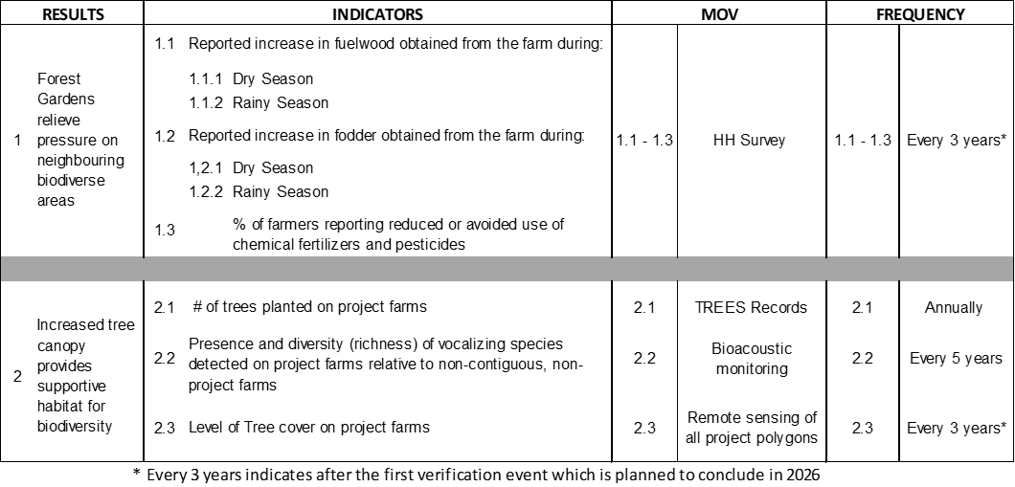
5.4.2 Biodiversity Monitoring Plan Dissemination (CCB, B4.3)
WB Carbon operates with transparency for all interested stakeholders. In accordance with the Exhibit 15 - Stakeholder Engagement Plan found in Appendix 1, stakeholders are given access to the Biodiversity Monitoring Plan and results will be publicly available in several ways: ● Soft copies in PDF format of documents will be available online on GFCCA’ website gfccafrica.org
- Regular updates from the monitoring plan will be translated to easily understood formats and shared through:
  - During the period of project training, monthly Lead Farmer meetings serve as points of contact for participants to receive information and to provide feedback on the Community Monitoring Plan and results.
  - Following the project training, an SMS/WhatsApp service will be used to send updates to participating farmers as monitoring results are made available in a timely manner.
- A component of the Monitoring Plan involves farmer monitoring of biodiversity, and this share will be shared by word of mouth and peer to peer learning.
- In partnership with the Rain Forest Connection (RFCx), sound monitoring for vocalizing species is publicly available in audio and visual representation on the Rainforest connection website at: Arbimon - Kenya GFCCA Forest Farmlands (rfcx.org).

APPENDIX 1: LIST OF EXHIBITS
This is a list of all supporting documents (Exhibits) referenced in the PDD sections and footnotes. For access to the exhibits available to the public, see GFCCA website: gfccafrica.org. The remaining exhibits are also listed on the website and will be provided for VVB review.

Exhibit 1- Kenya Technical Report Assessment of National Forest and Landscape Restoration
Opportunities 2016
Exhibit 2- Field Survey Report, “Assessment of Biodiversity Resources and Biodiversity Hotspot
Areas,” Commissioned by GFCCA, July 2023
Exhibit 3- New Project Area Stakeholder Identification Process
Exhibit 4- Kenya Vision 2030
Exhibit 5- Farmer Focus Group Feedback on FG Design
Exhibit 6- Design of the Full Forest Farmland and all its components Exhibit 7- Kenya’s First NDC updated version. Exhibit 8- MRF data from first outplanting.
Exhibit 9- First Instance of registered farmers
Exhibit 10- Adaptive Management Plan
Exhibit 11- Gender and Inclusion Workshop Report
Exhibit 12- Western Block Agroforestry Carbon Project Landholder Agreement
Exhibit 13- Long Term Management, Communications, Monitoring and Financial Plan Proof of
Financial Stability (Confidential)
Exhibit 14- Western Block Agroforestry Carbon Project LULCC Report
Exhibit 15- Stakeholder Engagement Plan
Exhibit 16- Technical Manual
Exhibit 17- Facilitators' Guide
Exhibit 18- Farmer Workbooks
Exhibit 19- Summary of Mobilization Process
19a- Mobilization Facilitator’s Guide
19b- Posters in English
19c- Posters in Swahili
19d- Carbon Posters
19e- Carbon contract talking points.
Exhibit 20- Lead Farmer Feedback
Exhibit 21- Kenya Personnel Manual and Code of Conduct
Exhibit 22- Issue Reporting (Whistleblower) Policy
Exhibit 23- Policy for Prevention, Reporting, and Response to Sexual Exploitation, Abuse and Harassment
Exhibit 24- FFAS Farmers Training Framework
Exhibit 25- Procurement Policy
Exhibit 26- Accounting Policy
Exhibit 27- Agriculture (Farm Forestry) Rules, 2009. Revised in 2012
Exhibit 28- Environmental Management and Coordination (Amendment) Act, 2015
Exhibit 29- Kenya Climate Change (Amendment) Act
Exhibit 30- National Land Policy, 2009
Exhibit 31- The Land Act, 2012
Exhibit 32- Land Laws (Amendment) Act, 2016
Exhibit 33- The National Wildlife Conservation and Management Policy, 2017
Exhibit 34- Wildlife Conservation and Management Act, 2013
Exhibit 35- Agriculture Fisheries and Food Authority Act, 2013
Exhibit 36- Environmental (Impact Assessment and Audit) Regulations (2003) Amendments in
2007 and 2009
Exhibit 37- Natural Resources Benefit Sharing Bill, 2014
Exhibit 38- The Water Act, 2002
Exhibit 39- County Government Act, 2012, revised 2013.
Exhibit 40- The Community Land Bill, 2015
Exhibit 41- National Museums and Heritage Act, 2006
Exhibit 42- National Policy on Gender and Development, 2000
Exhibit 43- Companies Act (Law of Kenya Cap 486)
Exhibit 44- Employment Act, Cap 226 of 2007 – Revised 2012
Exhibit 45- The Labour Institutions Act, 2007
Exhibit 46- Regulations of Wages (general) Order
Exhibit 47- Employment and Labor Relations Court Act
Exhibit 48- Workers Injury Benefits Act No.13, 2007
Exhibit 49- Occupational Safety and Health Act, 2006
Exhibit 50- National Social Security Fund Act
Exhibit 51- National Health Insurance Fund Act
Exhibit 52- Income Tax Act - Cap 480
Exhibit 53- Industrial Training Act
Exhibit 54- Data Protection Act, 2022
Exhibit 55- RothC Inputs
Exhibit 56- Soil Sample Collection Procedure
Exhibit 57- Field Area Measurement Survey Questions
Exhibit 58- Expert Attestations
Exhibit 59- NPRT complete and downloaded from Verra’s online tool.
Exhibit 60- GFCCA Climate Monitoring Plan
Exhibit 61- GFCCA Community Assessment Report
Exhibit 62- Monitoring Plan Supplemental Information
Exhibit 63- Seed Bank SOP (Standard Operating Procedures)
Exhibit 64- Seed Bank See Merchant Certificate
Exhibit 65- The Constitution of Kenya Exhibit 66- Grievance Mechanism feedback.
Exhibit 67- Validation Verification Payment Training Deck
Exhibit 68- Summary of Carbon Project Registration Requirement
Exhibit 69 -Use of Eucalyptus in Lake Victoria Basin
Exhibit 70 -National Forest Resources Assessment Report 2021, Kenya
Exhibit 71 -CRAF MIR Spectroscopy Prediction Report
Exhibit 72- RothC Outputs
Exhibit 73 -Summary Properties
Exhibit 74 -Additionality Excel
Exhibit 75- ICRAF ESM Soil Data
Exhibit 76- Land Cover Analysis Folder
Exhibit 77 -Polygon Training
Exhibit 78 – Calculations Summary
Exhibit 79 – Tree and Shrub Emissions
Exhibit 80 – Farm Management Emissions

Land with woody vegetation that meets an internationally accepted definition (e.g., UNFCCC, FAO, or IPCC) of what constitutes a forest, which includes threshold parameters, such as minimum forest area, tree height and level of crown cover, and may include mature, secondary, degraded and wetland forests (VCS Program Definitions)
Reduced emissions from deforestation and forest degradation (REDD) - Activities that reduce GHG emissions by slowing or stopping conversion of forests to non-forest land and/or reduce the degradation of forest land where forest biomass is lost (VCS Program Definitions)
Afforestation, reforestation, and revegetation (ARR) - Activities that increase carbon stocks in woody biomass (and in some cases soils) by establishing, increasing and/or restoring vegetative cover through the planting, sowing and/or humanassisted natural regeneration of woody vegetation (VCS Program Definitions)
Improved forest management (IFM) - Activities that change forest management practices and increase carbon stock on forest lands managed for wood products such as saw timber, pulpwood, and fuelwood (VCS Program Definitions)
Employed in project activities means people directly working on project activities in return for compensation (financial or otherwise), including employees, contracted workers, sub-contracted workers and community members that are paid to carry out project-related work.
Full time equivalency is calculated as the total number of hours worked (by full-time, part-time, temporary and/or seasonal staff) divided by the average number of hours worked in full-time jobs within the country, region or economic territory (adapted from the UN System of National Accounts (1993) paragraphs 17.14[15.102]; [17.28])
Livelihoods are the capabilities, assets (including material and social resources) and activities required for a means of living (Krantz, Lasse, 2001. The Sustainable Livelihood Approach to Poverty Reduction. SIDA). Livelihood benefits may include benefits reported in the Employment metrics of this table.
Well-being is people’s experience of the quality of their lives. Well-being benefits may include benefits reported in other metrics of this table (e.g. Training, Employment, Livelihoods, Health, Education and Water), and may also include other benefits such as strengthened legal rights to resources, increased food security, conservation of access to areas of cultural significance, etc.
Managed for biodiversity conservation in this context means areas where specific management measures are being implemented as a part of project activities with an objective of enhancing biodiversity conservation, e.g. enhancing the status of endangered species.
Per IUCN’s Red List of Threatened Species
In the absence of direct population or occupancy measures, measurement of reduced threats may be used as evidence of benefit.
Exhibit 1: Kenya Technical Report Assessment of National Forest and Landscape Restoration Opportunities 2016
See Appendix 1 of the VCS Standard
Exhibit 1- Kenya Technical Report Assessment of National Forest and Landscape Restoration Opportunities_2016 (Pg. 11, 29, 30)
Exhibit 14- Western Block Agroforestry Carbon Project LULCC Report
Exhibit 12- Western Block Agroforestry Carbon Project Landholder Agreement
17 Exhibit 5- First Instance of registered farmers
“Kenya SRTM DEM 30meters.” August 15, 2017. https://maps.rcmrd.org/arcgis/rest/services/Kenya/Kenya_SRTM30meters/ImageServer.
“The Harmonized World Soil Database.” FAO NSL Geospatial Unit: GAEZ Data Portal, 2022. https://gaez.fao.org/pages/hwsd.
Harmonized world soil database v2.0 | FAO SOILS PORTAL | Food and Agriculture Organization of the United Nations
Ministry of Agriculture, Livestock and Fisheries, Climate Risk Profile for Siaya County, 2018.
Harmonized world soil database v2.0 | FAO SOILS PORTAL | Food and Agriculture Organization of the United Nations
“Kenya - Rivers.” https://data.humdata.org/dataset/kenya-water-courses, September 11, 2019. https://data.world/ocha-rosea/b6b7401b-aeea-4cfa-b34b-0470c7e7ee12.
John T. Abatzoglou et al., “TerraClimate, a High-Resolution Global Dataset of Monthly Climate and Climatic Water Balance from 1958–2015,” Scientific Data 5, no. 1 (January 9, 2018): 170191, https://doi.org/10.1038/sdata.2017.191.
Kenya Forest Service. (2021). National Forest Resources Assessment Report 2021, Kenya. https://www.kenyaforestservice.org/national-forest-resources-assesment-report-2021kenya/
Exhibit 70 - National Forest Resources Assessment Report 2021, Kenya
Kenya National Bureau of Statistics, Kenya National Population and Housing Census, 2019 Volume I.
National Gender and Equality Commission NGEC - Kenya. Kenya, 2021. Web Archive. https://www.loc.gov/item/lcwaN0035883/.
Exhibit 2. Field Survey Report, “Assessment of Biodiversity Resources and Biodiversity Hotspot Areas,” Commissioned by GFCCA for the Future, July 2023
“Kenya - All Towns.” Vector Data, Global. ICPAC, October 24, 2017. https://geoportal.icpac.net/layers/geonode:kenya_all_towns
Kenya National Bureau of Statistics, The Kenya Poverty Report, 2023, p. 32.
Ibid.
Data drawn from The Kenya Bureau of National Statistics, Basic Report on Well-being in Kenya, 2018 and 2019 Kenya Population and Housing Census.
Kenya National Bureau of Statistics, 2019 Kenya Population and Housing Census, Vol. IV: Distribution of Population by Socio-Economic Characteristics, pp. 106, 132-134. ³⁶ Exhibit 61 - Community Assessment Report
Exhibit 61-GFCCA Community Assessment Report
41 Silsbe, Greg. “Lake Victoria Shapefiles.” 2015. https://doi.org/10.6084/M9.FIGSHARE.1494839.V1.
GFCCA has been engaged in tree planting with farmer groups in Africa since 2022. See section 2.4.3 for more details.
Exhibit 5- FFAS Farmers Training Framework
Exhibit 6 Design of the Full Forest Farmland and all its components
Exhibit 4 Kenya Vision 2023
46 Exhibit 7 Kenya’s First NDC updated version.
Exhibit 1- Kenya Technical Report Assessment of National Forest and Landscape Restoration Opportunities_2016
Exhibit 8- MRF data from first outplanting.
Exhibit 9- First Instance of registered farmers
Exhibit 10- Adaptive Management Plan
Exhibit 11- Long Term Management, Communications, Monitoring and Financial Plan
Exhibit 13- Long Term Management, Communications, Monitoring and Financial Plan
Exhibit 14- Western Block Agroforestry Carbon Project LULCC Report
Land use and land use change data was compiled from The Regional Centre for Mapping of Resources for Development (RCMRD) SLEEK System.
Benjamin Mutuku Kinyili, “Potential of Agroforestry in Sustainable Fuelwood Supply in Kenya,” Journal of Energy and Natural Resources 11, no. 1 (2022): 1, https://doi.org/10.11648/j.jenr.20221101.11
Exhibit 1- Kenya Technical Report Assessment of National Forest and Landscape Restoration Opportunities_2016
“KENYA NATIONAL AGROFORESTRY STRATEGY 2021 - 2030. FINAL DRAFT” (Ministry of Agriculture, Livestock, Fisheries and Cooperatives, March 2021), https://www.ctc- n.org/system/files/dossier/3b/KENYA%20AGROFORESTRY%20STRATEGY%20DRAFT%20February%202021_.pdf
Kenya National Agroforestry Strategy,”, p. 11.
Kenya Financial Sector Stability Report, Published by the Financial Sector Regulators, September 2023, Issue No. 14, p. 51.
Central Bank of Kenya (2019), “Bank supervision annual report 2018”, available at: http://www.centralbank.go.ke/downloads/bsd/annualreports/bsd2010.pdf
Exhibit 3: New Project Area Stakeholder Identification Process
Exhibit 4- Kenya Vision 2030
“Kenya National Adaptation Plan: 2015-2030” (Government of Kenya, July 2016), https://www4.unfccc.int/sites/NAPC/Documents%20NAP/Kenya_NAP_Final.pdf
“AGRICULTURAL SECTOR TRANSFORMATION and GROWTH STRATEGY. TOWARDS SUSTAINABLE AGRICULTURAL TRANSFORMATION and FOOD SECURITY IN KENYA. 2019-2029,” n.d., https://kilimo.go.ke/wpcontent/uploads/2022/03/ASTGS-Abridged-version.pdf
“Kenya Climate Smart Agriculture Strategy-2017-2026” (Ministry of Agriculture, Livestock and Fisheries, 2017), https://faolex.fao.org/docs/pdf/ken169535.pdf
Exhibit 15: Stakeholder Engagement Plan
Exhibit 3: New Project Area Stakeholder Identification Process ⁶⁹ Ibid
Exhibit 3: New Project Area Stakeholder Identification Process
Exhibit 19: Summary of Mobilization Process
Exhibit 67– Validation Verification Payment Training Deck
Exhibit 5- Farmer Focus Group Feedback on FG Design
Exhibit 19 Summary of Mobilization Process
Ibid
Exhibit 20 - Lead Farmer Feeback
Exhibit 12 Farmer Carbon Rights Agreement
Exhibit 10-- Adaptive Management Plan
Exhibit 10- Adaptive Management Plan
Exhibit 21- Kenya Personnel Manual and Code of Conduct
Exhibit 22- Issue Reporting (Whistleblower) Policy
Exhibit 23- Policy for Prevention, Reporting, and Response to Sexual Exploitation, Abuse and Harassment ⁸⁷ Exhibit 66 – Grievance Mechanism feedback.
Exhibit 16 – Technical Manual
Exhibit 18 – Farmer Workbooks
Exhibit 17 – Facilitators’ Guide
Exhibit 24- FFAS Farmers Training Framework
Exhibit 25 Procurement Policy
Exhibit 26 Accounting Policy
Exhibit 22 Issue Reporting (Whistleblower) Policy
Exhibit 27- Agriculture (Farm Forestry) Rules, 2009. Revised in 2012
Exhibit 28- Environmental Management and Coordination (Amendment) Act, 2015
Exhibit 29 -Kenya Climate Change (Amendment) Act
Exhibit 68 – Summary of Carbon Project Registration Requirements
Exhibit 30 National Land Policy, 2009
Exhibit 31 The Land Act, 2012
Exhibit 32 Land Laws (Amendment) Act, 2016
Exhibit 33- The National Wildlife Conservation and Management Policy, 2017
Exhibit 34 Wildlife Conservation and Management Act, 2013
Exhibit 35 Agriculture Fisheries and Food Authority Act, 2013
Exhibit 36 Environmental (Impact Assessment and Audit) Regulations (2003) Amendments in 2007 and 2009 ¹⁰⁸ Exhibit 37 Natural Resources Benefit Sharing Bill, 2014
Exhibit 38 The Water Act, 2002
Exhibit 39 County Government Act, 2012, revised 2013.
Exhibit 45- The Labour Institutions Act, 2007
Exhibit 46- Regulations of Wages (general) Order
Exhibit 47- Employment and Labor Relations Court Act
Exhibit 48 Workers Injury Benefits Act No.13, 2007
Exhibit 49 Occupational Safety and Health Act, 2006
Exhibit 50 National Social Security Fund Act
Exhibit 51 National Health Insurance Fund Act
Exhibit 52 Income Tax Act - Cap 480
Exhibit 53 Industrial Training Act
Exhibit 54- Data Protection Act, 2022
Exhibit 61-GFCCA Community Assessment Report
Exhibit 65 - The Constitution of Kenya
The Constitution of Kenya, Published by the National Council of Law Reporting with the authority of the Attorney General.
The Constitution of Kenya, 63(1)
“Land Rights as a Critical Factor in Donor Agricultural Investments: Constraints and opportunities for YieldWise in Kenya’s mango value chain,” A paper prepared by Landesa for The Rockefeller Foundation, p.6.
Act No.3 of 2012, Land Registration Act (2012), Section 24 ¹³³ The Marriage Act, 2014. No. 4 of 2014, Date of Assent: 29th April, http://kenyalaw.org/kl/fileadmin/pdfdownloads/Acts/TheMarriage_Act2014.pdf
The Matrimonial Property Act, 2013. No. 49 of 2013 Date of Assent: 24th December 2013. http://kenyalaw.org/kl/fileadmin/pdfdownloads/Acts/MatrimonialPropertyAct2013.pdf
The Land Registration Act, 2012. No.3 of 2012.Published by the National Council for Law Reporting with the Authority of the Attorney-General. http://www.kenyalaw.org/kl/fileadmin/pdfdownloads/Acts/Land_Registration_Act___No_3_of_2012_.pdf ¹³⁶ Land Act. No.6 of 2012.Revised Edition 2019 [2012]. Published by the National Council for Law Reporting with the Authority of the Attorney-General. http://kenyalaw.org:8181/exist/rest//db/kenyalex/Kenya/Legislation/English/Acts%20and%20Regulations/L/L and%20Act%20Cap.%20280%20-%20No.%206%20of%202012/docs/LandAct6of2012.pdf
The Law of Succession (Amendment) Bill, 2023. /http://www.parliament.go.ke/sites/default/files/2023- 05/The%20Law%20of%20Succession%20%28Amendment%29%20Bill%2C%202023.pdf
Nnoko-Mweanu, Juliana, “Securing Women’s Property Rights in Kenya”, Human Rights Watch, March 7, 2020, Published in The Daily Nation.
Exhibit 19: - Summary of Mobilization Process
Exhibit 12- Western Block Agroforestry Carbon Project Landholder Agreement
Exhibit 67– Validation Verification Payment Training Deck
Exhibit 12 – Western Block Agroforestry Carbon Project Landholder Agreement
Available here: Rothamsted Carbon Model (ROTHC) | Rothamsted Research
Guillermo Peralta et al., “Technical Manual Global Soil Organic Carbon Sequestration Potential Map GSOCseq. Fao-Gsp.Github.Io.” (Food and Agriculture Organization of the United Nations. n.d., November 25, 2020), https://fao-gsp.github.io/GSOCseq/index.html.
P.T. Kamoni et al., “Predicted Soil Organic Carbon Stocks and Changes in Kenya between 1990 and 2030,” Agriculture, Ecosystems & Environment 122, no. 1 (September 2007): 105–13, https://doi.org/10.1016/j.agee.2007.01.024.
Eleanor E Campbell and Keith Paustian, “Current Developments in Soil Organic Matter Modeling and the Expansion of Model Applications: A Review,” Environmental Research Letters 10, no. 12 (December 1, 2015): 123004, https://doi.org/10.1088/1748-9326/10/12/123004.
Saskia Reppin et al., “Contribution of Agroforestry to Climate Change Mitigation and Livelihoods in Western Kenya,” Agroforestry Systems 94, no. 1 (February 2020): 203–20, https://doi.org/10.1007/s10457-019-00383- 7.
Amy Quandt, Henry Neufeldt, and J. Terrence McCabe, “The Role of Agroforestry in Building Livelihood Resilience to Floods and Drought in Semiarid Kenya,” Ecology and Society 22, no. 3 (2017): art10, https://doi.org/10.5751/ES-09461-220310.
Exhibit 70 -National Forest Resources Assessment Report 2021, Kenya.
Available here: Rothamsted Carbon Model (ROTHC) | Rothamsted Research
Exhibit 55 - Roth C Input Excel
John T. Abatzoglou et al., “TerraClimate, a High-Resolution Global Dataset of Monthly Climate and Climatic Water Balance from 1958–2015,” Scientific Data 5, no. 1 (January 9, 2018): 170191, https://doi.org/10.1038/sdata.2017.191.
Peralta et al., “Technical Manual Global Soil Organic Carbon Sequestration Potential Map GSOCseq. FaoGsp.Github.Io.”
Exhibit 55 - RothC Inputs Excel
Abatzoglou et al., “TerraClimate, a High-Resolution Global Dataset of Monthly Climate and Climatic Water Balance from 1958–2015.”
Peralta et al., “Technical Manual Global Soil Organic Carbon Sequestration Potential Map GSOCseq. FaoGsp.Github.Io.”
Exhibit 55 - RothC Inputs Excel
Abatzoglou et al., “TerraClimate, a High-Resolution Global Dataset of Monthly Climate and Climatic Water Balance from 1958–2015.”
Exhibit 55 - RothC Inputs Excel
Amount of crop residues does not need to be measured directly. It can also be estimated from the crop production using equations listed in Table 11.2 in Volume 4 of the 2006 IPCC Guidelines. This would require measurements of amount of harvest fresh yield for each crop in tons fresh matter ha⁻¹ and area of each crop
Exhibit 55 - RothC Inputs Excel
Exhibit 55 - RothC Inputs Excel
Amount of manure does not need to be measured directly. It can also be estimated from the number and type of animals using values from Table 10A-4 in Chapter 10 of the 2006 IPCC Guidelines and 2019 update. This required recording how many types of each animal are on each farm as part of routine monitoring.
Regional Centre for Mapping of Resource for Development, “Eastern and Southern Africa Land Cover Viewer,” December 9, 2020, https://gmesgeoportal.rcmrd.org/apps/rcmrd::eastern-and-southern-africa-land-coverviewer/explore
Kenya Ministry of Agriculture and Livestock Development, “Kenya Agro-Ecological Zones Map,” August 30, 2023, https://statistics.kilimo.go.ke/en/aezdataset/
https://www.ams-samplers.com/1-x-36-plated-replaceable-tip-soil-probe-w-handle/
Exhibit 56- Soil Sample Collection Procedure
Exhibit 60--GFCCA Monitoring Plan for Climate
ICRAF, “Standard Operating Procedures of the Soil-Plant Spectral Diagnostics Laboratory of Worlds Agroforestry Centre,” https://www.worldagroforestry.org/sd/landhealth/soil-plant-spectral-diagnosticslaboratory/sops
J. W. Wendt and S. Hauser, “An Equivalent Soil Mass Procedure for Monitoring Soil Organic Carbon in Multiple Soil Layers,” European Journal of Soil Science 64, no. 1 (February 2013): 58–65, https://doi.org/10.1111/ejss.12002.
Exhibit 60--GFCCA Monitoring Plan for Climate
Coleman, K., and D. S. Jenkinson. “RothC-26.3 - A Model for the Turnover of Carbon in Soil.” In Evaluation of Soil Organic Matter Models, edited by David S. Powlson, Pete Smith, and Jo U. Smith, 237–46. Berlin, Heidelberg: Springer Berlin Heidelberg, 1996. https://doi.org/10.1007/978-3-642-61094-3_17.
Exhibit 57- Field Area Measurement Survey Questions
“National Forest Resource Assessment (NFRA) 2021” (Kenya National Forest Service., 2021), https://www.kenyaforestservice.org/national-forest-resources-assesment-report-2021-kenya/.
“Landscape Restoration in Kenya. Stocktaking of Key Innovations and Strategies” (Kenya National Forest Service., n.d.), https://www.kefri.org/assets/publications/tech/Landscape%20Restoration%20in%20Kenya2.pdf.
Exhibit 58- Expert Attestations
Exhibit 74 - Additionality Excel
186 Exhibit 78 Calculations Summary
Exhibit 79 – Tree and Shrub Emissions
Exhibit 80 – Farm Management Emissions
Exhibit 55 – RothC Inputs ¹⁹⁰ Exhibit 72 – RothC Outputs
Exhibit 74 – Additionality
Exhibit 75 – ICRAF ESM Soil Data
K. Coleman and D. S. Jenkinson, “RothC-26.3 - A Model for the Turnover of Carbon in Soil,” in Evaluation of Soil Organic Matter Models, ed. David S. Powlson, Pete Smith, and Jo U. Smith (Berlin, Heidelberg: Springer Berlin Heidelberg, 1996), 237–46, https://doi.org/10.1007/978-3-642-61094-3_17.
“Mobile Combustion.” IPCC Guidelines for National Greenhouse Gas Inventories: IPCC, 2006. https://www.ipcc-nggip.iges.or.jp/public/2006gl/pdf/2_Volume2/V2_3_Ch3_Mobile_Combustion.pdf
“Emissions from Livestock and manure Management.” 2019 Refinement to the 2006 IPCC Guidelines for National Greenhouse Gas Inventories: IPCC, 2019. https://www.ipccnggip.iges.or.jp/public/2019rf/pdf/4_Volume4/19R_V4_Ch10_Livestock.pdf
Ibid.
“2019 Refinement to the 2006 IPCC Guidelines for National Greenhouse Gas Inventories.”
“N2O Emissions from Managed Soils, and CO2 Emissions from Lime and Urea Application,” 2019 Refinement to the 2006 IPCC Guidelines for National Greenhouse Gas Inventories: IPCC, 2019, https://www.ipccnggip.iges.or.jp/public/2019rf/pdf/4_Volume4/19R_V4_Ch11_Soils_N2O_CO2.pdf
Ibid.
“Generic Methodologies Applicable to Multiple Land-Use Categories,” 2019 Refinement to the 2006 IPCC Guidelines for National Greenhouse Gas Inventories: IPCC< 2019, https://www.ipccnggip.iges.or.jp/public/2019rf/pdf/4_Volume4/19R_V4_Ch02_Generic%20Methods.pdf
Ibid.
“N2O Emissions from Managed Soils, and CO2 Emissions from Lime and Urea Application,” 2019 Refinement to the 2006 IPCC Guidelines for National Greenhouse Gas Inventories: IPCC, 2019, https://www.ipccnggip.iges.or.jp/public/2019rf/pdf/4_Volume4/19R_V4_Ch11_Soils_N2O_CO2.pdf
Ibid.
“Easygro Vegetative.” n.d. Agroduka Limited. Accessed March 26, 2024. https://agroduka.com/easygrovegetative#:~:text=A%20water%20soluble%20fertilizer%20with,during%20periods %20of%20vegetative%20growth
“Easygro Vegetative.” n.d. Agroduka Limited. Accessed March 26,2024. https://agroduka.com/files/vendor70/attachments/359/Easygro20-20VEGETATIVE.pdf
Note that the amount of Easy Grow is not 0 but is a very small decimal point not fully shown here for clarity. See Farm Management Emissions excel for additional details.
Liang, Chang & Kasimir, Åsa. (2019). Chapter 11: N2O Emissions from Managed Soils, and CO2 Emissions from Lime and Urea Application. In book: “2019 Refinement to the 2006 IPCC Guidelines for National Greenhouse Gas Inventories.” Agriculture, Forestry, and Other Land Use. Switzerland.: IPCC, 2019. https://www.ipcc-nggip.iges.or.jp/public/2019rf/pdf/4_Volume4/19R_V4_Ch11_Soils_N2O_CO2.pdf
“2019 Refinement to the 2006 IPCC Guidelines for National Greenhouse Gas Inventories.” Agriculture, Forestry, and Other Land Use. Switzerland.: IPCC, 2019. https://www.ipccnggip.iges.or.jp/public/2019rf/pdf/4_Volume4/19R_V4_Ch04_Forest%20Land.pdf ²²⁰ A guide to On- Farm Eucalyptus Growing in Kenya. Kenya Forest Services. December 2009. https://www.spgs.mwe.go.ug/sites/files/Eucalyptus%20guidelines%20.pdf
Oballa, P.O., P.K. Konuche, M.N. Muchiri, and B.N. Kigomo. “Facts on Growing and Use of Eucalyptus in Kenya,” September 2010. https://doi.org/10.60763/AFRICARXIV/44. ²²² Exhibit 69 – Use of Eucalyptus in Lake Victoria Basin
Ibid
IPCC. Good Practice Guidance for Land Use, Land-Use Change and Forestry /The Intergovernmental Panel on Climate Change. Ed. by Jim Penman. Edited by Jim Penman. Hayama, Kanagawa, 2003. https://www.ipccnggip.iges.or.jp/public/gpglulucf/gpglulucf_files/Chp3/Anx_3A_1_Data_Tables.pdf.
Schulz, Bethany K., William A. Bechtold and Stanley J. Zarnoch. “Sampling and estimation procedures for the vegetation diversity and structure indicator.” General Technical Report, Pacific Northwest Research Station, USDA Forest Service 781 (2009): https://www.fs.usda.gov/pnw/pubs/pnw_gtr781.pdf
Verified Carbon Standard (VCS) Module VM0017 Adoption of Sustainable Agricultural Land Management, v1.0. Version 1.0. Sectoral Scope 14. https://verra.org/methodologies/vm0017-adoption-of-sustainableagricultural-land-management-v1-0/
Liang, Chang & Kasimir, Åsa. (2019). Chapter 11: N2O Emissions from Managed Soils, and CO2 Emissions from Lime and Urea Application. In book: “2019 Refinement to the 2006 IPCC Guidelines for National Greenhouse Gas Inventories.” Agriculture, Forestry, and Other Land Use. Switzerland.: IPCC, 2019. https://www.ipcc-nggip.iges.or.jp/public/2019rf/pdf/4_Volume4/19R_V4_Ch11_Soils_N2O_CO2.pdf
ibid
ibid
“2019 Refinement to the 2006 IPCC Guidelines for National Greenhouse Gas Inventories.”
Richards, F. J. “A Flexible Growth Function for Empirical Use.” Journal of Experimental Botany 10, no. 2 (1959): 290–301. https://doi.org/10.1093/jxb/10.2.290.
Pienaar, Leon V. and Kenny Turnbull. “The Chapman-Richards Generalization of Von Bertalanffy's Growth Model for Basal Area Growth and Yield in Even - Aged Stands.” Forest Science 19 (1973): 2-22.
Exhibit 59- NPRT complete and downloaded from Verra’s online tool ²³⁴ Exhibit 58- Expert Attestations
Exhibit 60--GFCCA Climate Monitoring Plan
Exhibit 71 – ICRAF ESM soil data
AMS, Inc. Posted by Jim N on 6th Mar 2023. “1" x 36" Plated Replaceable Tip Soil Probe w/ Handle, 5/8" Thread.” https://www.ams-samplers.com/1-x-36-plated-replaceable-tip-soil-probe-w-handle/. Accessed 28 March 2024.
J. W. Wendt and S. Hauser, “An Equivalent Soil Mass Procedure for Monitoring Soil Organic Carbon in Multiple Soil Layers,” European Journal of Soil Science 64, no. 1 (February 2013): 58–65, https://doi.org/10.1111/ejss.12002.
AMS, Inc. Posted by Jim N on 6th Mar 2023. “1" x 36" Plated Replaceable Tip Soil Probe w/ Handle, 5/8" Thread.” https://www.ams-samplers.com/1-x-36-plated-replaceable-tip-soil-probe-w-handle/. Accessed 28 March 2024.
240 ibid
J. W. Wendt and S. Hauser, “An Equivalent Soil Mass Procedure for Monitoring Soil Organic Carbon in Multiple Soil Layers,” European Journal of Soil Science 64, no. 1 (February 2013): 58–65, https://doi.org/10.1111/ejss.12002.
Exhibit 71 – ICRAF ESM soil data
AMS, Inc. Posted by Jim N on 6th Mar 2023. “1" x 36" Plated Replaceable Tip Soil Probe w/ Handle, 5/8" Thread.” https://www.ams-samplers.com/1-x-36-plated-replaceable-tip-soil-probe-w-handle/. Accessed 28 March 2024.
J. W. Wendt and S. Hauser, “An Equivalent Soil Mass Procedure for Monitoring Soil Organic Carbon in Multiple Soil Layers,” European Journal of Soil Science 64, no. 1 (February 2013): 58–65, https://doi.org/10.1111/ejss.12002.
Exhibit 71 – ICRAF ESM soil data
AMS, Inc. Posted by Jim N on 6th Mar 2023. “1" x 36" Plated Replaceable Tip Soil Probe w/ Handle, 5/8" Thread.” https://www.ams-samplers.com/1-x-36-plated-replaceable-tip-soil-probe-w-handle/. Accessed 28 March 2024.
Exhibit 55 - RothC Inputs
Exhibit 72- RothC Outputs
Rothamsted Carbon Model (ROTHC): Understanding Soil Carbon Dynamics, Rothamsted Research, www.rothamsted.ac.uk/rothamsted-carbon-model-rothc. Accessed 28 Mar. 2024.
Exhibit Polygon Training
WOOMER, P.L, N.K KARANJA, and J.R OKALEBO1. “Opportunities for Improving Integrated Nutrient Management by Smallholder Farmers in the Central Highlands of Kenya.” Africa Crop Science Journal 7, no. 4 (1999): 441–54.
Sanginga, Nteranya, Paul L. Woomer, and Tropical Soil Biology and Fertility Institute, eds. Integrated Soil Fertility Management in Africa: Principles, Practices, and Developmental Process. Nairobi: Tropical Soil Biology and Fertility Institute of the International Centre for Tropical Agriculture, 2009.
Exhibit 60--GFCCA Climate Monitoring Plan
“Largest Ethnic Groups in Kenya,” World Atlas, accessed January 3, 2024, Largest Ethnic Groups In Kenya - WorldAtlas
Ravasco Kalenje. “Kisumu Town,” accessed January 5, 2024. https://www.juakenya.com/kisumutown/#Population
Kenya Bureau of National Statistics, 2019 Kenya Population and Housing Census: Vol. III: Distribution of Population by Population and Sex, 2019.
Kenya Bureau of National Statistics, 2019 Kenya Population and Housing Census: Vol. IV: Distribution of Population by Socio-Economic Characteristics, 2019.
“Kenya Overview,” World Bank, accessed February 20, 2024, Kenya Overview: Development news, research, data | World Bank
“Kenya Overview,” World Bank, September 19, 2023, Kenya Overview: Development news, research, data | World Bank
Kenya Bureau of National Statistics, Demographic and Health Survey, 2022, pages 180, 527, 557 and 587.
Exhibit 61 - Community Assessment Report
Kenya Bureau of National Statistics, Basic Report on Well-Being in Kenya, 2018.
Emma Ogao, “6 dead as Kenya rocked by nationwide anti-government protests over gas tax,” ABC News, July 20, 2023, 6 dead as Kenya rocked by nationwide anti-government protests over gas tax, Amnesty says - ABC News.
World Bank, Kenya Poverty and Equity Assessment 2023, 2023.
AGRA, “Africa Agriculture Status Report: Accelerating African Food Systems Transformation” (2022), 19.
National Council for Population and Development, Population and Food Security in Kenya, 2017.
Ministry of Agriculture, Livestock and Fisheries, Climate Risk Profile for Siaya County, 2018.
Ministry of Agriculture, Livestock and Fisheries, Climate Risk Profile for Kisumu County, 2018.
Ministry of Agriculture, Livestock and Fisheries, Climate Risk Profile for Homa Bay County, 2018.
Ministry of Agriculture, Livestock and Fisheries, Climate Risk Profile for Migori County, 2020.
Exhibit 61-GFCCA Community Assessment Report
High Conservation Value Resource Network, Common Guidance for the Identification of High Conservation Values, 2013. https://ic.fsc.org/file-download.common-guidance-for-the-identification-of-hcv.a-295.pdf ²⁷⁵ Erage, J. Community Assessment for Lake Victoria Watershed Area Carbon Project. 2023. Full report available in Appendix 4, p. 10.
Thuita Thenya et al, “Field Survey Report, Assessment of Biodiversity Resources and Biodiversity Hotspot Areas, Western Block Project (Kisumu-Migori-Homabay)” (Nairobi, Kenya: Wangari Maathai Institute, 2023), 33.
Giller, Ken E. et. al. “The Future of Farming: Who will produce our food?” Food Security (2021) 13:1073– 1099. https://doi.org/10.1007/s12571-021-01184-6 / Published online: 3 September 202, section 3.6.1.
Ibid
Exhibit 62 - Supplemental Monitoring Plan Information
Exhibit 15- Stakeholder Engagement Plan
A detailed map of sampling locations can be found in Section 2.1.6.
Thuita Thenya et al, “Field Survey Report, Assessment of Biodiversity Resources and Biodiversity Hotspot Areas, Lake Victoria Watershed Project (Kisumu-Migori-Homabay)” (Nairobi, Kenya: Wangari Maathai Institute, 2023).
Boaz Waswa, “Assessment of Land Degradation Patterns in Western Kenya: Implications for Restoration and Rehabilitation” (University of Bonn, Center for Development Research, 2012), 159.; The Republic of Kenya, “Fifth National Report to the Conference of Parties to the Convention on Biological Diversity,” 42.
Sara Scherr, Jeffrey McNeely, “Reconciling Agriculture and Biodiversity: Policy and Research Challenges of ‘Ecoagriculture.” (UNDP IEED, 2002), 1-2.; Beate Huber et al, “Organic agriculture - a viable solution to achieving SDGs,” Rural 21 - The International Journal for Rural Development, March 17, 2021.
Boaz, “Assessment of Land Degradation,” 9.
Masumi Gudka, “Kenya National Biodiversity Threat Assessment, Direct Human Threats Impacting Kenya’s Biodiversity.” (IUCN, 2020), 23.
“Species in the Vulnerable, Endangered and Critically Endangered categories are collectively described as ‘threatened’” according to: IUCN Red List, “Frequently Asked Questions: What are the IUCN Red List Categories and Criteria?” (IUCN, 2023)
Thenya, “Field Survey Report.”
Gudka, “Kenya Biodiversity Threat Assessment,” 24.
290 Thenya, “Field Survey Report,” 127.
Global Forest Watch, globalforestwatch.org Interactive Forest Map. Project areas accessed on 12/14/2023.
The Republic of Kenya, “Fifth National Report to the Conference of Parties to the Convention on Biological Diversity,” 93.
Ministry of Agriculture, Livestock, Fisheries and Cooperatives, National Agroforestry Strategy 2021-2030.
Exhibit 63 – Seed Bank SOP
Exhibit 64 – Seed Bank See Merchant Certificate
Thenya, “Field Survey Report,” 35-36.
IUCN, “Global Invasive Species Database,” https://www.iucngisd.org/gisd/.
Dr. Vincent Oeba, KEFRI. Notes from a meeting between Dr. Oeba and GFCCA for the Future, (December 21, 2023).
Ibid
Ibid
Robert Nyambati and Sebastian Kioko, “Production and Utilization of Fruit, Fodder and Bio-energy GFCCA,” (Kenya: KEFRI, 2018), 7.
Exhibit 62 - Supplemental Monitoring Plan Information
FAO. (2000). FRA 2000: On definitions of forest and forest change. FRA Working Paper (November).
Exhibit 15- Stakeholder Engagement Plan

