  Science/PSHE | RSPB Big Bird Watch
  Insert NCL/KSL | RSPB Big Bird Watch
  Date:
 |   Science  To identify features of a habitat  To experiment with  force  to create  flight  Geography  To identify physical features of a natural  environment  Art  To  use different materials to create a 3D  picture  PSHE  To gain an awareness of my  environment  To identify the impact humans have on  the natural habitat of birds
  By the end of these activities: | Most Pupils Will…  Explore the senses through exploratory experiences.  Be able to identify parts of an animal  Be able to identify the sound of an animal
  By the end of these activities: | Some Pupils Will…  Use sensory experiences to identify their key features of a bird
  By the end of these activities: | A Few Pupils Will…  Use sensory experiences to identify their key features of a bird and it’s habitat  Measure distance in relation to force and direction of a moving object
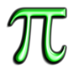
Cross
-

Curricular Links

English

To be able to
use descriptive words to
describe
birds and their habitats
features

Maths

To be able measure distance

To use shapes to create a paper
airplane

Activity |  | Step by Step | Resources | Sensory Input | ✓
 |  |  |  |  | A  c  h i  e v  e  d | R e  v i  s i t | R e d  o
Activity 1- Birdwatch  To develop the visual processing by exploring the environment around me  I can identify different objects in my environment. I can view a natural environment and identify animals and plants using my binoculars | o  o o  o | Create a set of binoculars or telescope using two toilet rolls (you can decorate and personlaise if you wish)  Use the binoculars to look around the environment If possible, go outside, or look out of a window, and try to spot animals, birds, trees and manmade objects (planes, cars, bus). If this is not possible, use Smartboard and project an image of a natural environment, or use nature books/magazines Pupils can make a tally chart of what they have seen | Toilet rolls  Tape  Smartboard or books if outside is not an option | - Auditory  - Visual  - Proprioception
Activity 2- Bird Bingo  To listen to bird sounds and identify the bird on the bingo sheet  I can identify the sound of different types of birds | - o o  - o o | Print off Bird Bingo sheet (below)  Play the audio of the birds randomly  When a pupil identifies the bird sound, they point a counter or cross out the picture (you may wish to put them in a wipeable overlay)  The person to correctly identify the birds first wins To develop this, print off the resources below, use the spinner instead of sound to develop the visual processing https://www.twinkl.co.uk/resource/british-birds-bingospinner-board-game-t-bg-1640775618 | Bingo sheet  Bird audio  (YouTube Clips) | - Auditory  - Visual
Activity 3- = Nest making  To create a ediable birds net.  I can create my own edicable bird nest | o o o | Ask pupils to wash hands  Risk assess the pupil for chocking and allergy risks In a bag or bowl, ask pupil to crush shredded wheat cereal until they are fine strands- encourage squeezing, bashing, mixing | Fondant Icing  Shredded wheat  Chocolate  Bowl  Spoon | - Auditory  - Visual  - Proprioception  - Tactile  - Taste  - Smell

 | o  o  o o | Pour some melted chocolate (you may need to use sugar free) into the bowl and encourage pupil to mix with hands or spoon  Place approx. a tablespoon of the mixture in a cupcake paper case, and push down the middle to create a nest shape  Place in a fridge or cool place until the nest is set  Using fondant icing, the pupils is to create their own bird for the nest | Cupcake paper cases
Activity 4- Magpies nest  To develop my visual processing by being able to spot objects that are missing.  I can look at and remember objects in a magpies nest, and  name the objects that are missing | - o  - o  o  - o | Create a magpie nest either by using clothing, a tray or a box  Place a number of random objects (try and make them different textures, shapes, sizes to encourage tactile exploration), making sure all are visible to the child Allow the child to look into the nest, and try to  remember what is in there  Cover the next with a towel or blanket and ask the pupil to close their eyes. Without the pupil seeing, remove one object and keep it hidden  Ask the pupil to remove the towel, and look inside the nest and to name the missing object either verbally, signing, or flashcards  Replace the object and repeat removing a different object  To make it more challenging remove more than one | Random objects Materials to make a nest A towel or blanket | - Visual  - Tactile
Activity 5- Create my own bird  To create a bird using several materials  I can create my own 3D bird | o o o | Put out a variety of materials, such as ripped up paper, feathers, felt, glitter, etc.  Using a template of a bird, ask pupils to use the different materials to create their own bird  Encourage pupils to cut, rip, roll, stick, push the materials down |  | - Auditory  - Visual  - Proprioception  - Vestibular  - Tactile
Activity 6 – Create a flying bird  To create a paper bird that can fly  . | o  o o | Using the template and instructions in the link below, fold paper into the shape of “The Blue Bird” paper airplane  You may choose to decorate and personalize the plane Experiment with force and direction to see how far the paper plane can fly | Template printed off Coloured pens and pencils Measuring stick  (optional) | - Visual  - Proprioception  - Vestibular  - Tactile
I can follow instructions to create a flying bird. I can experiment with fource and direction to see how far my bird can fly | o o | Extension- Use a measuring stick to measure the distance https://www.foldnfly.com/32d.html

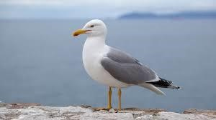 | 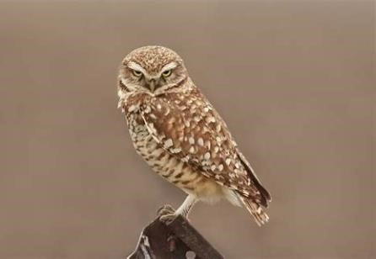 | 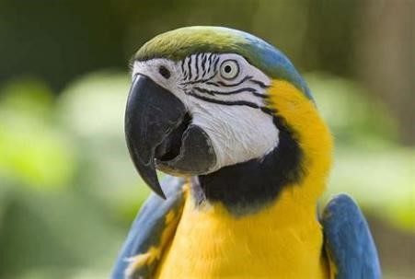
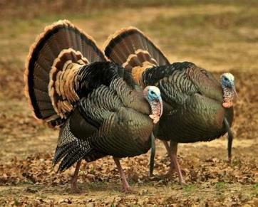 | 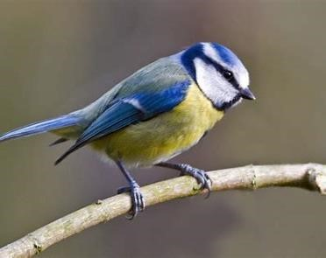 | 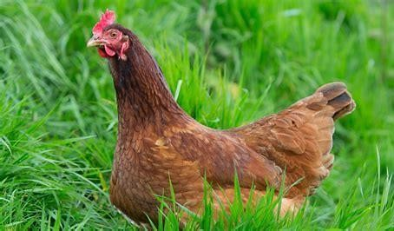

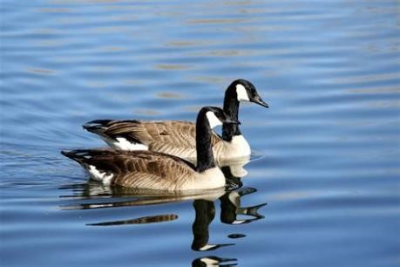 | 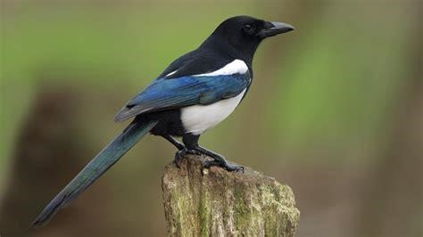 | 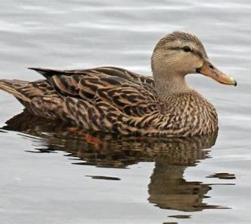

 | 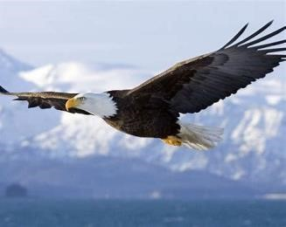 | 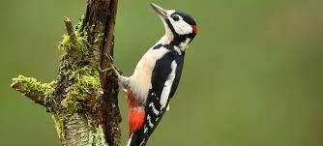
 |  | 