Earth day

Date:

By the end of these activities: | Most Pupils Will…  Be able to create sensory environments found on earth
By the end of these activities: | Some Pupils Will…  `Be able to identify impact of humans on the earth and how to recycle to reduce the impact
By the end of these activities: | A Few Pupils Will…  Identify where in the world and different features of environments on the planet and animals that live there
Cross- Curricular Links
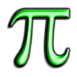 | Maths  - Counting  - Shape recognition
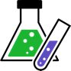 | Science  - Environments  - Mixing solutions
 | Geography  - Environments  - Echo systems  - Human impact  - Continents
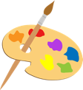 | Art  - Designing
 | PSHE  - Peer relationships  - Appropriate touch  - Impact of human behavior  - How to make a positive difference
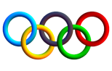 | PE  - Spatial awareness  - Turn taking  - Force

Activity | Step by Step | Resources | Sensory Input
 |  |  |  | Achieved | Revisit | Redo
Activity 1- Jelly Sea  To develop my olfactory skills by tasting food animals  I can explore new textures and flavor fruit animals | - Create food animals by either setting different flavored jelly in animal shape molds/straws. You can also create fruit animals by making fruit puree and freezing in the molds (banana doesn’t work very well)  - Place the jelly animals and/or frozen puree animals into a container  - Pour coloured jelly (blue for sea, green for land) and/or blitzed up biscuit for sand/soil  - Allow pupils to discover and taste the animals  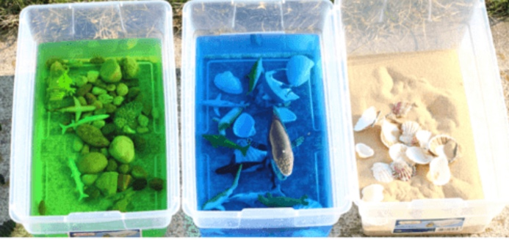 | - Jelly  - Fruit  - Biscuit  - Molds  - tupperwear | - Visual  - Proprioception  - Vestibular  - Tactile  - Olfactory
Activity 2- Earth bin sorting  To develop my proprioception and vestibular sense by collecting items and placing them in the recycle bin  I can identify rubbish and sort into the recycle bins using my hand-eye coordination | - Set out environments into a space/tufftray- these can be ocean, beach, land, forest  - Place items and/or words that are thrown out by people  - Attach a paperclip to each item/word  - Using a magnetic fishing rod ask pupils to collect the rubbish and place in the correct recycle bin  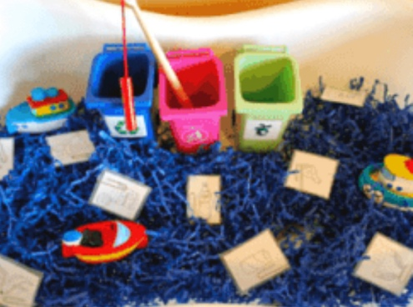 | - Fishing rod  - Rubbish (clean)  - Tufftrays or area to create an environment  - Materials to create an environment | - Auditory  - Visual  - Proprioception  - Vestibular  - Tactile
Activity 3- Earth bin sorting continued  To develop my proprioception and vestibular sense by collecting items and placing them in the recycle bin  I can identify rubbish and sort into the recycle bins using my hand-eye coordination and my fine motor skills | - Create recycle monsters using and old milk bottle and cutting a mouth into it  - Using smaller rubbish (bottle tops, glass pebbles, small yogurt pots) ask pupils to collect the item using tweezers and sort into the mouths  - You may chose to use this for counting practice too  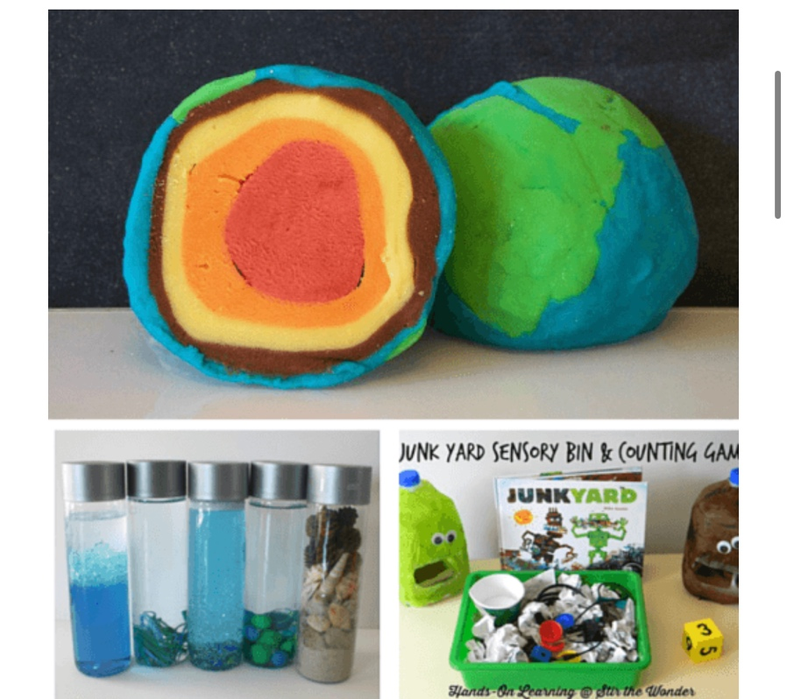 | - Small recycle objects  - Milk bottle monsters  - tweezers | - Visual  - Proprioception  - Vestibular  - Tactile
Activity 4- Dough Earth  To develop my tactile skills by using dough to create a earth  I can create a earth using dough | - `Have a selection of coloured playdough/airdry clay/foam – green, brown, orange, red yellow  - Ask pupils to create an earth using the layers (you may need a picture of the earth layers to help) | - Dough | - Visual  - Proprioception  - Tactile
Activity 5- Earth Sensory bottles  To develop my visual and auditory skills buy creating sensory bottles  I can create sensory bottles that represent the different environments on earth | - Using empty clear bottles, use objects, food dye, natural material, small plastic toys, glitter/gems, sands, etc. to create sensory bottles that represent the different environments on earth (sea, desert, jungle, earthy ground, artic, etc.)  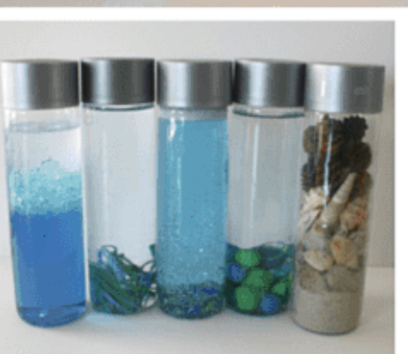 | - See through plastic bottles  - Water  - Content for the bottles | - Auditory  - Visual  - Proprioception  - Vestibular  - Tactile
Activity 6- Foam earth  To develop my tactile skills by experimenting with foam  I can identify where animals live on the earth by placing them on my foam earth | - Make blue and green foam by mixing shaving foam with food dye  - In a tray (doesn’t have to be large) make blue oceans and green earth  - Using small plastic animals or laminated pictures of animals ask pupils to place them on the correct place on earth (this can be as simple as water and land animals or more complex such as correct environments lions in Africa for example)  - Of course once all the animals are in the correct place, the pupils can play with the foam and animals  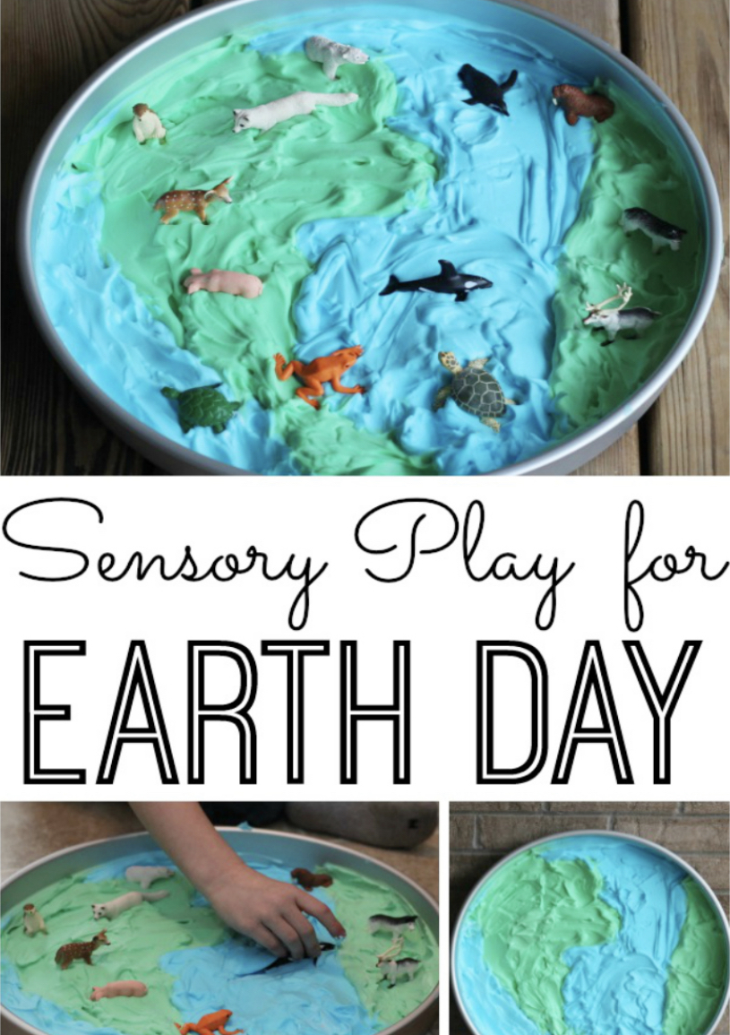 | Foam  Food dye  Animals | - Visual  - Proprioception  - Tactile

