Insert Subject | Summer
Insert NCL/KSL | Summer
Date:

By the end of these activities: | Most Pupils Will…  Be able to discover numbers through sensory experiences
By the end of these activities: | Some Pupils Will…  Identify numbers through sensory exploratory experiences
By the end of these activities: | Few Pupils Will…  Complete number challenges using sensory exploratory experiences

Activity | Step by Step | Resources | Cross- curricular Links | Sensory Input
 |  |  |  |  | Achieved | Revisit | Redo
Activity 1- Flower frame  To develop visual, tactile and proprioception skills  I can create flower art | - Cut a piece of cardboard into a picture frame  - Cover one side with sticky tape and sticky back plastic, so that one side is sticky  - Collect flowers and stick them onto the sticky side  - Cover the back with another piece of cardboard or sticky back plastic  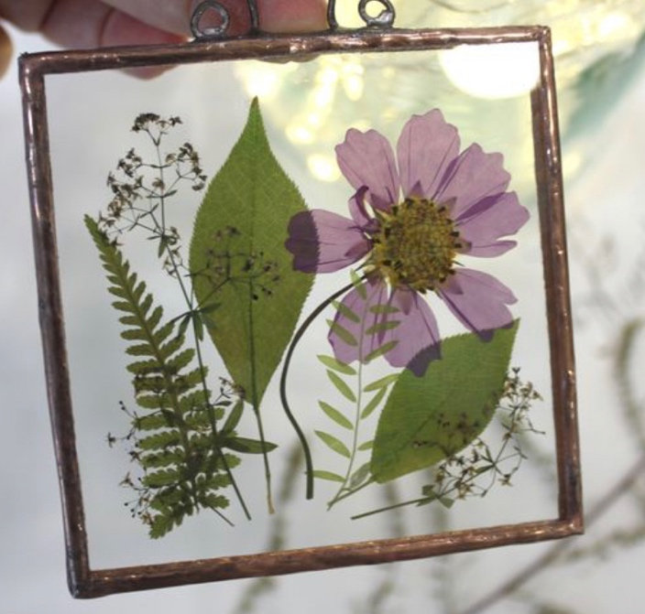 | Cardboard  Tape  Flowers | - Maths  - Science  - Art | - Visual  - Proprioception  - Tactile
Activity 2- Flower Vase  To develop my tactile and proprioception skills  I can create a flower vase | - Make a 5-7cm slice in a tennis ball half way up  - Draw a vase shape onto a bit of cardboard  - Punch holes in the top- spaced out above  - Collect flowers with stems  - Thread the stems through the holes to create flowers  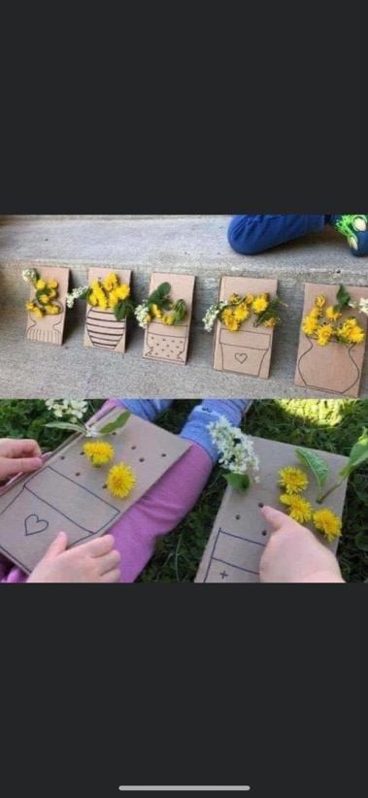 | Tennis ball  Cardboard  Flowers  Hole punch | - Maths  - Art | - Visual  - Proprioception  - Tactile
Activity 3- Plant in a bag  To develop my tactile skills  I can create a growing environment and grow my own plant from a seed | - In a sealable sandwich bag, pour 1/3 full of soil  - Plant a seed  - Tape to a light area  - Water regularly  - Watch the plant grow!  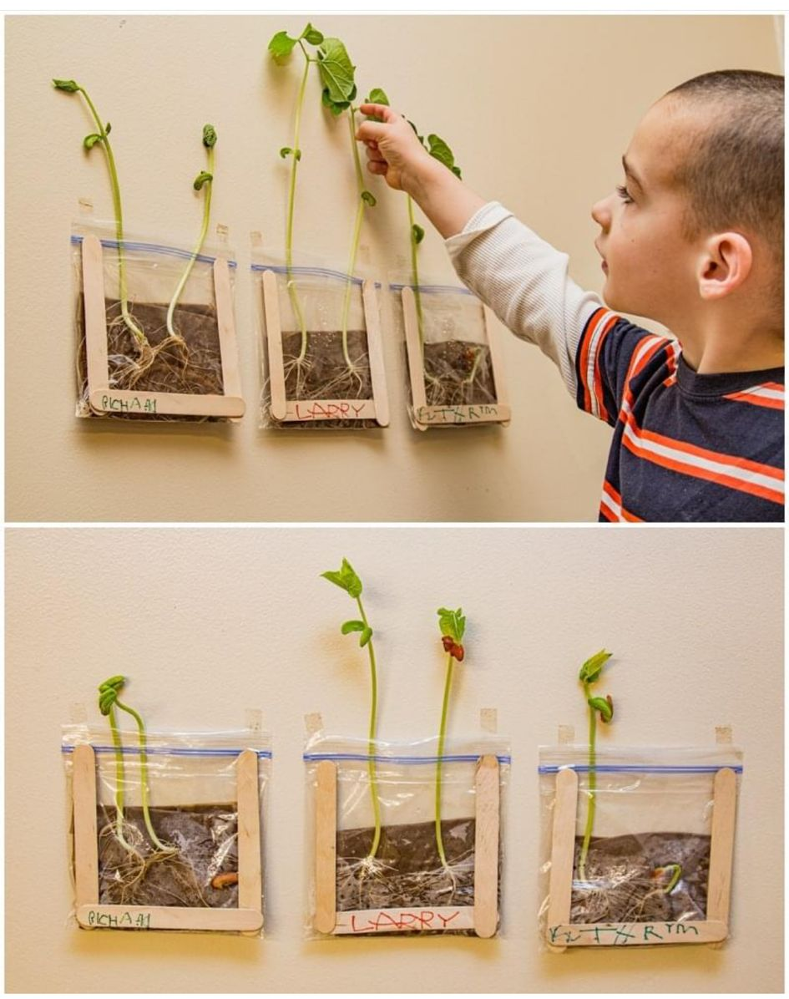 | Sealable sandwich bag  Soil  Seed  water | - English  - Maths  - Science  - Art | - Visual  - Proprioception  - Vestibular  - Tactile  - Olfactory
Activity 4- Flower soup  To develop my olfactory skills  I can create a flower soup | - In a large container, fill ½ with water  - Collect flowers – some with stems some without  - Place the flowers into the water – you may choose to pick some petals off  - Mix with a large plastic spoon  - DO NOT EAT THE SOUP!  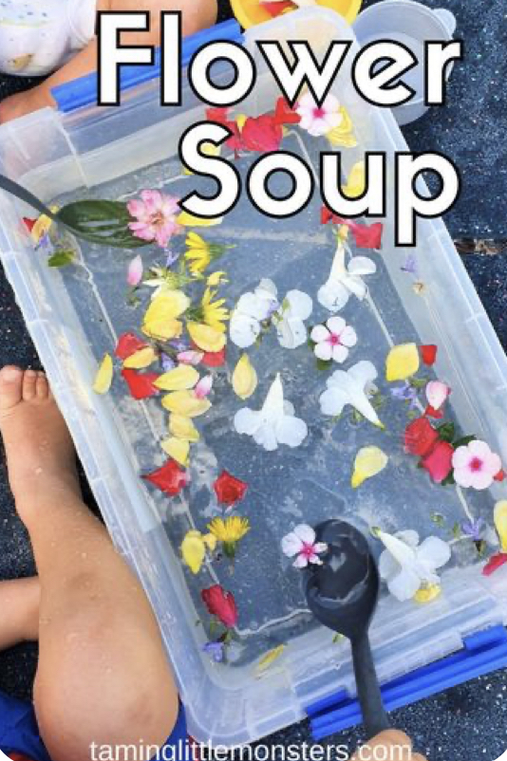 | Container  Water  Flowers | - Maths  - Science | Visual  - Proprioception  - Vestibular  - Tactile  - Taste  - Smell
Activity 5- Plant a flower sieve  To develop my visual, vestibular and proprioception skills  I can create a bunch of flowers by threading through a sieve | - Create flowers using pipe cleaners and tissue paper  - Turn a sieve upside down  - Thread and pull the pipe cleaner side through the holes to create a bunch of flowers  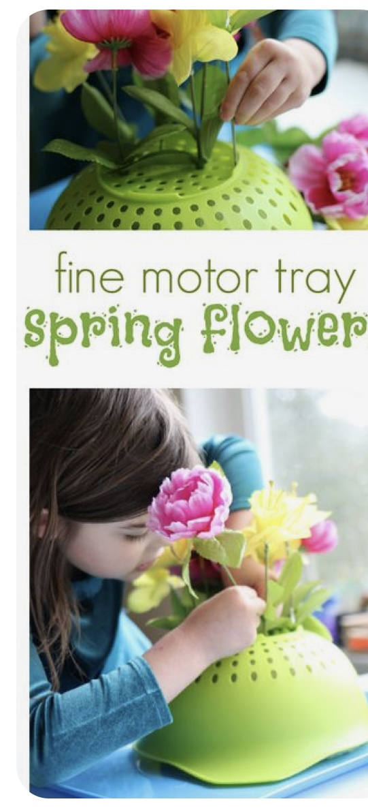 | Sieve  Pipe cleaners  Tissue paper | - Maths  - Art | - Visual  - Proprioception  - Tactile  - Vestibulat
Activity 6- Sensory flower suncatcher | - In a sealable zip bag, fill 1/3 of the way with clear hair gel  - Place flowers and leaves inside the bag  - Seal shut and tape onto a window  - Move the flowers around the gel  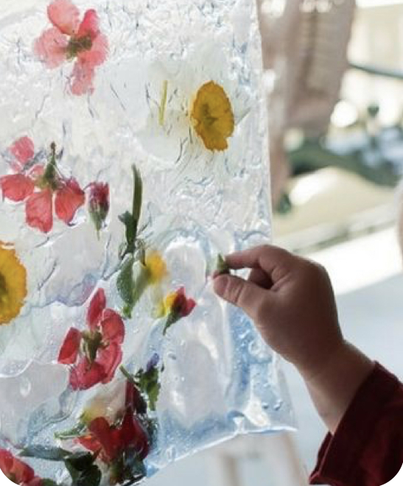 | Sealable bag  Flowers and leaves  Tape | - Maths  - Science  - Art | - Visual  - Proprioception  - Vestibular  - Tactile

