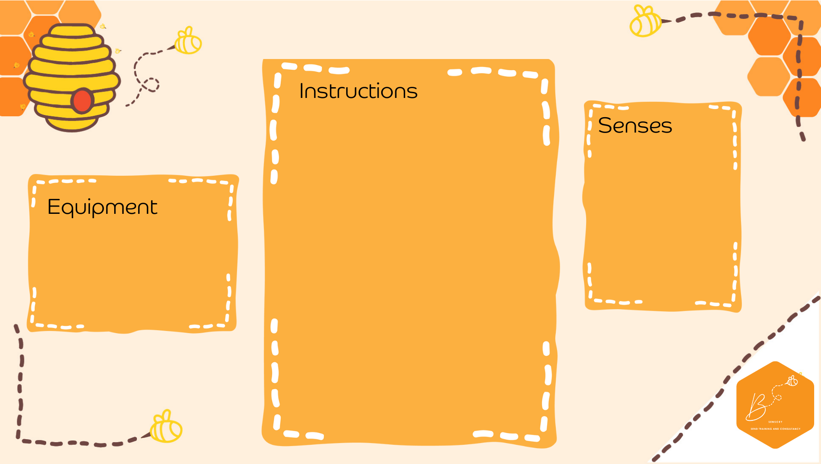
- In a container place different coloured balls
- Place a cupcake baking tray onto a flat surface
- Using a ladle scoop the ball and place it into the baking tray
- Can you copy a pattern too?
Baking Tray Balls
- Baking Tray
- Soft Play Balls
- Ladle
Visual | 
Proprioception | 
Vestibular | 

