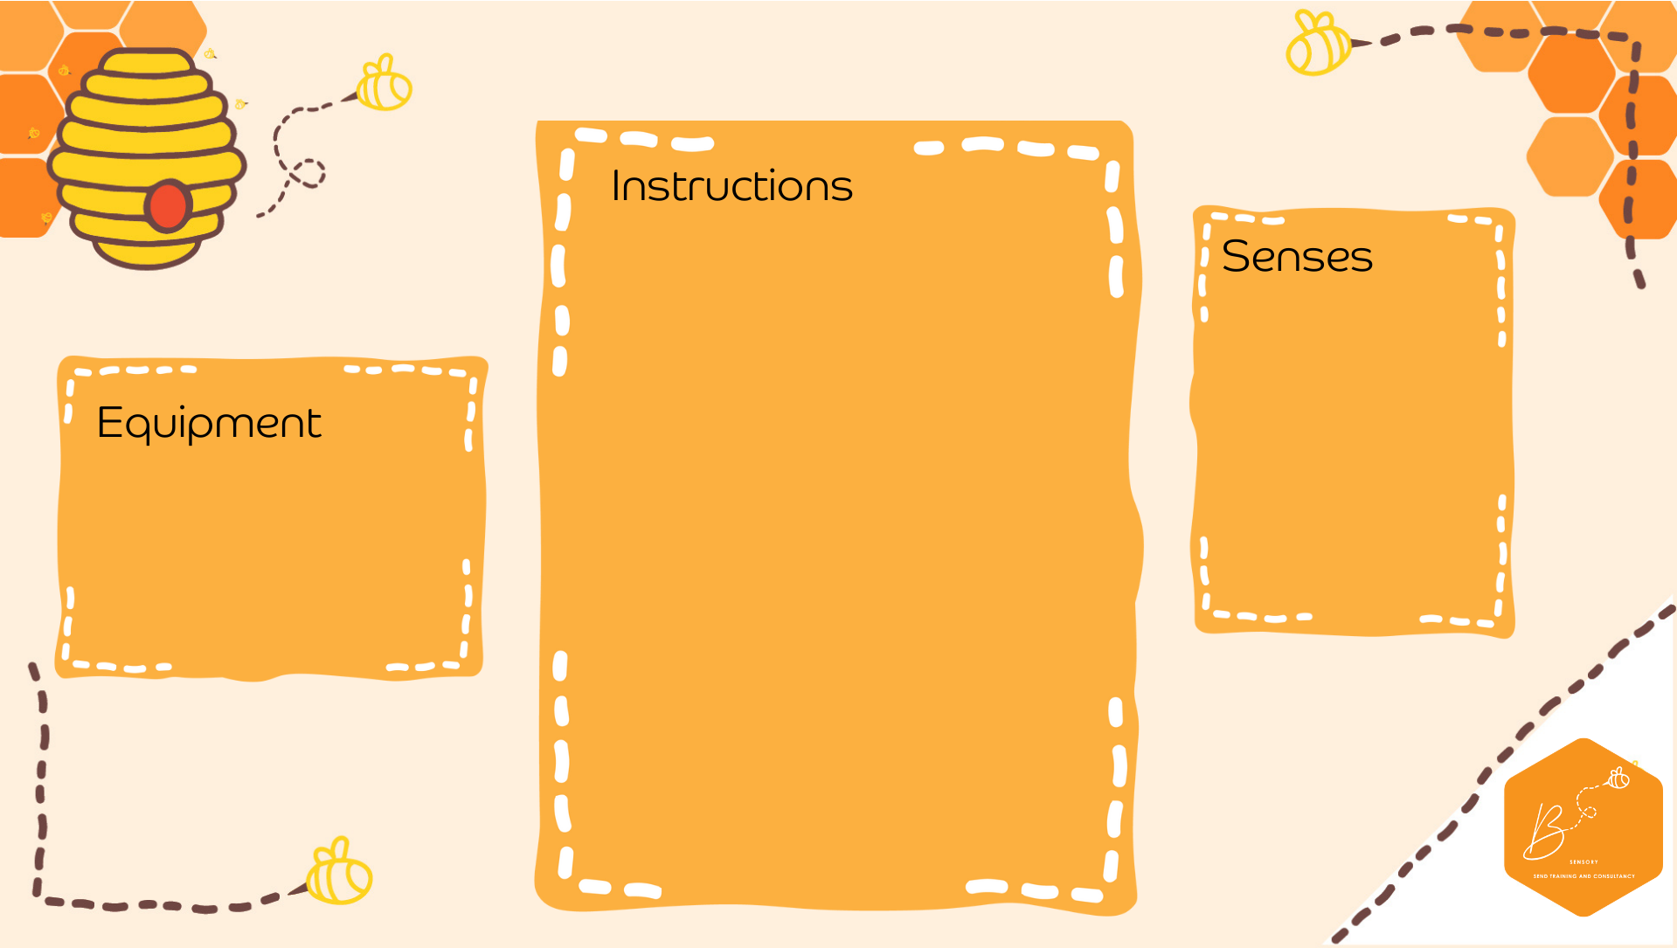
Visual | 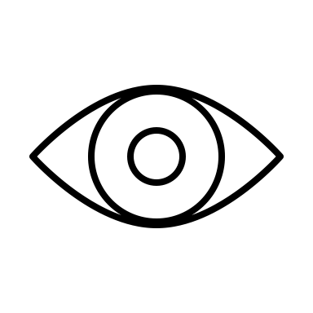
Touch | 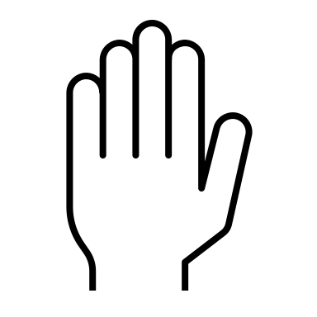

- Container
- Materials to make a bird nest
- Shiny/interesting objects
- Using a container (a draw or tuff tray is idea) create a birds nest using different materials (Sticks, paper, packaging, straw, material)
- Collect shiny, interesting objects and place in their Magpie nest
- Swop nest with someone else, or use a nest you have pre-made
- Find all the shiny and interesting things in the nest (remember magpies are good at hiding their finds in the nest)

Bird Nests

