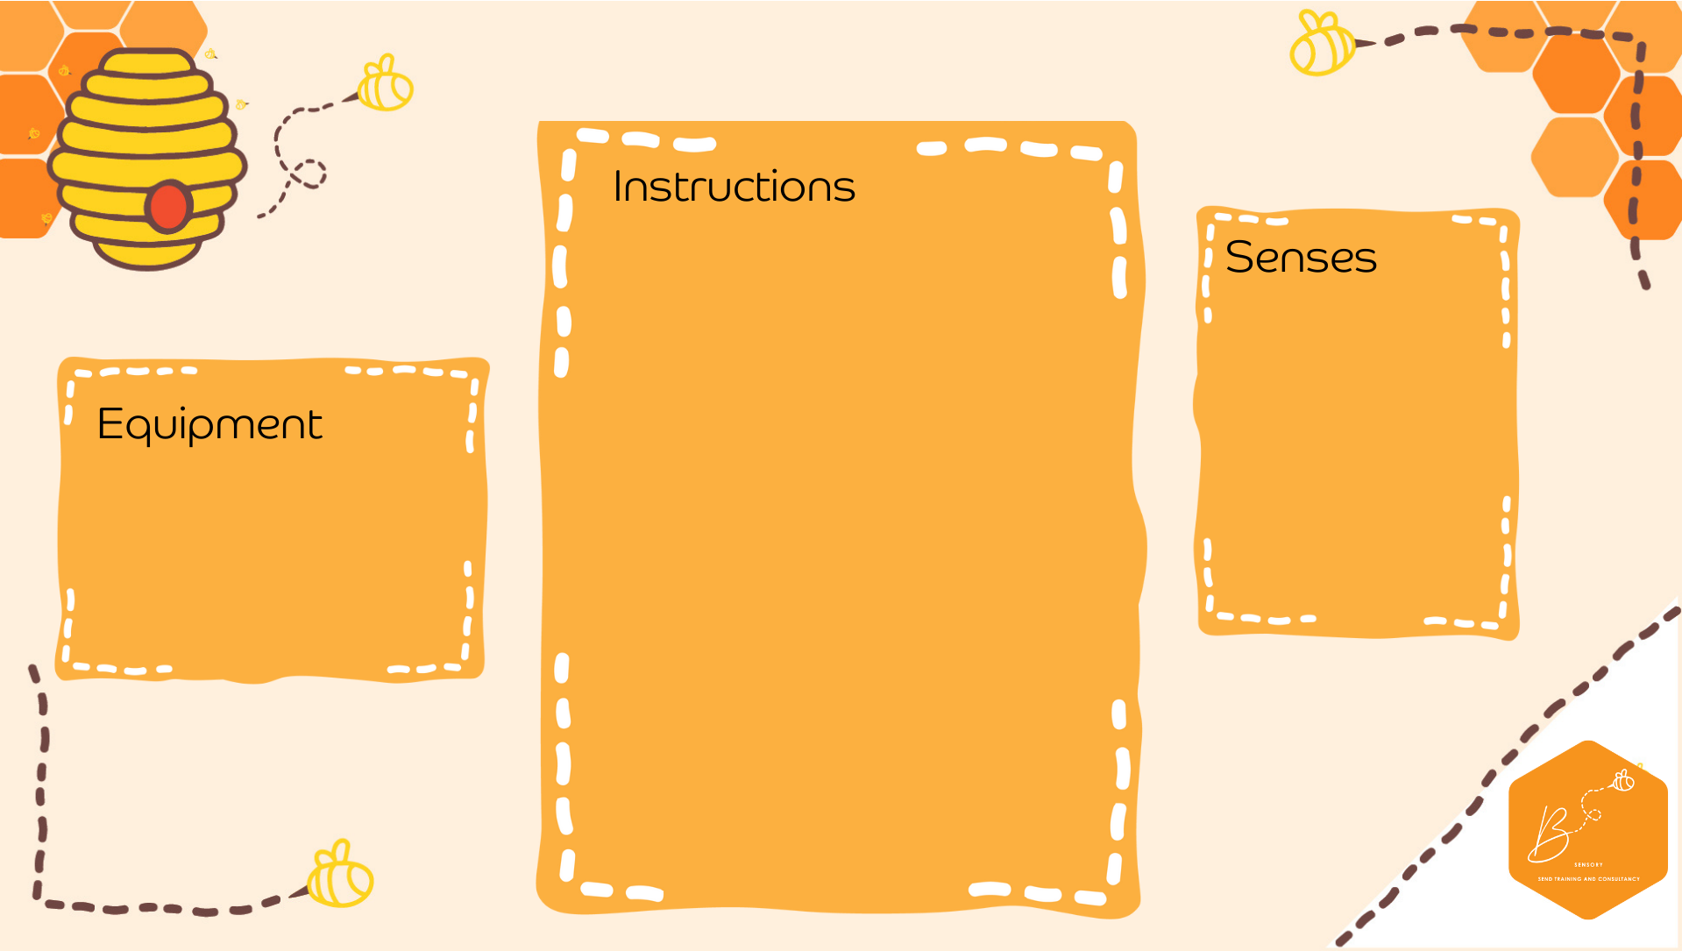
Visual | 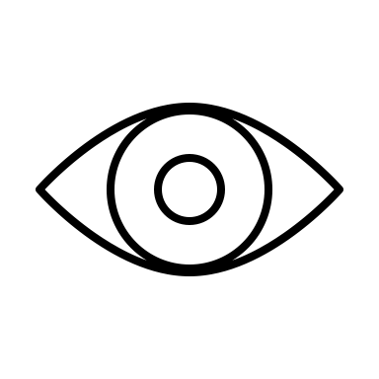

- Cardboard box
- Fairy lights
- Tape
- Paint optional
- On the top of a cardboard box, pierce holes through
- You can paint the inside black or navy blue if you wish but its not necessary
- Place a fairy light through each one of the holes
- Secure with Sellotape on the outside of the box
- Turn on
Easy Dark Den

