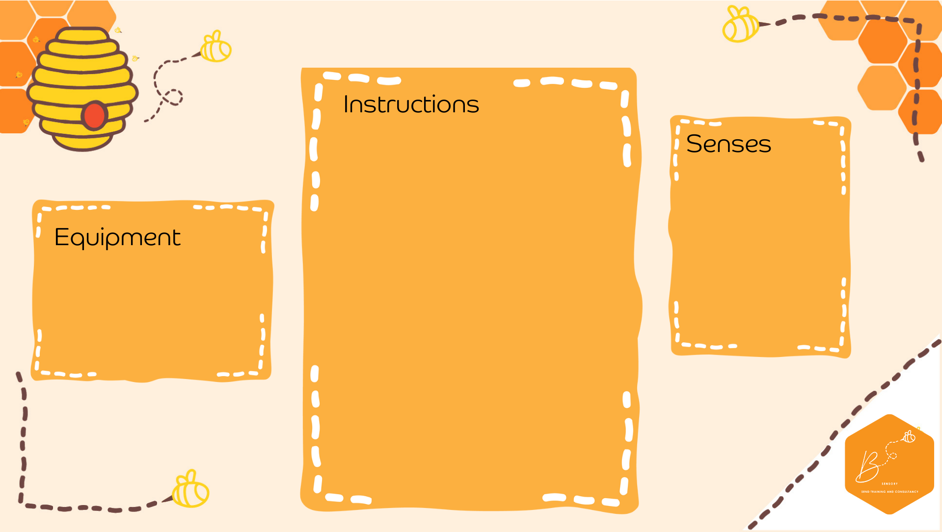
Visual | 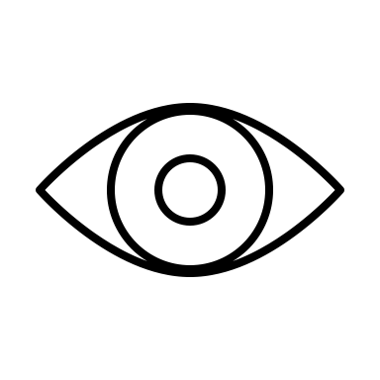

Egg Box Tetris
- Cut egg boxes into various shapes (Tetris shapes) and paint different colours
- Using a large egg box middle, place the shapes on to create a coloured square
- Egg boxes
- Paint

