Insert Subject | Eid
Insert NCL/KSL | Eid
Date:

By the end of these activities: | Most Pupils Will…  Be able to identify patterns used in religious materials
By the end of these activities: | Some Pupils Will…  Be able to identify the traditions shown during Eid
By the end of these activities: | Few Pupils Will…  Be able to identify practices used in the celebration of Eid

Activity | Step by Step | Resources | Cross- curricular Links |  | Sensory Input
 |  |  |  |  |  | Achieved | Revisit | Redo
Activity 1- Hand Henna  To develop my proprioception and visual skills by decorating a hand in henna  I can decorate a hand in Henna | - Cut out hand shapes out of thick card  - In a icing bag, fill ¼ of brown poster paint  - Cut a the end off the bag to create a small hole  - Tie a rubber band around the top to avoid spillages out  - Decorate the hand  OR  - Cut and cook biscuit dough into hand shapes  - Fill the icing bag with melted chocolate  - Decorate the hand biscuits  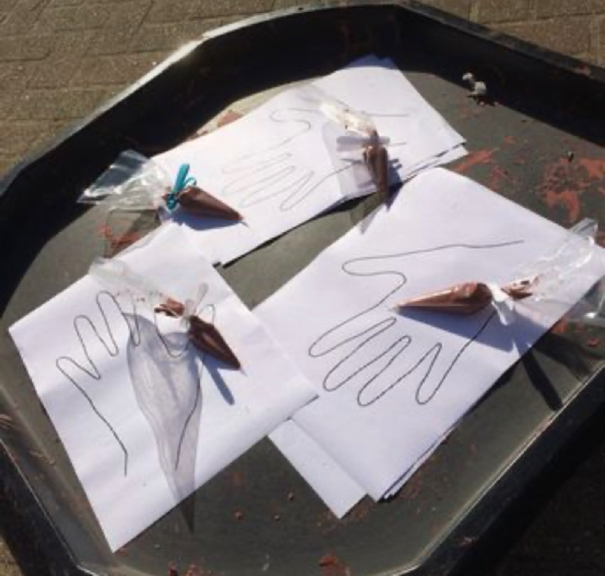 | Hand shape card  Icing bag  Brown paint  Biscuit dough  Hand shape cutter  Melted chocolate | - Maths  - Science  - Art  - RE  - English  - PSHE |  | - Visual  - Proprioception  - Tactile  - Olfactory
Activity 2- Prayer Mat  To develop my visual and tactile skills by creating a prayer mat  I can create a prayer mat | - On a piece of paper, used water colours to paint the background  - Using sequins, gems, feathers, etc, decorate the mat  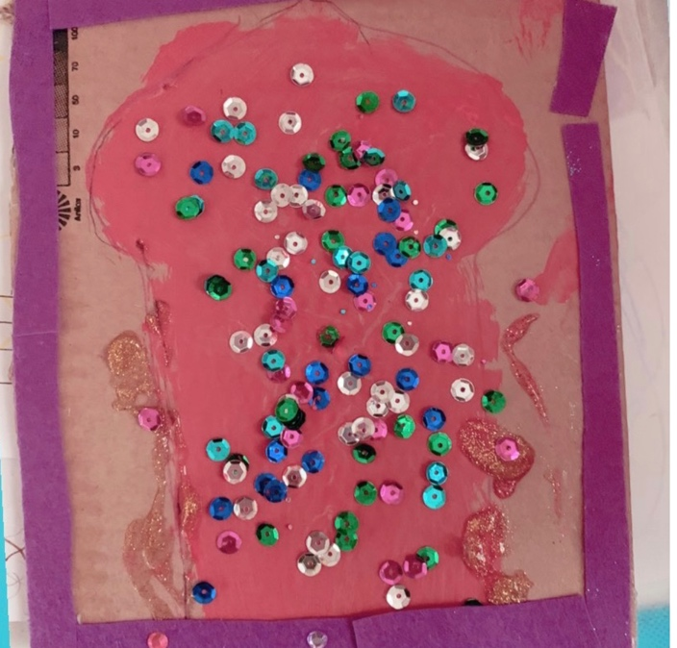 | Paper  Water colour paint  Materials to decorate | - Maths  - Art  - English |  | - Visual  - Proprioception  - Tactile  - Olfactory
Activity 3- Make my own Mosque  To develop olfactory skills by making a gingerbread mosque  I can create a gingerbread mosque | - Heat the oven to 200C/180C fan/gas 6  - Melt the butter, sugar and syrup in a pan. Mix the flour, bicarbonate of soda and ground ginger into a large bowl, then stir in the butter mixture to make a stiff dough. If it won’t quite come together, add a tiny splash of water  - Cut out the shape of a mosque (downloads are available online)  - Put a sheet of baking paper on a work surface and roll about one quarter of the dough to the thickness of two £1 coins  - Place the template onto the dough and cut around  - Bake for 12 mins or until firm and just a little darker at the edges. Leave to cool for a few minutes to firm up  - Using icing and cake decorations decorate once cool  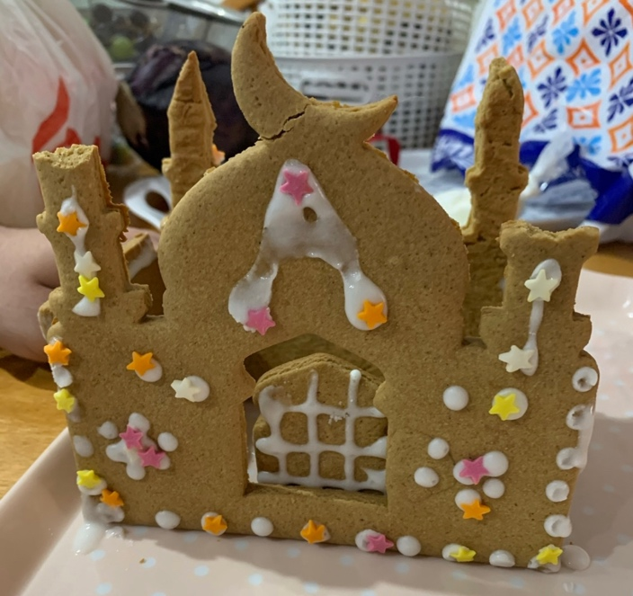 | 250g unsalted butter  200g dark muscovado sugar  7 tbsp golden syrup  600g plain flour  2 tsp bicarbonate of soda  4 tsp ground ginger  Icing sugar  Water  Icing bag |  | - English  - Maths  - Science  - Art  - PSHE | - Visual  - Proprioception  - Vestibular  - Tactile  - Olfactory
Activity 4- Moon Light Catcher  To develop my visual skills by creating a moon light catcher  I can | - Using tinfoil, squeeze and manipulate into a moon crescent  - Create a hole at the top using a hole punch  - Pick fresh flower petals or using gems- decorate the moon  - Hang in the light  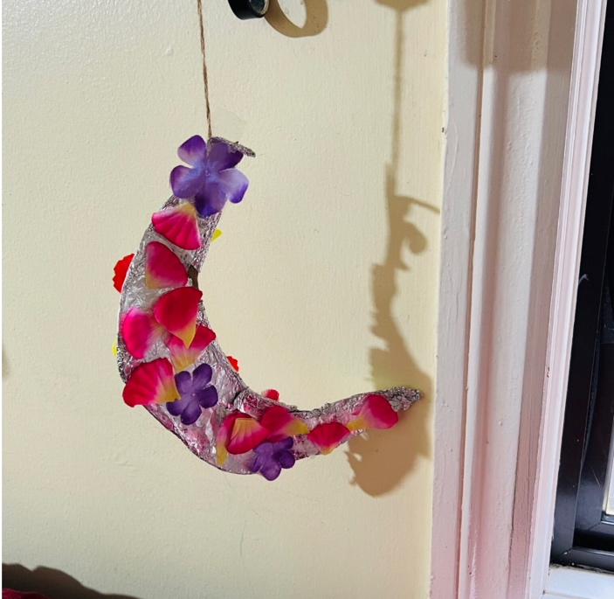 | Tin foil  Flower petals or gems  Ribbon | - Art  - English  - PSHE |  | Visual  - Proprioception
Activity 5- Lantern  I can create a lantern | Using a glass jar remove the lid  PVA glue tissue paper shapes onto the jar  Tie string around the top of the jar and create a loop to hang  Place a none-flame tea-light inside the lantern and watch it shine!  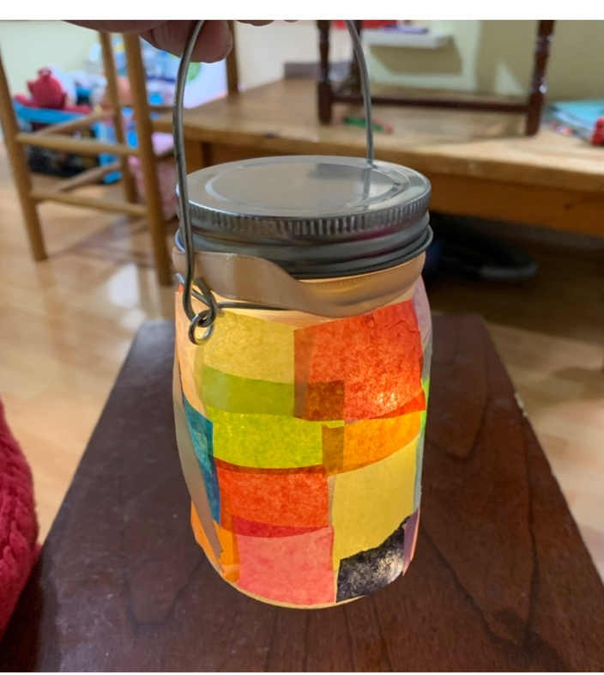 | Glass jar  Tissue paper  PVA glue | - Art  - PSHE |  | - Visual  - Proprioception  - Tactile
Activity 6- Celebration decorations  To develop my proprioception skills by creating celebration decorations  To create a celebration decoration | - Using air dry clay, cut the clay into shapes using a blunt knife or a cookie cutter  - Using a different coloured clay, create small decorations by rolling, cutting, pinching, stamping, pressing into the clay  - Create a small hole at the top with a pencil  - Leave to dry  - Thread some ribbon through and hang  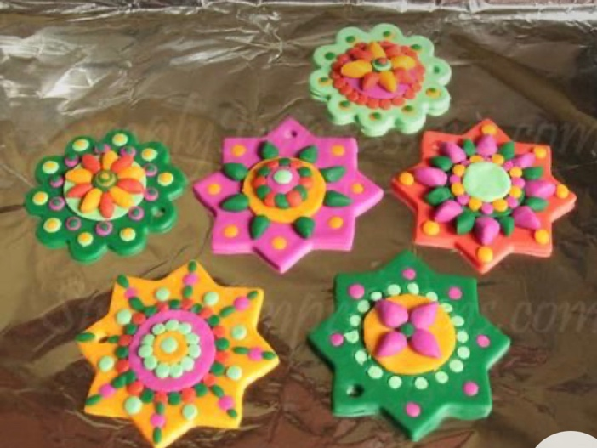 | Air dry clay  Ribbon | - Maths  - Science  - Art  - PSHE |  | - Visual  - Proprioception  - Tactile

