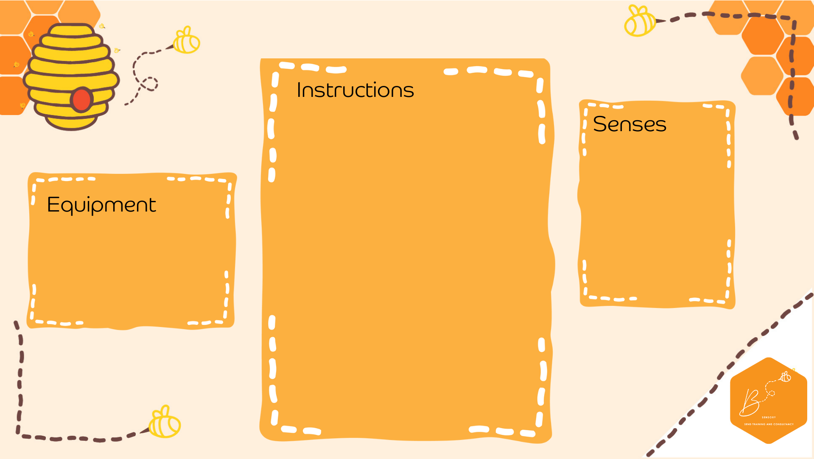
Easy Light Box
- Using a clear plastic box, stick LED strip lights on the underneath
- Turn the lights on
- You can also fill with sand and use a paintbrush to move the sand to reveal the light
- Plastic Box
- LED light strip
- Sand
Visual | 

