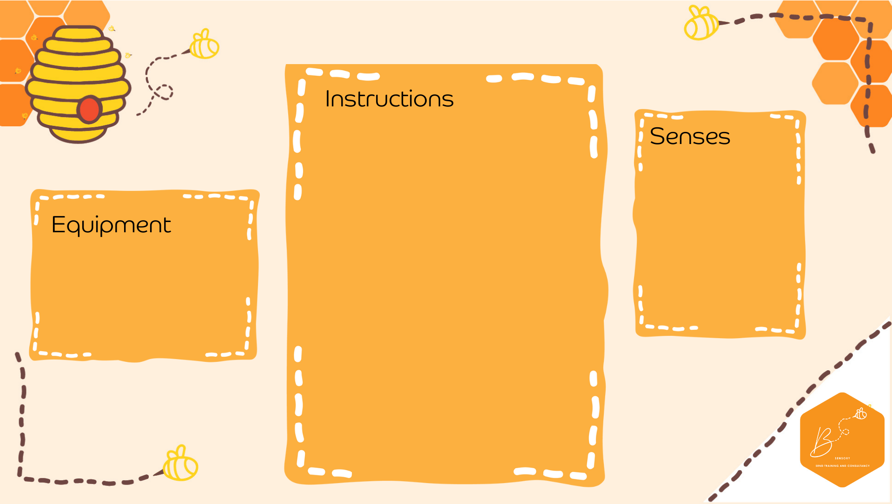
Mythical Cave
Visual | 

- Create a dark space- this maybe the whole classroom, corridor or a dark den- you can make it as simple or as Dragon Cave like as you like!
- You may chose to put on some background music to set the scene or use sound bottles
- Place pictures/teddies of dragons around the space
- Using a torch discover where all the dragons are hidden
- Once they are all found you may want to relax and read a dragon themed book (Zog is great for this!) using the torch to read with
- Dark space
- Dragons or teddies
- Torches

