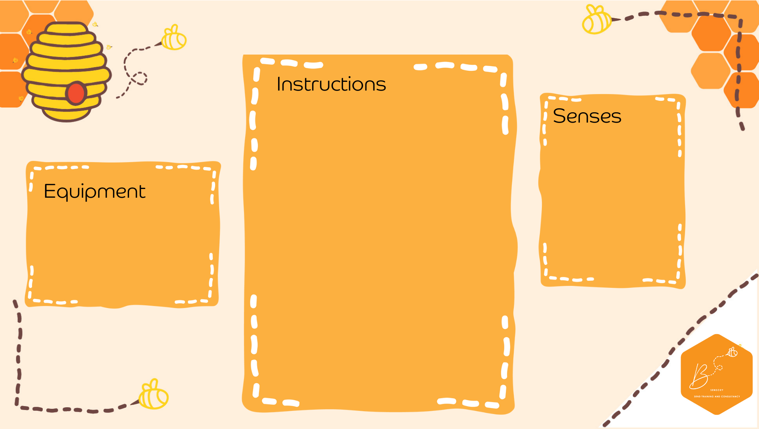
Visual | 
Proprioception | 

Spider Web Bounce
- Sit everyone down in a circle
- Using string/elastic/gift wrap ribbon- randomly pass the ribbon across the circle (you will eventually end up with everyone having hold of it, and a spiderweb in the middle
- Place a balloon in the middle (you could draw a spider on) and bounce it up and down using the web
- Try to not let it fall off the web
- Ribbon/elastic
- Balloon

