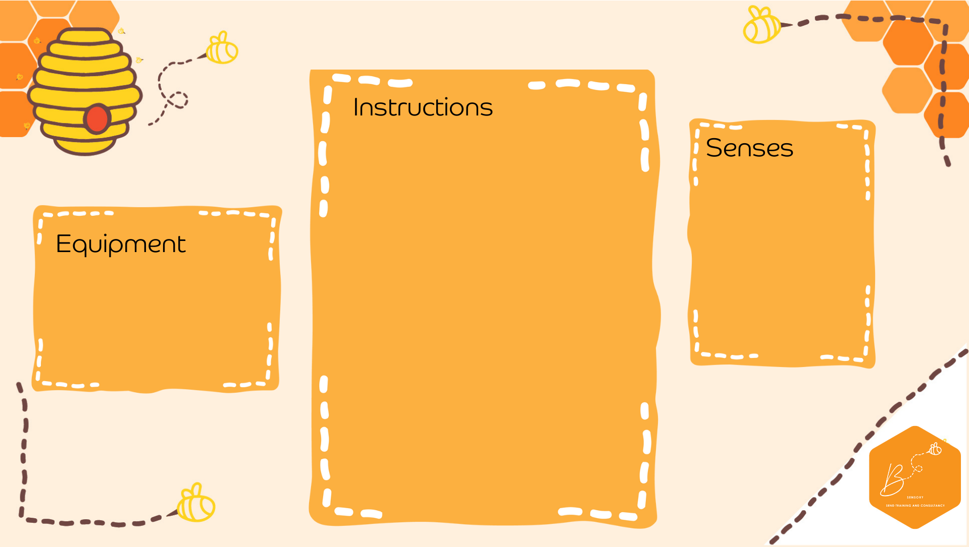
Auditory | 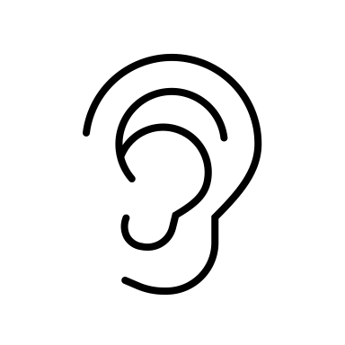
Olfactory | 
Proprioception | 

Balloon Talking
- Blow up a balloon
- Place the balloon over the ear
- The other person talks/hums on the other side of the balloon so the person with the balloon can hear
- Balloons

