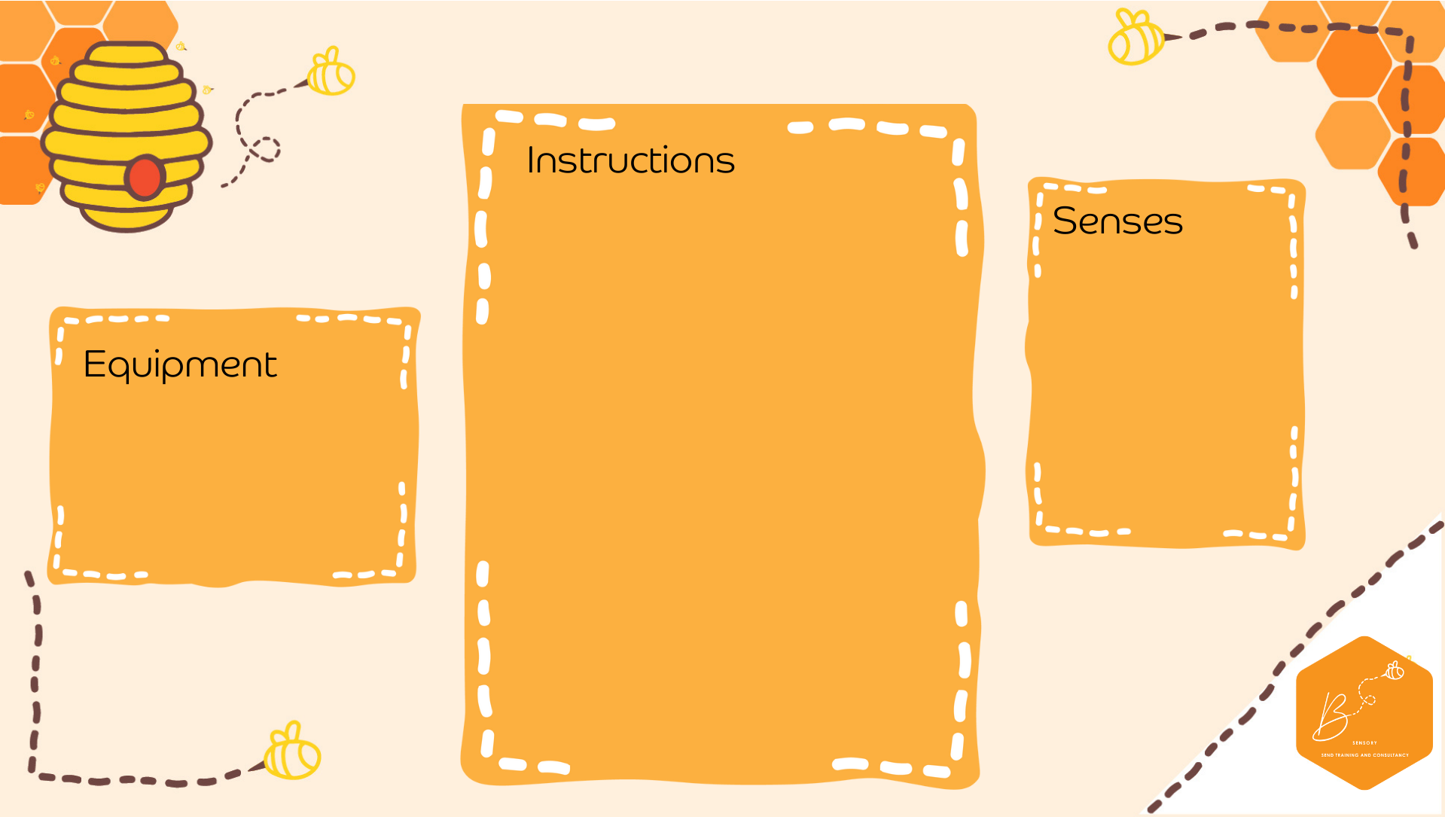
Auditory | 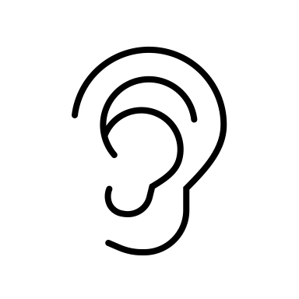
Touch | 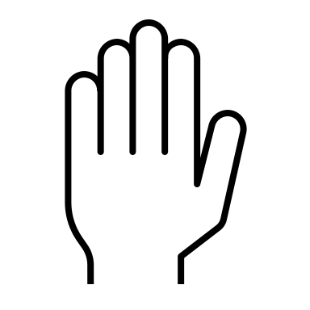
Proprioception | 
Vestibular | 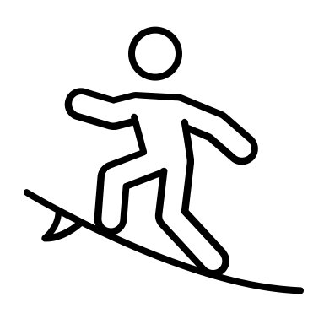

Bubble Wrap Pop
- Place a sheet of bubble wrap on the floor
- Lay down and pop the bubble wrap, walk/run/stomp on the bubble wrap or roll over the bubble wrap

- Bubble wrap

