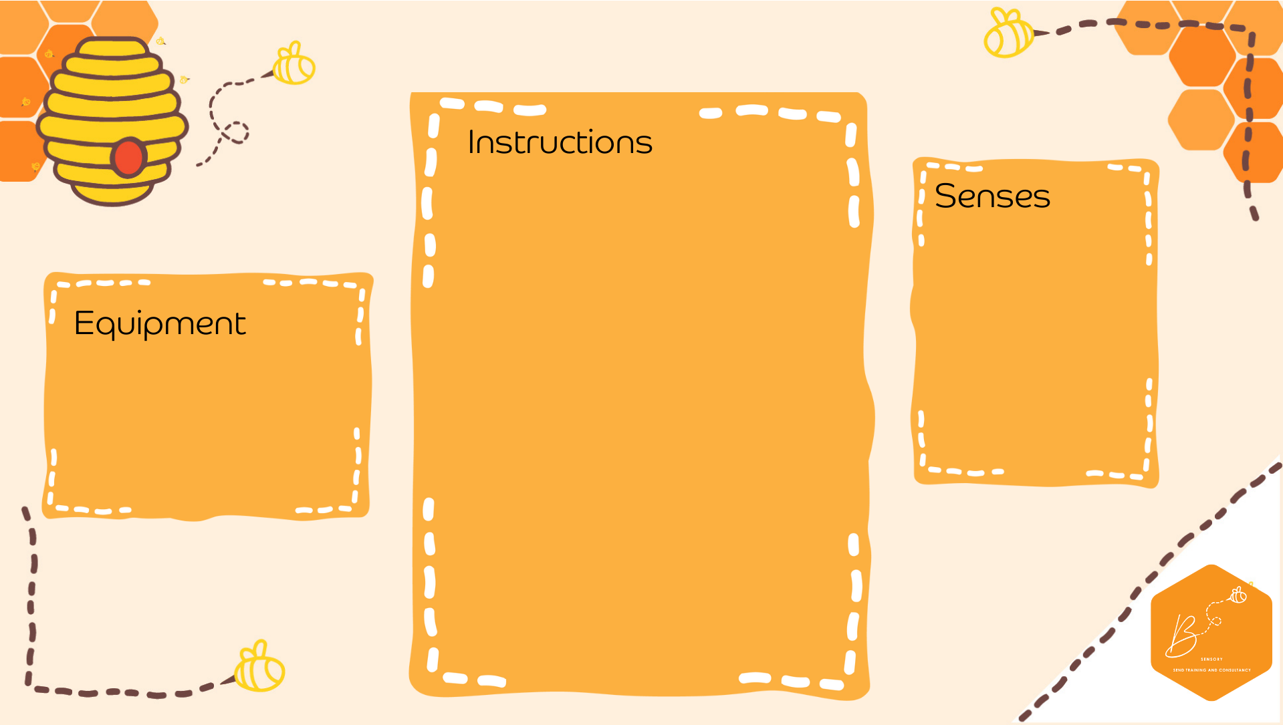
Auditory | 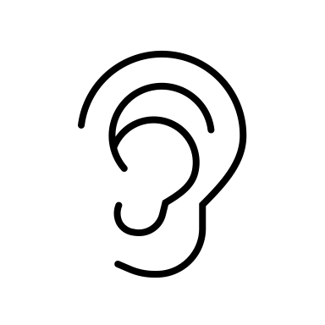
Visual | 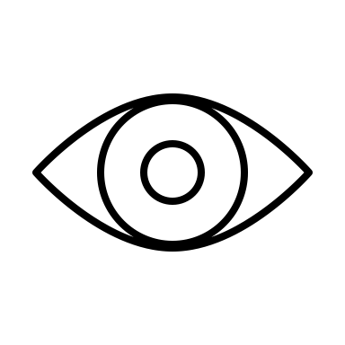
Touch | 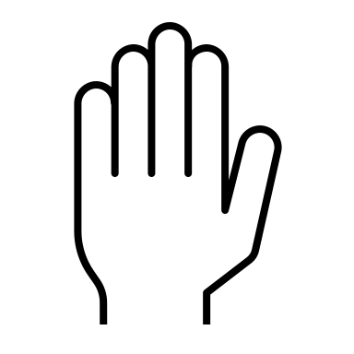
Proprioception | 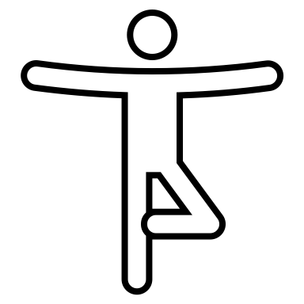
Vestibular | 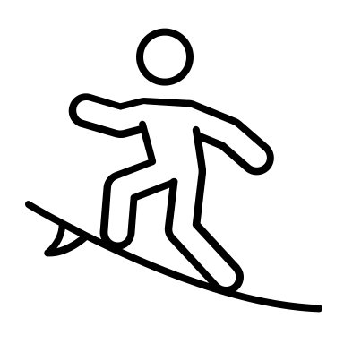

Sound Balloons
- In deflated balloon, fill with material of choice (rice, dried beans, coloured beads, sand)
- Blow the balloon up and tie the end
- Tap the balloon with your hands
- Or tie a rubber band around the tie and hold the rubber band and punch it away using the same hand
- Balloons
- Dried Materials
- Rubber band

