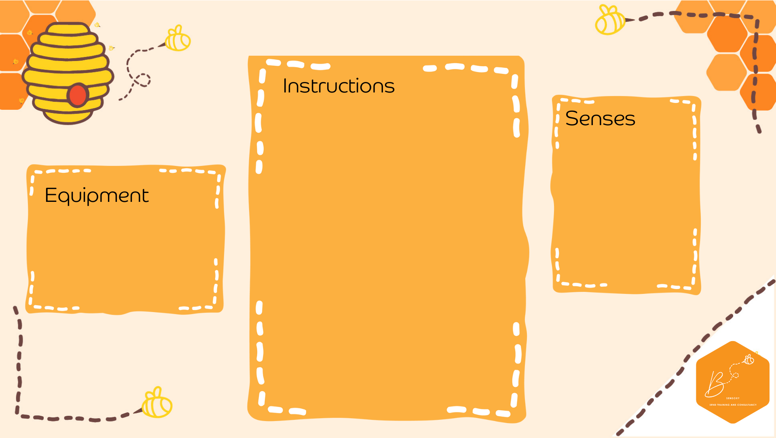
Sound Drums
Auditory | 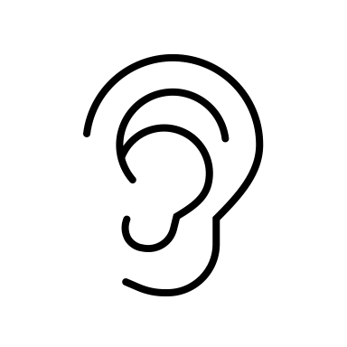
Visual | 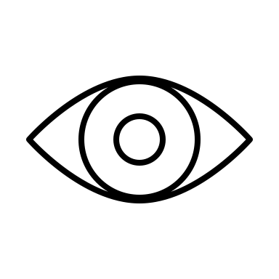
Touch | 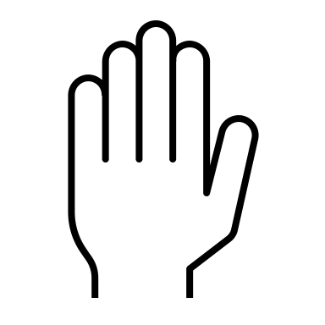
Proprioception | 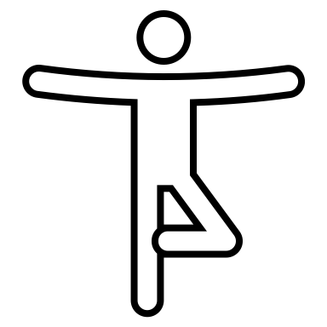

- Balloons
- Containers
- Dried materials
- Drum stick
- Cut the ends off balloons
- Over different sized empty containers, stretch the balloon rubber to cover the top
- Place different martials on top of the stretched rubber (rice, dried beans, water, marbles, beads)
- Tap the rubber with a drum stick/stick or hand
- Listen to the different sounds

