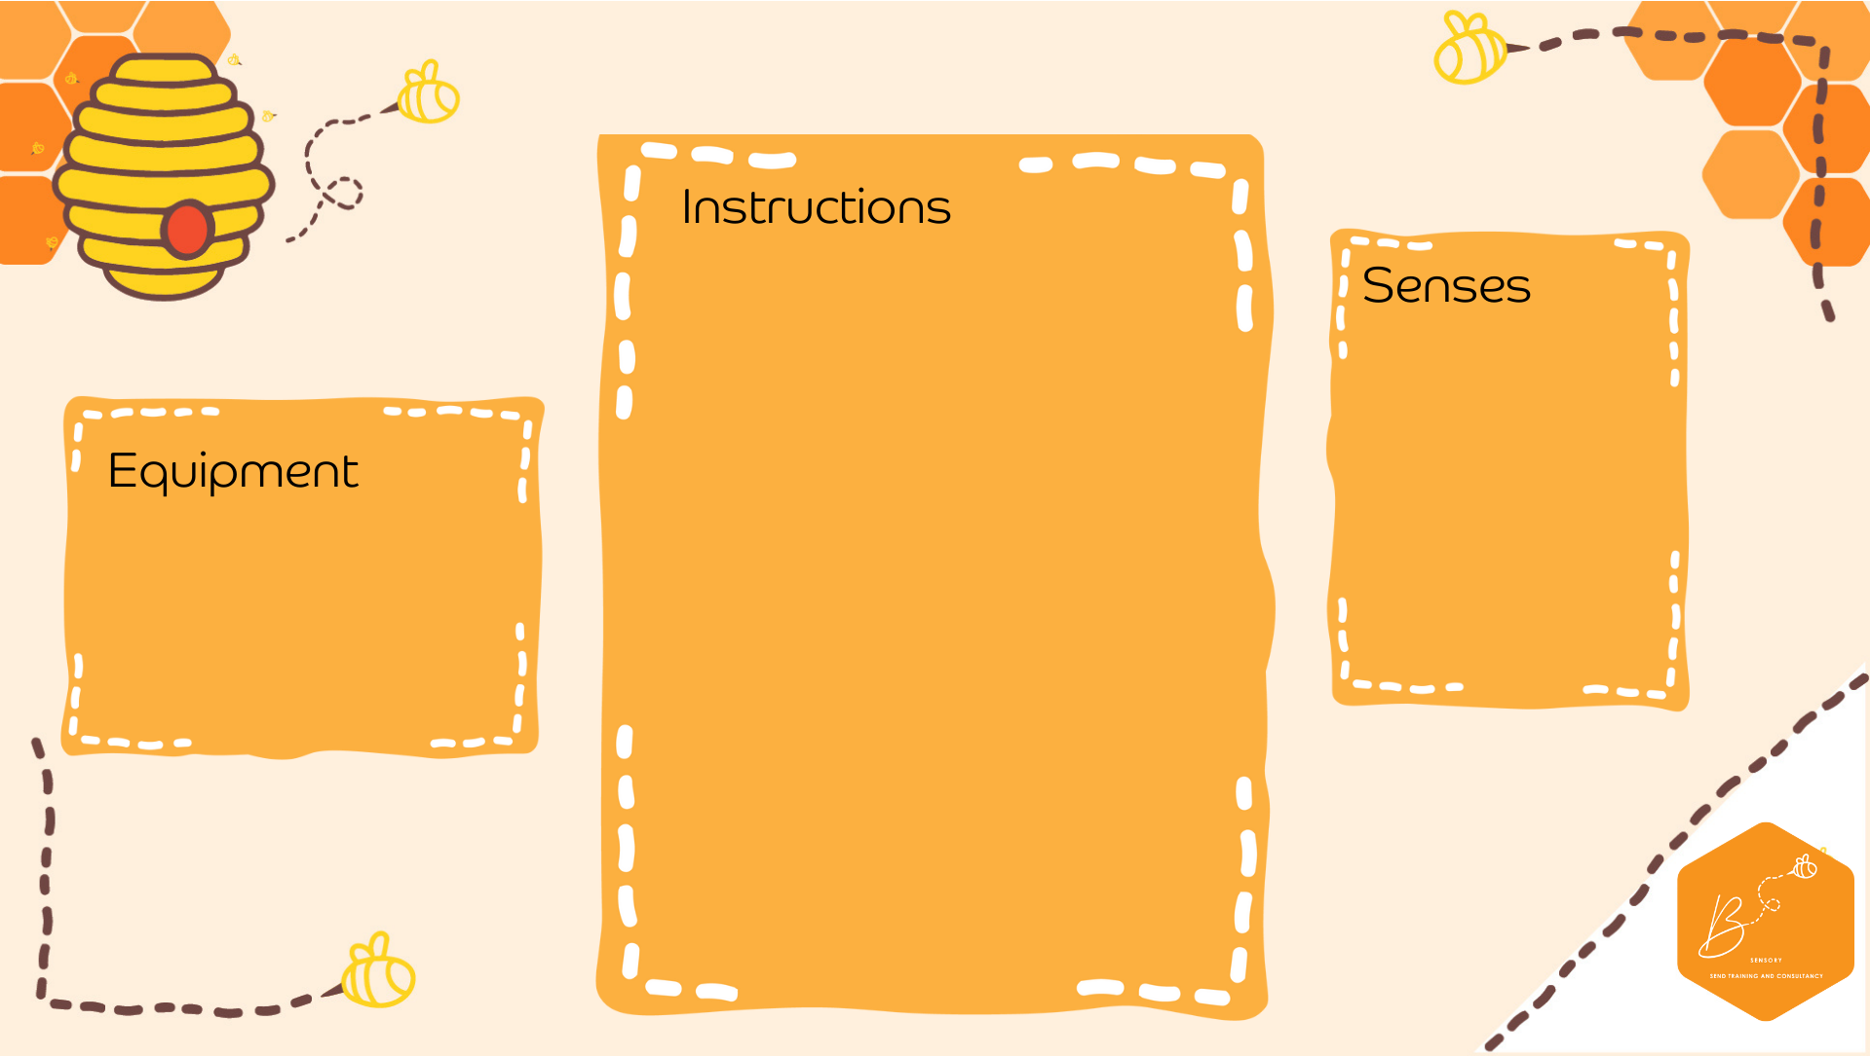
Auditory | 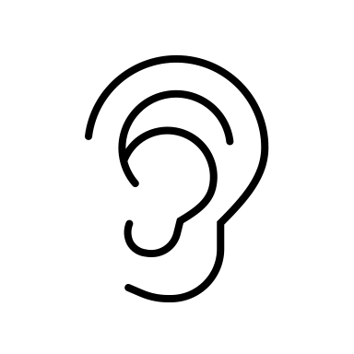
Touch | 

Sound Tubes
- On the bottoms of an empty toilet roll place a piece of paper over and secure with an elastic band
- Fill half way with different materials (dried beans, rice, pom poms, feathers, paper clips, sequins, etc.)
- Place another piece of paper over the top and secure with an elastic band
- Shake the tubes
- Toilet roll rolls
- Paper
- Dried materials

