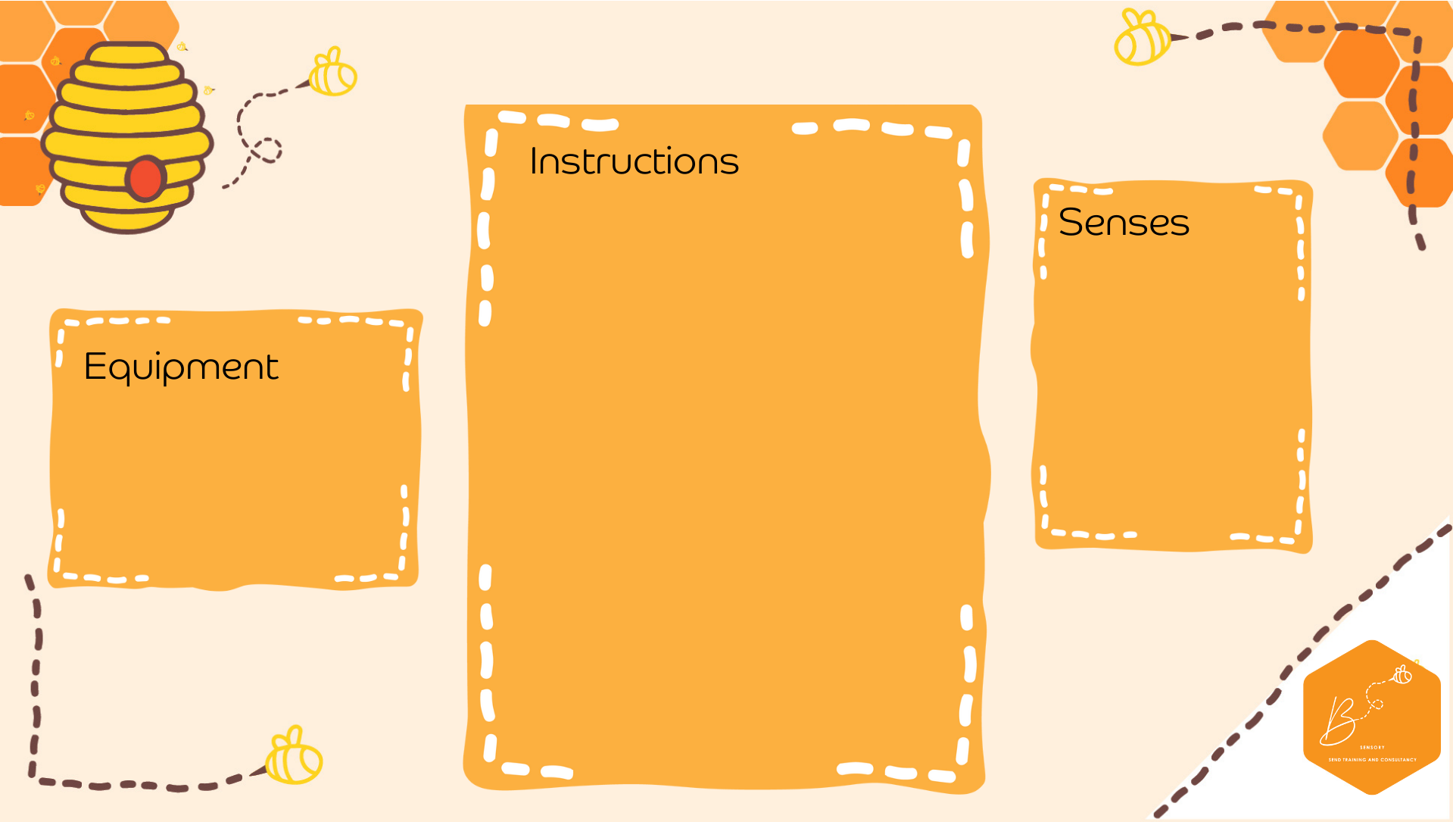
Water Xylophone
Auditory | 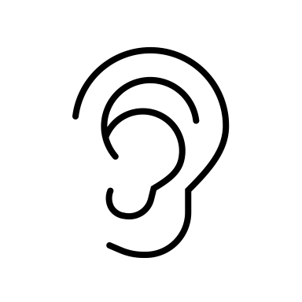
Visual | 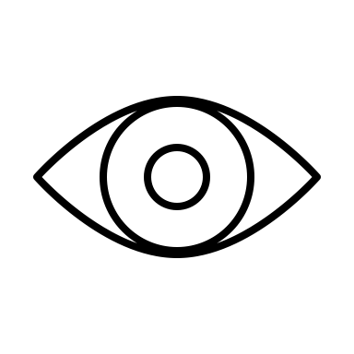
Proprioception | 

- Glasses
- Water
- Food colouring optional)
- Drum stick
- In 8 empty glasses, fill with different volumes of water
- You may choose to add different coloured food in each one
- You may choose to secure the glasses with playdough onto the table to prevent knocking over
- With a stick, pencil or drumstick- tap the side of the glasses
- Listen to the different sounds it makes
- Can you create a tune?

