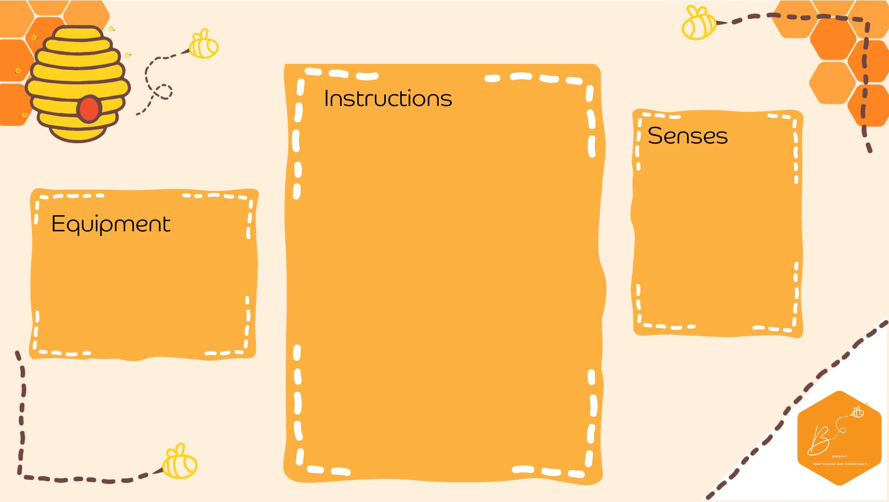
•

In your plastic b
ottle
,
fill
¼

with

clear PVA
gl
ue

•

Add leaf and
au
tu
mn
gl
itter confetti

•

Add food colouring to
water

•

F
ill the rest of the
bottle
with

the
c
olou
red wa
ter

•

Attach the bottle lid
and
ta
pe
if requi
red

Visual

•

Pla
stic bottle

•

PVA
glue

•

Autumn conf
etti

•

Water

•

Food colouring

Autumn Sensory Bo
ttle

