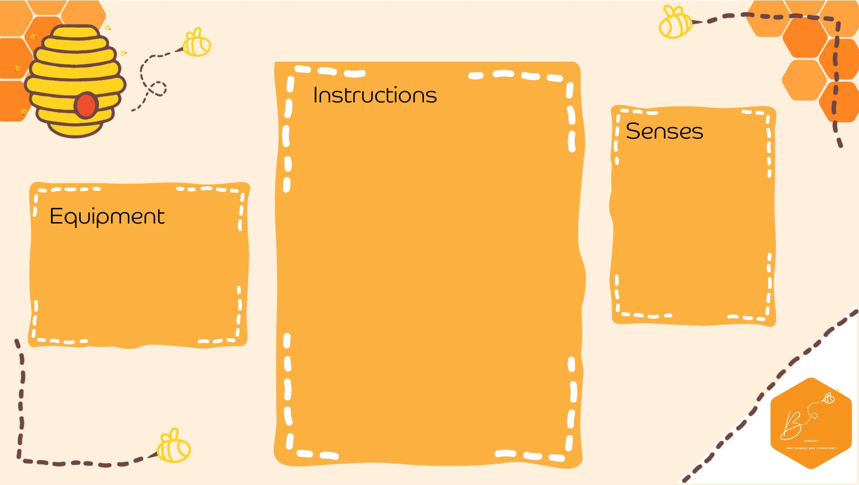
•

*** Sharp knife
–

adu
lt
only.
Please t
ake c
are
***

•

Cut the top off the pumpkin

•

Sc
oop
the seeds out

•

Place
pumpkin on a tray

•

A
dd a few
hea
ped teaspoo
ns
of b
aking soda into the
pumpkin

•

Add a few drops of
dish soap
and food colouring

inside

•

Us
i
ng droppers, drop some
vinegar

into the pumpkin

•

Wa
tch it bubble

•

For cauldron, paint the pumpkin
black and add a handle

Auditory

Visual

•

Pump
kin

•

Baking So
da

•

Vinegar

•

Dish Soap

•

Gre
e
n food colouring

•

Tray

Bubbling
Pump
kin
/Cau
ldron

