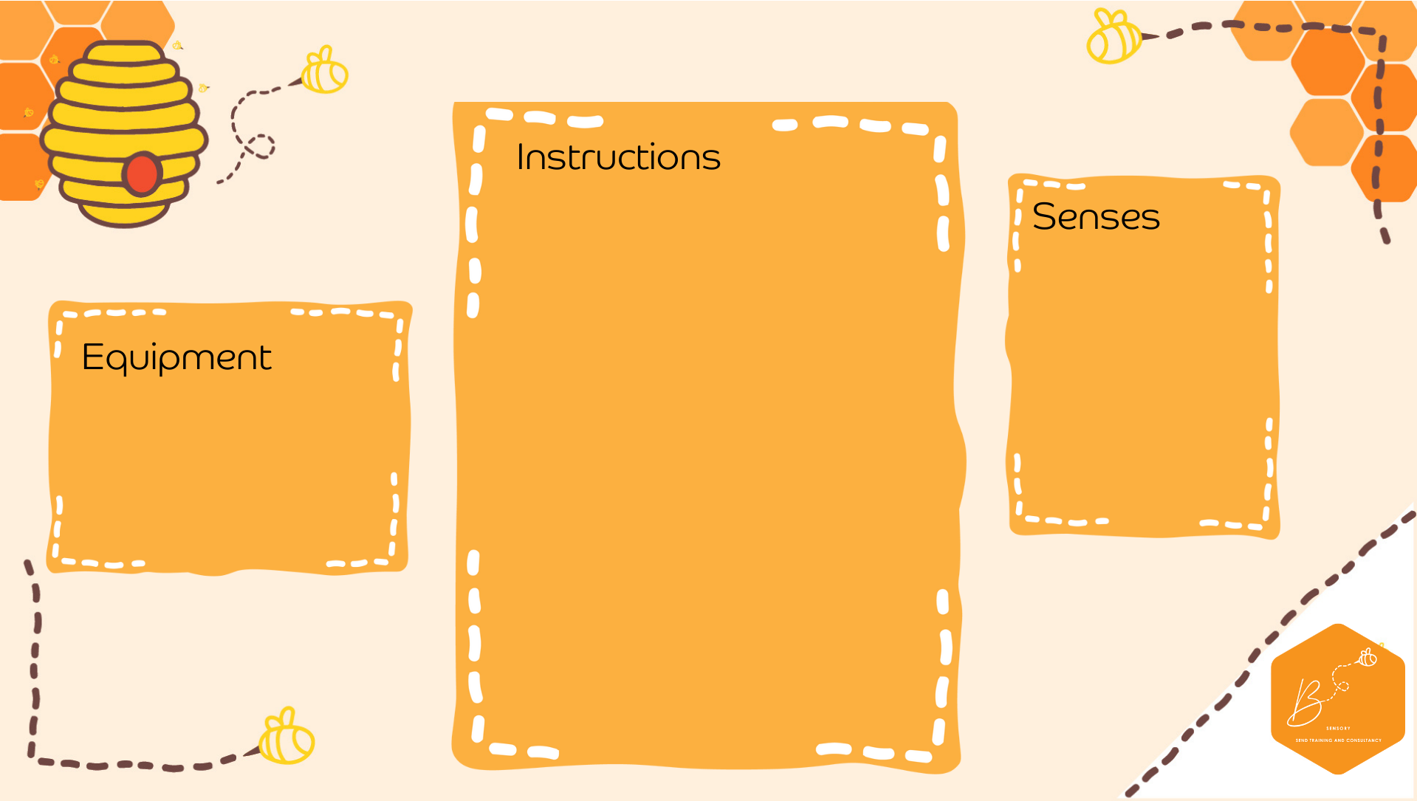
- Marrow or pumpkin
- Golf tees
- Plastic hammer
Construction Marrow
- Place the marrow or pumpkin on a flat surface so that it does not roll
- Using the hammer, hammer in the golf tees into the marrow/pumpkin

Auditory | 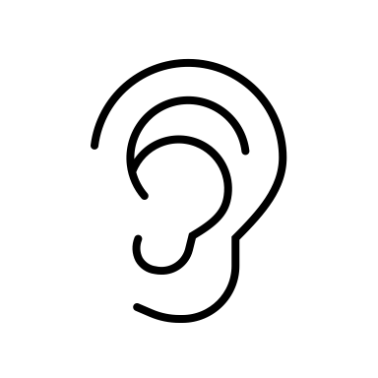
Visual | 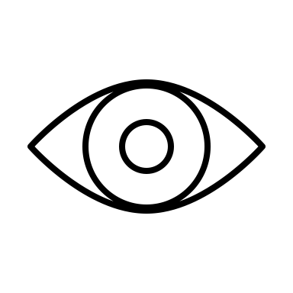
Touch | 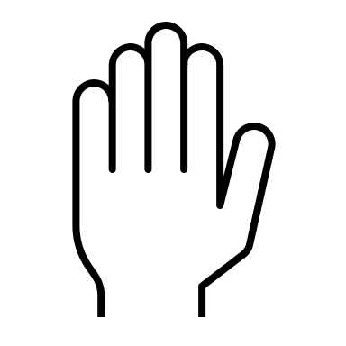
Proprioception | 