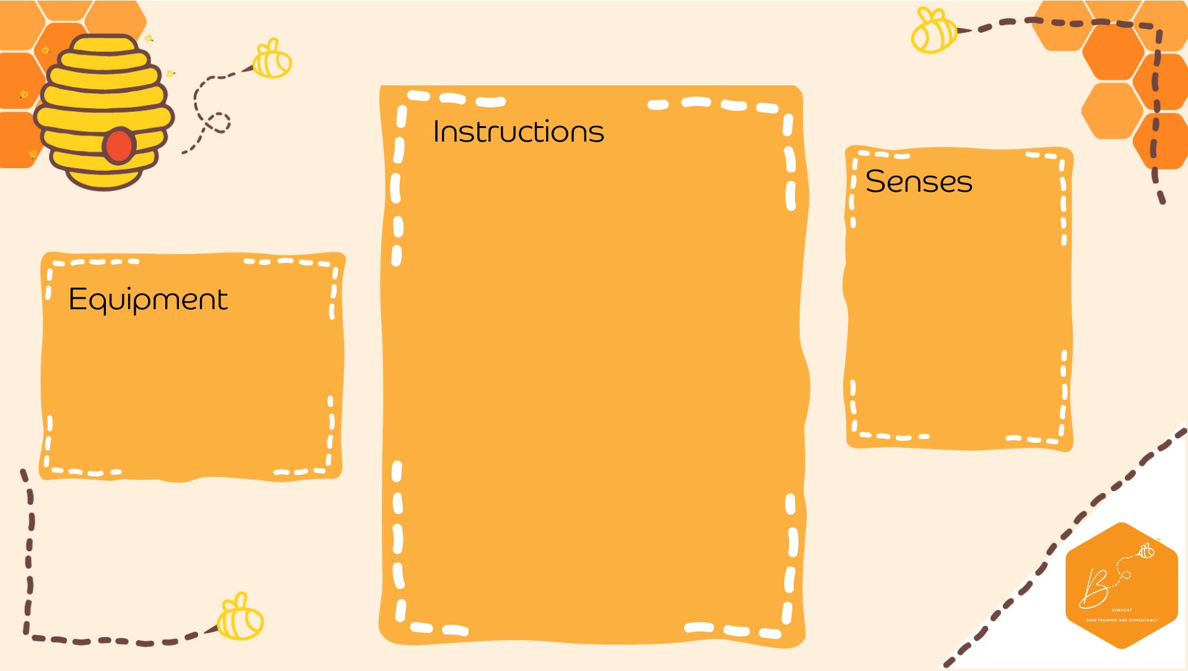
•

Pull and be
nd the straws

•

Fold over the bend to

make a
U shape

•

C
ut
the stem of the straws off

•

Attach a paper
clip onto both
ends of
the straw

•

A
dd
more
paper clips on to
make a small chain (3
-
clips
)
5

•

Place into the plastic bottle

•

Fill the bottle to al
most full
leave
(
approx.

cm from th
3
e
top)

•

Place the lid on the bottle

•

Squeeze and watch the
ghosts move

Visual

Propriocep.on

•

White straws

•

White paper clips

•

Empty plastic
drink b
ottle

•

Water

•

S
c
issors

Gh
ost Sensory Bottle

