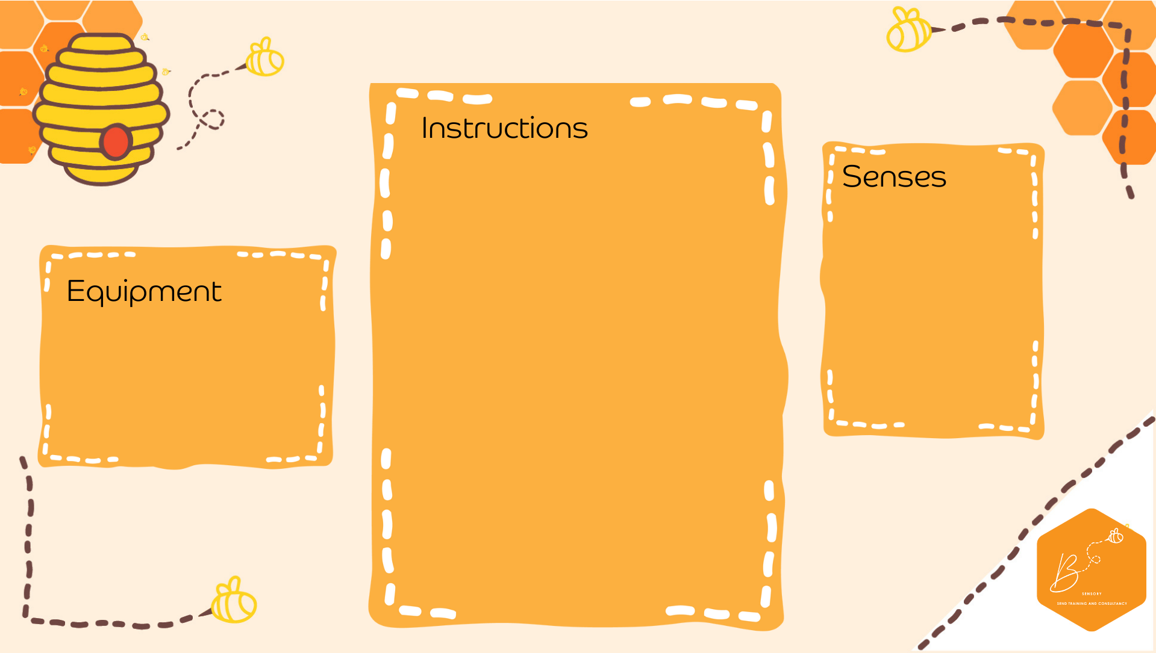
- Fallen leaves
- Sticky paper
- Cardboard
- Decorations
- Ribbon
Leaf Light Catcher
- Collect fallen leaves- the more colourful the better
- Cut the cardboard into a frame shape of choice
- Decorate the frame- you may use sticks, acorns or dried pumpkinseeds!
- Place the frame onto the sticky paper
- Place the dried leaves onto the sticky paper inside the frame
- Place sticky paper over the back of the frame
- Hang on some ribbon and place in a light area
Visual | 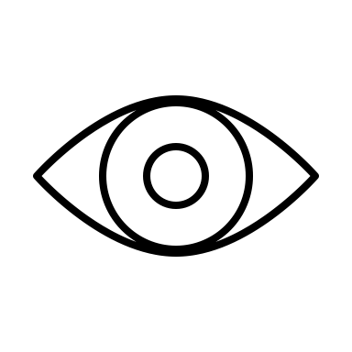
Touch | 

