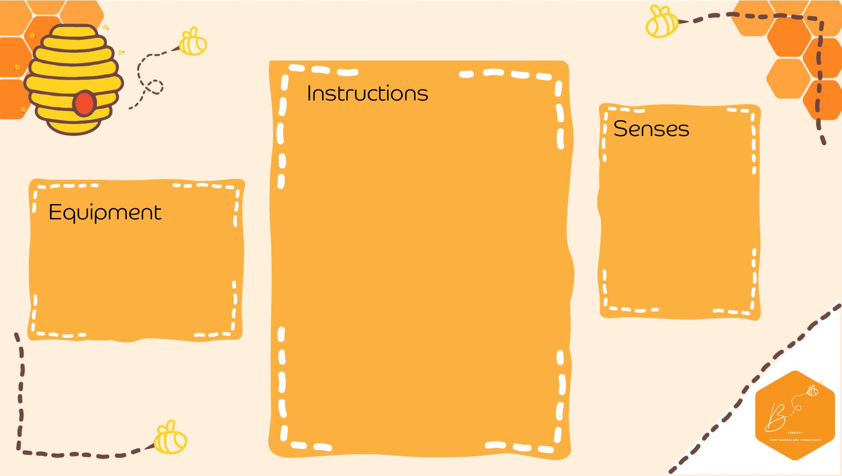
•

Slice
the pumpkin in half

•

Sc
oop

out the guts and
seeds and store in a di
sh

•

I
n a
separate

bowl add
2

cups of corn
flour

•

Mix water
with some
orange
/yellow food
colo
uring in a jug

•

Add
water bit
by b
it until
the mixture
become
s
gloopy but not runny

•

Add in the guts and seeds

•

Experiment
wit
h the

gloop
-

if you slap it
, it
goes solid

Visual

Touch

Propriocep0on

•

Pumpkin

•

Corn
flour

•

Water

•

Food colouring

•

Cup

•

Spare

dish

Pumpkin Goop (O
obleck)

