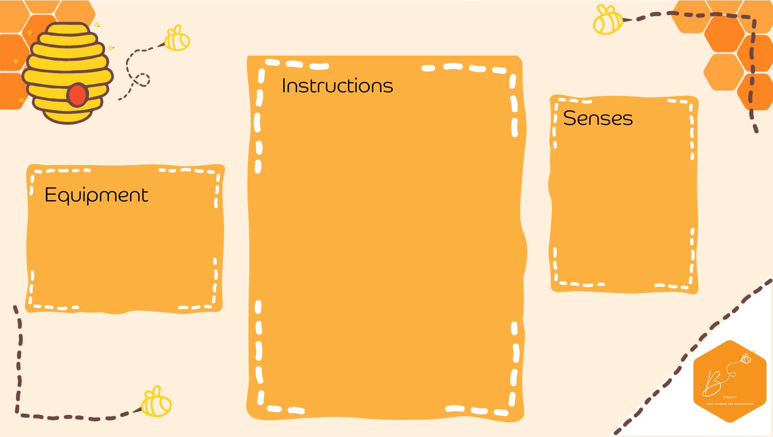
•

I
nside of the clear
plastic box, tap
e the
fai
ry lights
/LED
lights

so that
the
lights are
facing up towards t
he
lid

•

Turn the lights on

•

Place the lid on

top
(
tape to secure if
needed)

•

Place sand on

top of the
lid

Visual

Touch

•

Cl
ear plastic box

•

Battery Fairy
Lights

•

Tape

•

Sand

Sand Li
ght

Box

