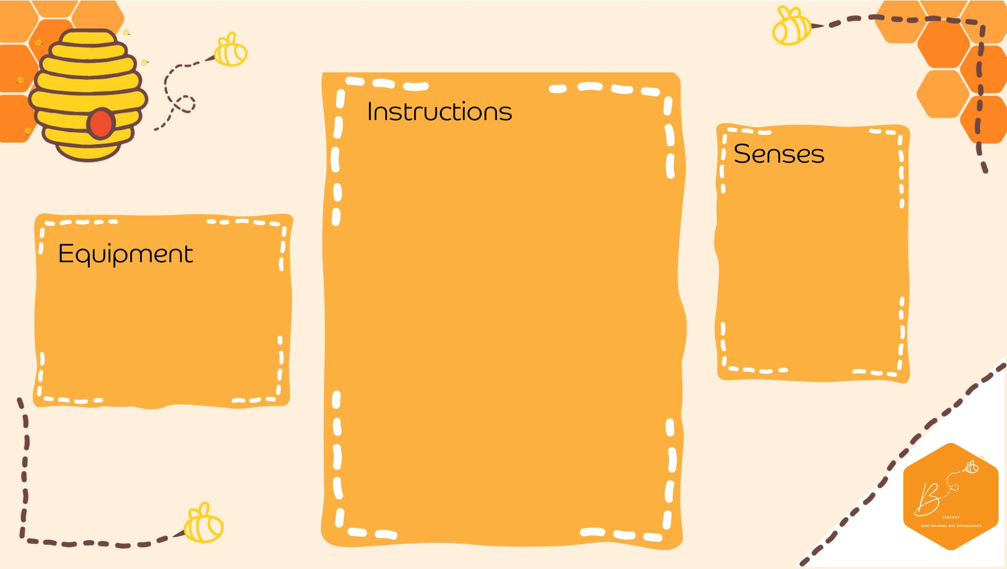
•

Beat 140 grams of soft butter with 60 grams
of caster sugar until you have a paste

•

Sprinkle in 190 grams of plain flour, 1 tsp of
cinnamon and 1tsp of mixed spice and stir
until you have crumbs

•

Then work with your hands until you have a
soft paste/dough ball

•

Roll out on a floured surface (about 1 cm
thick) and cut up with cutters.

•

Place on baking sheet and sprinkle with a
little more sugar.

•

Leave in fridge to cool while your oven
preheats to 190 degrees.

•

Bake for 15 mins or until the right colour.

•

Cool before
eating

•

Olfactory

Touch

Propriocep2on

•

g butter
140

•

)
room temperature
(

•

g caster sugar
60

•

g plain flour
190

•

1
tsp cinnamon

•

1
tsp mixed spice

Spice
d B
iscuits

