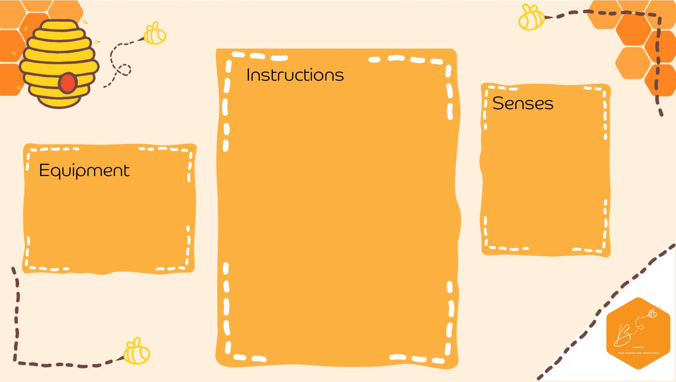
•

Draw a spider
onto
a
piece

of paper

•

Plac
e 8 pom poms
into the cent
re

•

Using

a straw, blow
the pom poms
onto the spiders
feet so that each
foot has
o
ne pom
pom on

Visual

Olfactory

Propriocep2on

•

Paper

•

Sha
r
pie

•

St
raw

•

Pom P
oms

Spide
r Fee
t B
low

