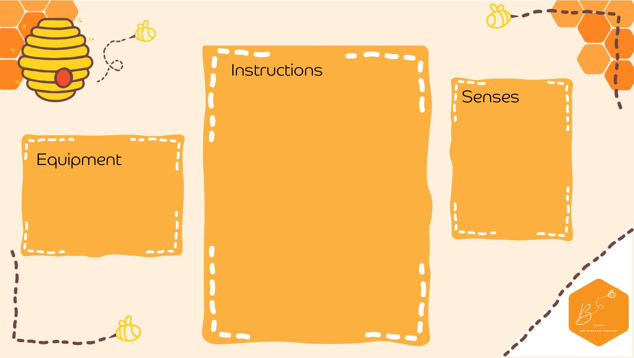
•

Using a small recorder or
phone
recording e
xperimen
t
with the
below, and record spo
o
ky sounds

-

B
lowing
i
nto an e
mpty
bottle to
sou
nd like
an owl

-

Running
a wet
finger
around the rim
of a
glass to
create ghost sounds

-

Flapping a bucket hat to sound like
bat wings

-

Crashing
cutlery

onto a metal tray for
glass breaking

-

Empty cups together to sound a like
haunted
horse galloping

-

A
boiling

kettle
for a cauldron

-

Pulling
alon
g
some str
ing underneath
a p
lastic cup

-

Blowing
into a turkey baster

-

Using a blunt saw and bending it or
use a vi
olin bow

-

Auditory

Propriocep.on

•

Sound
rec
order

•

Materials to
make spooky
sounds

Spooky Sound Collecting

