Champions Humanity Badge
Trust Infrastructure, Stablecoin Rails, and Operating Model
Board and Founder Brief
Comprehensive 6 Pager Plus Appendices

1. Executive Summary
Champions Humanity Badge is a pay it forward trust economy that connects capital with human potential. The program strengthens humanity through retreats, mentorship and community. The coin system provides a durable, verifiable record of trustworthiness and contribution. Stablecoins provide fast, low friction funding rails for the Champions Education Reserve and for cohort level allocations. Wallets provide digital identity, credential storage, and controlled access to resources.
This initiative is not a speculative cryptocurrency product. It is a mission aligned infrastructure that makes human development visible, portable, and investable while preserving dignity, consent and safeguarding.

2. The Structural Challenges Champions Faces
- Outcomes are long term while funding cycles are short and often episodic.
- Donors and sponsors want transparency and longitudinal proof of impact, but reporting is costly and slow.
- Participants lack portable credentials that signal trustworthiness and commitment beyond the program.
- Alumni networks lose intensity over time because there is no durable membership infrastructure.
- Capital providers and employers struggle to evaluate reliability for candidates without traditional signals.
- Community impact, ripple effects and pay it forward behavior are difficult to measure and reward.
The consequence is that humanity is undervalued. People who demonstrate reliability and service still face barriers to opportunity because trust is not captured in a portable and verifiable way.

3. Why Blockchain, Where to Use It, and What Not to Put on Chain
Blockchain is a shared ledger that provides a tamper resistant history of events. In this model it is used for three purposes:
- Proof of credential issuance and status (attendance, completion, roles).
- Proof of endorsements and validations (who validated what, when, under which rules).
- Proof of restricted funds movement at the program level (stablecoin reserve, cohort pools, disbursement events).
Where blockchain adds the most value in Champions:
- Credential integrity. Credentials become harder to forge and easier to verify for employers and funders.
- Auditability. Donors and boards can see transparent flows from reserve to cohort to approved uses.
- Portability. A participant keeps a lifelong record even if platforms change.
- Automation. Rules can trigger recognition, eligibility checks, and scheduled distributions.
What should not be placed on chain:
- Sensitive personal data such as health, trauma history, addresses, or private evaluations.
- Anything that could expose a participant to stigma, retaliation, or profiling.
- Detailed narrative notes. Store those off chain with strict access control.
Recommended pattern is hybrid architecture. Keep identities pseudonymous on chain, store sensitive data off chain, and anchor proofs on chain via hashes and signed attestations.

4. Stablecoins and Wallets: How the Financial Rails Work

4.1 Stablecoin concept
Stablecoins are blockchain based tokens designed to track a fiat currency such as the US dollar. For Champions they enable low friction, global contributions and fast internal allocations. Stablecoins should be used via compliant issuers and reputable rails. Champions does not need to issue its own stablecoin.

4.2 The Champions Education Reserve
The Education Reserve is a designated funding pool. Donors contribute by credit card, wire, or stablecoin. If donors use fiat, the platform can convert it to stablecoins for transparent pool accounting. The reserve then allocates funds to cohort wallets and program pools based on board approved budgets.

4.3 Wallet model and user experience
A wallet is a digital account that can hold tokens and credentials. The system should support two modes.
- Custodial mode (recommended for participants):
- Champions or a vetted partner manages keys and recovery. Participants log in with familiar methods such as email and phone. This reduces operational risk and user friction.
- Self custody mode (optional for advanced stakeholders):
- Donors and partners who prefer self custody can connect their own wallets. This supports global crypto native donors.

4.4 How disbursements can work
Disbursements to participants should not be automatic cash releases without safeguards. A safer approach is to provide access to approved resources. Examples include scholarship payments to institutions, travel bookings, stipends with controls, or vouchers for program materials. Stablecoin rails support fast settlement while policy controls define what is allowed.

5. Humanity Badge: Trust, Identity, and Reputation
The Humanity Badge is a digital trust credential. It represents membership and cumulative evidence of commitment to strengthening humanity. It is not a speculative asset and does not promise financial return.

5.1 What gives the badge value
- Verified participation in retreats and learning journeys.
- Endorsements from mentors, peers, and community leaders.
- Evidence of service and contribution to others.
- Leadership actions such as starting local chapters or facilitating sessions.
- Pay it forward contributions including mentorship, sponsorship, and capital back into the reserve.

5.2 Validation and reputation mechanics
The badge grows through attestations. Attestations are signed validations that confirm a milestone or contribution. A structured reputation layer prevents popularity contests by weighting validations based on validator role and credibility, applying moderation, and supporting appeals.

6. Visual Trust Economy Architecture
The following diagram describes the end to end trust economy flow.
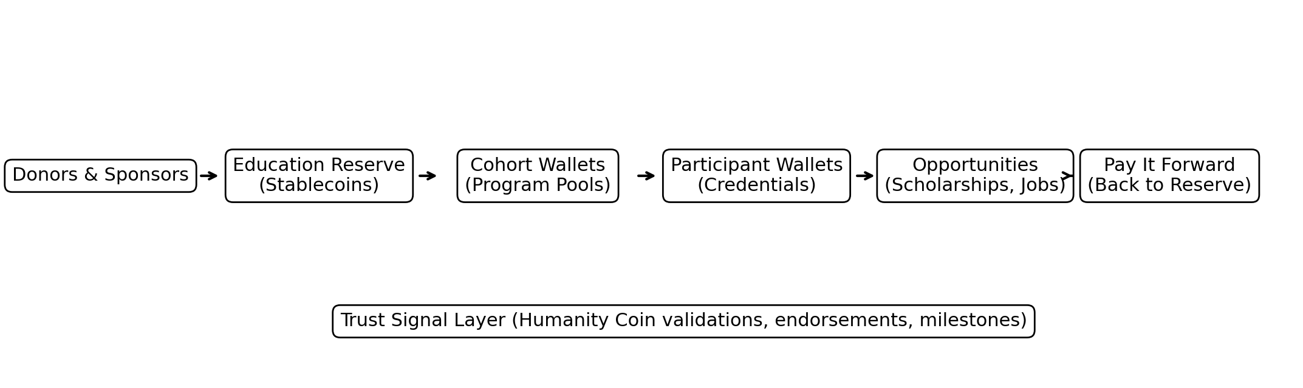

7. Participant Lifecycle Diagram
The lifecycle shows how identity and credentials persist over time and how pay it forward is reinforced.
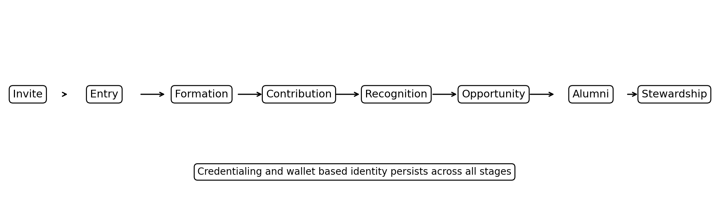

8. Operational Process: How the System Runs Day to Day

8.1 Core processes
- Process A: Cohort onboarding and wallet issuance
- Invite and consent. Participant opts in and accepts data and safeguarding terms.
- Identity setup. Create custodial wallet and profile.
- Issue initial Humanity Badge credential.
- Assign cohort membership and access rights.
- Set initial learning plan and milestones.
- Process B: Credentialing and milestone recording
- Capture attendance for retreats and sessions.
- Record completion of modules and assessments.
- Issue on chain credential proofs and store details off chain.
- Notify participant and update dashboards.
- Process C: Validation and endorsements
- Mentor or peer submits endorsement request with evidence.
- Moderation review for safety and fairness.
- Attestation is issued and linked to participant badge.
- Participant can accept, hide, or appeal within policy bounds.
- Process D: Funding allocation and spending controls
- Board approves cohort budget and permissible uses.
- Reserve allocates stablecoins to cohort wallet and program pools.
- Disbursements occur only through approved pathways such as payments to institutions, vendors, or controlled stipends.
- Monthly reconciliation between on chain events and accounting system.
- Process E: Opportunity matching
- Eligibility criteria defined by scholarship or employer partner.
- Participant opts in to share selected proof.
- Partner verifies credentials via public proofs and Champions issued attestations.
- Opportunity granted and outcome recorded as a milestone.

8.2 Controls and safeguarding
- Consent first. Participation in badge system is optional.
- Privacy by design. Sensitive content remains off chain.
- Role based access. Different visibility for mentors, donors, and public.
- Moderation and appeals for endorsements.
- Financial controls for disbursement categories and limits.
- Incident management plan for custody, fraud, and misuse.

9. Team Topology and Responsibilities
A lean operating model can run the system with a small core team plus shared functions. Below is a recommended topology.
Team | Primary responsibilities | Key outputs | Typical staffing
Program and Credential Ops | Milestone capture, credential issuance, data quality, participant onboarding | Credentials, cohort records, audit trails | 1 lead, part time support
Community and Alumni | Engagement, endorsements culture, alumni stewardship, events | Participation growth, mentorship matches, community health metrics | 1 lead
Capital and Partnerships | Donor management, employer partnerships, scholarship programs, matching campaigns | Reserve inflows, partner pipeline, opportunity placements | 1 lead
Platform and Security | Wallet operations, vendor management, integrations, security controls, incident response | Reliable platform, access controls, security posture, dashboards | 0.5 to 1 FTE or shared
Governance and Ethics | Policy, safeguarding, fairness, dispute resolution, privacy | Policies, review board, risk reports, appeals outcomes | Committee plus advisor

9.1 RACI highlights
- Champions board and founder
- Accountable for policy, risk tolerance, and approval of the reserve model.
- Program and Credential Ops
- Responsible for accuracy of credentials and milestones.
- Platform and Security
- Responsible for wallet safety, access controls, and incident response readiness.
- Community and Alumni
- Responsible for engagement, endorsement quality, and pay it forward culture.
- Capital and Partnerships
- Responsible for donor experience, matching campaigns, and opportunity pathways.

10. Benefits of Doing This With Blockchain
The benefits fall into mission, financial, governance, and ecosystem categories.

10.1 Mission and community benefits
- Belonging becomes durable. Membership persists and grows beyond the retreat.
- Motivation increases because progress and contribution are recognized.
- Alumni remain engaged through stewardship pathways.
- Ripple effects can be mapped and celebrated.

10.2 Funding and capital benefits
- Global stablecoin rails enable new donor segments and micro contributions.
- Matching campaigns become easier to run and verify.
- Reserve allocations can be tagged to cohorts and transparently reported.
- Over time, trust signals can support scholarships and micro capital programs with better confidence.

10.3 Governance and trust benefits
- Tamper resistant audit trail strengthens board oversight.
- Reduced reliance on narrative reporting alone.
- Clear separation between public proofs and private safeguarding data.
- Better ability to demonstrate integrity to institutional funders.

10.4 Ecosystem benefits
- Employers gain a new signal for trustworthiness and commitment.
- Partners can sponsor cohorts and access talent pipelines.
- The Champions identity becomes a movement credential that travels across borders.

11. Pilot Plan Using the Current Student Cohort
Start with 3 to 5 volunteer students from the current cohort. Focus on simplicity, safeguarding, and learning.
- Phase 1: Issue custodial wallets, cohort membership, and retreat completion credentials.
- Phase 2: Add mentor endorsements and simple peer validations with moderation.
- Phase 3: Launch donor facing dashboard for the cohort reserve and allocations.
- Phase 4: Pilot one opportunity pathway such as scholarship support or internship partner verification.
- Phase 5: Evaluate outcomes and decide on expansion to the full cohort and new chapters.

11.1 Success metrics
- Participant adoption and sentiment.
- Quality and fairness of endorsements.
- Donor engagement and retention.
- Number of verified opportunity placements or scholarships.
- Operational burden and security incidents, ideally zero.

